Patient-Reported Outcome Measure

Recommendations for Low Back Pain

September 2024

**The Australian Commission on Safety and Quality in Health Care acknowledges the traditional owners of Country throughout Australia, and their continuing connection to land, sea and community. We pay our respects to them and their cultures, and to elders both past and present.**

Published by the Australian Commission on Safety and Quality in Health Care

Level 5, 255 Elizabeth Street, Sydney NSW 2000

Phone: (02) 9126 3600

Email: [mail@safetyandquality.gov.au](mailto:mail@safetyandquality.gov.au)

Website: [www.safetyandquality.gov.au](http://www.safetyandquality.gov.au)

ISBN: 978-1-922880-86-4

© Australian Commission on Safety and Quality in Health Care 2024

All material and work produced by the Australian Commission on Safety and Quality in Health Care is protected by copyright. The Commission reserves the right to set out the terms and conditions for the use of such material.

As far as practicable, material for which the copyright is owned by a third party will be clearly labelled. The Australian Commission on Safety and Quality in Health Care has made all reasonable efforts to ensure that this material has been reproduced in this publication with the full consent of the copyright owners.

With the exception of any material protected by a trademark, any content provided by third parties and where otherwise noted, all material presented in this publication is licensed under a [Creative Commons Attribution–NonCommercial–NoDerivatives 4.0 International licence](http://creativecommons.org/licenses/by-nc-nd/4.0/).

Creative Commons Copyright logo

Enquiries about the licence and any use of this publication are welcome and can be sent to [communications@safetyandquality.gov.au](mailto:communications@safetyandquality.gov.au).

The Commission’s preference is that you attribute this publication (and any material sourced from it) using the following citation:

Australian Commission on Safety and Quality in Health Care. Patient-Reported Outcome Measure Recommendations for Low Back Pain. Sydney: ACSQHC; 2024.

**Disclaimer**

The content of this document is published in good faith by the Australian Commission on Safety and Quality in Health Care for information purposes. The document is not intended to provide guidance on particular healthcare choices. You should contact your healthcare provider on particular healthcare choices.

# Contents

Contents 3

Abbreviations 4

Quick guide – PROM recommendations for low back pain 5

Equity considerations when using PROMs 8

PROM recommendations for low back pain 9

Pain 10

Physical functioning 11

Negative affect 13

Health-related quality of life 15

Collection time points 17

Appendix A: Detailed information about recommended PROMs 18

Appendix B: Using PROM recommendations 28

Appendix C: Approach to developing condition-specific PROM recommendations 29

Appendix D: Definitions and COSMIN grading criteria for psychometric properties of PROMs 30

Appendix E: Summary grading of psychometric properties 33

Appendix F: Panel consensus criteria 34

Glossary 35

References 38

Acknowledgements 41

## 

# Abbreviations

|  |  |
| --- | --- |
| Term | Definition |
| COSMIN | COnsensus-based Standards for the selection of health Measurement INstruments |
| DASS‑21 | Depression Anxiety Stress Scale – 21 items |
| EQ-5D-5L | EuroQol – 5 Dimensions – 5 Levels |
| HRQoL | health-related quality of life |
| MK-K5 | Mayi Kuwayu Modified Kessler 5 |
| NPRS | Numerical Pain Rating Scale |
| ODI | Oswestry Disability Index |
| PROM | patient-reported outcome measure |
| RMDQ | Roland Morris Disability Questionnaire |

# Quick guide – PROM recommendations for low back pain

This two-page quick guide summarises the recommendations. It may be used and adapted to support communication and implementation of PROM recommendations.

Low back pain affects most people at some point in their lives.1 It often leads to psychological distress and poorer quality of life2, and is the leading cause of disability worldwide.1,3

Using patient-reported outcome measures (PROMs) can support clinicians to:

* Partner with patients in the management of their pain
* Assess and monitor the progress of low back pain and interventions from the patient’s perspective.

The Australian Commission on Safety and Quality in Health Care (the Commission) has developed evidence- and consensus-based recommendations for the use of PROMs for low back pain. These recommendations are intended to maximise the clinical usefulness of PROMs and minimise survey fatigue. Figure 1 shows the recommended PROMs for measuring the outcomes important to people with low back pain receiving either non-surgical or surgical interventions.

Figure 1: Overview of recommended PROMs for low back pain in patients receiving non‑surgical or surgical interventions, for people aged 16 and over

Figure 1: Overview of recommended PROMs for low back pain in patients receiving non‑surgical or surgical interventions, for people aged 16 and over

Pain: 
Measure using Numerical Pain Rating Scale

Physical functioning: 
Measure using Oswestry Disability Index or Roland Morris Disability Questionnaire

Negative affect*:
Measure using Depression Anxiety Stress Scale – 21 items or Mayi Kuwayu Modified Kessler 5†

Health-related quality of life:  
(Optional) Measure using EuroQol – 5 Dimensions – 5 Levels 



* For patients with chronic low back pain, or who are at risk of developing chronic back pain.

† For Aboriginal and Torres Strait Islander people.

## Summary of recommendations

There are many outcomes that are important to people who present with low back pain, including improving pain and being able to participate in daily activities. PROMs can be used to measure these outcomes to help assess and monitor progress from a patient’s perspective. For some outcomes, more than one PROM has been identified, and implementers can select one of these. Table 1 provides a summary of the recommended PROMs to use concurrently for low back pain.

Table 1: Summary of recommended PROMs for low back pain

|  |  |  |  |  |  |
| --- | --- | --- | --- | --- | --- |
| Outcome | Measure | Number of items | Time to complete | Licensing, fees and distributor | How to score |
|  |  |  |  |  |  |
| Pain | Numerical Pain Rating Scale (NPRS) | 1 | Less than 1 minute | * Licence not required * Free in public domain | Not applicable |
|  |  |  |  |  |  |
| Physical functioning  (choose one of either) | Oswestry Disability Index (ODI) | 10 | 3–5 minutes | * Licence required * Free for clinical practice * Fees may apply to healthcare organisations * [MAPI Research Trust ePROVIDE™](https://eprovide.mapi-trust.org/instruments/oswestry-disability-index) | Scoring guide at [MAPI Research Trust ePROVIDE™](https://eprovide.mapi-trust.org/instruments/oswestry-disability-index) |
| Roland Morris Disability Questionnaire (RMDQ) | 24 | 5 minutes | * Licence not required * Free in public domain * [www.rmdq.org](http://www.rmdq.org/) | Scoring guide at [www.rmdq.org](http://www.rmdq.org/) |
|  |  |  |  |  |  |
| Negative affect | Depression Anxiety Stress Scale – 21 items (DASS‑21) | 21 | Not assessed in any study | * Licence not required * Free in public domain * [Psychology Foundation of Australia](https://www2.psy.unsw.edu.au/dass/) | Scoring key provided at [DASS downloads](https://www2.psy.unsw.edu.au/dass/down.htm) and explained in [DASS FAQ #30](https://www2.psy.unsw.edu.au/dass/DASSFAQ.htm) |
| Mayi Kuwayu Modified Kessler 5 (MK-K5)  (Suitable for Aboriginal and Torres Strait Islander people) | 5 | Not assessed in any study | * Licence not required * Free * Mayi Kuwayu Modified Kessler 5 | Scoring guide within Mayi Kuwayu Modified Kessler 5 |
|  |  |  |  |  |  |
| Health-related quality of life  (optional) | EuroQol – 5 Dimensions – 5 Levels (EQ-5D-5L)  (Suitable for Aboriginal and Torres Strait Islander people) | 5 | Less than 5 minutes | * Licence required * Fees may apply * [EuroQol Group](https://euroqol.org/support/how-to-obtain-eq-5d/) | Scoring guide in [EQ-5D-5L User Guide](https://euroqol.org/wp-content/uploads/2023/11/EQ-5D-5LUserguide-23-07.pdf) |

Detailed information on the recommended PROMs, including samples for review, is provided in Appendix A, and guidelines for their use are in Appendix B. The development of the PROM recommendations is detailed in Appendices C, D, E and F.

# 

# Equity considerations when using PROMs

## Accessibility of PROMs

Patients with disability, low literacy skills or cognitive impairment, or those from diverse linguistic and cultural backgrounds may experience barriers with completing PROMs. The Commission aims to provide recommendations that are accessible. This includes identifying PROMs that have validated translations or that have been validated in specific population groups, and providing advice for using PROMs in specific groups.

Where the Commission has not given advice for a specific patient group, clinical judgment should be used to assess whether the recommended PROMs support clinician–patient communication and shared decision making.

## Cultural safety

The development of many PROMs is underpinned by Western biomedical models of health and wellbeing. Many PROMs may not be applicable to the needs of Aboriginal and Torres Strait Islander people4, or compatible with their conception of health and wellbeing.5 Other factors that may affect a PROM’s acceptability for Aboriginal and Torres Strait Islander people are the PROM’s length, language, wording and use of scales.4

Some research has engaged with communities on the cultural modification of PROMs and development of PROMs for Aboriginal and Torres Strait Islander people. Further work is needed to translate and culturally validate existing PROMs and design high-quality PROMs with and for Aboriginal and Torres Strait Islander communities.4

Where there is evidence of validity and reliability, the recommendations will highlight alternative PROMs that are suitable for Aboriginal and Torres Strait Islander people.

## Caveat for data analysis

If a healthcare service is using data from PROMs for service-level analyses, accommodating the diverse needs of patients may introduce measurement bias and affect the reliability and validity of responses.6 Analysis methodology should assess the impact of the potential bias and develop an approach to accommodate limitations.

See Agency for Clinical Innovation resource on [Analytic principles for patient-reported outcome measures](https://aci.health.nsw.gov.au/__data/assets/pdf_file/0007/633454/Analytic-Principles-for-Patient-Reported-Outcome-Measures.pdf).

# PROM recommendations for low back pain

## Context

Low back pain is a leading and increasing cause of disability and loss of productivity worldwide.7,8 It is associated with poor health-related quality of life in comparison to that of the general population, and limitations to mobility, self‑care, employment, and social participation. In Australia, one in six people report back problems.2

Data from the [Australian Atlas of Healthcare Variation Series](https://www.safetyandquality.gov.au/our-work/healthcare-variation/australian-atlas-healthcare-variation-series) identified significant service variations across Australia related to low back pain:

* In 2013–14, the number of Medicare-funded services for computed tomography imaging of the lumbar spine was 11.8 times higher in the areas with the highest rate compared to the area with the lowest rate.9
* Between 2015 and 2018, there was a 12-fold difference between the highest and lowest rates of lumbar spinal fusion surgery, and over a seven-fold difference in rates of lumbar spinal compression surgery.10

In response to these findings, the Commission developed the [Low Back Pain Clinical Care Standard](https://www.safetyandquality.gov.au/sites/default/files/2022-08/low_back_pain_clinical_care_standard.pdf). The standard consists of eight quality statements that describe the key components of care that a patient presenting with a new acute episode of low back pain should receive. This includes early clinical assessment, management, and review and referral. The standard also applies to patients with an acute episode, recurrence, or exacerbation of chronic low back pain.11

The [Third Australian Atlas of Healthcare Variation](https://www.safetyandquality.gov.au/sites/default/files/migrated/The-Third-Australian-Atlas-of-Healthcare-Variation-2018.pdf) (2018) also found a 5% increase in opioid prescribing nationally between 2013–14 and 2016–17.12 Opioids, which are commonly prescribed for acute low back pain13, are high-risk medicines with potential to cause harm, such as misuse, dependence and overdose. The [Opioid Analgesic Stewardship in Acute Pain Clinical Care Standard](https://www.safetyandquality.gov.au/sites/default/files/2022-04/opioid-analgesic-stewardship-in-acute-pain-clinical-care-standard.pdf) was developed to provide guidance on the appropriate use and review of analgesics for managing acute pain, to optimise patient outcomes and reduce the potential for opioid-related harm.14

The [Fourth Australian Atlas of Healthcare Variation](https://www.safetyandquality.gov.au/sites/default/files/2021-04/The%20Fourth%20Australian%20Atlas%20of%20Healthcare%20Variation%202021_Full%20publication.pdf) (2021) recommended addressing the identified service variations by using high-quality research and outcome monitoring, including PROMs, to identify patients who would benefit from spinal surgery rather than more conservative interventions for low back pain. This prompted the Commission to develop recommendations on validated PROMs for low back pain.10

There are many outcomes that are important to people who present with low back pain, such as improving pain and being able to participate in daily activities.15,16 Several PROMs can be used to measure these outcomes, to assist with assessing and monitoring progress from a patient’s perspective.16-18

Patients with low back pain may consult more than one type of clinician and receive multiple interventions for their pain. They may also transition between surgical and non-surgical points of care and can progress to recovery or chronicity. Recommending a set of PROMs for use across clinical areas to collect outcomes from patients with low back pain promotes consistency and a shared understanding between clinicians of a patient’s journey of care.

## Goal

To support clinicians to use PROMs to:

* Partner with patients in the management of their low back pain
* Assess and monitor the progress of low back pain and interventions from the patient’s perspective.

|  |
| --- |
| Pain  Numerical Pain Rating Scale (NPRS) |
| * **Number of items**: 1 * **Time to complete**: Less than 1 minute   Recommendation  Reducing pain is the most important outcome reported by patients seeking clinical care for their low back pain.15,18,19 The NPRS is recommended to assess pain intensity. It is a commonly used and comprehensible tool, and it is easy to administer either graphically or verbally.  Recall period  The recommended recall period for pain PROMs differs for patients with acute low back pain and chronic or persistent low back pain as follows:   * For patients presenting with **acute low back pain**, measuring pain ‘right now’ and ‘in the past 24 hours’ will provide clinicians with a baseline to aid monitoring of the patient’s progress. * For patients presenting with **chronic or persistent low back pain**, measuring pain ‘in the past 24 hours’ and ‘in the past week’ will provide clinicians with more information about the patient’s experience of pain over time. |

## Rationale

Pain intensity is consistently identified as the most important pain domain in low back pain literature and consensus-based development of core outcome domains for low back pain.18-21 The NPRS is the most frequently used PROM to measure pain intensity in people with low back pain in clinical practice, clinical trials and clinical quality registries.3,22

Consensus-based studies and initiatives have also selected the NPRS to measure pain. For example, it is used in an updated core outcome set for low back pain clinical research18, the International Consortium for Health Outcomes Measurement standard set for low back pain21, the National Institutes of Health Research Task Force’s set of standards for research on chronic low back pain23, and the Initiative on Methods, Measurement, and Pain Assessment in Clinical Trials recommendations for chronic pain clinical trials.20

A systematic review conducted using the COSMIN (COnsensus-based Standards for the selection of health Measurement INstruments) guidelines found that the NPRS had low or very low quality of evidence for content validity.19 However, it is still recommended for its simplicity and wide use in clinical practice. For more information and a sample of the NPRS, see Appendix A.

|  |
| --- |
| Physical functioning  Oswestry Disability Index (ODI) or Roland Morris Disability Questionnaire (RMDQ) |
| ODI:   * **Number of items**: 10 * **Time to complete**: 3–5 minutes   RMDQ:   * **Number of items**: 24 * **Time to complete**: 5 minutes   Recommendation  Physical functioning is measured to assess the effect of low back pain on activities of daily living, such as walking or moving around, personal care and sleep.24 Both the ODI and the RMDQ are recommended to measure this outcome. Although the ODI is the preferred tool, clinicians and healthcare services may choose to use the RMDQ if cost is a barrier. |

## Rationale

Low back pain can affect the ability of patients to participate in day-to-day activities, such as walking, self‑care and socialising.2,24 In conjunction with reducing pain intensity, increasing participation in everyday activities is an important outcome and rehabilitation goal for low back pain interventions.15 The ODI and RMDQ are the most frequently used PROMs to measure physical functioning in people with low back pain in clinical practice, clinical trials and clinical quality registries.3,22,25

A systematic review conducted using the COSMIN guidelines assessed the psychometric properties of the ODI and RMDQ in people with low back pain and did not find adequate quality evidence for content validity.25 The ODI provided marginally superior results in terms of its psychometric properties compared with the RMDQ. The ODI also has the advantage of being shorter and more widely used.26

In the absence of sufficient evidence to support the use of alternative PROMs to measure physical functioning, the ODI and RMDQ are considered to be useful tools to understand how low back pain is affecting a patient’s day-to-day activities.

## ODI or RMDQ?

The ODI is the preferred tool for assessing physical functioning. This is because the ODI captures more in-depth information, with multiple domains of daily living across 15 items, which patients can rate along a scale of impact. In comparison, the RMDQ has 24 items with a binary response, which can limit the amount of information that can be collected about the patient’s physical functioning. Additionally, the ODI is the selected PROM to assess physical functioning in standardised outcome sets for both research and clinical practice.

However, licensing requirements for the ODI may be a barrier for some clinicians and healthcare services, where fees may apply according to the conditions of use. The RMDQ is given as an option that is free in the public domain. For more information and samples of the ODI and RMDQ, see Appendix A.

|  |  |
| --- | --- |
| Implementation tip | |
| Implementation tip | The low back pain PROMs recommended in this document can be applied as an entire questionnaire set. However, to minimise survey burden and maximise clinical usefulness, clinicians can prioritise measuring pain and physical functioning to assess and monitor a patient’s progress. |

|  |  |
| --- | --- |
| Clinician communication tip | |
| Clinician communication tip | **Patients with low literacy skills** may be unable to complete a PROM themselves due to sentence length and unfamiliar words.6 Although PROMs are designed to be completed by the patient without interpretation of the patient’s response by a clinician or anyone else, clinicians may consider supporting patients with low literacy by reading through each item. This can be used as an opportunity to educate patients about the nature of low back pain, and how their pain experience may affect their mood and quality of life.  Related resource: [Supportive resources on health literacy](https://www.safetyandquality.gov.au/our-work/patient-and-consumer-centred-care/health-literacy/tools-and-resources-for-health-service-organisations) |

|  |
| --- |
| Negative affect  Depression Anxiety Stress Scale – 21 items (DASS‑21) |
| * **Number of items**: 21 * **Time to complete**: Not assessed in any study   Recommendation  Negative affect refers to the subjective experience of negative emotional states, such as anxiety, depression, stress, sadness, worry and anger. There is a link between negative affect and chronic low back pain. Low back pain can affect mood, and mood can increase the likelihood of chronicity.27 The DASS‑21 can be used to measure three categories of negative affect: depression, anxiety and stress. It can be used in people who present with a history of chronic low back pain, and in people with ongoing management of low back pain persisting more than 12 weeks beyond initial management of an acute exacerbation. |

## Rationale

There is a reciprocal relationship between mood and the experience of pain, and people with chronic low back pain are reported to have higher incidences of mental health comorbidities.11,27,28 Measuring a patient’s emotional state, or more specifically their negative affect, in conjunction with measuring pain intensity and physical functioning, can provide clinicians with a biopsychosocial understanding of a patient’s experience of pain, and assist in assessing and managing low back pain.

In Australia, the DASS‑21 is commonly used in patients with chronic low back pain who present to specialist pain services. A persistent pain collaboration that collects a standard set of data from specialist pain services in Australia and New Zealand includes the DASS‑21 to measure patient outcomes as a result of treatment.22,29

At the time of publishing these recommendations, no systematic review had been conducted to assess the psychometric properties of the DASS‑21 or other mood/distress PROMs using the COSMIN guidelines in people with low back pain or chronic pain. However, for the general population, the DASS‑21 has sufficient evidence for content validity and has been assessed to be psychometrically robust.30

The DASS‑21 was developed with no specific population in mind and has wide applicability to different patient populations.30-32 It is recommended for use with people who have or who may be at risk of developing chronic low back pain. For more information and a sample of the DASS‑21, see Appendix A.

|  |  |
| --- | --- |
| Cultural consideration | |
| Cultural consideration | The **Mayi Kuwayu Modified Kessler 5 (MK-K5)** is a measure of psychological distress that has been culturally modified and validated for Aboriginal and Torres Strait Islander people.33 It was modified from a five-item Kessler Psychological Distress Scale, which was adapted from the 10‑item version by Aboriginal and Torres Strait Islander representation at a social and wellbeing workshop. It was modified to be culturally sensitive and short for use in the National Aboriginal and Torres Strait Islander Health Survey.34  The MK‑K5 can be used as a culturally sensitive and shorter alternative to the DASS‑21 for Aboriginal and Torres Strait Islander people.  For more information and a sample of the MK-K5, see Appendix A. |

|  |  |
| --- | --- |
| Psychosocial assessment tools | |
| Psychosocial assessment tools | Psychosocial factors are associated with an increased risk of developing disability in people presenting with low back pain. These factors and emotional responses to pain are associated with delayed recovery, and their presence indicates the need for further assessment and appropriate intervention.35  Assessment tools used to identify unhelpful beliefs about pain and other psychosocial factors are clinically useful, but these tools are not PROMs.  For more information about using ‘yellow flag’ assessment tools, see **Quality statement 2 – Psychosocial assessment** in the [Low Back Pain Clinical Care Standard](https://www.safetyandquality.gov.au/sites/default/files/2022-08/low_back_pain_clinical_care_standard.pdf). |

|  |  |
| --- | --- |
| Clinician communication tip | |
| Clinician communication tip | Explaining negative affect to patients  There is a risk that patients may misinterpret a negative affect PROM as the clinician believing the pain is ‘all in their head’, and so may disengage.  Before completing the questionnaire, explain to the patient that pain can affect both the body and the mind, and vice versa. Some simple questionnaires can help identify their concerns and help in developing the best treatment and support for them. For example:  ‘Pain can cause us to feel stressed or sad, and feeling stressed or sad can make us feel more pain. It is like the volume is turned up on pain and other symptoms. Filling in this questionnaire can help me understand how the pain is affecting the way you feel and help figure out the best way to help you.’  Listen to the patient, and validate that their thoughts and feelings are understandable, and the pain they are experiencing is real.  For more useful communication tips, see the [Low Back Pain Clinical Care Standard](https://www.safetyandquality.gov.au/sites/default/files/2022-08/low_back_pain_clinical_care_standard.pdf). |

|  |
| --- |
| Health-related quality of life  EuroQol – 5 Dimensions – 5 Levels (EQ‑5D‑5L) |
| * **Number of items**: 5 * **Time to complete**: Less than 5 minutes  Recommendation Low back pain is associated with poor health-related quality of life (HRQoL) in comparison to the general population.15,36 HRQoL may be measured if there is an interest in global health outcomes. However, to minimise survey burden, clinicians should prioritise measuring pain and physical functioning as they are the most immediately important outcomes for patients with low back pain. The EQ‑5D‑5L is recommended to measure HRQoL in people with low back pain. |

## Rationale

Low back pain is associated with poor HRQoL in comparison to the general population.15,36 HRQoL is a commonly recommended outcome in clinical trials, but is less commonly used in clinical settings.

There is sufficient but very low-quality evidence for the relevance, comprehensibility and comprehensiveness of the EQ-5D-5L in people with low back pain. All other measurement properties have not been assessed in people with low back pain.36

Despite the lack of evidence of other psychometric properties of the EQ‑5D-5L in people with low back pain, it is still recommended by the International Consortium for Health Outcomes Measurement for the low back pain standard set due to its large evidence base for other patient populations and the general population, and the extensive availability of validated translations.21 In addition, the EQ‑5D-5L is shorter and relatively inexpensive compared with other commonly used HRQoL tools.

For more information and a sample of the EQ-5D-5L, see Appendix A.

### Psychometric evaluation of EQ‑5D‑5L in Aboriginal and Torres Strait Islander people

At the time of publishing these recommendations, there is no culturally appropriate HRQoL instrument available that has been designed by and validated specifically for use by Aboriginal and Torres Strait Islander people. Measurement of HRQoL within the Aboriginal and Torres Strait Islander framework of health and wellbeing must include domains of family and community, and constructs of connectedness beyond the individual.37

To determine whether meaningful data on HRQoL could be captured in this population, a study assessed the construct validity and reliability of the EQ‑5D‑5L in 1,012 Aboriginal adults across several distinct language groups. It found adequate reliability and good discriminant validity, and concluded that the EQ‑5D‑5L is a suitable tool for measuring HRQoL in Aboriginal and Torres Strait Islander people.38

# Collection time points

The time frames for collecting data from PROMs will vary depending on the acuity of the low back pain presentation, the goals of the patient and the clinician, and the intervention.

To assess the effect of an intervention, it is recommended that, at a minimum and where practical, clinicians use PROMs to collect information from patients at the start and end of treatment (for example, at the first or second visit, and when the patient returns for follow‑up appointments). If it is practicable, collecting at least three data points will establish a trend to determine whether a patient’s outcome score improves in response to an intervention.

## Acute presentation

Acute presentations of low back pain or interventions that provide short-term relief (such as analgesics) may not require extensive follow‑up administration of PROMs. PROMs may be used in the short term (such as when the patient returns for a follow‑up visit) to ensure an intervention is effective.

## Longer-term collection

Regular and longer-term collection of patient-reported outcomes using PROMs is recommended for patients with longer-term rehabilitation goals, for example, after surgical intervention or an episode of multidisciplinary care for chronic low back pain. If resources are available and patients are not lost to follow‑up, continued use of PROMs for more than six months after treatment is recommended to assess the longer-term outcomes of the intervention.

See Figure 2 for recommended collection time points for longer-term rehabilitation goals.

Figure 2: Recommended collection time points for low back pain PROMs for longer-term rehabilitation goals

Figure 2: Recommended collection time points for low back pain PROMs for longer-term rehabilitation goals

First visit

2 weeks

1 month

3 months

6 months

12 months

24 months



|  |  |  |
| --- | --- | --- |
| Risk factor for persistent spinal syndrome | |  |
| Risk factor for persistent spinal syndrome | It is recommended that patients receiving surgery have their pain measured **two weeks** after surgery to identify those who are experiencing severe pain. Patients with unidentified and unmanaged severe pain two weeks after surgery may have an increased risk of developing persistent spinal syndrome (formerly failed back surgery syndrome39). | |

# Appendix A: Detailed information about recommended PROMs

Please note that all versions of PROMs included in this appendix are samples and are for information purposes only to determine suitability for clinical use. Unless it is specified that the PROM is free in the public domain, the samples cannot be used without respective authorisation from distributors, copyright holders or developers. Refer to the licensing requirements for information on how to obtain authorised clinical use of PROMs.

## Numerical Pain Rating Scale (NPRS)

### PROM description

The NPRS (detailed in Table 2) is a self‑reported pain rating along an 11‑point Likert scale, ranging from 0 (no pain) to 10 (pain as bad as you can imagine or worst pain imaginable; see Figure 3). The descriptors of the anchor statements that refer to pain intensity vary. Patients are asked to circle a number that best represents their pain intensity. There may be introductory questions with or without recall periods. The most common recall variations include asking patients to report their pain currently, in the last 24 hours or in the last week.19

### Development

No publications were found with information about the development of the NPRS.

Table 2: Detailed information about Numerical Pain Rating Scale

|  |  |
| --- | --- |
| Characteristic | Details |
| Name | Numerical Pain Rating Scale |
| Abbreviation | NPRS |
| Country developed | Not known |
| Year validated | Not known |
| Short summary | Subjective measure for acute and chronic pain. It is a segmented, numerical version of the visual analogue scale. |
| Domains/dimensions | Unidimensional |
| Number of items | 1 |
| Time to complete | Less than 1 minute |
| Response type and range | 11-point Likert scale, from 0 (no pain) to 10 (pain as bad as you can imagine or worst pain imaginable) |
| Scoring guide | Not applicable |
| Translations | Minimal language translation is required |
| Licence required | No |
| Fees | No – free in public domain |
| Copyright | No copyright |
| References to the original papers | Not applicable |

Figure 3: Numerical Pain Rating Scale – Pain score 0–10

Figure 3: Numerical Pain Rating Scale – Pain score 0–10

No pain = 0

Moderate pain = 5

Worst pain possible = 10



## Oswestry Disability Index (ODI)

### PROM description

The ODI 2.1b (detailed in Table 3) consists of 10 sections (pain intensity, personal care, lifting, walking, sitting, standing, sleeping, sex life, social life, travelling), each containing six statements ranging in intensity (scored from 0 to 5); patients select the statement that best represents their situation (Figure 4). Scores on each of the 10 sections are summed, giving a maximum score of 50. The total score is then converted into a percentage (index) by multiplying it by two. Scores are stratified into severity: 0–20, minimal disability; 21–40, moderate disability; 41–60, severe disability; 61–80, crippling back pain; 81–100, patients are either bed-bound or have an exaggeration of their symptoms. A change in the patient’s score of 10% or more is considered a clinically significant result.

### Development

The ODI was first developed by specialist clinician John O’Brien in 1976 and later published by Jeremy Fairbank in 1980. The ODI was originally developed through patient interviews to identify the disturbance to activities of daily living caused by chronic back pain. It was designed for use with client groups that had acute, subacute or chronic back pain. The ODI was later modified by a Medical Research Council group in the United Kingdom, removing references to medication from the pain and sleeping items to improve the relevance of these items to people not taking medication. In 2000, the original ODI developer made additional modifications that led to version 2.0 (an option was added for ‘no pain’ in the pain intensity section), and then version 2.1 (alteration made to the travel section) and 2.1a (one-word adjustment to the opening statement).40 ODI 2.1b was developed with a one-word alteration made to the personal care section.

Table 3: Detailed information about Oswestry Disability Index

|  |  |
| --- | --- |
| Characteristic | Details |
| Name | Oswestry Disability Index |
| Abbreviation | ODI |
| Country developed | United Kingdom |
| Year validated | 1980 |
| Short summary | Measures pain-related disability for low back pain and spinal disorders more generally and is the preferred choice in severe disability when compared with the Roland Morris Disability Questionnaire. It is available in multiple versions and its items are included in the Patient-Reported Outcomes Measurement Information System® (PROMIS®). |
| Domains/dimensions | Unidimensional |
| Number of items | 10 |
| Time to complete | 3–5 minutes |
| Response type and range | Six-point Likert scales with various anchors |
| Scoring guide | [MAPI Research Trust ePROVIDE™](https://eprovide.mapi-trust.org/instruments/oswestry-disability-index) |
| Translations | [45 translations, including English for Australia](https://eprovide.mapi-trust.org/instruments/oswestry-disability-index#languages) |
| Licence required | Yes |
| Fees | * Free for clinical practice * Fees may apply to healthcare organisations |
| Distributors | Weblink | ODI Contact information and permission to use:   * Mapi Research Trust, Lyon, France * [eprovide.mapi-trust.org](https://eprovide.mapi-trust.org) |
| Copyright | ODI © Jeremy Fairbank, 1980. All rights reserved. |
| Author(s) | Fairbank JC |
| References to the original papers | Fairbank JC, Couper J, Davies JB, O’Brien JP. The Oswestry low back pain disability questionnaire. Physiotherapy 1980;66(8):271–3. |

Figure 4: Oswestry Disability Index Version 2.1b

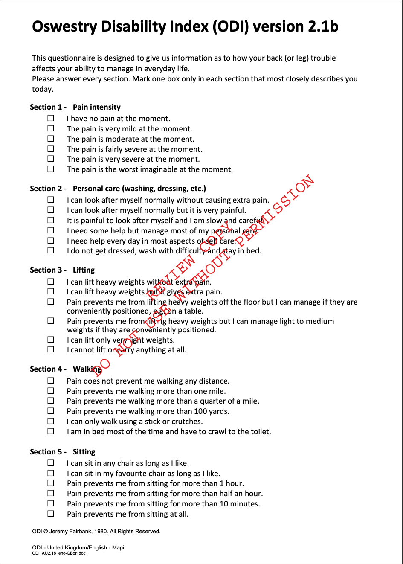

(continued)

Figure 4: Oswestry Disability Index Version 2.1b (continued)

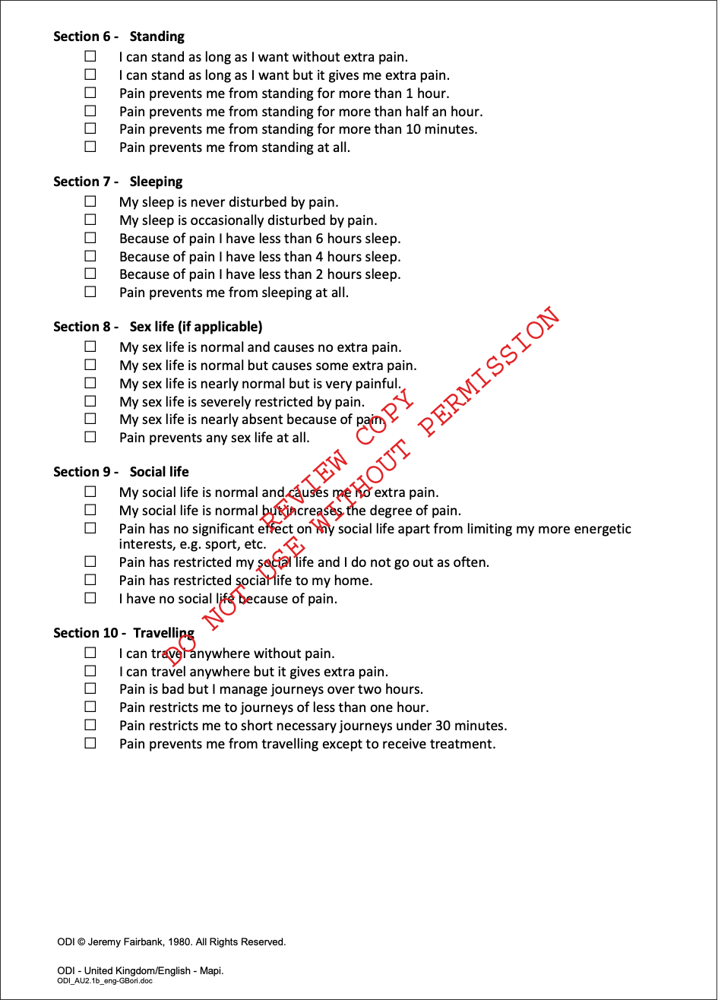

## Roland Morris Disability Questionnaire (RMDQ)

### PROM description

Patients completing the RMDQ (detailed in Table 4) are asked to place a check mark beside a statement if it applies to them ‘today’ (Figure 5). This approach was chosen to make it suitable for observing short-term changes in back pain. The score is calculated by adding up the number of items checked, with total scores ranging from zero (no disability) to 24 (maximum disability).

### Development

The RMDQ was first published in 1983, and was originally designed and tested for use in primary care settings for low back pain. It has since been used in a variety of other settings (for example, research, healthcare specialists).

Multiple versions of the RMDQ have been developed; however, the content between the different versions of the RMDQ varies considerably. These deviations make comparisons across studies challenging, with international experts calling for use of the original 24‑item version because of its widespread use and benefits in standardisation.41

Table 4: Detailed information about Roland Morris Disability Questionnaire

|  |  |
| --- | --- |
| Characteristic | Details |
| Name | Roland Morris Disability Questionnaire |
| Abbreviation | RMDQ |
| Country developed | United Kingdom |
| Year validated | 1983 |
| Short summary | A short measure of disability, particularly caused by low back pain. It is primarily recommended for mild to moderate disability, and focuses only on physical problems. It is available in a number of forms and uses a checklist format. 24-, 18- and 11-item questionnaires are available. |
| Domains/dimensions | Unidimensional |
| Number of items | 24 |
| Time to complete | 5 minutes |
| Response type and range | Respondents select from a list only those items that describe current function. |
| Scoring guide | [www.rmdq.org](http://www.rmdq.org) |
| Translations | [57 translations, including English for Australia](http://www.rmdq.org/Download.htm) |
| Licence required | No |
| Fees | No – free in public domain |
| Distributors | Weblink | [www.rmdq.org](http://www.rmdq.org/) |
| Copyright | Available in public domain and can be used without permission |
| Author(s) | Morris R and Roland MO |
| References to the original papers | * Roland M, Morris R. A study of the natural history of back pain. Part I: Development of a reliable and sensitive measure of disability in low‑back pain. Spine 1983;8(2):141–4. * Roland M, Fairbank JC. The Roland–Morris disability questionnaire and the Oswestry disability questionnaire. Spine 2000;25(24):3115–24. |

Figure 5: Roland Morris Disability Questionnaire

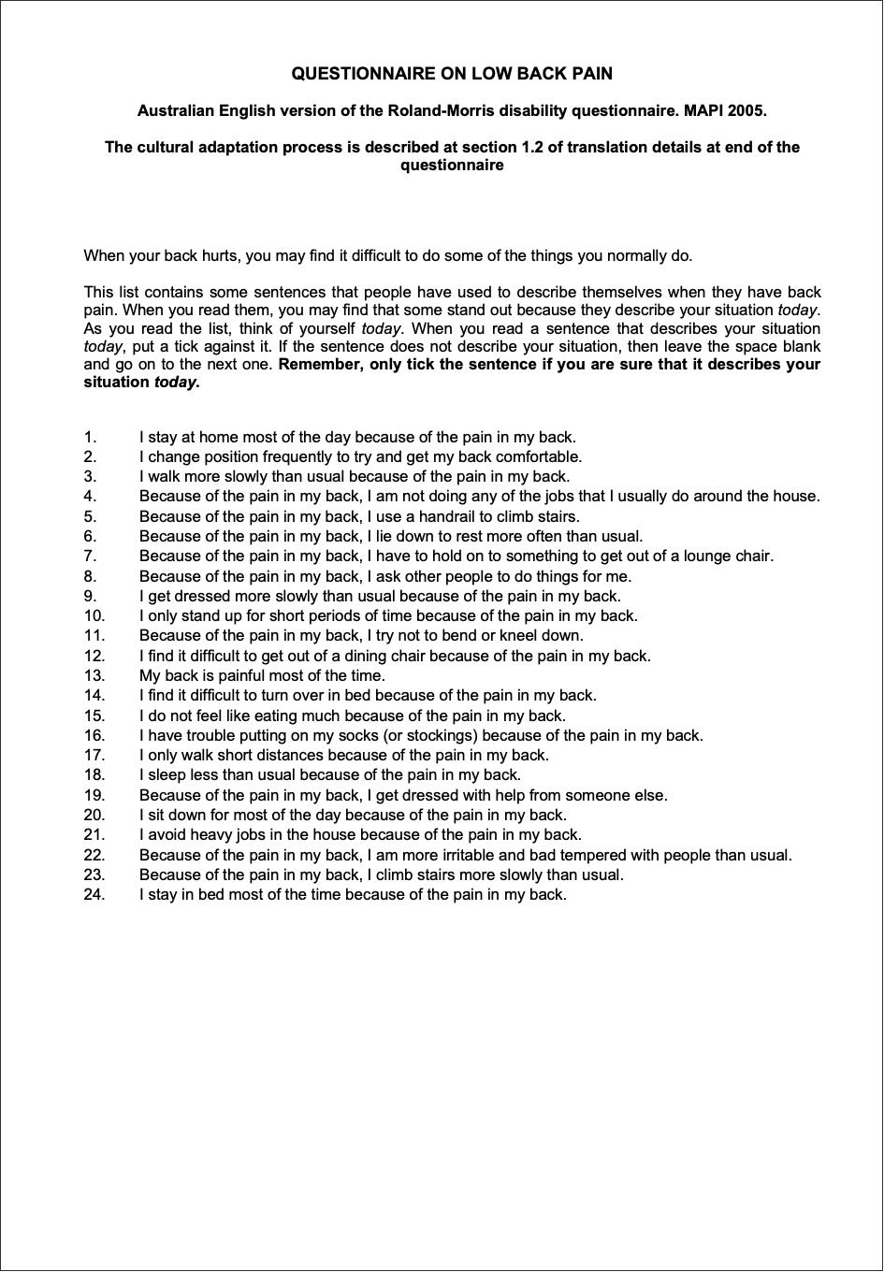

## Depression Anxiety Stress Scale – 21 items (DASS‑21)

### PROM description

The DASS‑21 (detailed in Table 5) is a measure of negative emotional states of depression, anxiety and stress (Figure 6). The patient indicates the presence of a symptom over the previous week. Each item is scored from 0 (did not apply to me at all over the last week) to 3 (applied to me very much or most of the time over the past week). The essential function of the DASS‑21 is to assess the severity of the core symptoms of depression, anxiety and stress.

Although the DASS may contribute to the diagnosis of anxiety or depression, it is not designed as a diagnostic tool. Indeed, symptoms typical of depression, such as sleep, appetite and sexual disturbances, are not covered by the DASS and will need to be assessed independently. The DASS is not meant to replace a comprehensive clinical interview.

### Development

The DASS was developed in 1995 by Lovibond and Lovibond, who identified a broad range of core symptoms of depression and anxiety, and identified stress as a separate factor with a different range of core symptoms. Based on these findings, Lovibond and Lovibond developed the DASS to assess the core symptoms of depression, anxiety and stress, and a brief 21‑item version, the DASS‑21.42

Table 5: Detailed information about Depression Anxiety Stress Scale – 21 items

|  |  |
| --- | --- |
| Characteristic | Details |
| Name | Depression Anxiety Stress Scale – 21 items |
| Abbreviation | DASS‑21 |
| Country developed | Australia |
| Year validated | 1995 |
| Short summary | A 21-item measure to assess the negative emotional states of depression, anxiety and stress. The DASS‑21 is a shorter version of the DASS-42. |
| Domains/dimensions | 3: Depression, anxiety, tension/stress |
| Number of items | 21 |
| Time to complete | Not assessed in any study |
| Response type and range | Four-point Likert scale, from 0 (did not apply to me) to 3 (applied to me very much or most of the time) |
| Scoring guide | Scoring key provided at [DASS downloads](https://www2.psy.unsw.edu.au/dass/down.htm) and explained in [DASS FAQ #30](https://www2.psy.unsw.edu.au/dass/DASSFAQ.htm) |
| Translations | [57 translations](http://www2.psy.unsw.edu.au/groups/dass/translations.htm) |
| Licence required | No |
| Fees | No – free in public domain |
| Distributors | Weblink | [Psychology Foundation of Australia](https://www2.psy.unsw.edu.au/dass/) |
| Copyright | Available in public domain and can be used without permission |
| Author(s) | Lovibond PF and Lovibond SH |
| References to the original papers | Lovibond PF, Lovibond SH. The structure of negative emotional states: comparison of the Depression Anxiety Stress Scales (DASS) with the Beck Depression and Anxiety Inventories. Behav Res Ther 1995;33(3):335–43. |

Figure 6: Depression Anxiety Stress Scale – 21 items

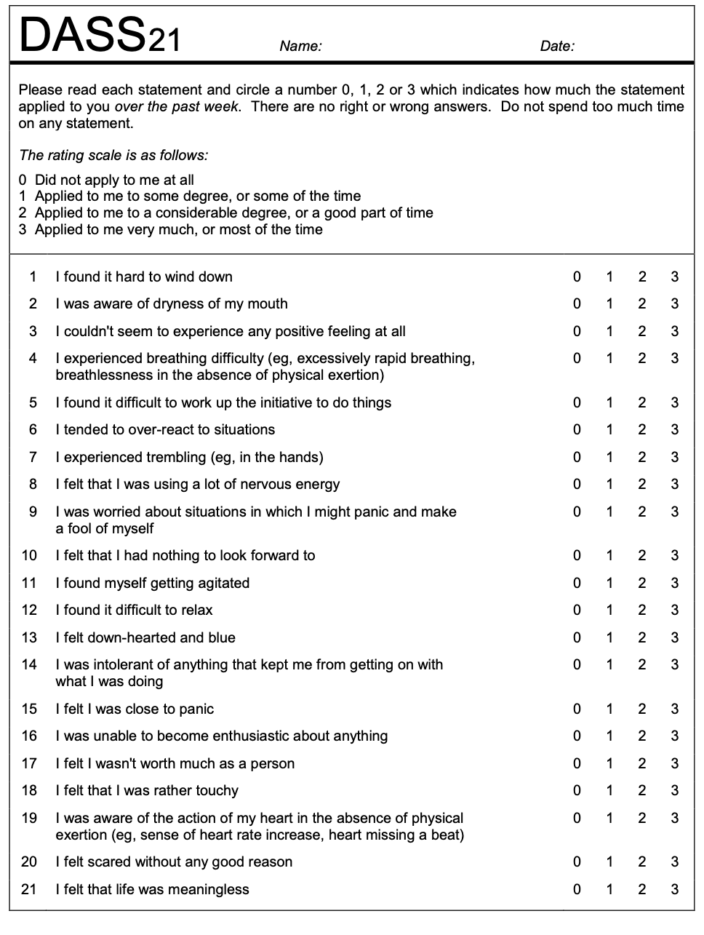

## Mayi Kuwayu Modified Kessler 5 (MK-K5)

### PROM description

The MK‑K5 (detailed in Table 6) is a culturally modified and validated version of the Kessler Psychological Distress Scale 5 (K5) for Aboriginal and Torres Strait Islander people, which assesses psychological distress (Figure 7).

### Development

The Kessler Psychological Distress Scale 10 (K10) was developed in 1992 by Ron Kessler and Dan Mroczek. Kessler and Mroczek reviewed approximately 500 psychological distress items from various sources, reducing these to 45 items. Based on United States surveys, the scale was further refined to 32 items, and then two sets: one with six items (K6) and one with 10 items (K10).

In 2003, Aboriginal and Torres Strait Islander stakeholders at a social and emotional wellbeing workshop raised concerns about the cultural appropriateness of the word ‘worthless’ in the K10, which might be considered offensive to some Aboriginal and Torres Strait Islander people. Professor Kessler and state and territory health authorities gave support for the inclusion of five questions to measure psychological distress among Aboriginal and Torres Strait Islander people.

Alterations were also made to two items to improve cultural comprehension: feeling ‘hopeless’ was changed to feeling ‘without hope’; and feeling ‘restless or fidgety’ was changed to feeling ‘restless or jumpy’.34 However, there was a lack of robust evidence for the validity of the modified version in Aboriginal and Torres Strait Islander peoples, especially younger adults, and for those residing outside of New South Wales.33

The MK‑K5 was developed and validated with further modifications to support comprehensibility in the Aboriginal and Torres Strait Islander population.

Table 6: Detailed information about Mayi Kuwayu Modified Kessler 5

|  |  |
| --- | --- |
| Characteristic | Details |
| Name | Mayi Kuwayu Modified Kessler 5 |
| Abbreviation | MK-K5 |
| Country developed | Australia |
| Year validated | 2021 |
| Short summary | A culturally modified Kessler 5 instrument that can be used to assess the psychological distress levels of Aboriginal and Torres Strait Islander people. |
| Domains/dimensions | Unidimensional |
| Number of items | 5 |
| Time to complete | Not assessed in any study |
| Response type and range | Five-point Likert scale, from 1 (none of the time) to 5 (all of the time) |
| Scoring guide | Scoring guide within Mayi Kuwayu Modified Kessler 5 |
| Translations | Unknown |
| Licence required | No |
| Fees | No |
| Distributors | Weblink | [Mayi Kuwaya – The National Study of Aboriginal and Torres Strait Islander Wellbeing](https://mkstudy.com.au/) |
| Copyright | Can be used without permission |
| Author(s) | Brinckley M, Calabria B, Walker J, Thurber KA and Lovett R |
| References to the original papers | Brinckley M, Calabria B, Walker J, Thurber KA, Lovett R. Reliability, validity, and clinical utility of a culturally modified Kessler scale (MK-K5) in the Aboriginal and Torres Strait Islander population. BMC Public Health 2021;21:1111. |

Figure 7: Mayi Kuwayu Modified Kessler 5

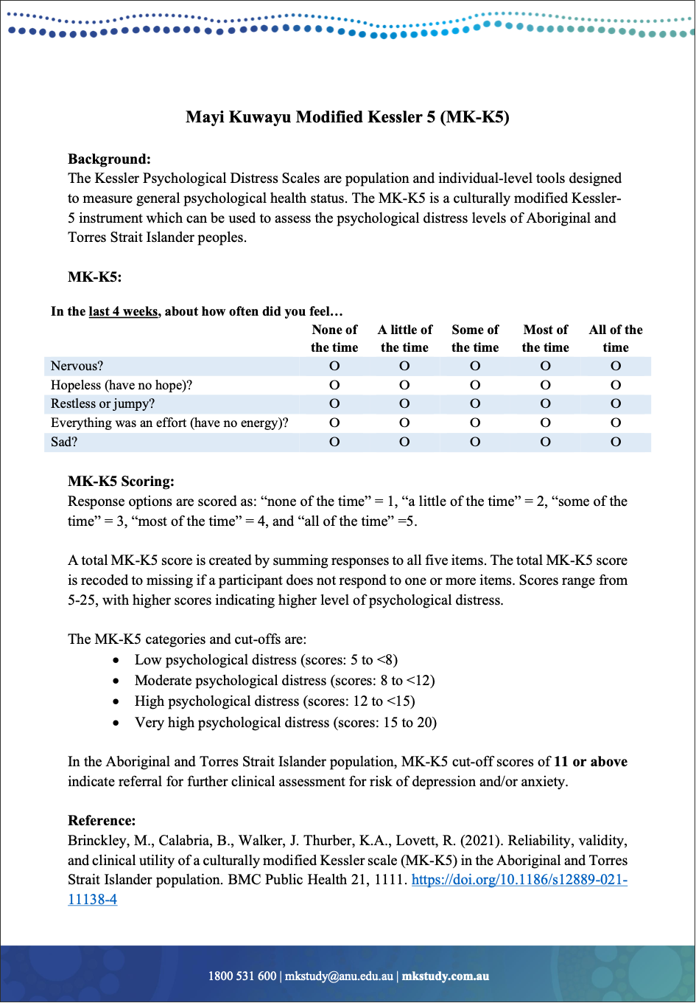

## EuroQol – 5 Dimensions – 5 Levels (EQ-5D-5L)

### PROM description

The EQ‑5D‑5L is a measure of health-related quality of life (HRQoL). The first part of the EQ‑5D‑5L consists of five items measuring mobility, self‑care, usual activities, pain/discomfort and anxiety/depression, with five descriptive response options each corresponding to severity. The second part consists of a 0–100 vertical visual analogue scale that scores self‑rated health from the best imaginable health state to the worst imaginable health state (Figure 8).

### Development

The EQ‑5D was developed by the EuroQol Group in the 1980s as a HRQoL measure to be used in large‑scale surveys to enable cross-national comparisons of health state valuations. Each dimension had three response options corresponding to severity (the EQ‑5D‑3L). In 2011, the EuroQol Group developed and tested a new five-level severity description system to improve sensitivity and reliability, which was renamed the EQ‑5D‑5L.43

Table 7: Detailed information about EuroQol – 5 Dimensions – 5 Levels

|  |  |
| --- | --- |
| Characteristic | Details |
| Name | EuroQol – 5 Dimensions – 5 Levels |
| Abbreviation | EQ-5D-5L |
| Country developed | Europe: Denmark, England, Italy, the Netherlands, Poland and Scotland |
| Year developed | 2011 |
| Short summary | Group of instruments that have been developed to describe and value health across a wide range of disease areas. A visual analogue scale records self‑rated health on a vertical scale with two end points. |
| Domains/dimensions | 5: Mobility, self‑care, usual activities, pain/discomfort, anxiety/depression |
| Number of items | 5 |
| Time to complete | Less than 5 minutes |
| Response type and range | Descriptive system comprising five dimensions. Respondents check the box corresponding to the level of severity that describes their health state in the given dimension. |
| Scoring guide | Scoring guide in [EQ-5D-5L User Guide](https://euroqol.org/wp-content/uploads/2023/11/EQ-5D-5LUserguide-23-07.pdf) |
| Translations | More than 150 translations, including English for Australia |
| Licence required | Yes |
| Fees | * Yes – fees may apply * Licensing fees are determined by the EuroQol Office based on the user information provided in the registration form. You are not obliged to purchase the EQ‑5D by registering. |
| Distributors | Weblink | [EuroQol Group](https://euroqol.org/support/how-to-obtain-eq-5d/) |
| Copyright | © EuroQol Research Foundation. EQ‑5D™ is a trademark of the EuroQol Research Foundation. |
| Author(s) | The EuroQol Group |
| References to the original papers | Herdman M, Gudex C, Lloyd A, Janssen M, Kind P, Parkin D, Bonsel G, Badia X. Development and preliminary testing of the new five-level version of EQ‑5D (EQ‑5D‑5L). Qual Life Res 2011;20(10):1727–36. |

Figure 8: EuroQol – 5 Dimensions – 5 Levels – Health Questionnaire – English version for Australia

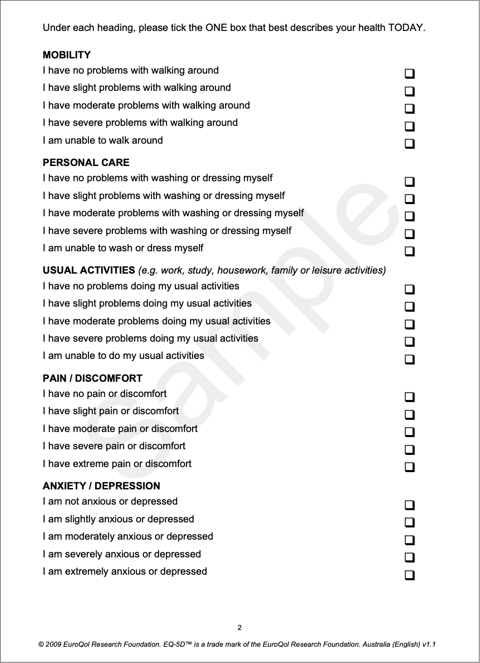

(continued)

Figure 8: EuroQol – 5 Dimensions – 5 Levels – Health Questionnaire – English version for Australia (continued)

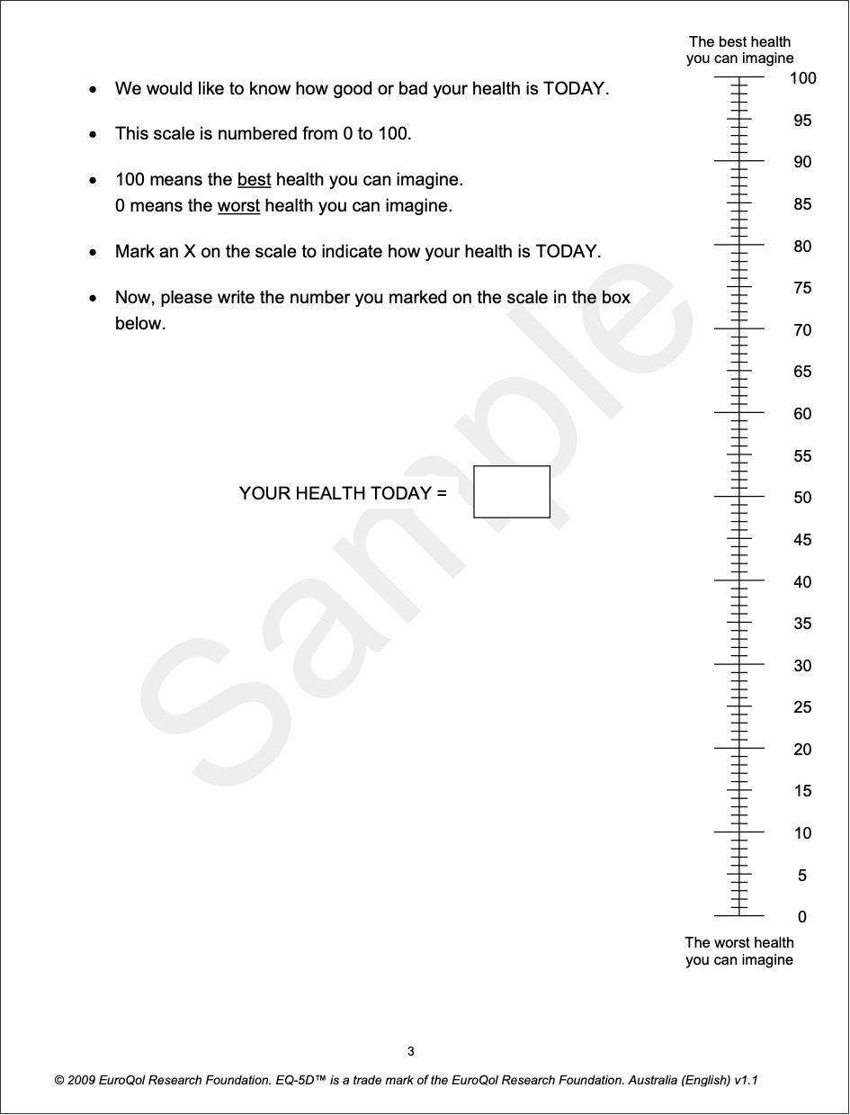

Reproduction of this EurQol instrument is not allowed. For use of this EuroQol instrument and any other EuroQol instrument, please submit a request by using the online registration page at   
[www.euroqol.org](http://www.euroqol.org).

# Appendix B: Using PROM recommendations

## Measurement for improvement

Healthcare services and clinicians can implement PROM recommendations as part of localised quality improvement. To monitor quality improvement, it is recommended that PROMs are used at specified and standard time points (see Collection time points). This will enable comparative analysis and reporting, such as by intervention and by provider.

### Using PROMs to meet national standards and accreditation

Implementing PROM recommendations for quality improvement can also support healthcare services to meet the requirements for the following criteria:

#### National Safety and Quality Health Service Standards

* [Action 1.08: Safety and quality systems – Measurement and quality improvement](https://www.safetyandquality.gov.au/standards/nsqhs-standards/clinical-governance-standard/patient-safety-and-quality-systems/action-108)
* [Action 1.28: Clinical performance and effectiveness – Variation in clinical practice and health outcomes](https://www.safetyandquality.gov.au/standards/nsqhs-standards/clinical-governance-standard/clinical-performance-and-effectiveness/action-128)

#### National Safety and Quality Primary and Community Healthcare Standards

* [Action 1.03: Patient safety and quality systems – Measurement and quality improvement](https://www.safetyandquality.gov.au/standards/primary-and-community-healthcare/clinical-governance-standard)
* [Action 1.21: Clinical performance and effectiveness – Variation in care delivered and health outcomes](https://www.safetyandquality.gov.au/standards/primary-and-community-healthcare/clinical-governance-standard)

### PROMs in clinical quality registries

The routine collection, analysis and reporting of patient-reported outcomes is increasingly being adopted by clinical quality registries (CQRs). CQRs systematically monitor the quality of health care within specific clinical domains. The information generated can be used to improve care of an eligible population, and risk-adjusted reports can be generated in a format that can be used for quality improvement activities. Clinicians and healthcare services may consider participating in national and/or international CQRs to inform quality improvement activities.

See the [Australian Register of Clinical Registries](https://www.safetyandquality.gov.au/publications-and-resources/australian-register-clinical-registries) to search for Australian CQRs by condition.

## Clinical care standards

PROM recommendations are aligned with and can be used to complement relevant [clinical care standards](https://www.safetyandquality.gov.au/standards/clinical-care-standards). Clinical care standards contain quality statements that provide guidance on the delivery of evidence-based care, and sometimes include advice on using validated tools to assess and monitor a patient-reported outcome. Clinicians and healthcare services may choose to implement PROMs from these recommendations or consider suggestions within the relevant standard as part of developing a systematic approach to using PROMs.

# Appendix C: Approach to developing condition-specific PROM recommendations

There are numerous resources that support the selection of the most suitable PROMs to use in clinical practice. Key considerations when selecting a PROM include its psychometric properties, its acceptability to patients and its feasibility in clinical practice (see the Commission’s advice on [selecting PROMs](https://www.safetyandquality.gov.au/our-work/indicators-measurement-and-reporting/patient-reported-outcomes/proms-implementers/selecting-proms) for a list of resources and key considerations for selecting PROMs).

There are hundreds of validated PROMs available for clinicians and healthcare services to select from, and the development of new PROMs is increasing. The Commission aims to support clinicians and healthcare services with selecting PROMs for specific conditions, to promote consistency across clinical areas and types of interventions. We do this by developing evidence- and consensus-based recommendations on:

* Outcomes that are relevant to people with a specific condition
* Existing and validated PROMs that best measure those outcomes
* When to use PROMs to collect these outcomes.

To develop the recommendations, the Commission conducts a literature review and environmental scan to identify existing PROMs for a specific condition. Candidate PROMs are selected based on their psychometric properties, which are assessed using definitions and gradings adopted from the COSMIN (COnsensus-based Standards for the selection of health Measurement INstruments) guidelines.44-46 A panel consisting of clinicians and consumers with lived experience consider the evidence to build consensus on which PROMs to use for the specific condition.

See Figure 9 for details on the approach to developing PROM recommendations.

Figure 9: Approach to developing condition-specific PROM recommendations

Figure 9: Approach to developing condition-specific PROM recommendations

Literature review: 
A literature review is conducted to identify existing PROMs for a specific condition. 

Environmental scan: 
An environmental scan is conducted to identify existing PROMs, collection practices, programs and standards across Australia and internationally. This scan is supplemented by interviews with experts in collecting outcomes and using PROMs for the specified condition. 

Psychometric assessment: 
Based on the findings of the literature review and environmental scan, the psychometric properties of candidate PROMs are graded using the COSMIN guidelines. The criteria used to assess evidence of psy-chometric properties, such as reliability and construct validity, can be found in Appendix D.

Panel consensus: 
A panel consisting of clinicians and consumers with lived experience considers findings from the literature review, environmental scan and psychometric assessment to build consensus on which PROMs to use for the specified condition. The panel assesses candidate PROMs against consensus criteria such as interpreta-bility and clinical relevance (see Appendix F). The panel considers the PROM’s alignment with best prac-tices in existing programs in Australia and internationally. The panel provides advice on time points for administration of PROMs and other considerations for implementation, such as how to meet diverse pa-tient needs. 

Recommendations: 
The Commission publishes recommendations on patient-reported outcomes that are important to patients with the specific condition, and which PROMs to use to measure those outcomes.

Review: 
Recommendations are based on current evidence and practices, and input from clinicians with extensive experience using PROMs in their clinical practice. It is expected that new evidence and validation studies will emerge over time that either support recommended PROMs or support newer PROMs that demon-strate superior psychometric properties. The Commission will review and refine its recommendations as more high-quality evidence and validation studies are published, and PROM collection practices evolve.


# Appendix D: Definitions and COSMIN grading criteria for psychometric properties of PROMs

Definitions and grading standards in Table 8 below were adopted from the COSMIN guidelines.44-46 The table provides the definitions for each of the psychometric properties, together with the COSMIN grading criteria. Each criterion was rated as positive (+), indeterminate (?) or negative (−). If no information for the property was available, a rating of zero (0) was applied.

Table 8: Definitions and COSMIN grading criteria for psychometric properties for PROMs

|  |  |  |  |
| --- | --- | --- | --- |
| Psychometric property | Definition | Rating | Rating criteria |
| Internal consistency | The extent to which the PROM (sub)scale items are correlated (homogenous), and thus measure the same concept. | + | At least low evidence for sufficient structural validity **and** Cronbach’s alpha(s) ≥0.70 for each unidimensional scale or subscale |
| ? | Criteria for ‘at least low evidence’ for sufficient structural validity not met |
| – | Low evidence for sufficient structural validity **and** Cronbach’s alpha(s) <0.70 for each unidimensional scale or subscale |
| Reliability | The consistency of scores over a time span of no clinical change; quantified through repeated administrations of the PROM in a time period when patients are not expected to experience clinical change. | + | ICC/weighted kappa ≥0.70 |
| ? | ICC/weighted kappa not reported |
| – | ICC/weighted kappa <0.70 |
| Measurement error | The systematic and random error of a patient’s score that is not attributed to be true in the construct measured. | + | SDC or LoA < MIC |
| ? | MIC not defined |
| – | SDC or LoA > MIC |
| Structural validity | The degree to which the scores of a PROM are an adequate reflection of the dimensionality of the construct to be measured. | + | CFA/IRT/Rasch: CFI or TLI or comparable measure >0.95 or RMSEA <0.06 or SRMR <0.08 |
| ? | CFA/IRT/Rasch: Not all information for ‘+’ reported |
| – | Criteria for ‘+’ not met |
| Criterion validity | The degree to which the scores of a PROM are an adequate reflection of a ‘gold standard’. The COSMIN panel reached consensus that no gold standard exists for PROMs. The only exception is when a shortened instrument is compared to the original long instrument. | + | Correlation with gold standard/AUC ≥0.70 |
| ? | Not all information for ‘+’ reported |
| – | Correlation with gold standard/AUC <0.70 |
| Construct validity | The extent to which an instrument’s scores relate to other measures in a manner that is consistent with theoretically derived hypotheses regarding the concepts being measured. | + | Correlation with an instrument measuring the same construct ≥0.50 **or** ≥75% of the results are in accordance with hypotheses **and** correlation with related constructs is higher than unrelated constructs |
| ? | No hypotheses defined **or** reported correlations solely with unrelated constructs |
| – | Correlation with an instrument measuring the same construct <0.50 **or** <75% of the results are in accordance with hypotheses **or** correlation with related constructs is lower than with unrelated constructs |
| Responsiveness | The ability of a PROM to detect change over time when clinically relevant change is expected to occur. Recommended metrics include standardised measures of effect size and the Norman’s responsiveness coefficient. | + | The results are in accordance with hypotheses |
| ? | No hypotheses were defined |
| – | The results are not in accordance with hypotheses |

+ = sufficient, – = insufficient, ? = indeterminate, AUC = area under curve, CFA = confirmatory factor analysis, CFI = comparative fit index, COSMIN = The COnsensus-based Standards for the selection of health Measurement INstruments, ICC = intraclass coefficient, IRT = item response theory, LoA = limits of agreement, MIC = minimal important change, PROM = patient-reported outcome measure, RMSEA = root mean square error of approximation, SDC = smallest detectable change, SRMR = standardised root mean residuals, TLI = Tucker–Lewis index.

# Appendix E: Summary grading of psychometric properties

Table 9: Summary grading of psychometric properties of recommended PROMs for low back pain

|  |  |  |  |  |  |
| --- | --- | --- | --- | --- | --- |
| Measurement properties | | NPRS19 | ODI25,26 | RMDQ25,26 | EQ-5D-5L (utility)36 |
| Content validity | **Relevance** | ?  Low | ?  Very low | +  Very low | +  Very low |
| **Comprehensiveness** | ?  Low | –  Very low | –  High | +  Very low |
| **Comprehensibility** | +  Very low | +  Very low | +  High | +  Very low |
| Structural validity | | N/A | ?  Moderate | –  High |  |
| Internal consistency | | N/A | +  Moderate | +  Moderate |  |
| Test–retest reliability | | ?  Low | +  Moderate | +  Moderate |  |
| Measurement error | | –  High | +  Moderate | +  Moderate |  |
| Construct validity | | ?  Very low | +  Moderate | +  Moderate |  |
| Responsiveness | | ?  Moderate | ?  Moderate | ?  Moderate |  |

+ = sufficient results, – = insufficient results, ? = indeterminate results, EQ-5D-5L = EuroQol – 5 Dimensions – 5 Levels, ODI = Oswestry Disability Index, N/A = not applicable, NPRS = Numerical Pain Rating Scale, RMDQ = Roland Morris Disability Questionnaire.

Empty cells represent measurement properties not assessed in any study.

Cross-cultural validity was not assessed for any instrument.

# Appendix F: Panel consensus criteria

Table 10: Panel consensus criteria to assess candidate PROMs

|  |  |
| --- | --- |
| Criterion | Definition |
| Interpretability | The score and change in score are easy to calculate and comprehensible |
| Clinical relevance and actionability | The domains and score are clinically useful and provide information that supports clinical practice, patient–clinician communication and shared decision making.  Factors include:   * Scores for individual domains are actionable for clinical practice * Changes in score over time are clinically useful |
| Consumer acceptability | The PROM addresses domains that are important to consumers and is comprehensible.  Factors include:   * Reading age * Required mental and physical ability level * Completion time * Length of instrument |
| Cost | The PROM requires licensing or payment of a fee for usage |
| Accessibility | Validated translations of the PROM are available in the most spoken languages other than English in Australia |
| Level of agreement | There is evidence of national and international use of the PROM in clinical practice |

# Glossary

|  |  |
| --- | --- |
| Term | Definition |
| Acute low back pain | Low back pain that lasts less than three months. The term ‘acute’ indicates the duration of symptoms and is not a diagnosis. |
| Australian Atlas of Healthcare Variation | A series developed by the Commission that explores the extent to which the use of health care in Australia varies depending on where people live, how their care is funded and their level of socioeconomic disadvantage. The aim is to prompt further investigation into whether the observed variation reflects a response to differences in people’s healthcare needs or in the informed choices they make about their treatment options. |
| Biopsychosocial (also known as socio-psycho-biomedical) framework | A framework that helps clinicians understand the complexity of their patient’s experience and lays a foundation for assessment and more effective pain management. The way a person processes nociceptive signals in their brain, and their resulting pain experience, depends on their developmental stage (for example, infancy, adolescence, adulthood), the social and cultural context (socio-), their emotional state (psycho-) and their biological health (-biomedical). A biopsychosocial approach considers the bidirectional relationship between these factors and the person’s pain experience to determine strengths and areas that may need support during management.47 |
| Chronic low back pain (also referred to as persistent pain) | Low back pain that is present for more than three months. The term ‘chronic’ indicates the duration of symptoms and is not a diagnosis. Chronic low back pain may have a specific cause, or may be non-specific – that is, no cause has been identified.35,47 |
| Clinical care standards | Standards developed by the Commission to help support the delivery of evidence-based clinical care and promote shared decision making between patients, carers and clinicians. Clinical care standards aim to ensure that people receive best‑practice care for a specific clinical condition or procedure, regardless of where they are treated in Australia. |
| Clinician | A trained health professional who provides direct clinical care to patients. A clinician may be a registered or non-registered practitioner, and may provide care within a healthcare service as an employee, a contractor or a credentialed healthcare provider, or under other working arrangements. Clinicians include nurses, midwives, medical practitioners, allied health professionals, paramedics and other professionals who provide health care, and students who provide health care under supervision. |
| Content validity | A psychometric property that indicates the degree to which the content of a PROM is an adequate reflection of the construct to be measured. It is considered to be the most important measurement property of a PROM. A PROM with sufficient content validity indicates that all items of the PROM are relevant to a specific population and context of use (relevant), capture concerns of the patient (comprehensive) and are understood by the patient (comprehensibility).44 |
| COSMIN | The COnsensus-based Standards for the selection of health Measurement INstruments initiative that aims to improve the selection of PROMs in research and clinical practice by developing tools for selecting the PROM that is most fit for purpose. This initiative has established quality standards for reporting and grading of reliability and validity in PROMs. |
| Health-related quality of life (HRQoL) | The ‘health aspects of quality of life, generally considered to reflect the impact of disease and treatment on disability and daily functioning. HRQoL also reflects the impact of perceived health on an individual’s ability to live a fulfilling life.’48 |
| Multidisciplinary approach | An approach to chronic pain management that simultaneously addresses all biopsychosocial factors affecting the patient’s pain, and helps patients achieve their goals sooner than approaches that address only some contributors to the patient’s pain. |
| Negative affect | The subjective experience of negative emotional states, such as anxiety, depression, stress, sadness, worry and anger. |
| Pain | An unpleasant sensory experience associated with, or resembling that associated with, actual or potential tissue damage. |
| Patient-reported outcome measures | PROMs are questionnaires that help patients to report on outcomes relating to their health. These questionnaires focus on various aspects of health, such as symptoms, daily functioning and quality of life. PROMs are usually used to measure outcomes on two or more occasions to enable comparisons to be made over time. |
| Physical functioning | The ability to participate in daily activity and movement, such as walking, sleeping and socialising. |
| Psychometric properties | The validity and reliability of PROMs. Many PROMs have undergone rigorous psychometric development. Careful design and testing of PROMs increase confidence that they measure what they have been developed to measure (they are valid) and do so in a consistent manner (they are reliable). |
| Recurrent pain (also referred to as episodic pain) | Pain that occurs episodically over three months or more. Each episode is similar in presentation – it may be recurrent acute nociceptive pain or episodes of a chronic pain condition. |
| Reliability | The degree to which the measurement is free from measurement error. Three properties of reliability can be evaluated for a PROM: internal consistency, test–retest reliability and measurement error. |
| Responsiveness | Captures the ability of a PROM to detect change over time when clinically relevant change is expected to occur. |
| Validity | The degree to which a PROM measures the construct(s) it purports to measure in terms of structural, construct and criterion validity. |

# References

1. The Lancet Rheumatology. The global epidemic of low back pain [editorial]. Lancet Rheumatol 2023;5(6):e305.

2. Australian Institute of Health and Welfare. Back problems. Canberra: AIHW; 2023.

3. van Hooff ML, Jacobs WC, Willems PC, Wouters MW, de Kleuver M, Peul WC, et al. Evidence and practice in spine registries: a systematic review, and recommendations for future design of registries. Acta Orthop 2015;86(5):534–44.

4. Ryder C, Stephens JH, Ullah S, Coombes J, Cominos N, Sharpe P, et al. Community engagement and psychometric methods in Aboriginal and Torres Strait Islander patient-reported outcome measures and surveys – a scoping review and critical analysis. Int J Environ Res Public Health 2022;19(16):10354.

5. Angell B, Muhunthan J, Eades A-M, Cunningham J, Garvey G, Cass A, et al. The health-related quality of life of Indigenous populations: a global systematic review. Qual Life Res 2016;25(9):2161–78.

6. Cella D, Hahn EA, Jensen SE, Butt Z, Nowinski CJ, Rothrock N, et al. Patient-reported outcomes in performance measurement. Research Triangle Park (NC): RTI Press; 2015.

7. Schofield DJ, Shrestha RN, Cunich M, Tanton R, Kelly S, Passey ME, et al. Lost productive life years caused by chronic conditions in Australians aged 45–64 years, 2010–2030. Med J Aust 2015;203(6):260.e1–6.

8. Ferreira ML, de Luca K, Haile LM, Steinmetz JD, Culbreth GT, Cross M, et al. Global, regional, and national burden of low back pain, 1990–2020, its attributable risk factors, and projections to 2050: a systematic analysis of the Global Burden of Disease Study 2021. Lancet Rheumatol 2023;5(6):e316-29.

9. Australian Commission on Safety and Quality in Health Care. Australian atlas of healthcare variation. Sydney: ACSQHC; 2015.

10. Australian Commission on Safety and Quality in Health Care. The fourth Australian atlas of healthcare variation. Sydney: ACSQHC; 2021.

11. Australian Commission on Safety and Quality in Health Care. Low back pain clinical care standard. Sydney: ACSQHC; 2022.

12. Australian Commission on Safety and Quality in Health Care. The third Australian atlas of healthcare variation. Sydney: ACSQHC; 2018.

13. Jones CM, Day RO, Koes BW, Latimer J, Maher CG, McLachlan AJ, et al. Opioid analgesia for acute low back pain and neck pain (the OPAL trial): a randomised placebo-controlled trial. Lancet 2023;402(10398):304–12.

14. Australian Commission on Safety and Quality in Health Care. Opioid analgesic stewardship in acute pain clinical care standard – acute care edition. Sydney: ACSQHC; 2022.

15. Eilayyan O, Gogovor A, Zidarov D, Mayo N, Ahmed S. Identifying domains of health-related quality of life: the perspective of individuals with low back pain. J Patient Rep Outcomes 2023;7(1):79.

16. Stamm TA, Boesendorfer A, Omara M, Ritschl V, Štefanac S, Mosor E. Outcomes research in non-specific low back pain: knowledge transfer in clinical practice. Wien Klin Wochenschr 2019;131(21–22):550–7.

17. Australian Commission on Safety and Quality in Health Care. Rapid review and evidence synthesis on patient-reported outcome measures for low back pain. Sydney: ACSQHC; 2021.

18. Chiarotto A, Boers M, Deyo RA, Buchbinder R, Corbin TP, Costa LO, et al. Core outcome measurement instruments for clinical trials in nonspecific low back pain. Pain 2018;159(3):481.

19. Chiarotto A, Maxwell LJ, Ostelo RW, Boers M, Tugwell P, Terwee CB. Measurement properties of visual analogue scale, numeric rating scale, and pain severity subscale of the brief pain inventory in patients with low back pain: a systematic review. J Pain 2019;20(3):245–63.

20. Dworkin RH, Turk DC, Farrar JT, Haythornthwaite JA, Jensen MP, Katz NP, et al. Core outcome measures for chronic pain clinical trials: IMMPACT recommendations. Pain 2005;113(1–2):9–19.

21. Clement RC, Welander A, Stowell C, Cha TD, Chen JL, Davies M, et al. A proposed set of metrics for standardized outcome reporting in the management of low back pain. Acta Orthop 2015;86(5):523–33.

22. Australian Commission on Safety and Quality in Health Care. An environmental scan of the use of low back pain patient-reported outcome measures. Sydney: ACSQHC; 2023.

23. Deyo RA, Dworkin SF, Amtmann D, Andersson G, Borenstein D, Carragee E, et al. Report of the NIH Task Force on research standards for chronic low back pain. Phys Ther 2015;95(2):e1–18.

24. Grabovac I, Dorner TE. Association between low back pain and various everyday performances: activities of daily living, ability to work and sexual function. Wien Klin Wochenschr 2019;131(21–22):541–9.

25. Chiarotto A, Ostelo RW, Boers M, Terwee CB. A systematic review highlights the need to investigate the content validity of patient-reported outcome measures for physical functioning in patients with low back pain. J Clin Epidemiol 2018;95:73–93.

26. Australian Commission on Safety and Quality in Health Care. Evaluation of shortlisted PROMS for low back pain: a targeted review and assessment of psychometric properties. Sydney: ACSQHC; 2022.

27. Nieminen LK, Pyysalo LM, Kankaanpää MJ. Prognostic factors for pain chronicity in low back pain: a systematic review. Pain Rep 2021;6(1):e919.

28. Gerdle B, Dragioti E, Rivano Fischer M, Ringqvist Å. Pain intensity and psychological distress show different associations with interference and lack of life control: a clinical registry-based cohort study of >40,000 chronic pain patients from SQRP. Front Pain Res 2023;4:1093002.

29. Australian Health Services Research Institute. Introduction to the Electronic Persistent Pain Outcomes Collaboration (ePPOC) – adult services. Wollongong (NSW): AHSRI; 2020.

30. Lee J, Lee E-H, Moon SH. Systematic review of the measurement properties of the Depression Anxiety Stress Scales-21 by applying updated COSMIN methodology. Qual Life Res 2019;28(9):2325–39.

31. Antony MM, Bieling PJ, Cox BJ, Enns MW, Swinson RP. Psychometric properties of the 42‑item and 21‑item versions of the Depression Anxiety Stress Scales in clinical groups and a community sample. Psychol Assess 1998;10(2):176–81.

32. Henry JD, Crawford JR. The short‑form version of the Depression Anxiety Stress Scales (DASS‑21): construct validity and normative data in a large non‑clinical sample. Br J Clin Psychol 2005;44(2):227–39.

33. Brinckley M-M, Calabria B, Walker J, Thurber KA, Lovett R. Reliability, validity, and clinical utility of a culturally modified Kessler scale (MK-K5) in the Aboriginal and Torres Strait Islander population. BMC Public Health 2021;21:1111.

34. Australian Institute of Health and Welfare. Measuring the social and emotional wellbeing of Aboriginal and Torres Strait Islander peoples. Canberra: AIHW; 2009. (AIHW Cat. No. IHW 24.)

35. NSW Agency for Clinical Innovation. Management of people with acute low back pain: model of care. Sydney: NSW Health; 2016.

36. Chiarotto A, Terwee CB, Kamper SJ, Boers M, Ostelo RW. Evidence on the measurement properties of health-related quality of life instruments is largely missing in patients with low back pain: a systematic review. J Clin Epidemiol 2018;102:23–37.

37. Le Grande M, Ski C, Thompson D, Scuffham P, Kularatna S, Jackson A, et al. Social and emotional wellbeing assessment instruments for use with Indigenous Australians: a critical review. Soc Sci Med 2017;187:164–73.

38. Ribeiro Santiago PH, Haag D, Macedo DM, Garvey G, Smith M, Canfell K, et al. Psychometric properties of the EQ-5D-5L for aboriginal Australians: a multi-method study. Health Qual Life Outcomes 2021;19:81.

39. Christelis N, Simpson B, Russo M, Stanton‑Hicks M, Barolat G, Thomson S, et al. Persistent spinal pain syndrome: a proposal for failed back surgery syndrome and ICD‑11. Pain Med 2021;22(4):807–18.

40. Fairbank JC. Why are there different versions of the Oswestry Disability Index?: a review. J Neurosurg Spine 2014;20(1):83–6.

41. Roland M, Fairbank J. The Roland–Morris disability questionnaire and the Oswestry disability questionnaire. Spine 2000;25(24):3115–24.

42. Lovibond PF, Lovibond SH. The structure of negative emotional states: comparison of the Depression Anxiety Stress Scales (DASS) with the Beck Depression and Anxiety Inventories. Behav Res Ther 1995;33(3):335–43.

43. Herdman M, Gudex C, Lloyd A, Janssen M, Kind P, Parkin D, et al. Development and preliminary testing of the new five-level version of EQ-5D (EQ-5D-5L). Qual Life Res 2011;20(10):1727–36.

44. Prinsen CA, Mokkink LB, Bouter LM, Alonso J, Patrick DL, de Vet HC, et al. COSMIN guideline for systematic reviews of patient-reported outcome measures. Qual Life Res 2018;27(5):1147–57.

45. Mokkink LB, de Vet HC, Prinsen CA, Patrick DL, Alonso J, Bouter LM, et al. COSMIN risk of bias checklist for systematic reviews of patient-reported outcome measures. Qual Life Res 2018;27(5):1171–9.

46. Terwee CB, Prinsen CA, Chiarotto A, Westerman MJ, Patrick DL, Alonso J, et al. COSMIN methodology for evaluating the content validity of patient-reported outcome measures: a Delphi study. Qual Life Res 2018;27(5):1159–70.

47. Pain and Analgesia Expert Group. Therapeutic guidelines: pain and analgesia, version 7. Melbourne: Therapeutic Guidelines Limited; 2020.

48. Mayo NE, editor. Dictionary of quality of life and health outcomes measurement (1st ed). Milwaukee (WI): International Society for Quality of Life Research; 2015:69.

# Acknowledgements

Many individuals have freely given their time and expertise in the development of these recommendations. In particular, the Commission wishes to thank the Low Back Pain PROMs Recommendation Consensus Panel, and other key experts who have given their time and advice. The involvement and willingness of all concerned to share their experience and expertise are greatly appreciated.

## Consensus Panel

* Dr Phoebe Holdenson Kimura (Co-chair)
* Dr Lee Fong (Co-chair)
* Dr Nick Christelis
* Dr Natalie Clohesy
* Dr Mitchell Hansen
* Ms Rachel Kovacevic
* Dr Ivan Lin
* Mr Tony Thiveos
* Dr Samuel Whittle
* Dr Hester Wilson
* Dr Leo Zeller.

## Commission staff

The following Commission staff were also involved in the writing and review of these recommendations, and the Commission wishes to acknowledge:

* Suchit Handa
* Suzanna Henderson
* Vivi Nguyen.



Level 5, 255 Elizabeth Street, Sydney NSW 2000  
GPO Box 5480, Sydney NSW 2001

Phone: (02) 9126 3600

Email: [mail@safetyandquality.gov.au](mailto:mail@safetyandquality.gov.au)   
Website: [www.safetyandquality.gov.au](http://www.safetyandquality.gov.au/)