# Australian Commission on Safety and Quality logotypeOn the Radar

Issue 673

4 November 2024

*On the Radar* is a summary of some of the recent publications in the areas of safety and quality in health care. Inclusion in this document is not an endorsement or recommendation of any publication or provider. Access to particular documents may depend on whether they are Open Access or not, and/or your individual or institutional access to subscription sites/services. Material that may require subscription is included as it is considered relevant.

*On the Radar* is available online, via email or as a PDF or Word document from <https://www.safetyandquality.gov.au/newsroom/subscribe-news/radar>

If you would like to receive *On the Radar* via email, you can subscribe on our website <https://www.safetyandquality.gov.au/newsroom/subscribe-news>  
or by emailing us at H[Umail@safetyandquality.gov.auU](mailto:mail@safetyandquality.gov.au).  
You can also send feedback and comments to H[Umail@safetyandquality.gov.auU](mailto:mail@safetyandquality.gov.au).

For information about the Commission and its programs and publications, please visit <https://www.safetyandquality.gov.au>

**On the Radar**

Editor: Dr Niall Johnson

***National Safety and Quality Health Service Standards User Guide for the health care of people with intellectual disability***

Australian Commission on Safety and Quality in Health Care

Sydney: ACSQHC; 2024.

<https://www.safetyandquality.gov.au/publications-and-resources/resource-library/nsqhs-standards-user-guide-health-care-people-intellectual-disability>

The Australian Commission on Safety and Quality in Health Care has released the *NSQHS Standards User Guide for the Health Care of People with Intellectual Disability*. The User Guide assists health service organisations and clinicians to address safety and quality risks for people with intellectual disability.

It includes:

* Specific NSQHS Standards and Actions to ensure systems of clinical governance and person-centred approaches are in place
* Suggested evidence-based strategies for improvement
* Resources to support the strategies
* Spotlight summaries on key issues affecting the health care of people with intellectual disability.

**Reports**

*Stories That Transform: A Guide to Storytelling in Healthcare*

Members of The Beryl Institute’s Global Patient & Family Advisory Board, Storytelling Guide Workgroup, Bartel R, Castro I, Cousins J, Foran K, et al

Nashville: The Beryl Institute; 2024. p. 36.

|  |  |
| --- | --- |
| URL | <https://theberylinstitute.org/special-interest-communities/patient-and-care-partners-community/> |
| Notes | The Beryl Institute in the USA has developed this resource for patients and family care partners who wish to share their personal journeys to drive meaningful change in healthcare, as well as for health organisations that seek to cultivate a storytelling culture within their institutions. This guide complements the Institute’s earlier *We are not visitors: Working together with family caregivers and care partners: A guide for providers, care partners, policy makers, and researchers* that is available from the same webpage.  In a number of ways the Commission’s [*Partnering with Consumers: A guide for consumers*](https://www.safetyandquality.gov.au/consumers#partnering-with-consumers-a-guide-for-consumers) has similar intent. This Guide explains how to build and strengthen consumer partnerships at all levels of the health system to support person-centred care and drive positive change. Using the Guide, both consumers and health service organisations can improve their understanding of how to get the most from their partnerships, so there are better health outcomes for everyone |

*Sexual safety: the implications for patient safety. Investigation report*

Health Services Safety Investigation Body

Poole: HSSIB; 2024.

|  |  |
| --- | --- |
| URL | <https://www.hssib.org.uk/patient-safety-investigations/sexual-safety-the-implications-for-patient-safety/investigation-report/> |
| Notes | The Health Services Safety Investigation Body (HSSIB) in the UK has released this report following ‘exploratory work to consider the potential of conducting an investigation into patient safety risks associated with sexual safety.’ The HSSIS notes that ‘In recent years, a number of high-profile reports have demonstrated evidence that there is widespread sexism, sexual misconduct and harassment in healthcare.’ The report observes that ‘Sexual safety means ‘feeling safe from any behaviours, circumstances or environments that a person might perceive to be a sexual harm to themselves. Feelings of sexual safety are individualised and each person will have different situations that may cause them to feel greater or lesser safety from sexual harm’ (National Collaborating Centre for Mental Health, 2020). Sexual behaviours can range from making sexual or sexist comments, jokes and/or innuendos to rape, sexual assault and sexual harassment (General Medical Council, 2023). HSSIB considered all types of sexual behaviours when exploring the potential for conducting an investigation about sexual safety.’ While the evidence for a link between sexual safety and patient safety was limited, the ‘HSSIB considered the issue of bullying and harassment more broadly and found there was a range of international research which indicated that threats to worker safety through bullying and harassment was associated with poor clinical outcomes’. The HSSIB has made a number of safety observations in this report, including:   * Health and care organisations can improve patient safety by capturing the impacts, events and circumstances where sexual safety incidents have affected the provision of safe care. This would help organisations to understand and assess the risks posed to patient safety. |

**Journal articles**

*World Medical Association Declaration of Helsinki: Ethical Principles for Medical Research Involving Human Participants*

World Medical Association

JAMA. 2024.

|  |  |
| --- | --- |
| DOI | <https://doi.org/10.1001/jama.2024.21972>  <https://www.wma.net/policies-post/wma-declaration-of-helsinki/> |
| Notes | On the 60th anniversary of the Declaration of Helsinki the World Medical Association has once again revised the declaration, the ninth revision. The Declaration is a statement of ethical principles for medical research involving human participants, including research using identifiable human material or data.  An account of the revision on the 60th anniversary by Australia’s delegate to the World Medical Association is available at <https://insightplus.mja.com.au/2024/42/the-declaration-of-helsinki-gets-a-hometown-makeover-for-its-60th-birthday/> This piece notes that ‘The fundamental principles of the Declaration are based on respect for individuals, their right to make informed decisions, and recognition of vulnerable groups in the conduct of research.’ |

For information on the *Australian Charter of Healthcare Rights* see <https://www.safetyandquality.gov.au/our-work/partnering-consumers/australian-charter-healthcare-rights>

*Opioid Prescribing for Acute Pain Management in Children and Adolescents in Outpatient Settings: Clinical Practice Guideline*

Hadland SE, Agarwal R, Raman SR, Smith MJ, Bryl A, Michel J, et al

Pediatrics. 2024:e2024068752.

|  |  |
| --- | --- |
| DOI | <https://doi.org/10.1542/peds.2024-068752> |
| Notes | Clinical practice guideline from the American Academy of Pediatrics outlining evidence-based approaches to safely prescribing opioids for acute pain in outpatient settings. The article states that ‘The central goal is to aid clinicians in understanding when opioids may be indicated to treat acute pain in children and adolescents and how to minimize risks (including opioid use disorder, poisoning, and overdose).’ |

For information on the Commission’s work on medication safety see <https://www.safetyandquality.gov.au/our-work/medication-safety>

*Medicine communication from hospital to residential aged care facilities: a cross-sectional survey of aged care facility staff*

Browning S, Raleigh RA, Hattingh HL

International Journal of Clinical Pharmacy. 2024.

|  |  |
| --- | --- |
| DOI | <https://doi.org/10.1007/s11096-024-01801-2> |
| Notes | Australian study that ‘explored medicines management practices at facilities during patients’ transfer of care from hospital, and staff experiences with medicines information handover from hospitals.’ The study involved 31 residential aged care facilities and surveyed them about the facilities, medicines management practices, and medicines management at transfer of care from 2 public hospitals in a metropolitan region in Australia, in February 2022. The authors report a range of variation in facility size, level of care and processes in medicines management. Also noted was the ‘inconsistency in information received when residents transfer from hospital to facilities, potentially compromising patient safety.’ |

For information on the Commission’s work on transitions of care see <https://www.safetyandquality.gov.au/our-work/transitions-care>

*The Burden of Health Care Utilization, Cost, and Mortality Associated with Select Surgical Site Infections*

Shambhu S, Gordon AS, Liu Y, Pany M, Padula WV, Pronovost PJ, et al

The Joint Commission Journal on Quality and Patient Safety. 2024 2024/08/24/.

|  |  |
| --- | --- |
| DOI | <https://doi.org/10.1016/j.jcjq.2024.08.005> |
| Notes | Report on a retrospective observational cohort study that examined a sample of 4620 cases of surgical site infections (SSI) using ‘commercial and [USA] Medicare Advantage/Supplement claims from 2016 to 2021’. The study examined the impact of ‘mediastinitis/SSI after coronary artery bypass graft, SSI after bariatric surgery for obesity, and SSI after certain orthopedic procedures.’ The 4620 sample ‘were compared to a 1:1 propensity score-matched group of patients with the same surgeries but without SSI on outcomes up to one year postdischarge.’ The authors report ‘Patients with SSIs experienced higher LOS, readmission rates, and total medical costs, and higher mortality for some populations’. |

For information on the Commission’s work on infection prevention and control see <https://www.safetyandquality.gov.au/our-work/infection-prevention-and-control>

For information on the Commission’s work on healthcare-associated infection see <https://www.safetyandquality.gov.au/our-work/healthcare-associated-infection-program>

*Healthcare Quarterly*

Volume 27, Issue 2, 2024

|  |  |
| --- | --- |
| URL | [https://www.longwoods.com/publications/healthcare-quarterly/27425/](https://www.longwoods.com/publications/healthcare-quarterly/27425/1/vol-27-no.-2-2024) |
| Notes | A new issue of *Healthcare Quarterly* has been published with a focus on mental health and substance use disorders. Content in this issue of *Healthcare Quarterly* includes:   * The **Mental Health of Healthcare Workers**: Navigating the New Normal (Michael Cooper and Shauna Major) * Response to “**Hospital Staffing and Hospital Harm Trends Throughout the COVID-19 Pandemic**” by Campbell et al. (2024) (Linda Hughes, Wendy Nicklin, Katharina Kovacs Burns and Ioana Popescu) * Data-Driven Insights and Solutions For the **Health And Human Resource Crisis In Canada** (Daniel Myran, Maya Gibb, Claire Kendall, Andrea Simpson, Manish Sood, Chantal Backman, Joan Tranmer and P Tanuseputro) * Measurement of and Reporting on **Wait Times for Priority Procedures** in Canada (Andrey Kildyushov, Ben Reason, Mary Kwakyepeprah, Meredith Nichols, Yasmine Léger and Xi-Kuan Chen) * **Observing Healthcare** With Mary in Her Final Weeks of Life (Neil Seeman) * Introduction: Why a Special Focus on **Mental Health and Substance Use**? (Ruby Brown and Anne Wojtak) * 9-8-8: Suicide Crisis Helpline – Implementing a Pan-Canadian **Program to Prevent Suicide** (Allison Crawford, Jenny Hardy, Stephanie Carter, Anne Kirvan, Chantalle Clarkin, Helen Davies, Amanda Gambin, Lee Fairclough and Eva Serhal) * Designing Peer-Led Strategies Meeting the Needs of People With **Mental Illness and Substance Use Disorders** (Rachel VanEvery, Mary Ellen Ruddell, Sue Phipps, James Gillett and Harrison Wheeler) * Accounting for **Cognitive Impairment in Concurrent Disorders Treatment**: Practical Resources to Meet the Needs of Our Most Complex Clients (Carolyn Lemsky and Tim Godden) * **Health Quality 5.0**: What Does **Co-Creation** Have to Do With It? (Leslee J Thompson) * The First Nations Health Authority’s Self-Assessment Aligning With the British Columbia **Cultural Safety and Humility Standard** (Laurie Edmundson, Alex Fraess-Phillips, Th’et-simiya (Wendy Ritchie) and S Ho) * Building and Sustaining **Aging in Place** Through the Naturally Occurring Retirement Community (NORC) Ambassadors Program (Lisa Meschino, Jen Recknagel, Susan Bartleman, Allie Dai and Shoshana Hahn-Goldberg) * **Multimorbidity in Older Adult Acute Care Hospital Patients**: Impacts on Patient Flow, Medical Management, Care Transitions and Cost (Tyler Chalk, David Srour and Derek McNally) * Emerging Through Adversity: Early Implementation Learnings of Leadership Capacity Supports to Bolster **Team Resilience** (Rosanra Yoon, Nilusha Jiwani-Ebrahim and Julia Roitenberg) |

*BMJ Quality & Safety* online first articles

|  |  |
| --- | --- |
| URL | <https://qualitysafety.bmj.com/content/early/recent> |
| Notes | *BMJ Quality &Safety* has published a number of ‘online first’ articles, including:   * County-level **racial bias** is associated with worse care for white and especially black older US adults: a cross-sectional observational study (Matthew L Mizel, Ann Haas, John L Adams, Steven C Martino, Amelia M Haviland, Bonnie Ghosh-Dastidar, Jacob W Dembosky, Malcolm Williams, Gary Abel, Jessica Maksut, Jennifer Gildner, Marc N Elliott) |

*International Journal for Quality in Health Care* online first articles

|  |  |
| --- | --- |
| URL | <https://academic.oup.com/intqhc/advance-articles> |
| Notes | *International Journal for Quality in Health Care* has published a number of ‘online first’ articles, including:   * Effect of integrated medicines management on quality of **discharge medication information** – a secondary endpoint in a randomized controlled trial (Liv Mathiesen et al) * Challenges to Implementing Clinical Guidelines for Preparticipation Physical Evaluations in **Youth Sports** (Tammy Ng et al) |

**Online resources**

***Australian Living Evidence Collaboration***

<https://livingevidence.org.au/>

***[UK] NIHR Evidence***

https://evidence.nihr.ac.uk/

The UK’s National Institute for Health Research (NIHR) has posted new evidence alerts on its site. Evidence alerts are short, accessible summaries o f health and care research which is funded or supported by NIHR. This is research which could influence practice and each Alert has a message for people commissioning, providing or receiving care. The latest alerts <https://evidence.nihr.ac.uk/browse-content/?_sft_articletype=alert> include:

* More people with **inflammatory bowel disease** could benefit from flu vaccination
* How to make **remote consultations** safer
* How best to deliver cognitive remediation as an early intervention in **psychosis**?
* Schoolchildren with **asthma** face different risks at different ages
* Can peer support workers benefit **mental health services**?
* **Stop smoking intervention** in emergency departments helps people quit
* **Pilonidal sinus**: what type of surgery is best?
* **Urinary problems in men**: self-management advice is helpful.

The NIHR has also collated this evidence collection:

* **Frailty**: research shows how to improve care <https://evidence.nihr.ac.uk/collection/frailty-research-shows-how-to-improve-care/>

***[USA] Effective Health Care Program reports***

<https://effectivehealthcare.ahrq.gov/>

The US Agency for Healthcare Research and Quality (AHRQ) has an Effective Health Care (EHC) Program The EHC has released the following final reports and updates:

* *Diagnosis and Treatment of* ***Tethered Spinal Cord*** <https://effectivehealthcare.ahrq.gov/products/tethered-spinal-cord/research>

***[USA] AHRQ Perspectives on Safety***

<https://psnet.ahrq.gov/psnet-collection/perspectives>

The US Agency for Healthcare Research and Quality (AHRQ) publishes occasional Perspectives on Safety essays. Recent essays include:

* ***Harm Reduction Strategies*** *to Improve Safety for People Who Use Substances* <https://psnet.ahrq.gov/perspective/harm-reduction-strategies-improve-safety-people-who-use-substances>

***[USA] AHRQ PSNet Curated libraries***

<https://psnet.ahrq.gov/curated-article-libraries>

The US Agency for Healthcare Research and Quality (AHRQ) PSNet (Patient Safety Network) has created a number of ‘curated libraries’ on various topics. More recent additions include:

* National Healthcare Quality Week 2024 (6 articles)
* Falls Prevention Awareness Week 2024 (4 articles)
* Sepsis Awareness Month 2024 (4 articles)
* Artificial Intelligence: System-Level Considerations (19 articles)
* Diagnostic Safety Improvement (24 articles)
* Implementation of Patient Safety Projects (21 articles)
* Nurse Wellbeing and Patient Safety (23 articles)
* Diagnostic Error (16 articles)
* Organizational Learning (22 articles)
* Value and Patient Safety (24 articles).

**COVID-19 resources**

https://www.safetyandquality.gov.au/covid-19

The Australian Commission on Safety and Quality in Health Care has developed a number of resources to assist healthcare organisations, facilities and clinicians. These and other material on COVID-19 are available at <https://www.safetyandquality.gov.au/covid-19>

These resources include:

* ***Poster – Combined contact and droplet precautions*** <https://www.safetyandquality.gov.au/publications-and-resources/resource-library/infection-prevention-and-control-poster-combined-contact-and-droplet-precautions>  
  [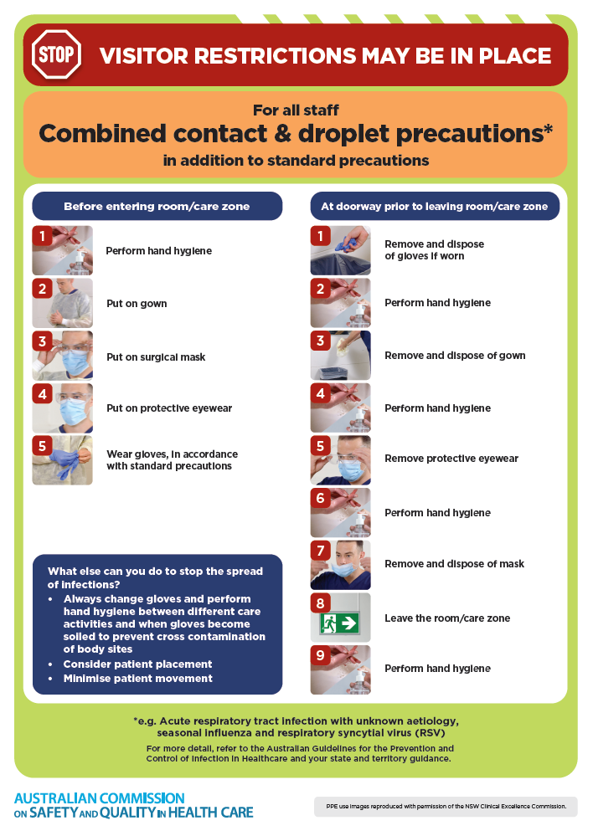](https://www.safetyandquality.gov.au/publications-and-resources/resource-library/infection-prevention-and-control-poster-combined-contact-and-droplet-precautions)
* ***Poster – Combined airborne and contact precautions***<https://www.safetyandquality.gov.au/publications-and-resources/resource-library/infection-prevention-and-control-poster-combined-airborne-and-contact-precautions>  
     
  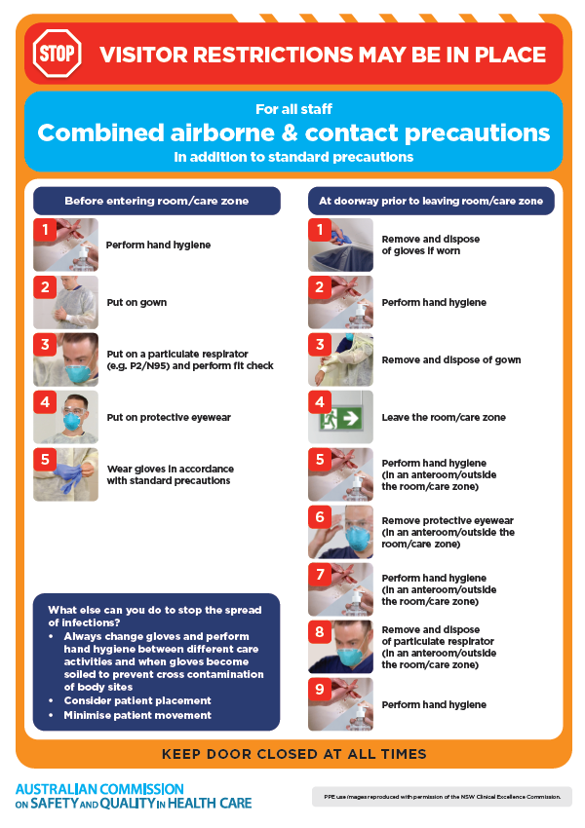
* ***Environmental Cleaning and Infection Prevention and Control*** [www.safetyandquality.gov.au/environmental-cleaning](http://www.safetyandquality.gov.au/environmental-cleaning)
* ***COVID-19 infection prevention and control risk management – Guidance*** <https://www.safetyandquality.gov.au/publications-and-resources/resource-library/covid-19-infection-prevention-and-control-risk-management-guidance>
* ***Safe care for people with cognitive impairment during COVID-19***<https://www.safetyandquality.gov.au/our-work/cognitive-impairment/cognitive-impairment-and-covid-19>
* ***Break the chain of infection*** poster  
  <https://www.safetyandquality.gov.au/publications-and-resources/resource-library/break-chain-infection-poster>  
    
  **[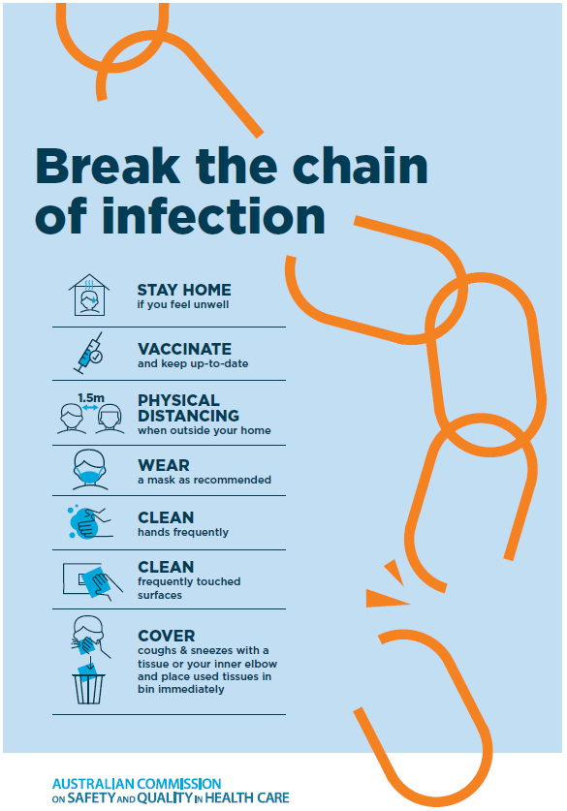](https://www.safetyandquality.gov.au/publications-and-resources/resource-library/break-chain-poster-a3https:/www.safetyandquality.gov.au/publications-and-resources/resource-library/break-chain-poster-a3)**
* ***COVID-19 and face masks – Information for consumers*** <https://www.safetyandquality.gov.au/publications-and-resources/resource-library/covid-19-and-face-masks-information-consumers>

[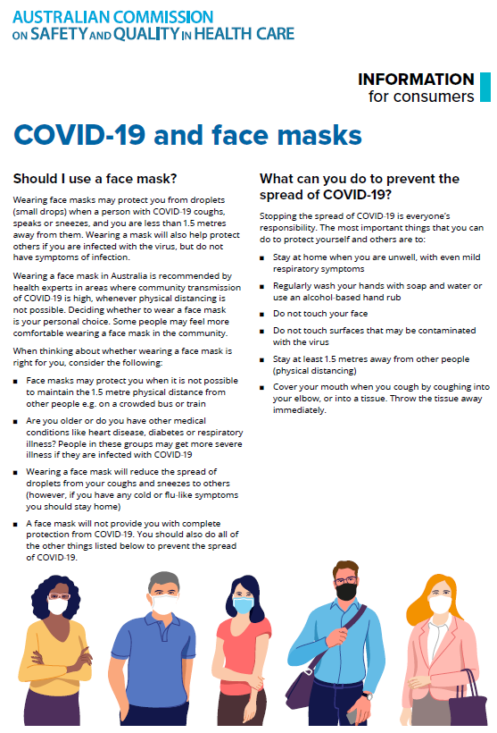](https://www.safetyandquality.gov.au/sites/default/files/2020-07/covid-19_and_face_masks_-_information_for_consumers.pdf)

**Disclaimer**

On the Radar is an information resource of the Australian Commission on Safety and Quality in Health Care. The Commission is not responsible for the content of, nor does it endorse, any articles or sites listed. The Commission accepts no liability for the information or advice provided by these external links. Links are provided on the basis that users make their own decisions about the accuracy, currency and reliability of the information contained therein. Any opinions expressed are not necessarily those of the Australian Commission on Safety and Quality in Health Care.