# Australian Commission on Safety and Quality logotypeOn the Radar

Issue 674

11 November 2024

*On the Radar* is a summary of some of the recent publications in the areas of safety and quality in health care. Inclusion in this document is not an endorsement or recommendation of any publication or provider. Access to particular documents may depend on whether they are Open Access or not, and/or your individual or institutional access to subscription sites/services. Material that may require subscription is included as it is considered relevant.

*On the Radar* is available online, via email or as a PDF or Word document from <https://www.safetyandquality.gov.au/newsroom/subscribe-news/radar>

If you would like to receive *On the Radar* via email, you can subscribe on our website <https://www.safetyandquality.gov.au/newsroom/subscribe-news>  
or by emailing us at H[Umail@safetyandquality.gov.auU](mailto:mail@safetyandquality.gov.au).  
You can also send feedback and comments to H[Umail@safetyandquality.gov.auU](mailto:mail@safetyandquality.gov.au).

For information about the Commission and its programs and publications, please visit <https://www.safetyandquality.gov.au>

**On the Radar**

Editor: Dr Niall Johnson, Kylie Tran, Farzana Flora

***World Antimicrobial Resistance (AMR) Awareness Week (WAAW)***

<https://www.safetyandquality.gov.au/our-work/antimicrobial-stewardship/world-amr-awareness-week>

World Antimicrobial Resistance (AMR) Awareness Week (WAAW) is a global campaign held annually from 18 to 24 November to raise awareness of AMR and encourage best practice among the public, One Health stakeholders and policy makers. The World Health Organization identifies AMR among the top 10 global health threats and Australia has developed a [National AMR Strategy](https://www.amr.gov.au/resources/australias-national-antimicrobial-resistance-strategy-2020-and-beyond) to address this issue at a national level.

The theme for 2024 is ‘Educate. Advocate. Act now.’, which calls on the global community to educate stakeholders on AMR, advocate for bold actions and take concrete actions in response to AMR.

This year also marks the 10th anniversary of the release of the [*Antimicrobial Stewardship (AMS) Clinical Care Standard*](https://www.safetyandquality.gov.au/our-work/antimicrobial-stewardship/antimicrobial-stewardship-clinical-care-standard) – the first Clinical Care Standard developed by the Commission.  
AMS remains critical strategy in Australia’s effort to prevent the development of resistance by promoting appropriate use of antimicrobials.

The Commission has updated a range of resources to support health service organisations participate in WAAW. For more information, visit <https://www.safetyandquality.gov.au/our-work/antimicrobial-stewardship/world-amr-awareness-week>

[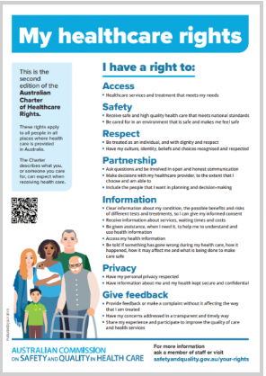](https://www.safetyandquality.gov.au/our-work/partnering-consumers/australian-charter-healthcare-rights/charter-translations)**New community language translations of the *Australian Charter of Healthcare Rights* and My Healthcare Rights**

<https://www.safetyandquality.gov.au/our-work/partnering-consumers/australian-charter-healthcare-rights/charter-translations>

The Commission has released new community language translations of the *Australian Charter of Healthcare Rights* (the Charter) and My Healthcare Rights consumer flyer. Bengali, Burmese, Farsi, Fijian, Filipino, French, Hazaragi, Indonesian, Japanese, Karen, Oromo, Persian, Samoan, Somali, Tagalog, Tamil, Tibetan, Tongan and Ukrainian have joined the existing suite, with a total of 32 community language translations now available.

The Charter describes the rights of all people accessing health care, and provides patients, their families, carers and health service organisations with a shared understanding of healthcare rights. The My Healthcare Rights consumer flyer is a quick-reference summary of the seven healthcare rights and describes what to expect when receiving health care. Patients can use the Charter and the consumer flyer to support conversations with their clinicians about healthcare rights.

[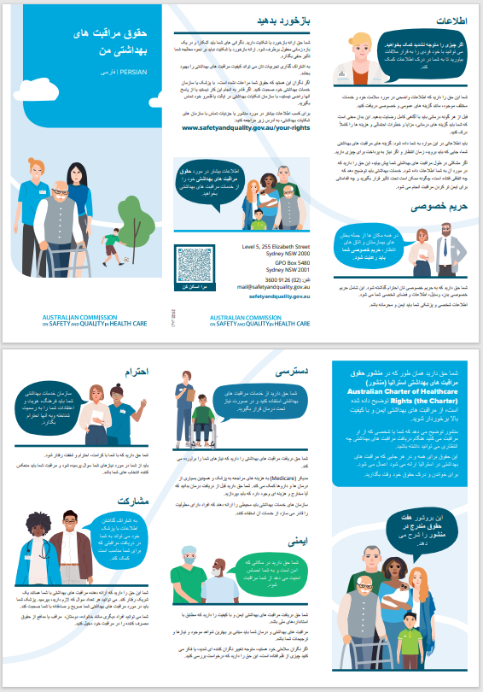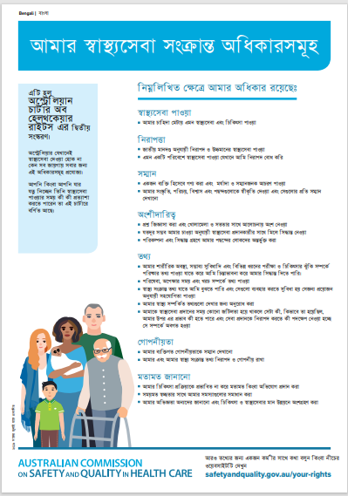](https://www.safetyandquality.gov.au/our-work/partnering-consumers/australian-charter-healthcare-rights/charter-translations)The full suite of translations are available at <https://www.safetyandquality.gov.au/our-work/partnering-consumers/australian-charter-healthcare-rights/charter-translations>

**Reports**

*WHO guideline on the prevention and diagnosis of rheumatic fever and rheumatic heart disease*

World Health Organization

Geneva: WHO; 2024. p. 53.

|  |  |
| --- | --- |
| URL | <https://www.who.int/publications/i/item/9789240100077> |
| Notes | The WHO’s webpage for this new guideline states:  ‘Rheumatic fever (RF) and Rheumatic heart disease (RHD) are a preventable public health problem in low- and middle-income countries and in marginalized communities in middle- and high-income countries.  RF is an autoimmune inflammatory reaction to throat infections (pharyngitis) or possibly to superficial skin and skin structure infections caused by *Streptococcus pyogenes*, a group A beta‐haemolytic Streptococcus (GAS) bacterium. The first episode of RF is commonly seen in children aged 5 to 14 years. Recurrent episodes are most common within 1 year of the first episode but can occur throughout the life course.  RHD is characterized by chronic structural and/or functional changes in the heart, most commonly in the valves, caused by one or more episodes of rheumatic fever (RF). RHD most commonly starts in childhood with a diagnostic peak in young adults aged 20 to 39 years. RHD can lead to death or lifelong disability, however, effective early intervention can prevent premature morbidity and mortality.  The WHO guideline on the prevention and diagnosis of rheumatic fever (RF) and rheumatic heart disease (RHD) provides evidence-informed recommendations for the prevention and management of RF and RHD. It encompasses three areas;  1) primary prevention of rheumatic fever and rheumatic heart disease, specifically the identification and treatment of suspected group A (beta-haemolytic) Streptococcus (GAS) pharyngitis and skin infections;  2) secondary prevention of recurrent rheumatic fever and of rheumatic heart disease, specifically use of long-term antibiotic prophylaxis, interventions to increase adherence to antibiotic prophylaxis, and screening for early rheumatic heart disease; and  3) management of rheumatic fever, specifically the treatment with anti-inflammatory drugs.’  In Australia, as the [AIHW notes](https://www.aihw.gov.au/reports/indigenous-australians/arf-rhd-2022/contents/about), ‘Acute rheumatic fever (ARF) and rheumatic heart disease (RHD) are preventable diseases disproportionately affecting Aboriginal and Torres Strait Islander (First Nations) people living in regional and remote areas. Prevalence rates were highest in women and children.’ |

*Mental health inpatient settings: Creating conditions for the delivery of safe and therapeutic care to adults. Investigation report*

Health Services Safety Investigation Body

Poole: HSSIB; 2024.

|  |  |
| --- | --- |
| URL | <https://www.hssib.org.uk/patient-safety-investigations/mental-health-inpatient-settings/investigation-report/> |
| Notes | Recent report from the Health Services Safety Investigation Body (HSSIB) in the UK that ‘explored the risks to patient safety associated with the workforce and working conditions in acute mental health inpatient settings for adults.’ The report includes findings on the mental health inpatient workforce, built mental health inpatient environments, and social and organisational factors influencing mental health inpatient care in the UK. The report also includes a number of safety recommendations for each of these along with a series of safety observations and suggested safety responses. |

**Journal articles**

*Patient–Clinician Diagnostic Concordance upon Hospital Admission*

Lam A, Plombon S, Garber A, Garabedian P, Rozenblum R, Griffin JA, et al

Applied Clinical Informatics. 2024;15(04):733-742.

|  |  |
| --- | --- |
| DOI | <https://doi.org/10.1055/s-0044-1788330> |
| Notes | There are various forms of diagnostic error. It can be said that the failure to communicate a diagnosis clearly to a patient is a diagnostic error. This study, conducted in a US hospital sought to examine the agreement or ‘concordance of the admission diagnosis reported by the patient and entered by the clinician’ into the electronic health record (EHR). From 157 completed questionnaires provided to patients, 49.0%, 29.3% and 21.7% ‘were rated fully concordant, partially concordant, and not concordant, respectively’. |

*The impact of surgical complications on obstetricians’ and gynecologists’ well-being and coping mechanisms as second victims*

Collings R, Potter C, Gebski V, Janda M, Obermair A

American Journal of Obstetrics and Gynecology. 2024.

|  |  |
| --- | --- |
| DOI | <https://doi.org/10.1016/j.ajog.2024.07.043> |
| Notes | Australian study examining how surgical complications can affect health care workers as well as patients. In this study, 727 obstetrics and gynaecology surgeons responded to a survey of their experiences of surgical complications. The authors report that ‘The vast majority of obstetrics and gynecology surgeons experience a major impact on their health and well-being when one of their patients develops a complication.’ It was also found that ‘Complications caused most stress when they resulted in poor patient outcomes (653 [90%]), had severe patient consequences (630 [87%]), or were a result of surgeon error (627 [86%]).’ Less experienced and female surgeons appeared more likely to report impacts in this survey and less likely to engage with others after complications occurred. |

*Journal for Healthcare Quality*

Volume 46, Number 6, November/December 2024

|  |  |
| --- | --- |
| URL | <https://journals.lww.com/jhqonline/toc/2024/12000> |
| Notes | A new issue of the *Journal for Healthcare Quality (JHQ)* has been published. Articles in this issue of *Journal for Healthcare Quality Pediatric Quality & Safety* include:   * Improving **Time to Antibiotics for Long-Bone Open Fractures**: A Quality Improvement Initiative (Samita M Heslin, Candice King, Robert Schwaner, James Vosswinkel, Adam Singer, Eric J Morley) * Streamlining **Atrial Fibrillation Care**: Building a Comprehensive Program to Provide High-Quality, Individualized Care (David Lam, Jen Farrell, Bob Fletcher, Adam Zivin) * Implementation of an Evidence-Based Treatment Protocol and Order Set for **Alcohol Withdrawal Syndrome** (Nathan Robert Luzum, Anna Beckius, Thomas W Heinrich, Kimberly Stoner) * A Process Evaluation Approach to **Central Line–Associated Bloodstream Infection** Reduction in a Neonatal Population (Soraya Riley, Erin Osterholm, Emily Vadner, Julianne Cramer) * Collaboration to Remove Barriers to **Pump Integration With the Electronic Health Record** (Celeste R Romp, Lori Ross, Sabrina Baucom, Breanna K Dalmolin, Catherine Chang) * Increasing **Diabetic Retinopathy Screening** in Resident-Run Clinic Through Partnership With Ophthalmology Clinic: A Pilot Study (Catherine Mahoney, Caitlin Toomey) * The Use of a Single Risk Assessment Tool for Mortality and Numerous **Hospital-Acquired Conditions** (Erwin Wang, Aditya Samaroo, Joseph Weisstuch, Bret Rudy) |

*Health Affairs*

Volume 43, Number 11, November 2024

|  |  |
| --- | --- |
| URL | <https://www.healthaffairs.org/toc/hlthaff/43/11> |
| Notes | A new issue of *Health Affairs* has been published with the themes ‘Health insurance, Pharmaceuticals and more’. Articles in this issue of *Health Affairs* include:   * Is It Possible To Pay For More **Equitable Health Outcomes**? (M S Gerber) * Health Benefits In 2024: Higher Premiums Persist, Employer Strategies For GLP-1 Coverage And Family-Building Benefits (Gary Claxton, Matthew Rae, Anthony Damico, Aubrey Winger, and Emma Wager) * Expected **Out-Of-Pocket Costs**: Comparing Medicare Advantage With Fee-For-Service Medicare (Benedic Ippolito, Erin Trish, and Boris Vabson) * **Medicare Advantage** Plans With High Numbers Of Veterans: Enrollment, Utilization, And Potential Wasteful Spending (Yanlei Ma, Jessica Phelan, Kathleen Yoojin Jeong, Thomas C Tsai, Austin B Frakt, Steven D Pizer, Melissa M Garrido, Allison Dorneo, and José F Figueroa) * Resumption Of **Medicaid Eligibility Redeterminations**: Little Change In Overall Insurance Coverage (Sumedha Gupta, Christopher Behrer, Velda Wang, Jessica S. Banthin, and M Kate Bundorf) * **Perinatal Health Insurance** And Health Care Use By Immigration Status In 6 US States, 2020–22 (Maria W Steenland and Jamie R Daw) * **Electronic Health Record Documentation Burden** Crowds Out Health Information Exchange Use By Primary Care Physicians (A Jay Holmgren, Julia Adler-Milstein, and Nate C Apathy) * **Small-Molecule Drugs** Offer Comparable Health Benefits To Biologics At Lower Costs (Katherine A Clifford, A Alex Levine, Daniel E Enright, Peter J Neumann, and James D Chambers) * Evidence That Regulatory And Market Forces Are Driving Adoption Of **Biosimilars** (Janice Jhang and Troyen A Brennan) * **School-Entry Vaccine Policies**: States’ Responses To Federal Recommendations Varied From Swift To Substantially Delayed (Anna Larson, Devon R Minnick, Spreeha Choudhury, and Richard Hughes) * **US Nonprofit Hospitals** Have Widely Varying Criteria To Decide Who Qualifies For Free And Discounted Charity Care (Luke Messac, A T Janke, L H Rogers, I Fonfield, J Walker, E Rushbanks, N V Becker, and G Bai) * Loss Of Public Health Emergency Funds Challenges The **Financial Viability Of Nursing Homes**, Especially Not-For-Profit Facilities (Christopher S Brunt, John R Bowblis, and Robert Applebaum) * Availability Of Adult Dental Plans In The **Affordable Care Act Marketplaces**, 2016–23 (Hawazin W Elani, Md Shahinoor Rahman, Jacob Wallace, Meredith B Rosenthal, and Benjamin D Sommers) * Effects Of Medicaid Waivers On Use Of Medications For **Opioid Use Disorder** And Nonfatal Overdoses In 17 States (Stephan Lindner, Kyle Hart, Brynna Manibusan, Kirbee A Johnston, Dennis McCarty, and K J McConnell) * Morbidity And Mortality: Delays In My Patient’s **Cancer Care** (A S Rahman) |

*Health Affairs Scholar*

Volume 2, Issue 10, October 2024

|  |  |
| --- | --- |
| URL | <https://academic.oup.com/healthaffairsscholar/issue/2/10> |
| Notes | A new issue of *Health Affairs* Scholar has been published. Articles in this issue of *Health Affairs* *Scholar* include:   * Exploring the **geospatial variations in the public health workforce**: implications for diversifying the supply of potential workers in governmental settings (Sezen O Onal et al)) * **Primary care telehealth utilization** by access-challenged populations in Medicare Advantage (Emily Boudreau et al) * **Biopharmaceutical pipeline** funded by venture capital firms, 2014 to 2024 (So-Yeon Kang et al) * Assessing the feasibility and likelihood of policy options to lower **specialty drug costs** (Erin A Taylor et al) * Learning from employer experiences with **paid leave policy** expansions during the COVID-19 pandemic (William H Dow et al) * The opioid industry's use of scientific evidence to advance claims about **prescription opioid safety and effectiveness** (Ravi Gupta et al) * The impact of **Medicaid expansion** under the Affordable Care Act on HIV care continuum outcomes across the United States (Peter F Rebeiro et al) * How are **US hospitals adopting artificial intelligence**? Early evidence from 2022 (Redwan Bin Abdul Baten) * Understanding the factors that impact **federal rulemaking**: a survey of former EPA regulators (Rachel J Topazian et al) * Changes in **hospital-supported substance use services** across US nonprofit hospitals, 2015-2021 (Cory E Cronin et al) |

*BMJ Quality & Safety* online first articles

|  |  |
| --- | --- |
| URL | <https://qualitysafety.bmj.com/content/early/recent> |
| Notes | *BMJ Quality &Safety* has published a number of ‘online first’ articles, including:   * Experiences with **diagnostic delay among underserved racial and ethnic patients**: a systematic review of the qualitative literature (Elena Faugno, Alison A Galbraith, Kathleen Walsh, Paul J Maglione, J R Farmer, M-S Ong) * Editorial: From insight to action: tackling **underperformance in health professionals** (William Martinez) |

*International Journal for Quality in Health Care* online first articles

|  |  |
| --- | --- |
| URL | <https://academic.oup.com/intqhc/advance-articles> |
| Notes | *International Journal for Quality in Health Care* has published a number of ‘online first’ articles, including:   * Diagnostic Performance of a Newly-Launched Canadian Fast-Track Ultrasound Clinic by Rheumatologists for the Diagnosis of **Giant Cell Arteritis** (Jean-Charles Mourot et al) * Use and De-implementation of **Fecal Occult Blood Tests** in the Acute Care Setting: A Systematic Review and Meta-Analysis (Rebekah O Russell et al) |

**Online resources**

***Australian Living Evidence Collaboration***

<https://livingevidence.org.au/>

***[UK] NICE Guidelines and Quality Standards***

<https://www.nice.org.uk/guidance>

The UK’s National Institute for Health and Care Excellence (NICE) has published new (or updated) guidelines and quality standards The latest reviews or updates include:

* NICE Guideline NG23 ***Menopause****: identification and management* <https://www.nice.org.uk/guidance/ng23>

**COVID-19 resources**

https://www.safetyandquality.gov.au/covid-19

The Australian Commission on Safety and Quality in Health Care has developed a number of resources to assist healthcare organisations, facilities and clinicians. These and other material on COVID-19 are available at <https://www.safetyandquality.gov.au/covid-19>

These resources include:

* ***Poster – Combined contact and droplet precautions*** <https://www.safetyandquality.gov.au/publications-and-resources/resource-library/infection-prevention-and-control-poster-combined-contact-and-droplet-precautions>  
  [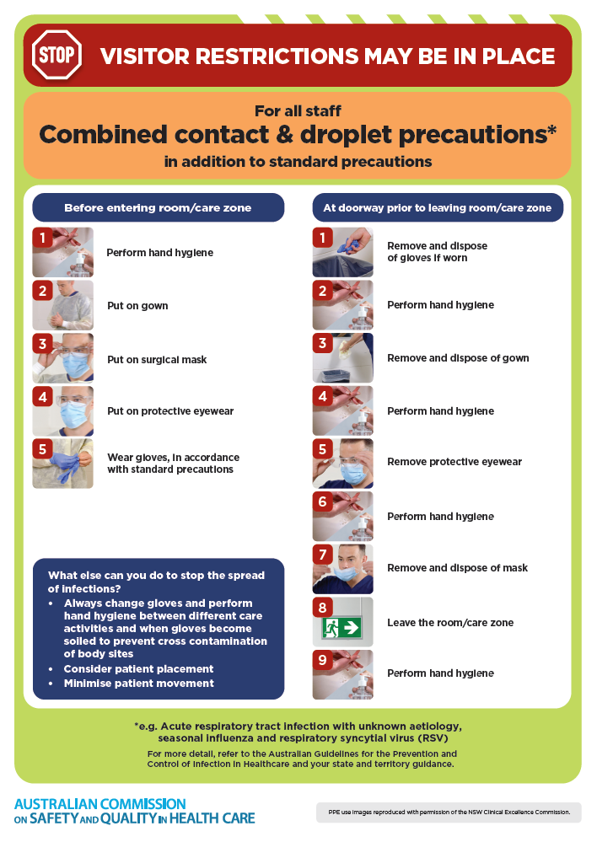](https://www.safetyandquality.gov.au/publications-and-resources/resource-library/infection-prevention-and-control-poster-combined-contact-and-droplet-precautions)
* ***Poster – Combined airborne and contact precautions***<https://www.safetyandquality.gov.au/publications-and-resources/resource-library/infection-prevention-and-control-poster-combined-airborne-and-contact-precautions>  
     
  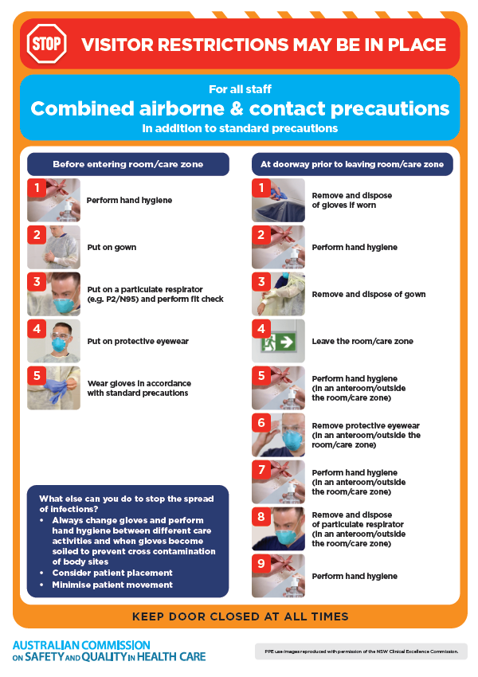
* ***Environmental Cleaning and Infection Prevention and Control*** [www.safetyandquality.gov.au/environmental-cleaning](http://www.safetyandquality.gov.au/environmental-cleaning)
* ***COVID-19 infection prevention and control risk management – Guidance*** <https://www.safetyandquality.gov.au/publications-and-resources/resource-library/covid-19-infection-prevention-and-control-risk-management-guidance>
* ***Safe care for people with cognitive impairment during COVID-19***<https://www.safetyandquality.gov.au/our-work/cognitive-impairment/cognitive-impairment-and-covid-19>
* ***Break the chain of infection*** poster  
  <https://www.safetyandquality.gov.au/publications-and-resources/resource-library/break-chain-infection-poster>  
    
  **[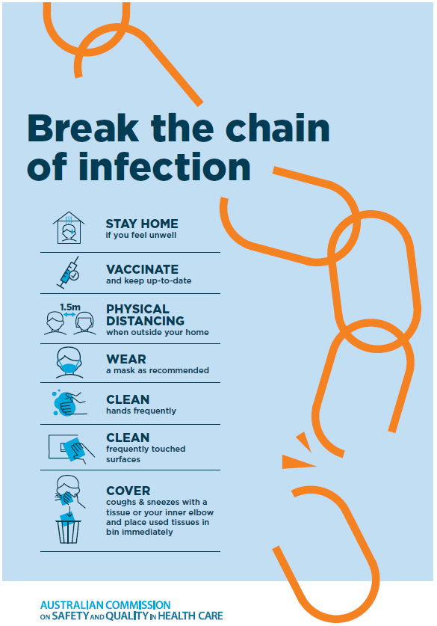](https://www.safetyandquality.gov.au/publications-and-resources/resource-library/break-chain-poster-a3https:/www.safetyandquality.gov.au/publications-and-resources/resource-library/break-chain-poster-a3)**
* ***COVID-19 and face masks – Information for consumers*** <https://www.safetyandquality.gov.au/publications-and-resources/resource-library/covid-19-and-face-masks-information-consumers>

[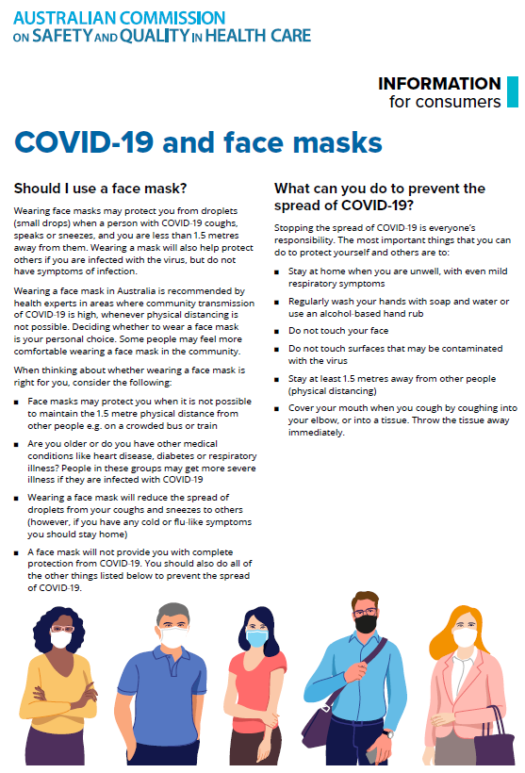](https://www.safetyandquality.gov.au/sites/default/files/2020-07/covid-19_and_face_masks_-_information_for_consumers.pdf)

**Disclaimer**

On the Radar is an information resource of the Australian Commission on Safety and Quality in Health Care. The Commission is not responsible for the content of, nor does it endorse, any articles or sites listed. The Commission accepts no liability for the information or advice provided by these external links. Links are provided on the basis that users make their own decisions about the accuracy, currency and reliability of the information contained therein. Any opinions expressed are not necessarily those of the Australian Commission on Safety and Quality in Health Care.