# Australian Commission on Safety and Quality logotypeOn the Radar

Issue 676

25 November 2024

*On the Radar* is a summary of some of the recent publications in the areas of safety and quality in health care. Inclusion in this document is not an endorsement or recommendation of any publication or provider. Access to particular documents may depend on whether they are Open Access or not, and/or your individual or institutional access to subscription sites/services. Material that may require subscription is included as it is considered relevant.

*On the Radar* is available online, via email or as a PDF or Word document from <https://www.safetyandquality.gov.au/newsroom/subscribe-news/radar>

If you would like to receive *On the Radar* via email, you can subscribe on our website <https://www.safetyandquality.gov.au/newsroom/subscribe-news>  
or by emailing us at H[Umail@safetyandquality.gov.auU](mailto:mail@safetyandquality.gov.au).  
You can also send feedback and comments to H[Umail@safetyandquality.gov.auU](mailto:mail@safetyandquality.gov.au).

For information about the Commission and its programs and publications, please visit <https://www.safetyandquality.gov.au>

**On the Radar**

Editor: Dr Niall Johnson

**Books**

*Management of type 2 diabetes: A handbook for general practice*

Royal Australian College of General Practitioners and Diabetes Australia

Melbourne: RACGP; 2024. p. 326.

|  |  |
| --- | --- |
| URL | <https://www.racgp.org.au/clinical-resources/clinical-guidelines/key-racgp-guidelines/view-all-racgp-guidelines/management-of-type-2-diabetes/> |
| Notes | Diabetes Australia and the Royal Australian College of General Practitioners (RACGP) have released a new edition of the ‘Diabetes Handbook’ to equip general practitioners with updated, evidence-based guidelines on managing type 2 diabetes. |

**Journal articles**

*Intergenerational equity and the health of Australia's young people*

Zuccala E, Skilton M

Medical Journal of Australia. 2024;221(10):505-505.

*The Future Healthy Countdown 2030 consensus statement: core policy actions and measures to achieve improvements in the health and wellbeing of children, young people and future generations*

Lycett K, Lane H, Frykberg G, Maury S, Wallace C, Taafua L, et al

Medical Journal of Australia. 2024;221(S10):S6-S17.

*Guidelines for the design and implementation of youth participation initiatives to safeguard mental health and wellbeing*

Guo K, Meas D, Mautner D, Yan F, Al-Hadaya I, Donohoe-Bales A, et al.

Medical Journal of Australia. 2024;221(S10):S34-S40.

|  |  |
| --- | --- |
| DOI | Zuccala and Skilton <https://doi.org/10.5694/mja2.52515>  Lycett et al <https://doi.org/10.5694/mja2.52494>  Guo et al <https://doi.org/10.5694/mja2.52485> |
| Notes | In their piece in the *Medical Journal of Australia* (MJA), Zuccala and Skilton observe that it’s known that ‘childhood and adolescence are a critical window for investing in the health of populations. Simply put, ensuring young people have a safe and healthy start to life pays dividends across the life course for individuals, their families, and communities.’ However, as they also note, ‘Australia's children and adolescents continue to face enormous threats to their lifelong health and wellbeing.’ This issue of the MJA (<https://onlinelibrary.wiley.com/toc/13265377/2024/221/10>) is dedicated to child and adolescent health while a supplement (Volume 221, Issue S10 <https://onlinelibrary.wiley.com/toc/13265377/2024/221/S10>) focuses on The Future Healthy Countdown 2030.  In the supplement Lycett et al offer The Future Healthy Countdown 2030 consensus statement. The statement’s main recommendations include:   * Provide financial support to invest in families with young children and address poverty and material deprivation in the first 2000 days of life. * Establish a national investment fund to provide sustained, culturally relevant, maternal and child health and development home visiting services for the first 2000 days of life for all children facing structural disadvantage and/or adversity. * Implement a dedicated funding model for Aboriginal and Torres Strait Islander community-controlled early years services across the country to ensure these services are fully resourced to provide quality early learning and integrated services grounded in culture and community. * Properly fund public schools, starting by providing full and accountable Schooling Resource Standard funding for all schools, with immediate effect for schools in communities facing structural disadvantage. * Establish legislation and regulation to protect children and young people aged under 18 years from the marketing of unhealthy and harmful products. * Amend the electoral act to extend the compulsory voting age to 16 years. * Legislate an immediate end to all new fossil fuel projects in Australia. * Establish a federal Future Generations Commission with legislated powers to protect the interests of future generations.   Also in the supplement, Guo et al offer some guidelines on the design and implementation for youth participation in one of the most pressing issues, mental health and wellbeing. The recommendations here address   * prioritising clear and respectful communication; * creating safe and flexible practices for young people; * facilitating social and emotional support; * empowering young people to participate in meaningful and impactful ways; and * supporting young people to develop skills. |

*Mental health of Australian frontline nurses during the COVID-19 pandemic: results of a large national survey*

Zamanzadeh A, Eckert M, Corsini N, Adelson P, Sharplin G

Health Policy. 2024:105214.

|  |  |
| --- | --- |
| DOI | <https://doi.org/10.1016/j.healthpol.2024.105214> |
| Notes | Also examining mental health is this study that looked at the mental health impacts on nurses during the COVID-19 pandemic. The study used ‘de-identified self-report survey data from approximately 11,000 Australian nurses and midwives during the pandemic’ and from their analyses the authors identified a number of ‘highlights’:   * ‘Increased work demands worsen anxiety, depression and stress of frontline nurses * Quantitative and emotional demands are positively associated with burnout during COVID-19 * Emotional demands have sizable effects on people with severe mental symptoms * Hospital nurses experience increased anxiety, depression, and stress during a pandemic * Concerns about job security lead to poorer mental health among nurses.’ |

*Exploring Consumer and Clinician Attitudes towards Patient Reported Outcome Measures (PROMs) in an Australian Inpatient Musculoskeletal Rehabilitation Unit: A Qualitative Pilot Study*

Di Rico R, Ng L, Capell JT.

Patient Experience Journal. 2024;11(3):16-28.

*Co-developing a Paediatric Patient Reported Experience Measure: The Perspectives of Children and Young People*

Barr KR, Nikolovski J, White L, Elliott S, McCartney L, Treadgold C, et al.

Patient Experience Journal. 2024;11(3):64-72.

|  |  |
| --- | --- |
| URL | Di Rico et al <https://doi.org/10.35680/2372-0247.1851>  Barr et al <https://doi.org/10.35680/2372-0247.1924> |
| Notes | A pair of items in the latest issue of *Patient Experience Journal* (PXJ) on the topic of PROMs/PREMs (patient reported outcome measures and patient reported experience measures). Another commonality to these two studies is that they are both Australian studies.  Di Rico et al describe the experience of working with rehabilitation clinicians and consumers to examine the relevance and utility of patient reported outcome measures (PROMs) in that setting. They noted that ‘While the potential benefits of PROMs were recognised, numerous risks and logistical challenges were also identified.’  Barr et al describe a project that sought to capture the views of children and young people in the co-design of Paediatric Patient Reported Experience Measures (PREMs). The project included interviews with 55 children and young people from a diverse range of sociocultural backgrounds, across six Australian hospitals. It is noted that the ‘Interviews were conducted by `Captain Starlight', professional performers who engage with children and positively impact their hospital experience’.  It is noted that the Australian Commission for Safety and Quality in Health Care provided input for the data analysis and report writing of this study |

For information on the Commission’s work on patient-reported measures, including PROMs and PREMs, see <https://www.safetyandquality.gov.au/our-work/partnering-consumers/person-centred-care/person-centred-care-network/patient-reported-measures>

*BMJ Quality & Safety*

Volume 33, Issue 12, December 2024

|  |  |
| --- | --- |
| URL | <https://qualitysafety.bmj.com/content/33/12> |
| Notes | A new issue of *BMJ Quality & Safety* has been published. Many of the papers in this issue have been referred to in previous editions of *On the Radar* (when they were released online). Articles in this issue of *BMJ Quality & Safety* include:   * Editorial: Safety netting: time to stop relying on verbal interventions to manage **diagnostic uncertainty**? (Georgia B Black) * Editorial: **Beyond polypharmacy** to the brave new world of minimum datasets and artificial intelligence: thumbing a nose to Henry (Adam Todd, Barbara Hanratty) * Editorial: Integration and connection: the key to effectiveness of **large-scale pharmacist-led medication reviews**? (A Husband, A Robinson-Barella) * Role of **communicating diagnostic uncertainty** in the safety-netting process: insights from a vignette study (Caitríona Cox, T Hatfield, Zoë Fritz) * Longitudinal cohort study of discrepancies between **prescribed and administered polypharmacy rates**: implications for National Aged Care Quality Indicator Programs (Nasir Wabe, Rachel Urwin, Karla Seaman, Johanna I Westbrook) * Crowdsourcing a diagnosis? Exploring the accuracy of the size and type of **group diagnosis**: an experimental study (Jonathan Sherbino, Matt Sibbald, Geoffrey Norman, Andrew LoGiudice, Amy Keuhl, Mark Lee, S Monteiro) * How **therapeutic relationships develop in group-based telehealth** and their perceived impact on processes and outcomes of a complex intervention: a qualitative study (Luis F Sousa Filho, M K Farlie, T P Haines, P Malliaras) * Components of **pharmacist-led medication reviews** and their relationship to outcomes: a systematic review and narrative synthesis (Miriam E Craske, Wendy Hardeman, Nicholas Steel, Michael J Twigg) * Why a sociotechnical framework is necessary to address **diagnostic error** (Meagan M Ladell, Sarah Yale, Brett J Bordini, Matthew C Scanlon, Nancy Jacobson, Elizabeth Lerner Papautsky) |

*Journal of Patient Safety*

Volume 20, Issue 8, December 2024

|  |  |
| --- | --- |
| URL | <https://journals.lww.com/journalpatientsafety/toc/2024/12000> |
| Notes | A new issue of *Journal of Patient Safety* has been published. Articles in this issue of *Journal of Patient Safety* include:   * “What Else Could It Be?” A Scoping Review of **Questions for Patients to Ask Throughout the Diagnostic Process** (Mary A Hill, Tess Coppinger, Kimia Sedig, W J Gallagher, K M Baker, H Haskell, K E Miller, K M Smith) * Associations Between **Oversedation and Agitation in Postanesthesia Recovery** Room and Subsequent Severe Behavioral Emergencies (Mary Labib, Atousa Deljou, R J Morgan III, D R Schroeder, J Sprung, T N Weingarten * The Influence of Hospital Physician Integration on **Culture of Patient Safety** (Soumya Upadhyay, Lung-Chang Chien) * Exploring the Relationship Between **Hospital Patient Safety Culture and Performance** on Measures of Hospital-Acquired Conditions (Pejmon Noghrehchi, Jennifer L Hefner, Hendrik Stegall, Daniel M Walker) * Using Patient Experience Surveys to Identify Potential **Diagnostic Safety Breakdowns**: A Mixed Methods Study (Kelley M Baker, Mark Brahier, Mara Penne, Mary A Hill, Siara Davis, William J Gallagher, K E Miller, K M Smith) * Adverse Events in **Patients Transitioning From the Emergency Department to the Inpatient Setting** (Dennis Tsilimingras, Jeffrey Schnipper, Liying Zhang, Phillip Levy, Steven Korzeniewski, James Paxton) * Knowledge and Practices Regarding Prevention of **Central Venous Catheter Removal-Associated Air Embolism**: A Survey of Nonintensive Care Unit Medical and Nursing Staff (Maria Karlinskaya, Liad Scharf, Nadav Sarid) * Patient Safety and Perception of Quality in **University Dental Hospitals**: A French National Survey (Pierre Hervy, Brigitte Keriven-Dessomme, Alexandra Cloitre, Béatrice Thivichon-Prince, Bérengère Phulpin, Anne-Gaëlle Chaux) * Increased Risk and Unique Clinical Course of Patient Safety Indicator-3 **Pressure Injuries** Among COVID-19 Hospitalized Patients (Jennifer B Cowart, Jorge Sinclair De Frías, Benjamin D Pollock, Camille Knepper, Nora Sammon, Sadhana Jonna, Trisha Singh, Shivang Bhakta, Lorenzo Olivero, Shari Ochoa, Kannan Ramar, Pablo Moreno Franco) * Assessing **Between- and Within-Hospital Differences in Patient Safety** Between Medicaid and Privately Insured Hospital Patients (A Gangopadhyaya) * The Predictors of **Patient Safety Culture in Hospital Setting**: A Systematic Review (Anja Vibe, Sara Haurum Rasmussen, Nikolaj Ohm Pranger Rasmussen, Doris Østergaard, Peter Dieckmann) * Rethinking **Surgical Safety**: Investigating the Impact of Gamified Training on Severe Flow Disruptions in Surgery (Tara Cohen, Falisha Kanji, Jennifer Zamudio, Catherine Breese, Ray Avenido, Christine Yoshizawa, Stephanie Bartkowicz, Kenneth Catchpole, Jennifer Anger) * Involving Patients and/or Their Next of Kin in **Serious Adverse Event Investigations**: A Qualitative Study on Hospital Perspectives (Linda J Knap, Rachel I Dijkstra-Eijkemans, Roland D Friele, Johan Legemaate) * Clinical Characteristics and Outcomes of Patients With COVID-19 Treated in Mayo Clinic’s **Advanced Care at Home Program** (Rachel A Gothot, Michael J Maniaci, Margaret R Paulson, Igor Dumic, Amy A Haney, Zhuo Li, Karla C Maita, Brittane T Valles, Charles D Burger) * Editorial: From Compliance to Collaboration: Learning From Transatlantic Frameworks for **Healthcare Safety Improvement** (Olivia Lounsbury, Mark Sujan, Ken Catchpole) * **Intraprocedural Fall of an Obese Patient** During an Interventional Radiology Procedure (Brian Liu, Shayan Sadiq, Helen Wang, Estele Odo de Barros, Zhuoxuan Li, Kevin Nguyen, Sujai Jaipalli, Molly Li, Robert P Liddell) * **Second Victims in Mental Health** Care (Deborah Oyine Aluh, Jesus David Cortes) * Enhancing Compliance With **Work-Hour Restrictions** Through Safety Culture and Leadership in Medical Residencies (Waseem Jerjes) |

*Nursing Leadership*

Volume 37, Number 2, December 2024

|  |  |
| --- | --- |
| URL | <https://www.longwoods.com/publications/nursing-leadership/27462/1/vol.-37-no.-2-2024> |
| Notes | A new issue of *Nursing Leadership* has been published. Articles in this issue of *Nursing Leadership* include:   * Editorial: What Do Genomics, Float Pools and Cardiac Surgery Have in Common? **Innovating Nurses** (Ruth Martin-Misener) * Foreword: Fostering Innovation Through **Nursing Retention** Strategies (Leigh Chapman) * Manitoba’s Provincial Travel Nurse Team: A Unique **Staffing Model for Nurses** (Monika Warren and Nicole Sneath) * Leadership Strategies for **Genomics Integration**: A Descriptive Study Using the Canadian Adaptation of the Genetics and Genomics Nursing Practice Survey (Jacqueline Limoges, Rebecca Puddester, April Pike, Kathy Calzone, Lindsay Carlsson, Nicole Letournea and Andrea Gretchev) * Fostering Pan-Canadian Collaboration to Advance **Nursing Workforce Development**: A Case Study From the Genomics Experience (Patrick Chiu, Andrea Gretchev, Jacqueline Limoges, Rebecca Puddester, Lindsay Carlsson, April Pike, Kathleen Leslie and Dzifa Dordunoo) * Optimizing the New Model of **Nurse Practitioner Regulation** in Canada to Support the Integration of Genomics (Michelle Acorn, Patrick Chiu, Jacqueline Limoges and Andrea Gretchev) * Nurse-Led **Clinical Pathway Development for Cardiac Surgery**: A Systematic Quality Improvement Approach (Clare Koning, Leonard Eulalia, Amar Sriram, Eunice Cho and Sheila Finamore) |

*International Journal for Quality in Health Care* online first articles

|  |  |
| --- | --- |
| URL | <https://academic.oup.com/intqhc/advance-articles> |
| Notes | *International Journal for Quality in Health Care* has published a number of ‘online first’ articles, including:   * Exploring the Development of **Safety Culture** among Physicians with Text Mining of Patient Safety Reports: A Retrospective Study (Daisuke Koike et al) * Optimizing **Neurosurgery Clinic Operations**: A Comparative Study of Interventions in Finland’s Public Healthcare System (Jukka Huttunen and Timo Koivisto) * The Influence Mechanism Analysis of **Family Doctor Team Effectiveness**: A Mixed-method Approach (Anning He et al)) * Developing a **Patient-Centered Computerized Clinical Decision Support System** with Patient-Level Outcome Measures (Mari Nezu et al) * Setting **Standards in Residential Aged Care**: Identifying Achievable Benchmarks of Care for Long-term Aged Care Services (Johannes Schwabe et al) * Examining the joint effect of **clinical quality, meaningful use of HIT and patient-caregiver interaction** on mortality rates in US acute care hospitals (Aber Elsaleiby) |

**Online resources**

***Residential Aged Care Communiqué***

[**https://www.thecommuniques.com/aged-care**](https://www.thecommuniques.com/aged-care)

**The team that develops the Clinical *Communiqué* and the *Future Leaders Communiqué* also develop a *Residential Aged Care Communiqué.* The latest issue is now available.**

***Australian Living Evidence Collaboration***

<https://livingevidence.org.au/>

***[USA] Effective Health Care Program reports***

<https://effectivehealthcare.ahrq.gov/>

The US Agency for Healthcare Research and Quality (AHRQ) has an Effective Health Care (EHC) Program The EHC has released the following final reports and updates:

* Use of **Life Cycle Assessment in the Healthcare Industry**: Environmental Impacts and Emissions Associated With Products, Processes, and Waste <https://effectivehealthcare.ahrq.gov/products/lifecycle-assessment/tech-brief>
* Linking **Dental Services to Treatment Outcomes for Diabetes**: A Rapid Response Review <https://effectivehealthcare.ahrq.gov/products/treatment-outcomes-diabetes/rapid-research>
* Linking **Dental Services to Treatment Outcomes for Chronic Kidney Disease**: A Rapid Response Review <https://effectivehealthcare.ahrq.gov/products/treatment-outcomes-chronic-kidney/rapid-research>
* The Association Between Outcomes and **Dental Services in Persons With Autoimmune Disease** Treated With Biologics and Other Immunosuppressants: A Rapid Response Review <https://effectivehealthcare.ahrq.gov/products/autoimmune-disease/rapid-research>

**COVID-19 resources**

https://www.safetyandquality.gov.au/covid-19

The Australian Commission on Safety and Quality in Health Care has developed a number of resources to assist healthcare organisations, facilities and clinicians. These and other material on COVID-19 are available at <https://www.safetyandquality.gov.au/covid-19>

These resources include:

* ***Poster – Combined contact and droplet precautions*** <https://www.safetyandquality.gov.au/publications-and-resources/resource-library/infection-prevention-and-control-poster-combined-contact-and-droplet-precautions>  
  [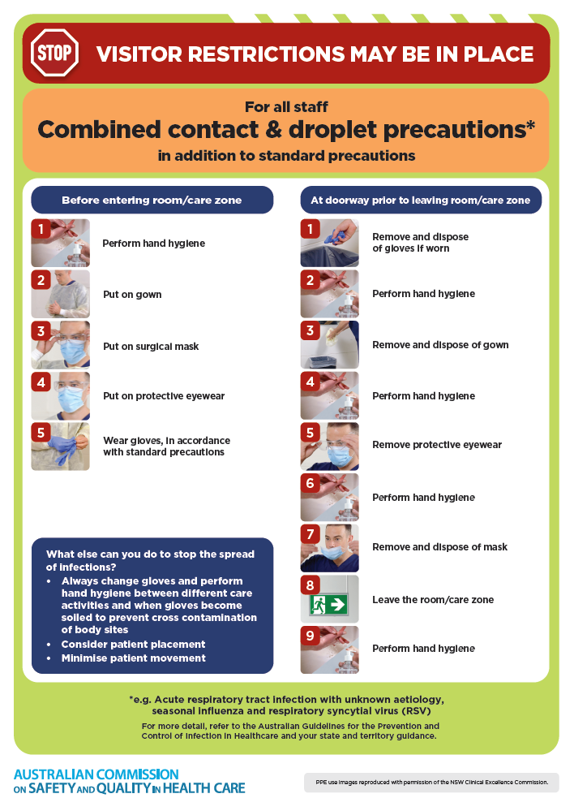](https://www.safetyandquality.gov.au/publications-and-resources/resource-library/infection-prevention-and-control-poster-combined-contact-and-droplet-precautions)
* ***Poster – Combined airborne and contact precautions***<https://www.safetyandquality.gov.au/publications-and-resources/resource-library/infection-prevention-and-control-poster-combined-airborne-and-contact-precautions>  
     
  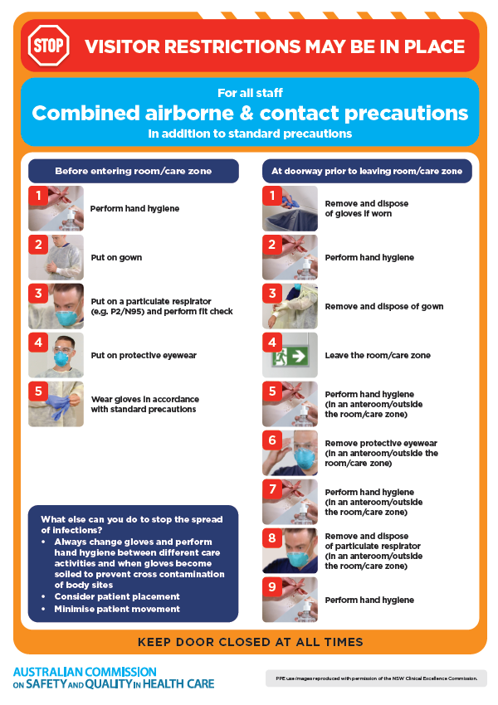
* ***Environmental Cleaning and Infection Prevention and Control*** [www.safetyandquality.gov.au/environmental-cleaning](http://www.safetyandquality.gov.au/environmental-cleaning)
* ***COVID-19 infection prevention and control risk management – Guidance*** <https://www.safetyandquality.gov.au/publications-and-resources/resource-library/covid-19-infection-prevention-and-control-risk-management-guidance>
* ***Safe care for people with cognitive impairment during COVID-19***<https://www.safetyandquality.gov.au/our-work/cognitive-impairment/cognitive-impairment-and-covid-19>
* ***Break the chain of infection*** poster  
  <https://www.safetyandquality.gov.au/publications-and-resources/resource-library/break-chain-infection-poster>  
    
  **[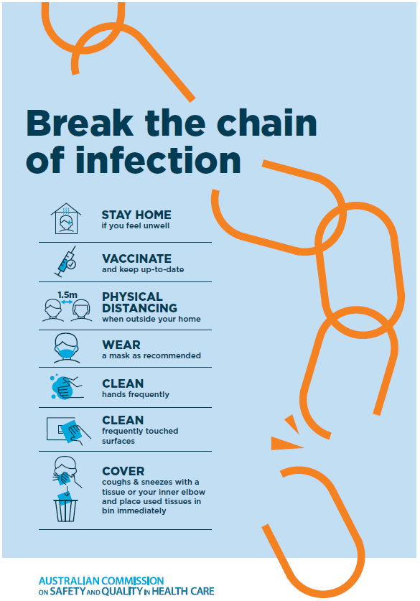](https://www.safetyandquality.gov.au/publications-and-resources/resource-library/break-chain-poster-a3https:/www.safetyandquality.gov.au/publications-and-resources/resource-library/break-chain-poster-a3)**
* ***COVID-19 and face masks – Information for consumers*** <https://www.safetyandquality.gov.au/publications-and-resources/resource-library/covid-19-and-face-masks-information-consumers>

[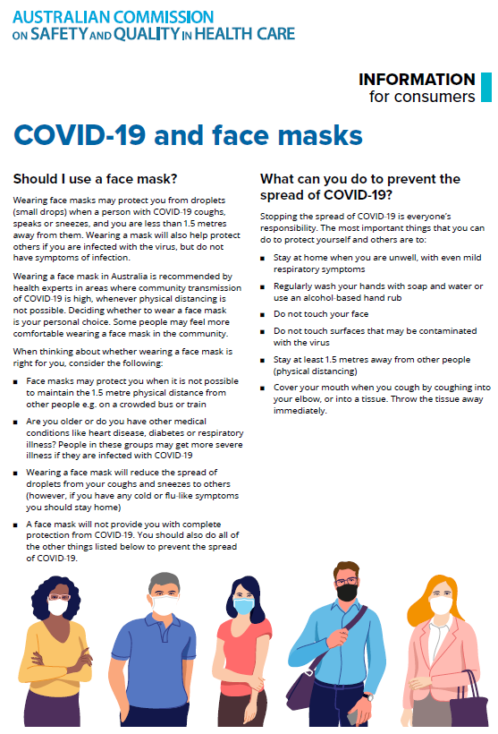](https://www.safetyandquality.gov.au/sites/default/files/2020-07/covid-19_and_face_masks_-_information_for_consumers.pdf)

**Disclaimer**

On the Radar is an information resource of the Australian Commission on Safety and Quality in Health Care. The Commission is not responsible for the content of, nor does it endorse, any articles or sites listed. The Commission accepts no liability for the information or advice provided by these external links. Links are provided on the basis that users make their own decisions about the accuracy, currency and reliability of the information contained therein. Any opinions expressed are not necessarily those of the Australian Commission on Safety and Quality in Health Care.