# Australian Commission on Safety and Quality logotypeOn the Radar

Issue 679

16 December 2024

*On the Radar* is a summary of some of the recent publications in the areas of safety and quality in health care. Inclusion in this document is not an endorsement or recommendation of any publication or provider. Access to particular documents may depend on whether they are Open Access or not, and/or your individual or institutional access to subscription sites/services. Material that may require subscription is included as it is considered relevant.

*On the Radar* is available online, via email or as a PDF or Word document from <https://www.safetyandquality.gov.au/newsroom/subscribe-news/radar>

If you would like to receive *On the Radar* via email, you can subscribe on our website <https://www.safetyandquality.gov.au/newsroom/subscribe-news>  
or by emailing us at H[Umail@safetyandquality.gov.auU](mailto:mail@safetyandquality.gov.au).  
You can also send feedback and comments to H[Umail@safetyandquality.gov.auU](mailto:mail@safetyandquality.gov.au).

For information about the Commission and its programs and publications, please visit <https://www.safetyandquality.gov.au>

**On the Radar**

Editor: Dr Niall Johnson, Amy Forsyth, Paul Miles

***[](https://www.safetyandquality.gov.au/NMS24)***

***National Medicines Symposium 2024***

<https://www.safetyandquality.gov.au/NMS24>

Watch the highlights from NMS 2024

The National Medicines Symposium 2024 session recordings are now available. Whether you missed a session or want to revisit the insightful discussions, you can now explore the key highlights from the event.

Panel highlights to explore:

* **Managing Medicines for an Ageing Population** – Hear from Professor Jennifer Martin, Professor Libby Roughead and Mr Steve Waller on challenges of medication safety in an ageing population such as polypharmacy and multimorbidity and opportunities for improvement.
* **Deprescribing in Practice** – Join Professor Sarah Hilmer AM, Dr Lisa Kouladjian O’Donnell and Professor Jenny May AM as they explore practical approaches to safely deprescribe medications when the risks outweigh the benefits, ensuring patient safety.
* **Digital Tools for Safe Medication Use** – Gain insights from Professor Melissa Baysari, Mr Michael Bakker, Ms Kate Oliver and Ms Alice Nugent on how innovative digital tools can be leveraged to enhance medication management.

Watch these videos and much more <https://www.safetyandquality.gov.au/NMS24>

***Connect. Care. Confidence Summit on Clinical Governance in Digital Health***

<https://www.digitalhealth.gov.au/c3point0>

[Register now](https://www.digitalhealth.gov.au/c3point0-registration#_blank) for the second [Connect. Care. Confidence. 2025](https://www.digitalhealth.gov.au/c3point0#_blank) Summit on Clinical Governance in Digital Health, featuring insights from senior leaders in digital health.

Streaming live on 18 February 2025 (10.00am to 4.00pm AEDT), the event follows the success of the first summit in 2023, co-hosted by the Australian Digital Health Agency and the Australian Commission on Safety and Quality in Health Care.

This interactive event is designed as an immersive experience with a range of sessions. You will be able to join plenary sessions as well as choose from concurrent streams, grouped according to the three ‘Cs’ of Connect, Care, and Confidence.

[Register here](https://www.digitalhealth.gov.au/c3point0-registration#_blank) and secure your place with leading innovators, service providers, software vendors, expert clinicians and consumers for a day of panel discussions, case studies and Q&A sessions with local and international presenters.

For more information on the Summit visit the [Connect. Care. Confidence. 2025](https://www.digitalhealth.gov.au/c3point0#_blank) webpage.

[](https://www.digitalhealth.gov.au/c3point0)

**Books**

*Supply Chain Management. Elements of Improving Quality and Safety in Healthcare*

Williams SJ

Cambridge: Cambridge University Press; 2024.

|  |  |
| --- | --- |
| DOI | <https://doi.org/10.1017/9781009325271> |
| Notes | This is the latest release in the [Elements of Improving Quality and Safety in Healthcare](https://www.cambridge.org/core/publications/elements/elements-of-improving-quality-and-safety-in-healthcare) series from The Healthcare Improvement Studies Institute (the THIS Institute) in Cambridge. This volume examines the key principles and definitions of healthcare supply chains. Practical insights into the design and operation of healthcare supply chains are also provided. Core characteristics of effective supply chain management such as performance management, systems thinking, and supply chain integration are examined along with the application of specific supply chain design and improvement approaches. |

**Reports**

*Medication not given: administration of time critical medication in the emergency department*

Investigation report

Health Services Safety Investigation Body

Poole: HSSIB; 2024.

|  |  |
| --- | --- |
| URL | <https://www.hssib.org.uk/patient-safety-investigations/medication-related-harm/investigation-report/> |
| Notes | This latest report from the Health Services Safety Investigation Body (HSSIB) looks at a particular form of medication error in a particular context: missed medications in the emergency department (ED). This investigation was prompted by the case of an 85 year old patient who did not receive time-critical medication for Parkinson’s disease while attending an ED for three days. The patient should have received 18 doses of the medication, but 7 doses were missed and 3 doses were given late. The patient died four weeks after admission to a medical ward. The investigation report includes findings along with observations and consideration of the role played by electronic prescribing and medicines administration systems in supporting care in this area. |

For information on the Commission’s work on medication safety see <https://www.safetyandquality.gov.au/our-work/medication-safety>

**Journal articles**

*Safety of inpatient care in surgical settings: cohort study*

Duclos A, Frits ML, Iannaccone C, Lipsitz SR, Cooper Z, Weissman JS, et al

BMJ. 2024;387:e080480.

|  |  |
| --- | --- |
| DOI | <https://doi.org/10.1136/bmj-2024-080480> |
| Notes | This paper in the *British Medical Journal* (BMJ) reports on a multi-centre retrospective cohort study conducted across 11 hospitals the USA that sought to examine adverse events associated with perioperative care. The study included ‘1009 patients from a randomly selected sample of 64 121 adults admitted for surgery during 2018.’  Among the results reported:   * ‘Among 1009 patients reviewed, **adverse events** were identified in **38.0%** (95% confidence interval 32.6 to 43.4), with **major adverse events** occurring in **15.9%** (12.7 to 19.0). * Of 593 identified adverse events, 353 (**59.5%**) were **potentially preventable** and 123 (**20.7%**) were **definitely or probably preventable.** * The most common adverse events were related to **surgical procedures** (n=292, 49.3%), followed by **adverse drug events** (n=158, 26.6%), **healthcare associated infections** (n=74, 12.4%), **patient care** events (n=66, 11.2%), and **blood transfusion reactions** (n=3, 0.5%).’ |

*Virtual care: supporting acute care service delivery in rural and remote communities*

Medical Journal of Australia, Volume 221, Issue 11 Supplement

|  |  |
| --- | --- |
| URL | [https://www.mja.com.au/journal/2024/221/11/supplement](https://www.mja.com.au/journal/2024/221/11/supplement?janus_id=niall.johnson@safetyandquality.gov.au) |
| Notes | This supplement to the *Medical Journal of Australia* is focused on **Virtual care: supporting acute care service delivery in rural and remote communities**. This supplement includes the following (open access) articles:   * The Virtual Rural Generalist Service: a hybrid virtual model of care designed to improve health access and outcomes in rural and remote communities * Health service access and quality of care provided by the Western NSW Local Health District Virtual Rural Generalist Service: a retrospective analysis of linked administrative data * Clinician experiences of a hybrid virtual medical service supporting rural and remote hospitals: a qualitative study * Patient and carer experiences of hospital‐based hybrid virtual medical care: a qualitative study * An economic evaluation of the Virtual Rural Generalist Service versus usual care in Western NSW Local Health District * Barriers, facilitators and next steps for sustaining and scaling virtual hospital services in Australia: a qualitative descriptive study * Defining a core set of research and development priorities for virtual care in the post‐pandemic environment: a call to action. |

*Health Policy*

Volume 151, January 2025

|  |  |
| --- | --- |
| URL | <https://www.sciencedirect.com/journal/health-policy/vol/151/> |
| Notes | A new issue of *Health Policy* has been published. Articles in this issue of *Health Policy* include:   * Using outcome measures in **sub-national level performance management**: When and under what circumstances? (Pushkar Silwal, Tim Tenbensel, Daniel Exeter, Arier Lee) * NHS action on **social and economic development** in England: Vague national policy expectations (Phoebe Dunn, Lucinda Allen, Luisa Buzelli, Leo Ewbank, Hugh Alderwick) * Implementation of socio-economic variables in **risk adjustment systems**: A quantitative analysis using the example of Germany (Gerald Lux, Theresa Hüer, Florian Buchner, Jürgen Wasem) * Predictors of Croatian **nurses' turnover intention**: A cross-sectional study (Ivana Gusar, Dragan Šijan, Tomislav Sorić, Sonja Šare, ... Marija Ljubičić) * Please mind the gap between **guidelines & behavior change**: A systematic review and a consideration on effectiveness in healthcare (Stefano Gandolfi, Nicola Bellè, Sabina Nuti) * The **influenza vaccination's impact** elderly's health outcomes in Catalonia (Spain) (Toni Mora, Montserrat Martínez-Marcos, Carmen Cabezas-Peña) * **Physical activity policy implementation** and physical activity levels in the European Union: Are we on track to close the gap between policy and practice? (Stephen Whiting, Karim Abu-Omar, Peter Gelius, João Firmino-Machado, ... Romeu Mendes) * Urban–rural disparities in **hospital admissions for depression** in Austria: A spatial panel data analysis (Michael Berger, Martin Zuba, Judit Simon) * **Primary prevention in hospitals** in 20 high-income countries in Europe – A case of not “Making Every Contact Count”? (Bernd Rechel, Béatrice Durvy, Gonçalo Figueiredo Augusto, Isabelle Aujoulat, ... Madelon Kroneman) * **Mental health of Australian frontline nurses during the COVID-19** pandemic: Results of a large national survey (Akbar Zamanzadeh, Marion Eckert, Nadia Corsini, Pam Adelson, Greg Sharplin) * How COVID-19 illness perceptions and individual shocks are associated with **trust during the COVID-19 pandemic** in Australia, France, Germany, and South Africa (Marie-Hélène Broihanne, Daria Plotkina, Stefanie Kleimeier, Anja S. Göritz, Arvid O I Hoffmann) |

*JBI Evidence Synthesis*

Volume 22, Issue 12, December 2024

|  |  |
| --- | --- |
| URL | <https://journals.lww.com/jbisrir/toc/2024/12000> |
| Notes | A new issue of *JBI Evidence Synthesis* has been published. Articles in this issue of *JBI Evidence Synthesis* include:   * Editorial: Bringing **artificial intelligence** safely to the clinics: hope is not a strategy (Eline Sandvig Andersen) * Monitoring performance of **clinical artificial intelligence** in health care: a scoping review (Eline Sandvig Andersen, Johan Baden Birk-Korch, Rasmus Søgaard Hansen, Line Haugaard Fly, Richard Röttger, Diana Maria Cespedes Arcani, Claus Lohman Brasen, Ivan Brandslund, Jonna Skov Madsen) * Experiences of adult patients living with **depression-related insomnia**: a qualitative systematic review (Sanne T Kristiansen, Cecilie N Lyhne, Mette Kragh, Karen R Sigaard, Poul Videbech, Erik R Larsen, Merete B Bjerrum) * Characteristics of natural environment use by **occupational therapists working in mental health care**: a scoping review (Ruth Bishop, Frazer Underwood, Fiona Fraser, Lisa Burrows, Jill Shawe) * Artificial intelligence applied in human **health technology assessment**: a scoping review protocol (Denis Satoshi Komoda, Marilia Mastrocolla de Almeida Cardoso, Brígida Dias Fernandes, Marília Berlofa Visacri, Carlos Roberto Silveira Correa) * Effectiveness of receiving **cardiovascular disease genetic risk information** on health behaviors, psychological responses, and associated risk factor modification in individuals: a systematic review protocol (Ruofei (Trophy) Chen, Vincent Pearson, Orathai Suebkinorn, Lemma N. Bulto, Alice Anderson, Adam J Nelson, Sophia Zoungas, Stephen J Nicholls, R A Clark) * Experiences of siblings of children with **profound intellectual and multiple disabilities**: a qualitative systematic review protocol (Yuta Koto, Masami Tanaka, Shingo Ueki, Kazuteru Niinomi) * **Deprescribing** for older adults during acute care admission: a scoping review protocol (Erika Sprake, Janice Kung, Michelle Graham, R Tsuyuki, W Gibson) * Methods to incorporate patient preferences into **medical decision algorithms and models**, and their quantification, balancing, and evaluation: a scoping review protocol (Jakub Fusiak, U Mansmann, Verena S Hoffmann) * Return on investment of **tobacco control** measures: a systematic review protocol (Paramita Bhattacharya, Sajda Khatoon, Suraya Roy, Nirmalya Mukherjee, Amit Yadav, Pranay Lal, Subhash Pokhrel, Denny John) * Experiences of **breastfeeding among mothers of preterm infants** during their infants’ hospital stay: a qualitative systematic review protocol (Tippawan Srichalerm, Donruedee Kamkhoad, Ratchanok Phonyiam) * Education and training programs for **health professionals’ competence in virtual consultations**: a scoping review protocol (Louise M W Mathiesen, Bettan Bagger, D Høgsgaard, M V Nielsen, S S Gjedsig, M-B Hägi-Pedersen) * Strategies to increase **accessibility for students with disabilities in health professional programs**: a scoping review protocol (Shaminder Dhillon, Michelle Ira Roque, Dina Brooks, Sarah Wojkowski) * Experiences of empathy of caregivers caring for persons with **dementia**: a qualitative systematic review protocol (Meiling Han, Hunsa Sethabouppha, Nonglak Chaloumsuk, Patraporn Bhatarasakoon) * Strategies used to **deliver bad news to the family of unexpected and sudden death victims**: a scoping review protocol (Hélène Ferreira Malta, Rui Carlos Negrão Baptista, Maria Aurora Gonçalves Pereira, Paulo Gonçalves Parente, Mónica Alexandra Pinho da Silva, Eduardo Santos) * Consumer experience and outcomes related to **short and midline peripheral intravenous catheters** in acute health care (Paulo Santos-Costa) |

*BMJ Quality & Safety* online first articles

|  |  |
| --- | --- |
| URL | <https://qualitysafety.bmj.com/content/early/recent> |
| Notes | *BMJ Quality &Safety* has published a number of ‘online first’ articles, including:   * Editorial: Low-quality evidence on practices to prevent **transmission of resistant organisms** calls for rigorous trials and a paradigm shift (Barbara Trautner, Marin L Schweizer) * Editorial: **Diagnostic delay**: lessons learnt from marginalised voices (Farah Acher Kaiksow) * Contextual factors that influence adoption and sustainment of **self-management support in cancer survivorship care**: a practical application of theory with qualitative interviews (Nickola Pallin, John Browne, Roisin Connolly, Josephine Hegarty, Sheena McHugh) * Improving the **maternity experience for Black, African, Caribbean and mixed-Black families** in an integrated care system: a multigroup community and interprofessional co-production prioritisation exercise using nominal group technique (Sarindi Aryasinghe, Phoebe Averill, Carole Waithe, Susan Ibuanokpe, Rhianna Newby-Mayers, Nawal Lakhdar, Moussa Amine Sylla, Elizabeth Cox, Sabrina Das, Erik Mayer) |

*International Journal for Quality in Health Care* online first articles

|  |  |
| --- | --- |
| URL | <https://academic.oup.com/intqhc/advance-articles> |
| Notes | *International Journal for Quality in Health Care* has published a number of ‘online first’ articles, including:   * The maturity of **lean management** in a large academic medical center in Finland: a qualitative study (Irmeli Hirvelä, Paulus Torkki, Mervi Javanainen, Elina Reponen) |

**Online resources**

***Australian Living Evidence Collaboration***

<https://livingevidence.org.au/>

***[USA] Effective Health Care Program reports***

<https://effectivehealthcare.ahrq.gov/>

The US Agency for Healthcare Research and Quality (AHRQ) has an Effective Health Care (EHC) Program The EHC has released the following final reports and updates:

* *Making Healthcare Safer IV:* ***Nursing Staff Shortages.*** *Research Protocol* <https://effectivehealthcare.ahrq.gov/products/nursing-staff-shortages/protocol>
* ***Impact of Healthcare Worker Safety and Wellness****: A Systematic Review****.*** *Research Protocol* <https://effectivehealthcare.ahrq.gov/products/worker-safety-wellness/protocol>
* *Diagnosis and Management of* ***Obsessive Compulsive Disorders*** *in Children*  
  <https://effectivehealthcare.ahrq.gov/products/obsessive-compulsive-disorder/research>

**COVID-19 resources**

https://www.safetyandquality.gov.au/covid-19

The Australian Commission on Safety and Quality in Health Care has developed a number of resources to assist healthcare organisations, facilities and clinicians. These and other material on COVID-19 are available at <https://www.safetyandquality.gov.au/covid-19>

These resources include:

* ***Poster – Combined contact and droplet precautions*** <https://www.safetyandquality.gov.au/publications-and-resources/resource-library/infection-prevention-and-control-poster-combined-contact-and-droplet-precautions>  
  [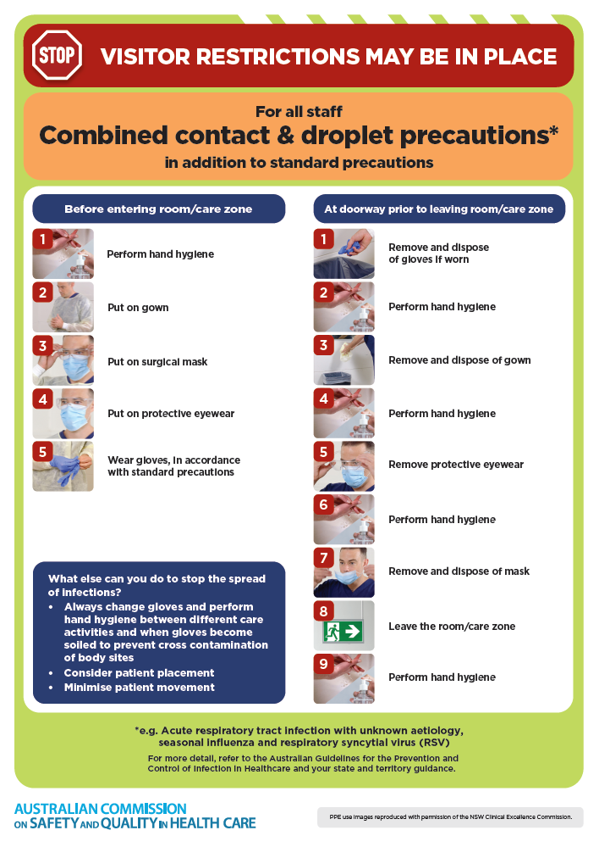](https://www.safetyandquality.gov.au/publications-and-resources/resource-library/infection-prevention-and-control-poster-combined-contact-and-droplet-precautions)
* ***Poster – Combined airborne and contact precautions***<https://www.safetyandquality.gov.au/publications-and-resources/resource-library/infection-prevention-and-control-poster-combined-airborne-and-contact-precautions>  
     
  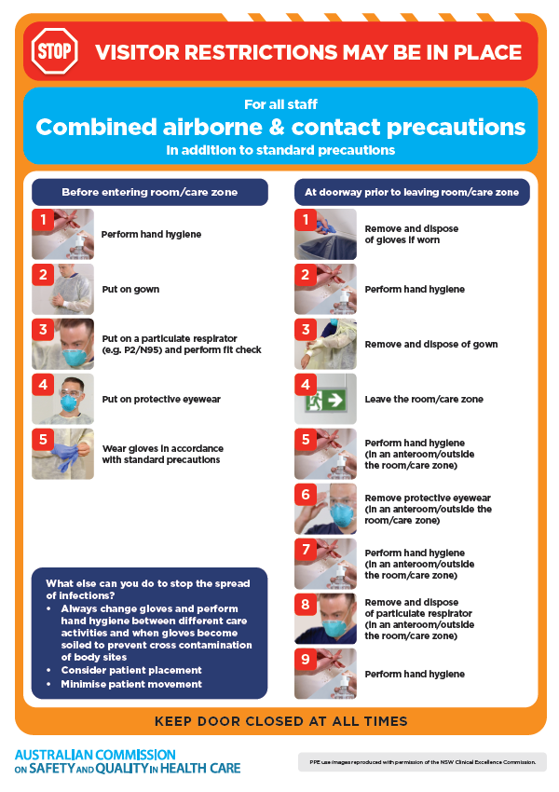
* ***Environmental Cleaning and Infection Prevention and Control*** [www.safetyandquality.gov.au/environmental-cleaning](http://www.safetyandquality.gov.au/environmental-cleaning)
* ***COVID-19 infection prevention and control risk management – Guidance*** <https://www.safetyandquality.gov.au/publications-and-resources/resource-library/covid-19-infection-prevention-and-control-risk-management-guidance>
* ***Safe care for people with cognitive impairment during COVID-19***<https://www.safetyandquality.gov.au/our-work/cognitive-impairment/cognitive-impairment-and-covid-19>
* ***Break the chain of infection*** poster  
  <https://www.safetyandquality.gov.au/publications-and-resources/resource-library/break-chain-infection-poster>  
    
  **[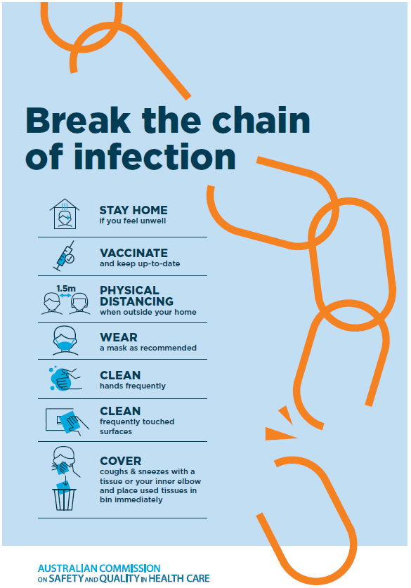](https://www.safetyandquality.gov.au/publications-and-resources/resource-library/break-chain-poster-a3https:/www.safetyandquality.gov.au/publications-and-resources/resource-library/break-chain-poster-a3)**
* ***COVID-19 and face masks – Information for consumers*** <https://www.safetyandquality.gov.au/publications-and-resources/resource-library/covid-19-and-face-masks-information-consumers>

[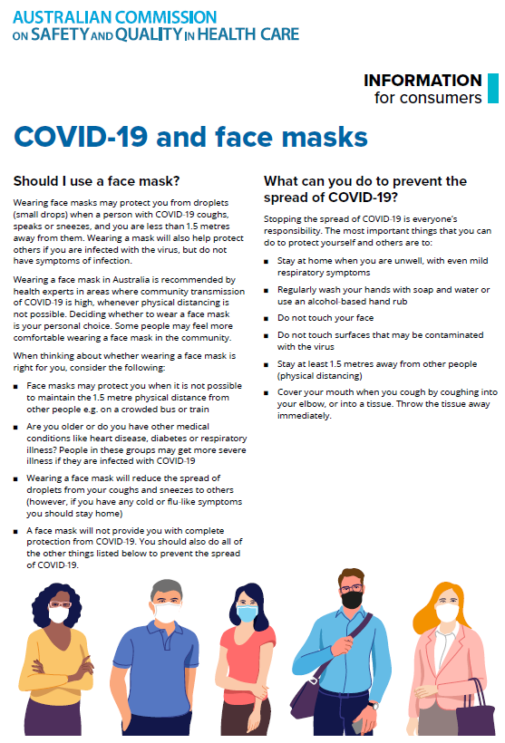](https://www.safetyandquality.gov.au/sites/default/files/2020-07/covid-19_and_face_masks_-_information_for_consumers.pdf)

**Disclaimer**

On the Radar is an information resource of the Australian Commission on Safety and Quality in Health Care. The Commission is not responsible for the content of, nor does it endorse, any articles or sites listed. The Commission accepts no liability for the information or advice provided by these external links. Links are provided on the basis that users make their own decisions about the accuracy, currency and reliability of the information contained therein. Any opinions expressed are not necessarily those of the Australian Commission on Safety and Quality in Health Care.