# Australian Commission on Safety and Quality logotypeOn the Radar

Issue 682

27 January 2025

*On the Radar* is a summary of some of the recent publications in the areas of safety and quality in health care. Inclusion in this document is not an endorsement or recommendation of any publication or provider. Access to particular documents may depend on whether they are Open Access or not, and/or your individual or institutional access to subscription sites/services. Material that may require subscription is included as it is considered relevant.

*On the Radar* is available online, via email or as a PDF or Word document from <https://www.safetyandquality.gov.au/newsroom/subscribe-news/radar>

If you would like to receive *On the Radar* via email, you can subscribe on our website <https://www.safetyandquality.gov.au/newsroom/subscribe-news>  
or by emailing us at H[Umail@safetyandquality.gov.auU](mailto:mail@safetyandquality.gov.au).  
You can also send feedback and comments to H[Umail@safetyandquality.gov.auU](mailto:mail@safetyandquality.gov.au).

For information about the Commission and its programs and publications, please visit <https://www.safetyandquality.gov.au>

**On the Radar**

Editor: Dr Niall Johnson

**Books**

*Measurement for Improvement*

Elements of Improving Quality and Safety in Healthcare

Toulany A, Shojania KG

Cambridge: Cambridge University Press; 2025.

|  |  |
| --- | --- |
| DOI | <http://dx.doi.org/10.1017/9781009326063> |
| Notes | This volume is the latest release in the [Elements of Improving Quality and Safety in Healthcare](https://www.cambridge.org/core/publications/elements/elements-of-improving-quality-and-safety-in-healthcare) series from The Healthcare Improvement Studies Institute (the THIS Institute) in Cambridge. This volume examines the role of measurement in healthcare improvement. This includes discussion of the key principles and core concepts, along with challenges.  The authors open with the observation:  Measurement is a key characteristic of any healthcare improvement effort. ‘If you can’t measure it, you can’t improve it’, is a widely quoted mantra, often attributed to engineer, statistician, and management pioneer Edwards Deming. It is true that Deming saw measurement as fundamental to improvement work. But what he actually said is rather different: ‘It is wrong to suppose that if you can’t measure it, you can’t manage it – a costly myth’. Deming recognised that management can occur on the basis of what we might now call qualitative signals or ‘soft intelligence’. In practice, most improvement interventions benefit from a mix of qualitative and quantitative measures – certainly during the development and refinement of an intervention and often in its eventual evaluation. In this Element, we outline the major principles that underpin measurement related to healthcare improvement’ |

**Reports**

*Practical Guide for Building Climate-Resilient Health Systems*

Abruzzo G

Brussels: Health Care Without Harm; 2024. p. 50.

|  |  |
| --- | --- |
| URL | <https://europe.noharm.org/resources/practical-guide-building-climate-resilient-health-systems> |
| Notes | This guide has been developed as part of a project aimed at developing resources to increase the climate resilience capacity of the European healthcare sector and related critical infrastructures. The Guide's purpose is to help organisations integrate climate resilience into healthcare planning. It is aimed at those responsible for developing a Climate Resilience Plan for their health system or organisation. The Guide is designed to provide a path for health systems, guiding them from the initial stages of building climate resilience to the development of a comprehensive, implementable plan. |

**Journal articles**

*Vital Directions for Health and Health Care*

Washington DC: National Academy of Medicine; 2025

|  |  |
| --- | --- |
| URL | <https://nam.edu/initiatives/vital-directions-for-health-and-health-care/> |
| Notes | Since 2016 the US National Academy of Medicine has produced a series of papers on critical areas of US health care around each US presidential election. The papers have been written by the experts and intended to provide nonpartisan guidance to the incoming administration. This series has published as a series of articles in the journal *Health Affairs*   * *Overview* <https://doi.org/10.1377/hlthaff.2024.01200> * Revitalizing the **biomedical research enterprise** <https://doi.org/10.1377/hlthaff.2024.01001> * Modernizing **public health** <https://doi.org/10.1377/hlthaff.2024.01010> * Charting new directions for **women's health** <https://doi.org/10.1377/hlthaff.2024.01004> * Safely integrating **artificial intelligence** throughout the health care system <https://doi.org/10.1377/hlthaff.2024.01003> * Addressing the impact of **climate change** on health and equity <https://doi.org/10.1377/hlthaff.2024.01008> * Transforming the **US health care system** to one that performs at par with the systems of other industrialized nations <https://doi.org/10.1377/hlthaff.2024.01007>. |

*High-risk medication errors: Insight from the UK National Reporting and learning system*

Alrowily A, Alfaraidy K, Almutairi S, Alamri A, Alrowily W, Abutaleb M, et al

Exploratory Research in Clinical and Social Pharmacy. 2025;17:100531.

|  |  |
| --- | --- |
| DOI | <https://doi.org/10.1016/j.rcsop.2024.100531> |
| Notes | Paper reporting on a study that used data from the UK’s National Reporting and Learning System (NRLS) to examine errors involving high-risk medications. Based on 1500 incidents recorded in the NRLS during 2015 the study focused on ‘three categories of high-risk drugs: opioids, insulin, and anticoagulants.’ For these data and their analyses, the authors reported that ‘the insulin category had both the highest risk and most errors compared with anticoagulants and opioids. These errors primarily result from issues related to administering, prescribing, and dispensing the drugs. Inadequate drug checks, communication difficulties among staff and patients, and high staff workloads are often linked to these errors.’ |

For information on the Commission’s work on medication safety see <https://www.safetyandquality.gov.au/our-work/medication-safety>

*Characteristics and trends of medical diagnostic errors in the United States*

Ao HS, Matthews T

Patient Safety. 2025;6(1):123603.

|  |  |
| --- | --- |
| DOI | <https://doi.org/10.33940/001c.123603> |
| Notes | This study analysed data on 226,781 paid malpractice claims data in the USA for the period 1999–2018 in order to examine the issue of diagnostic error. In this dataset, more than a quarter of cases involved diagnostic errors, of which a significant proportion resulted in death. The authors report that ‘The leading specific malpractice allegations were failure to diagnose, delay in diagnosis, wrong or misdiagnosis, and failure to order appropriate test.' |

*What are the unintended patient safety consequences of healthcare technologies? A qualitative study among patients, carers and healthcare providers*

Abdelaziz S, Garfield S, Neves AL, Lloyd J, Norton J, van Dael J, et al

BMJ Open. 2024;14(11):e089026.

|  |  |
| --- | --- |
| DOI | <https://doi.org/10.1136/bmjopen-2024-089026> |
| Notes | Paper reporting on a study that used the experiences of patients, carers and healthcare providers in the UK to examine patient-safety-related unintended consequences of healthcare technologies. Based on 5 focus groups involving 40 participants, the study ‘identified five main themes of unintended consequences with implications for patient safety:  inequity of access,  increased end-user burden,  loss of the human element of healthcare,  over-reliance on technology and  unclear responsibilities.’ |

*Experiences of Nurses Speaking Up in Healthcare Settings: A Qualitative Metasynthesis*

Lee E, De Gagne Jennie C, Randall Paige S, Tuttle B, Kwon H

Journal of Advanced Nursing. 2024.

|  |  |
| --- | --- |
| DOI | <https://doi.org/10.1111/jan.16592> |
| Notes | The importance of a safety culture, incorporating psychological safety and encouraging people to speak up, has been identified for some time. However, achieving and maintaining such an environment can be challenging. This study reviewed 15 studies to ‘review and synthesise qualitative research on nurses' experiences of speaking up’. Barriers to speaking up included hierarchical structures and poor work environment, while the factors supporting speaking up included interprofessional responsibility and a supportive atmosphere. |

*How Peer Support Helps Heal the Culture of Medicine from Within*Quinn M A, Chaudhari A, Brazeau C, Lawrence E, Olson K  
NEJM Catalyst.6(1):CAT.23.0373.

*Creating Systemwide Interdisciplinary Well-Being Committees to Reduce Physician Burnout*Sukhija-Cohen A, C., Stults CD, Deng S, Gregg L, Le Sieur-Hosseini S, S., Kacher Cobb JM

NEJM Catalyst.6(1):CAT.24.0251.

*VA Writes: A Reflective Writing Workshop to Improve Well-Being in Health Care Employees*   
Chen P W, Charness Michael E, Reisman A  
NEJM Catalyst.6(1):CAT.24.0300.

|  |  |
| --- | --- |
| DOI | Quinn et al <https://doi.org/10.1056/CAT.23.0373>  Sukhija-Cohen et al <https://doi.org/10.1056/CAT.24.0251>  Chen et al <https://doi.org/10.1056/CAT.24.0300> |
| Notes | Somewhat related to an item in the last issue of *On the Radar* on mitigating burnout (<https://doi.org/10.1136/leader-2023-000921>) are these three pieces from *NEJM Catalyst* that relate to well-being and peer support.  Quinn et al review the significance and impact of peer support and various means it can be enacted while Sukhija-Cohen et al and Chen et al describe particular well-being initiatives that have been developed and implemented.  Once again, while these pieces may focus on clinician well-being they apply to the non-clinical workforce also.  In a similar vein, a recent special issue of the *International Journal of Public Health* was focused on **psychological safety in healthcare settings** (<https://www.ssph-journal.org/research-topics/22/psychological-safety-in-healthcare-settings>). |

*The Joint Commission Journal on Quality and Patient Safety*

Volume 51, Issue 2, February 2025

|  |  |
| --- | --- |
| URL | <https://www.sciencedirect.com/journal/the-joint-commission-journal-on-quality-and-patient-safety/vol/51/issue/2> |
| Notes | A new issue of *The Joint Commission Journal on Quality and Patient Safety* has been published. Articles in this issue of *The Joint Commission Journal on Quality and Patient Safety* include:   * Editorial: **We Count Our Successes in Lives** (Brent C James) * **Optimizing and Sustaining Clinical Outcomes** in 88 US Hospitals Post-Pandemic: A Quality Improvement Initiative (Mohamad G Fakih, Florian Daragjati, Lisa K Sturm, Collin Miller, Betsy McKenzie, Kelly Randall, Frederick A Masoudi, Jamie Moxham, Subhangi Ghosh, Jyothi Karthik Raja, Allison Bollinger, Stacy Garrett-Ray, Maureen Chadwick, T Aloia, R Fogel) * Implementation of the Revised American Academy of Pediatrics **Clinical Practice Guidelines for Hyperbilirubinemia** Decreases Necessity for Serum Bilirubin and Phototherapy (Matthew R Michienzi, Dakota K Tomasini, Carleigh C Fisher, Adharsh P Ponnapakkam) * The Impact of a Cohort Structure on Grantee Experiences Developing Clinical Quality Measures for **Diagnostic Excellence** (Abigail T Evans, Meridith Eastman, Mujahed Khan, Jeffrey J Geppert, Lydia Stewart-Artz) * Effect of Interprofessional Crisis Simulation Training in a Non-Operating Room Anesthesia Setting on **Team Coordination**: A Mixed Methods Study (Hedwig Schroeck, Bridget Hatton, Pablo Martinez-Camblor, Michaela A Whitty, Louise Wen, Andreas H Taenzer) * Prevention of **Central Line–Associated Bloodstream Infections** by Leadership Focus on Process Measures (Kathleen McMullen, Fran Hixson, M Peters, K Nelson, W Sistrunk, J Reames, C Standlee, D Tannehill, K Starke) * Examining **Patient Safety Events** Using the Behaviour Change Wheel: A Cross-Sectional Analysis (Mari Somerville, Christine Cassidy, Shannon MacPhee, Douglas Sinclair, Jane Palmer, Daniel Keefe, Shauna Best, J Curran) * Simulation-Debriefing Enhanced Needs Assessment to Address Quality Markers in Health Care: An Innovation for **Prospective Hazard Analysis** (Lisa T Barker, William F Bond, Ann M Willemsen-Dunlap, K L Cooley, J S McGarvey, R L Ruger, A Kohlrus, M J Kremer, M Sergel, J A Vozenilek) * How Do We Know When We Have Done Enough? Ensuring Sufficient **Patient Notification Efforts After a Large-Scale Adverse Event** (David Alfandre, Mary Beth Foglia, Mark Holodniy, A Rani Elwy) |

*Emergency Medicine Australasia*

Volume 37, Issue 1, February 2025

|  |  |
| --- | --- |
| URL | <https://onlinelibrary.wiley.com/toc/17426723/2025/37/1> |
| Notes | A new issue of *Emergency Medicine Australasia* has been published. Articles in this issue of *Emergency Medicine Australasia* include:   * **Zero risk doesn't exist**; using test thresholds to balance harms and benefits (Michael Lousick, Gerben Keijzers, Richard AF Pellatt) * Children exposed to **family and domestic violence** perpetrated against their mother are at an increased risk of emergency department attendance in childhood (Carol Orr, Scott Sims, Colleen M Fisher, Melissa O'Donnell, Rebecca A Glauert, David B Preen) * Experience, knowledge, practices and attitudes of emergency department medical staff regarding **teledermatology** (Sophie Walter, Angela L Chiew, Linda K Martin ) * Review article: Scoping review of interventions that reduce **mechanical restraint** in the emergency department (Joseph Lee, Daiv J Lown, Patrick J Owen, Judith Hope) * Prehospital use of **spinal precautions** by emergency medical services in children and adolescents (Natalie Phillips, Nitaa Eapen, Catherine L Wilson, Ziad Nehme, Franz E Babl) * **Prisoners in the emergency department**: Lessons from a recent inquest (Anne-Maree Kelly) * Risk–benefit analysis of a **multi‐site radiographer comment model** for emergency departments (Ingrid Klobasa, Gary Denham, Derek J Roebuck, Jenny Sim, Marilyn Baird, D Petrie, J Best, J Abood, A Tonks, C Tu, C Jones) * Review article: Electronic screening and brief intervention for **alcohol‐related trauma**: A systematic review and meta‐analysis (Matthew Woliansky, Kai Lee, Santosh Tadakamadla) * What proportion of women presenting to the emergency department with **early pregnancy bleeding** receive appropriate care? (Baylie Trostian, Andrea McCloughen, Kate Curtis) * Effect of case identification changes on **pre‐hospital intubation** performance indicators in an Australian helicopter emergency medical service (Alan A Garner, Andrew Scognamiglio, Sviatlana Kamarova) * Utility of computed tomography brain scans in **intubated patients with overdose** (Michael Lousick, Serena Edwards, Gerben Keijzers, R A F Pellatt) * Prevalence of **clinical deterioration in the pre‐hospital setting** (Emma Bourke-Matas, Tan Doan, Kelly-Ann Bowles, Emma Bosley) * A cluster of **multi‐drug intoxications** involving xylazine, benzimidazole opioids (nitazenes) and novel benzodiazepines in South Australia (Emma Partridge, Peter Stockham, M Kenneally, A Luong, C Kostakis, S Alfred) * Effectiveness of a **Disability Liaison Officer service** in a metropolitan emergency department (Elizabeth O'Shannessy, Carly Talarico, Douglas McCaskie, Ali Lakhani, C Koolstra, J Standen, K Roberts, D V Smit, B Mitra) * Sources and content of **advice sought by parents/guardians prior to emergency department attendance** (Scott McNeil, Nikita Goyal, Mandy Parr, John Cheek, Gary Freed, Alastair Meyer, Adam West, Simon Craig) * SAFE: Safety of **procedural sedation and analgesia administration** in the fast‐track area of the emergency department (Ned Freeman, Ammara Doolabh, Ellie Maas, Braden Cupitt, Aaron Shap, C Bertenshaw, G Mitchell) * The use and impact of **pathology tests in emergency department patients with mental health‐related complaints**: A cross sectional study (Daniel Brouillard, Geoffrey Melville, Mary K Lam, Jessie Woods, J Martoo, G Wilkie, H Makoni, A Rahman, E Odigboh, T Carrigan, S Binks, N Fielding, K Curtis) * **Ambulance offload** performance, patient characteristics and disposition for patients offloaded to different areas of the emergency department (James L Mallows, Mark D Salter, Mitchell Chapman) * Supporting clinicians post exposure to potentially traumatic events: **Emergency department peer support program evaluation** (Belinda Carne, Jeremy Furyk) * Impact of the Astra Zeneca **COVID‐19 vaccine** on an emergency department (Jamie Deans, Brian Burns, W Portas, C Hannah, J Buchanan, Y Motashar) * The diagnostic utility of **prehospital hyperglycaemia in major trauma patients**: An observational study (Jordi Shahab, Michael Noonan, Shelley Cox, Ziad Nehme, Matthew Shepherd, Ben Meadley, Alexander Olaussen) * **Care during conflicts**: Emergency support systems in Oceania (Derrick Tin, Lenard Cheng, George Braitberg, Ilikini Naitini, G A de Jesus, G Ciottone) * We can do better: Recommendations for **mental health crisis care** from people with lived experience (Helena Roennfeldt, Helen Glover, Calista Castles, Cath Roper, Nicole Hill, Louise Byrne, Bridget E Hamilton) * Effects of a **Virtual Trauma Clinic** on admissions and length of stay for minor to moderate trauma (Amber Shuja, Fay Balian, Michael M Dinh, Radhika Seimon, Jameela Truman, Matthew Oliver) * Review article: Primer for clinical researchers on **innovative trial designs for emergency medicine** (Katherine J Lee, Melissa Middleton, Robert K Mahar) * Reducing **mechanical restraint** in emergency departments: International perspectives and Taiwan's experience (Chi-Hua Lan, Lien-Chung Wei) * **De‐implementing low‐value care in emergency medicine**: A framework for sustainable improvement (Fahad Yousif, Elyssia M Bourke) * What they did next: Using follow‐up phone calls to investigate health care access patterns of **patients who take their own leave** (Isabelle Stewart, Sam Freeman, Georgina Phillips, J Maplesden, D Barnes, S Soderland, J Hutton) * **Low‐acuity emergency department presentation** characteristics and their association with Medicare‐subsidised general practitioner services across New South Wales: A data linkage study (Mahsa Kaikhosrovi, Kendall Bein, Philip Haywood, Radhika Seimon, Michael Dinh) * **Skeletal radiograph interpretation discrepancies** in the emergency department setting: A retrospective chart review (Jack Kinnersly, Furqan Ahmed, Chris Selman, Elyssia M Bourke) * Evaluation of **older patients with minor blunt head trauma** to identify those who do not have clinically important traumatic brain injury and can be safely managed without cranial computed tomography (Tanya Mellett, Courtney West, Theophilus I Emeto, J Dutson, A Khoo, V Gangathimmaiah) * **Patient care on the ramp**: Who is legally responsible? (Michael Eburn, Tina Cockburn, Anne-Maree Kelly) * Expert consensus on **serratus anterior plane block** education and credentialing: A modified‐Delphi study (Christopher Partyka, Daniel Gaetani, Anthony Delaney, Kate Curtis) * Establishing **trust in emergency telehealth consultations** (Jennie Hutton, Veal Michael, Suzanne M Miller, Belinda Baines, Marija Kirjanenko, Loren Sher, Joanna Lawrence, James Boyd, Adam Semciw, R Jessup, J Talevski) * Gender equity in **authorship of emergency medicine publications** in Australasia (Laura R Joyce, Laura M Hamill, Alice Rogan, A Collins, S Beck) * Evaluating accuracy of **cervical spine computed tomography interpretation** by emergency trainees with the use of a structured protocol (Geetika Malhotra, Dinesh Varma, Biswadev Mitra) * Introduction of the **Broset Violence Checklist** in the emergency department: A retrospective cohort study (Biswadev Mitra, Kate Settle, Christine Koolstra, Carly Talarico, De Villiers Smit, Peter A Cameron) * Learning from the lived experiences of **medical women working and studying at the national hospital in Fiji**: A mixed methods study (Manisha L Shankar, Shivani Shailin, Georgina Phillips) |

*BMJ Quality & Safety* online first articles

|  |  |
| --- | --- |
| URL | <https://qualitysafety.bmj.com/content/early/recent> |
| Notes | *BMJ Quality &Safety* has published a number of ‘online first’ articles, including:   * A realist review of how, why, for whom and in which contexts **quality improvement in healthcare impacts inequalities** (Lucy Lara Johnson, Geoff Wong, Isla Kuhn, Graham P Martin, Anuj Kapilashrami, Laura Lennox, Georgia Bell Black, Matthew Hill, Ryan Swiers, Hashum Mahmood, Linda Jones, Jude Beng, John Ford) * Editorial: The beast and the burden: **will pruning performance measurement improve quality?** (Eric C Schneider) |

*International Journal for Quality in Health Care* online first articles

|  |  |
| --- | --- |
| URL | <https://academic.oup.com/intqhc/advance-articles> |
| Notes | *International Journal for Quality in Health Care* has published a number of ‘online first’ articles, including:   * **“What matters to you ?”:** A powerful question to unlocking partnership in care (Anthony Staines et al) * **Case management in Emergency Care**: Impact Evaluation of the CARED Program (Colin Eng Choon Ong et al) * **Psychological safety, Job satisfaction, and the Intention to Leave** among German early-career physicians (Nicola Etti et al) * **Transforming Emergency Care**: Lessons from Innovations Beyond Healthcare (Poonam Gupta et al) * Advancing **Quality Management in the Medical Devices Industry**: Strategies for Effective ISO 13485 Implementation (Diego Augusto De Jesus Pacheco et al) |

**Online resources**

***Clinical Communiqué***

<https://www.thecommuniques.com/post/clinical-communiqu%C3%A9-volume-11-issue-3-december-2024>

Volume 11, Issue 3, December 2024

This issue of *Clinical Communiqué* examines issues around illicit drug use at music festivals, particularly MDMA. In addition to the coronial findings from a number of cases there is an expert summary on the clinical features of MDMA toxicity, with management principles and key learnings, and a commentary about emerging trends of recreational drug use, particularly at music events, and the use of pill testing across Australian jurisdictions.

***Australian Living Evidence Collaboration***

<https://livingevidence.org.au/>

**Infection prevention and control and COVID-19 resources**

The Australian Commission on Safety and Quality in Health Care has developed a number of resources to assist healthcare organisations, facilities and clinicians. These resources include:

* ***Poster – Combined contact and droplet precautions*** <https://www.safetyandquality.gov.au/publications-and-resources/resource-library/infection-prevention-and-control-poster-combined-contact-and-droplet-precautions>  
  [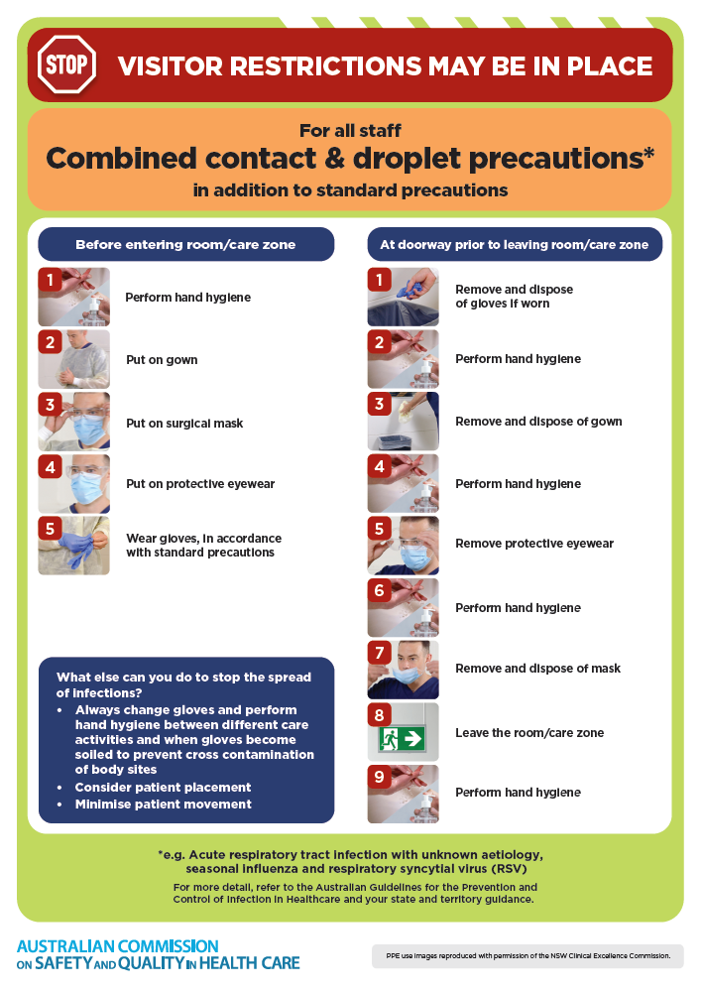](https://www.safetyandquality.gov.au/publications-and-resources/resource-library/infection-prevention-and-control-poster-combined-contact-and-droplet-precautions)
* ***Poster – Combined airborne and contact precautions***<https://www.safetyandquality.gov.au/publications-and-resources/resource-library/infection-prevention-and-control-poster-combined-airborne-and-contact-precautions>  
  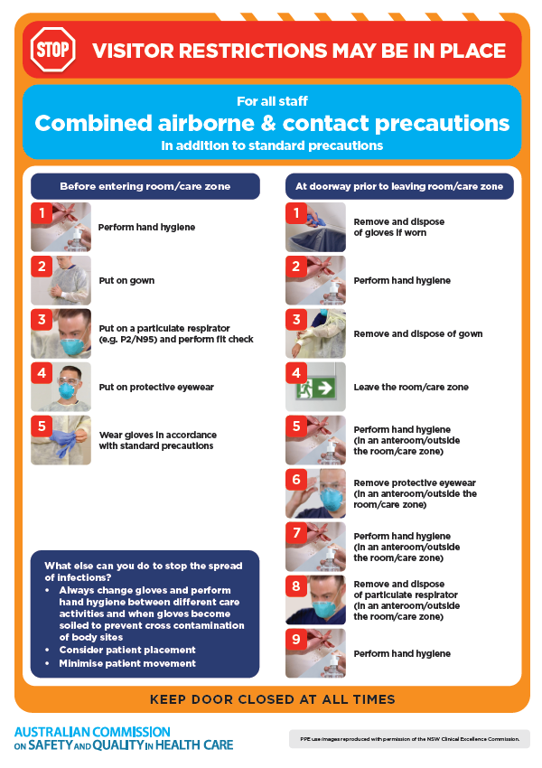
* ***Environmental Cleaning and Infection Prevention and Control*** [www.safetyandquality.gov.au/environmental-cleaning](http://www.safetyandquality.gov.au/environmental-cleaning)
* ***Break the chain of infection*** poster  
  <https://www.safetyandquality.gov.au/publications-and-resources/resource-library/break-chain-infection-poster>  
    
  **[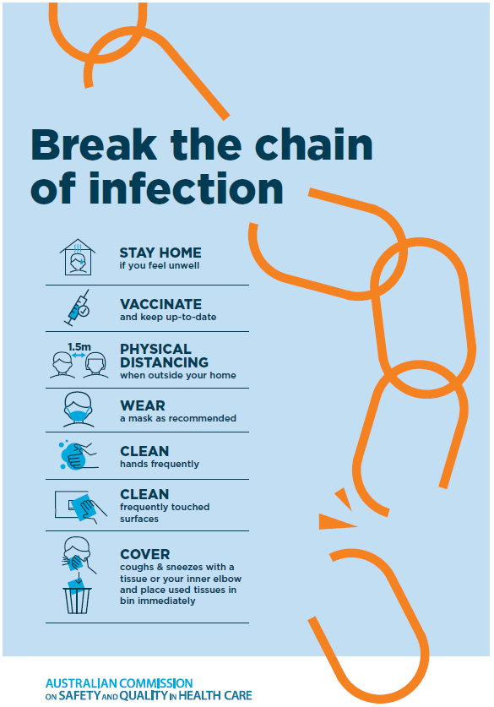](https://www.safetyandquality.gov.au/publications-and-resources/resource-library/break-chain-poster-a3https:/www.safetyandquality.gov.au/publications-and-resources/resource-library/break-chain-poster-a3)**

**Disclaimer**

On the Radar is an information resource of the Australian Commission on Safety and Quality in Health Care. The Commission is not responsible for the content of, nor does it endorse, any articles or sites listed. The Commission accepts no liability for the information or advice provided by these external links. Links are provided on the basis that users make their own decisions about the accuracy, currency and reliability of the information contained therein. Any opinions expressed are not necessarily those of the Australian Commission on Safety and Quality in Health Care.