# Australian Commission on Safety and Quality logotypeOn the Radar

Issue 690

24 March 2025

*On the Radar* is a summary of some of the recent publications in the areas of safety and quality in health care. Inclusion in this document is not an endorsement or recommendation of any publication or provider. Access to particular documents may depend on whether they are Open Access or not, and/or your individual or institutional access to subscription sites/services. Material that may require subscription is included as it is considered relevant.

*On the Radar* is available online, via email or as a PDF or Word document from <https://www.safetyandquality.gov.au/newsroom/subscribe-news/radar>

If you would like to receive *On the Radar* via email, you can subscribe on our website <https://www.safetyandquality.gov.au/newsroom/subscribe-news>  
or by emailing us at H[Umail@safetyandquality.gov.auU](mailto:mail@safetyandquality.gov.au).  
You can also send feedback and comments to H[Umail@safetyandquality.gov.auU](mailto:mail@safetyandquality.gov.au).

For information about the Commission and its programs and publications, please visit <https://www.safetyandquality.gov.au>

**On the Radar**

Editor: Dr Niall Johnson  
Contributors: Niall Johnson, Jan Gralton

***Cleaning and disinfection of ultrasound transducers***Sydney: ACSQHC; 2025  
<https://www.safetyandquality.gov.au/publications-and-resources/resource-library/cleaning-and-disinfection-ultrasound-transducers>

The Australian Commission on Safety and Quality in Health Care has produced this fact sheet that outlines the essential steps required to clean and disinfect ultrasound transducers used for percutaneous procedures.

**Reports**

*Patient Safety in the Digital NHS: User-centric approaches to technology and transformation*

Semmeling S

London: Public Policy Projects; 2025. p. 40.

|  |  |
| --- | --- |
| URL | <https://live.publicpolicyprojects.com/PatientSafetyProgramme#/psreports?lang=en> |
| Notes | The report published by the UK thinktank Public Policy Projects, in collaboration with Patient Safety Learning, draws on a series roundtable discussions to discuss patient safety through the lens of technology, digital innovation and data-driven transformation. Participants included health sector and patient safety leaders, industry representatives, as well as patients and clinicians. The report (and its insights and recommendations) is arranged by   * System leadership and user needs * Patient safety information * Digitally enabled citizens.   This thematic arrangement emphasises the importance of a user-centred approach to innovation, the primacy of patient safety and the potential to empower patients. |

**Journal articles**

*BMJ Quality & Safety*

Volume 34, Issue 4, April 2025

|  |  |
| --- | --- |
| URL | <https://qualitysafety.bmj.com/content/34/4> |
| Notes | A new issue of *BMJ Quality & Safety* has been published. Many of the papers in this issue have been referred to in previous editions of *On the Radar* (when they were released online). Articles in this issue of *BMJ Quality & Safety* include:   * Editorial: **Choosing ‘Less’ Wisely** as a marker of decisional conflict (Karen Okrainec, Melissa Roy) * Editorial: Low-quality evidence on practices to prevent **transmission of resistant organisms** calls for rigorous trials and a paradigm shift (Barbara Trautner, Marin L Schweizer) * Equity in Choosing Wisely and beyond: the **effect of health literacy on healthcare decision-making** and methods to support conversations about overuse (Danielle M uscat, Erin Cvejic, Jenna Smith, Rachel Thompson, Edward Chang, Marguerite Tracy, Joshua Zadro, Robyn Linder, K McCaffery) * Global, regional and national time trends in **incidence of adverse effects of medical treatment**, 1990–2019: an age–period–cohort analysis from the Global Burden of Disease 2019 study (Liangquan Lin) * Factors associated with **proximal femoral fractures in older adults** during hospital stay: a cross-sectional study (Mutsuko Moriwaki, Asuka Takae, Mikayo Toba, Miki Sasaki, Yasuko Ogata, Satoshi Obayashi, Masayuki Kakehashi, Kiyohide Fushimi) * Prevention in adults of transmission of infection with **multidrug-resistant organisms**: an updated systematic review from Making Healthcare Safer IV (Sean McCarthy, Aneesa Motala, Paul G Shekelle) * **Rapid response systems, antibiotic stewardship and medication reconciliation**: a scoping review on implementation factors, activities and outcomes (Jonas Torp Ohlsen, Eirik Søfteland, Per Espen Akselsen, Jörg Assmus, Stig Harthug, Regina Küfner Lein, Nick Sevdalis, Hilde Valen Wæhle, John Øvretveit, Miriam Hartveit) * The problem with uptake as a quality metric for **population-based screening programmes** (Natalie Armstrong, Sian Taylor-Phillips) * The problem with the existing **reporting standards for adverse event and medical error** research (Christopher R Carpenter, Richard T Griffey, Anne W S Rutjes, Maria Unbeck, Lee M Adler, David C Stockwell, David Classen) |

*Journal for Healthcare Quality*

Volume 47, Number 1, January/March 2025

|  |  |
| --- | --- |
| URL | <https://journals.lww.com/jhqonline/toc/2025/03000> |
| Notes | A new issue of *The Journal for Healthcare Quality (JHQ)* has been published. Articles in this issue of *The Journal for Healthcare Quality* include:   * **State-Level Hospital Quality in the United States**: Analyzing Variation and Trends From 2013 to 2021 (Arjun Teotia, Brent D Fulton, Dan R Arnold, Richard M. Scheffler) * A **Composite Score** Reflecting an Initiative to Reduce Harm, Protect Patients, and Promote Safety (Katelynd Smith, Julia McAvoy, J D Six, L Goss) * Personalizing Quality Improvement: Addressing Anticoagulation Gaps in **Atrial Fibrillation** (Gary D Owen, Christopher J Terry, Erin B Neal, Scott D Nelson, Mohamed Omar, Mariah J Pettapiece-Phillips, Sunil Kripalani) * Preoperative Optimization of Patients Undergoing Orthopedic **Foot and Ankle Surgery**: A Single Institution Cohort (Julia Kessel, Rebecca J Cleveland, Trapper Lalli, Joshua Tennant, Jennifer Woody) * Pharmacist-Led Population Health Initiative to Address **Statin Care Gaps**: A Quality Improvement Project (Danielle Raymer, Anna Everhart, D Baker) * Reducing **Emergency Department Hold Hours**: A Hospital-wide Effort (Jill McCormick, Faith Kinsinger, Ritika J Patel, Grant Wicklund, Deb Roybal) * Electronic Clinical Quality Measures for **Prosthetic Joint Infection Diagnosis**: Pitfalls and Potential (Andy O Miller, Amy S Chin, Alberto V Carli, George Sayegh, Diana Chee, Daniel B Buchalter, S Simon, C H Maclean) * Continuous Quality Improvement in **Social Needs Screening**: Evaluation of an Intervention in Bariatric Specialty Care (Claire Chang, Samantha Cooley, Bradley Iott, Jordan Greene, Dilhara Muthukuda, Renuka Tipirneni) |

Healthcare*Papers*

Volume 22, Number 3, March 2025

|  |  |
| --- | --- |
| URL | <https://www.longwoods.com/publications/healthcarepapers/27525/1/> |
| Notes | A new issue of Healthcare*Papers* has been published with a theme of ‘Reimagining the Canada Health Act at 40’. Articles in this issue of Healthcare*Papers* include:   * Is the **Canada Health Act** Untouchable? (Sara Allin and Audrey Laporte) * **Medicare Makeover**: Reimagining the Canada Health Act at 40 (Colleen M Flood and Bryan Thomas) * The Time is Ripe for **Canada Health Act 2.0** (Bill Tholl and G Marchildon) * The Canada Health Act Viewed Through an **Equity Lens** (Amélie Quesnel-Vallée and Emmanuelle Arpin) * **Portability** and the Canada Health Act (Antonia Maioni) * The Canada Health Act and Medicare Services for **Indigenous Peoples** (Constance MacIntosh) * **Reimagining Primary Care**: A Pan-Canadian Perspective on the Canada Health Act (Sydney Dianne Pearce, Danyaal Raza, Pierre-Gerlier Forest and Danielle Martin) * The Canada Health Act and **Mental Health and Addiction Services** (Erika Dyck) * Dealing With **Oral Healthcare** Within Broader Healthcare Policy: The Need for Conceptual Before Operational Steps (Carlos Quiñonez) * **Medicare Makeover** and More (Jane Philpott and Duncan Sinclair) * **Medicare Makeover**: A Response to Peer Commentaries (Colleen M Flood and Bryan Thomas) * Book Review: There is No Medicare Without Tommy Douglas (Arjumand Siddiqi) |

*BMJ Quality & Safety* online first articles

|  |  |
| --- | --- |
| URL | <https://qualitysafety.bmj.com/content/early/recent> |
| Notes | *BMJ Quality &Safety* has published a number of ‘online first’ articles, including:   * Editorial: Just how many **diagnostic errors and harms** are out there, really? It depends on how you count (David E Newman-Toker) * Editorial: Learning from **an allied health perspective on quality and safety** (Nicole Müller, Refaie Amr El, Margaret McGrath, Joseph McVeigh) |

*International Journal for Quality in Health Care* online first articles

|  |  |
| --- | --- |
| URL | <https://academic.oup.com/intqhc/advance-articles> |
| Notes | *International Journal for Quality in Health Care* has published a number of ‘online first’ articles, including:   * Evaluation of **temporomandibular disorder self-management apps** in Australia: A systematic review to inform clinical use (Anita Lim et al) * **Dying in hospital** – A retrospective medical record analysis on care in the dying phase in intensive care units and general wards (Sophie Meesters et al) * Systematic recording and discussion of **intraoperative adverse events** using ClassIntra: Results of a qualitative context analysis before implementation (Monika Finsterwald, Zuzanna Kita, Salome Dell-Kuster, Katrin Burri-Winkler, Anne Auderset, Judith Winkens, Christoph S Burkhart, Amanda van Vegten, Lauren Clack) |

**Infection prevention and control and COVID-19 resources**

The Australian Commission on Safety and Quality in Health Care has developed a number of resources to assist healthcare organisations, facilities and clinicians. These resources include:

* ***Poster – Combined contact and droplet precautions*** <https://www.safetyandquality.gov.au/publications-and-resources/resource-library/infection-prevention-and-control-poster-combined-contact-and-droplet-precautions>  
  [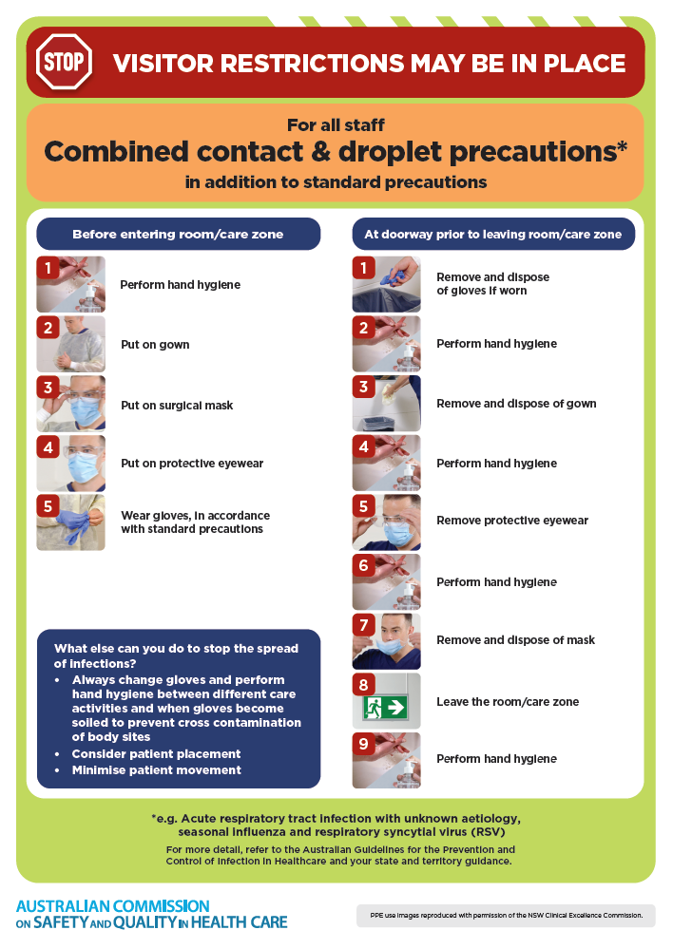](https://www.safetyandquality.gov.au/publications-and-resources/resource-library/infection-prevention-and-control-poster-combined-contact-and-droplet-precautions)
* ***Poster – Combined airborne and contact precautions***<https://www.safetyandquality.gov.au/publications-and-resources/resource-library/infection-prevention-and-control-poster-combined-airborne-and-contact-precautions>  
  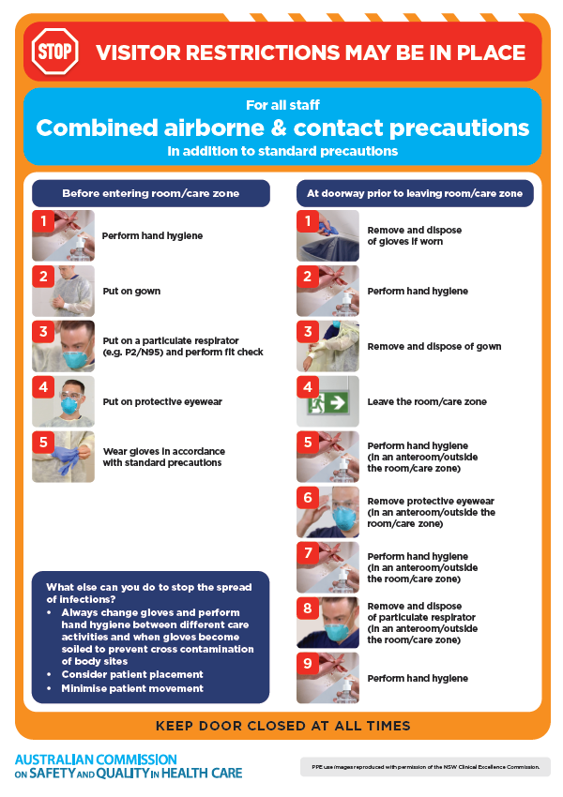
* ***Environmental Cleaning and Infection Prevention and Control*** [www.safetyandquality.gov.au/environmental-cleaning](http://www.safetyandquality.gov.au/environmental-cleaning)
* ***Break the chain of infection*** poster  
  <https://www.safetyandquality.gov.au/publications-and-resources/resource-library/break-chain-infection-poster>  
    
  **[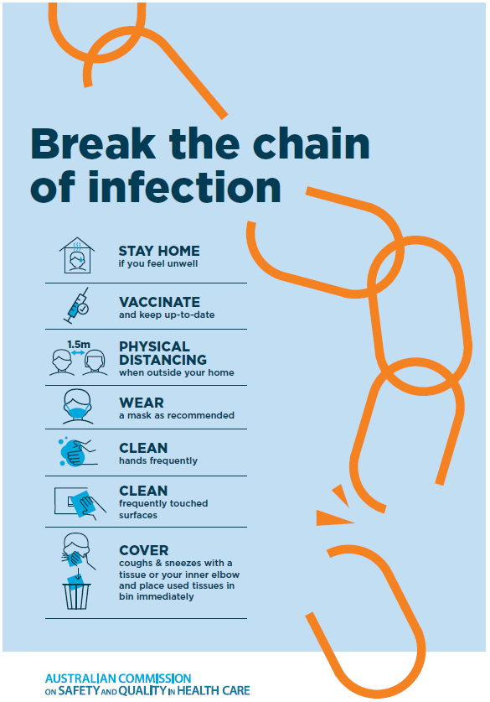](https://www.safetyandquality.gov.au/publications-and-resources/resource-library/break-chain-poster-a3https:/www.safetyandquality.gov.au/publications-and-resources/resource-library/break-chain-poster-a3)**

**Disclaimer**

On the Radar is an information resource of the Australian Commission on Safety and Quality in Health Care. The Commission is not responsible for the content of, nor does it endorse, any articles or sites listed. The Commission accepts no liability for the information or advice provided by these external links. Links are provided on the basis that users make their own decisions about the accuracy, currency and reliability of the information contained therein. Any opinions expressed are not necessarily those of the Australian Commission on Safety and Quality in Health Care.