# Australian Commission on Safety and Quality logotypeOn the Radar

Issue 692

7 April 2025

*On the Radar* is a summary of some of the recent publications in the areas of safety and quality in health care. Inclusion in this document is not an endorsement or recommendation of any publication or provider. Access to particular documents may depend on whether they are Open Access or not, and/or your individual or institutional access to subscription sites/services. Material that may require subscription is included as it is considered relevant.

*On the Radar* is available online, via email or as a PDF or Word document from <https://www.safetyandquality.gov.au/newsroom/subscribe-news/radar>

If you would like to receive *On the Radar* via email, you can subscribe on our website <https://www.safetyandquality.gov.au/newsroom/subscribe-news>  
or by emailing us at H[Umail@safetyandquality.gov.auU](mailto:mail@safetyandquality.gov.au).  
You can also send feedback and comments to H[Umail@safetyandquality.gov.auU](mailto:mail@safetyandquality.gov.au).

For information about the Commission and its programs and publications, please visit <https://www.safetyandquality.gov.au>

**On the Radar**

Editor: Dr Niall Johnson  
Contributors: Niall Johnson, Jan Gralton

***Appropriate and safe use of chlorhexidine***

Chlorhexidine is a broad-spectrum antiseptic, with activity against gram-positive and gram-negative bacteria, fungi, and viruses. Chlorhexidine plays an important role in infection prevention and control in health care, particularly in procedural settings. To support healthcare organisations and clinicians to use chlorhexidine appropriately and safely, the Commission has developed the following guidance:

*Joint Safety Statement -Topical application of chlorhexidine and the risks of accidental injection in regional anaesthesia and vascular access procedures*

Australian Commission on Safety and Quality in Health Care and Australian and New Zealand College of Anaesthetists  
Sydney: ASCQHC; 2018.  
<https://www.safetyandquality.gov.au/publications-and-resources/resource-library/joint-safety-statement-topical-application-chlorhexidine-and-risks-accidental-injection-regional-anaesthesia-and-vascular-access-procedures>

*Appropriate and safe use of chlorhexidine in healthcare settings*Australian Commission on Safety and Quality in Health Care  
Sydney: ASCQHC; 2023.  
<https://www.safetyandquality.gov.au/publications-and-resources/resource-library/appropriate-and-safe-use-chlorhexidine-healthcare-settings>

**Reports**

*The economics of diagnostic safety*

OECD Health Working Papers, No 176

Slawomirski L, Kelly D, de Bienassis K, Kallas K-A, Klazinga N

Paris: OECD Publishing; 2025. p. 101.

|  |  |
| --- | --- |
| DOI | <https://doi.org/10.1787/fc61057a-en> |
| Notes | The OECD has released this as their latest Health Working Paper. The paper examines the economics of diagnostic safety  According to the report’s abstract,  ‘Diagnosis is complex and iterative, therefore liable to error in accurately and timely identifying underlying health problems, and communicating these to patients. **Up to 15% of diagnoses are estimated to be inaccurate, delayed or wrong**. Diagnostic errors negatively impact patient outcomes and increase use of healthcare resources. The **direct financial burden of misdiagnosis, underdiagnosis and overdiagnosis combined is estimated to be 17.5% of total healthcare** expenditure, or 1.8% of GDP in a typical OECD country where one tenth of GDP is spent on health care. Reducing diagnostic error has the potential for large cost savings through improvements in healthcare efficiency and reductions in patient harm. Halving rates of diagnostic error could lead to savings of 8% of healthcare expenditure. This report   1. defines the scope of diagnostic error, 2. illustrates the burden of diagnostic error in commonly diagnosed conditions, 3. estimates the direct costs of diagnostic error 4. provides policy options to improve diagnostic safety.’ |

*Guidance on mental health policy and strategic action plans*

World Health Organization

Geneva: WHO

|  |  |
| --- | --- |
| URL | <https://www.who.int/publications/i/item/9789240106796> |
| Notes | The World Health Organization (WHO) has produced this guidance ‘on mental health policy and strategic action plans’ to provide ‘countries with a comprehensive pathway to mental health policy reform’. The ‘Guidance calls for mental health systems that promote legal capacity, non-coercive practices, participation, and community inclusion. It aims to ensure that all people are treated with dignity, respect, and on an equal basis with others’  The guidance comprises 5 modules:  [Module 1. Introduction, purpose and use of the guidance](https://www.who.int/publications/i/item/9789240106796)  [Module 2. Key reform areas, directives, strategies, and actions for mental health policy & strategic action plans](https://www.who.int/publications/i/item/9789240106819)  [Module 3. Process for developing, implementing, and evaluating mental health policy & strategic action plans](https://www.who.int/publications/i/item/9789240106833)  [Module 4. Country case scenarios](https://www.who.int/publications/i/item/9789240106857)  [Module 5. Comprehensive directory of policy areas, directives, strategies and actions.](https://www.who.int/publications/i/item/9789240106871) |

*12-lead electrocardiograms (ECGs) in ambulance services: paramedic education, training and competence*

Investigation report

Health Services Safety Investigation Body

Poole: HSSIB; 2025.

|  |  |
| --- | --- |
| URL | <https://www.hssib.org.uk/patient-safety-investigations/pre-hospital-interpretation-of-electrocardiograms-ecg-in-ambulance-services/investigation-report/> |
| Notes | This latest report from the Health Services Safety Investigation Body (HSSIB) in the UK examines the use of 12-lead electrocardiograms (ECGs) in UK ambulance services. This followed a UK coroner’s report that had identified an incident involving a 29-year-old female patient with chest pain where an ECG was reported as being misinterpreted and the patient later died of an acute myocardial infarction. The investigation looked at paramedic education, training and competence in ECG practice in the UK, and the task of carrying out and interpreting an ECG in the context of the patient’s clinical signs and symptoms. The report includes a number of observations, findings and recommendations. |

*Programs for Responding to Harms Experienced by Patients During Clinical Care. Rapid Review*

Sokol-Hessner L, Stewart CM, Sharma R, Zhang A, Gallagher TH, Kachalia A, et al

Rockville, MD: Agency for Healthcare Research and Quality; 2025. p. 73.

|  |  |
| --- | --- |
| URL | <https://effectivehealthcare.ahrq.gov/products/clinical-care/rapid-research> |
| Notes | The US Agency for Healthcare Research and Quality (AHRQ) has released this rapid review examining ‘s the current literature on the effectiveness of programs used by healthcare organizations to respond after patients experience harm during their care’. The review ‘focused on communication and resolution programs (CRPs) that included communication with the patient and family, event review, quality improvement, and in a qualifying subset of events, an apology for causing harm and an offer of compensation.’ The review found that while ‘studies of CRPs’ effects have focused on organizational liability and cost outcomes rather than patient-oriented outcomes’ they did find ‘CRPs appear to have positive or neutral effects on the measured outcomes, with no significant negative effects. Our findings support the implementation of CRPs while highlighting the need for more research about patient, family, and clinician-oriented outcomes.’ |

**Journal articles**

*Audit and feedback: effects on professional practice*

Ivers N, Yogasingam S, Lacroix M, Brown KA, Antony J, Soobiah C, et al

Cochrane Database of Systematic Reviews. 2025 (3).

|  |  |
| --- | --- |
| DOI | <https://doi.org/10.1002/14651858.CD000259.pub4> |
| Notes | Cochrane review looking into the evidence on the effects of audit and feedback [A&F] on the practice of healthcare professionals. Based on 292 studies, the review authors concluded:  ‘A&F can be effective in improving professional practice, but effects vary in size. A&F is most often delivered along with co‐interventions which can contribute additive effects. A&F may be most effective when designed to help recipients prioritise and take action on high‐priority clinical issues and with the following characteristics:   1. targets important performance metrics where health professionals have substantial room for improvement (audit); 2. measures the individual recipient's practice, rather than their team or organisation (audit); 3. involves a local champion with an existing relationship with the recipient (feedback); 4. includes multiple, interactive modalities such as verbal and written (feedback); 5. compares performance to top peers or a benchmark (feedback); 6. facilitates engagement with the feedback (action); 7. features an actionable plan with specific advice for improvement (action).’ |

*International Journal for Quality in Health Care*

Volume 37, Issue 1, 2025

|  |  |
| --- | --- |
| URL | <https://academic.oup.com/intqhc/issue/37/1> |
| Notes | A new issue of the *International Journal for Quality in Health Care* has been published. Many of the papers in this issue have been referred to in previous editions of *On the Radar* (when they were released online). Articles in this issue of the *International Journal for Quality in Health Care* include:   * **Improving primary care** through multidisciplinary teamwork: possibilities and challenges (Michael Kidd, Shona Marie Bates et al) * Effects of early **palliative care** intervention on medical resource use among end-of-life patients (Chia-Chia Lin, Tsing-Fen Ho et al) * Exploring the development of **safety culture** among physicians with text mining of patient safety reports: a retrospective study (Daisuke Koike, Masahiro Ito et al) * Promoting human rights-based **deinstitutionalization** in Lithuania by applying the World Health Organization’s QualityRights Assessments (Ugnė Grigaitė, Karilė Levickaitė et al) * Analyzing and mitigating the risks of patient harm during **operating room to intensive care unit patient handoffs** (Nara Regina Spall Martins, Edson Zangiacomi Martinez et al) * **Case management in emergency care**: impact evaluation of the CARED Program (Colin Eng Choon Ong, Joanne Yan Ting Yap et al) * Supporting equitable access to **kidney transplant** in remote Western Australia using continuous quality improvement (Felicity Stewart, Nicholas Corsair et al) * Developing and validating a Global Trigger Tool for assessing frequency, level of harm, and preventability of **adverse drug events in pediatric inpatients units** (Amit Gutkind, Amos Toren et al) * Comparative analysis of **routine clinical debriefings and incident reports**: insights for patient safety and teamwork enhancement (Méryl Paquay, Michaela Kolbe et al) * Factors associated with harm in reported **patient safety incidents** and characteristics during health screenings in Korea: a secondary data analysis (Jeongin Choe, Kyungmi Woo) * Prevalence and contributing factors of **intravenous medication administration errors** in emergency departments: a prospective observational study (Shirlyn Tan, Lih Jiuan Teh et al) * **Indirect effects of the COVID-19 pandemic** on healthcare contacts, quality of care, and social disparities across essential healthcare domains (Søren Valgreen Knudsen, Henry Jensen et al) * Psychological safety, job satisfaction, and the **intention to leave** among German early-career physicians (Nicola Etti, Matthias Weigl et al) * Applying the Human Factors Analysis and Classification System within **root cause analysis** to prevent medical errors and enhancing patient safety culture: insights from a medical center (Jiun-Yih Lee, Chien-Hsien Huang et al) * The sustainability of **hospital accreditation models**: a cross-sectional study (Mohammed Hussein, Milena Pavlova et al) * **HemeTEAM** India: together everyone achieves more (Rahul Bhargava, Nathany Shrinidhi et al) * Determinants of **quality in the independent and public hospital sectors** in England (Harriet Bullen, Vasudha Wattal et al) * **Look-alike, sound-alike medication perioperative incidents** in a regional Australian hospital: assessment using a novel medication safety culture assessment tool (Alexandra N Ryan, Kelvin L Robertson et al) * Editorial: Safeguarding **quality of care in active conflict**: priority issues and interventions in Sudan (Sheila Leatherman, Aparna Ghosh Kachoria et al) * Editorial: **Adverse medication reactions**: raising a red flag locally, sharing lessons globally, and improving safety and quality in health care (Linda Velta Graudins) * Editorial: Improvements to **safety and quality**: mastery of tools and techniques is not enough, people and culture matter (Alessandro Laureani) * Editorial: Holding up the crystal ball: using **regulatory intelligence insights** to support quality in healthcare (Martin Fletcher, Samantha Stark et al) * Editorial: **“What matters to you?”**: a powerful question to unlocking partnership in care (Anthony Staines, Lisa Laroussi-Libeault et al) * Editorial: Creating transformative change in the **disabilities** field: promoting both bottom-up and top-down inclusion through the UNCRPD and QualityRights Toolkit (Michela Atzeni, Mauro Giovanni Carta et al) * Editorial: Protocols for **ischaemic stroke** in Flemish hospitals: correlation between availability and content versus adherence (Charlotte Lens, Lotte Hermans et al) * Use of **wireless geographic locating** system to improve medical equipment utilization and medical quality (Tien-Lin Huang, Yi-Fang Lei et al) * Advancing quality management in the **medical devices** industry: strategies for effective ISO 13485 implementation (Diego Augusto de Jesus Pacheco, Samuel Vinícius Bonato et al) * Use and de-implementation of **fecal occult blood tests** in the acute care setting: a systematic review and meta-analysis (Rebekah O Russell, Alejandro C Arroliga et al) |

*BMJ Quality & Safety* online first articles

|  |  |
| --- | --- |
| URL | <https://qualitysafety.bmj.com/content/early/recent> |
| Notes | *BMJ Quality &Safety* has published a number of ‘online first’ articles, including:   * Randomised controlled trial of audit-and-feedback strategies to reduce **imaging overutilisation** in the emergency department (Karl T Chamberlin, Christopher DiTullio, Jennifer Rossman, Bruce A Barton, Martin Reznek, Kevin Kotkowski) * Editorial: We will take some team resilience, please: Evidence-based recommendations for supporting **diagnostic teamwork** (Gabriela Fernández Castillo, Eduardo Salas, Eric J Thomas) * **Patient-reported harm** from NHS treatment or care, or the lack of access to care: a cross-sectional survey of general population prevalence, impact and responses (Helen Crocker, David A Cromwell, Shivali Modha, Alastair McIntosh Gray, Chris Graham, Lavanya Thana, Raymond Fitzpatrick, Charles Vincent, Helen Hogan, Michele Peters) |

*International Journal for Quality in Health Care* online first articles

|  |  |
| --- | --- |
| URL | <https://academic.oup.com/intqhc/advance-articles> |
| Notes | *International Journal for Quality in Health Care* has published a number of ‘online first’ articles, including:   * From Compliance to Excellence: How Can ISO 13485 Standards Transform Quality, Safety and Innovation in **Medical Devices**? (Usman Iqbal et al) * Associations of Hospital Unit Occupancy with **Inpatient Falls and Fall-Risk Assessment** Completion: A Retrospective Cohort Study (Jared Chiu et al) * In Good Hands: Exploring **patient safety in the Philippines** (D A Cordero) * **Dedicated Rapid Response Team Implementation** Associated with Reductions in Hospital Mortality and Hospital Expenses: A Retrospective Cohort Analysis (Jacob Sessim Filho et al) * Disparities in the quality of care for adults with **type 2 diabetes** according to socioeconomic level and ethnicity in Mexico (Sergio Flores-Hernández et al) |

**Online resources**

***Australian Living Evidence Collaboration***

<https://livingevidence.org.au/>

***USA] Effective Health Care Program reports***

<https://effectivehealthcare.ahrq.gov/>

The US Agency for Healthcare Research and Quality (AHRQ) has an Effective Health Care (EHC) Program The EHC has released the following final reports and updates:

* *Making Healthcare Safer IV: Programs for* ***Responding to Harms Experienced by Patients During Clinical Care*** <https://effectivehealthcare.ahrq.gov/products/clinical-care/rapid-research>
* ***Breastfeeding*** *and Health Outcomes for Infants and Children: Systematic review* <https://effectivehealthcare.ahrq.gov/products/breastfeeding-health-outcomes/research>

**Infection prevention and control and COVID-19 resources**

The Australian Commission on Safety and Quality in Health Care has developed a number of resources to assist healthcare organisations, facilities and clinicians. These resources include:

* ***Poster – Combined contact and droplet precautions*** <https://www.safetyandquality.gov.au/publications-and-resources/resource-library/infection-prevention-and-control-poster-combined-contact-and-droplet-precautions>  
  [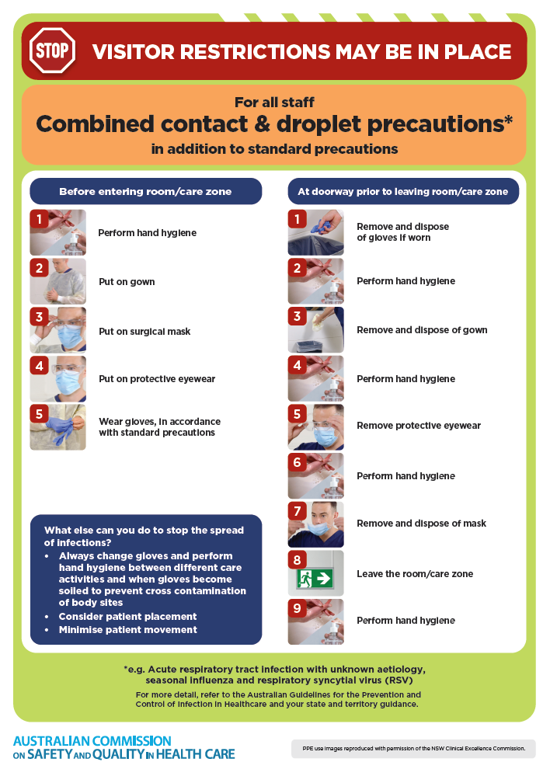](https://www.safetyandquality.gov.au/publications-and-resources/resource-library/infection-prevention-and-control-poster-combined-contact-and-droplet-precautions)
* ***Poster – Combined airborne and contact precautions***<https://www.safetyandquality.gov.au/publications-and-resources/resource-library/infection-prevention-and-control-poster-combined-airborne-and-contact-precautions>  
  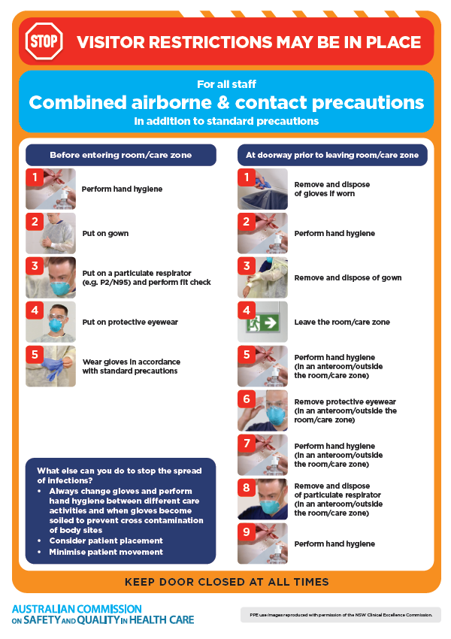
* ***Environmental Cleaning and Infection Prevention and Control*** [www.safetyandquality.gov.au/environmental-cleaning](http://www.safetyandquality.gov.au/environmental-cleaning)
* ***Break the chain of infection*** poster  
  <https://www.safetyandquality.gov.au/publications-and-resources/resource-library/break-chain-infection-poster>  
    
  **[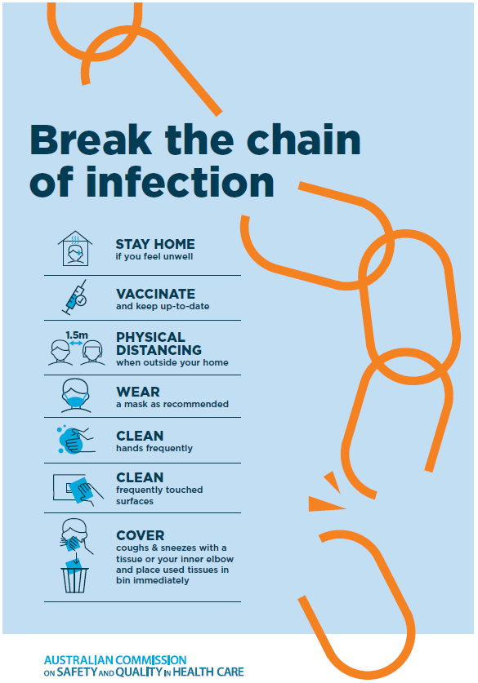](https://www.safetyandquality.gov.au/publications-and-resources/resource-library/break-chain-poster-a3https:/www.safetyandquality.gov.au/publications-and-resources/resource-library/break-chain-poster-a3)**

**Disclaimer**

On the Radar is an information resource of the Australian Commission on Safety and Quality in Health Care. The Commission is not responsible for the content of, nor does it endorse, any articles or sites listed. The Commission accepts no liability for the information or advice provided by these external links. Links are provided on the basis that users make their own decisions about the accuracy, currency and reliability of the information contained therein. Any opinions expressed are not necessarily those of the Australian Commission on Safety and Quality in Health Care.