Antimicrobial use in Australian hospitals

2014 report of the National Antimicrobial Utilisation Surveillance Program

Logo for SA Health (Government of South Australia)

Logo for the Australian Commission on Safety and Quality in Health Care

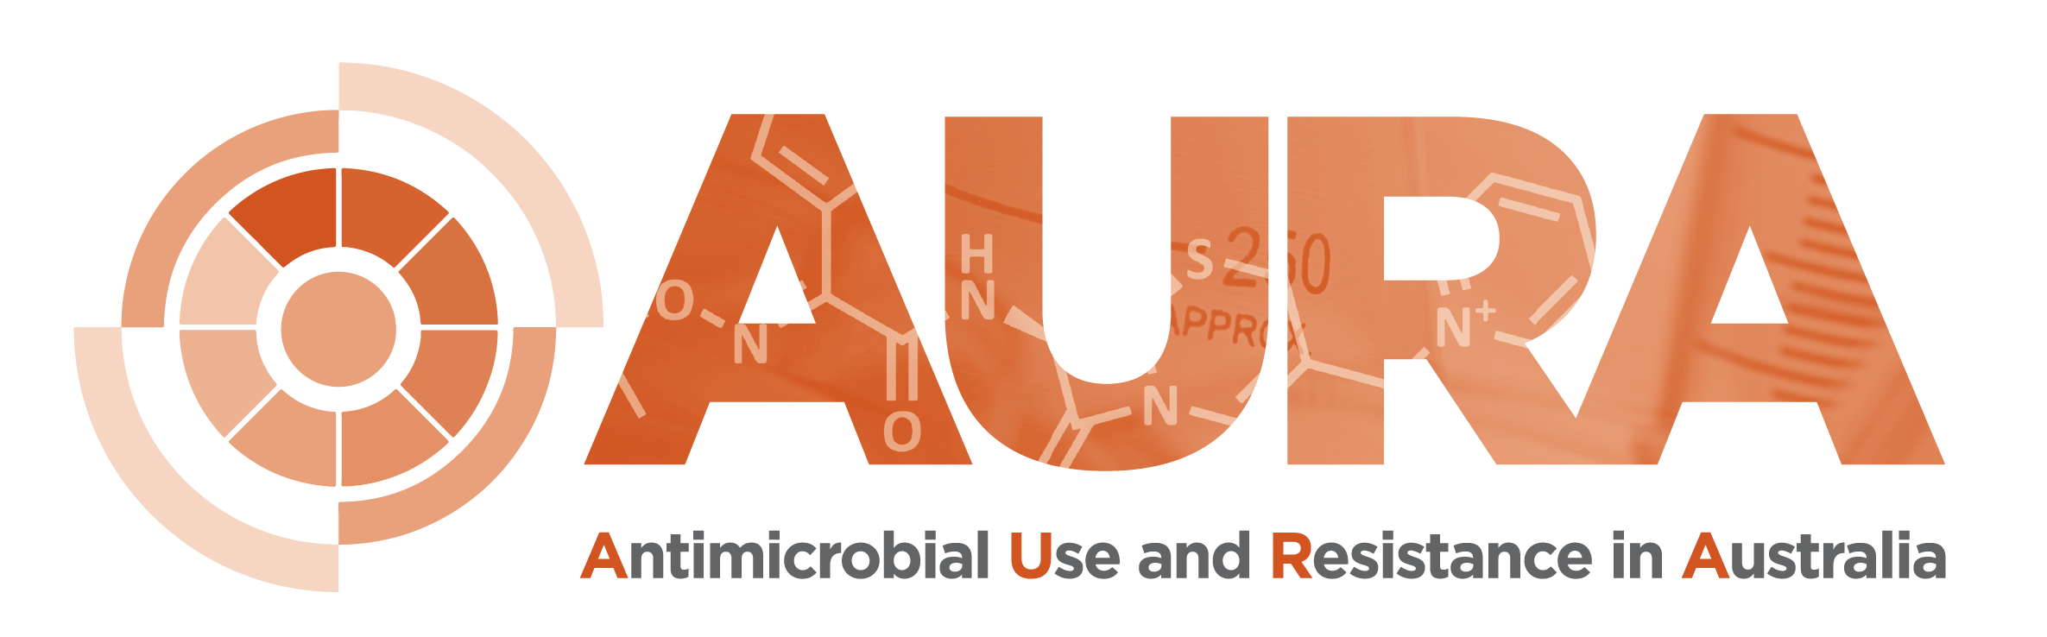

© Commonwealth of Australia 2015

Antimicrobial use in Australian hospitals: 2014 annual report of the National Antimicrobial Utilisation Surveillance Program

ISBN 978-1-925224-12-2 (print), 978-1-925224-14-6 (online)

This annual report was prepared by:

Infection Control Service  
Communicable Disease Control Branch  
SA Department for Health and Ageing   
11 Hindmarsh Square  
Adelaide, South Australia 5000

in collaboration with:

Australian Commission on Safety and Quality in Health Care  
Level 5, 255 Elizabeth Street  
Sydney, New South Wales 2000

Enquiries for SA Department for Health and Ageing to Vicki McNeil:  
vicki.mcneil@sa.gov.au  
Ph: +61 8 7425 7169

Enquiries for ACSQHC to Professor John Turnidge:  
john.turnidge@safetyandquality.gov.au  
Ph: +61 2 9126 3508

This annual report can be accessed at the websites of the South Australian Department for Health and Ageing (<www.sahealth.sa.gov.au/nausp>), and the Australian Commission on Safety and Quality in Health Care (<www.safetyandquality.gov.au>).

Disclaimer: The data presented in this report were correct at the time of publication and reflect usage rates based on data on antimicrobial quantities and occupied bed-days supplied by individual contributors. Minor discrepancies with previous reports may occur as a result of data adjustments made by contributing hospitals.

This work is copyright. It may be reproduced in whole or in part for study or training purposes subject to the inclusion of an acknowledgment of the source. Requests and inquiries concerning reproduction and rights for purposes other than those indicated above require the written permission of the Australian Commission on Safety and Quality in Health Care, GPO Box 5480, Sydney, NSW 2001, or mail@safetyandquality.gov.au.

This publication is part of the work being conducted by the Australian Commission on Safety and Quality in Health Care to establish a national antimicrobial resistance and usage surveillance system. The work is being undertaken through the Antimicrobial Use and Resistance in Australia (AURA) project.

The Australian Commission on Safety and Quality in Health Care wishes to thank those involved in producing this report.

Foreword

The National Antimicrobial Utilisation Surveillance Program (NAUSP) commenced in July 2004. This report is the first of its kind for NAUSP, providing national data on antimicrobial use in 129 adult acute care hospitals, both public and private. This represents more than 90% of principal referral hospital beds and 82% of total beds in hospitals with more than 50 beds across Australia.

The report was commissioned by the Australian Commission on Safety and Quality in Health Care to give healthcare professionals and administrators an overview of antimicrobial use by contributors to NAUSP during January–December 2014. It includes historical comparisons over 5- and 10-year periods. Interstate and intrastate data are presented for the first time, along with comparisons of usage rates between the new Australian Institute of Health and Welfare peer groups for selected antimicrobial classes.

NAUSP is supported by the Antimicrobial Use and Resistance in Australia (AURA) project, conducted by the Australian Commission on Safety and Quality in Health Care on behalf of the Australian Government Department of Health. NAUSP is managed by the Infection Control Service, Communicable Disease Control Branch, SA Health.

Contents

Abbreviations 3

Executive summary 4

Introduction 6

Methods 7

Contributing hospitals 7

Units of measurement 8

Data quality 9

Data exclusions 9

Data classification, restrictions and limitations 10

Overview of antimicrobial usage rates, 2014 11

Total-hospital annual antimicrobial usage rates 11

Top 20 antibacterials 16

Comparison of usage rates by state 17

Intrastate usage rates 19

Annual usage rates by antimicrobial class, 2010–14 25

Total-hospital usage rates for antibacterial classes 25

Antimicrobial usage rates by individual agent, 2014 28

Aminoglycosides – amikacin, gentamicin, tobramycin 28

Carbapenems – doripenem, ertapenem, imipenem, meropenem 29

Third- and fourth-generation cephalosporins – ceftriaxone, cefotaxime, ceftazidime, cefepime 29

Fluoroquinolones – ciprofloxacin, norfloxacin, moxifloxacin 30

Glycopeptides – vancomycin, teicoplanin 32

Macrolides – azithromycin, clarithromycin, erythromycin, roxithromycin 33

Penicillins – penicillin/ß-lactamase inhibitor combinations: ticarcillin with clavulanate, piperacillin with tazobactam, amoxycillin with clavulanic acid 34

Reserve-line agents – colistin, daptomycin, linezolid, tigecycline, ceftaroline 36

Analysis of antibacterial usage by peer group 37

Aminoglycosides 37

Carbapenems 37

Third- and fourth-generation cephalosporins – ceftriaxone, cefotaxime, ceftazidime, cefepime 38

Fluoroquinolones – ciprofloxacin, norfloxacin, moxifloxacin 38

Glycopeptides – vancomycin, teicoplanin 39

Macrolides – azithromycin, clarithromycin, erythromycin, roxithromycin 39

Penicillins – antipseudomonal penicillin/ß-lactamase inhibitor combinations: ticarcillin with clavulanate, piperacillin with tazobactam 40

Reserve-line agents – colistin, daptomycin, linezolid 40

Benchmarking with other antimicrobial usage data 42

International total-hospital usage rates 43

Discussion 45

Acknowledgments 48

Appendix 1 Contributor information 49

Appendix 2 Definitions 51

Appendix 3 WHO defined daily doses for antibacterial agents included in the NAUSP annual report 52

Glossary 57

References 59

# Abbreviations

|  |  |
| --- | --- |
| AIHW | Australian Institute of Health and Welfare |
| AMS | antimicrobial stewardship |
| DANMAP | Danish Integrated Antimicrobial Resistance Monitoring and Research Programme |
| DDD | defined daily dose |
| MRO | multidrug-resistant organism |
| NAUSP | National Antimicrobial Utilisation Surveillance Program |
| NethMap | Consumption of antimicrobial agents and antimicrobial resistance among medically important bacteria in the Netherlands report |
| OBD | occupied-bed-days |
| SWEDRES | Swedish Antibiotic Utilisation and Resistance in Human Medicine report |
| WHO | World Health Organization |

Note on terminology

The term ‘antimicrobial’ is now most widely used when referring to agents used to treat or prevent infections caused by microbes. The term embraces antibacterial, antifungal, antiviral and antiparasitic agents. The common term ‘antibiotic’ is ambiguous and is now not used except in public communication and common parlance.

In this report, ‘antimicrobial’ is used when it implies that data on all, or almost all, the classes of agents have been captured in a surveillance program. Since this report is confined to systemic antibacterial agents, ‘antibacterial’ is used when referring to the output of analyses, and when comparisons are made with data reported by other countries.

# Executive summary

The National Antimicrobial Utilisation Surveillance Program (NAUSP) commenced in July 2004 to provide ongoing, nationally representative data on antimicrobial use in adult acute care hospitals.1 Since 2008, all Australian states and territories have been represented in the program. The number of hospitals participating in the program has doubled since the introduction of the National Safety and Quality Health Service Standards in 2011 by the Australian Commission on Safety and Quality in Health Care.

At the end of 2014, the total number of participating contributors with more than six months of data was 129 (111 public and 18 private hospitals). For Australian public hospital beds, this represents more than 90% of principal referral hospital beds and 82% of total beds in hospitals with more than 50 beds.

The program uses standardised usage density rates, based on the World Health Organization’s Anatomical Therapeutic Chemical standards for ‘defined daily doses’ (DDDs). The denominator is the frequently used metric of inpatient ‘occupied-bed-days’ (OBDs). Reporting on antimicrobial use, based on DDDs, enables assessment and comparison of total-hospital use as a rate.

This report covers antimicrobial use for the period January–December 2014. It includes data from 129 Australian hospitals, ranging from principal referral hospitals to small public acute hospitals, as classified by the Australian Institute of Health and Welfare.

Previous NAUSP annual reports included data for principal referral hospitals. In those reports, usage rates varied several-fold between hospitals for some antibacterials across the national sample. Each contributing hospital needs to determine whether usage rates are appropriate in light of their hospital’s activity.

The Antimicrobial Use and Resistance in Australia (AURA) project will analyse these surveillance data and, in combination with appropriateness data from the National Antimicrobial Prescribing Survey, inform uptake of improved antimicrobial stewardship.

**Key findings include the following:**

The 20 systemic antibacterials most frequently dispensed nationally are amoxycillin with clavulanic acid, flucloxacillin, cephazolin, amoxycillin, doxycycline, cephalexin, piperacillin with tazobactam, ceftriaxone, metronidazole, azithromycin, gentamicin, ciprofloxacin, ampicillin, benzylpenicillin, vancomycin, trimethoprim, meropenem, sulfamethoxazole with trimethoprim, roxithromycin and clindamycin. This accounts for 92% of antibacterials dispensed in NAUSP hospitals.

Use of highly reserved agents such as colistin, daptomycin, linezolid and tigecycline is very low (less than 5 DDDs per 1000 OBDs in the majority of hospitals). Daptomycin usage rates, although extremely low (less than 2 DDDs per 1000 OBDs), are increasing.

Australian usage rates continue to be greater than in the Netherlands and Sweden, and on par with Denmark’s. Broader international comparisons are limited by differences in data collection methods and units of measurement between countries.

Since 2005, there has been a noticeable increase in the use of ß-lactamase inhibitor combinations (especially amoxycillin with clavulanic acid and piperacillin with tazobactam), a more modest increase in the use of first-generation cephalosporins, and a noticeable decrease in the use of aminoglycosides and fluoroquinolones.

During the period January–December 2014, the average aggregate annual rate for total-hospital antibacterial use was 943.6 DDDs per 1000 OBDs, a decrease of 2.2% from the 2013 rate and a decrease of 6.2% from Australia’s peak usage (1006 DDDs per 1000 OBDs) in 2010. Tasmania recorded the highest usage, with 1242 DDDs per 1000 OBDs, followed by New South Wales and the Australian Capital Territory, with 1092 DDDs per 1000 OBDs.

# Introduction

Effective surveillance of inpatient antimicrobial use requires quantitative measures and data against which facilities can benchmark their use of antimicrobials. This benchmarking provides a baseline and allows continual feedback for any antimicrobial stewardship (AMS) activities and interventions that facilities undertake.

The National Antimicrobial Utilisation Surveillance Program (NAUSP) commenced in July 2004. Participating hospitals (Appendix 1) contribute on a voluntary basis, and the number of hospitals has increased greatly since the introduction of the National Safety and Quality Health Service Standards in 2011. NAUSP participation supports successful implementation of Standard 3: Preventing and Controlling Healthcare Associated Infections.

The program has steadily expanded, and all Australian states and territories are now represented in the program; 32 hospitals have contributed continuously since July 2004 (13 since 2001, when only South Australian hospitals participated). This report contains data from 129 Australian hospitals (111 public and 18 private hospitals). For the public hospitals (principal referral hospitals through to small public acute hospitals), this represents 82% of total beds in hospitals with 50 beds or more (Figure 1).

For the first time, this annual NAUSP report presents data on state-specific antimicrobial use.

Figure 1 Cumulative number of hospitals (public and private) contributing to NAUSP

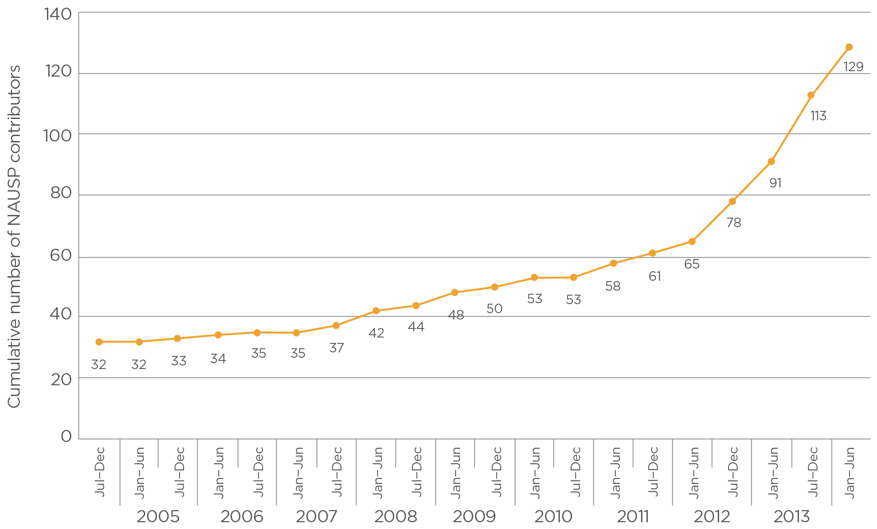

# Methods

## Contributing hospitals

This report covers total in-hospital antimicrobial usage data collected from 129 contributing hospitals across Australia, as shown in Table 1. The number of hospitals contributing to NAUSP, and the number with intensive care units, vary from year to year. Although the Northern Territory supplies data to NAUSP, it has been excluded from this 2014 report because of issues with the scope of data supplied.

As additional hospitals join the surveillance program, data from months before they join may be provided and added to the NAUSP database. These data are incorporated into subsequent annual and bimonthly reports. This may result in variations from previous NAUSP reports in the data reported for 2014.

The Australian Institute of Health and Welfare (AIHW) criteria used to classify hospitals have recently been reviewed, and new peer groupings came into effect from December 2014. The peer group system is designed to be flexible and robust, and the updated peer groups are a reflection of the type and nature of services provided. For more information, see Appendix C in AIHW’s Australian hospital statistics 2012–13.2

This annual report relates to the first application of the revised AIHW peer groups by NAUSP, and provides an instrument for benchmarking future analyses.

The participating hospitals for 2014 fell into the following peer groups, as classified by the AIHW; the percentage of all hospitals in each peer group is shown in parentheses:

principal referral – 28 contributors (97%)

specialist women’s – 2 contributors (32%)

large public acute – 51 contributors (82%)

medium public acute – 26 contributors (58%)

small public acute with surgery and/or obstetrics – 4 contributors (3%).

Private hospitals are not included in the AIHW peer grouping. Instead, they have been assigned to a classification by NAUSP for routine bimonthly reporting of hospital antimicrobial use based on the facility’s individual characteristics (e.g. bed numbers, geographical location, specialties) to enable them to benchmark with similar hospitals. However, in this annual report, private hospital data have only been included in intrastate usage rate analyses, where the hospitals are de-identified.

Table 1 2014 contributors to NAUSP, by peer group

| State | Peer group | | | | | | |
| --- | --- | --- | --- | --- | --- | --- | --- |
| Principal referral | Specialist women’s | Large  public acute | Medium public acute | Small public acute | Private  (non-peered) | Total |
| NSW and ACT | 12 | 0 | 21 | 10 | 0 | 0 | 43 |
| Qld | 5 | 1 | 12 | 5 | 0 | 6 | 29 |
| SA | 2 | 0 | 4 | 4 | 3 | 6 | 19 |
| Tas | 1 | 0 | 2 | 1 | 0 | 1 | 5 |
| Vic | 6 | 0 | 8 | 5 | 0 | 4 | 23 |
| WA | 2 | 1 | 4 | 1 | 1 | 1 | 10 |
| **Total** | **28** | **2** | **51** | **26** | **4** | **18** | **129** |

Pharmacy departments of participating hospitals supply NAUSP with aggregate monthly details of antimicrobials issued to individual inpatients and ward imprest supplies (ward stock managed by the pharmacy) via dispensing reports. Hospital occupancy data are collected in the form of overnight occupied bed-days.

NAUSP uses semi-automated statistical algorithms to detect irregular values, as part of rigorous quality assurance processes that occur during loading of data and before report production. Contributors are alerted if suspect data are detected. Nevertheless, responsibility for the accuracy of data supplied to NAUSP lies with contributing hospitals.

NAUSP assigns each contributing hospital a unique code to identify its usage rates of selected antimicrobials, by therapeutic group, in charts supplied to contributors and jurisdictions.

## Units of measurement

Antimicrobial data are aggregated over the period of interest at hospital level and converted to standardised usage density rates based on the World Health Organization (WHO) definition of defined daily dose (DDD), with 1000 occupied-bed-days (OBDs) as the denominator (Appendix 2). The DDD for any drug represents the average maintenance dose per day for an average adult for the main indication of the medicine.3,4

Values calculated from raw data submitted to NAUSP include:

the DDDs of the antimicrobial agent

the aggregate number of grams of the antimicrobial used for a month

monthly antimicrobial usage rates

a three- or five-month moving average of the usage rate.

Standardised usage density rates are widely accepted as appropriate measures of adult medicine use in non-ambulatory settings and adopted by international antimicrobial surveillance programs.5-7 Use of an internationally accepted standard rate enables comparison of usage data for antimicrobial agents that have different doses, aggregation of data to assess use by antimicrobial class, and comparisons with data from other surveillance programs or studies. However, such comparisons need to be made with care because of variations in the casemix of patients and international healthcare practices.

## Data quality

All data submitted to NAUSP are validated by automated and manual processes before reports are generated and disseminated to contributors. The database used by the program provides alerts when quantities fall outside a ‘usual’ or expected range. This enables verification of data at an early stage of data submission. Data validation activities are scheduled immediately before production of national bimonthly and annual reports. Semi-automated statistical algorithms are used to compare data with previous submissions, detect irregular values, validate suspect values against original contributor data and processed usage data, and confirm denominator and numerator data used for usage rate calculations. Pharmacists are involved in this process, enabling NAUSP officers to apply reasoned, skilled judgment, and notify contributors of any anomalies requiring attention or resubmission of data.

Records of data validation activities undertaken during the 12-month period January–December 2014 revealed that 2493 individual data entries were manually checked. The number of errors detected was 64 (2.56%). Types of errors detected and corrected include:

inadvertent inclusion of antimicrobials issued to excluded wards

duplication of the numerator (i.e. multiple months with identical data), as supplied by contributors

antimicrobials assigned an incorrect alias by NAUSP during data loading

incorrect parameter settings for automated usage and OBD reports generated by contributors

incomplete or inaccurate data as a result of changes in contributors’ data download methods.

Although NAUSP will alert contributors if data are suspected to be erroneous, each contributing site is responsible for the accuracy of its data.

## Data exclusions

NAUSP reports exclude:

most topical antimicrobial formulations (except some inhalation ones), antimycobacterials (except rifampicin), antifungals, antivirals, antiparasitics, and infuser packs of antibacterials

antimicrobial use in paediatric hospitals and paediatric wards within general hospitals, as use in this population cannot easily be translated into a standard usage density rate based on the WHO definition of DDDs

antimicrobial usage data for outpatient areas, discharge prescriptions and external services (e.g. hospital in the home), to ensure that data reflect in-hospital use of antimicrobials

pharmacy issues of antimicrobials to individuals and wards classified as specialty areas, such as psychiatric, rehabilitation, dialysis and day-surgery units.

## Data classification, restrictions and limitations

Data provided to NAUSP do not include the indication for which antimicrobials are used, or any patient-specific data. Although some contributing hospitals provide data on ward-by-ward antimicrobial consumption, specialist area reporting is currently outside the scope of NAUSP reporting.

This report presents usage rates for the most commonly used antibacterial classes and agents. A comprehensive list of antibacterials available in Australia, along with the WHO Anatomical Therapeutic Classification and the DDD for each route of administration, is provided in Appendix 3.

Under the new AIHW peer grouping classifications, NAUSP representation is heavily weighted toward principal referral and large public hospitals, where AMS activities may already be established. This report reflects usage in Australian hospitals with 50 beds or more, and this should be taken into account when inferences are made from the data.

It is anticipated and hoped that the number of smaller public acute hospitals contributing to NAUSP will increase, to provide a more accurate representation of national antimicrobial use. The Antimicrobial Use and Resistance in Australia (AURA) project will be working with NAUSP to target specific hospital groups, which should increase the overall data collection of NAUSP. This will also provide meaningful feedback on antimicrobial use to smaller sites that may not have access to specialist infectious disease or AMS resources.

From a medium-sized regional hospital:

*‘*We really appreciate the information you provide, and now we actually have an AMS committee and executive commitment to the concept.’

# Overview of antimicrobial usage rates, 2014

Differences in antimicrobial usage rates within and between hospital services are complex and multifactorial, and may reflect differences in casemix; differences in microbial resistance rates; implementation of AMS programs; and changes in hospital formularies, policies and regulation.

## Total-hospital annual antimicrobial usage rates

During the period January–December 2014, the average total-hospital antibacterial usage rate for all contributors (n = 129) was 936 DDDs per 1000 OBDs (Figure 2). This is a 2.6% decrease from 2013, when the rate was 961 DDD per 1000 OBDs (n = 113). This decrease was influenced by the increased number of contributors to NAUSP – the majority of new contributors were from the large public acute category, and the remainder were medium public acute or private hospitals. When these new contributors are not included, the decrease is 1.6%.

Annual average usage rates for individual hospitals in 2014 ranged from 330 to 2040 DDDs per 1000 OBDs. The median annual usage rate for individual hospitals was 907 DDDs per 1000 OBDs.

Australia’s peak antimicrobial use occurred in 2010, after which a gradual decline can be observed (Figure 2). Figures 3–5 show the trends in usage rates for three of the updated AIHW peer groups over the past decade (2005–14). For this analysis, data from the small public acute and specialist women’s peer groups were not included because of the low number of contributors (four and two, respectively). Table 2 shows the total number of contributors in these peer groups over the decade.

Figure 2 Total-hospital annual antimicrobial use in hospitals participating in NAUSP, 2005–14

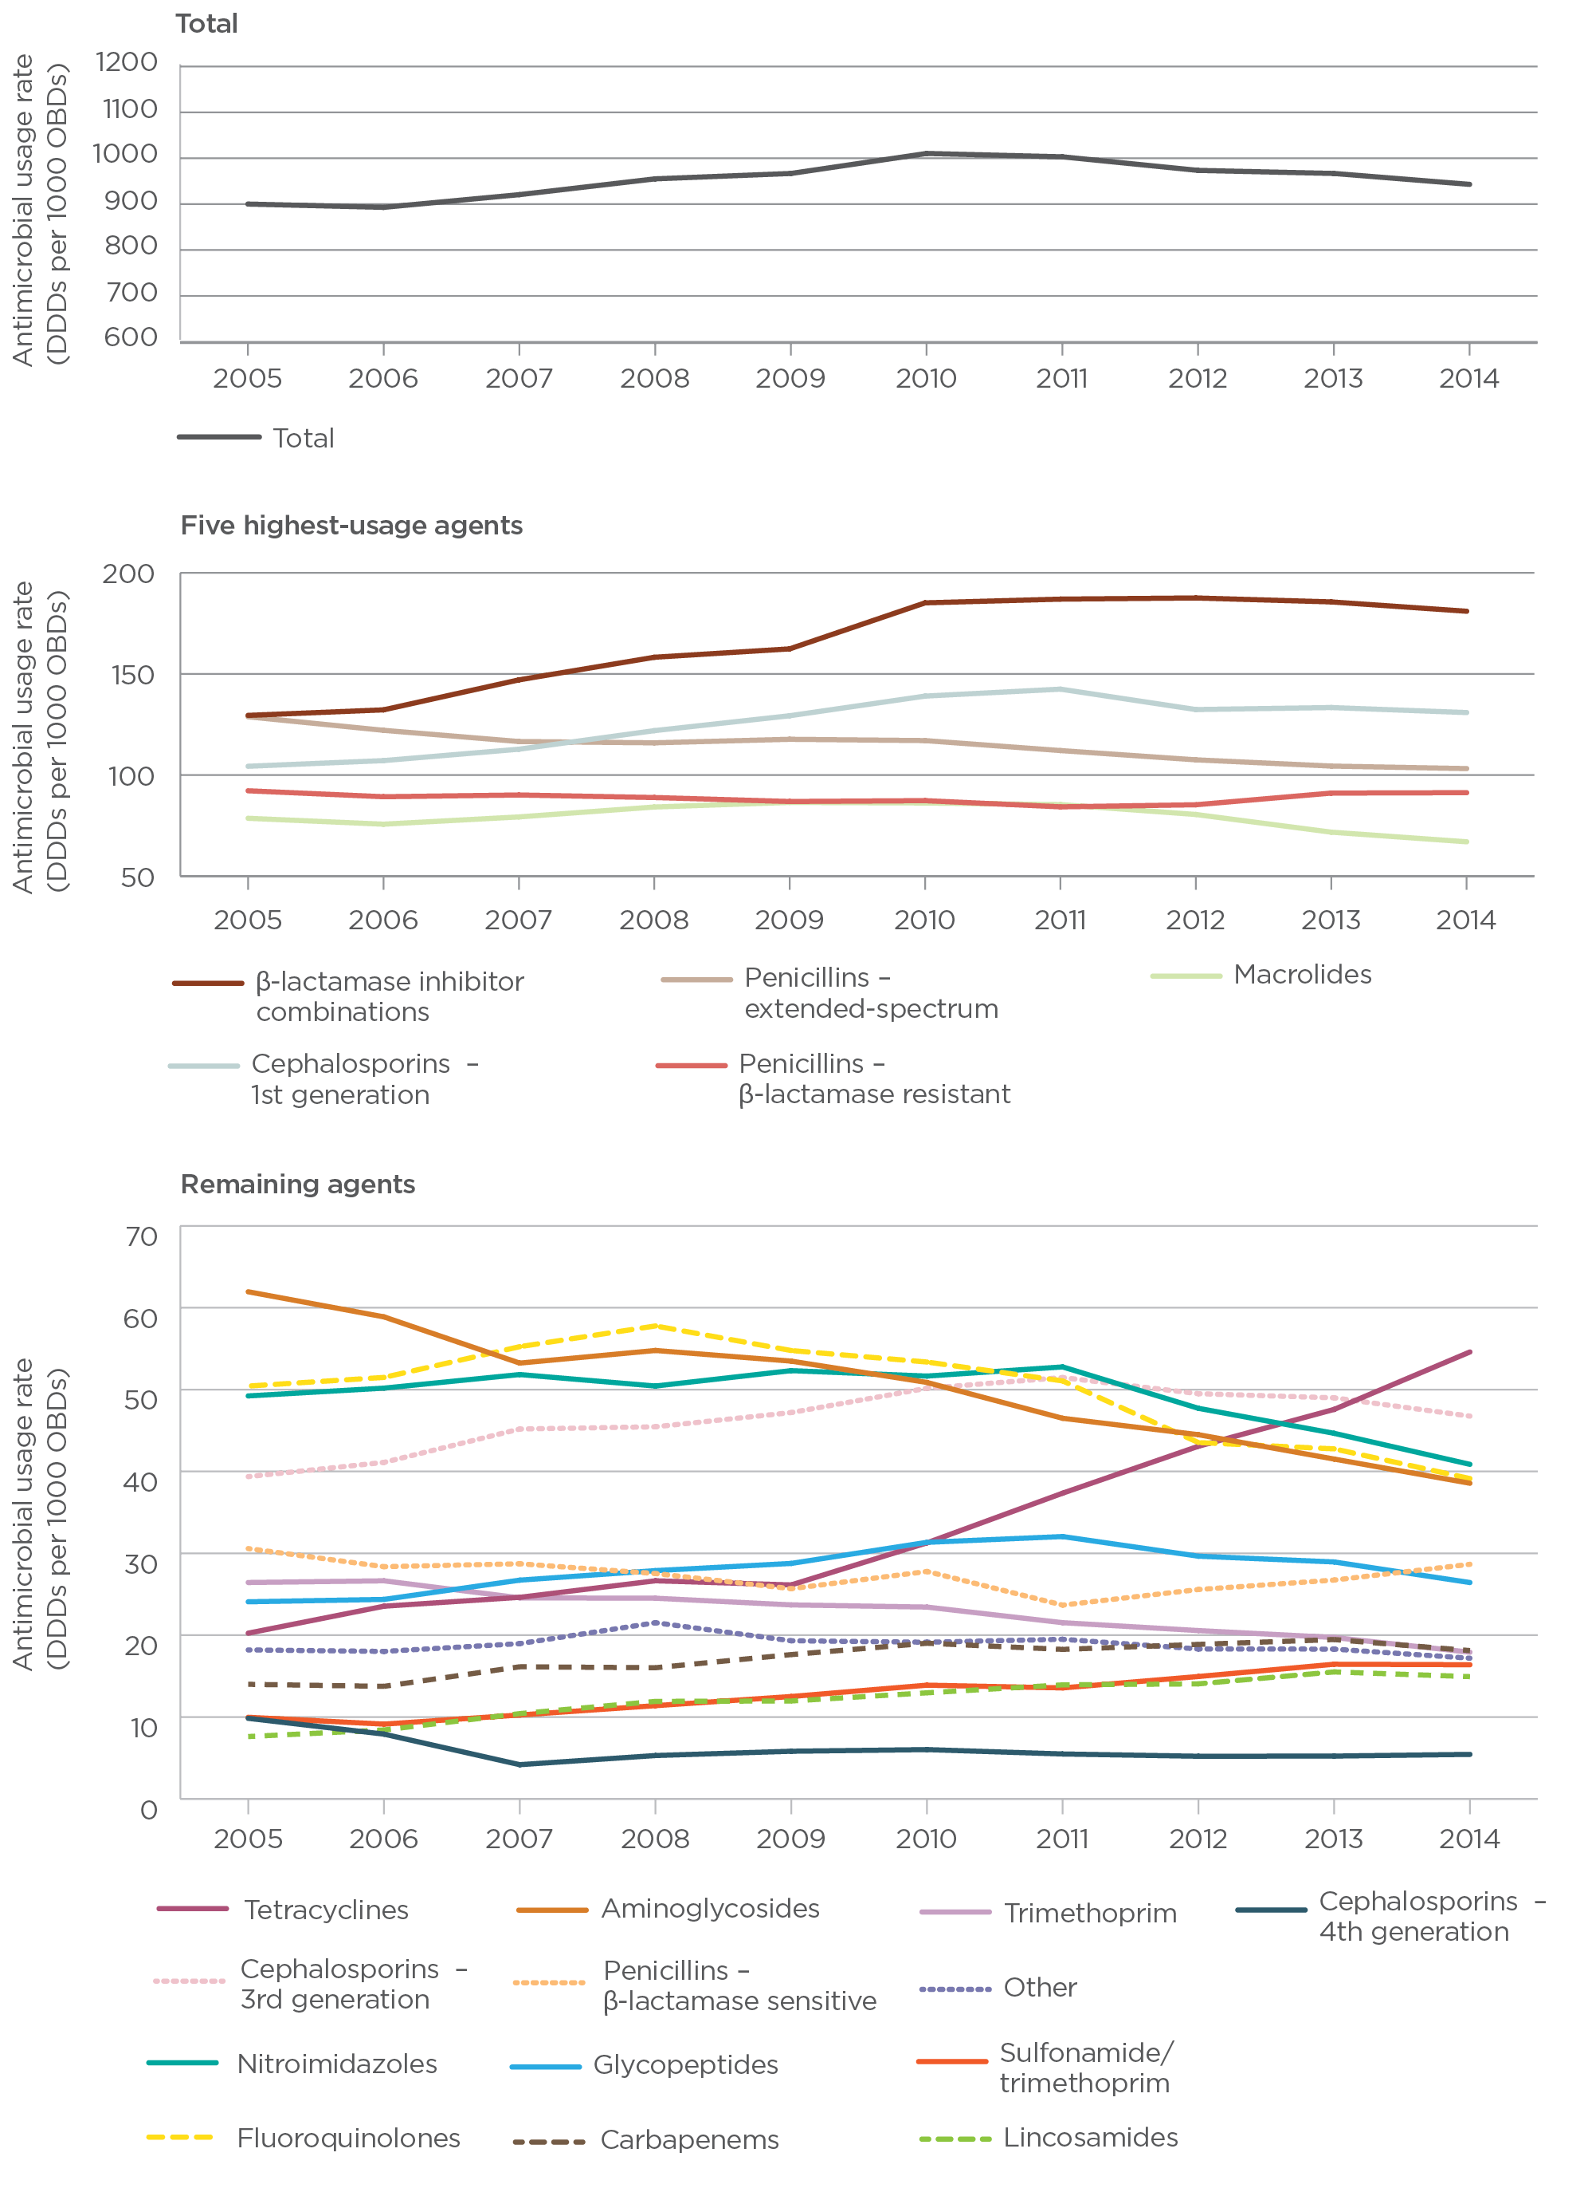

Figure 3 Total-hospital annual antimicrobial use in principal referral hospitals participating in NAUSP, 2005–14

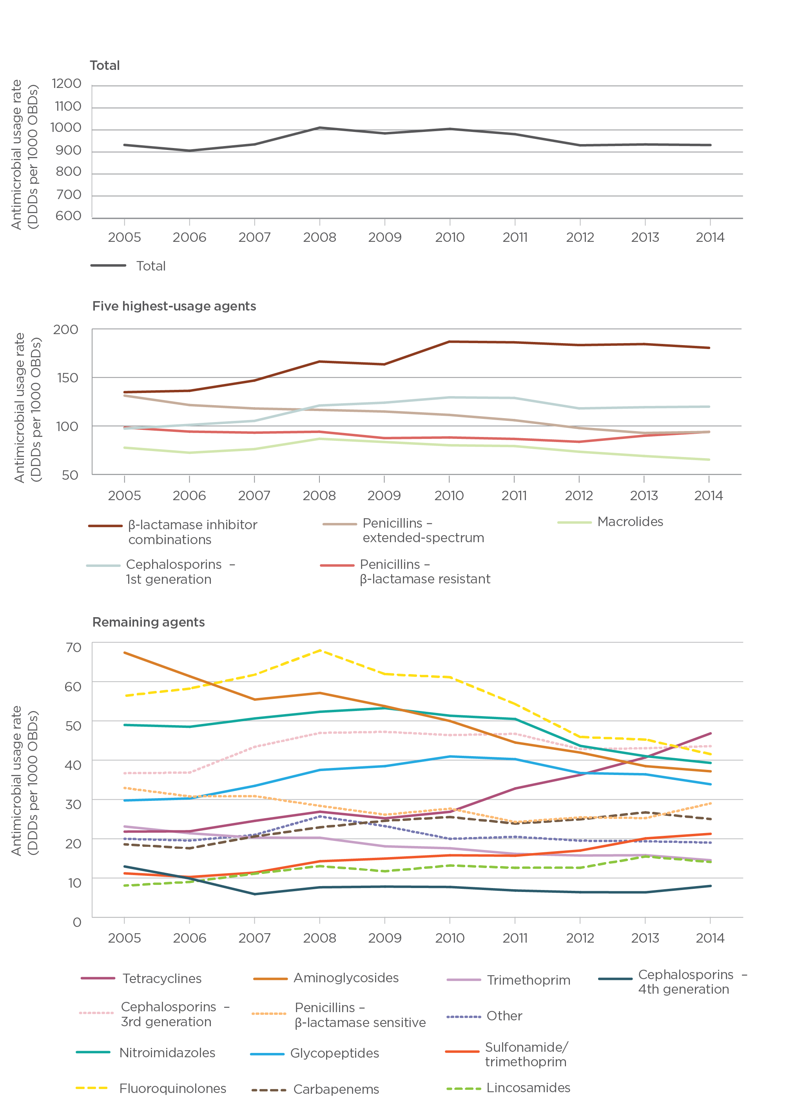

Figure 4 Total-hospital annual antimicrobial use in large public acute hospitals participating in NAUSP, 2005–14

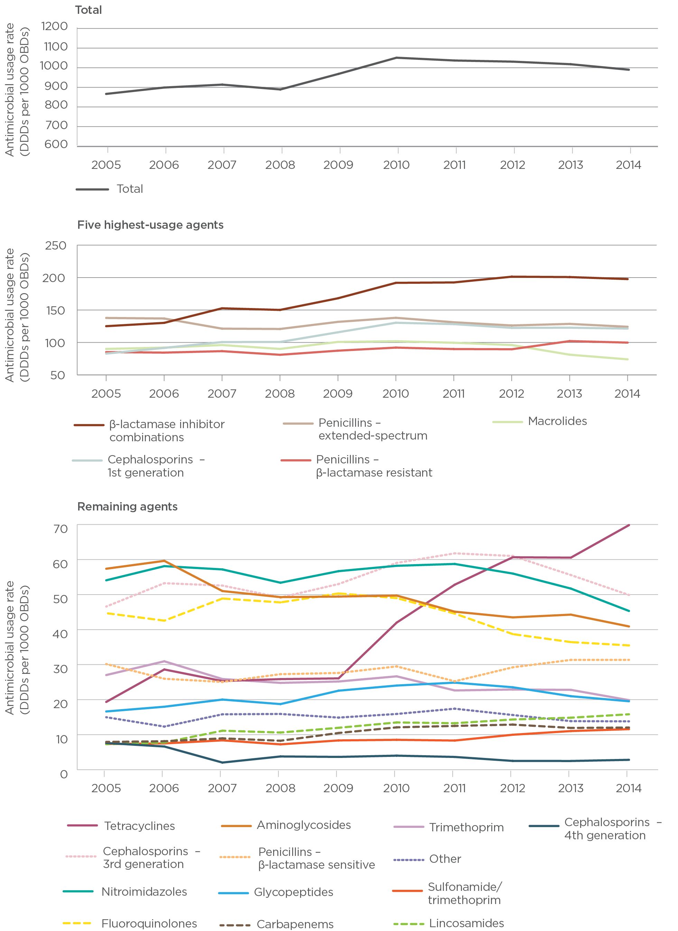

Figure 5 Total-hospital annual antimicrobial use in medium public acute hospitals participating in NAUSP, 2005–14

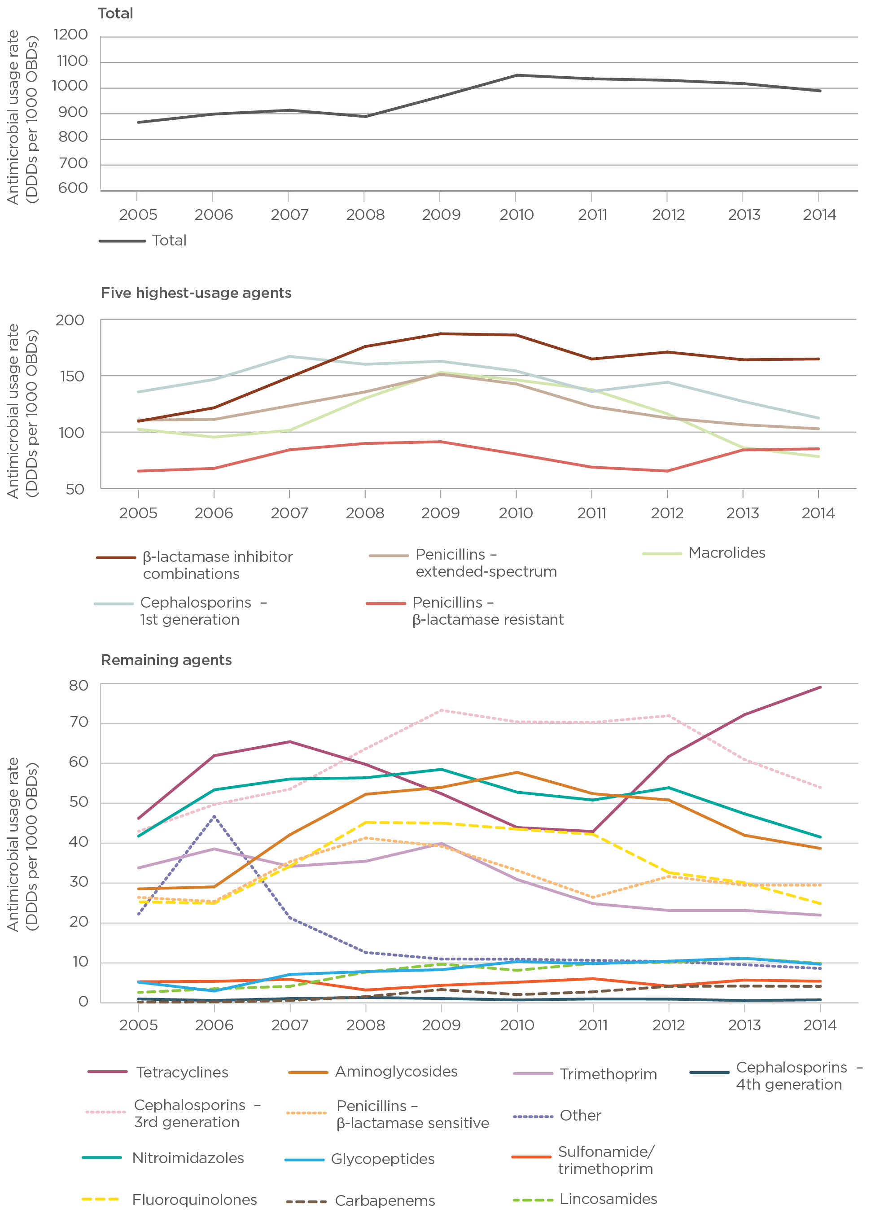

Table 2 Number of contributing hospitals, by year of joining NAUSP and peer group

| Year of joining | Peer group | | |
| --- | --- | --- | --- |
| Principal referral | Large public acute | Medium public acute |
| 2005 | 13 | 8 | 4 |
| 2006 | 15 | 9 | 4 |
| 2007 | 16 | 9 | 5 |
| 2008 | 18 | 12 | 7 |
| 2009 | 18 | 16 | 9 |
| 2010 | 18 | 18 | 9 |
| 2011 | 20 | 22 | 10 |
| 2012 | 25 | 32 | 13 |
| 2013 | 28 | 42 | 24 |
| 2014 | 28 | 51 | 26 |

## Top 20 antibacterials

Twenty agents accounted for 92% of all antibacterials used in Australian hospitals, on a DDDs per 1000 OBDs basis (Figure 6). Six antibacterials – amoxycillin with clavulanic acid, flucloxacillin, cephazolin, amoxycillin, doxycycline and cephalexin – represented more than 50% of antibacterials.

Highly reserved antibacterials accounted for very small percentages of total antibacterial usage – for example, linezolid (0.13%), daptomycin (0.12%) and colistin (0.08%).

These findings are consistent with those from the National Antimicrobial Prescribing Survey (NAPS), which found that ceftriaxone, cephazolin, metronidazole, amoxycillin with clavulanic acid, and piperacillin with tazobactam were the most commonly prescribed antimicrobials. Differences may be due to the timing of surveys under NAPS. Often these surveys occur in October so that the results can be presented during Antibiotic Awareness Week in November (i.e. not during the winter months). In contrast, NAUSP is a continuous data collection program.

Figure 6 Top 20 antibacterials used in Australian hospitals in 2014

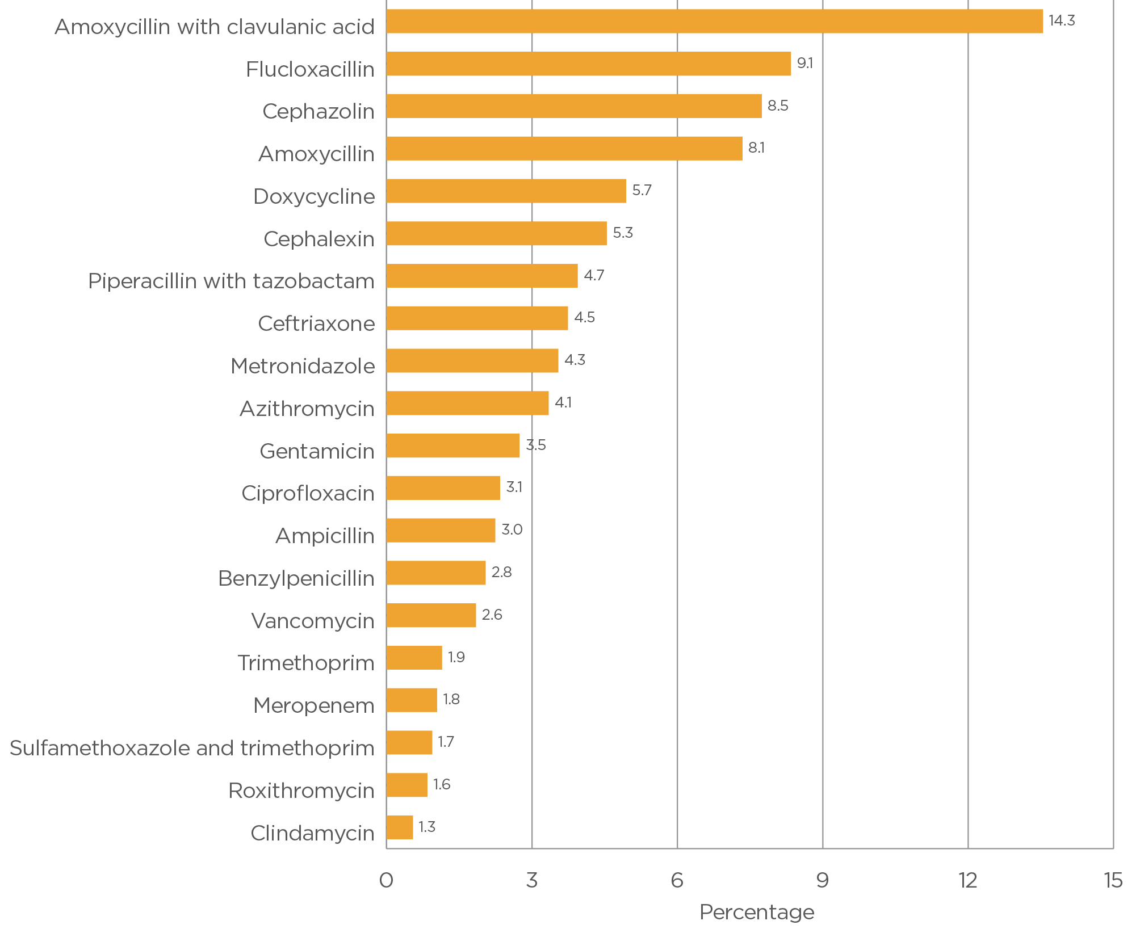

## Comparison of usage rates by state

Aggregated annual total-hospital antibacterial usage rates for NAUSP contributors for 2014 are shown by state in Figure 7.

Table 3 shows annual antibacterial usage rates for 2014 by state and AIHW peer group. These data should be viewed with caution for states in which the number of contributing hospitals is low, meaning that the data are not truly representative.

Figure 7 Overall antimicrobial usage rates, 2014

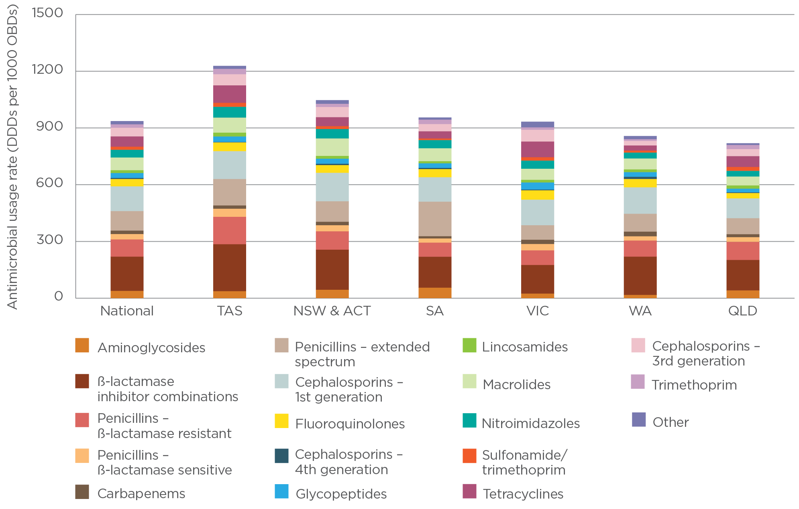

Table 3 Aggregate antibacterial usage rates (DDDs per 1000 OBDs) by jurisdiction and AIHW peer group, 2014

| State or territory | Peer group | | | |
| --- | --- | --- | --- | --- |
| Principal referral | Large public acute | Medium public acute | Small public acute |
| NSW and ACT | 979.8 | 1150.1 | 1078.8 | na |
| Qld | 768.4 | 869 | 693.4 | na |
| SA | 1050.6 | 975.5 | 894.1 | 819.1 |
| Tas | 1182.4 | 1382.2 | 1345.1 | na |
| Vic | 939.2 | 1004.2 | 779.1 | na |
| WA | 971.6 | 712.2 | 873.6 | 373.4 |

na = not available

Note: Private hospitals and specialist women’s hospitals are not included.

## Intrastate usage rates

For the purposes of this report, individual hospitals are not identifiable; each NAUSP contributor has been allocated an alphanumeric code. The following sections illustrate comparative usage rates at individual hospitals by state.

### New South Wales and Australian Capital Territory

New South Wales has the greatest number of contributors to NAUSP, with 11 principal referral, 21 large public acute and 10 medium acute hospitals. One hospital in the Australian Capital Territory is included in the New South Wales cohort.

During 2014, the mean New South Wales and Australian Capital Territory total-hospital antimicrobial usage rate was 1092 DDDs per 1000 OBDs (range 566–2040; median 1005) (Figure 8).

Figure 8 Total-hospital antimicrobial use, New South Wales and Australian Capital Territory, 2014

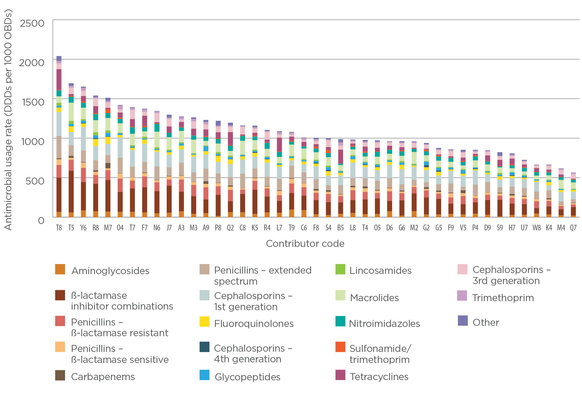

### Queensland

Queensland’s 29 hospitals contributing to NAUSP comprise 5 principal referral, 1 specialist women’s, 12 large public acute, 5 medium acute and 6 private facilities. During 2014, the mean Queensland total-hospital antimicrobial usage rate was 848 DDDs per 1000 OBDs (range 330–1412; median 822) (Figure 9).

Figure 9 Total-hospital antimicrobial use, Queensland, 2014

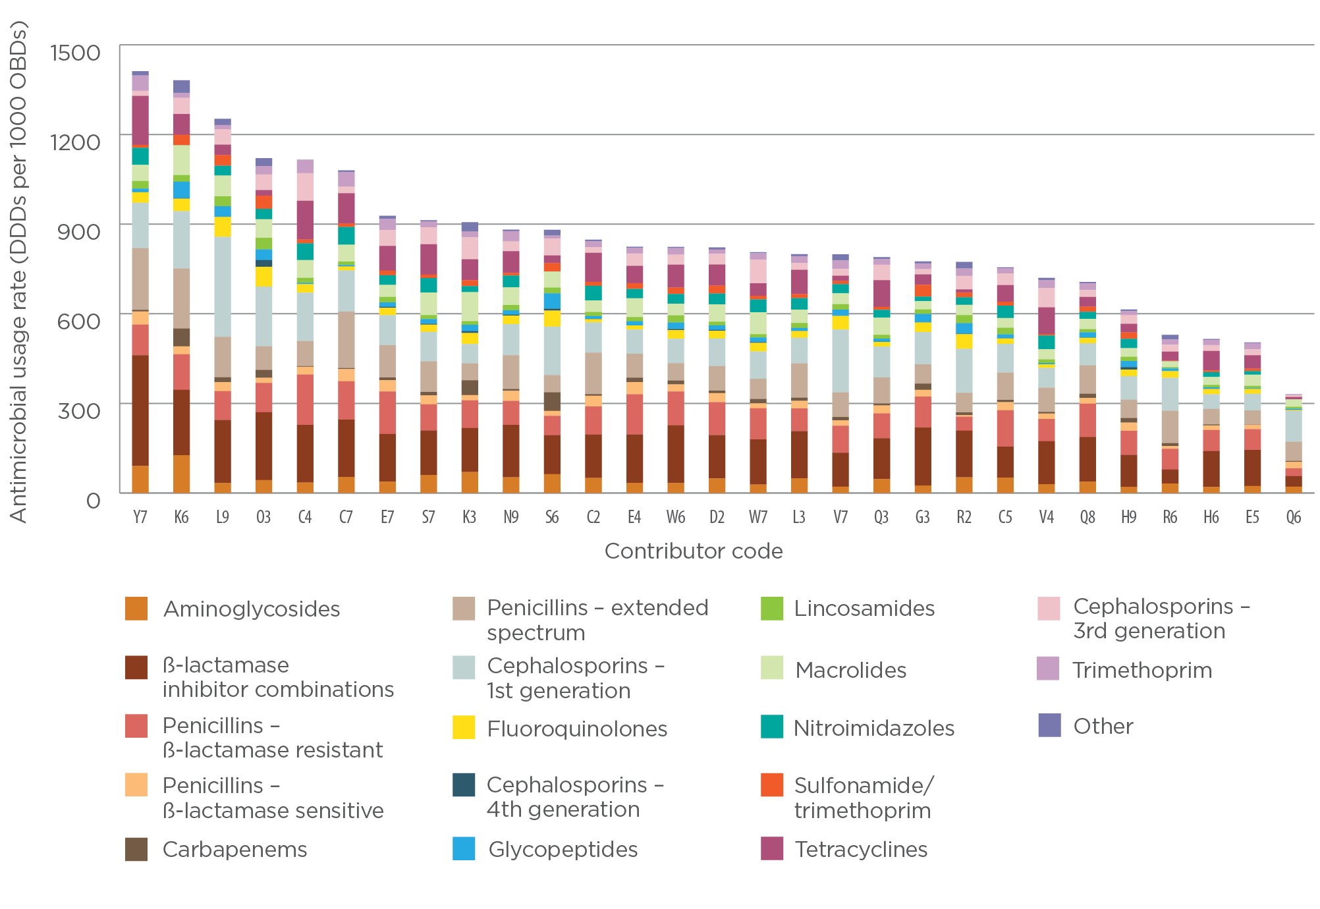

### South Australia

Hospitals contributing to NAUSP in South Australia comprise 2 principal referral, 4 large public acute, 4 medium public acute, 3 small public acute and 6 private facilities. During 2014, the mean South Australian total-hospital antimicrobial usage rate was 892 DDDs per 1000 OBDs (range 458–1300; median 880) (Figure 10).

Figure 10 Total-hospital antimicrobial use, South Australia, 2014

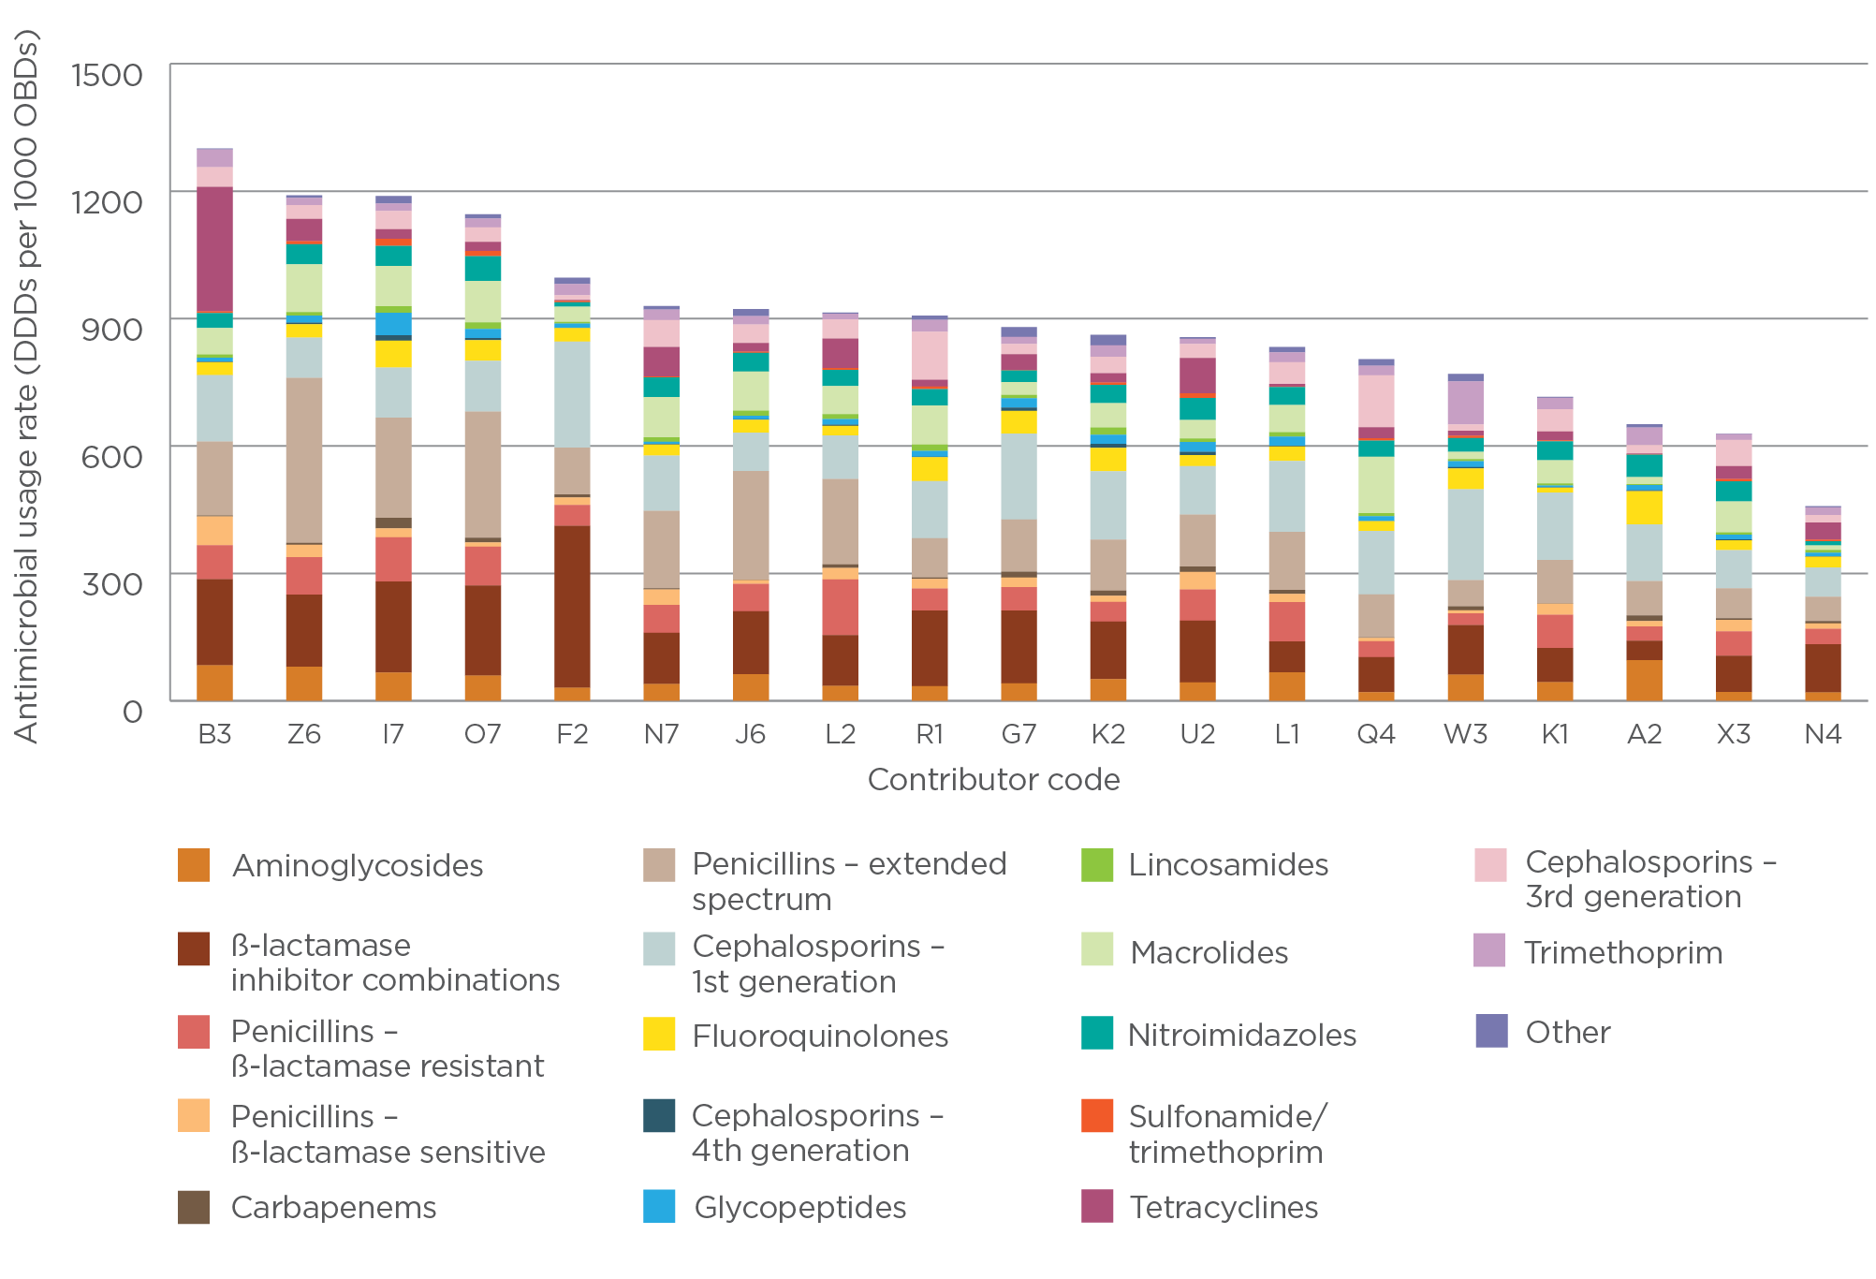

### Tasmania

In Tasmania, 1 principal referral, 2 large public acute, 1 medium public acute and 1 private hospitals contribute to NAUSP. During 2014, the mean total-hospital antimicrobial usage rate was 1242 DDDs per 1000 OBDs (range 792–1552; median 1336) (Figure 11).

Figure 11 Total-hospital antimicrobial use, Tasmania, 2014

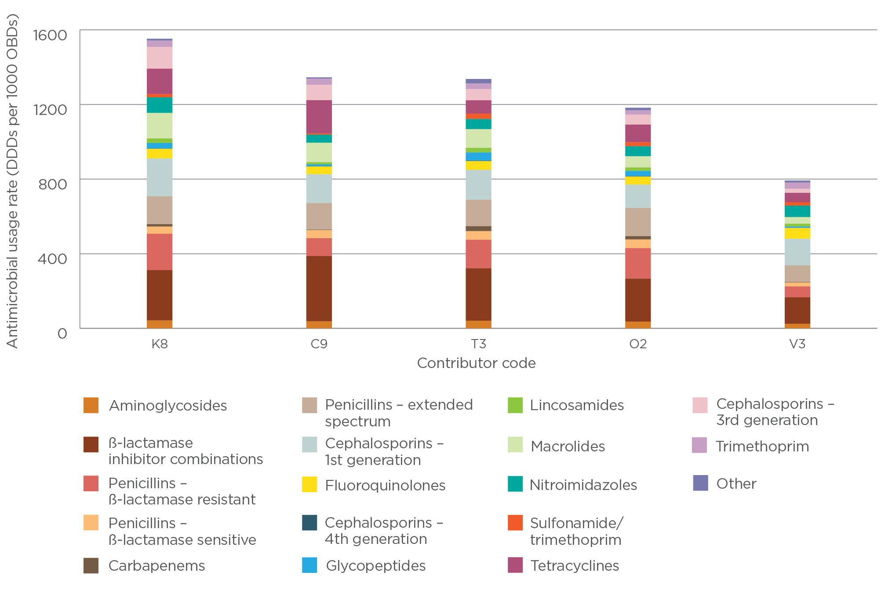

### Victoria

In Victoria, 6 principal referral, 8 large public acute, 5 medium public acute and 4 private hospitals contribute to NAUSP. During 2014, the mean total-hospital antimicrobial usage rate was 940 DDDs per 1000 OBDs (range 544–1552; median 887) (Figure 12).

Figure 12 Total-hospital antimicrobial use, Victoria, 2014

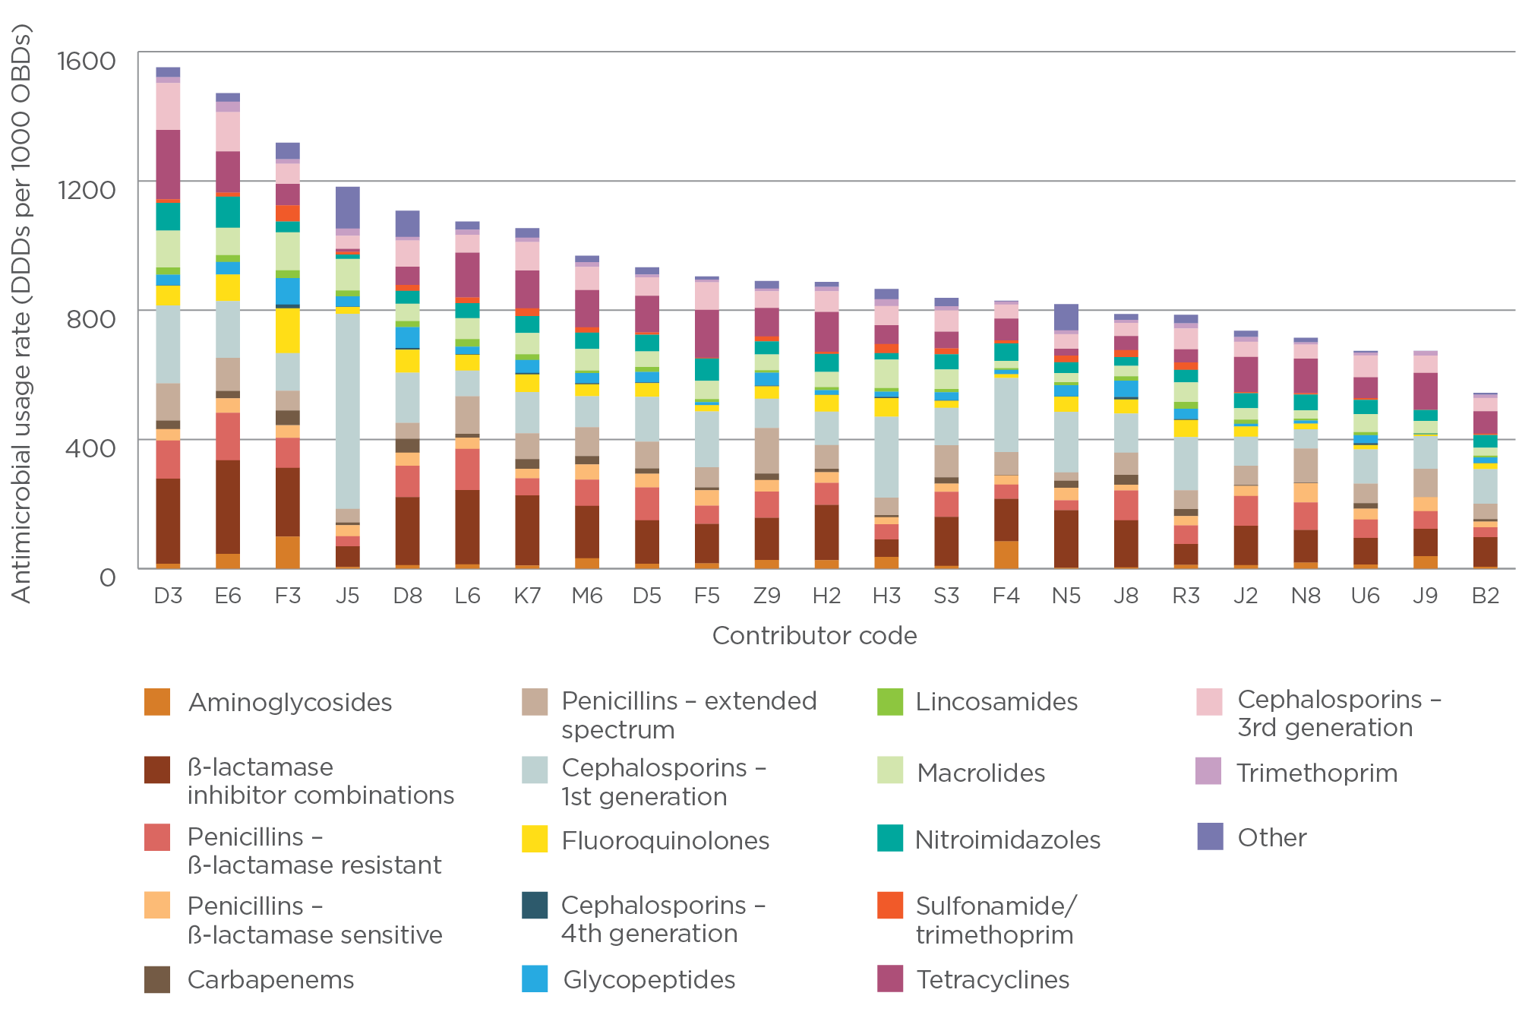

### Western Australia

Western Australia has 10 hospitals contributing to NAUSP, comprising 2 principal referral, 1 specialist women’s, 4 large public acute, 1 medium public acute, 1 small public acute and 1 private facility. During 2014, the mean Western Australian total-hospital usage rate was 812 DDDs per 1000 OBDs (range 373–1168; median 812) (Figure 13).

Figure 13 Total-hospital antimicrobial use, Western Australia, 2014

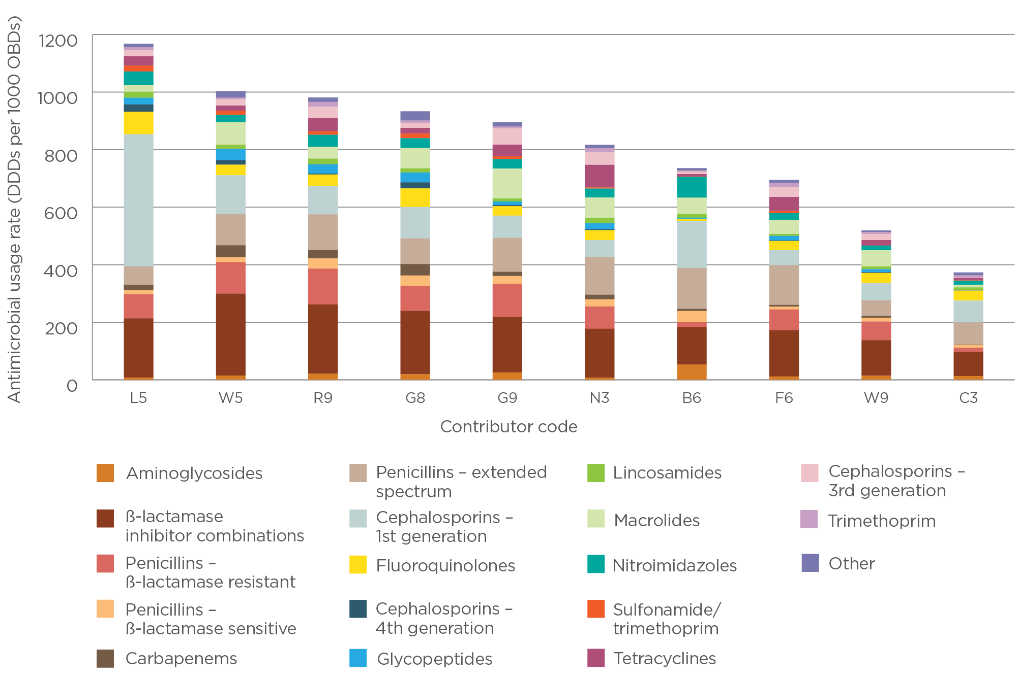

# Annual usage rates by antimicrobial class, 2010–14

Antimicrobial classes are categorised in Table 4 and Figures 14–20 into therapeutic groups using the WHO Anatomical Therapeutic Classification system (Appendix 3).

Aggregation of NAUSP data into therapeutic groups allows:

assessment of the relative use of particular classes of antimicrobials

comparisons between contributing hospitals of pooled class-specific antimicrobial usage rates

benchmarking with usage data from similar studies.

Changes in antimicrobial usage rates with time may occur as a result of several factors. Modifications in prescribing practice with evolving clinical practice and establishment of AMS practices will be responsible for most of the change. Another factor, which may not directly affect the ‘antibiotic burden’, is the change in length of inpatient stay, particularly for acute hospital admissions, where shorter inpatient stays are becoming more common. Changes may also reflect simple variations in WHO-defined DDDs and the doses currently used in clinical practice.

## Total-hospital usage rates for antibacterial classes

Annual usage rate data from NAUSP contributors, aggregated by year and therapeutic group, for the five years to December 2014 demonstrate continuing decreases in usage rates for aminoglycosides, fluoroquinolones, macrolides, nitroimidazoles (metronidazole) and fusidic acid. In contrast, consistent (although often small) increases in aggregated annual usage rates were observed for ‘other antibacterials’ (daptomycin and linezolid), sulfamethoxazole with trimethoprim, and tetracyclines (Table 4).

Table 4 Total-hospital antibacterial usage rates (DDDs per 1000 OBDs) by antibacterial group, 2010–14

| Antibiotic class | 2010 (**n** = 53) | 2011 (**n** = 61) | 2012 (**n** = 79) | 2013 (**n** = 114) | 2014 (**n** = 129) |
| --- | --- | --- | --- | --- | --- |
| Aminoglycosides | 50.87 | 46.50 | 44.49 | 41.52 | 38.45 |
| Amphenicols | 0.01 | 0.00 | 0.00 | 0.00 | 0.00 |
| β-lactamase inhibitor combinations | 185.15 | 186.99 | 187.57 | 186.82 | 180.70 |
| β-lactamase-resistant penicillins | 87.35 | 84.27 | 85.30 | 91.29 | 91.03 |
| β-lactamase-sensitive penicillins | 27.78 | 23.68 | 25.58 | 26.74 | 28.66 |
| Carbapenems | 19.02 | 18.27 | 18.88 | 19.49 | 17.79 |
| Extended-spectrum penicillins | 117.04 | 112.10 | 107.52 | 104.83 | 103.39 |
| First-generation cephalosporins | 139.04 | 142.48 | 132.39 | 133.66 | 130.90 |
| Fluoroquinolones | 53.37 | 51.06 | 43.53 | 42.90 | 39.21 |
| Fourth-generation cephalosporins | 6.03 | 5.49 | 5.21 | 5.24 | 5.50 |
| Glycopeptides | 31.34 | 32.05 | 29.65 | 28.95 | 26.01 |
| Lincosamides | 12.96 | 13.93 | 14.06 | 15.59 | 14.93 |
| Macrolides | 86.17 | 85.38 | 80.49 | 71.81 | 67.13 |
| Monobactams | 0.20 | 0.18 | 0.36 | 0.42 | 0.45 |
| Nitrofurans | 1.23 | 1.11 | 0.87 | 0.88 | 0.81 |
| Nitroimidazoles | 51.65 | 52.77 | 47.71 | 44.76 | 40.80 |
| Other antibacterials (daptomycin + linezolid) | 1.56 | 1.16 | 2.18 | 2.40 | 2.38 |
| Other cephalosporins and penems (ceftaroline) | 0.00 | 0.00 | 0.00 | 0.04 | 0.05 |
| Polymyxins | 0.43 | 0.58 | 0.63 | 0.81 | 0.77 |
| Rifamycins | 7.74 | 7.84 | 6.38 | 5.99 | 5.06 |
| Second-generation cephalosporins | 5.39 | 5.83 | 5.41 | 5.55 | 5.75 |
| Steroids | 2.42 | 2.33 | 1.93 | 1.61 | 1.34 |
| Streptogramins | 0.13 | 0.42 | 0.54 | 0.51 | 0.51 |
| Streptomycins | 0.03 | 0.05 | 0.01 | 0.01 | 0.00 |
| Sulfonamide/trimethoprim combinations | 13.90 | 13.56 | 14.95 | 16.62 | 16.18 |
| Tetracyclines | 31.28 | 37.35 | 43.08 | 47.96 | 54.34 |
| Third-generation cephalosporins | 50.17 | 51.47 | 49.50 | 48.99 | 46.17 |
| Trimethoprim | 23.44 | 21.53 | 20.57 | 19.75 | 18.00 |
| **Total** | **1005.70** | **998.38** | **968.79** | **965.14** | **936.31** |

Note: Figures may vary slightly from previous reports as a result of retrospective data adjustments.

# Antimicrobial usage rates by individual agent, 2014

This section shows usage rates of individual antimicrobial agents, demonstrating trends over the past five years.

## Aminoglycosides – amikacin, gentamicin, tobramycin

Gentamicin is the most commonly used aminoglycoside in Australia. Usage rates have steadily decreased over the past five years in all Australian states (Figure 14). Amikacin and tobramycin usage rates remain low compared with gentamicin rates. Higher usage rates of tobramycin appear to be confined to larger hospitals with referral services for cystic fibrosis patients.

Figure 14 Aminoglycoside usage rates, 2010–14 (3-month moving average)

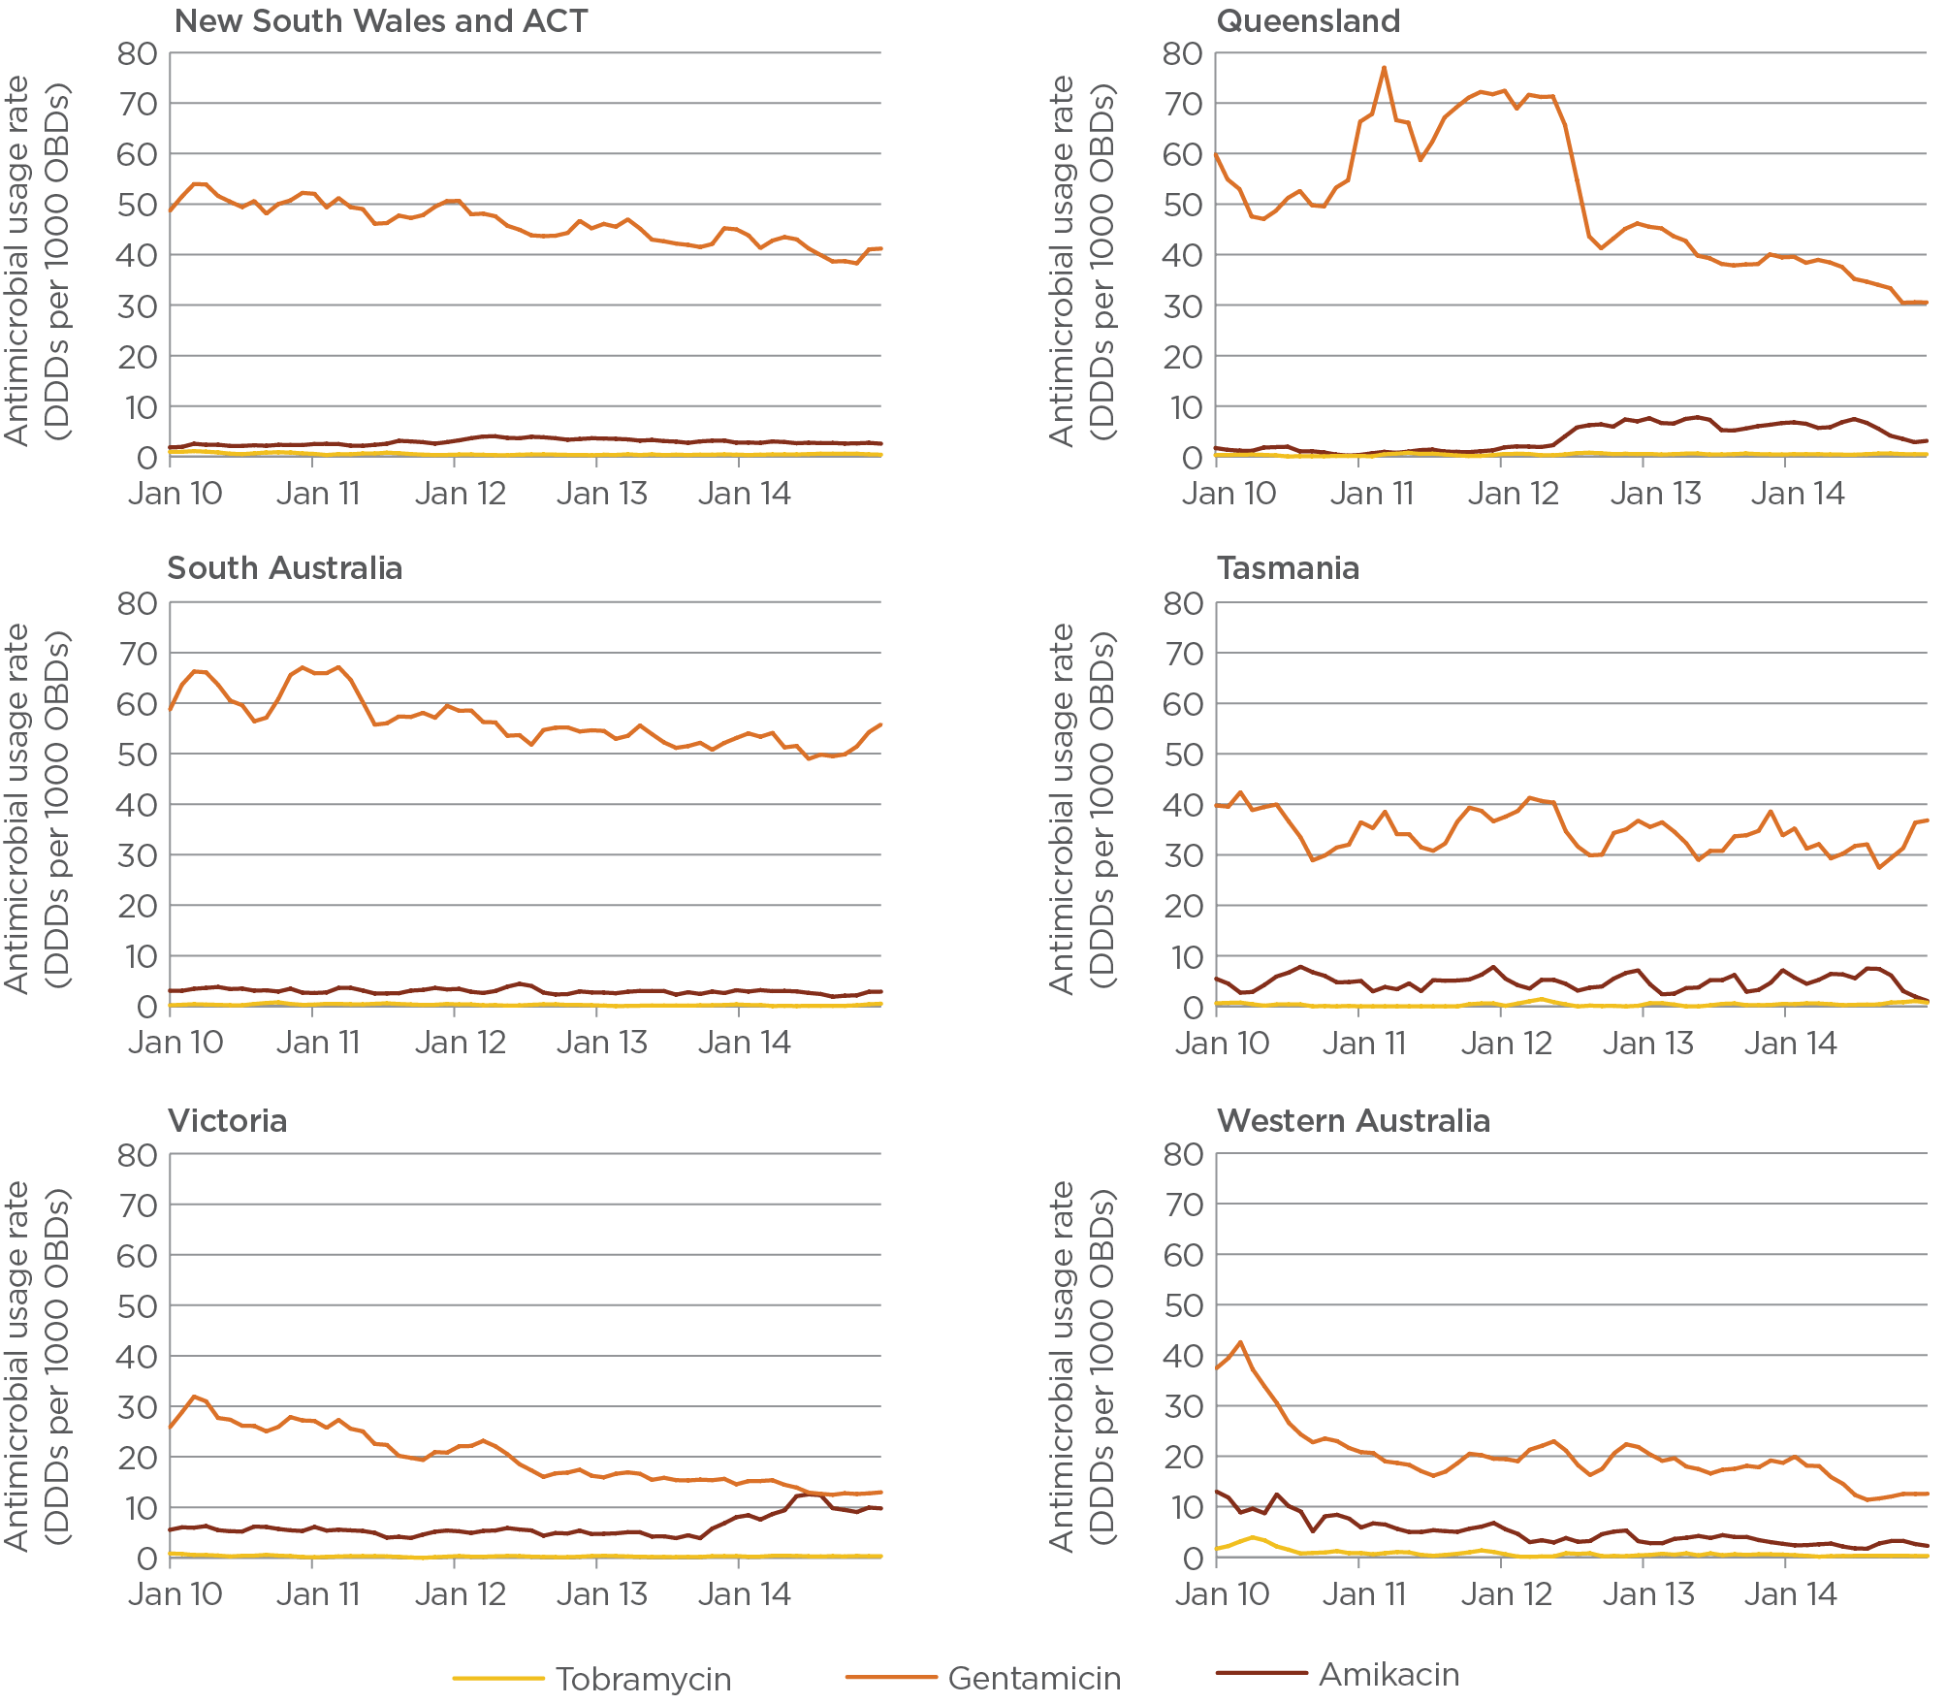

Note: Tobramycin usage rates include inhaled formulations.

## Carbapenems – doripenem, ertapenem, imipenem, meropenem

Meropenem is the dominant carbapenem used in Australian hospitals. It has become a key reserve-line antibacterial with the increasing incidence of infections with extended-spectrum β-lactamase-producing microorganisms.

Usage rates of other carbapenems are low, and possibly influenced by prescribing preferences in particular hospitals (Figure 15).

Figure 15 Carbapenem usage rates, 2010–14 (3-month moving average)

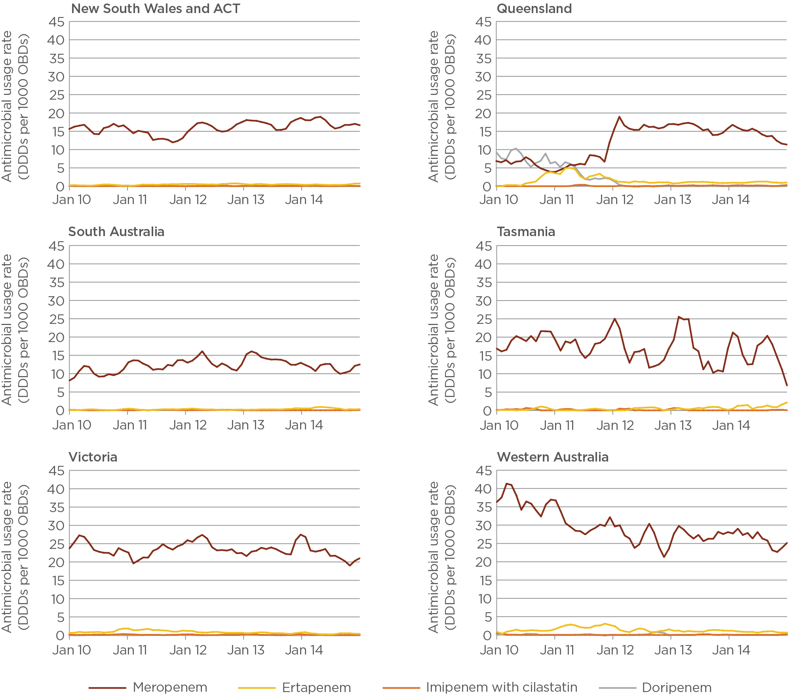

Note: No doripenem use was recorded in South Australia or Tasmania.

## Third- and fourth-generation cephalosporins – ceftriaxone, cefotaxime, ceftazidime, cefepime

Figure 16 shows the usage rates of third- and fourth-generation cephalosporins (ceftriaxone, cefotaxime, ceftazidime, cefepime) over the past five years.

Ceftriaxone, a third-generation cephalosporin, shows a pattern of seasonal use, reflecting its role in the treatment of lower respiratory infections.

Figure 16 Cephalosporin usage rates, 2010–14 (3-month moving average)

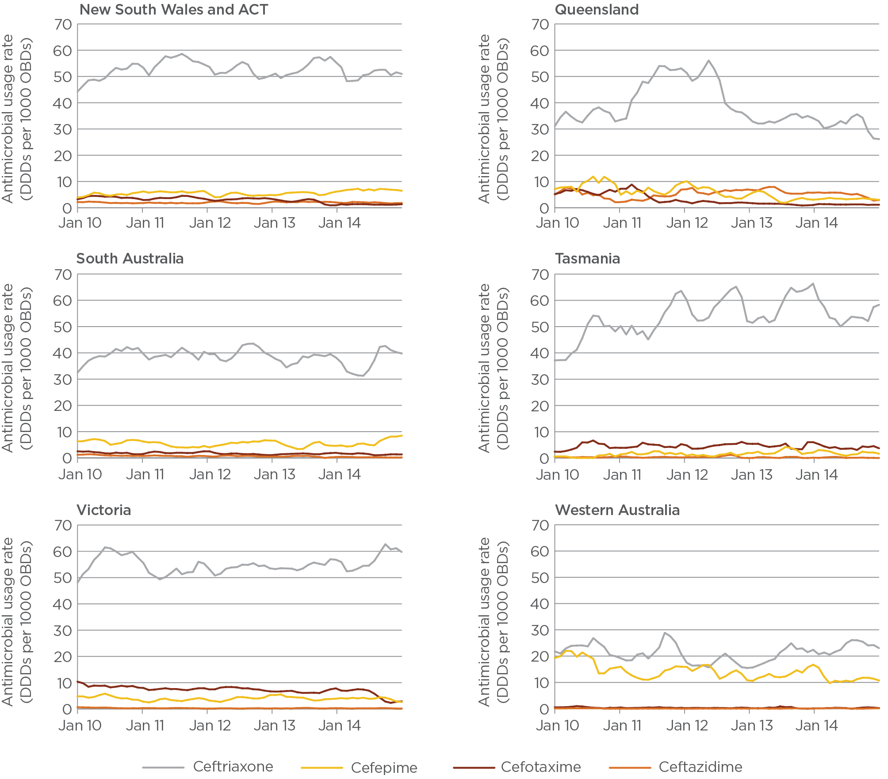

## Fluoroquinolones – ciprofloxacin, norfloxacin, moxifloxacin

Fluoroquinolone usage rates appear to have trended downwards since 2010 (Figure 17).

Ciprofloxacin is the most frequently used fluoroquinolone. Usage rates of norfloxacin and moxifloxacin have remained relatively constant.

Figure 17 Fluoroquinolone usage rates, 2010–14 (3-month moving average)

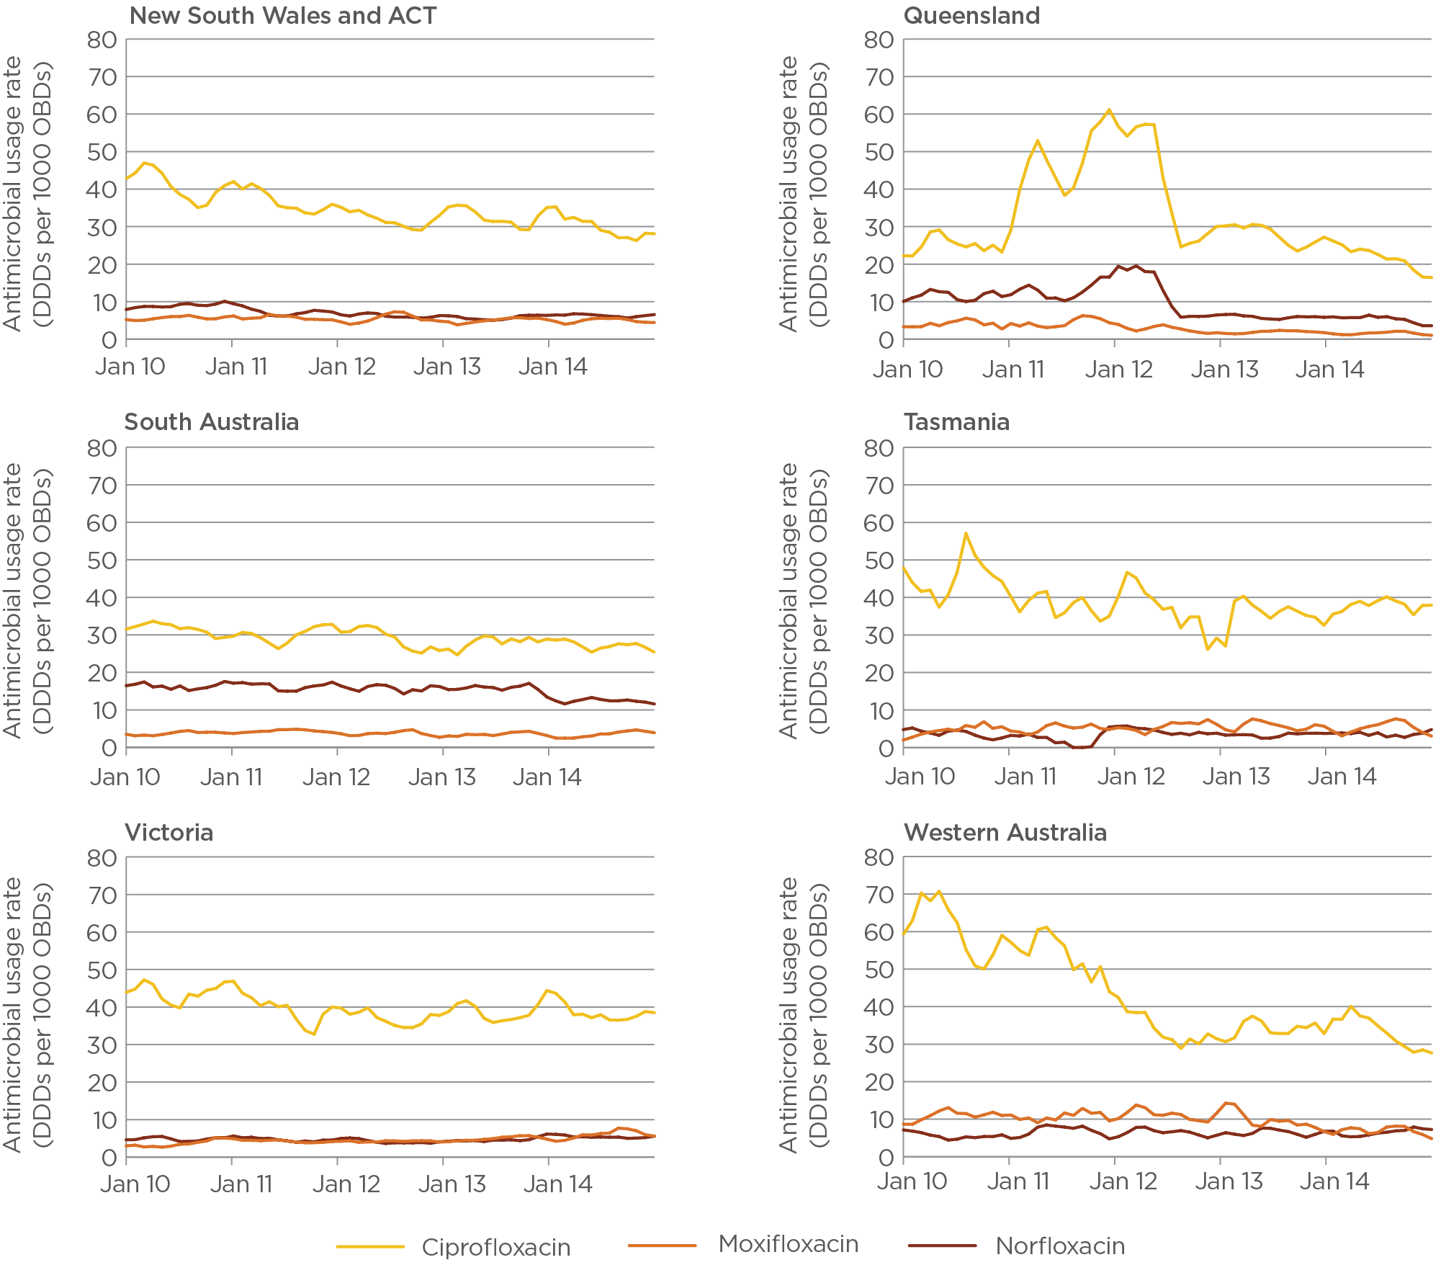

From a medium-sized private hospital:

‘We conducted an in-house audit to assess appropriate use’

NAUSP reporting showed that oral ciprofloxacin and norfloxacin were regularly being used more than the national comparator average in a medium-sized metropolitan hospital. In-house audits were conducted to assess appropriate use, with the following outcomes:

The AMS committee was able to address specific prescribers and highlight inappropriate use.

The reporting of urinary tract infection pathology results was altered to offer norfloxacin as a sensitive antibacterial only if the specimen was resistant to other first-line antibacterials.

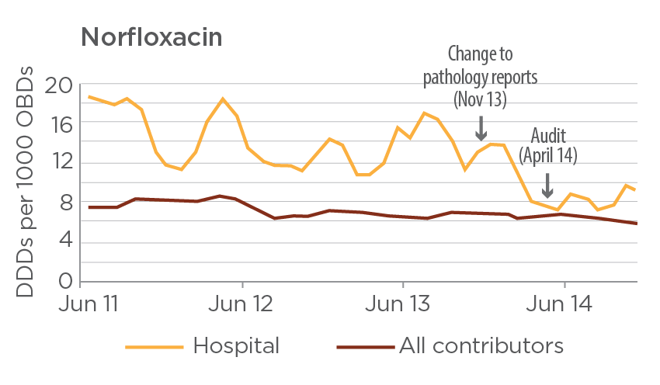

## Glycopeptides – vancomycin, teicoplanin

Vancomycin and teicoplanin are the only glycopeptides available in Australia. Since 2010, aggregated vancomycin usage rates have decreased (Figure 18). Although aggregate monthly teicoplanin use remains low (five-year mean 1.7 DDDs per 1000 OBDs), large variations in usage rates occur between hospitals.

Figure 18 Glycopeptide usage rates, 2010–14 (3-month moving average)

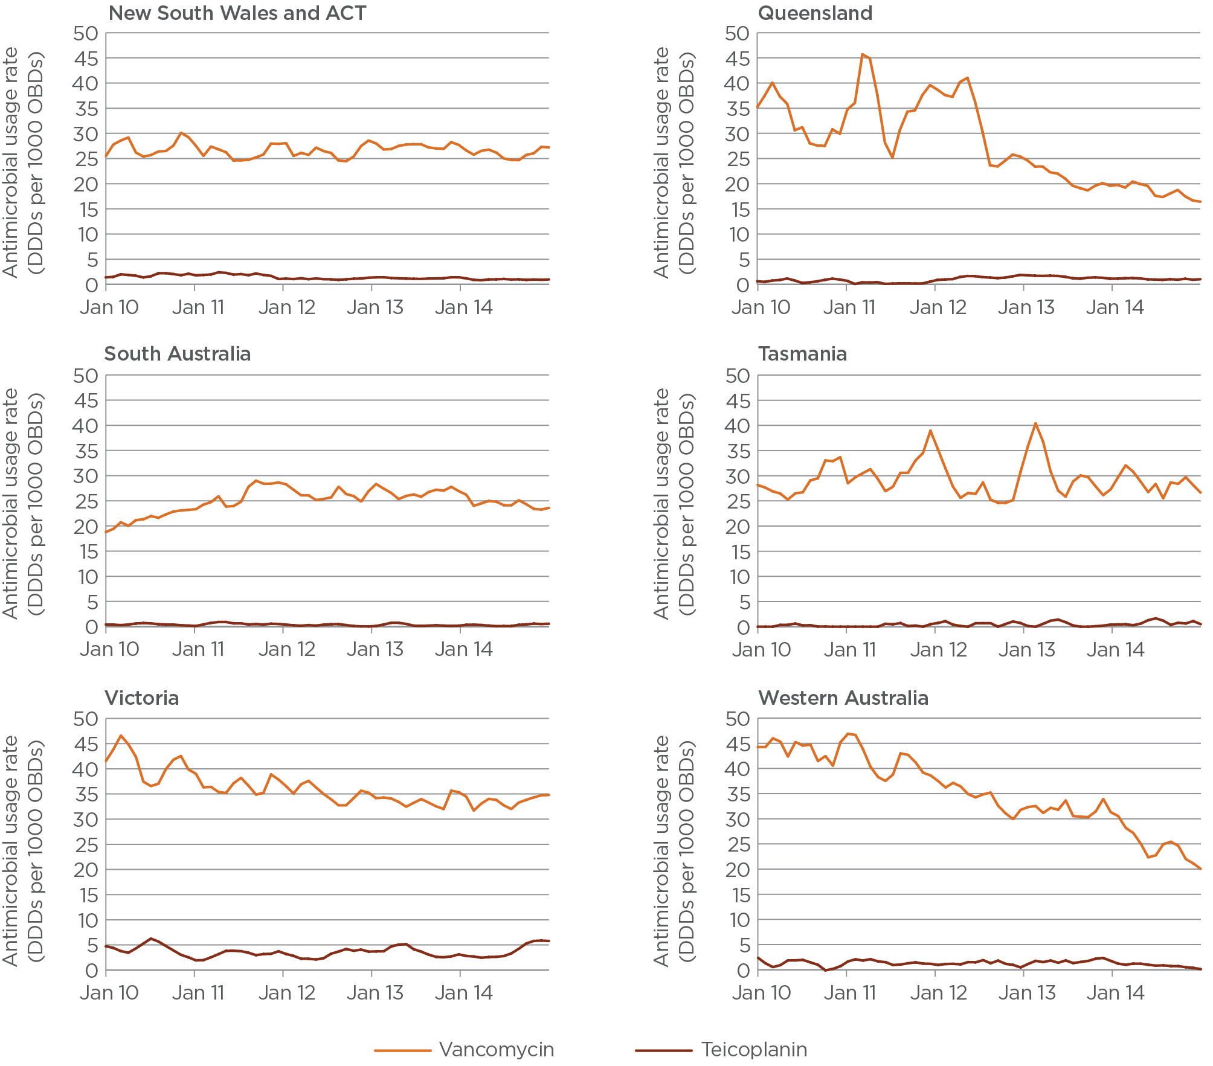

## Macrolides – azithromycin, clarithromycin, erythromycin, roxithromycin

Marked seasonal variation is evident in the monthly usage rates for both azithromycin and roxithromycin, with maximum use occurring in the winter months (Figure 19). Large variations in usage rates occur between individual hospitals; this may be related to differing patterns of prescribing for the treatment of community-acquired pneumonia.

Macrolide usage rates are influenced by an anomaly in the WHO DDD for parenteral erythromycin, where the allocated DDD of 1 gram (Appendix 3) is much lower than clinical doses, resulting in an exaggerated use of this antibacterial. In addition, the proportion of erythromycin used as a gastric motility agent rather than an antimicrobial agent remains unknown. Azithromycin is now the dominant macrolide used in Australian hospitals.

Figure 19 Macrolide usage rates, 2010–14 (3-month moving average)

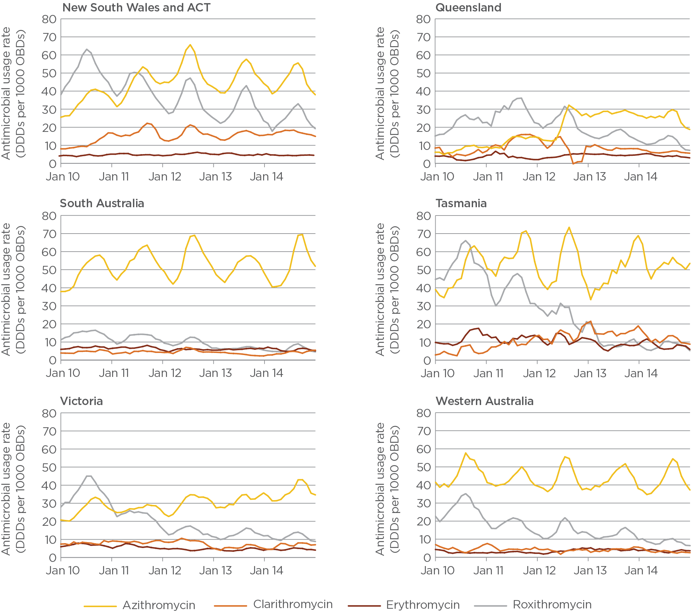

## Penicillins – penicillin/ß-lactamase inhibitor combinations: ticarcillin with clavulanate, piperacillin with tazobactam, amoxycillin with clavulanic acid

Usage rates of two antipseudomonal penicillin/β-lactamase inhibitor combinations (ticarcillin with clavulanate and piperacillin with tazobactam) increased steadily until 2010. Since then, a drop in use of ticarcillin with clavulanate has been accompanied by an increase in use of piperacillin with tazobactam (Figure 20). A possible explanation is the decreased cost of piperacillin with tazobactam as generic formulations became available. The anaerobic spectrum of piperacillin with tazobactam makes it suitable for use in critically ill patients, including those with polymicrobial abdominal infections. A reduction in the use of metronidazole (a nitroimidazole) (Table 4) has accompanied the increase in use of piperacillin with tazobactam.

Figure 20 Penicillin/ß-lactamase inhibitor combination usage rates, 2010–14 (3-month moving average)

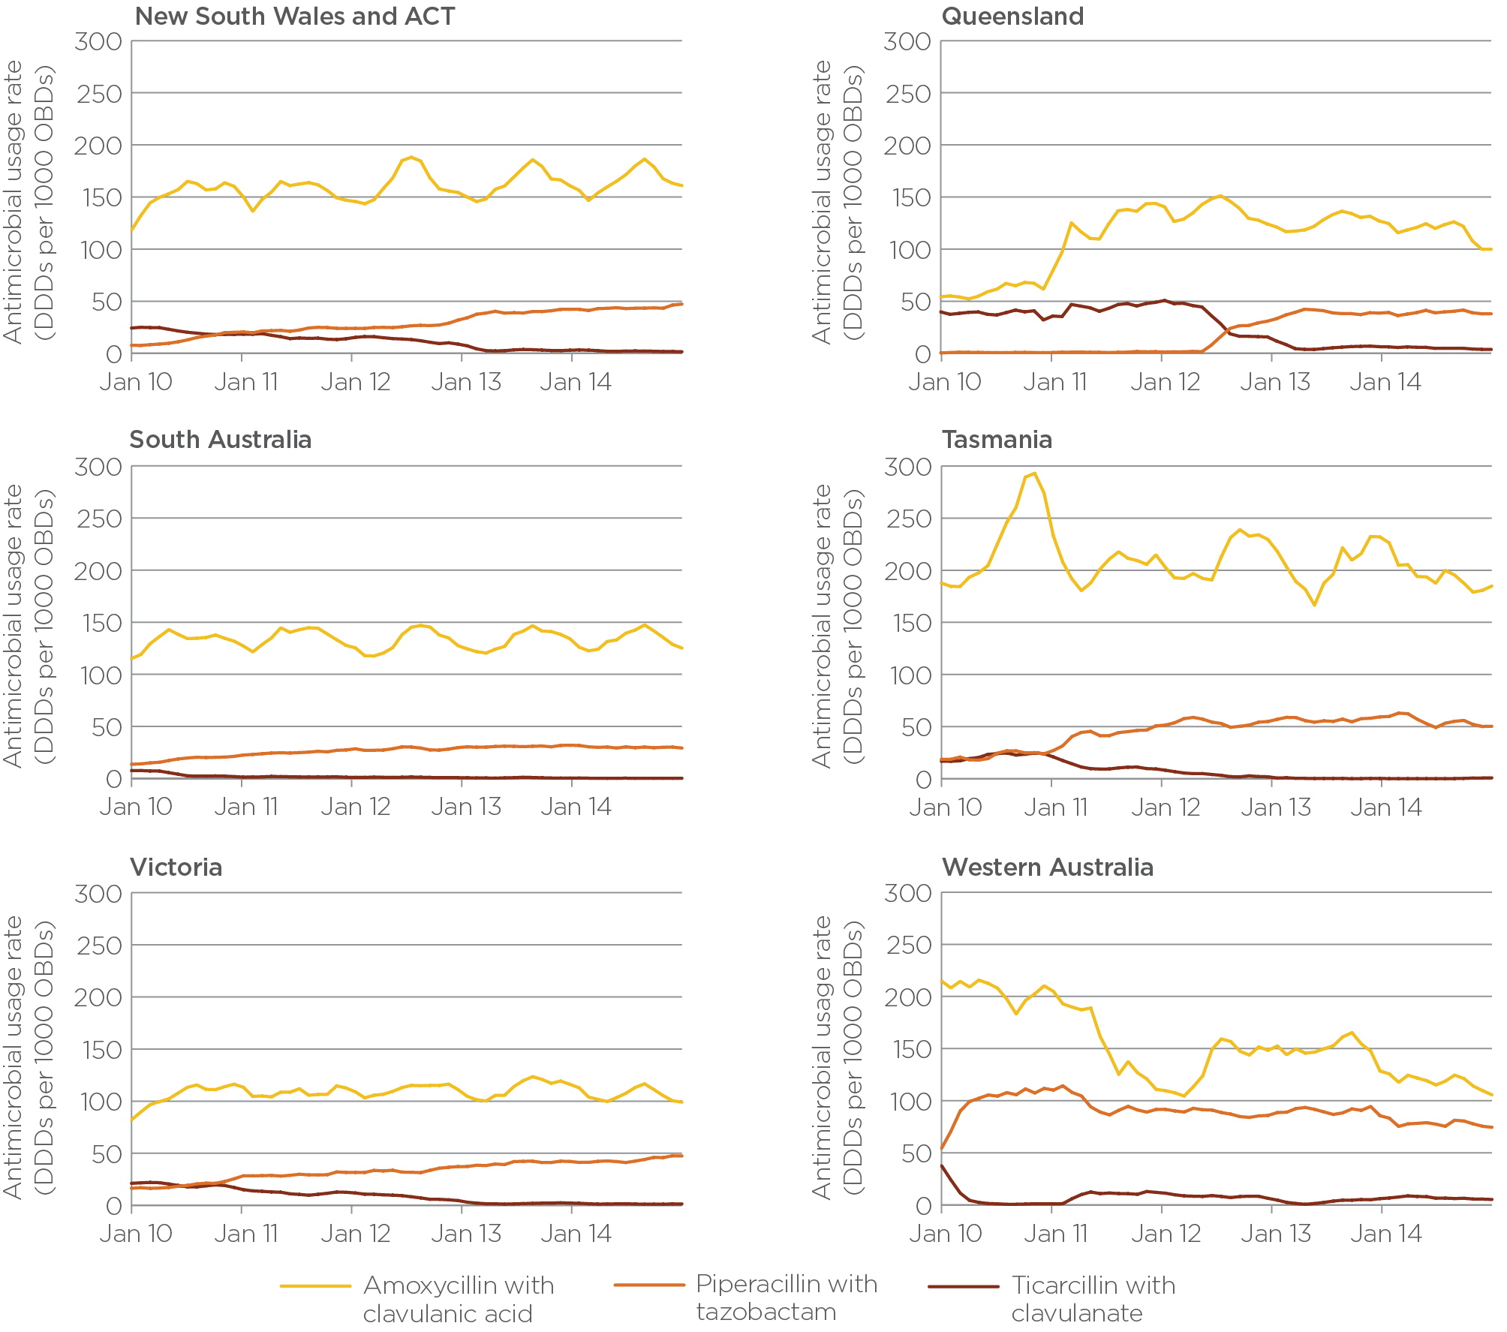

Piperacillin with tazobactam is used in intensive care units (ICUs) for indications such as suspected pseudomonal ventilator-associated pneumonia. Out of the ICU setting, it is used in multiple patient groups, including haematology–oncology patients and those with severe mixed aerobic/anaerobic infections. Amoxycillin with clavulanic acid does not have antipseudomonal properties and is only available as oral formulations in Australia. It has a range of indications, including de-escalation from intravenous antimicrobial agents.

From an antimicrobial stewardship pharmacist:

‘We use your data to model improved usage’

The appropriate use of antimicrobials is the key objective of using NAUSP data to guide improved practice. However, reducing innappropriate use has broader potential benefits for overall use of resources.

Using NAUSP’s bimonthly reports, a large metropolitan hospital has identified multiple agents that are consistently used at more than 10 DDDs above the national peer group average. The hospital estimates that it could achieve potential cost savings of around $120 000 annually by reducing total hospital use of piperacillin with tazobactam alone, based on usage rates from the past 24 months.

## Reserve-line agents – colistin, daptomycin, linezolid, tigecycline, ceftaroline

Parenteral colistin has become an important agent in the treatment of carbapenemase-producing multidrug-resistant gram-negative organisms, where meropenem is ineffective. It should be noted that colistin usage rates include both nebulised and parenteral formulations, because some contributors are not able to provide data differentiating between these delivery types (Figure 21). Usage rates of daptomycin, although minimal, are increasing.

Although linezolid usage rates are low, there is marked interhospital variation. Linezolid is reserved for complex and multidrug-resistant gram-positive infections, including vancomycin-resistant enterococci (VRE). This multidrug-resistant organism is becoming more prevalent in Australia. Data are not yet available to determine whether linezolid use can be correlated with VRE infections. Tigecycline use remains very low in Australian hospitals.

Figure 21 Reserve-line agent usage rates, 2010–14 (3-month moving average)

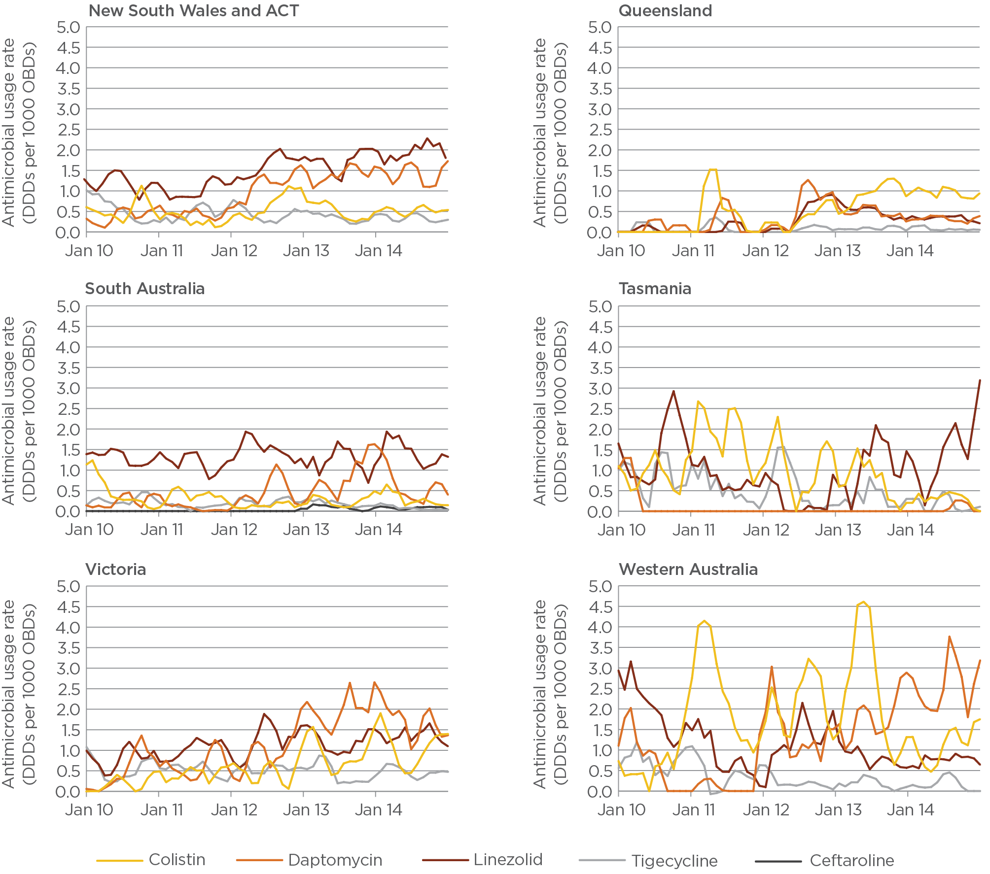

# Analysis of antibacterial usage by peer group

Use of broader-spectrum antibacterials and agents reserved to treat infections caused by multidrug-resistant organisms would be expected to occur mainly in the principal referral and large public acute hospitals. Several antibacterial classes were analysed to determine whether this expectation is supported by data on antimicrobial use.

Private hospitals were excluded from these analyses because they have not yet been assigned to the revised AIHW peer groups. Since there are only four hospitals in the small public acute group, these data cannot be considered representative.

## Aminoglycosides

Aminoglycoside usage rates show downward trends in each peer group over the period 2010–14 (Figure 22). In 2014, usage rates in principal referral, large public acute and medium public acute hospitals were similar, and nearly double the rates in smaller hospitals. Gentamicin is the most frequently used aminoglycoside in Australia and is widely used as initial empirical therapy.

Figure 22 Aminoglycoside usage rates, 2010–14 (3-month moving average)

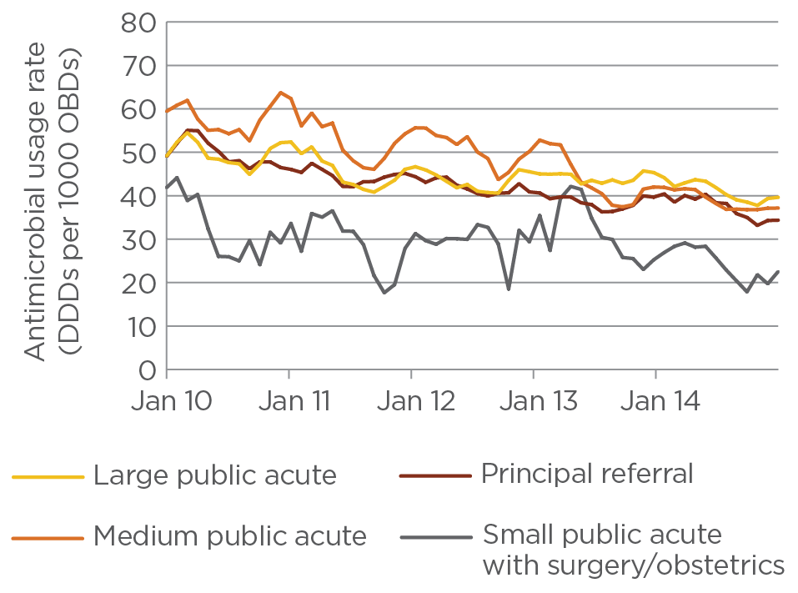

## Carbapenems

Carbapenems (predominantly meropenem) are broad-spectrum agents reserved for treatment of infections caused by multidrug-resistant organisms. As expected, usage rates were highest in principal referral hospitals, followed by large and medium public acute hospitals (Figure 23). Use in small hospitals was minimal.

Figure 23 Carbapenem usage rates, 2010–14 (3-month moving average)

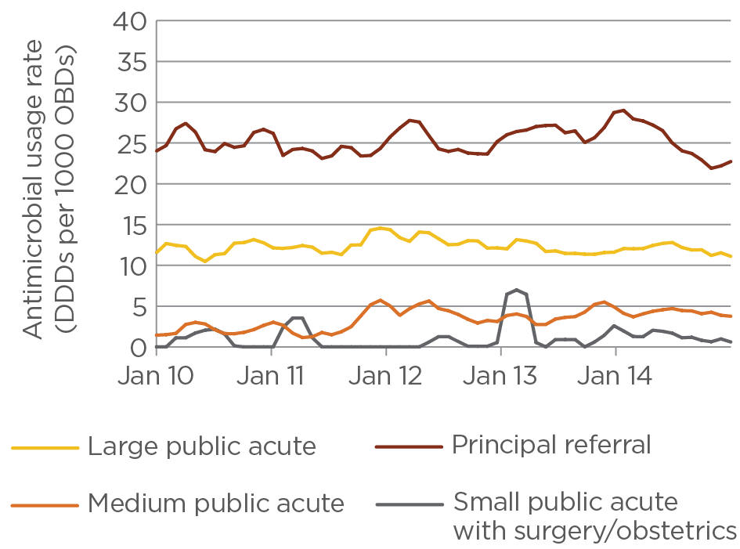

## Third- and fourth-generation cephalosporins – ceftriaxone, cefotaxime, ceftazidime, cefepime

Usage rates of third- and fourth-generation cephalosporins were similar in all four peer groups (Figure 24). Although NAUSP data do not include any assessment of appropriateness of prescribing, in general, greater usage of broad-spectrum cephalosporins would be expected in larger hospitals. Investigation at hospital level would be required to determine whether use in non-principal referral hospitals was appropriate. The 2013 National Antimicrobial Prescribing Survey reported that 34% of ceftriaxone prescriptions were deemed inappropriate.8

Figure 24 Third- and fourth-generation cephalosporin usage rates, 2010–14 (3-month moving average)

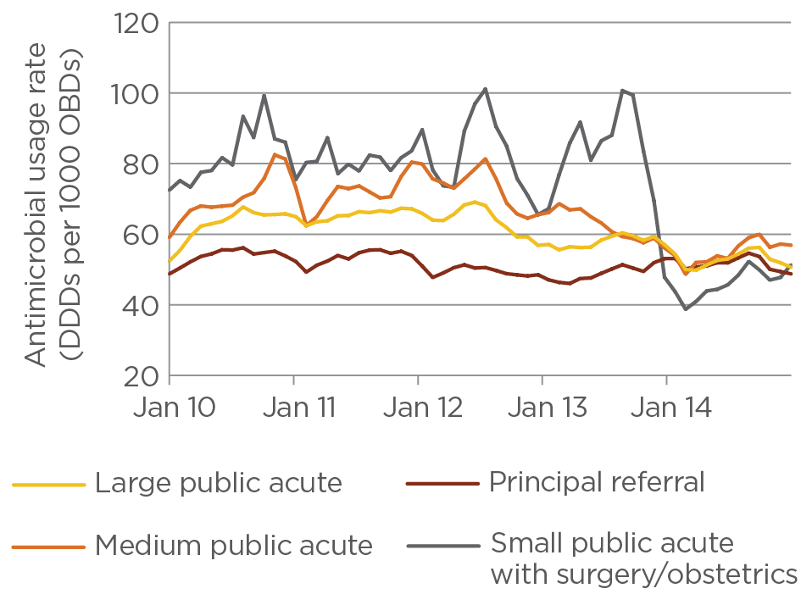

Note: The drop in usage rates in November 2013 for the small public group is related to low numbers in this peer group (four hospitals) from that year. In addition, a hospital that has very low usage rates of these agents began contributing to NAUSP in November 2013, which reduced the average usage rate.

## Fluoroquinolones – ciprofloxacin, norfloxacin, moxifloxacin

Usage rates of fluoroquinolones have declined in the past five years (Figure 25). The most dramatic decline occurred in the principal referral peer group. Usage rates for the small public acute group are lower than for other peer groups, and do not show a downward trend as in the other peer groups.

Figure 25 Fluoroquinolone usage rates, 2010–14 (3-month moving average)

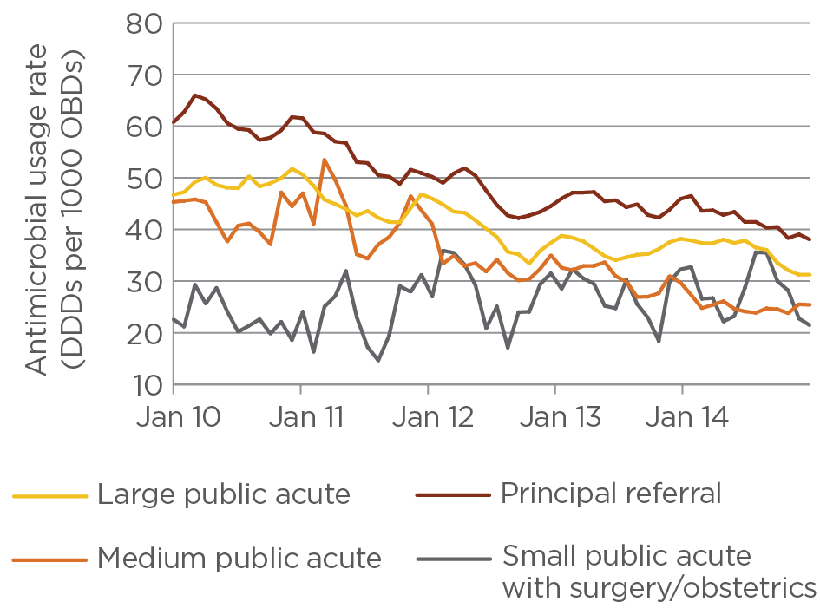

## Glycopeptides – vancomycin, teicoplanin

Usage rates of glycopeptides are highest in principal referral hospitals and lowest in smaller hospitals, as would be expected for this reserve-line antibacterial class.

Figure 26 Glycopeptide usage rates, 2010–14 (3-month moving average)

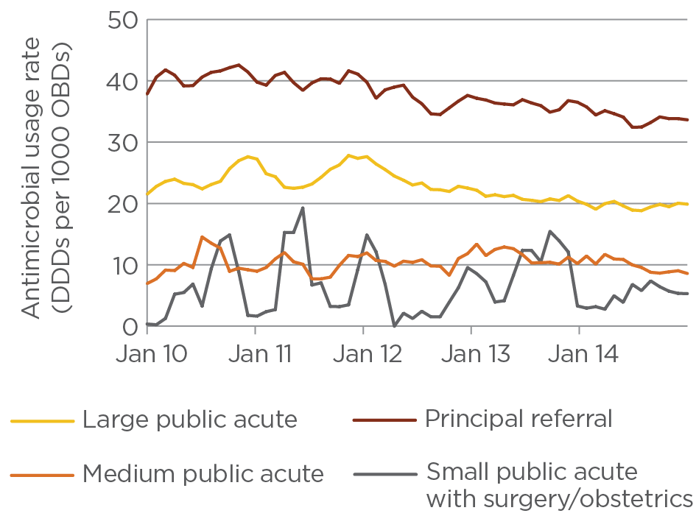

## Macrolides – azithromycin, clarithromycin, erythromycin, roxithromycin

Macrolide usage rates show definite seasonal patterns, with use being greatest in the winter months (Figure 27). Differences in use between the peer groups are not as pronounced for macrolides as for other antibacterial classes. Most Australian hospitals do not have restrictions on macrolide antibacterials (with the exception of intravenous azithromycin).

Figure 27 Macrolide usage rates, 2010–14 (3-month moving average)

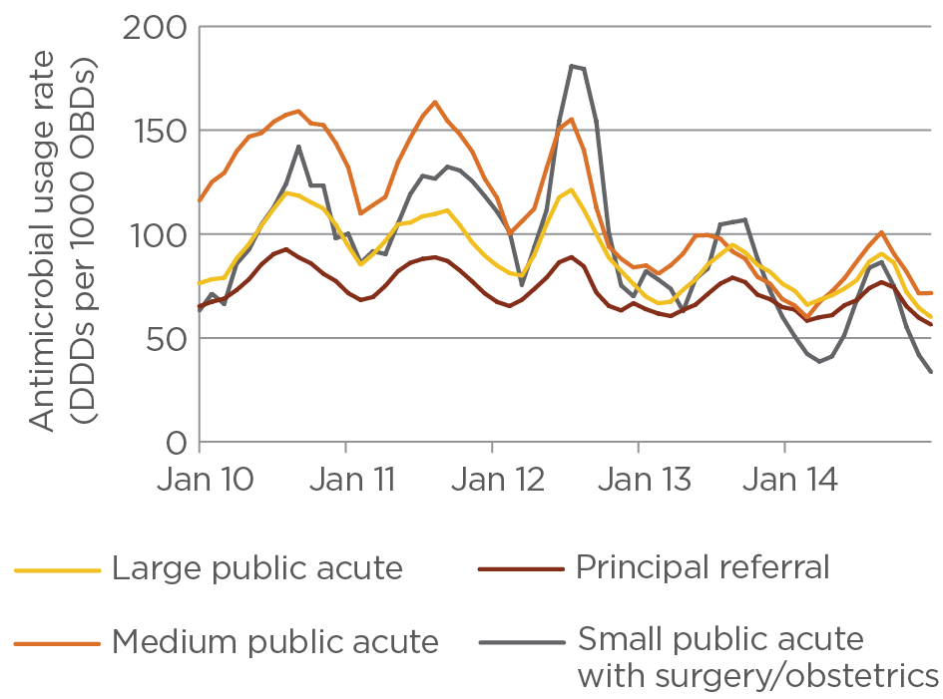

## Penicillins – antipseudomonal penicillin/ß-lactamase inhibitor combinations: ticarcillin with clavulanate, piperacillin with tazobactam

Usage rates of antipseudomonal penicillin/β-lactamase inhibitor combinations are greatest in larger hospitals (Figure 28). As these antibacterials are generally restricted, this pattern is to be expected.

Figure 28 Piperacillin with tazobactam and ticarcillin with clavulanate usage rates, 2010–14 (3-month moving average)

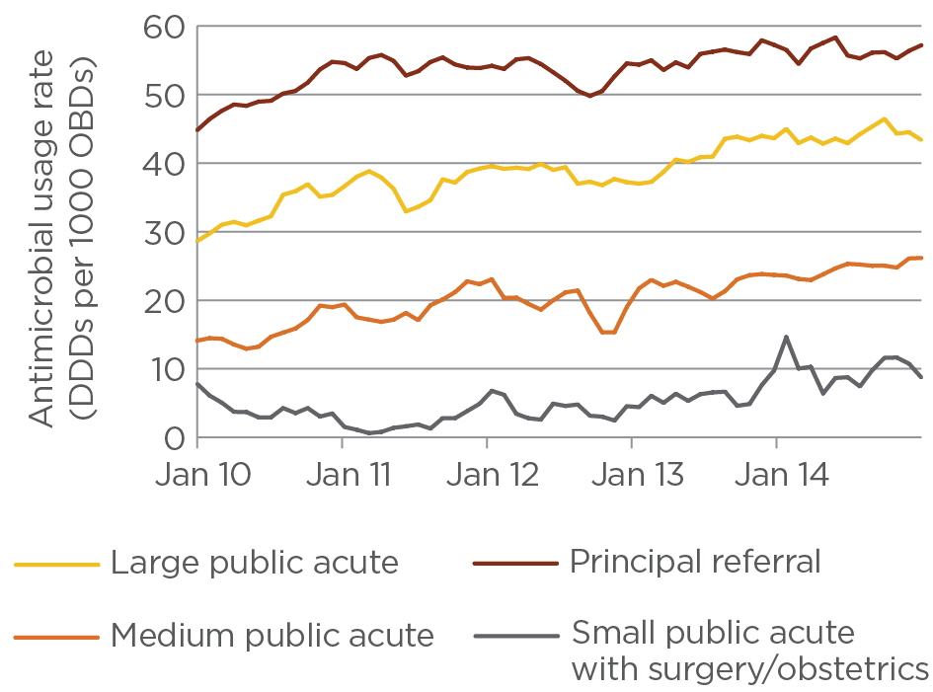

## Reserve-line agents – colistin, daptomycin, linezolid

Use of highly reserved agents is almost solely confined to principal referral and large public acute hospitals (Figure 29). These agents are used to treat seriously ill patients when the causative organisms are multiply resistant to standard antibacterial treatment. Such patients would generally be admitted to a large hospital. Increased usage can be attributed to rising rates of multiresistant bacterial infections.

Figure 29 Colistin, daptomycin and linezolid usage rates, 2010–14 (3-month moving average)

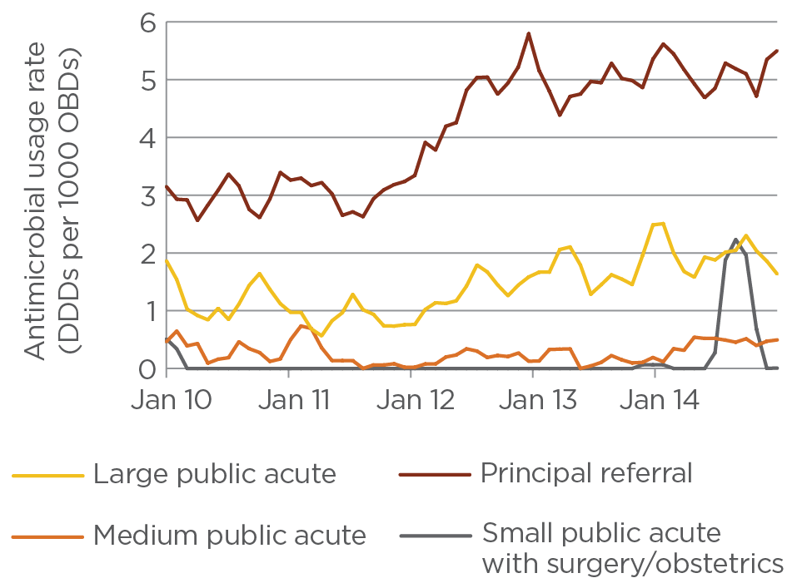

# Benchmarking with other antimicrobial usage data

NAUSP has collected data on antimicrobial use in Australian tertiary referral hospitals since July 2004. Standardised methodology for collecting data and reporting on usage rates allows comparisons between programs that measure, analyse and compare antibacterial consumption. WHO has developed an internationally accepted classification system for drug consumption, including a technical unit of measurement, the DDD (see Appendixes 2 and 3). Figure 30 shows antimicrobial usage rates in Australian hospitals during 2014 compared with rates published in surveillance reports for Denmark (2013), the Netherlands (2012) and Sweden (2012), all of which used DDD related to bed occupancy.

The Danish Integrated Antimicrobial Resistance Monitoring and Research Programme (DANMAP) was established in 1995 to conduct coordinated national surveillance and research on antimicrobial consumption, as well as antimicrobial resistance in humans, animals and the food supply chain in Denmark. DANMAP has published both primary healthcare and hospital usage rates, using DDD as a measure, since 1997.5 NAUSP reports are confined to surveillance of hospital antimicrobial use.

In the Netherlands, antimicrobial usage rates are published in the annual report Consumption of antimicrobial agents and antimicrobial resistance among medically important bacteria in the Netherlands (NethMap).7 The Swedish Antibiotic Utilisation and Resistance in Human Medicine report (SWEDRES)6 provides Swedish antimicrobial usage data.

Surveillance of antimicrobial use is well established in many other countries. The European Centre for Disease Prevention and Control publishes the report Surveillance of antimicrobial consumption in Europe for the European Surveillance of Antimicrobial Consumption Network (ESAC-Net). This report compiles usage data from 30 European nations across both community and hospital sectors, and is now in its third instalment.9 Although the ESAC-Net report represents a significant data holding, it cannot be directly compared with Australian data, because the metric used is DDDs per 1000 inhabitants per day rather than DDDs per 1000 OBDs.

Comparisons of Australian antibacterial use with these other surveillance programs must be made with care, although NAUSP applies similar exclusions. There may be variation in data collection processes, as well as the patient populations included, referral patterns and inpatient practices. For example, the Australian rates reported by NAUSP are adult acute care usage rates in hospitals with more than 50 beds. Other programs may calculate rates based on pooled data from a broader range of hospitals or include primary care settings. It should also be noted that usage data in this report refer to quantities dispensed by hospital pharmacies, and give no information regarding prescriptions, diagnoses or severity of disease at the time of presentation at ward level. Further differences may arise from differences in the range of antimicrobials available in different countries, antimicrobial resistance patterns, patient groups (e.g. hospitals with oncology units) and sources of denominator data collected for rate calculation.

Comparisons with other European surveillance programs are also problematic because different methodologies are used. DANMAP reports data from ‘somatic hospitals’ and excludes data from ‘psychiatric hospitals, rehabilitation centres and hospices’.5 Somatic hospitals account for the majority (97%) of antimicrobial consumption in the hospital sector in Denmark.5 NethMap 2013 collected data from 78 out of 91 Dutch hospitals via questionnaires distributed to hospital pharmacists.7 SWEDRES 2013 hospital care data were obtained from ‘all Swedish hospitals as well as data from those nursing homes and other caregivers that order their antibiotics through requisitions’ and are based on sales data.6

## International total-hospital usage rates

Data from three European programs give relative frequencies of usage rates of particular antimicrobial classes that can be compared with Australian data (Figure 30). Total aggregate antimicrobial usage rates for NAUSP hospitals for 2014 can be compared with aggregated hospital usage rates from the surveillance programs DANMAP 2013, NethMap 2014 and SWEDRES 2013 (noting that these report on different calendar years).

The Australian NAUSP records higher usage rates than those of the other countries, but only marginally higher than Denmark’s. Differences in usage patterns are evident for macrolides, glycopeptides and cephalosporins. These differences may reflect differences in drug availability, prescribing preferences, microbial resistance patterns, policies and regulation. Of note is the higher use of fluoroquinolones in these European countries compared with Australia. For many years, Australia has taken a conservative approach to fluoroquinolone use in both hospital and community settings through AMS practices and regulatory measures.

Benchmarking with international data demonstrates high usage rates in Australia for many classes of antimicrobials, but markedly lower rates for others. This supports goals for reduction in usage in Australian hospitals through improved prescribing practices.

Figure 30 Antimicrobial usage rates in hospitals in Australia, Denmark, the Netherlands and Sweden

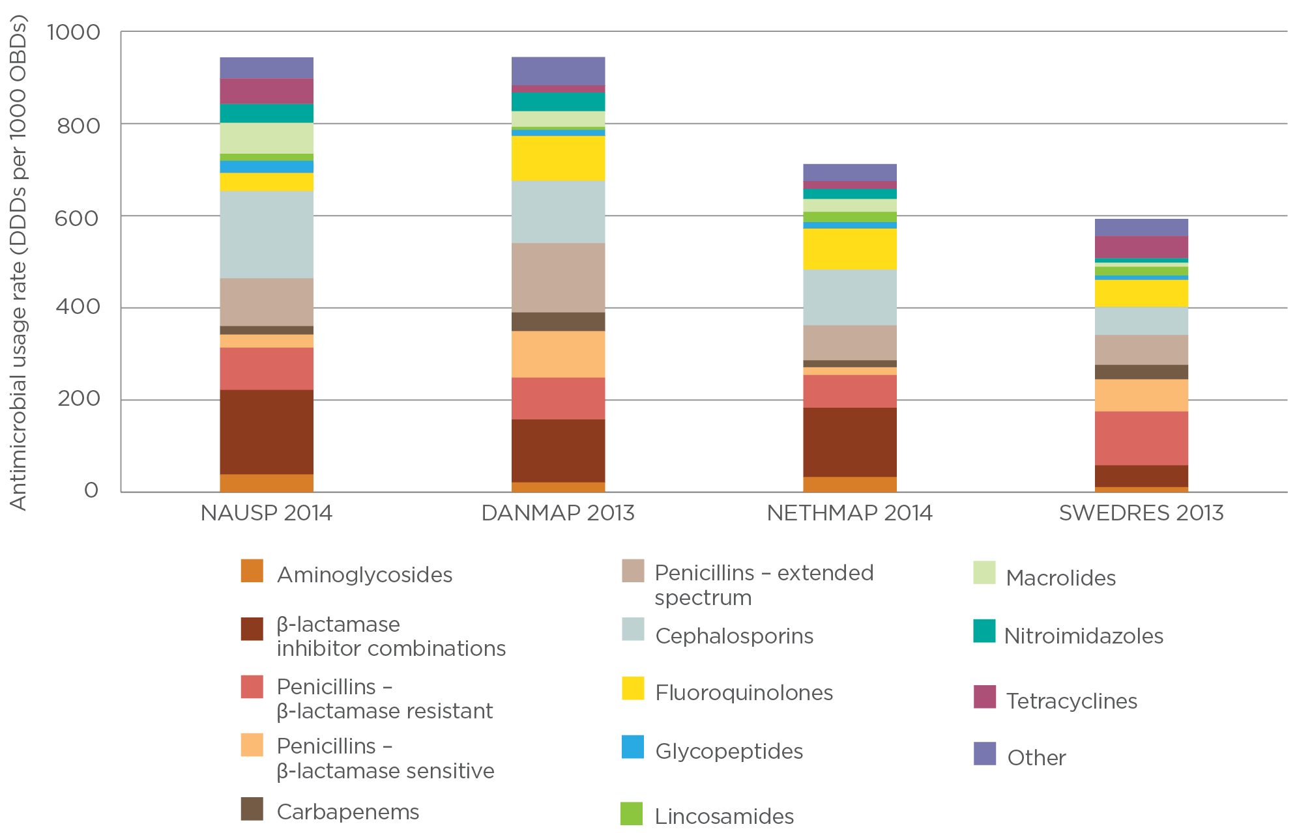

Notes: NAUSP 2014 includes Australian data from January to December 2014 (129 hospitals). NethMap 2014 shows rates for 2012. SWEDRES 2013 rates use denominator data from 2012. ‘Other’ comprises lipopeptides, monobactams, methenamine, nitrofurans, oxazolidinones, polymyxins, rifamycins, short-acting sulfonamides, streptogramins, steroids, sulfonamide/trimethoprim combinations and trimethoprim.

# Discussion

Prudent antimicrobial prescribing is a primary tool for reducing the emergence of widespread antimicrobial resistance in pathogens. The drive for an increased understanding of antimicrobial usage patterns in Australian hospitals is increasing, and NAUSP provides a rich data source for analyses of these usage patterns and development of strategies for improved AMS. The number of contributors to NAUSP has increased as hospitals use the program to undertake surveillance and optimise their local use of antimicrobials.

Consistent measurement of antimicrobial consumption is essential for evaluating and monitoring interventions that are implemented through AMS programs. AMS programs aim to optimise antimicrobial use and minimise selection pressure for development of antimicrobial resistance in pathogens.10 AMS is included in the National Safety and Quality Health Service Standards, which were implemented in 2013 by the Australian Commission on Safety and Quality in Health Care.11 Many other factors, such as poor infection control practices and lack of standardised hospital cleaning, also contribute to the development and spread of multidrug-resistant organisms (MROs) in the hospital setting. Implementation of the National Safety and Quality Health Service Standards would be expected to improve these practices and limit the spread of resistant bacteria.

Measuring antimicrobial use is also a key element in determining a relationship between antimicrobial use and antimicrobial resistance patterns. Understanding the relationship between antimicrobial use and microbial resistance in Australian hospitals is one of the aims of a nationally coordinated surveillance system that is currently being developed.12 The Antimicrobial Use and Resistance in Australia (AURA) surveillance project, led by the Australian Commission on Safety and Quality in Health Care, commenced in October 2013. Its goal is to establish an Australia-wide integrated surveillance system for antimicrobial resistance and antimicrobial use.13 NAUSP is a key component of this national surveillance system and will be supported by the Commission to increase participation rates of target hospital groups and private hospitals. In addition, NAUSP infrastructure will be enhanced to improve access to data by hospital participants and facilitate local integration of data.

The NAUSP report for 2014 shows a large variation in use of antibacterial classes between the Australian states, with more than 400 DDDs per 1000 OBDs separating the aggregate rates of Queensland and Tasmania (Queensland: 819; Tasmania: 1228).

A marked decline in the usage rates of some agents (gentamicin, vancomycin, fluoroquinolones, cephalosporins) has been observed since July 2012 in Queensland, with a notable increase in meropenem use over the same period. This corresponds with a significant increase in the number of hospitals contributing to NAUSP, with more consistent usage derived from principal referral and large public hospitals, resulting in ‘smoothing’ of usage rates.

Substitution of ticarcillin/clavulanate with piperacillin/tazobactam is nearly complete across all states. It appears that Queensland was the final state to achieve complete crossover; however, it is likely that this is based on changes to contributors (as outlined above). Piperacillin with tazobactam has a broad spectrum that includes anaerobes; this could be the reason that nitroimidazole (metronidazole) usage rates decreased during the same period.

Macrolide antimicrobials show the greatest amount of seasonal variation in use, with peak use across the winter months. To a lesser degree, this trend is also observed with cephalosporins.

The application of revised AIHW peer groupings shows that antimicrobial consumption of broader-spectrum and reserve-line agents is higher in more acute settings; usage rates across most classes in these settings are 2–3 times higher than for smaller hospitals. A notable exception is the macrolides, for which use by small public acute hospitals exceeds that of principal referral facilities. Over the five-year period January 2010 to December 2014, fluoroquinolone use steadily declined across all peer groups except small public hospitals, where a slight increase was observed. Although this may appear significant, it is important not to draw firm conclusions because of underrepresentation of this cohort and the low volume of data held by NAUSP across this group.

Use of reserve-line antimicrobials has doubled in principal referral hospitals in the past four years. However, rates remain low (less than 6 DDDs per 1000 OBDs). Although comprehensive national data on infections with MROs are not available, the South Australian Healthcare Associated Infection Surveillance Program has been monitoring infections with a variety of MROs. The most recent MRO annual report from this program shows that the number of infections caused by extended-spectrum β-lactamase-producing Enterobacteriaceae bacteria has at least doubled in the past four years.14

Although the DDDs/OBDs measure is an accepted metric in international surveillance programs for antimicrobial usage rates and enables benchmarking between institutions, it does not account for patient variability and actual dose administered. Further research is required to determine whether it is indeed a good measure for correlation with antimicrobial-associated risks.15-17 A further limitation of the DDD is the lack of definitions for paediatric populations, in which daily doses depend on age and weight of children – this prohibits incorporation of antimicrobial data relating to children into NAUSP.

Australia’s antibacterial consumption reached its peak in 2010, with mean national use of 1006 DDDs per 1000 OBDs. Since then, a slow but steady decline has occurred that places the nation on par with Danish antibacterial usage rates (Figure 30). Various factors may have contributed to this decline, including increased participation in Antibiotic Awareness Week (held in November each year) and point prevalence surveys under the National Antimicrobial Prescribing Survey.

Increased implementation of AMS programs with specific antimicrobial policies, electronic guides for prescribing decisions, and approved use of restricted agents will help to effect change and rationalise the prescribing of agents of interest. Some NAUSP contributor sites with AMS programs restricting the use of target agents have successfully changed prescribing practices and used NAUSP data to illustrate changes in antimicrobial usage rates. A number of examples are included as vignettes in this report.

Surveillance of hospital antimicrobial use in a consistent manner enables identification and investigation of changes that may be linked to the development of resistance, and measurement of the impact of AMS programs. Benchmarking and comparison with similarly peered hospitals can stimulate more in-depth analysis of prescribing practices by individual hospitals or healthcare networks, and subsequent interventions. As NAUSP becomes more nationally representative through additional hospitals joining the program, these aims will increasingly be met. Specific efforts will be made to increase the number of small public hospital contributors to NAUSP, providing a more accurate representation of antimicrobial use and meaningful feedback to these sites.

Currently, NAUSP collects usage data only from acute care hospitals. The impact of antimicrobial use in the community and residential aged care on inpatient MRO burdens is not yet known. As factors contributing to resistance selection are further investigated, surveillance activities conducted by NAUSP may need to be expanded to include other areas – for example, use of topical antimicrobials, and antimicrobial use in outpatient settings and mental health units.

# Acknowledgments

Funding for the National Antimicrobial Utilisation Surveillance Program was provided by the Australian Commission on Safety and Quality in Health Care through the Australian Government Department of Health.

We thank all contributors to the program who voluntarily provide monthly data to SA Health.

# Appendix 1 Contributor information

Table A1 Hospitals contributing to the National Antimicrobial Utilisation Surveillance Program, 2014

| State or territory | Hospital |
| --- | --- |
| Australian Capital Territory | Canberra Hospital |
| New South Wales | Auburn Hospital, Bankstown Hospital, Bathurst Base Hospital, Bega District Hospital, Belmont Hospital, Blacktown Hospital, Bowral Hospital, Calvary Mater Hospital Newcastle, Campbelltown Hospital, Coffs Harbour Hospital, Concord Hospital, Dubbo Base Hospital, Fairfield Hospital, Gosford Hospital, Goulburn Base Hospital, Griffith Base Hospital, Hornsby Ku-Ring-Gai Hospital, John Hunter Hospital, Lismore Base Hospital, Liverpool Hospital, Maitland Hospital, Manly Hospital, Manning Hospital, Mona Vale Hospital, Mount Druitt Hospital, Nepean Hospital, Orange Health Service, Prince of Wales Hospital, Royal North Shore Hospital, Royal Prince Alfred Hospital, Ryde Hospital, Shellharbour Hospital, Shoalhaven Hospital, St George Hospital, St Vincent’s Hospital, Sutherland Hospital, Tamworth Hospital, Tweed Hospital, Wagga Base Hospital, Westmead Hospital, Wollongong Hospital, Wyong Hospital |
| Queensland | Bundaberg Hospital, Caboolture Hospital, Cairns Base Hospital, Gladstone Hospital, Gold Coast University Hospital, Greenslopes Hospital, Hervey Bay Hospital, Ipswich Hospital, Logan Hospital, Mackay Base Hospital, Maryborough Hospital, Mater Adult Hospital, Mater Mothers’ Hospital, Mater Private Hospital, Mater Redland Private Hospital, Nambour General Hospital, Prince Charles Hospital, Princess Alexandra Hospital, Queen Elizabeth II Hospital, Redcliffe Hospital, Redland Hospital, Robina Hospital, Rockhampton Hospital, Royal Brisbane and Women’s Hospital, St Andrew’s Private Hospital, Sunshine Coast Private Hospital, Toowoomba Hospital, Townsville Hospital, Wesley Hospital |
| South Australia | Ashford Hospital, Calvary Hospital, Flinders Medical Centre, Flinders Private Hospital, Gawler Health Service, Lyell McEwin Hospital, Memorial Hospital, Modbury Hospital, Mount Gambier Hospital, Noarlunga Hospital, Port Augusta Hospital, Port Pirie Hospital, Queen Elizabeth Hospital, Repatriation General Hospital, Riverland Regional Health Service, Royal Adelaide Hospital, St Andrew’s Hospital, Wakefield Hospital, Whyalla Hospital |
| Tasmania | Hobart Private Hospital, Launceston General Hospital, Mersey Community Hospital, Northwest Regional Hospital, Royal Hobart Hospital |
| Victoria | Albury Wodonga Health – Albury, Albury Wodonga Health – Wodonga, Alfred Hospital, Angliss Hospital, Austin Hospital, Box Hill Hospital, Cabrini Private Hospital (Brighton), Cabrini Private Hospital (Malvern), Casey Hospital, Dandenong Hospital, Frankston Hospital, Geelong Hospital, Maroondah Hospital, Monash Medical Centre (Clayton), Monash Medical Centre (Moorabbin), Royal Melbourne Hospital, Sandringham Hospital, St Vincent’s Hospital, St Vincent’s Private Hospital (East Melbourne), St Vincent’s Private Hospital (Fitzroy), Warrnambool Base Hospital, West Gippsland Hospital, Western Hospital (Footscray) |
| Western Australia | Armadale Health Service, Bunbury Regional Hospital, Fremantle Hospital, Joondalup Health Campus, King Edward Memorial Hospital, Osborne Park Hospital, Rockingham Hospital, Royal Perth Hospital, Sir Charles Gairdner Hospital, St John of God Hospital |

# Appendix 2 Definitions

World Health Organization definition for defined daily dose

The defined daily dose (DDD) for any drug is defined as the average dose per day to treat the main indication for an average adult patient. The World Health Organization (WHO) has determined standard DDDs for most drugs, and these values have been used in calculating usage rates. Use of this internationally accepted standard enables comparison of the use of antimicrobial agents with differing doses, aggregation of data to assess use of antimicrobial classes, and comparisons with data from other surveillance programs or studies.

The number of DDDs used is calculated as follows:

$$Number of DDD=\frac{Total grams used}{WHO assigned DDD value}$$

Occupied-bed-days

Occupied-bed-days (OBDs) are defined as the sum of the length of stay for each acute adult inpatient separated during the reporting period, who remained in hospital overnight (adapted from the definition of the Australian Institute of Health and Welfare). Day patients, outpatients, hospital-in-the-home, and psychiatric and rehabilitation units are excluded.

Usage density rate

The usage density rate is defined as the number of DDDs used per 1000 OBDs. This usage rate has been accepted as an appropriate measurement of usage in the non-ambulatory setting, and has been adopted by many international programs. Antimicrobial usage data for outpatient areas, including hospital-in-the-home, day treatment centres, day surgery and dialysis clinics, are excluded, to ensure that data correspond to pharmacy issues for inpatients.

The rate is calculated as follows:

$$Usage density rate=\frac{Number of DDD/time period}{OBD/time period} ×1000$$

# Appendix 3 WHO defined daily doses for antibacterial agents included in the NAUSP annual report

| ATC code | Generic name | DDD (g) | Route |
| --- | --- | --- | --- |
| **J01AA** | **Tetracyclines** | | |
| J01AA02 | Doxycycline | 0.1 | O, P |
| J01AA08 | Minocycline | 0.2 | O, P |
| J01AA12 | Tigecycline | 0.1 | P |
| **J01B** | **Amphenicols** | | |
| J01BA01 | Chloramphenicol | 3 | O, P |
| **J01C** | **β-lactam antibacterials, penicillins** | | |
| *J01CA* | *Penicillins with extended spectrum* | | |
| J01CA01 | Ampicillina | 2 | O, P |
| J01CA04 | Amoxycillina | 1 | O, P |
| *J01CE* | *β -lactamase-sensitive penicillins* | | |
| J01CE01 | Benzylpenicillina | 3.6 | P |
| J01CE02 | Phenoxymethylpenicillina | 2 | O |
| J01CE08 | Benzathine benzylpenicillina | 3.6 | P |
| J01CE09 | Procaine penicillina | 0.6 | P |
| *J01CF* | *β -lactamase-resistant penicillins* | | |
| J01CF01 | Dicloxacillin | 2 | O, P |
| J01CF05 | Flucloxacillin | 2 | O, P |
| *J01CR* | *Combinations of penicillins, including β-lactamase inhibitors* | | |
| J01CR02 | Amoxycillin and enzyme inhibitora | 1 | O |
| J01CR03 | Ticarcillin and enzyme inhibitorb | 15 | P |
| J01CR05 | Piperacillin and enzyme inhibitorb | 14 | P |
| **J01D** | **Other β-lactam antibacterials** | | |
| *J01DB* | *First-generation cephalosporins* | | |
| J01DB01 | Cefalexin | 2 | O |
| J01DB03 | Cefalotin | 4 | P |
| J01DB04 | Cefazolin | 3 | P |
| *J01DC* | *Second-generation cephalosporins* | | |
| J01DC01 | Cefoxitin | 6 | P |
| J01DC02 | Cefuroxime | 0.5 | O |
| J01DC04 | Cefaclor | 1 | O |
| *J01DD* | *Third-generation cephalosporins* | | |
| J01DD01 | Cefotaxime | 4 | P |
| J01DD02 | Ceftazidime | 4 | P |
| J01DD04 | Ceftriaxone | 2 | P |
| *J01DE* | *Fourth-generation cephalosporins* | | |
| J01DE01 | Cefepime | 2 | P |
| *J01DH* | *Carbapenems* | | |
| J01DH02 | Meropenem | 2 | P |
| J01DH51 | Imipenem and enzyme inhibitor | 2 | P |
| J01DH03 | Ertapenem | 1 | P |
| J01DH04 | Doripenem | 1.5 | P |
| *J01DF* | *Monobactams* | | |
| J01DF01 | Aztreonam | 4 | P |
| *J01DI* | *Other cephalosporins* | | |
| J01DI02 | Ceftaroline | 1.2 | P |
| **J01E** | **Sulfonamides and trimethoprim** | | |
| J01EA01 | Trimethoprim | 0.4 | O, P |
| J01EE01 | Sulfamethoxazole and trimethoprim | 1.92 | O, P |
| **J01F** | **Macrolides, lincosamides and streptogramins** | | |
| *J01FA* | *Macrolides* | | |
| J01FA01 | Erythromycin | 1 | O, P |
| J01FA01 | Erythromycin ethylsuccinate | 2 | O |
| J01FA06 | Roxithromycin | 0.3 | O |
| J01FA09 | Clarithromycin | 0.5 | O |
| J01FA10 | Azithromycin | 0.3 | O |
| J01FA10 | Azithromycin | 0.5 | P |
| *J01FF* | *Lincosamides* | | |
| J01FF01 | Clindamycin | 1.2 | O |
| J01FF01 | Clindamycin | 1.8 | P |
| J01FF02 | Lincomycin | 1.8 | O, P |
| *J01FG* | *Streptogramins* | | |
| J01FG01 | Pristinamycin | 2 | O |
| J01FG02 | Quinupristin/dalfopristin | 1.5 | P |
| **J01GB** | **Aminoglycoside antibacterials** | | |
| J01GB01 | Tobramycin | 0.24 | P |
| J01GB01 | Tobramycin | 0.3 | Inh solution |
| J01GB01 | Tobramycin | 0.112 | Inh powder |
| J01GB03 | Gentamicin | 0.24 | P |
| J01GB05 | Neomycin | 1 | O |
| J01GB06 | Amikacin | 1 | P |
| **J01MA** | **Quinolone antibacterials** | | |
| J01MA01 | Ofloxacin (oral product not marketed in Australia but available through Special Access Scheme) | 0.4 | O |
| J01MA02 | Ciprofloxacin | 1 | O |
| J01MA02 | Ciprofloxacin | 0.5 | P |
| J01MA06 | Norfloxacin | 0.8 | O |
| J01MA14 | Moxifloxacin | 0.4 | O, P |
| **J01X** | **Other antibacterials** | | |
| *J01XA* | *Glycopeptide antibacterials* | | |
| J01XA01 | Vancomycin | 2 | O, P |
| J01XA02 | Teicoplanin | 0.4 | P |
| *J01XB* | *Polymyxins* | | |
| J01XB01 | Colistin | 3 MU | P, Inh |
| *J01XC* | *Steroid antibacterials* | | |
| J01XC01 | Fusidic acid | 1.5 | O, P |
| *J01XD* | *Imidazole derivatives* | | |
| J01XD01 | Metronidazole | 1.5 | P |
| J01XD01 | Metronidazole | 2 | O, R |
| J01XD02 | Tinidazole | 2 | O |
| *J01XX* | *Other antibacterials* | | |
| J01XX08 | Linezolid | 1.2 | O, P |
| J01XX09 | Daptomycin | 0.28 | P |
| *J04* | *Antimycobacterials* | | |
| J04AB02 | Rifampicin | 0.6 | O, P |

ATC = Anatomical Therapeutic Classification; Inh = inhalation; MU = million units; O = oral; P = parenteral; R = rectal

a Without antipseudomonal activity

b With antipseudomonal activity

Source: World Health Organization Collaborating Centre for Drug Statistics Methodology3

# Glossary

| Term | Definition |
| --- | --- |
| acute care | The health system components, or care delivery platforms, used to treat sudden, often unexpected, urgent or emergent episodes of injury and illness that can lead to death or disability without rapid intervention. This is often care where the intent is to perform surgery, diagnostic or therapeutic procedures. |
| antimicrobial | A chemical substance that inhibits or destroys bacteria, parasites, viruses or fungi and that can be safely administered to humans or animals. |
| antimicrobial resistance | Failure of an antimicrobial to inhibit a microorganism at the antimicrobial concentrations usually achieved over time with standard dosing regimens. |
| antimicrobial stewardship | An ongoing effort by a health service to reduce the risks associated with increasing microbial resistance and to extend the effectiveness of antimicrobial treatments. Antimicrobial stewardship may incorporate a broad range of strategies, including monitoring and review of antimicrobial use. |
| broad-spectrum antimicrobials | A class of antimicrobials that affect many organisms. |
| defined daily dose | The average dose per day to treat the main indication for an average adult patient. |
| extended-spectrum-β-lactamase | Enzyme that is produced by some gram-negative bacteria. These bacteria are usually found in the bowel and urinary tract, and are considered multiresistant organisms because they are resistant to a large number of antimicrobials. |
| highly reserved agent | Antimicrobial requiring formal approval before dispensing, and not subject to pre-approval. |
| National Antimicrobial Prescribing Survey (NAPS) | A national survey that uses a standardised auditing tool. The survey is designed to assist healthcare facilities to assess the quantity and quality of antimicrobial prescribing. NAPS is developed by the National Centre for Antimicrobial Stewardship at the Doherty Institute (a joint venture between the Royal Melbourne Hospital and the University of Melbourne), and is supported by the Australian Commission on Safety and Quality in Health Care, with the aim of improving appropriateness of antimicrobial prescribing. |
| National Safety and Quality Health Service (NSQHS) Standards | Standards developed by the Australian Commission on Safety and Quality in Health Care to drive the implementation of safety and quality systems, and improve the quality of health care in Australia. The NSQHS Standards provide a nationally consistent statement about the level of care consumers can expect from health service organisations. |
| occupied-bed-days | The total number of bed days of all admitted patients accommodated during the reporting period, taken from a count of the number of inpatients at about midnight each day. |
| parenteral (agents) | Antimicrobials that must be given by injection, such as via the intravenous or intramuscular routes, to be effective. |
| (hospital) peer group | Hospitals of a similar size (major, large, medium or small) or geographical location. Peer groups only apply to public hospitals. The grouping allows comparison between similar hospitals. This minimises the effect of different hospital size, service provision and rurality when comparing hospitals. |
| primary (health) care | Includes most health services not provided by hospitals. |
| principal referral hospital | Major city hospitals with more than 20 000 acute casemix-adjusted separations, and regional hospitals with more than 16 000 acute casemix-adjusted separations per year. |
| standardised usage density rate | The number of defined daily doses used per 1000 occupied-bed-days. |
| therapeutic group | Categorisation of drugs that have similar chemical structure and spectrum. |
| topical (medication) | A medication that is applied to body surfaces such as the skin or mucous membranes; includes creams, foams, gels, lotions and ointments. |

# References

1. Commonwealth Department of Health and Aged Care. Report of the Joint Expert Technical Advisory Committee on Antibiotic Resistance (JETACAR). Canberra: Commonwealth Government, 1999.

2. Australian Institute of Health and Welfare. Australian hospital statistics 2012–13. Appendix C: Public hospital peer groups. Canberra: AIHW, 2014, [www.aihw.gov.au/WorkArea/DownloadAsset.aspx?id=60129547084.](http://www.aihw.gov.au/WorkArea/DownloadAsset.aspx?id=60129547084.)

3. World Health Organization Collaborating Centre for Drug Statistics Methodology. ATC/DDD index 2015, [www.whocc.no/atcddd](http://www.whocc.no/atcddd).

4. WHO Collaborating Centre for Drug Statistics Methodology. Purpose of the ATC/DDD system, [www.whocc.no/atc_ddd_methodology/purpose_of_the_atc_ddd_system](http://www.whocc.no/atc_ddd_methodology/purpose_of_the_atc_ddd_system).

5. National Food Institute, Statens Serum Institute. DANMAP 2013: use of antimicrobial agents and occurrence of antimicrobial resistance in bacteria from food animals, food and humans in Denmark. Søborg/Copenhagen: Statens Serum Institute, National Veterinary Institute, National Food Institute, 2014, [www.danmap.org/~/media/Projekt%20sites/Danmap/DANMAP%20reports/DANMAP%202013/DANMAP%202013.ashx?utm_source=DN+Nyhedsbreve&utm_campaign=dba67a1145-DN_Nyhedsbrev_uge_39_2014&utm_medium=email&utm_term=0_16ebc33b07-dba67a1145-42049169](http://www.danmap.org/~/media/Projekt%20sites/Danmap/DANMAP%20reports/DANMAP%202013/DANMAP%202013.ashx?utm_source=DN+Nyhedsbreve&utm_campaign=dba67a1145-DN_Nyhedsbrev_uge_39_2014&utm_medium=email&utm_term=0_16ebc33b07-dba67a1145-42049169).

6. Hellman J, Aspevall O, Bengtsson B, Greko C (eds). SWEDRES–SVARM 2013: use of antimicrobials and occurrence of antimicrobial resistance in Sweden. Solna/Uppsala: Public Health Agency of Sweden, National Veterinary Institute, 2013, [www.folkhalsomyndigheten.se/pagefiles/17612/Swedres-Svarm-2013.pdf](http://www.folkhalsomyndigheten.se/pagefiles/17612/Swedres-Svarm-2013.pdf).

7. de Greeff ISC, Mouton JW (eds). NethMap 2014: consumption of antimicrobial agents and antimicrobial resistance among medically important bacteria in the Netherlands in 2013. Dutch Foundation of the Working Party on Antibiotic Policy (SWAB), 2014, [www.wageningenur.nl/upload_mm/1/a/1/0704c512-5b42-4cef-8c1b-60e9e3fb2a62_NethMap-MARAN2014.pdf](http://www.wageningenur.nl/upload_mm/1/a/1/0704c512-5b42-4cef-8c1b-60e9e3fb2a62_NethMap-MARAN2014.pdf).

8. Australian Commission on Safety and Quality in Health Care. Antimicrobial prescribing practice in Australia: results of the 2013 National Antimicrobial Prescribing Survey. Sydney: ACSQHC, 2014.

9. European Centre for Disease Prevention and Control. Surveillance of antimicrobial consumption in Europe 2012. Stockholm: ECDC, 2014, [http://ecdc.europa.eu/en/publications/Publications/antimicrobial-consumption-europe-esac-net-2012.pdf](http://ecdc.europa.eu/en/publications/Publications/antimicrobial-consumption-europe-esac-net-2012.pd).

10. Duguid M, Cruikshank M (eds). Antimicrobial stewardship in Australian hospitals 2011. Sydney: Australian Commission on Safety and Quality in Health Care, 2011.

11. Australian Commission on Safety and Quality in Health Care. Standard 3 – Preventing and Controlling Healthcare Associated Infections – safety and quality improvement guide. Sydney: ACSQHC, 2012, [www.safetyandquality.gov.au/wp-content/uploads/2012/10/Standard3_Oct_2012_WEB.pdf](http://www.safetyandquality.gov.au/wp-content/uploads/2012/10/Standard3_Oct_2012_WEB.pdf).

12. Shaban RZ, Cruickshank M, Christiansen K, Antimicrobial Resistance Standing Committee. National surveillance and reporting of antimicrobial resistance and antibiotic usage for human health in Australia. Canberra: Antimicrobial Resistance Standing Committee, Australian Health Protection Principal Committee, 2013.

13. Australian Commission on Safety and Quality in Health Care. Antimicrobial Use and Resistance in Australia project, [www.safetyandquality.gov.au/national-priorities/amr-and-au-surveillance-project/](http://www.safetyandquality.gov.au/national-priorities/amr-and-au-surveillance-project/).

14. Cope C, Wilkinson I. SA Healthcare Associated Infection Surveillance Program. Multi-resistant organisms – 2013 annual report. Adelaide: South Australian Department for Health and Ageing, 2013, [www.sahealth.sa.gov.au/wps/wcm/connect/02193d004ffc9eed8f5cbf4826472d56/SA-HAI-MRO-2013-annual-report-phcs-ics-20141127.pdf?MOD=AJPERES&CACHEID=02193d004ffc9eed8f5cbf4826472d56](http://www.sahealth.sa.gov.au/wps/wcm/connect/02193d004ffc9eed8f5cbf4826472d56/SA-HAI-MRO-2013-annual-repor).

15. de With K, Bestehorn H, Steib-Bauert M, Kern WV. Comparison of defined versus recommended versus prescribed daily doses for measuring hospital antibiotic consumption. Infection 2009;37(4):349–52.

16. Berrington A. Antimicrobial prescribing in hospitals: be careful what you measure. Journal of Antimicrobial Chemotherapy 2009;65:163–8.

17. Muller A, Monnet DL, Talon D, Hénon T, Bertrand X. Discrepancies between prescribed daily doses and WHO defined daily doses of antibacterials at a university hospital. British Journal of Clinical Pharmacology 2006;61(5):585–91.

For more information

Infection Control Service  
Public Health and Clinical Systems

SA Department for Health and Ageing  
11 Hindmarsh Square  
Adelaide, South Australia 5000  
  
Telephone: 1300 232 272  
  
www.sahealth.sa.gov.au/

AURA Project  
Australian Commission on Safety and Quality in Health Care

Level 5, 255 Elizabeth Street  
Sydney, New South Wales 2000

Telephone: 02 9126 3600

www.safetyandquality.gov.au/