
On the Radar
Issue 242
28 September 2015

On the Radar is a summary of some of the recent publications in the areas of safety and quality in health care. Inclusion in this document is not an endorsement or recommendation of any publication or provider. Access to particular documents may depend on whether they are Open Access or not, and/or your individual or institutional access to subscription sites/services. Material that may require subscription is included as it is considered relevant.

On the Radar is available online, via email or as a PDF document from http://www.safetyandquality.gov.au/publications-resources/on-the-radar/

If you would like to receive On the Radar via email, you can subscribe on our website http://www.safetyandquality.gov.au/ or by emailing us at HUmail@safetyandquality.gov.auU.
You can also send feedback and comments to HUmail@safetyandquality.gov.auU.

For information about the Commission and its programs and publications, please visit http://www.safetyandquality.gov.au
You can also follow us on Twitter @ACSQHC.
On the Radar
Editor: Dr Niall Johnson niall.johnson@safetyandquality.gov.au
Contributors: Niall Johnson

Books

Improving Diagnosis in Health Care
National Academies of Sciences, Engineering, and Medicine
Washington, DC: The National Academies Press; 2015. 346 p.
URL | http://iom.nationalacademies.org/Reports/2015/Improving-Diagnosis-in-Healthcare  http://www.nap.edu/catalog/21794/improving-diagnosis-in-health-care
Notes | Recent years have seen some attention paid to the issue of diagnosis as a safety and quality topic. The [US] Institute of Medicine established a Committee on Diagnostic Error in Health Care. The Committee has produced this document arguing that “improving diagnosis will require collaboration and a widespread commitment to change among health care professionals, health care organizations, patients and their families, researchers, and policy makers.” A British Medical Journal item (http://www.bmj.com/content/351/bmj.h5064) on this report started by noting that the report suggests “Diagnostic errors contribute to approximately 10% of patient deaths and to as many as 17% of hospital adverse events, yet have remained largely ignored in recent quality improvement and patient safety initiatives”.  The New England Journal of Medicine also has an item, titled Reducing Diagnostic Errors — Why Now?, summarising the significance of the issue and identifying some of the same opportunities (http://dx.doi.org/10.1056/NEJMp1508044).  The report describes a number of goals (and associated recommendations) for improving diagnosis. The goals include:  - Facilitate more effective teamwork in the diagnostic process among health care professionals, patients, and their families  - Enhance health care professional education and training in the diagnostic process  - Ensure that health information technologies support patients and health care professionals in the diagnostic process  - Develop and deploy approaches to identify, learn from, and reduce diagnostic errors and near misses in clinical practice  - Establish a work system and culture that supports the diagnostic process and improvements in diagnostic performance  - Develop a reporting environment and medical liability system that facilitates improved diagnosis by learning from diagnostic errors and near misses  - Design a payment and care delivery environment that supports the diagnostic process  - Provide dedicated funding for research on the diagnostic process and diagnostic errors.  Along with the report various other resources have been made available, including a Diagnostic Error Toolkit resource for patients, families, and health care professionals.  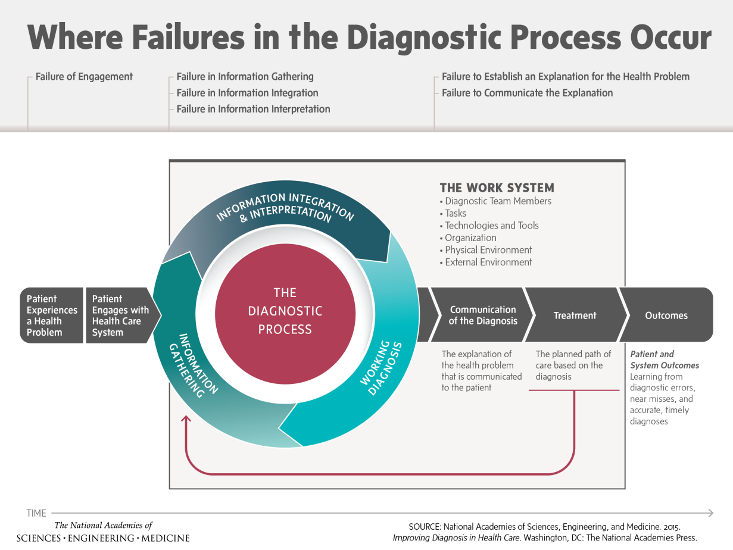

Reports

State of the World's Antibiotics, 2015
Center for Disease Dynamics, Economics & Policy
Washington, D.C.: CDDEP; 2015. p. 84.
URL | http://cddep.org/publications/state_worlds_antibiotics_2015
Notes | This report from the [US] Center for Disease Dynamics, Economics, and Policy is accompanied by interactive maps (available at http://resistancemap.cddep.org/) that show resistance trends by country. The report seeks to address the questions:  What is the current state of antibiotic use and resistance in humans and animals around the globe? In low- and middle-income countries? What national-level strategies can help countries combat antibiotic resistance?  The interactive maps show drug resistance trends in 39 countries and antibiotic use in 69 nations. They track infections caused by 12 common and sometimes lethal bacteria, including Escherichia coli, Salmonella, and methicillin-resistant Staphylococcus aureus (MRSA).  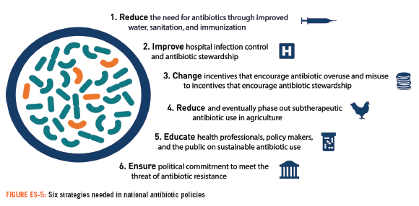

For information on the Commission’s work on healthcare associated infection, including antimicrobial resistance and antimicrobial stewardship, see http://www.safetyandquality.gov.au/our-work/healthcare-associated-infection/

Never Events for Hospital Care in Canada: Safer Care for Patients
Health Quality Ontario and Canadian Patient Safety Institute
Toronto: Health Quality Ontario and Canadian Patient Safety Institute; 2015.
URL | http://www.hqontario.ca/about-us/news-and-media/new-list-of-never-events-for-hospital-care-in-canada
TRIM | D15-33783
Notes | A group of Canadian health care organizations have compiled this list of eleven patient safety incidents (considered ‘never event’s) that should never happen in Canadian hospitals. Led by Health Quality Ontario and supported by the Canadian Patient Safety Institute, the report’s authors apply the definition that:  Never events are patient safety incidents that result in serious patient harm or death, and that can be prevented by using organizational checks and balances.  In addition to the ‘never events’ listed, the group assessed a number of other events that they deemed not to be ‘never events’, due to lack of preventability, were better reflected by other events, criminality, etc.  The never events include:  - Surgery on the wrong body part or the wrong patient, or conducting the wrong procedure  - Wrong tissue, biological implant or blood product given to a patient  - Unintended foreign object left in a patient following a procedure  - Patient death or serious harm arising from the use of improperly sterilized instruments or equipment provided by the health care facility  - Patient death or serious harm due to a failure to inquire whether a patient has a known allergy to medication, or due to administration of a medication where a patient’s allergy had been identified  - Patient death or serious harm due to the administration of the wrong inhalation or insufflation gas  - Patient death or serious harm as a result of one of five pharmaceutical events  - Wrong-route administration of chemotherapy agents  - Intravenous administration of a concentrated potassium solution  - Inadvertent injection of epinephrine intended for topical use  - Overdose of hydromorphone by administration of a higher-concentration solution than intended  - Neuromuscular blockade without sedation, airway control and ventilation capability  - Patient death or serious harm as a result of failure to identify and treat metabolic disturbances  - Any stage III or stage IV pressure ulcer acquired after admission to hospital  - Patient death or serious harm due to uncontrolled movement of a ferromagnetic object in an MRI area  - Patient death or serious harm due to an accidental burn.

Putting the pieces together: removing the barriers to excellent patient care
Royal College of Physicians
London: Royal College of Physicians; 2015. p. 12.
URL | https://www.rcplondon.ac.uk/press-releases/patients-still-face-fragmented-care-when-trying-negotiate-nhs-services
Notes | The [UK] Royal College of Physicians has released this brief report outlining some of the structural and systematic challenges patients face but also offering a vision of how to reform and improve the systems and structures that underpin the NHS.  As the RCP’s site notes, the report shows that in some areas of patient care, physicians have found that services are planned and commissioned in such a fragmented way that care is often disrupted and in some cases not available at all. As the complexity of accessing the many diverse services, often in different places, with different healthcare providers and professionals becomes just too complicated for patients to negotiate.  The report also describes examples of how strong collaborative relationships have developed to improve patient care. To support such models, the report has priority areas for action and a set of core principles outlining how clinicians commissioners and service planners and clinicians can support excellent patient care. These include:  - Empowering commissioners to collaborate  - Valuing quality of care above competition  - Valuing clinical engagement and joined up leadership  - Not making short-term plans for long term problems  - Building better payment systems  - Fostering a sustainable workforce  - Promoting innovation.

For information on the Commission’s work on patient and consumer centred care, see http://www.safetyandquality.gov.au/our-work/patient-and-consumer-centred-care/

Journal articles

Trustworthy guidelines – excellent; customized care tools – even better
Elwyn G, Quinlan C, Mulley A, Agoritsas T, Vandvik PO, Guyatt G
BMC Medicine. 2015;13(1):1-5.
DOI | http://dx.doi.org/10.1186/s12916-015-0436-y
Notes | The role and utility of guidelines has seen some debate – and some activity to move towards more trustworthy guidelines and ways to better use that knowledge in routine care. This paper reflects some of this but focuses on that the “case to be made for creating tools that translate existing evidence into tools to help patients and clinicians work together to decide next steps”. The authors encourage a future in which “trustworthy evidence can be used collaboratively in clinical encounters, with clinicians willing and able to achieve shared decision making with patients. Such tools would include patients in the development process, and would move away from the view that medicine has to be determined solely by ‘what is medically best’ and allow patients’ priorities, concerns, and preferences to be considered as well. It is time to move beyond the limitations of current clinical practice guidelines and focus our energy on tools that will help facilitate customized care at the level of individuals and their families.”

For information on the Commission’s work on shared decision making, see http://www.safetyandquality.gov.au/our-work/shared-decision-making/

Reducing pain during vaccine injections: clinical practice guideline
Taddio A, McMurtry CM, Shah V, Riddell RP, Chambers CT, Noel M, et al
Canadian Medical Association Journal. 2015 September 22, 2015;187(13):975-82.
DOI | http://dx.doi.org/10.1503/cmaj.150391
Notes | The pain experienced when being vaccinated may seem trivial; but for some it can be the hurdle that cannot be overcome and the cause of refusal or non-compliance. Or as the authors of this piece put it, “concerns about pain contribute to vaccine hesitancy across the lifespan”. This paper reports on a Canadian effort to develop/extend a clinical practice guideline on reducing pain during vaccination across the lifespan. The guideline provides recommendations for interventions that can mitigate vaccination pain and many of the interventions are feasible across vaccination settings. While the confidence in many of the interventions is not very strong, the large range of interventions may offer some options that clinicians may consider using.

BMJ Quality and Safety
October 2015, Vol. 24, Issue 10
URL | http://qualitysafety.bmj.com/content/24/10
Notes | A new issue of BMJ Quality and Safety has been published. Many of the papers in this issue have been referred to in previous editions of On the Radar (when they were released online). Articles in this issue of BMJ Quality and Safety include:  - Editorial: The wisdom of patients and families: ignore it at our peril (Liam J Donaldson)  - Editorial: Venous thromboembolism prophylaxis: a path toward more appropriate use (Paul J Grant, Scott A Flanders)  - Editorial: The Quadruple Aim: care, health, cost and meaning in work (Rishi Sikka, Julianne M Morath, Lucian Leape)  - The problem with eliminating ‘low-value care’ (Alan Willson)  - How can healthcare standards be standardised? (Charles D Shaw)  - A patient-initiated voluntary online survey of adverse medical events: the perspective of 696 injured patients and families (Frederick S Southwick, Nicole M Cranley, Julia A Hallisy)  - Infection prevention and control in nursing homes: a qualitative study of decision-making regarding isolation-based practices (Catherine Crawford Cohen, Monika Pogorzelska-Maziarz, Carolyn T A Herzig, Eileen J Carter, Ragnhildur Bjarnadottir, Patricia Semeraro, Jasmine L Travers, P W Stone)  - Impact of laws aimed at healthcare-associated infection reduction: a qualitative study (Patricia W Stone, Monika Pogorzelska-Maziarz, Julie Reagan, Jacqueline A Merrill, Brad Sperber, Catherine Cairns, Matthew Penn, Tara Ramanathan, Elizabeth Mothershed, Elizabeth Skillen)  - Integrating empowerment evaluation and quality improvement to achieve healthcare improvement outcomes (Abraham Wandersman, Kassandra Ann Alia, Brittany Cook, Rohit Ramaswamy)  - A unit-based intervention aimed at improving patient adherence to pharmacological thromboprophylaxis (Charles Alexander Baillie, James P Guevara, Raymond C Boston, Todd E H Hecht)

BMJ Quality and Safety online first articles
URL | http://qualitysafety.bmj.com/content/early/recent
Notes | BMJ Quality and Safety has published a number of ‘online first’ articles, including:  - Perioperative diabetes care: development and validation of quality indicators throughout the entire hospital care pathway (Inge Hommel, Petra J van Gurp, Cees J Tack, Hub Wollersheim, Marlies EJL Hulscher)

International Journal for Quality in Health Care online first articles
URL | http://intqhc.oxfordjournals.org/content/early/recent?papetoc
Notes | International Journal for Quality in Health Care has published a number of ‘online first’ articles, including:  - Patients' use of digital audio recordings in four different outpatient clinics (Maiken Wolderslund, Poul-Erik Kofoed, René Holst, and J Ammentorp)

Online resources

[UK] NHS Atlas of Variation in Healthcare
http://www.rightcare.nhs.uk/atlas
Public Health England (PHE), NHS England and NHS Right Care have launched the latest and biggest NHS Atlas of Variation in Healthcare to help commissioners, service providers and health professionals deliver the best healthcare.
The NHS Atlas of Variation in Healthcare 2015 identifies where opportunities to address ‘unwarranted’ variation exist – by revealing the possible over-use and under-use of different aspects of healthcare.
The data comes with supporting commentary, links to resources and ‘options for action’ so services can learn from the highest achieving areas.
This NHS Atlas of Variation in Healthcare Compendium 2015 is the 9th in a series of NHS Atlases of Variation. All of the atlases are available as PDF downloads and as InstantAtlas interactive tools at www.rightcare.nhs.uk/atlas
Patient groups can also use this opportunity to increase patient knowledge of what constitutes high quality care and to engage with clinicians in this debate.

For information on the Commission’s work on variation in health care, including the forthcoming Australia Atlas of Healthcare Variation, see http://www.safetyandquality.gov.au/our-work/variation-in-health-care/

Patient Blood Management Guidelines: Module 6 Neonatal and Paediatrics
http://www.blood.gov.au/public-consultation
The National Blood Authority is seeking input and feedback on their draft Patient Blood Management Guidelines: Module 6 Neonatal and Paediatrics. Submissions will be accepted until 5:00pm Friday 23 October 2015.

Disclaimer
On the Radar is an information resource of the Australian Commission on Safety and Quality in Health Care. The Commission is not responsible for the content of, nor does it endorse, any articles or sites listed. The Commission accepts no liability for the information or advice provided by these external links. Links are provided on the basis that users make their own decisions about the accuracy, currency and reliability of the information contained therein. Any opinions expressed are not necessarily those of the Australian Commission on Safety and Quality in Health Care.

