# Australian COmmission on Safety and Quality in Health Care logo with Radar imageOn the Radar

Issue 245

19 October 2015

*On the Radar* is a summary of some of the recent publications in the areas of safety and quality in health care. Inclusion in this document is not an endorsement or recommendation of any publication or provider. Access to particular documents may depend on whether they are Open Access or not, and/or your individual or institutional access to subscription sites/services. Material that may require subscription is included as it is considered relevant.

*On the Radar* is available online, via email or as a PDF document from <http://www.safetyandquality.gov.au/publications-resources/on-the-radar/>

If you would like to receive *On the Radar* via email, you can subscribe on our website <http://www.safetyandquality.gov.au/> or by emailing us at H[Umail@safetyandquality.gov.auU](mailto:mail@safetyandquality.gov.au).   
You can also send feedback and comments to H[Umail@safetyandquality.gov.auU](mailto:mail@safetyandquality.gov.au).

For information about the Commission and its programs and publications, please visit <http://www.safetyandquality.gov.au>

You can also follow us on Twitter @ACSQHC.

**On the Radar**

Editor: Dr Niall Johnson [niall.johnson@safetyandquality.gov.au](mailto:niall.johnson@safetyandquality.gov.au)

Contributors: Niall Johnson, Luke Slawomirski

**Reports**

*Antimicrobial Resistance in G7 Countries and Beyond: Economic Issues, Policies and Options for Action*

Cecchini M, Langer J, Slawomiriski L

Paris: OECD; 2015. p. 75.

|  |  |
| --- | --- |
| URL | <http://www.oecd.org/health/health-systems/antimicrobial-resistance.htm> |
| Notes | The increasing recognition of the importance of antimicrobial resistance is reflected in this OECD report created for the recent G7 Health Ministers Meeting.  Among the report’s key findings:   * **Antimicrobial resistance** is rapidly becoming a top health problem that could pose a **significant challenge** to the functioning of **healthcare systems** and their budget. * Interventions to tackle excessive or unnecessary use of antimicrobial therapies (AMTs) as well as interventions to prevent the transmission of antimicrobial-resistant microorganisms (ARMs) are needed to contain the health and economic burden caused by antimicrobial resistance (AMR). * The spreading of ARMs from one country to others makes AMR a unique global health challenge requiring a multifaceted and comprehensive approach. * **Patients** infected by ARMs are **significantly more likely to develop complications** (e.g. +13% limb loss and +71% complications in the central nervous system for infections by methicillin-resistant *S. Aureus*) and **to die** (e.g. up to 2-3 times higher mortality depending on the microorganism). * Globally, **700,000 deaths** may be caused **each year** by ARMs. * Compared to a world with no AMR, the economic impact associated with current rates of AMR may reach about 0.03% of GDP in OECD countries in 2020, 0.07% in 2030 and 0.16% in 2050. This would result in **cumulative losses of about USD 2.9 trillion**. * Trade and agriculture is among the sectors of the wider economy that is most likely to be affected by AMR. * Only a minority of countries around the world have implemented response plans and policies to tackle AMR. * Well-designed and implemented **stewardship programmes** targeting hospital healthcare personnel may **decrease antibiotic prescription and consumption** by 20-40% and **reduce the prevalence** of ARMs by 9.4%.   The report is accompanied by a policy brief. |

For information on the Commission’s work on health care associated infection, including antimicrobial resistance and antibiotic stewardship, see <http://www.safetyandquality.gov.au/our-work/healthcare-associated-infection/>

*Measuring the performance of local health systems: A review for the Department of Health*

Ham C, Raleigh V, Foot C, Robertson R, Alderwick H.

The King's Fund; 2015. p. 102.

|  |  |
| --- | --- |
| URL | <http://www.kingsfund.org.uk/publications/articles/measuring-performance-local-health-systems> |
| TRIM | D15-36166 |
| Notes | The UK charity The King’s Fund was commissioned by the UK Department of Health to review how the performance of local health systems could be assessed. The review examined how to measure the performance of health services within clinical commissioning group (CCG) areas, including how well these services work with social care and public health services.  The authors:   * Recommend a radical simplification and alignment of existing NHS performance frameworks into a single framework covering the NHS, public health and adult social care. * Recommend a small set of headline indicators are selected to present key performance information to the public. It is important to engage with the public to determine what indicators should be used and what domains to be covered as this is an evidence-free zone. A larger set of indicators should be available to enable patients and the public to drill down into population groups and medical conditions of particular interest to them and to support commissioners and providers in quality improvement. * Do not recommend using this data to provide an aggregate score of performance * Recommend that a wide variety of data should be made available for the purpose of transparency and to support the improvement in care by commissioners and providers. * Recommend that there is a consolidation of the disparate array of websites presenting information about local health system performance. |

*Indicators of quality of care in general practices in England: An independent review for the Secretary of State for Health*

Dixon J, Spencelayh E, Howells A, Mandel A, Gille F

London: Health Foundation; 2015. p. 112.

|  |  |
| --- | --- |
| URL | <http://www.health.org.uk/publication/indicators-quality-care-general-practices-england> |
| TRIM | D15-36165 |
| Notes | The UK charity Health Foundation was commissioned by the UK Secretary of State for Health to undertake a brief review of indicators of the quality of care provided by general practices in England. The authors examined how indicators could be developed to generate meaningful information that supports improvements to care and helps the public choose which practice might best meet their needs.  The authors made a series of recommendations to government, including:   * developing a small set of indicators that show information about what matters most to the public, health care professionals and those accountable for the quality of general practice * consolidating the multiple existing websites currently sharing information about general practice quality, with information selected and presented to meet the differing needs of health care professionals and the public * developing a national strategy for improving the quality of general practice and primary care that guides indicator development, with progress assessed through the Secretary of State’s annual report * providing support to those working in general practice about how to understand and use information to improve patient care.   The review also strongly advises against making a composite score out of selected indicators to indicate the quality of care overall in general practice, or for particular population groups. |

*Making Time in General Practice*

Clay H, Stern R

London: NHS Alliance and Primary Care Foundation; 2015. p. 83.

|  |  |
| --- | --- |
| URL | <http://www.nhsalliance.org/mediacentre/making-time-in-general-practice> |
| Notes | The NHS Alliance and Primary Care Foundation were commissioned by NHS England to study GP working practices with a view to finding ways of improving them. The authors suggest that possibly as much as **27% of GP appointments could potentially be avoided** if there was **more coordinated working** between GPs and hospitals, wider use of **other primary care staff**, better use of **technology** to streamline administrative burdens, and wider **system changes**.  The authors argue that a significant amount of GP time could be freed up if they were not having to spend time rearranging hospital appointments, and chasing up test results from local hospitals. This work accounted for 4.5% of appointments in the study.  The report also estimated that 1 in 6 of the patients in the study could potentially have been seen by someone else in the wider primary care team, such as clinical pharmacists, practice nurses or physician assistants, or by being supported to meet their own health needs.  The report states:   * 6.5% of their appointments could have been seen by another professional within the practice; * 5.5% could have been seen by community pharmacy or the patient could have been given support to deal with the problem through self-care, and; * 4% of appointments might have been dealt with through social prescribing / navigation. |

*U.S. Health Care from a Global Perspective: Spending, Use of Services, Prices, and Health in 13 Countries*

D. Squires and C. Anderson

New York: The Commonwealth Fund; 2015.

|  |  |
| --- | --- |
| URL | <http://www.commonwealthfund.org/publications/issue-briefs/2015/oct/us-health-care-from-a-global-perspective> |
| Notes | Anyone familiar with other Commonwealth Fund comparative reports (or indeed any comparison of US healthcare with that of peer nations) will be unsurprised to read that health costs/spending in the USA is substantially higher than in peer developed nations, including Australia.  Using data from the OECD and other cross-national analyses the report compares health care spending, supply, utilisation, prices, and health outcomes across 13 high-income countries: Australia, Canada, Denmark, France, Germany, Japan, Netherlands, New Zealand, Norway, Sweden, Switzerland, the United Kingdom, and the United States.  The analysis suggests that drivers of this difference are “**greater use of medical technology and higher health care prices**, rather than more frequent doctor visits or hospital admissions. In contrast, U.S. spending on social services made up a relatively small share of the economy relative to other countries. Despite spending more on health care, Americans had poor health outcomes, including shorter life expectancy and greater prevalence of chronic conditions.” However, it is wrong to conclude from this that the Australian experience is an entirely positive one as Australians have one of the larger out-of-pocket expenditures. |

**Journal articles**

*Living In A Country With A Strong Primary Care System Is Beneficial To People With Chronic Conditions*

Hansen J, Groenewegen PP, Boerma WGW, Kringos DS

Health Affairs. 2015 September 1, 2015;34(9):1531-7.

|  |  |
| --- | --- |
| DOI | <http://dx.doi.org/10.1377/hlthaff.2015.0582> |
| Notes | Paper reporting on a study that used survey data across 27 European countries to examine whether strong primary care was associated with improved health outcomes for those with chronic illness. The study examined five dimensions of care: structure, accessibility, continuity, coordination, and comprehensiveness.  Unsurprisingly, the authors found that people with chronic conditions were more likely to be in good or very good health in countries that had a stronger primary care structure and better coordination of care. They noted that “while having access to a strong primary care system mattered for people with chronic conditions, the degree to which it mattered differed across specific subgroups (for example, people with primary care–sensitive conditions) and primary care dimensions. Primary care reforms, therefore, should be person centered, addressing the needs of subgroups of patients while also finding a balance between structure and service delivery.” |

*Patient satisfaction surveys and care quality: a continuum conundrum*

Hutchinson M, Jackson D

Journal of Nursing Management. 2015;23(7):831-2.

|  |  |
| --- | --- |
| DOI | <http://dx.doi.org/10.1111/jonm.12339> |
| Notes | Editorial recounting the rise (and fall) of patient satisfaction measures “as drivers of quality and accountability”, particularly from the nursing perspective. Much of the debate has moved on from patient satisfaction to the broader scope of patient experience (along the entire patient journey), partly in response to the concern that satisfaction was influenced by factors that do not depend upon or determine clinical quality and safety of care. These are reflected in the conclusion to this editorial: “**Improving patient outcomes and experience of the care journey remains a central tenet of nursing practice**. Few nurses would dispute that quality of care is influenced by nurse-patient relationships. It is also likely that most nurses would agree that patients are good discriminators about the quality of their healthcare experience. In the current environment there is a risk that patient satisfaction will be taken as a proxy measure for nursing care quality. Without careful consideration of the nexus between patient satisfaction and care quality there is a risk that efforts may be directed towards improving scores on satisfaction surveys, rather than **improving the patient experience and outcomes from nursing care**.” |

For information on the Commission’s work on patient experience measures, see <http://www.safetyandquality.gov.au/our-work/information-strategy/indicators/hospital-patient-experience/>

For information on the Commission’s work on patient and consumer centred care, see <http://www.safetyandquality.gov.au/our-work/patient-and-consumer-centred-care/>

*BMJ Quality and Safety* online first articles

|  |  |
| --- | --- |
| URL | <http://qualitysafety.bmj.com/content/early/recent> |
| Notes | *BMJ Quality and Safety* has published a number of ‘online first’ articles, including:   * Editorial: Identifying **adverse events after outpatient surgery**: improving measurement of patient safety (Amy K Rosen, Hillary J Mull) * **Patient safety climate** strength: a concept that requires more attention (Liane Ginsburg, Debra Gilin Oore) * A mixed-methods investigation of health professionals’ perceptions of a **physiological track and trigger system** (Sinéad Lydon, Dara Byrne, Gozie Offiah, Louise Gleeson, Paul O'Connor) * Measuring **patient-perceived quality of care** in US hospitals using Twitter (Jared B Hawkins, John S Brownstein, Gaurav Tuli, Tessa Runels, Katherine Broecker, Elaine O Nsoesie, David J McIver, Ronen Rozenblum, Adam Wright, Florence T Bourgeois, Felix Greaves) * Linking **social media and medical record data**: a study of adults presenting to an academic, urban emergency department (Kevin A Padrez, Lyle Ungar, Hansen Andrew Schwartz, Robert J Smith, Shawndra Hill, Tadas Antanavicius, D M Brown, P Crutchley, D A Asch, R M Merchant) * Do patients with gastrointestinal cancer want to decide where they have tests and surgery? A questionnaire study of **provider choice** (Ben E Byrne, Omar D Faiz, Charles Vincent) * Differing perceptions of **safety culture** across job roles in the **ambulatory setting**: analysis of the AHRQ Medical Office Survey on Patient Safety Culture (John Hickner, Scott A Smith, Naomi Yount, Joann Sorra) * Underlying risk factors for **prescribing errors in long-term aged care**: a qualitative study (Amina Tariq, Andrew Georgiou, Magdalena Raban, Melissa Therese Baysari, Johanna Westbrook) |

*International Journal for Quality in Health Care* online first articles

|  |  |
| --- | --- |
| URL | <http://intqhc.oxfordjournals.org/content/early/recent?papetoc> |
| Notes | *International Journal for Quality in Health Care* has published a number of ‘online first’ articles, including:   * Documentation and disclosure of **adverse events** that led to compensated patient injury in a Norwegian university hospital (Susanne Skjervold Smeby, Roar Johnsen, and Gudmund Marhaug) * Quality management and perceptions of **teamwork and safety climate** in European hospitals (Solvejg Kristensen, Antje Hammer, Paul Bartels, Rosa Suñol, Oliver Groene, Caroline A. Thompson, Onyebuchi A. Arah, Halina Kutaj-Wasikowska, Philippe Michel, and Cordula Wagner) * Population **experiences of primary care** in 11 Organization for Economic Cooperation and Development countries (James Macinko and Frederico C. Guanais) * Implementation of a multidisciplinary clinical pathway for the management of **postpartum hemorrhage**: a retrospective study (Hee Young Cho, Sungwon Na, Man Deuk Kim, Incheol Park, Hyun Ok Kim, Young-Han Kim, Yong-Won Park, Ja Hae Chun, Seon Young Jang, Hye Kyung Chung, Dawn Chung, Inkyung Jung, and Ja-Young Kwon) * **Quality improvement and accountability** in the Danish health care system (Jan Mainz, Solvejg Kristensen, and Paul Bartels) * The **internal audit of clinical areas**: a pilot of the internal audit methodology in a health service emergency department (Alison Brown, Mario Santilli, Belinda Scott) * Predictors and outcomes of **unplanned readmission to a different hospital** (Hongsoo Kim, William W. Hung, Myunghee Cho Paik, Joseph S. Ross, Zhonglin Zhao, Gi-Soo Kim, Kenneth Boockvar) |

**Online resources**

*e-Mental health: a guide for GPs*

<http://www.racgp.org.au/your-practice/guidelines/e-mental-health/>

The Royal Australian College of General Practitioners (RACGP) has developed *e-Mental health: A guide for GPs* to assist General Practitioners in using e-mental health interventions with their patients. The Guide is designed to provide an introduction to the field of e-mental health, provide links to key online resources for GPS and their patients, and help GPs to determine how to use e-mental health in their practice.

*How experience impacts quality*

<http://www.aprilstrategy.com/infographic/>

Infographic summarising some of the evidence on the relationship between patient experience, health staff engagement and care quality.

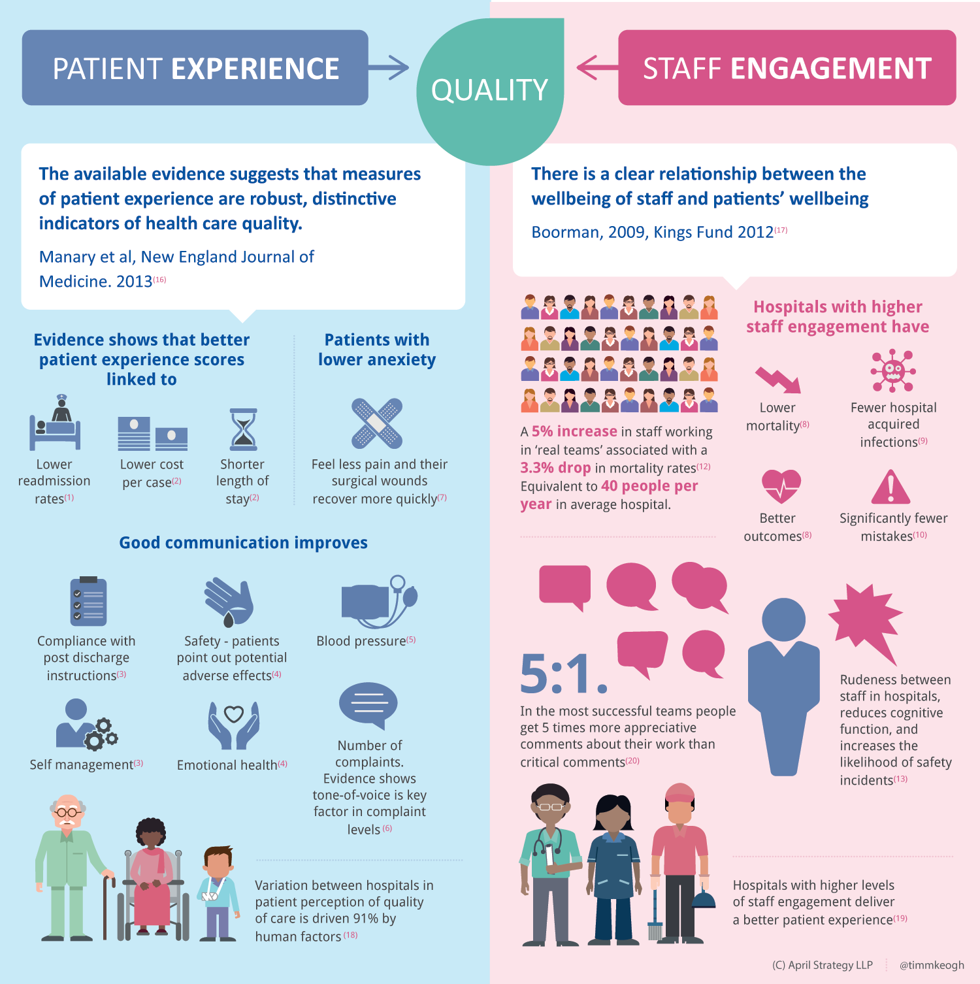

**Disclaimer**

*On the Radar* is an information resource of the Australian Commission on Safety and Quality in Health Care. The Commission is not responsible for the content of, nor does it endorse, any articles or sites listed. The Commission accepts no liability for the information or advice provided by these external links. Links are provided on the basis that users make their own decisions about the accuracy, currency and reliability of the information contained therein. Any opinions expressed are not necessarily those of the Australian Commission on Safety and Quality in Health Care.