
On the Radar
Issue 248
9 November 2015

On the Radar is a summary of some of the recent publications in the areas of safety and quality in health care. Inclusion in this document is not an endorsement or recommendation of any publication or provider. Access to particular documents may depend on whether they are Open Access or not, and/or your individual or institutional access to subscription sites/services. Material that may require subscription is included as it is considered relevant.

On the Radar is available online, via email or as a PDF document from http://www.safetyandquality.gov.au/publications-resources/on-the-radar/

If you would like to receive On the Radar via email, you can subscribe on our website http://www.safetyandquality.gov.au/ or by emailing us at HUmail@safetyandquality.gov.auU.
You can also send feedback and comments to HUmail@safetyandquality.gov.auU.

For information about the Commission and its programs and publications, please visit http://www.safetyandquality.gov.au
You can also follow us on Twitter @ACSQHC.
On the Radar
Editor: Dr Niall Johnson niall.johnson@safetyandquality.gov.au
Contributors: Niall Johnson

Reports

Rapid Diagnostics: Stopping unnecessary use of antibiotics
Review on Antimicrobial Resistance
London: Review on Antimicrobial Resistance; 2015. p. 39.
URL | http://amr-review.org/
Notes | The UK’s Review on Antimicrobial Resistance committee have published their latest report. This report provides an overview of how diagnostics can play an important role in the fight against antimicrobial resistance, by reducing unnecessary use, particularly outside of hospital usage. In many hospital settings the use of antimicrobial stewardship systems has allowed for more appropriate use of antibiotics. This report suggests that better and more rapid diagnostics can also aid in the more appropriate and targeted use of antimicrobials.

For information on the Commission’s work on antimicrobial use and resistance, see http://www.safetyandquality.gov.au/national-priorities/amr-and-au-surveillance-project/

Journal articles

10 new rules to accelerate healthcare redesign
Loehrer S, Feeley D, Berwick DM
Healthcare Executive. 2015;30(6):66-9.
URL | http://www.ihi.org/resources/Pages/Publications/10NewRulesAccelerateHealthcareRedesign.aspx
Notes | The (US) Institute for Healthcare Improvement have made this article written by three of their senior staff available on their site. The article describes ten "new rules" that were developed and are being tested by members of the IHI Leadership Alliance as a set of guiding principles to help accelerate their progress toward delivering on the full promise of the Triple Aim (simultaneously improving the health of the population, enhancing the experience and outcomes of the patient, and reducing per capita cost of care for the benefit of communities).  The suggested rules are:  - Change the balance of power  - Standardize what makes sense  - Customize to the individual  - Promote well-being  - Create joy in work  - Make it easy  - Move knowledge, not people  - Collaborate and cooperate  - Assume abundance  - Return the money.  The article also briefly describes three case studies. The authors also warn that “comprehensive, radical redesign…is not for the timid” and that “Leaders need to be generous with power, seeking to uncover the assets and ambitions of their staff, patients and communities. Leaders need to be curious, eager to seek assistance from others outside their organizations and even outside the healthcare field. And they need to be courageous, committed to finding and testing new ideas and welcoming of not only successes but also failures, which can provide badly needed insights for course corrections and next steps.”

Consumer participation in early detection of the deteriorating patient and call activation to rapid response systems: a literature review
Vorwerk J, King L
Journal of Clinical Nursing. 2015 [epub].
DOI | http://dx.doi.org/10.1111/jocn.12977
Notes | The value and utility of rapid response teams (RRT) or medical emergency teams (MET) has been examined in recent years. This paper reviewed that literature (11 studies published in 2006–2014) focusing on the role of consumers (patients, families, etc.). The review found that consumer education programs for team activation led to more rapid response/medical emergency calls by both consumers and clinicians and was associated with decreased rates of patient mortality.

For information on the Commission’s work on recognising and responding to clinical deterioration, see http://www.safetyandquality.gov.au/our-work/recognising-and-responding-to-clinical-deterioration/

Six habits to enhance MET performance under stress: A discussion paper reviewing team mechanisms for improved patient outcomes
Fein EC, Mackie B, Chernyak-Hai L, O’Quinn CRV, Ahmed E
Australian Critical Care [epub].
DOI | http://dx.doi.org/10.1016/j.aucc.2015.07.006
Notes | This (Australian) paper also looks at the MET/RRT, but this time focuses on the team itself and how a ‘shared mental model’ and team development can affect performance and outcomes. From their experience of developing and using a model decision making the authors offer recommendations aimed at enhancing MET decision making under stress.

Delayed Rapid Response Team Activation Is Associated With Increased Hospital Mortality, Morbidity, and Length of Stay in a Tertiary Care Institution
Barwise A, Thongprayoon C, Gajic O, Jensen J, Herasevich V, Pickering BW
Critical Care Medicine. 2015 [epub].
DOI | http://dx.doi.org/10.1097/CCM.0000000000001346
Notes | A further paper on rapid response systems. In this study examining all rapid response team activations in 2012 in a US teaching hospital covering 1725 adult patients. Patients were considered to have a delayed rapid response team activation if more than 1 hour passed between the first appearance in the record of an abnormal vital sign meeting rapid response team criteria and the activation of an rapid response team. 57% of patients had a delayed activation and those with delay had a higher proportion of calls between midnight and 08:00. The delayed group had higher hospital mortality (15% vs 8%); 30-day mortality (20% vs 13%); and hospital length of stay (7 vs 6 d) compared with the no-delay group.

Partnering with Parents and Families to Provide Safer Care: Seeing and Achieving Safer Care through the Lens of Patients and Families
Micalizzi D, Dahlborg T, Zhu H
Current Treatment Options in Pediatrics. 2015 2015/10/15:1-11.
URL | http://dx.doi.org/10.1007/s40746-015-0034-4
Notes | This piece discusses the need for and the difficulties in achieving patient-centred care, particularly in the paediatric setting. The authors describe a number of case studies, the various relationships involve across and within clinicians, clinical teams, patients and their families, and some of the lessons learned from their experiences. They also touch on some less discussed aspects, such as communicating with adolescents, bereavement and after-care. The authors see patient-centredness as enhancing the care experience in various ways: “Clinicians who demonstrate a family-centered approach to medical care are better positioned to create empathetic and collaborative partnerships. Using the lens of quality improvement will lead to improved medical outcomes, increased patient safety, and a decrease in the emotional detachment of the care team. As we become a more open medical community, the rewards for the children will be unparalleled, and we will reinforce the reason why we selected health care as our career”

For information on the Commission’s work on patient and consumer centred care, see http://www.safetyandquality.gov.au/our-work/patient-and-consumer-centred-care/

A Difference-in-Difference Analysis of Changes in Quality, Utilization and Cost Following the Colorado Multi-Payer Patient-Centered Medical Home Pilot
Rosenthal M, Alidina S, Friedberg M, Singer S, Eastman D, Li Z, et al.
Journal of General Internal Medicine. 2015 [epub]
DOI | http://dx.doi.org/10.1007/s11606-015-3521-1
Notes | This paper is an evaluation of a patient-centred medical home initiative involving 15 practices and 98,000 patients in the US state of Colorado. The evaluation found sustained reductions in hospital admissions and emergency department use (1.6 fewer ED visits per thousand member-months, or a 9.3 percent drop from baseline) over three years. However, quality-of-care results were varied, including cervical cancer screening rates improving but colon cancer screenings and haemoglobin testing for diabetes patients decreased.

Identifying priorities for improved child healthcare: A mixed methods analysis of safety incident reports
Rees P, Edwards A, Powell C, Williams H, Hibbert P, Makeham M, et al
BMJ Quality & Safety. 2015 November 1, 2015;24(11):730-1.

Vulnerable children and their care quality issues: A descriptive analysis of a national database
Omar A, Rees P, Evans HP, Williams H, Cooper A, Bannerjee S, et al
BMJ Quality & Safety. 2015 November 1, 2015;24(11):732-3.
DOIs | Rees et al http://dx.doi.org/10.1136/bmjqs-2015-IHIabstracts.16  Omar et al http://dx.doi.org/10.1136/bmjqs-2015-IHIabstracts.18
Notes | A pair of abstracts published in the BMJ Quality and Safety for the IHI meeting that differ from most abstracts in that they contain some specific content. In this instance they contain figures demonstrating how safety incident report data can be used to inform the production of priority driver diagrams. They also describe other improvement tools to illustrate findings from the data, including Ishikawa diagrams. These come from a UK project using a national database on children and healthcare incidents.  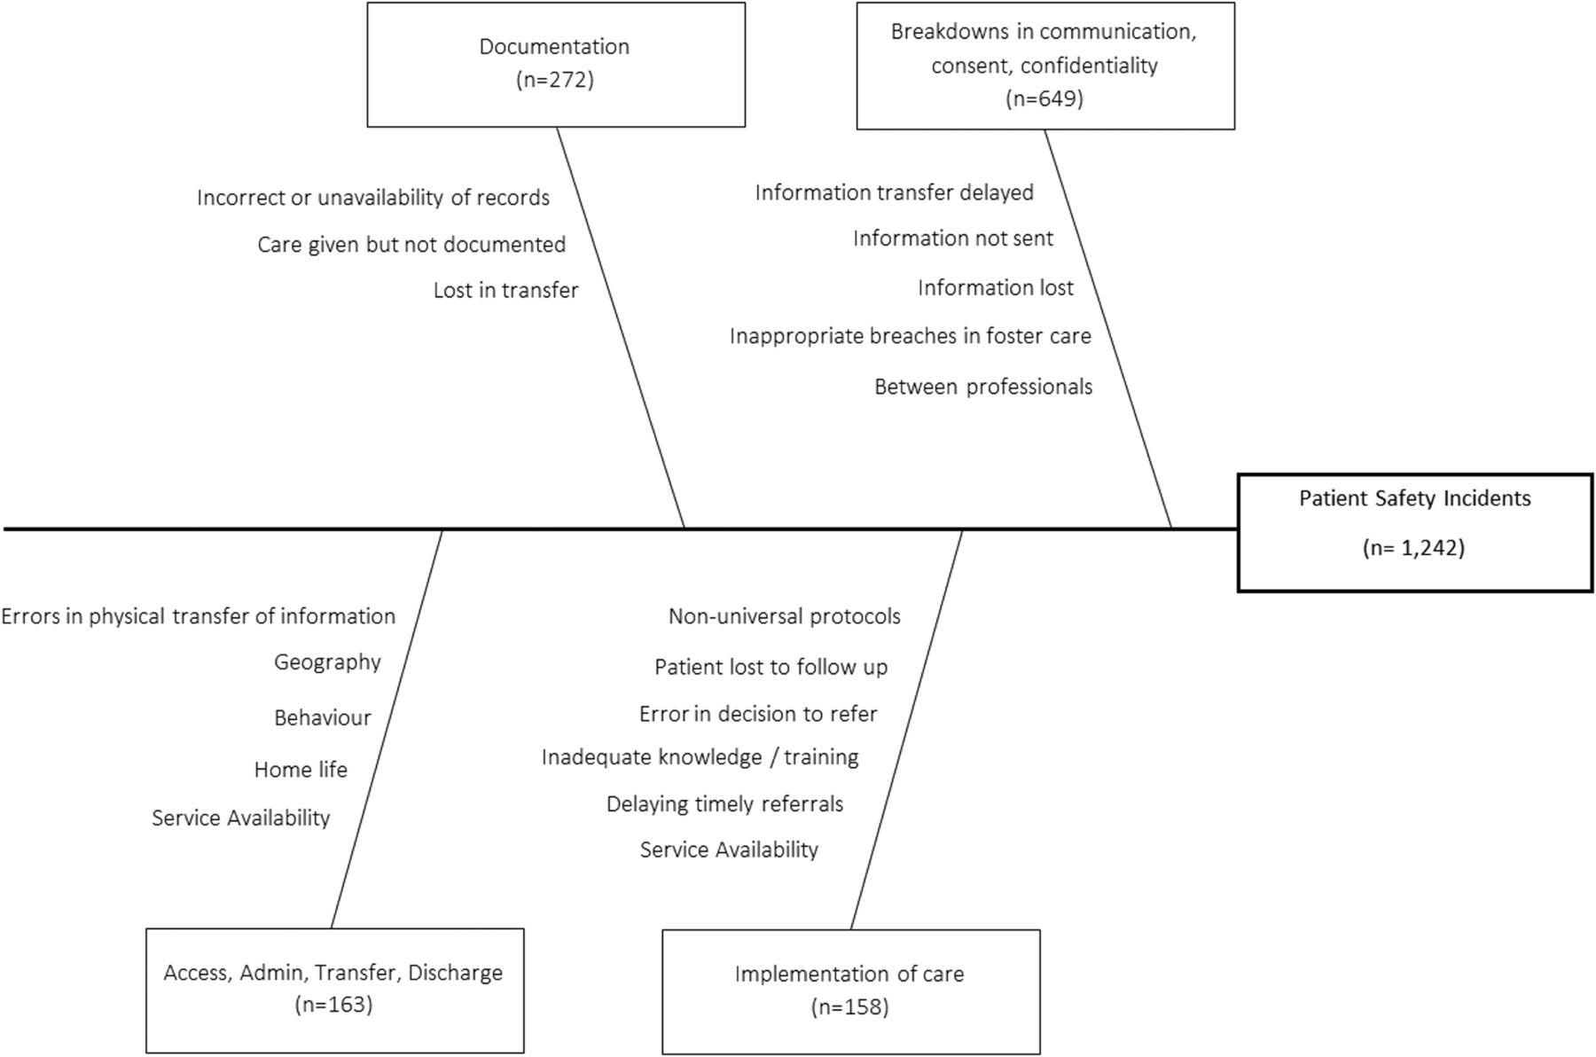  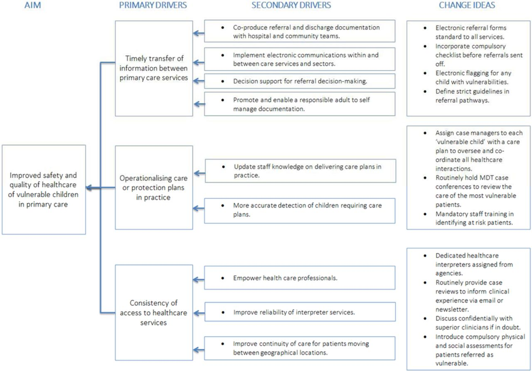

Australian Health Review
Volume 39 Number 5
URL | http://www.publish.csiro.au/nid/271/issue/7473.htm
Notes | A new issue of Australian Health Review has been published. Articles in this issue of Australian Health Review include:  - Is our health workforce prepared for future health megatrends? (G E Day)  - Models of care choices in today’s nursing workplace: where does team nursing sit? (Greg Fairbrother, Mary Chiarella and Jeffrey Braithwaite)  - Models of care involving district hospitals: a rapid review to inform the Australian rural and remote context (Susan A. Nancarrow, Alison Roots, Sandra Grace and Vahid Saberi)  - Implementation and impact of an extended-hours service in mental health care: lessons learned (Deanna Erskine, Barbara Baumgartner and Sue Patterson)  - A multi-organisation aged care emergency service for acute care management of older residents in aged care facilities (Jane Conway, Sophie Dilworth, Carolyn Hullick, Jacqueline Hewitt, C Turner and I Higgins)  - Evaluation of a mobile X-ray service for elderly residents of residential aged care facilities (Michael Montalto, Simon Shay and Andy Le)  - Can the simple clinical score usefully predict the mortality risk and length of stay for a recently admitted patient? (Minh T Nguyen, Richard J Woodman, Paul Hakendorf, Campbell H Thompson and Jeff Faunt)  - Relinquishing or taking control? Community perspectives on barriers and opportunities in advance care planning (Vanette E J McLennan, Jennifer H M Boddy, Michelle G Daly and Lesley M Chenoweth)  - National Emergency Access Targets metrics of the emergency department–inpatient interface: measures of patient flow and mortality for emergency admissions to hospital (Clair Sullivan, Andrew Staib, Rob Eley, Alan Scanlon, Judy Flores and Ian Scott)  - Back to basics: an audit of measurement of infant growth at presentation to hospital (Lesley Alison Williams, Robert S Ware and Peter S W Davies)  - The ‘unnecessary’ use of emergency departments by older people: findings from hospital data, hospital staff and older people (Debbie Faulkner and Julia Law)  - Advance care planning in 21st century Australia: a systematic review and appraisal of online advance care directive templates against national framework criteria (Tim Luckett, Priyanka Bhattarai, Jane Phillips, Meera Agar, David Currow, Yordanka Krastev and Patricia M Davidson)  - Sudden cardiac death rates in an Australian population: a data linkage study (Jia-Li Feng, Siobhan Hickling, Lee Nedkoff, Matthew Knuiman, Christopher Semsarian, Jodie Ingles and Tom G Briffa)  - Chronic wounds should be one of Australia’s National Health Priority Areas (Suzanne Kapp and Nick Santamaria)

BMJ Quality and Safety online first articles
URL | http://qualitysafety.bmj.com/content/early/recent
Notes | BMJ Quality and Safety has published a number of ‘online first’ articles, including:  - Procedural instruction in invasive bedside procedures: a systematic review and meta-analysis of effective teaching approaches (Grace C Huang, Jakob I McSparron, Ethan M Balk, Jeremy B Richards, C Christopher Smith, Julia S Whelan, Lori R Newman, Gerald W Smetana)  - Making comparative performance information more comprehensible: an experimental evaluation of the impact of formats on consumer understanding (Olga C Damman, Anco De Jong, Judith H Hibbard, Danielle R M Timmermans)  - Identifying patient safety problems associated with information technology in general practice: an analysis of incident reports (Farah Magrabi, Siaw Teng Liaw, Diana Arachi, William Runciman, Enrico Coiera, Michael R Kidd)  - Tall Man lettering and potential prescription errors: a time series analysis of 42 children's hospitals in the USA over 9 years (Wenjun Zhong, James A Feinstein, Neil S Patel, Dingwei Dai, Chirs Feudtner)  - Primary care physicians’ willingness to disclose oncology errors involving multiple providers to patients (Kathleen Mazor, Douglas W Roblin, Sarah M Greene, Hassan Fouayzi, Thomas H Gallagher)

International Journal for Quality in Health Care online first articles
URL | http://intqhc.oxfordjournals.org/content/early/recent?papetoc
Notes | International Journal for Quality in Health Care has published a number of ‘online first’ articles, including:  - Health information technology and team work to improve health care (Usman Iqbal, Shabbir Syed-Abdul, and Yu-Chuan (Jack) Li)

Online resources

Medical Devices Safety Update
Volume 3, Number 6, November 2015
http://www.tga.gov.au/publication-issue/medical-devices-safety-update-volume-3-number-6-november-2015
The Therapeutic Goods Administration (TGA) has released the latest edition of its medical device safety bulletin. Topics covered in this issue include:
- Joint registry data offers insight into Australian orthopaedic implants
- Reprocessing issues – health professionals are reminded of the need to ensure proper processes are followed when reprocessing (i.e. cleaning and sterilising) equipment used in operating rooms.
- ‘Mild’ hyperbaric chambers cancelled after advertising complaints – public complaints about therapeutic goods advertising can trigger a TGA investigation leading to their cancellation.
- Recent safety alerts

[UK] NICE Guidelines and Quality Standards
http://www.nice.org.uk
The UK’s National Institute for Health and Care Excellence (NICE) has published new (or updated) guidelines and quality standards. The latest updates are:
- NICE Guideline NG22 Older people with social care needs and multiple long-term conditions http://www.nice.org.uk/guidance/ng22

Disclaimer
On the Radar is an information resource of the Australian Commission on Safety and Quality in Health Care. The Commission is not responsible for the content of, nor does it endorse, any articles or sites listed. The Commission accepts no liability for the information or advice provided by these external links. Links are provided on the basis that users make their own decisions about the accuracy, currency and reliability of the information contained therein. Any opinions expressed are not necessarily those of the Australian Commission on Safety and Quality in Health Care.

