# Australian COmmission on Safety and Quality in Health Care logo with Radar imageOn the Radar

Issue 352

18 December 2017

*On the Radar* is a summary of some of the recent publications in the areas of safety and quality in health care. Inclusion in this document is not an endorsement or recommendation of any publication or provider. Access to particular documents may depend on whether they are Open Access or not, and/or your individual or institutional access to subscription sites/services. Material that may require subscription is included as it is considered relevant.

*On the Radar* is available online, via email or as a PDF or Word document from <https://www.safetyandquality.gov.au/publications-resources/on-the-radar/>

If you would like to receive *On the Radar* via email, you can subscribe on our website <https://www.safetyandquality.gov.au/> or by emailing us at H[Umail@safetyandquality.gov.auU](mailto:mail@safetyandquality.gov.au).   
You can also send feedback and comments to H[Umail@safetyandquality.gov.auU](mailto:mail@safetyandquality.gov.au).

For information about the Commission and its programs and publications, please visit <https://www.safetyandquality.gov.au>

You can also follow us on Twitter @ACSQHC.

**On the Radar**

Editor: Dr Niall Johnson [niall.johnson@safetyandquality.gov.au](mailto:niall.johnson@safetyandquality.gov.au)

Contributors: Niall Johnson

**National Safety and Quality Health Service Standards User Guide for Aboriginal and Torres Strait Islander Health**

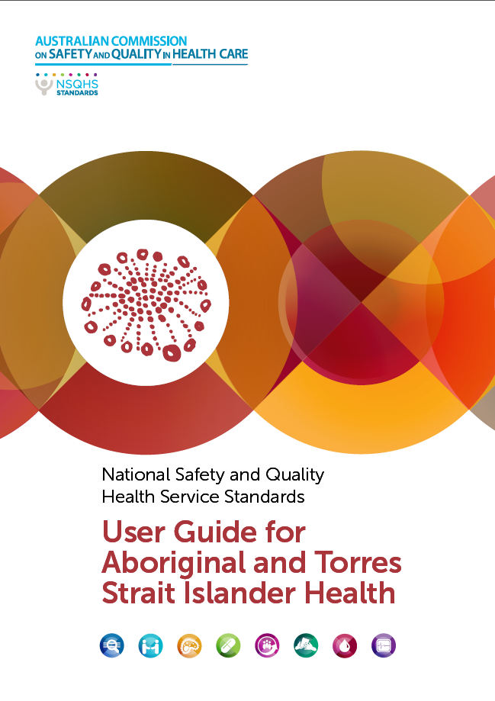The Wardliparingga Aboriginal Research Unit of the South Australian Health and Medical Research Institute

Sydney: Australian Commission on Safety and Quality in Health Care; 2017.

<https://www.safetyandquality.gov.au/our-work/assessment-to-the-nsqhs-standards/nsqhs-standards-second-edition/>

This User Guide provides health service organisations with practical strategies to improve care provided to Aboriginal and Torres Strait Islander people.

**Books**

*Combating Antimicrobial Resistance: A One Health Approach to a Global Threat: Proceedings of a Workshop*

National Academies of Sciences, Engineering, Medicine

Mundaca-Shah C, Ogawa VA, Nicholson A, editors

Washington, DC: The National Academies Press; 2017. 172 p.

|  |  |
| --- | --- |
| URL | <http://nationalacademies.org/hmd/Reports/2017/combating-antimicrobial-resistance-proceedings.aspx> |
| Notes | Antimicrobial resistance is understood to have the potential to render many of the current antimicrobials less effective. One of the challenges is the use of these is animal husbandry and food production as well as in human health. Consequently, a ‘One health’ approach, which this report typifies as “a collaborative approach of multiple disciplines—working locally, nationally, and globally—for strengthening systems to counter infectious diseases and related issues that threaten human, animal, and environmental health” has emerged. This is reflected in many national antimicrobial resistance and stewardship programs, such as in Australia. This volume summarises a two-day workshop held under the auspices of the Forum of Microbial Threats at the (US) National Academies of Sciences, Engineering and Medicine. |

For information on the Commission’s work on antimicrobial resistance, see <https://www.safetyandquality.gov.au/antimicrobial-use-and-resistance-in-australia/>

**Reports**

*Getting it Right for Children and Young People*

*Self assessment tool for general practice nurses and other first contact settings providing care for children and young people*

Royal College of Nursing

London: Royal College of Nursing; 2017. p. 22.

|  |  |
| --- | --- |
| URL | <https://www.rcn.org.uk/professional-development/publications/pub-006507> |
| Notes | The (UK) Royal College of Nursing has released this updated guidance that is intended to support nurses working outside of hospital settings in providing care to children and young people. One of the aims is to assist these nurses in reviewing their existing knowledge and skills, identifying their training needs and further developing their practice in discussion with their clinical supervisor. |

*Menopause*

*RCN guidance for nurses, midwives and health visitors*

Royal College of Nursing

London: Royal College of Nursing; 2017. p. 28.

|  |  |
| --- | --- |
| URL | <https://www.rcn.org.uk/professional-development/publications/pub-006329> |
| Notes | Also from the (UK) Royal College of Nursing is this guidance for health care professionals to gain awareness of the menopause and the safety and efficacy of modern therapy options available. To provide support and advice to women it is important that health care professionals understand the changes that women face at the time of their menopause and the issues related to improving health after menopause. This publication is endorsed by the British Menopause Society. |

**Journal articles**

*Organisational paradoxes in speaking up for safety: implications for the interprofessional field*

Rowland P

Journal of Interprofessional Care. 2017;31(5):553-6.

|  |  |
| --- | --- |
| DOI | <http://dx.doi.org/10.1080/13561820.2017.1321305> |
| Notes | Speaking up can be difficult. This can be made even more fraught in complex settings, such as where large, complex health systems and settings where inter-professional barriers or demarcations may be present. Among the discussion is the observation that “there is a risk that those who express the moral courage to speak up may find themselves met by organisational silence, particularly as they are learning whom to speak up to, to what intent, and to what effect. By risking these organisational silences, these programmes might actually participate in creating professional disengagement and future interprofessional silences. Tools that aid in the act of speaking up need to be accompanied by the situated learning of how to direct concerns, which networks to mobilise, and how to generate influence. The inherent tensions in these programmes might be managed through increased reflexivity, dialogue, and appreciation for the many interdependent networks that must articulate in order to create patient safety.” |

*Patient safety culture in care homes for older people: a scoping review*

Gartshore E, Waring J, Timmons S

BMC Health Services Research. 2017;17(1):752.

|  |  |
| --- | --- |
| DOI | <http://dx.doi.org/10.1186/s12913-017-2713-2> |
| Notes | Culture is critical to the success of any organisation. Some settings may prove more challenging, This paper reports on scoping review that sought to assess the status of safety culture and improvement in residential aged care (as much of the research and developments in safety culture has predominantly taken place in hospital settings). The authors report that the quantity and quality of the published of studies was lacking and that none of the reviewed studies included insights from the patients and families. From the 24 studies and one literature review they found that this research has been largely based in the USA, within Nursing Homes rather than Residential Home settings. |

*Economic evaluation of pharmacist-led medication reviews in residential aged care facilities*

Hasan SS, Thiruchelvam K, Kow CS, Ghori MU, Babar Z-U-D

Expert Review of Pharmacoeconomics & Outcomes Research. 2017;17(5):431-9.

*Towards a more patient-centered approach to medication safety*

Lee JL, Dy SM, Gurses AP, Kim JM, Suarez-Cuervo C, Berger ZD, et al

Journal of Patient Experience. 2017 [epub].

|  |  |
| --- | --- |
| DOI | Hassan et al <http://dx.doi.org/10.1080/14737167.2017.1370376>  Lee at al <http://dx.doi.org/10.1177/2374373517727532> |
| Notes | A couple of pieces that reveal have various ‘actors’ can play a role in enhancing medication safety.  The role and importance of pharmacist-involvement in many medication safety interventions is well recognised. This study adds to the knowledge on the economic impact of pharmacists on reducing inappropriate polypharmacy in aged care facilities and the cost-effectiveness of this.  The greater appreciation of the value and use of patient perspectives in ensuring quality and safety has spread to medication safety. In this commentary piece the potential of measuring medication safety via patient insight and how such evaluation may change the implementation of meditation safety initiatives are discussed.  The authors argue that  “A patient-centered approach to evaluating interventions therefore calls for a broader perspective of medication safety that incorporates   1. patient-reported measures, such as medication-related symptoms and burdens and 2. a patient-centered approach to measurement, including addressing long-term issues and those that affect the quality of life.”   As is often observed, health is a team game and the patient is a key member of the team (they are one who is always ‘on the field’). |

For information on the Commission’s work on medication safety, see <https://www.safetyandquality.gov.au/our-work/medication-safety/>

*Seen through the patients' eyes: safety of chronic illness care*

Desmedt M, Petrovic M, Bergs J, Vandijck D, Vrijhoef H, Hellings J, et al

International Journal for Quality in Health Care. 2017 [epub].

|  |  |
| --- | --- |
| DOI | <http://dx.doi.org/10.1093/intqhc/mzx137> |
| Notes | In keeping with the theme, this paper looks at the ways patients with chronic disease can identify safety issues in their care. Based on survey responses from 399respondents recruited from a European patient advocacy forum, the study found that a significant proportion identified safety incidents in their experiences of living with chronic illness, including falls, adverse drug events, and errors in diagnosis or treatment. According to the paper, “Almost **one quarter of respondents experienced an incident**, mainly related to self-reported **fall** incidents (50.4%), **wrong diagnoses or treatments** (37.8%) and **adverse drug events** (11.8%). Also, more than half of respondents who experienced an incident (64.9%) indicated that **poor communication** between their healthcare professionals was the main cause.”  This further extends the basis for engaging patients (and their families and carers) in safety and quality initiatives and interventions. |

For information on the Commission’s work on patient and consumer centred care, see <https://www.safetyandquality.gov.au/our-work/patient-and-consumer-centred-care/>

*HealthcarePapers*

*Vol. 17, No. 1, 2017*

|  |  |
| --- | --- |
| URL | <http://www.longwoods.com/publications/healthcarepapers/25331> |
| Notes | A new issue of *Healthcare Papers* has been published with the theme ‘Five Years of Experience Using Front-Line Ownership to Improve Healthcare Quality and Safety’. Articles in this issue of *Healthcare Papers* include:   * Cracking the Code on **Quality and Safety in Healthcare** – What Will It Take? (Chris Power) * Five Years of Experience Using **Front-Line Ownership to Improve Healthcare Quality and Safety** (Michael Gardam, Leah Gitterman, Liz Rykert, Elisa Vicencio and Erika Bailey) * **Patients as Front-Line Owners and Partners** in Improving Quality and Safety (Linda Hughes, Katarina R Busija, Esha Ray Chaudhuri and Ioana Cristina Popescu) * **People Powered Health**™: Taking Front-Line Ownership to the Next Level (Leslee J Thompson and Louise Clement) * **Front-Line Ownership** – Necessary but not Sufficient (Brian Robson) * **Understanding the System** You Are in Is Key to Improving It (Paul Plsek) * A Matter of Balance: Sharing Front-Line Ownership for Quality and Safety with Patients and Families (Maura Davies) * **Quality Improvement**: Lessons from the **English National Health Services** (Suzie Bailey and Helen Bevan) * **Healthcare Quality Improvement** Requires Many Approaches (Michael Gardam, Leah Gitterman, Liz Rykert, Elisa Vicencio and Erika Bailey) |

*BMJ Quality and Safety* online first articles

|  |  |
| --- | --- |
| URL | <https://qualitysafety.bmj.com/content/early/recent> |
| Notes | *BMJ Quality and Safety* has published a number of ‘online first’ articles, including:   * Editorial: Putting rising **emergency hospital admissions for children** into perspective: how do international comparisons help? (Lucia Kossarova, Eilís Keeble) * Are the NHS **national outcomes frameworks** past their sell-by date? (Veena S Raleigh, Julia Cream, Richard Murray) |

*International Journal for Quality in Health Care* online first articles

|  |  |
| --- | --- |
| URL | <https://academic.oup.com/intqhc/advance-access?papetoc> |
| Notes | *International Journal for Quality in Health Care* has published a number of ‘online first’ articles, including:   * Factors to consider in the introduction of **huddles on clinical wards**: perceptions of staff on the SAFE programme (Emily Stapley; Evelyn Sharples; Peter Lachman; Monica Lakhanpaul; Miranda Wolpert; Jessica Deighton) * Assessment of **patient safety culture** in private and public hospitals in Peru (Alejandro Arrieta; Gabriela Suárez; Galed Hakim) |

**Online resources**

*[USA] Top 10 Health Technology Hazards for 2018*

<https://www.ecri.org/Pages/2018-Hazards.aspx>

The ECRI Institute has released its annual list of the more significant hospital health technology hazards. This year’s list is:

1. Ransomware and Other **Cybersecurity Threats** to Healthcare Delivery Can Endanger Patients
2. **Endoscope Reprocessing** Failures Continue to Expose Patients to Infection Risk
3. **Mattresses and Covers** May Be Infected by Body Fluids and Microbiological Contaminants
4. **Missed Alarms** May Result from Inappropriately Configured Secondary Notification Devices and Systems
5. **Improper Cleaning** May Cause Device Malfunctions, Equipment Failures, and Potential for Patient Injury
6. Unholstered **Electrosurgical Active Electrodes** Can Lead to Patient Burns
7. Inadequate Use of **Digital Imaging Tools** May Lead to Unnecessary Radiation Exposure
8. Workarounds Can Negate the Safety Advantages of **Bar-Coded Medication Administration Systems**
9. Flaws in **Medical Device Networking** Can Lead to Delayed or Inappropriate Care
10. Slow Adoption of Safer **Enteral Feeding Connectors** Leaves Patients at Risk.

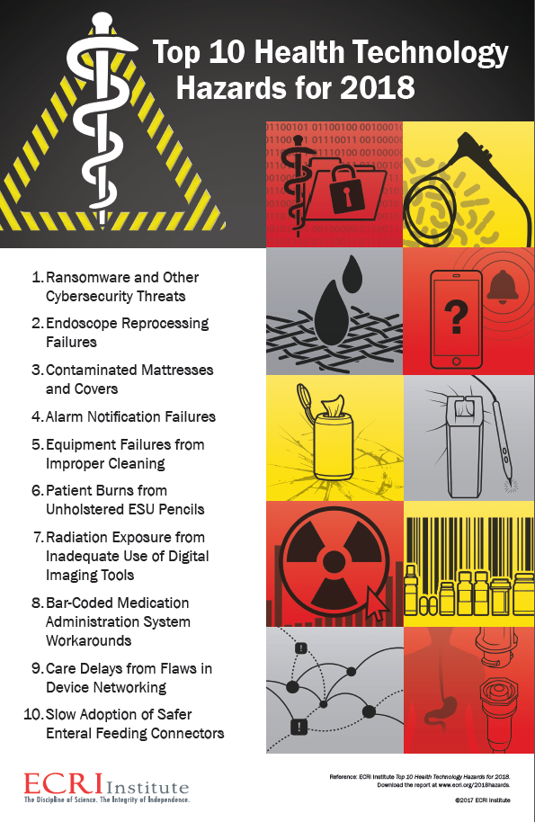

**On the Radar’s most popular items**

The most popular items to date in this year’s issues of *On the Radar* include:

* *National Safety and Quality Health Service (NSQHS) Standards (second edition) Fact sheets* <https://www.safetyandquality.gov.au/our-work/assessment-to-the-nsqhs-standards/nsqhs-standards-second-edition/>
* *Report on the Supply and Management of Schedule 8 Controlled Drugs at Certain Public Hospitals in Western Australia* <http://bit.ly/2tq5HhC>
* *National Safety and Quality Health Service Standards. 2nd edition* <http://www.safetyandquality.gov.au/second-edition>
* *Recommendations to OECD Ministers of Health from the High Level Reflection Group on the Future of Health Statistics: Strengthening the international comparison of health system performance through patient-reported indicators* <https://www.oecd.org/els/health-systems/Recommendations-from-high-level-reflection-group-on-the-future-of-health-statistics.pdf>
* *Leading a Culture of Safety: A Blueprint for Success* <https://www.npsf.org/page/cultureofsafety>
* *Why do surgeons receive more complaints than their physician peers?* <http://dx.doi.org/10.1111/ans.14225>
* *Final Report: Sentinel Event Research Project* <https://www2.health.vic.gov.au/hospitals-and-health-services/quality-safety-service/clinical-risk-management/sentinel-event-program>
* *Pressure Injury Prevention in Hospitals Training Program* <https://www.ahrq.gov/professionals/systems/hospital/pressureinjurypxtraining/index.html>
* *Embedding a culture of quality improvement*<https://www.kingsfund.org.uk/publications/embedding-culture-quality-improvement>
* *National Consensus Statement: Essential elements for recognising and responding to deterioration in a person’s mental state* <https://www.safetyandquality.gov.au/publications/national-consensus-statement-essential-elements-for-recognising-and-responding-to-deterioration-in-a-persons-mental-state/>

**Disclaimer**

*On the Radar* is an information resource of the Australian Commission on Safety and Quality in Health Care. The Commission is not responsible for the content of, nor does it endorse, any articles or sites listed. The Commission accepts no liability for the information or advice provided by these external links. Links are provided on the basis that users make their own decisions about the accuracy, currency and reliability of the information contained therein. Any opinions expressed are not necessarily those of the Australian Commission on Safety and Quality in Health Care.