
On the Radar
Issue 380
30 July 2018

On the Radar is a summary of some of the recent publications in the areas of safety and quality in health care. Inclusion in this document is not an endorsement or recommendation of any publication or provider. Access to particular documents may depend on whether they are Open Access or not, and/or your individual or institutional access to subscription sites/services. Material that may require subscription is included as it is considered relevant.

On the Radar is available online, via email or as a PDF or Word document from https://www.safetyandquality.gov.au/publications-resources/on-the-radar/

If you would like to receive On the Radar via email, you can subscribe on our website https://www.safetyandquality.gov.au/ or by emailing us at HUmail@safetyandquality.gov.auU.
You can also send feedback and comments to HUmail@safetyandquality.gov.auU.

For information about the Commission and its programs and publications, please visit https://www.safetyandquality.gov.au
You can also follow us on Twitter @ACSQHC.
On the Radar
Editor: Dr Niall Johnson niall.johnson@safetyandquality.gov.au
Contributors: Niall Johnson

Reports

The #hellomynameis story: ‘Through adversity comes legacy’
Deeble Institute Perspectives Brief No. 2
Pointon C
Canberra: Australian Healthcare and Hospitals Association; 2018. p. 6.
URL | https://deebleinstitute.org.au/publication/deeble-institute-perspective-briefs/deeble-perspectives-brief-no2-hellomynameis-story
Notes | #hellomynameis is a social media campaign designed to remind healthcare staff to introduce themselves to their patients and family; and then use that opportunity to help build a relationship with them. This Perspectives Brief from the Deeble Institute has been written by Chris Pointon. Chris is the co-founder of the #hellomynameis campaign and husband of the late Dr. Kate Granger MBE. In this brief he discusses some of the personal challenges and rewards of running a social media campaign and the importance of patient-centred and compassionate care.

For information on the Commission’s work on patient and consumer centred care, see https://www.safetyandquality.gov.au/our-work/patient-and-consumer-centred-care/

Moving Forward - Physiotherapy for Musculoskeletal Health and Wellbeing
Themed review
National Institute for Health Research
London: NHS NIHR; 2018. p. 64.
URL | https://www.dc.nihr.ac.uk/themed-reviews/research-into-physiotherapy-for-musculoskeletal-conditions.htm
Notes | The UK’s National Institute for Health Research (NIHR) has produced this themed review of the evidence from the NIHR and others on why research in this area matters, assessment and matching patients to treatment, restoring musculoskeletal health and maintaining musculoskeletal wellbeing. The report features:  - 37 published studies  - 25 ongoing research projects  - Questions to ask physiotherapy musculoskeletal services.

Journal articles

Rate of avoidable deaths in a Norwegian hospital trust as judged by retrospective chart review
Rogne T, Nordseth T, Marhaug G, Berg EM, Tromsdal A, Sæther O, et al
BMJ Quality &Safety. 2018 [e]pub.
DOI | https://doi.org/10.1136/bmjqs-2018-008053
Notes | It is not uncommon to hear terms such as ‘avoidable deaths’ or ‘preventable hospitalisations’. However, the extent or scale of the issue is not always clear. This paper described a retrospective case record review of 1000 consecutive non-psychiatric hospital deaths in a Norwegian hospital trust where each death was evaluated to what degree it could have been avoided and to identify problems in care. The review found 42 (4.2%) of deaths to be “at least probably avoidable (more than 50% chance of avoidability).” The authors also report finding “Life expectancy was shortened by at least 1 year among 34 of the 42 patients with an avoidable death. Patients whose death was found to be avoidable were less functionally dependent compared with patients in the non-avoidable death group. The surgical department had the greatest proportion of such deaths. Very few of the avoidable deaths were reported to the hospital’s report system.” Among the authors’ conclusions was the observation that “Avoidable hospital deaths occur less frequently than estimated by the national monitoring tool, but much more frequently than reported through mandatory reporting systems.”

Characteristics of healthcare organisations struggling to improve quality: results from a systematic review of qualitative studies
Vaughn VM, Saint S, Krein SL, Forman JH, Meddings J, Ameling J, et al.
BMJ Quality & Safety. 2018 [epub].
DOI | https://doi.org/10.1136/bmjqs-2017-007573
Notes | What makes a health organization a high performing, high reliability or a learning organisation are all of interest. But, conversely, what characterises an organisation that is struggling or may struggle to improve can also be of use. This systematic review sought to examine the literature so as to identify and summarise organisational factors associated with struggling healthcare organisations. As the authors observe “Understanding and identifying these characteristics may provide a first step to helping low performers address organisational challenges to improvement.”  Based on 33 studies, the authors identified five domains that characterised struggling healthcare organisations:  - poor organisational culture (limited ownership, not collaborative, hierarchical, with disconnected leadership)  - inadequate infrastructure (limited quality improvement, staffing, information technology or resources)  - lack of a cohesive mission (mission conflicts with other missions, is externally motivated, poorly defined or promotes mediocrity)  - system shocks (i.e., events such as leadership turnover, new electronic health record system or organisational scandals that detract from daily operations), and  - dysfunctional external relations with other hospitals, stakeholders, or governing bodies.

Disclosure Coaching: An Ask-Tell-Ask Model to Support Clinicians in Disclosure Conversations
Shapiro J, Robins L, Galowitz P, Gallagher TH, Bell S
Journal of Patient Safety. 2018 [epub].
DOI | http://doi.org/10.1097/PTS.0000000000000491
Notes | Among the ‘difficult conversations’ that clinicians may have to have in their working lives, disclosure conversations after errors and the like may be some of the most difficult. This is despite policies and guidance being developed in recent years. This commentary piece summarises a disclosure coaching initiative that sought to assist clinicians. It includes the toolkit and approaches used to help develop the necessary skills.

For information about the Commission’s work on open disclosure, including the Australian Open Disclosure Framework, see https://www.safetyandquality.gov.au/our-work/open-disclosure/

Surgical Gatekeeping — Modifiable Risk Factors and Ethical Decision Making
Leeds IL, Efron DT, Lehmann LS
New England Journal of Medicine. 2018;379(4):389-94.
DOI | https://doi.org/10.1056/NEJMms1802079
Notes | This piece poses some interesting and challenging questions about if and when surgery should be withheld or delayed when patients have behavioural and modifiable risk factors. Many of these factors can affect the risks associated with surgery, including the risk of complications, length of stay, outcomes. As the authors observe “Preoperative mitigation of such risk factors improves the odds of successful surgical outcomes, but deferring surgery to attempt to optimize risk may result in continued patient suffering. Furthermore, patients may have tried unsuccessfully to modify their risk factors and may perceive delaying their surgery in an effort to improve their outcome as futile and paternalistic. Should surgeons respect patients’ willingness to accept a higher likelihood of complications in order to expeditiously improve their quality of life? Even if patients accept this risk, how, if at all, should the increased cost to society be factored into decision making?” These decisions touch on many aspects of care and the relationship between clinician and patient, including autonomy, preferences, risk appetite, shared decision making, value care, and the perspectives of patient, clinical and wider society.

Safe staffing: this is how many doctors we really need
Limb M
BMJ. 2018;362(k3136).

Safe staffing
Godlee F
BMJ. 2018;362:k3152.
DOI | Limb https://doi.org/10.1136/bmj.k3136  Godlee https://doi.org/10.1136/bmj.k3152
Notes | As the related editorial notes, there has been some discussion about the level of nursing staffing and patient safety (for example, the last edition of On the Radar I included an item on a systematic review on nurse staffing and omissions in nursing care https://doi.org/10.1111/jan.13564). The focus of Limb’s piece here and the editorial is what does safe staffing mean in terms of the number of doctors available within a hospital setting? Limb’s item reports on the UK’s Royal College of Physicians’ recommendations for safe medical staffing levels in UK hospitals. The College has urged NHS trusts in the UK to measure their workforce against these ‘indicative’ standards to guard against shortages that pose risks to patients. The recommendations give indicative figures for how many person hours for junior, middle ranking, and senior doctors are needed in the assessment and admissions team, on a medical ward in the week and at weekends, and for day and night on-call cover in different sized hospitals, including allowances for annual, study and sick leave.  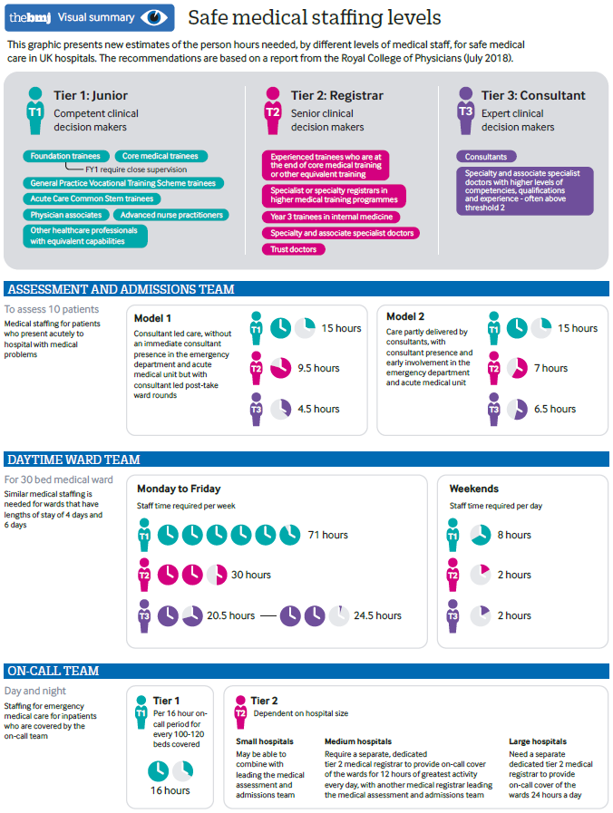
The cost of quality: an academic health center's annual costs for its quality and patient safety infrastructure
Blanchfield BB, Demehin AA, Cummings CT, Ferris TG, Meyer GS
Joint Commission Journal on Quality and Patient Safety. 2018 [epub].
DOI | https://doi.org/10.1016/j.jcjq.2018.03.012
Notes | Does quality cost or is quality (and safety) cost-effective? This study sought to measure the costs associated with maintaining an US teaching hospital’s quality and safety infrastructure, including safety measurement and improvement programs. Using forensic accounting methods, the authors estimate that 1.1% of gross clinical revenues were devoted to quality improvement and safety efforts, with the largest proportion going to ensuring adherence to regulations around mandatory data reporting.

Creating a comprehensive, unit-based approach to detecting and preventing harm in the neonatal intensive care unit
Sedlock EW, Ottosen M, Nether K, Sittig DF, Etchegaray JM, Tomoaia-Cotisel A, et al.
Journal of Patient Safety and Risk Management. 2018 [epub].
DOI | https://doi.org/10.1177/2516043518787620
Notes | Paper describing the development and implementation of unit-based approach to improving quality, in this case in the neonatal intensive care unit (NICU) of a US hospital. This particular approach used seven ‘building blocks’ to develop “a comprehensive approach to detect and prevent harm at the unit level”. The building blocks being:  - unit quality council and stakeholder buy-in  - parent engagement and advisory council  - frontline clinician and parent quality improvement training  - measurement of organizational contextual factors  - electronic health record trigger development and synthesis of harm measures  - subcommittees to review harm, and  - quality improvement teams.

First-year analysis of the Operating Room Black Box study
Jung JJ, Jüni P, Lebovic G, Grantcharov T
Annals of Surgery. 2018 [epub].
DOI | http://doi.org/10.1097/SLA.0000000000002863
Notes | In recent years there has been discussion about the development of a ‘black box’ for surgery as a safety and quality tool. Akin to the more familiar aviation black box, the surgical black box is a technological solution – a system that captures audio and video (potentially with other data) of surgical procedures. This piece reports on a prospective cohort study in 132 consecutive patients undergoing elective laparoscopic general surgery at an US academic hospital during the first year after the definite implementation of a multiport data capture system called the OR Black Box to identify intraoperative errors, events, and distractions. Analysis of the data revealed “frequent intraoperative errors and events [1 cognitive distraction in 64% of cases; medians of 20 errors and 8 events per case], variation in surgeons’ technical skills, and a high amount of environmental distractions were identified [a median of 138 auditory distractions per case]”.

Provider perspectives on partnering with parents of hospitalized children to improve safety
Rosenberg RE, Williams E, Ramchandani N, Rosenfeld P, Silber B, Schlucter J, et al.
Hospital Pediatrics. 2018;8(6):330-7.
DOI | http://doi.org/10.1542/hpeds.2017-0159
Notes | This paper – covering similar ground to some in the new issue of Patient Experience Journal (see below) – describes the results of a survey of inpatient paediatric healthcare providers giving their perspectives on partnering with parents to improve safety. Themes that were revealed included on facilitators, barriers, and role negotiation and/or balancing interpersonal interactions in parent-provider safety partnership.  Facilitators included  - mutual respect of roles  - parent advocacy and rule-following  - provider quality care, empathetic adaptability, and transparent communication of expectations.  Barriers included:  - lack of respect  - differences in parent versus provider risk perception and parent lack of availability  - provider medical errors and inconsistent communication, lack of engagement skills and time, and fear of overwhelming information.

Patient Experience Journal
Volume 5, Issue 2 (2018)
URL | http://pxjournal.org/journal/vol5/iss2/
Notes | A new issue of the Patient Experience Journal (PXJ) has been published with the theme ‘Patient & Family Experience in Children’s Hospitals and Pediatric Care’. Articles in this issue of Patient Experience Journal include:  - Editorial: Lessons for patient experience from the voices of pediatrics and children’s hospitals (Jason A Wolf)  - Partners for excellence: Committed to meaningful partnerships with patients and families in paediatrics (Rachel Biblow and Sara Toomey)  - What medicine can learn from pediatrics: A mother's perspective (Nancy Michaels)  - Life with my baby in a neonatal intensive care unit: Embracing the Family Integrated Care model (Yasmin Lalani)  - Breaking bad news and the importance of compassionate palliative care of the infant (William S Sessions II, Sean Y Kow, Elizabeth Waldrop, Kayle Stevenson, Ayo Olanrewaju, Thu Tran, and Mubariz Naqvi)  - Tertiary care centres must do more for patients with unknown conditions: Lessons learned from a child (Guido Filler and Lana Rothfels)  - Caring moments within an interprofessional healthcare team: Children and adolescent perspectives (Amélia Didier, David Gachoud, Gabriela von Niederhäusern, Lazare Benaroyo, and Maya Zumstein-Shaha)  - The pediatric emergency department care experience: A quality measure (Terri L Byczkowski, Kimberly A Downing, Michael R FitzGerald, Stephanie S Kennebeck, Gordon L Gillespie, and Evaline A Alessandrini)  - What constitutes the patient experience of children? Findings from the photo elicitation and the video diary study (Nina Karisalmi, Hanna Stenhammar, and Johanna Kaipio)  - Can an interactive application be used to collect meaningful feedback from paediatric patients and their parents in a hospital setting? (Janelle O'Neill, Graham R. Reeks, and Lauren Kearney)  - Partnering with pediatric patients and families in high reliability to identify and reduce preventable safety events (Julie Kirby, Courtney Cannon, Lynn Darrah, and Yolanda Milliman-Richard)  - Integrating the patient and caregiver voice in the context of pediatric, adolescent, and young adult care: A family-centered approach (Sarah K Featherston, Beatriz N Rozo, Danielle A Buzanga, Alexandra M Garcia, Joanne Greene, Laura K Salvador, and Joan O'Hanlon-Curry)  - Family Experience Tracers: Patient Family Advisor led interviews generating detailed qualitative feedback to influence performance improvement (Kathryn Taff, Sheryl Chadwick, and DeeJo Miller)  - Wait time reality check: The convergence of process, perception, and expectation (Marian Hill, Lorianne Classen, Andrea Romay, and Erika Diaz)  - Condition Help: 10 years of experience enhancing our culture of family engagement (Andrew McCormick, Catherine Polak, Michael Fox, Michele Carlson, Charles Guthrie, Michael Decker, D Hupp, G Butler, and A Urbach)

BMJ Quality and Safety online first articles
URL | https://qualitysafety.bmj.com/content/early/recent
Notes | BMJ Quality and Safety has published a number of ‘online first’ articles, including:  - Connecting perspectives on quality and safety: patient-level linkage of incident, adverse event and complaint data (Marit S de Vos, Jaap F Hamming, Jolanda J C Chua-Hendriks, Perla J Marang-van de Mheen)  - Rate of avoidable deaths in a Norwegian hospital trust as judged by retrospective chart review (Tormod Rogne, Trond Nordseth, Gudmund Marhaug, Einar Marcus Berg, Arve Tromsdal, Ola Sæther, Sven Gisvold, Peter Hatlen, Helen Hogan, Erik Solligård)  - Characteristics of healthcare organisations struggling to improve quality: results from a systematic review of qualitative studies (Valerie M Vaughn, Sanjay Saint, Sarah L Krein, Jane H Forman, Jennifer Meddings, Jessica Ameling, Suzanne Winter, Whitney Townsend, Vineet Chopra)

International Journal for Quality in Health Care online first articles
URL | https://academic.oup.com/intqhc/advance-access
Notes | International Journal for Quality in Health Care has published a number of ‘online first’ articles, including:  - Cross-cultural adaptation and validation of the Romanian Hip disability and Osteoarthritis Outcome Score for Joint Replacement (Horia Haragus; Bogdan Deleanu; Radu Prejbeanu; Bogdan Timar; C Levai; D Vermesan)  - Balancing measures: identifying unintended consequences of diabetes quality performance measures in patients at high risk for hypoglycemia (David C Aron; Chin-Lin Tseng; Orysya Soroka; Leonard M Pogach)

Online resources

Future Leaders Communiqué
http://vifmcommuniques.org/future-leaders-communique-volume-3-issue-3-july-2018/
Victorian Institute of Forensic Medicine
Volume 3 Issue 3 July 2018
This issue of the Future Leaders Communiqué focuses on the outcomes of inadequate discharge planning. Inadequate discharge planning has the potential to disrupt continuity of care, and increases the likelihood of adverse events. This issue identifies some of the lessons that can be taken from two cases involving discharge of patients from emergency departments who subsequently died.

No Harm Done podcast
http://www.noharmdonepodcast.com/
No Harm Done is described as a monthly podcast series that is “about improving, exploring, understanding and getting on with healthcare safety and quality”. Presented by Cathy Balding and Cathy Jones who both have extensive experience in the world of safety and quality in healthcare.

[UK] NICE Guidelines and Quality Standards
https://www.nice.org.uk
The UK’s National Institute for Health and Care Excellence (NICE) has published new (or updated) guidelines and quality standards. The latest reviews or updates are:
- Quality Standard QS171 Medicines management for people receiving social care in the community https://www.nice.org.uk/guidance/qs171

Disclaimer
On the Radar is an information resource of the Australian Commission on Safety and Quality in Health Care. The Commission is not responsible for the content of, nor does it endorse, any articles or sites listed. The Commission accepts no liability for the information or advice provided by these external links. Links are provided on the basis that users make their own decisions about the accuracy, currency and reliability of the information contained therein. Any opinions expressed are not necessarily those of the Australian Commission on Safety and Quality in Health Care.

