# Australian COmmission on Safety and Quality in Health Care logo with Radar imageOn the Radar

Issue 396

19 November 2018

*On the Radar* is a summary of some of the recent publications in the areas of safety and quality in health care. Inclusion in this document is not an endorsement or recommendation of any publication or provider. Access to particular documents may depend on whether they are Open Access or not, and/or your individual or institutional access to subscription sites/services. Material that may require subscription is included as it is considered relevant.

*On the Radar* is available online, via email or as a PDF or Word document from <https://www.safetyandquality.gov.au/publications-resources/on-the-radar/> 10.1136/bmjqs-2018-008219

If you would like to receive *On the Radar* via email, you can subscribe on our website <https://www.safetyandquality.gov.au/> or by emailing us at H[Umail@safetyandquality.gov.auU](mailto:mail@safetyandquality.gov.au).   
You can also send feedback and comments to H[Umail@safetyandquality.gov.auU](mailto:mail@safetyandquality.gov.au).

For information about the Commission and its programs and publications, please visit <https://www.safetyandquality.gov.au>

You can also follow us on Twitter @ACSQHC.

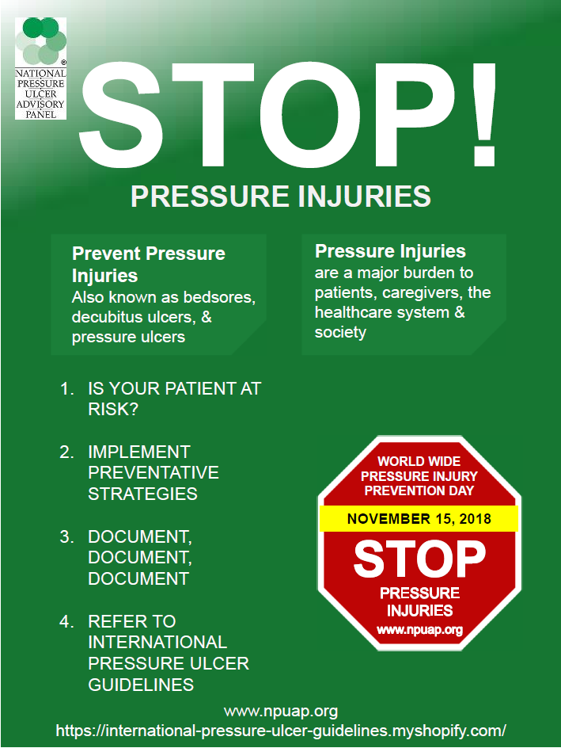**On the Radar**

Editor: Dr Niall Johnson [niall.johnson@safetyandquality.gov.au](mailto:niall.johnson@safetyandquality.gov.au)

Contributors: Niall Johnson

**2018 World Wide Pressure Injury Prevention Day**

<http://www.npuap.org/resources/educational-and-clinical-resources/2018-world-wide-pressure-injury-prevention-day/>

The [US] National Pressure Ulcer Advisory Panel (NPUAP) has deemed 15 November 2018 as World Wide Pressure Injury Prevention Day. The objective of World Wide Pressure Injury Prevention Day is to increase national awareness for pressure injury prevention and to educate the public on this topic. The NPUAP has created this page of educational and clinical resources to mark the day.

Worldwide STOP Pressure Injury (Ulcer) day started in 2012. This initiative aims to increase awareness of pressure injuries amongst the public, medical professionals and politicians. The European Pressure Ulcer Advisory Panel (EPUAP) joined and encouraged countries internationally to participate.

<http://www.epuap.org/>

For the 2018 Stop Pressure Injury Day, the NPUAP, EPUAP and the Pan Pacific Pressure Injury Alliance (PPPIA) are promoting the *International Pressure Injury Guideline*. The guideline is available from the New Zealand Wound Care Society website at <https://nzwcs.org.nz/who-we-are/pressure-injury-advisory-group/70-2014-prevention-and-treatment-of-pressure-ulcers-clinical-practice-guideline>

The New Zealand Wound Care Society has also developed a webpage of resources and links, including some in a number of languages. The webpage is at <https://www.nzwcs.org.nz/resources/stop-pi-day>

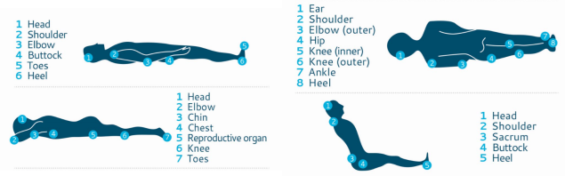

The prevention of pressure injuries are addressed in the Comprehensive Care standard of the National Safety and Quality Health Service (NSQHS) Standards. For information about the NSQHS Standards, see the Commission’s NSQHS Standards microsite at <http://www.nationalstandards.safetyandquality.gov.au>

[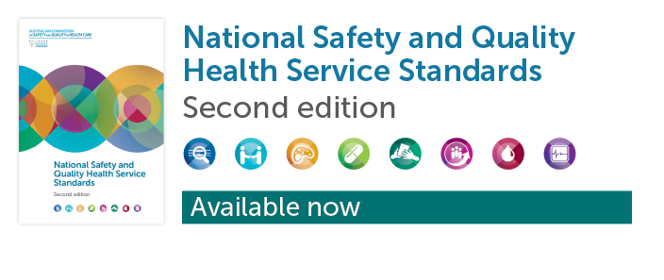](http://www.nationalstandards.safetyandquality.gov.au)

**Reports**

*Digital Health Implementation Playbook*

American Medical Association

Chicago: American Medical Association; 2018. p. 96.

|  |  |
| --- | --- |
| URL | <https://www.ama-assn.org/ama-digital-health-implementation-playbook> |
| Notes | The American Medical Association (AMA) has created this resource to help physicians extend care with technologies that are changing the way patients interact with healthcare. The *Playbook* offers a guide for providers to applying digital health solutions, including key steps, best practices, and resources to achieving digital health adoption. The Playbook is designed for care teams and administrators in medical practices of any and specialty. It is intended to be a ‘living document’ that will be updated over time. As it evolves, it will provide a 12-steps process to guide the implementation of various digital health solutions. The first six steps are core to the implementation of any solution, while the subsequent six steps focus on specific digital health solutions and the considerations relevant to that specific technology. |

**Journal articles**

*Engaging patients to improve quality of care: a systematic review*

Bombard Y, Baker GR, Orlando E, Fancott C, Bhatia P, Casalino S, et al

Implementation Science. 2018;13(1):98.

*Patient and family engagement in incident investigations: exploring hospital manager and incident investigators' experiences and challenges*

Kok J, Leistikow I, Bal R

Journal of Health Services Research & Policy. 2018;23(4):252-61.

*Learning from patients' experiences related to diagnostic errors is essential for progress in patient safety*

Giardina TD, Haskell H, Menon S, Hallisy J, Southwick FS, Sarkar U, et al

Health Affairs. 2018;37(11):1821-7.

|  |  |
| --- | --- |
| DOI | Bombard et al <https://doi.org/10.1186/s13012-018-0784-z>  Kok et al <http://doi.org/10.1177/1355819618788586>  Giardina et al <http://doi.org/10.1377/hlthaff.2018.0698> |
| Notes | A number of items looking at the value and utility of the patient experience in informing safety and quality improvements We speak of a patient, consumer or person-centred approach to care. While that does involve ensuring that the patient is the focus of the care episode, it is actually more than that. It is also the inclusion of the patient in a series of partnerships.  Bombard et al provide a systematic review on the issue of involving patients in the improvement of care. The review focused on 48 studies that reported on the input of patients, family members, or caregivers on health care quality improvement initiatives. The authors sought to identify factors that facilitate successful engagement, patients' perceptions regarding their involvement, and patient engagement outcomes. The simple answer is that yes, “**Patient engagement can inform patient and provider education and policies**, as well as **enhance service delivery and governance**.”  Kok et al focus on the how hospital managers and incident investigators have worked with patients and families in investigations. This qualitative study from the Netherlands used interviews in 13 hospitals to examine incident investigation routines and their experiences of involving affected patients or family members. While seen as important and providing useful information, the authors suggest that the existing approach is not deriving the full benefit and that “by placing **patient and family criteria of significance at the centre of incident investigations** …, hospitals may be able to expand their **learning potential and improve patient-centeredness** following an incident.”  Giardina et al discuss how the patient perspective in diagnostic errors can contribute to improving the safety aspects of diagnosis. They argue that to date the research into diagnostic error has “largely focused on individual clinicians’ decision making and system design, while overlooking information from patients”. They describe their analysis of adverse event reports that revealed many **patient narratives of diagnostic error**. These narratives had problems related to **patient-physician interactions**, including “behavioral and interpersonal factors that reflected unprofessional clinician behavior, including ignoring patients’ knowledge, disrespecting patients, failing to communicate, and manipulation or deception”. The authors asset that understating “**Patients’ perspectives** can lead to a **more comprehensive understanding of why diagnostic errors occur** and help develop strategies for mitigation. Health systems should develop and implement formal programs to collect patients’ experiences with the diagnostic process and use these data to promote an organizational culture that strives to reduce harm from diagnostic error.” |

For information about the Commission’s work on patient and consumer centred care, see <https://www.safetyandquality.gov.au/our-work/patient-and-consumer-centred-care/>

*Developing and evaluating clinical leadership interventions for frontline healthcare providers: a review of the literature*

Mianda S, Voce A

BMC Health Services Research. 2018;18(1):747.

|  |  |
| --- | --- |
| DOI | <http://doi.org/10.1186/s12913-018-3561-4> |
| Notes | This piece reports on a systematic review examining clinical leadership training with a focus on clinical leadership development interventions among frontline healthcare providers, particularly for improved maternal and newborn care. Eventually, 24 papers were identified and included in the review. The reported interventions for clinical leadership development involved the development of clinical skills, leadership competencies, teamwork, the environment of care and patient care. Work-based learning with experiential teaching techniques was reported as the most effective, to ensure the clinical leadership development of frontline healthcare providers. The authors suggest that “**Clinical leadership development** is an **on-going process** and must target both novice and veteran frontline health care providers. The content of clinical leadership development interventions must encompass a **holistic conceptualization of clinical leadership**, and should use **work-based learning**, and **team-based approaches**, to improve clinical leadership competencies of frontline healthcare providers, and overall service delivery.” |

*The influence of stress responses on surgical performance and outcomes: literature review and the development of the surgical stress effects (SSE) framework*

Chrouser KL, Xu J, Hallbeck S, Weinger MB, Partin MR

The American Journal of Surgery. 2018;216(3):573-84.

|  |  |
| --- | --- |
| DOI | <http://doi.org/10.1016/j.amjsurg.2018.02.017> |
| Notes | Following on the teamwork issues that were included in some of the previous items, this piece looks at how stress in the surgical team and individuals can affect the team, including behaviours, performance and outcomes. Following a literature search looking at the relationship between negative (emotional and behavioural) responses to acute intraoperative stressors and provider performance or patient surgical outcomes, the authors have developed a framework, Surgical Stress Effects (SSE) framework, that attempts to illustrate how those emotional and behavioural responses to stressors can influence individual surgical clinician performance, team performance, and patient outcomes. It also seeks to indicate how “uncompensated intraoperative threats and errors can lead to adverse events”. |

*Pennsylvania Patient Safety Advisory*

October 31, 2018, Vol. 15, Suppl. 1

|  |  |
| --- | --- |
| URL | <http://patientsafety.pa.gov/ADVISORIES/Pages/201810_home.aspx> |
| Notes | The Pennsylvania Patient Safety Authority has published a supplement to their *Pennsylvania Patient Safety Advisory*. This special issue focuses on the challenges involved in the diagnostic process. Items in this special issue include:   * Identifying and Learning from **Events Involving Diagnostic Error**: It’s a Process – Healthcare facilities can use the modified DEER taxonomy to classify events from various sources, identify vulnerabilities in the diagnostic process, and prioritize areas for learning and improvement. * Beyond the Lab: The Link between **Health IT and Laboratory Test Problems** – As the role of health IT in the laboratory testing process has advanced, so too has the possibility for patient safety to be compromised. * Ask the Experts: A Roundtable Discussion with Some of the Nation's Leaders in **Improving Diagnosis** – The Authority convened an expert panel of 10 speakers to discuss issues in diagnostic error and strategies for improvement. * **Misdiagnosis** Can Cause Guilt for Those **Seeking Resolution**: From the Bedside to the Courtroom, the Perspective of a Clinician Turned Malpractice Attorney – Discusses how, as a team, the practitioner and patient can avoid the guilt associated with diagnostic error and its aftermath, by working through the differential diagnosis process together to improve patient safety. * The Star of the **Diagnostic Journey**: Assessing **Patient Perspectives** – The needs of every patient may be different; still, healthcare professionals should view the patient and family as a focal point in the journey to diagnosis. * **Failures in the Diagnostic Process** When Assessing **Suicidal Intent** – Improving information gathering at all stages of the patient’s crisis and ensuring that relevant data is communicated throughout the continuum of care can contribute to a more accurate diagnostic process. * From Virtual Autopsies to Expedited Stroke Detection: How Facilities are **Improving the Diagnostic Process** * Getting Creative: Harnessing **Synergy to Tackle Big Patient Safety Challenges** – A conceptual framework that can be used to tackle any complex patient safety challenge, as well as a learning journey in progress to address diagnostic error. * **Acquiring Diagnostic Skill**: Understanding the Decision Making Processes Used by Experts – How contemporary Safety-II principles align with the premise that providing appreciation and reinforcing successful identification of diagnostic patterns will improve the diagnostic process. * **Improving Diagnosis**: Action and Insights – Discusses highlights from the special issue and explains that theory and conceptual understanding of diagnostic error are important, but understanding must be translated into actions that lead to solutions to improve diagnosis and reduce harm and death from diagnostic error. |

**Online resources**

*Medical Devices Safety Update*

Volume 6, Number 6, November 2018

<https://www.tga.gov.au/publication-issue/medical-devices-safety-update-volume-6-number-6-november-2018>

The Therapeutic Goods Administration (TGA) has released the latest edition of its medical device safety bulletin. Topics covered in this issue include:

* Be alert to standards to prevent risk of **misconnections**
* **Eltrombopag**: reports of interference with bilirubin and creatinine test results
* **Amniotic fluid tests** should be used in conjunction with a clinical assessment
* What to report? Please report **adverse events**, as well as near misses.

*[USA] Reducing Diagnostic Errors in Primary Care Pediatrics Toolkit*

<https://www.ahrq.gov/professionals/quality-patient-safety/diagnostic-safety/toolkit.html>

The US Agency for Healthcare Research and Quality (ARHQ) has produces this toolkit to assist primary care practice teams with a systematic approach to reduce diagnostic errors among children in three important areas:

* Elevated blood pressure, which is misdiagnosed in 74 to 87 percent of children
* Adolescent depression, which affects nearly 10 percent of teenagers, and is misdiagnosed in almost 75 percent of adolescents
* Actionable paediatric diagnostic tests, which are potentially delayed up to 26 percent of the time.

This toolkit walks teams through the measurement, screening, recognition, diagnosis, follow-up, and reduction of diagnostic errors in these areas. It is based on clinical evidence, best practices, and a compilation of resources from the project, which involved over 100 primary care physicians and their care teams working across the United States of America to improve care for children.

**Disclaimer**

On the Radar is an information resource of the Australian Commission on Safety and Quality in Health Care. The Commission is not responsible for the content of, nor does it endorse, any articles or sites listed. The Commission accepts no liability for the information or advice provided by these external links. Links are provided on the basis that users make their own decisions about the accuracy, currency and reliability of the information contained therein. Any opinions expressed are not necessarily those of the Australian Commission on Safety and Quality in Health Care.