Reduction in Radiation Exposure to Children and Young People from CT Scans

Summary report



© Commonwealth of Australia 2015

The Commission wishes to acknowledge the significant contribution of the members of the Reduction in Radiation Exposure to Children and Young People from CT Scans Project Reference Group in the development of resources and this report.

This work is copyright. It may be reproduced in whole or in part for study or training purposes subject to the inclusion of an acknowledgement of the source. Requests and inquiries concerning reproduction and rights for purposes other than those indicated above require the written permission of the Australian Commission on Safety and Quality in Health Care:

Australian Commission on Safety and Quality in Health Care  
GPO Box 5480  
Sydney NSW 2001  
Email: [mail@safetyandquality.gov.au](mailto:mail@safetyandquality.gov.au)

ISBN: 978-1-925224-23-8

Citation: Australian Commission on Safety and Quality in Health Care. Reduction in Radiation Exposure to Children and Young People from CT Scans Project. Sydney: ACSQHC, 2015.

Photos depicting CT courtesy of Royal Children’s Hospital Melbourne. Photos depicting cone beam CT courtesy of Western Sydney Local Health District.

Contents

Glossary and shortened forms 5

Executive summary 7

1 Background 10

2 The process 12

Project Reference Group 13

The patient journey 13

Partnerships 14

3 The data 15

Public hospital data 15

Medicare data 16

Supplementary information 23

Conclusions 24

4 The resources 26

Resource development 26

Parent and carer brochure 27

Waiting room poster 29

Fact sheet for referrers 30

Internet landing page 30

Resources for oral health 31

Frequently asked questions 32

ARPANSA’s Radiation Protection of the Patient module 32

AIR radiographer dose optimisation training module 33

WA Health’s Diagnostic Imaging Pathways 33

DIP 4 Kids app 33

RANZCR InsideRadiology 34

ACPSEM dedicated web page 34

5 Communication and distribution of resources 35

6 Other issues relating to CT scans in children and young people 36

7 Conclusion 37

Appendix 1 Project Reference Group terms of reference and membership 38

# Glossary and shortened forms

| Term | Definition |
| --- | --- |
| ACPSEM | Australasian College of Physical Scientists & Engineers in Medicine: the peak professional body for diagnostic imaging medical physicists. |
| ADA | Australian Dental Association: the peak professional body for the dental professions. |
| AHMAC | Australian Health Ministers’ Advisory Council: comprises the heads of each health department from the Australian Government and each state and territory. In addition, the New Zealand health authority and the Australian Government Department of Veterans’ Affairs attend. |
| AIR | Australian Institute of Radiography: the peak professional body for radiographers. |
| ANZAOMS | Australian and New Zealand Association of Oral and Maxillofacial Surgeons: the peak professional body for the specialty of oral and maxillofacial surgery. |
| ARPANSA | Australian Radiation Protection and Nuclear Safety Agency: the Australian Government’s primary authority on radiation protection and nuclear safety. ARPANSA aims to protect people and the environment from the harmful effects of radiation. |
| ASO | Australian Society of Orthodontists: the peak professional body for orthodontists. |
| AWCH | Association for the Wellbeing of Children in Healthcare: a national organisation advocating for the needs of children, young people and families within the healthcare system in Australia. |
| CBCT | cone beam computed tomography: an imaging modality that uses a cone-shaped X-ray beam with a flat panel detector to acquire images, in contrast to the fan-shaped beams and multiple detectors used in medical CT. A computer turns the X-ray images into 3D images. CBCT is sometimes called cone beam volumetric CT, or volumetric tomography, to distinguish it from multidetector CT used in medical imaging. |
| CT | computed tomography: a diagnostic imaging modality that involves X-rays taken by a rotating ring that moves around the body. A computer turns the X-ray images into 3D images. |
| diagnostic imaging medical physicist | A health professional who plays an important role in the quality assurance of equipment, and ensures that the radiation dose to the patient from the medical imaging technique is the minimum possible while achieving images of diagnostic quality. |
| DIP | Diagnostic Imaging Pathways: a clinical guidance tool for referrers and providers developed by WA Health. |
| GP | general practitioner |
| MBS | Medicare Benefits Schedule |
| MRI | magnetic resonance imaging: a medical imaging technique that uses radiowaves and magnetic fields to produce images of the body. Unlike computed tomography, it does not use ionising radiation. |
| NPS  MedicineWise | A government-funded organisation that provides evidence-based tools and information to improve the way technologies, medicines and medical tests are prescribed and used. |
| PRG | Project Reference Group |
| RACGP | Royal Australian College of General Practitioners: the peak professional body for general practitioners. |
| RACP | Royal Australasian College of Physicians: the peak professional body for physicians, including paediatricians. |
| radiographer | A qualified health professional who undertakes diagnostic medical imaging through the use of X-rays and other modalities, which are used to diagnose and treat injury or disease. |
| radiologist | A specialist medical practitioner who is trained to assist other doctors and specialists to treat their patients by making a diagnosis and providing treatment using medical imaging. |
| RANZCR | Royal Australian and New Zealand College of Radiologists: the peak professional body for radiologists and radiation oncologists. |
| RIS/PACS | Radiology information systems (RIS) are computerised databases used by diagnostic imaging departments to store, manipulate and distribute patient radiological data and imagery. Picture archiving and communication systems (PACS) are used in diagnostic imaging to store, retrieve, distribute, analyse and digitally process medical images. |
| WA Health | Department of Health, Western Australia |

# Executive summary

More than 80 000 computed tomography (CT) scans are performed on children and young people in Australia each year.[1] CT scans are a valuable diagnostic tool and are of benefit in a wide range of clinical situations. However, they use a higher level of ionising radiation than other types of imaging, and their use in children and young people has been linked to a slight increase in the risk of developing cancer later in life.[2]

The Australian Commission on Safety and Quality in Health Care (the Commission) has completed the Reduction in Radiation Exposure to Children from CT ScansProject. The project, which was funded by the Australian Government Department of Health, aimed to contribute to a reduction in the potential for harm to children and young people from unnecessary radiation exposure from CT scans.

As with much work undertaken by the Commission, the project needed to achieve a balance: in this case, between information on the valuable role of an appropriately referred and conducted CT scan, and information to raise awareness of the potential for harm.

Key elements of the project included:

an analysis of existing data collections for children and young people referred for, and/or receiving, CT scans

an assessment of the availability of existing protocols for CT scans, and of clinical decision-making tools for referral and optimisation of radiation doses for children

development of a range of referral guides and protocols for CT use, and a review of existing materials, such as those developed by the Australian Radiation Protection and Nuclear Safety Agency (ARPANSA) during roundtable meetings convened by the Australian Government Chief Medical Officer

development of a strategy to sustain the uptake and currency of resources developed under the project, beyond the life of the project

development of materials to improve long-term patient outcomes.

With the guidance of a Project Reference Group and the involvement of a number of partners, the Commission has developed a suite of resources to provide guidance for those involved in the pathway of care – from parents and carers, to the referring doctors and dentists who request CT scans, to the imaging professionals who perform CT scans.

Development of the resources was underpinned by the principle that CT scans can be essential in time-critical situations, and where there are evidence-based protocols for particular conditions and diseases.

The major sources of information for the project were data from state and territory health departments, Medicare claiming data, and data on equipment from the Location Specific Practice Number Register. The data analysis primarily examined the volume of activity with regard to CT scans, the disciplines of the medical practitioners who ordered scans, and the types of scans provided to children and young people. These data were used to target the development of the resources.

Between 2004/05 and 2013/14, Medicare data showed that there was a decrease in CT services for children and young people aged up to 16 years. Specifically, CT services decreased from 8.2 scans per 1000 children in 2008/09 to 6.1 scans per 1000 children in 2013/14. Between 2004/05 and 2008/09, service levels remained relatively constant at around 8 scans per 1000 children.

During this period, magnetic resonance imaging (MRI), which provides an appropriate alternative imaging technique for many of the indications in question, increased threefold, from 3.9 scans per 1000 children in 2004/05 to 11.3 scans per 1000 children in 2013/14. MRI use increased steadily throughout this period, but more rapidly after general practitioners gained referring rights to MRI in November 2012. The number of Medicare-eligible (partially and fully eligible) MRI machines increased from 125 in 2008 to 349 in 2014.

The Commission conducted the project using broad-based consultation, an evidence-based approach, and development of partnerships with key expert and stakeholder organisations. A strategic aim was to achieve partnerships that would facilitate uptake, promotion and sustainability of the resources developed under the project.

The resources developed under the project include:

**brochures for parents and carers** outlining the benefits and risks of CT scans, which are available in general practices, hospitals, dental practices, medical imaging services and early childhood health centres across Australia

**companion posters** that outline useful questions that parents and carers could ask their doctor, specialist or dentist about CT scans

**a fact sheet for referring clinicians**, which provides information on typical radiation doses and key questions for clinicians to consider when deciding whether to refer a child or young person for a CT scan; it was produced in conjunction with the relevant clinical groups and ARPANSA, based on the resources developed during the roundtable meetings

**answers to frequently asked questions** about CT scanning for children and young people

**an online training module for radiographers** to support radiographers undertaking CT scans for children and young people; it was produced in conjunction with the Australian Institute of Radiography

**a mobile app – DIP 4 Kids** –which provides decision-making support for clinicians referring children and young people for CT scans; this was developed in conjunction with the Department of Health, Western Australia (WA Health), based on the paediatric pathways in the WA Health Diagnostic Imaging Pathways (DIP) clinical guidance tool

**an internet landing page** that provides support for safer, quality CTs for children and young people by bringing together a wide range of information concerning CT scanning. Developed in partnership with Healthdirect Australia, it supports all those involved in the CT patient journey, with specific sections for parents and carers, professionals who refer children and young people for CT scans, providers of medical imaging services and dental professionals

**content for a web page of the Australasian College of Physical Scientists and Engineers in Medicine** that explains the role of dose optimisation for CT services.

The Commission has distributed these resources to the states and territories, general practitioners, dental practitioners, public hospitals, private radiology practices (including practices at private hospitals) and early childhood health centres. The resources and this summary report are also being distributed to a wide range of other stakeholders, to support a reduction in radiation exposure to children and young people from CT scans. Where additional resources are developed by the Commission, these will be included on the Commission and Healthdirect Australia web sites.

# 1 Background

The Australian Commission on Safety and Quality in Health Care (the Commission) leads and coordinates improvements in safety and quality in health care across Australia. This includes developing national standards; providing advice about best practice; coordinating work in specific areas to improve outcomes for patients; and providing information, publications and resources for healthcare teams, healthcare providers, organisations and policy makers.

The Commission was engaged by the Australian Government Department of Health to lead a project – the Reduction in Radiation Exposure to Children from CT Scans Project – to develop a range of resources to support a reduction in the potential for harm to children and young people from unwarranted radiation exposure from computed tomography (CT) scans. These resources were developed with guidance from a Project Reference Group (PRG) and a number of partners. They inform parents and carers, referrers, radiographers, general practitioners (GPs) and other clinicians of the radiation exposure that accompanies each CT scan.

More than 80 000 CT scans are performed on children and young people in Australia each year.[3] CT scans are an important and effective tool, especially in time-critical circumstances, to assist in diagnosis and inform treatment decisions for conditions such as cancer, cardiac conditions and traumatic injury. They play an essential role in clinical practice in acute and primary care settings. However, a number of recent studies of the health impacts of paediatric CT scans, including a study led by Professor John Mathews, indicate small increased risks of the development of cancer following CT scans.[4],[5],[6] Children have a greater sensitivity to radiation than adults, as demonstrated in epidemiological studies of exposed populations.

These recent studies mean that careful consideration needs to be given to a number of issues when referring for, or undertaking, a CT scan. The risks need to be considered alongside the benefits of CT scans for a number of diseases and conditions. The Chair of the Commission’s Board, Professor Villis Marshall, said in a message to parents and carers, ‘If your child needs a CT scan, or has had one in the past, don’t be alarmed. It is important to talk to your doctor about the benefits and potential risks associated with CT scans’.

Issues that should be considered include the condition or disease for which the scan is intended, the reason for referral for the scan and whether it is time-critical, whether recent scans have been undertaken, and whether alternative diagnostic investigations could be considered. It is important to ensure that CT scans are undertaken in time-critical situations, and where there are existing evidence-based protocols for conditions or diseases – for example, serious head trauma.

This project was also informed by work led by the Australian Government Chief Medical Officer, through a roundtable process involving the states and territories, clinicians and technical experts, as well as through discussions by the Australian Health Protection Principal Committee. Both the Council of Australian Governments Health Council (formerly the Standing Council on Health) and the Australian Health Ministers’ Advisory Council have supported the importance of improvements in this area, with the states and territories to review CT protocols and criteria for referral, and investigate the ability to increase data collection for paediatric patients.

This report provides details on the conduct of the project and the development of resources. It discusses:

the approach to the work the Commission has undertaken in meeting the project objectives, and the outcomes of this work

the resources developed to improve referral for, and use of, CT scans in children and young people

the strategy to improve and sustain uptake and use of resources by parents and carers, clinicians, and medical imaging services.

The Australian Radiation Protection and Nuclear Safety Agency (ARPANSA) has undertaken complementary work to improve the safety and quality of diagnostic imaging in Australia. It has developed an education module – Radiation Protection of the Patient – for requesters of medical imaging procedures. The Commission and ARPANSA have worked together to maximise shared access by both organisations to clinical and technical experts through the PRG, and to other clinical experts. The Commission has also worked with ARPANSA to consult on, and revise, a fact sheet for referrers for CT scans.

Although the project’s focus was CT scanning in the diagnostic medical imaging context, analysis of the volume of CT scans billed through Medicare indicated that significant numbers of cone beam CT (CBCT) scans were being used in oral health care. CBCT is also known as cone beam volumetric tomography or CBVT. CBCT scans deliver an effective radiation dose that is typically less than 10% of the dose from diagnostic CT scans. However, the effective dose from CBCT is higher than for other individual oral health radiology tests. Because of this situation, the Commission considered it appropriate to also develop resources for the oral health sector.

# 2 The process

The Commission developed its approach by considering the patient journey for children and young people who have CT scans, and assessing the points along the journey at which increased awareness and education about the risks of radiation exposure would be most likely to reduce this exposure.

A short literature review was undertaken, drawing on the key themes and findings of the roundtable meetings convened by the Australian Government Chief Medical Officer. The Commission considered the literature and current practice, and options for reducing radiation exposure to children and young people from CT scans.

National data on paediatric CT use in both public and private settings were analysed to determine:

the types of CT services being ordered

which practitioner groups were ordering them

the age groups of the children and young people receiving CT scans

the settings in which the scans were delivered.

This helped to identify possible areas for improvement, such as how referrals could be better considered and how medical imaging practices that only occasionally undertake paediatric scans could have ready access to information to support dose optimisation.

Qualitative data were also gathered, using interviews and questionnaires, to provide an understanding of current practice. States and territories, and other stakeholders, were involved in this activity, so that their needs could be identified. This was supported by a process of scoping the availability of current information resources.

Primary aims were to develop resources using a collaborative approach, current knowledge about health literacy, expert clinical advice and the Commission’s health policy expertise. The objective was to ensure easy access to the range of information needed by the various parties involved in the paediatric CT patient journey.

Following a detailed assessment of the scoping information and data analysis, a strategy to improve and sustain uptake and use of guidance material was developed, using the conceptual framework of ‘What, Who, How and When’:

**What** – increasing awareness of, and access to, existing resources, and creating new resources where gaps were identified

**Who** – identifying the target audiences

**How** – identifying the means and media by which access to content can be supported and sustained

**When** – setting timelines for the activities required.

The project culminated in a national workshop, which provided a mechanism to introduce the range of resources to an audience of clinicians, health service managers, regulators and consumers. The workshop also offered an opportunity for the participants to share experiences of improving radiation exposure to children and young people from CT scans.

## Project Reference Group

The Commission convened the PRG, which comprised representatives from several state health departments, colleges and professional bodies, consumer organisations, and other key stakeholders. The PRG’s main roles were to provide strategic oversight, monitor progress towards the project’s objectives, provide technical and clinical advice on the development of resource materials, and provide advice on the communication and consultation process.

Appendix 1 lists the terms of reference and membership of the PRG.

The PRG worked through face-to-face, videoconference and teleconference meetings, supported by email communications to achieve the appropriate level of clinical and technical input. It convened small ‘virtual’ working groups, where needed, to target the individual expertise of PRG members. This proved to be a very effective and time-efficient approach for the clinicians and technical experts in the group.

## The patient journey

The patient journey was used as the foundation for assessing the need for, and developing, resources that would support a reduction in radiation exposure from CT scans in children and young people. The Commission followed the patient journey of a child or young person who may be referred for, and undergo, a CT scan (Figure 1).

Figure 1 Overview of the patient journey for children and young people referred for a CT scan

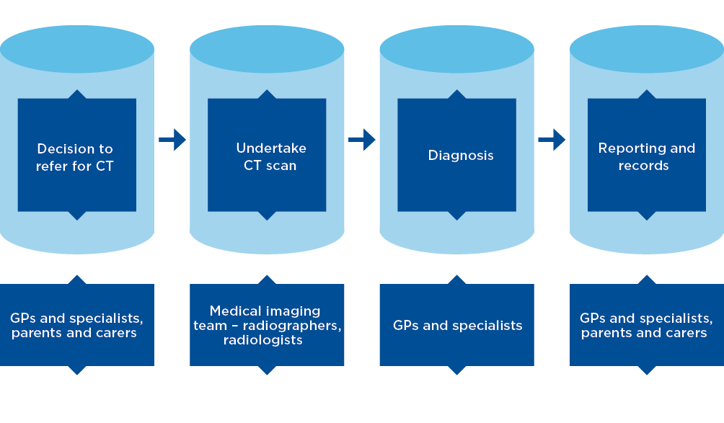

## Partnerships

Effective engagement and collaboration with clinicians, technical experts and consumers in the development of the project’s resources are key to successful uptake of the resources and achievement of the project’s objectives. Patients, carers, consumers and members of the public play an important role in ensuring that the health system achieves its purpose, and that society achieves good health outcomes and safe, high-quality health care. It was therefore essential that these groups were involved in this work, and in ensuring that the Commission provides information, publications and resources for these audiences. It is hoped that this will improve the experiences and outcomes of patients and their parents and carers.

In developing resources, the Commission worked with state and territory health departments, ARPANSA, NPS MedicineWise, the Association for the Wellbeing of Children in Healthcare (AWCH), the Royal Australian College of General Practitioners (RACGP), the Royal Australasian College of Physicians (RACP), the Australian Institute of Radiography (AIR), the Royal Australian and New Zealand College of Radiologists (RANZCR), the Australasian College of Physical Scientists and Engineers in Medicine (ACPSEM), the Australian Dental Association (ADA), the Australian Society of Orthodontists (ASO), and the Australian and New Zealand Association of Oral and Maxillofacial Surgeons (ANZAOMS). The Commission also consulted with the Australian Government Department of Health, state and territory health departments, the Australian Institute of Health and Welfare, the Independent Hospital Pricing Authority and a number of other bodies.

The Commission carefully considered existing materials and tools, assessing their application across jurisdictions and the potential to increase their distribution. This involved consultation and engagement with key stakeholders.

Following a review of the existing information and an assessment of material that would support a reduction in radiation exposure to children and young people, the Commission decided that a high priority was to improve the efficiency of access to validated resources. The Commission worked closely with Healthdirect Australia to develop an internet landing page (‘gateway’) that would provide easy centralised access to the newly developed resources, and to other relevant and validated material.

The Commission’s assessment of existing resources highlighted the Department of Health, Western Australia (WA Health) Diagnostic Imaging Pathways (DIP)clinical guidance tool. This highly regarded decision support tool has been reviewed extensively and validated, and has both national and international endorsement from key stakeholders. Because DIP includes paediatric content (including for CT scans), there were clear synergies with the current project, as well as an opportunity to raise the profile of the DIP material across the public and private sectors.

The Commission consulted with the ADA, the ASO and ANZAOMS to ensure appropriate engagement and advice relating to resources for the use of CBCT in oral health care.

# 3 The data

The major sources of information that informed the project were Medicare Benefits Schedule (MBS) data, public hospital data from the states and territories, and data on equipment from the Medicare Location Specific Practice Number Register. Because the most common definition of paediatric patients is children and young people up to their 16th birthday, the focus of this project’s data analysis was children and young people aged from birth to 16 years. However, where data were available for young people up to 19 years of age, these data have also been included.

The data analysis primarily examined the types of medical practitioners who ordered CT scans and the types of scans that were provided.

Following detailed analysis of the data for Medicare-eligible CT scans, and available data from the state and territory health departments, the Commission developed a baseline to inform targeted action to reduce radiation doses for paediatric patients.

## Public hospital data

State and territory health departments were consulted to provide data about CT scans undertaken in public facilities that were not billed to Medicare – that is, for public patients. The Commission sought assistance from the jurisdictions in the form of a limited data collection, for the financial year 2012/13, from a sample of public hospitals providing CT services for children and young people.

Some states and territories were able to provide a snapshot of data for 2012/13 for a specialist paediatric hospital and, in some instances, a regional site that undertakes paediatric scans. Data were provided for around 11 000 scans for children aged 0–15 years. Although important data are collected through radiology information systems (RIS) and picture archiving and communication systems (PACS), the data are not always stored in a manner that allows coordinated analysis. A number of jurisdictions advised that they are expanding their RIS and PACS systems; this will enable more comprehensive information to support many aspects of improved service delivery.

Key findings from the public data were as follows:

Consistent with the general view of people in this field and the findings of other studies, this national snapshot of CT scans undertaken in public hospitals showed that the majority of CT scans provided to children 0–15 years of age were not billed to Medicare. The total number of scans in this study was 13 449, of which 3073 were Medicare-billed scans and 10 376 were not Medicare billed.

Scans involving the brain and/or orbits, chest, abdomen and/or pelvis, extremities, spine and petrous bones were the most frequent CT scans provided in the sample hospitals, and were also the scans most commonly billed to Medicare. The highest number of CT scans were for the brain and/or orbits. However, care should be taken in interpreting and comparing data from Medicare with the states and territories because the scan categories are not directly comparable. Data from the states and territories involved around 620 different scan descriptors. As a result, it was necessary to group the scans into 24 categories. The Medicare data are more granular than this, with more than 50 different Medicare items for CT scans claimed for the 0–15-year age cohort in the same period.

As expected, emergency medicine physicians were the highest referrers across all states and territories. The other high-volume clinical disciplines were oncology, neurosurgery, orthopaedics and general paediatrics.

## Medicare data

The MBS is a listing of professional services for which Medicare benefits are payable. Services listed on the MBS generally only apply when rendered by practitioners in private practice, or practitioners acting under rights of private practice arrangements in public and private hospitals. Services can be provided to patients admitted to hospital or to non-admitted patients. The MBS does not provide benefits for services rendered to public patients.

The Australian Government collects data from claims made for services listed on the MBS.

Medicare data for CT scans are comprehensive and can identify a number of characteristics about the nature of the service and to whom it was provided, including the type of practitioner who requested the scan, the type of scan and the age of the patient. Because Medicare data are more comprehensive than other available data sources, they could be analysed in more detail. However, it is important to note that the major limitation of Medicare data is that they do not capture public patients.

Data were analysed for more than 615 000 Medicare records for children 0–15 years of age, covering the 10-year period 2004/05 to 2013/14.

The information below is a snapshot of the data analysis.[7] An analysis of CBCT is provided later in this chapter (under ‘Cone beam CT service data for children and young people under 16 years of age’, p.18).

### CT service data for children and young people under 16 years of age (excluding CBCT)

The data for this age cohort included 327 306 CT services (excluding CBCT) and 283 685 magnetic resonance imaging (MRI) services provided to 428 773 young patients[8] (CT – 272 322 patients; MRI – 197 302 patients).

Between 2004/05 and 2013/14, CT services decreased overall, from 8.2 per 1000 children in 2008/09 to 6.1 per 1000 children in 2013/14. Between 2004/05 and 2008/09, CT services were relatively steady, at around 8 per 1000 children (Figure 2).

Figure 2 also shows a threefold increase in MRI services during the same period, from 3.9 per 1000 children in 2004/05 to 11.3 per 1000 children in 2013/14. MRI use increased steadily throughout most of the period, but at a greater rate after GPs gained referring rights on 1 November 2012. Greater access to MRI services occurred over this period, and the number of partially and fully Medicare-eligible MRI machines increased from 125 in 2008 to 349 in 2014. The growth in MRI services can be attributed to the increased number of, and geographic access to, MRI machines over this period, accompanied by increased affordability as a result of the Medicare eligibility of MRI services.

Figure 2 Annual rate of CT and MRI services (excluding cone beam CT) per 1000 population, 0–15-year-olds, 2004/05 to 2013/14

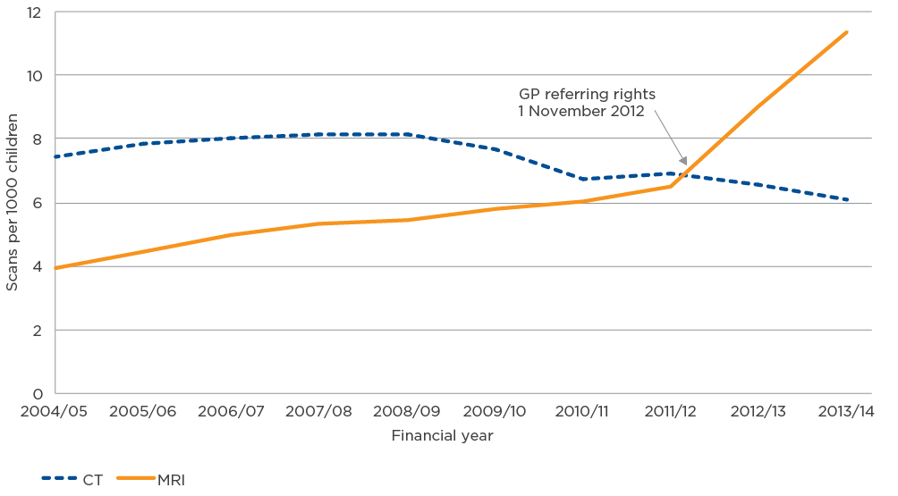

CT = computed tomography; GP = general practitioner; MRI = magnetic resonance imaging

Source: MBS Analytics Section, Australian Government Department of Health, *Medicare-funded CT and MRI services to children, Australia: 2004–05 to 2013–14*, unpublished paper, August 2015

An analysis of CT scans by age group found that the decline in CT services per 1000 children did not occur evenly across age groups. In percentage terms, the greatest decrease during the decade occurred for children aged under 10 years, despite the numbers starting from a lower base. CT scan rates for older children (aged 11–15 years) increased to 17.5 per 1000 children in 2008/09 but by 2013/14 had decreased to around the rate they had been in 2004/05. Some of the variation between younger and older children can be explained by the predominant role of specialised children’s services in the diagnosis and care of younger children, where there are fewer Medicare-billed scans.

The three highest-volume CT items claimed for 0–15-year-olds under Medicare in 2013/14, equivalent to around 65% of all services, were:

scans of the extremities (without contrast)

scans of the brain (without contrast)

scans of facial bones/paranasal sinuses (without contrast).

Children up to and including 5 years of age had more Medicare-billed scans performed in the public sector, whereas older children had more Medicare-billed scans in the private sector (Figure 3). This is likely to reflect the need for general anaesthetic or sedation for certain types of scans in younger patients, and specialist paediatric skills for delivery of safe, high-quality services.

Figure 3 Medicare-billed CT scans (excluding cone beam CT) by age and practice type, 2013/14

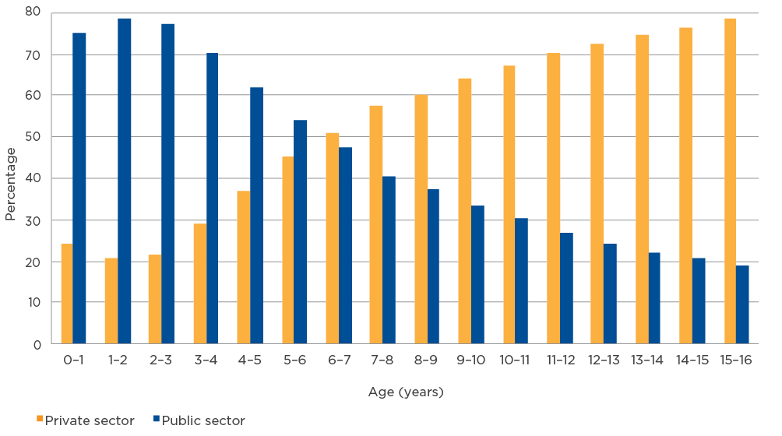

CT = computed tomography

Source: Medicare data supplied by the Australian Government Department of Health to the Commission, July 2014

### Referral data

Overall, GPs requested the highest number of Medicare-billed scans (52% in 2013/14) (Figure 4). Ear, nose and throat specialists (9%), orthopaedic surgeons (9%) and consultant paediatricians (8%) were the next highest-volume requesters. Paediatricians requested the highest proportion of scans for children up to the age of about 4 years.

Figure 4 Referrers for Medicare-billed CT scans, 0–15-year-olds, 2013/14 (excluding cone beam CT)

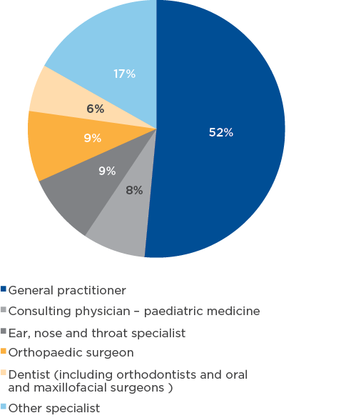

CT = computed tomography

Source: Medicare data supplied by the Australian Government Department of Health to the Commission, July 2014

The proportion of GP referrals compared with specialist referrals varies, depending on the number of CT services the child has had. For the decade 2004/05 to 2013/14, children who had a greater number of scans were more likely to have been referred by a specialist for those scans (Figure 5):

For children who had only one CT scan during the decade, 66% were requested by GPs.

For children who received five CT scans during the decade, 78% were requested by specialists.

For children who received 10 or more CT scans during the decade, 96% were requested by specialists.

This pattern is to be expected for children and young people who have highly complex, urgent or chronic conditions requiring regular follow-up or diagnosis to assist surgery or other treatment options.

Figure 5 Sources of CT referrals (excluding cone beam CT), 0–15-year-olds, 2004/05 to 2013/14

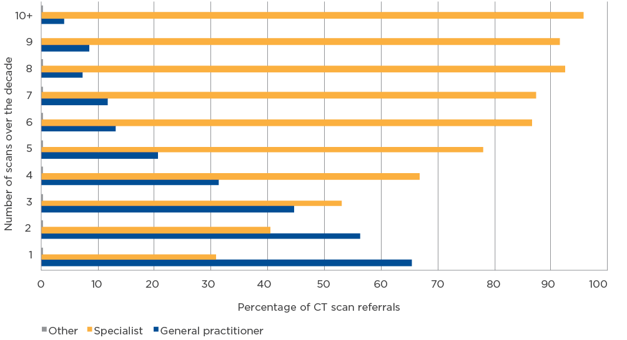

CT = computed tomography

Source: MBS Analytics Section, Australian Government Department of Health, *Medicare-funded CT and MRI services to children, Australia: 2004–05 to 2013–14*, unpublished paper, August 2015

### CT service data for young people aged 16–19 years

Although the focus on data analysis for the project was children up to 16 years of age, at the request of the PRG, a further 500 000 Medicare records were analysed for 16–19-year-olds for the years 2004/05 to 2013/14. The aim of this analysis was to detect any substantial differences in requesting and claiming patterns in this age cohort compared with younger age cohorts.

The analysis found that GPs were the highest-volume requesters of Medicare-billed CT services for 16–19-year-olds. They requested 62–67% of scans in 2013/14, which is higher than the rate for 0–15-year-olds (52%).

The most commonly requested scans for 16–19-year-olds in 2013/14 were head scans, followed by scans of the extremities. In the 0–15-year age group, scans of the extremities were more common.

However, unlike the service patterns for 0–15-year-olds, the number of CT services for 16–19-year-olds was higher than the number of Medicare-billed MRI services.

MRI services are trending up and expected to exceed the number of CT scans within the next couple of years if the same growth rate continues. As with the 0–15-year age group, the number of MRI services claimed for 16–19-year-olds increased sharply after the introduction of GP requesting rights for MRI in November 2012.

### Cone beam CT service data for children and young people under 16 years of age

This section summarises CBCT for oral health purposes for children and young people aged 0–15 years from 2011/12 to 2013/14. In 2013/14, CBCT services for this age cohort accounted for about 30% of all CT services claimed under Medicare.

Two MBS item numbers for CBCT – 56025 and 56026, covering CBCT of teeth and supporting bone structures – were used in this analysis. These item numbers were interim items; they were permanently listed from 1 November 2014 as items 57362 and 57363. The new items have an expanded item descriptor and a number of benefit conditions, including limiting the payment of benefits to one per patient per day and requiring the services to be requested by dental specialists.

Almost all CBCT services (99%) were requested by dental professionals (Table 1). The data showed a 46% increase in Medicare-billed CT scans between 2011/12 (8409 scans) and 2013/14 (12 265 scans). The highest activity was 2062 MBS scans for the 13 to <14-year age group (Table 2).

Table 1 Referrers for Medicare-billed cone beam CT scans, 0–15-year-olds, 2011/12 to 2013/14

| Specialty | 2011/12 (%) | 2012/13 (%) | 2013/14 (%) |
| --- | --- | --- | --- |
| Accredited orthodontist | 51 | 55 | 46 |
| Dentist (registered) | 37 | 34 | 43 |
| Dentist (approved) | 8 | 7 | 6 |
| Oral and maxillofacial surgeon | 3 | 3 | 4 |
| **Total** | **99** | **99** | **99** |

CT = computed tomography

Note: An ‘approved’ dentist is a registered dental practitioner able to render oral and maxillofacial services under Medicare through special arrangements that existed before 1 November 2004.

Source: Medicare data supplied by the Australian Government Department of Health to the Commission, July 2014

Table 2 Age groups for Medicare-billed cone beam CT scans, 0–15-year-olds, 2013/14

| Age group (years) | Number of services |
| --- | --- |
| Under 5 | 47 |
| 5 to <6 | 68 |
| 6 to <7 | 230 |
| 7 to <8 | 534 |
| 8 to <9 | 738 |
| 9 to <10 | 953 |
| 10 to <11 | 877 |
| 11 to <12 | 1238 |
| 12 to <13 | 1801 |
| 13 to <14 | 2062 |
| 14 to <15 | 1953 |
| 15 to <16 | 1764 |
| **Total** | **12 265** |

CT = computed tomography

Source: Medicare data supplied by the Australian Government Department of Health to the Commission, July 2014

### Age profile of CT scanners

The Commission also analysed the age profile of CT equipment on the Location Specific Practice Number Register (Figure 6). This analysis indicates that diagnostic imaging services have more than 60% of machines aged less than 5 years. This means that services have the potential for access to the more contemporary dose optimisation functionality that is available on the newer generation of scanners.

Figure 6 Age and numbers of CT machines registered on the Location Specific Practice Number Register, June 2005, 2010 and 2014

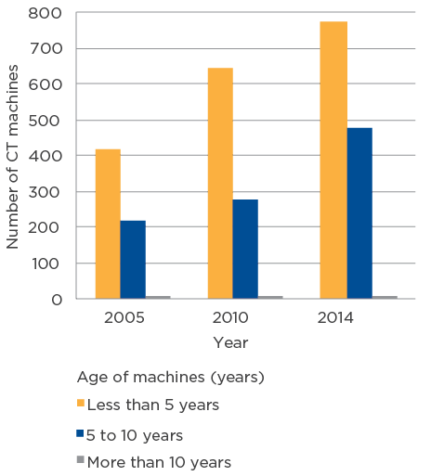

CT = computed tomography

## Supplementary information

In August 2015, the Australian Government Department of Health provided the Commission with additional data analysis that it had undertaken following completion of the Commission’s analysis. This report included an examination of the referring characteristics of GPs – referrers of the highest number of CT services.

Key findings from this analysis were as follows (Figure 7):

In 2013/14, 25% of GPs ordered CT services for children.

Of the GPs who ordered CT services, 69% ordered fewer than five scans per 1000 children seen.

A small but significant number of GPs had much higher referral rates.

Figure 7 Referral rates by general practitioners for child CT services (excluding cone beam CT), 2013/14

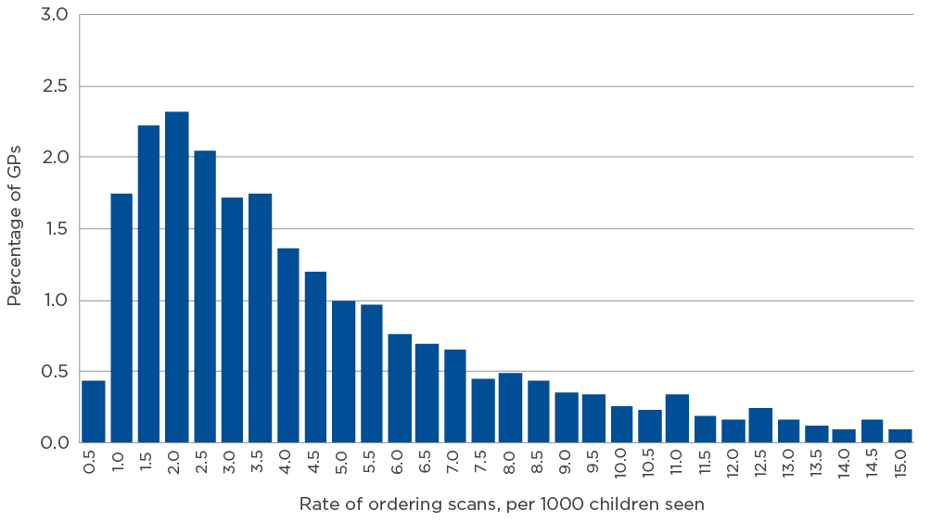

CT = computed tomography; GP = general practitioner

Source: MBS Analytics Section, Australian Government Department of Health, Medicare-funded CT and MRI services to children, Australia: 2004–05 to 2013–14, unpublished paper, August 2015

The national rate of referrals, including specialist referrals, of children for CT services in 2013/14 was 6.1 CT services per 1000 children. A small but significant number of GPs have CT service referral rates that are higher than this.

## Conclusions

Medicare data for CT scans are comprehensive and can identify a number of characteristics about the nature of the service and to whom it was provided, including the type of practitioner who requested the scan, the type of scan and the age of the patient. However, Medicare data alone give an incomplete picture of CT and MRI services provided to children in Australia.

Services provided by one sector, or through one funding source, cannot be considered in isolation. For example, an increase or decrease in Medicare-funded scans may be offset by scans in privately funded or hospital settings. Therefore, when considering strategies to reduce inappropriate referrals for, and conduct of, CT scans, the Commission assessed the characteristics of referral and service delivery to develop a range of resources to respond to these factors.

A retrospective longitudinal study of children’s exposure to radiation, linking both Medicare and hospital data, would provide valuable information about patterns of exposure through childhood, and could be used to derive meaningful measures to track over time.

Although the Medicare data have limitations, the analysis suggested areas where future policy initiatives could be targeted.

The highest rates of Medicare-funded CT scans were seen in older children. Although the scan rates for this age group have fallen since their peak in 2008/09, they did not return to the rates in 2004/05 until 2013/14. Measures to encourage further reductions in CT services for children aged over 10 years may be appropriate.

The majority of children receiving Medicare-funded CT scans received only one scan during the decade analysed. In 2013/14, 52% of services were requested by GPs.

Individual GP ordering patterns varied widely. Three-quarters of GPs did not order any CT scans for children during the decade, but a small proportion of GPs had rates of CT referral that were above the national average for all practitioners, including specialists. In part, this may be due to a particular GP specialising in a disease or condition where CT is a primary diagnostic technique. However, resources such as those developed through this project may also assist to reduce the number of any unwarranted CT referrals.

# 4 The resources

## Resource development

The consultation process undertaken by the Commission (see Chapter 2) involved a wide range of experts and stakeholder organisations, including the Australian Government Department of Health, state and territory health departments, ARPANSA, medical colleges, professional bodies and consumers. The first stage included an audit of existing resource materials across the continuum of care, from referral for CT to follow-up care. This audit identified a number of existing resources, developed by trusted organisations, that could be incorporated into the suite of resources to be included on the Healthdirect Australia landing page.

The data analyses described in Chapter 3 informed the development of resources by clarifying the key referrers for CT services and the nature of the scans undertaken. At an early stage of planning, the Commission focused on the patient journey as another means to identify key target areas for development of resources to support the reduction in radiation exposure to children and young people from CT scans.

Themes that emerged during the consultation and analysis phases of the project included the following:

An opportunity exists to work with undergraduates and medical trainees to provide further education and raise awareness of the range of options for radiation protection and reducing radiation exposure.

Important resources that have been developed by the states and territories potentially warrant national attention. For example, WA Health’s DIP clinical pathways tool was considered to provide an evidence-based and functional decision support tool.

The importance of dose optimisation needs to be elevated and addressed by service providers. Medical physicists are particularly well placed to support the imaging team in this pursuit. Participation in the National Diagnostic Reference Level Service should also be encouraged.

Advice from the PRG following the consultation process, together with findings from the Commission’s data analysis, informed the target groups and the nature of resources required (see Figure 8).

Figure 8 Resource development process

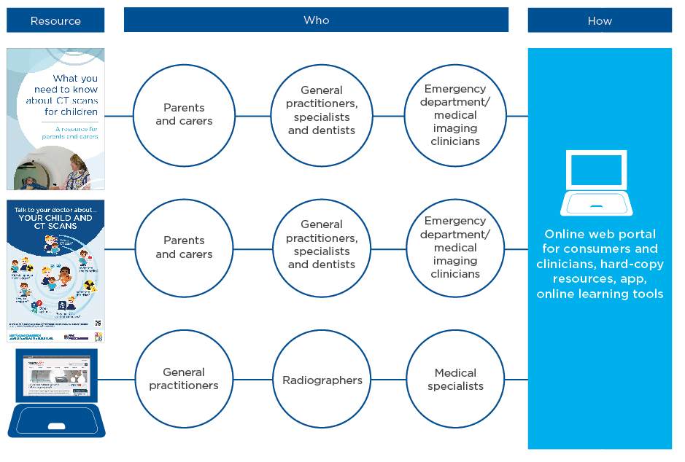

Resources were developed across the patient care pathway – for patients and their parents and carers, referrers, radiographers, dentists, and medical imaging services where paediatric CT scans are provided.

In addition to clinical and technical advice, consultation with consumers was an important component of the resource development process, to develop appropriate communications for parents and carers.

To ensure that the resources produced through the project remain current, partnerships have been established with a number of relevant organisations with expertise in these areas.

Resources developed or promoted through the project are described below.

## Parent and carer brochure

The brochure ‘What you need to know about CT scans for children: a resource for parents and carers’ was developed in partnership with NPS MedicineWise and the AWCH. The aim of the resource is to provide parents and carers with balanced, factual information, in line with contemporary health literacy principles. The brochure addresses both medical diagnostic CT scanning and CBCT used in oral health care. It provides information on the nature of CT scans, benefits and risks of CT scans, how radiation exposure might be reduced (e.g. letting the referrer know if the child has had previous scans), and preparing the child for a CT scan, with the aim of minimising the likelihood of the scan needing to be repeated.

The resource will support parents and carers to be more informed, and promote discussion with the child’s clinician. By providing relevant information about CT procedures in plain language, it will also support clinicians referring for CT services and diagnostic imaging service providers.

This and other project resources have been produced in a variety of print and web formats to maximise their accessibility all audiences.

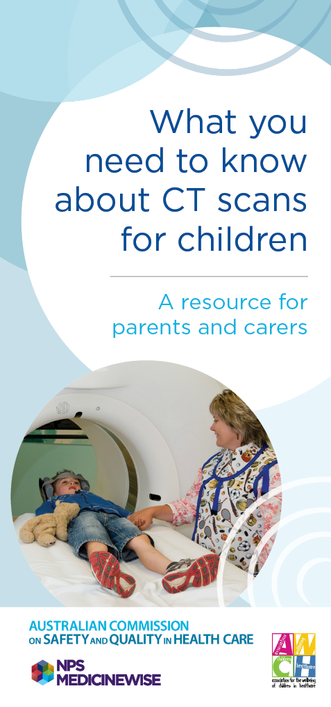 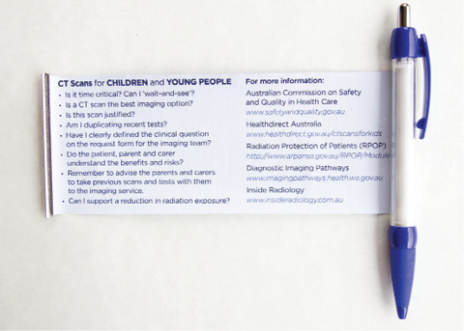

## Waiting room poster

An A3-sized poster titled ‘Talk to your doctor about your child and CT scans’ has been developed for display in general practice and medical imaging waiting rooms, and early childhood centres. It covers questions that parents and carers might ask about CT scanning.

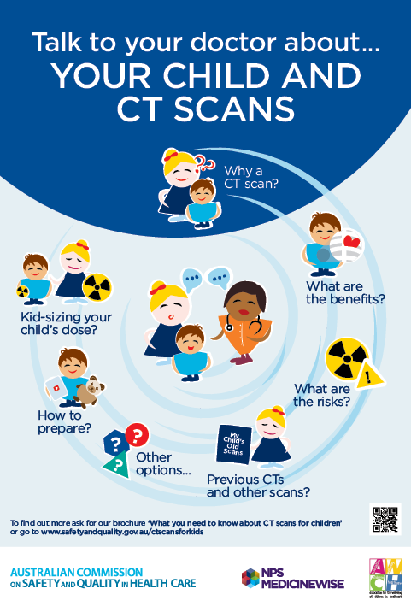

## Fact sheet for referrers

The Commission worked with ARPANSA to refresh the fact sheet for referrers. The new brochure, ‘CT scans for children: information for referrers’, provides general information about CT scans, the benefits and possible risks for children and young people, and the importance of considering alternatives to CT scanning, including ‘watchful waiting’. The fact sheet was developed in consultation with a range of clinicians for content and how best to communicate key messages. Coupled with the consumer brochure, this resource aims to highlight the importance of radiation exposure from CT scans with referrers.

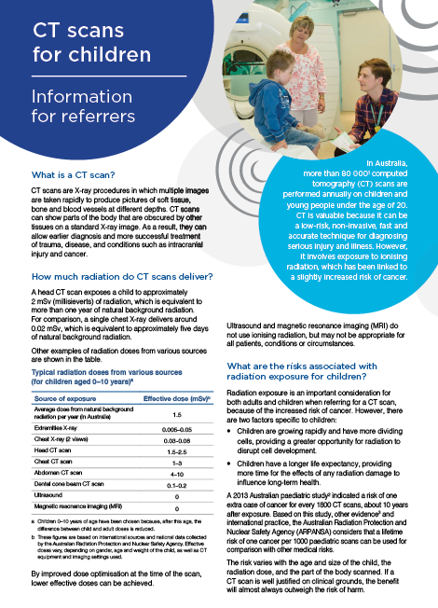

## Internet landing page

Following consultation with stakeholders and the review of existing resources, it became clear that a challenge for parents, carers and clinicians was identifying relevant resources from the large range of current and appropriate resources that were available. The Commission’s work with Healthdirect Australia highlighted the value of a web portal for a validated suite of resources, organised for the individual groups searching for this information.

The landing page, or ‘gateway’, enables quick and easy access to the newly developed resources and those available on other Australian web sites. Development of the landing page was a centrepiece of the work to increase access to resources and guidance materials. Healthdirect Australia worked with the Commission to develop the content and format, with Healthdirect Australia hosting and maintaining the web site.

This gateway supports all people involved in the CT patient journey, with specific sections for parents and carers, professionals who refer children for CT scans, providers of medical imaging services and dental professionals.

The project resources and many others supported by the PRG are now available on the Healthdirect Australia web site.[9] The Healthdirect Australia landing page has links to many other resources and protocols related to the project.

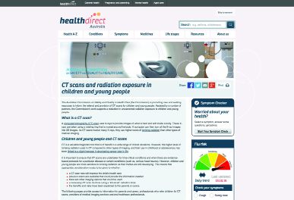

## Resources for oral health

Given the significant proportion of scans for children and young people undertaken for oral health care, a brochure for parents and carers has been developed for CBCT used in dental imaging: ‘Cone beam CT scans in oral health care for children and young people: a resource for parents and carers’.

In developing the brochure, the Commission worked with the key professional bodies with an interest in oral health care: the ADA, the ASO and ANZAOMS.

The brochure provides similar information to the parents and carers brochure for medical CT, but is tailored to CBCT. It covers the benefits and risks of using the technology in the context of oral health care.

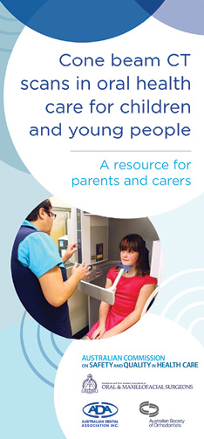

## Frequently asked questions

More detailed information about CT scanning has been developed and incorporated into a set of frequently asked questions (FAQs). The FAQs were researched and written in partnership with the PRG members and key stakeholders. They are a complementary resource to support the parents and carers brochures, and the fact sheet for referrers. The document is available on the Commission’s web site.[10]

## ARPANSA’s Radiation Protection of the Patient module

Many types of medical imaging use ionising radiation, and it is important for referring medical practitioners to be aware of the benefits and risks of radiation. To raise the level of awareness, ARPANSA, in collaboration with the medical sector, has developed an online education module – the Radiation Protection of the Patient (RPOP) module. It specifically aims to support GPs, but is suitable for all referrers.

The key principles in the module are justification and optimisation. Justification means that the benefits of imaging outweigh the risks – for example, the imaging procedure will benefit the patient and inform patient management. Optimisation means that doses should be ‘as low as reasonably achievable’ – this requires a balance to be achieved between diagnostic image quality and radiation dose.

The decision to use an online platform for the module takes into account feedback that this medium is effective (with most referrers now having appropriate online access), and that referrers are time poor, so that information must be easily accessible in a way that complements their workflow.

In developing the module, ARPANSA partnered with peak bodies to influence, promote and promulgate the work, including those with direct access to their members as referrers (RACGP, the Australian College of Rural and Remote Medicine, and NPS MedicineWise). It also collaborated with WA Health, whose DIP clinical guidance tool has made positive inroads into the Western Australian education and medical system, and nationally with its referral guidelines.

The RPOP module is scalable and accessible from multiple devices (PCs, tablets, smart phones, etc.) The module is intended for ‘once only’ completion, but provides links to further information for referrers and their patients. Continued engagement is planned with related professional bodies, including AIR, the RANZCR and the ADA.

The module is available on the ARPANSA web site.[11]

## AIR radiographer dose optimisation training module

To support radiographers who may not regularly perform CT scans on children and young people, the Commission has worked with AIR and other stakeholders to develop an online training module to assist these professionals to optimise the radiation dose delivered to children via CT scans. This resource will particularly support radiographers in rural and outer metropolitan hospitals who may see children less often.

Radiographers will be able to access this resource online,[12] and it can form part of their continuing professional development.

## WA Health’s Diagnostic Imaging Pathways

The Commission is supporting the broader promotion of WA Health’s DIP[13] through the Healthdirect Australia gateway and other project activities. WA Health has recently released a mobile/tablet app of the web site protocol, to be included in these promotional activities.

## DIP 4 Kids app

The Commission and WA Health have worked together to develop a dedicated app (DIP 4 Kids) that provides decision support for clinicians in the medical imaging of children and young people. The aim is to support those who regularly request paediatric CT scans. The app also provides links to a range of resources developed by the Commission and other key organisations involved in this area of medical imaging. The app provides a convenient means to instantly share these resources with a parent or carer.

## RANZCR InsideRadiology

As part of the Quality Use of Diagnostic Imaging Program, the RANZCR has developed InsideRadiology.[14] This online service provides consumers and health professionals with free, easily accessible, accurate, up-to-date, credible information about medical imaging tests and procedures. The Healthdirect Australia gateway includes links to this resource.

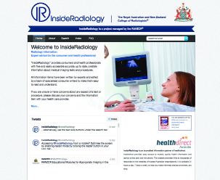

## ACPSEM dedicated web page

The Commission has worked with the ACPSEM to create content for its web page[15] that explains the important role that diagnostic imaging medical physicists play in supporting dose optimisation in delivery of CT services. The Healthdirect Australia gateway includes links to this page. The aim is to provide comprehensive information for those with policy responsibility for operating and setting up radiology services.

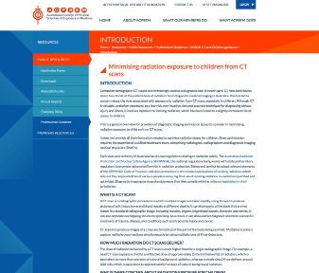

# 5 Communication and distribution of resources

An individualised approach to the successful distribution of each of the resources was developed as part of this project. The strategy to improve uptake and use of resources encompassed five concurrent approaches to reach the target audiences:

a centralised internet access point for resources

ongoing discussion with relevant colleges and professional bodies

articles in industry publications

a national workshop

targeted written advice and distribution of the resources.

An area of focus was to increase awareness and skills in key groups with an ongoing role in CT scans for children and young people. For example, as key referrers of CT scans for children, packages introducing and containing the new resources were distributed to all GP practices nationally. This was supported by a range of activities with the project partners, including focused information strategies for each audience, the formal launch of the resources and internet landing page, media releases, and an associated social media push by the Commission and partners through Facebook and Twitter.

Articles have also been published promoting the project’s resources, including in:

the AIR Spectrum magazine

the RANZCR InsideNews magazine

the HCF e-newsletter for members

RACGP state faculty e-newsletters

the RACP Paediatric Division Pot-pourri publication

the Australian Hospital and Healthcare Bulletin

the Australian College of Emergency Medicine e-bulletin

the NPS MedicineWise health professional e-newsletter NPS Direct (NPS Direct has more than 30 000 health professional subscribers)

the AWCH Child and Adolescent Healthcare e-newsletter and blog

the ADA News Bulletin (hard copies of the oral health care brochure and poster were included as inserts in this magazine).

# 6 Other issues relating to CT scans in children and young people

During the project, a number of related issues were identified that were either outside the terms of reference of the project, or require further investigation or consideration by other organisations. They include issues relating to education, funding policy, financial issues, and other drivers for CT ordering and use.

These issues have been referred for appropriate action to the relevant organisations, such as the Australian Government Department of Health, state and territory health departments, universities, and professional and regulatory bodies.

Technology developments for CT scanners have resulted in the potential for reduced and improved radiation dose delivery. Discussions with the suppliers of CT scanners will also be progressed in light of the resources produced.

# 7 Conclusion

In undertaking the project, the Commission and its partners considered the balance of the benefits that CT scanning plays in time-critical situations – where it might be a superior diagnostic tool – and the potential risks of using ionising radiation in children and young people. A balance has also been important between the potential for an unnecessary increase in concern about CT scans for children and young people, and the objective of providing relevant stakeholders with appropriate information.

Referring clinicians need to consider alternative diagnostic imaging and the potential for watchful waiting, where appropriate. It is also essential to ensure that scans that are clinically necessary are performed optimally, which includes preparation of the child for the procedure.

Both quantitative and qualitative data were collected by the Commission to identify the optimal points along the patient pathway where opportunities existed for action. A major finding was that, although a range of information was available to support best practice, knowledge of how to access this information was extremely variable.

The Commission considered a number of factors in prioritising and developing target resources. Through the partnership with Healthdirect Australia, an existing, well-recognised provider of health information, the internet landing page was developed to improve access to information and resources across the range of audiences. The Commission is also providing access to these resources through its own web site. In addition, a number of partners including NPS MedicineWise and the AWCH are profiling the resources.

These improved access points will provide links to existing resources, and to new resources developed by the Commission and with a range of project partners. A key consideration has been that the project outcomes address identified needs beyond the life of the project, through partnering with key organisations.

The new material has drawn on contemporary health literacy concepts and current best-practice evidence. As a result, parents and carers, requesters of services and medical imaging services now have better access to information to support their decision making in relation to referral for, and conduct of, CT scans for children and young people.

# Appendix 1 Project Reference Group terms of reference and membership

Terms of reference

The main roles of the Project Reference Group are to:

provide strategic oversight and continuity in the provision of technical and project advice throughout the project

monitor and provide advice on issues impacting on the progress and achievement of key milestones and objectives

participate, as required, in discussions regarding data and research findings with a view to providing advice and recommendations to the Commission

advise on the development of resource materials, and communications and consultation with regard to the development of the tools, resources and guidance material

provide a point of reference for consideration of relevant issues referred to the Commission from other key committees in this domain

participate in key consultation processes, as required

provide advice to the Project Director on the planning, delivery and performance of the project

provide strategic oversight and continuity in the provision of technical and project advice throughout the project.

Members of the Project Reference Group

| Name | Organisation |
| --- | --- |
| Dr Stephen Christley (Chair) | Department for Health and Ageing, Government of South Australia |
| Mr Steve Adams | Medical Imaging and Breastscreen, Western NSW Local Health District |
| Dr Michael Brydon | The Sydney Children’s Hospitals Network (Randwick and Westmead) |
| Dr Eleanor Chew | Royal Australian College of General Practitioners |
| Dr Malcolm Coombs | Faculty of Dentistry, University of Sydney; Head of Oral Surgery and Diagnostic Imaging, Sydney Dental Hospital |
| Ms Anne Cutler | Association for the Wellbeing of Children in Healthcare |
| Professor Michael Ditchfield | Royal Australian and New Zealand College of Radiologists |
| Professor Peter Johnston | Australian Radiation Protection and Nuclear Safety Agency |
| Ms Andrea Kuncaa | Best Practice Regulation and Deregulation Branch, Australian Government Department of Health |
| Dr Robyn Lindner | NPS MedicineWise |
| Mr Abel MacDonald | Commonwealth Programs, Australian Commission on Safety and Quality in Health Care |
| Ms Rachel McGlynn | Australian Institute of Radiography |
| Dr Don McLean | Australasian College of Physical Scientists and Engineers in Medicine |
| Ms Kathy Meleady | Commonwealth Programs, Australian Commission on Safety and Quality in Health Care |
| Professor Susan Moloney | Paediatrics and Child Health Division, Royal Australasian College of Physicians |
| Dr Stephen Newbery | Tasmanian Department of Health and Human Services |
| Professor Ed Oakley | Australian College of Emergency Medicine |

a Ms Kunca replaced Ms Celia Street as the department’s representative on the PRG in February 2015. Ms Street attended the PRG meetings in August and November 2014.

For more information

Australian Commission on Safety and Quality in Health Care   
GPO Box 5480   
Sydney NSW 2001

Email: mail@safetyandquality.gov.au

[www.safetyandquality.gov.au](http://www.safetyandquality.gov.au)

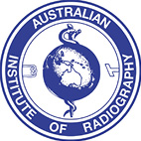   

  

  

1. Based on 2013/14 financial year Medicare data; does not include patients imaged as public inpatients.
2. Mathews JD, Forsythe AV, Brady Z, Butler MW, Goergen SK, Byrnes GB, et al. Cancer risk in 680,000 people exposed to computed tomography scans in childhood or adolescence: data linkage study of 11 million Australians. BMJ 2013;346:2360.
3. Based on 2013/14 financial year Medicare data; does not include patients imaged as public inpatients.
4. Mathews JD, Forsythe AV, Brady Z, Butler MW, Goergen SK, Byrnes GB, et al. Cancer risk in 680,000 people exposed to computed tomography scans in childhood or adolescence: data linkage study of 11 million Australians. BMJ 2013;346:2360.
5. National Council on Radiation Protection and Measurements. Uncertainties in the estimates of radiation risks and probability of disease causation. Report no. 171. NCRP, 2012.
6. Pearce MC, Salotti JA, Little MP, McHugh K, Lee C, Kim KP, et al. Radiation exposure from CT scans in childhood and subsequent risk of leukaemia and brain tumours: a retrospective cohort study. Lancet 2012;380:499–505.
7. The data analysis in this report is a combination of the Commission’s analysis of data that were provided to the Commission in July 2014, and a further analysis by the Australian Government Department of Health in August 2015. Where the Commission’s analysis and the department’s analysis covered the same data characteristics (e.g. trends in services and referral rates), the department’s analysis has been used.
8. Patient totals are less than the number of scans because some patients had multiple CT and MRI services, and some patients had both CT and MRI scans. For example, 40 851 patients had both MRI and CT scans.
9. [www.healthdirect.gov.au/ctscansforkids](http://www.healthdirect.gov.au/ctscansforkids)
10. [www.safetyandquality.gov.au/publications/frequently-asked-questions-ct-scans-for-kids](http://www.safetyandquality.gov.au/publications/frequently-asked-questions-ct-scans-for-kids)
11. [www.arpansa.gov.au/RPOP/Module](http://www.arpansa.gov.au/RPOP/Module)
12. [www.air.asn.au/paedct.php](http://www.air.asn.au/paedct.php)
13. <http://imagingpathways.health.wa.gov.au>
14. [www.insideradiology.com.au](http://www.insideradiology.com.au)
15. [www.acpsem.org.au/resources/acsqh-ct-and-children-guidance/acsqh-guidelines-intro](http://www.acpsem.org.au/resources/acsqh-ct-and-children-guidance/acsqh-guidelines-intro)