Vital Signs 2014:

The State of Safety and Quality   
in Australian Health Care

© Commonwealth of Australia 2014

This work is copyright. It may be reproduced in whole or in part for study or training purposes, subject to the inclusion of an acknowledgement of the source.

Address requests and inquiries concerning reproduction and rights for purposes other than those indicated above in writing to:

Australian Commission on Safety and Quality in Health Care, GPO Box 5480, Sydney NSW 2001

Or email mail@safetyandquality.gov.au.

Suggested citation: Australian Commission on Safety and Quality in Health Care. Vital Signs 2014: The State of Safety and Quality in Australian Health Care. Sydney: ACSQHC, 2014.

An online version of this report can be accessed at www.safetyandquality.gov.au.

ISSN: 2202-7696 (print and online).

Contents

Acronyms and abbreviations 2

Introduction 3

1 Will my care be safe? 6

**Safety and quality standards:** there are standards for safety and quality that my   
health service needs to meet 8

**Hand hygiene:** healthcare providers receive training about hand hygiene to reduce the risk of infection 16

***Staphylococcus aureus* infection**: action to reduce infections means that my care is safer 21

**Medication safety:** my health service makes sure I get the right medicines when   
I go in and out of hospital 25

**Recognising and responding to clinical deterioration**: if my health deteriorates while I am in   
hospital there are systems to ensure I get the care I need 31

**Seclusion and restraint:** if I have mental illness and my condition deteriorates this will be   
managed without causing additional harm 36

**2 Will I get the right care?** **39**

**Healthcare variation:** if health care varies across the country, am I getting the right care? 41

**Cognitive impairment:** my healthcare providers will detect and treat my delirium 51

**Advance care planning:** even if I am no longer able to speak for myself, healthcare providers   
will know what my wishes are 55

**3 Will I be a partner in my care?** **58**

**Decision aids:** there are tools to help me understand information and make decisions about my care 60

**Health literacy:** making medication labels easier for me to understand means my care is safer 64

**Patient stories and feedback:** information I share about my healthcare experience   
will be listened to and acted on 69

**4 Case studies** **72**

**Stroke** 74

**Palliative Care** 80

**5 Conclusion** **87**

****References**** 74

# Acronyms and abbreviations

**BTF**

Between the Flags

**Commission, the**

Australian Commission on Safety and Quality in Health Care

**NHHI**

National Hand Hygiene Initiative

**NSQHS Standards**

National Safety and Quality Health Service Standards

**OECD**

Organisation for Economic Co-operation and Development

**PCOC**

Palliative Care Outcomes Collaboration

**PCEHR**

Personally Controlled Electronic Health Record

**SAB infection**

Staphylococcus aureus bloodstream infection

**WHO**

World Health Organization

# INTRODUCTION

Welcome to Vital Signs 2014, the Australian Commission on Safety and Quality in Health Care’s (the Commission’s) second report on the safety and quality of health care in Australia.

The Commission leads and coordinates national improvements in safety and quality in health care, to contribute to better health outcomes and experiences for patients, as well as a more productive and sustainable health system. The Commission’s key functions include developing national standards; providing advice about best practice; coordinating work in specific areas to improve outcomes for patients; and providing information, publications and resources about safety and quality.

One of the Commission’s functions is to report on the safety and quality of the Australian health system. This is important because it can help people understand their health system, what the system is doing to improve safety and quality, and how successful these efforts have been. It can also help to bring about change, and improved experiences and outcomes for patients.

The purpose of Vital Signs 2014 is to provide information for the general community about the safety and quality of health care. The report is structured around three important questions that members of the public can ask about their health care:

* Will my care be safe?
* Will I get the right care?
* Will I be a partner in my care?

The Australian health system is a complex mix of different types of services and healthcare providers. For most people, their main contact with the health system is through their general practitioner (GP). Other parts of the system include public and private hospitals; medical specialists; diagnostic testing services such as imaging and pathology; and a wide range of allied health services, including areas such as pharmacy, physiotherapy and podiatry.

Australia generally performs very well in international comparisons about health. For example, the Australian population has a relatively high life expectancy, a relatively low rate of avoidable deaths and a high proportion of people reporting that they are in good health.1, 2 However, measuring the safety and quality of care is a challenge. While we have information about things such as the diagnoses people receive, how many people die and how many procedures people have, we have less complete information about the safety and quality of health care provided. Vital Signs 2014 brings together information from a range of sources to provide a snapshot of safety and quality performance on a number of important health topics.

Vital Signs 2014 also includes two case studies focusing on the quality of care in some important clinical areas. These case studies describe and analyse key quality issues that affect outcomes for patients. They also illustrate the in-depth work needed to properly understand the issues surrounding safety and quality in health care, and to develop suitable solutions.

1 Will my care be safe?

Safety and quality standards:

there are standards for safety and quality that my health service needs to meet

Hand hygiene:

healthcare providers receive training about hand hygiene to reduce the risk of infection

*Staphylococcus aureus* infection:

action to reduce infections means that my care is safer

Medication safety:

my health service makes sure I get the right medicines when I go in and out of hospital

Recognising and responding to clinical deterioration:

if my health deteriorates while I am in hospital there are systems to ensure I get the care I need

Seclusion and restraint:

if I have mental illness and my condition deteriorates this will be managed without causing additional harm

Will my care be safe?

Most people who receive health care in Australia receive care that is safe and of high quality. Unfortunately, however, some people are harmed as a result of the care they receive. Doctors, nurses and everyone involved in providing health care work very hard to ensure people are always safe. But health care is a complex process that requires much planning and coordination, and sometimes things do go wrong.

An important way to minimise the likelihood of harm occurring is to ensure good processes are in place. Health services should have systems in place to ensure safety, and to make sure people working in health services are appropriately skilled, are aware of those systems and use them properly.

This is one of the most important roles of the Commission: ensuring that good systems are in place. The Commission has worked with the Australian Government, all state and territory governments, the private hospital sector and clinical groups to develop a new set of safety and quality standards that all hospitals and day procedure services in Australia need to be assessed against. There are also standards that apply in general practices. These were developed by the Royal Australian College of General Practitioners (RACGP) and provide a framework for quality care and risk management in general practice.

This section provides information about the new national safety and quality standards, the new system of accreditation that goes with them and accreditation in general practice. It also highlights some areas where there have been improvements in safety over time, particularly in preventing infections, tracking medications, and identifying and managing clinical deterioration.

Safety and quality standards: there are standards for safety and quality that my health service needs to meet

The community expects health services to put the safety of patients first. One way this is achieved is through a process known as accreditation, where the health service is tested against an agreed set of standards. Accreditation can be complex, and in Australia there are different schemes in place for different types of health services.

## Safety and Quality Standards

## Standards and accreditation for hospitals and day procedure services

In Australia, many hospitals and day procedure services have been accredited continuously for decades, others have held accreditation irregularly, and a very small number have not been part of an accreditation cycle.

In January 2013, the Australian Government and all state and territory governments introduced a new scheme that requires all hospitals and day procedure services in Australia to be accredited to a new set of standards for the safety and quality of health care: the National Safety and Quality Health Service (NSQHS) Standards.3

The NSQHS Standards cover areas where we know patients experience higher levels of harm, and where there is good evidence of how safer and better care could be provided.

Over the next three years, all hospitals and day procedure services will be accredited to all 10 of the NSQHS Standards.

The 10 NSQHS Standards are:

|  |  |
| --- | --- |
| Standard 1 Governance for safety and quality organisations | Governance for safety and quality organisations |
| NSQHS Standard 2 Partnering with consumers | Partnering with consumers |
| NSQHS Standard 3 Preventing and controlling healthcare associated infections | Preventing and controlling healthcare associated infections |
| NSQHS Standard 4 Medication safety | Medication safety |
| NSQHS Standard 5 Patient identification and procedure matching | Patient identification and procedure matching |
| NSQHS Standard 6 Clinical handover | Clinical handover |
| NSQHS Standard 7 Blood and blood products | Blood and blood products |
| NSQHS Standard 8 Preventing and managing pressure injuries | Preventing and managing pressure injuries |
| NSQHS Standard 9 Recognising and responding  to clinical deterioration | Recognising and responding to clinical deterioration in  acute health care |
| NSQHS Standard 10 Preventing falls and harm from falls | Preventing falls and harm from falls |

## Assessment to the NSQHS Standards

As of January 2013, hospitals and day procedure services will be assessed to the NSQHS Standards when they next need to be accredited. Not all hospitals and day procedure services are accredited at the same time, but all will have some assessment to the NSQHS Standards between January 2013 and December 2015.

Although 2013 was the first year of the new accreditation scheme, substantial progress was made towards accrediting all hospitals and day procedure services. Within the year, 679 hospitals and day procedure services were assessed, which is more than 40 per cent of all hospitals and more than 70 per cent of all day procedure services (see Figures 1 and 2).

Seventeen new health services opened in Australia in 2013. These new health services were also tested to ensure they have the processes in place to provide safe care.

Figure 1

Progress towards accreditation in Australian hospitals, by year

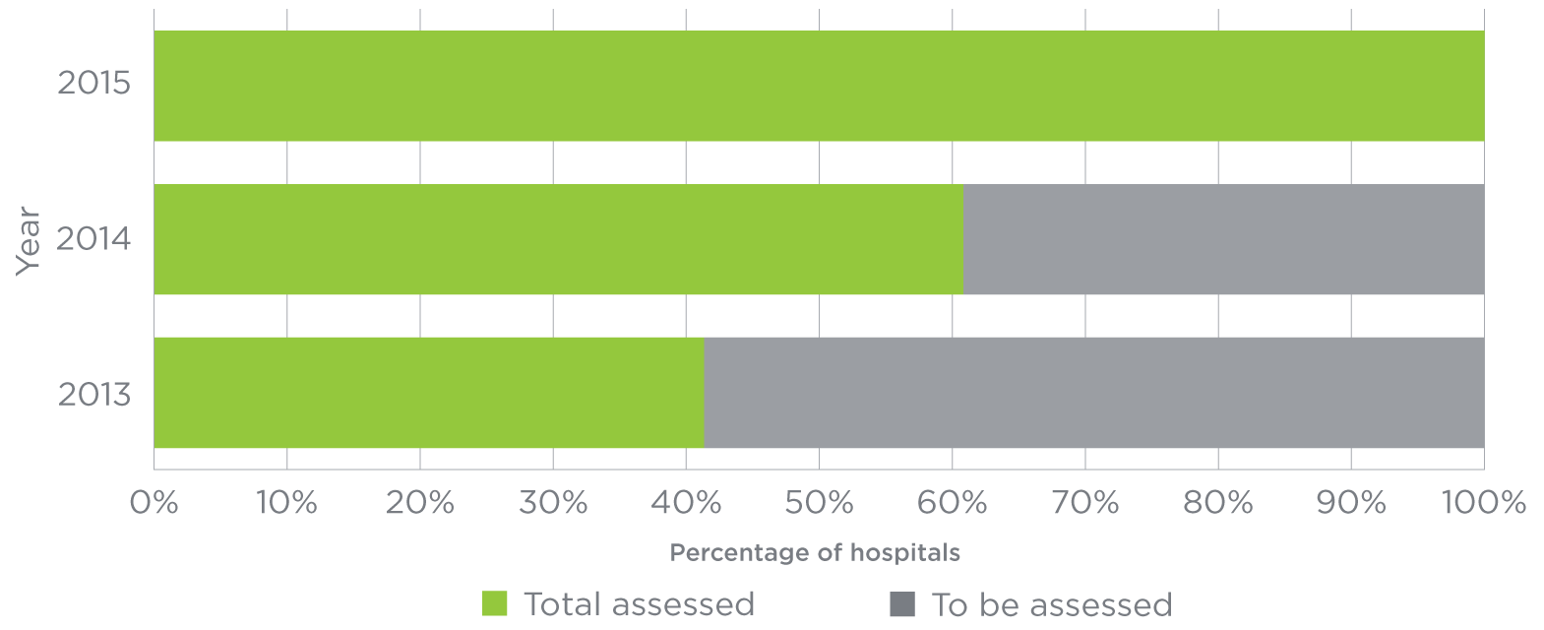

Source: Australian Commission on Safety and Quality in Health Care, 2014.

Figure 2

Progress towards accreditation in Australian day procedure services, by year

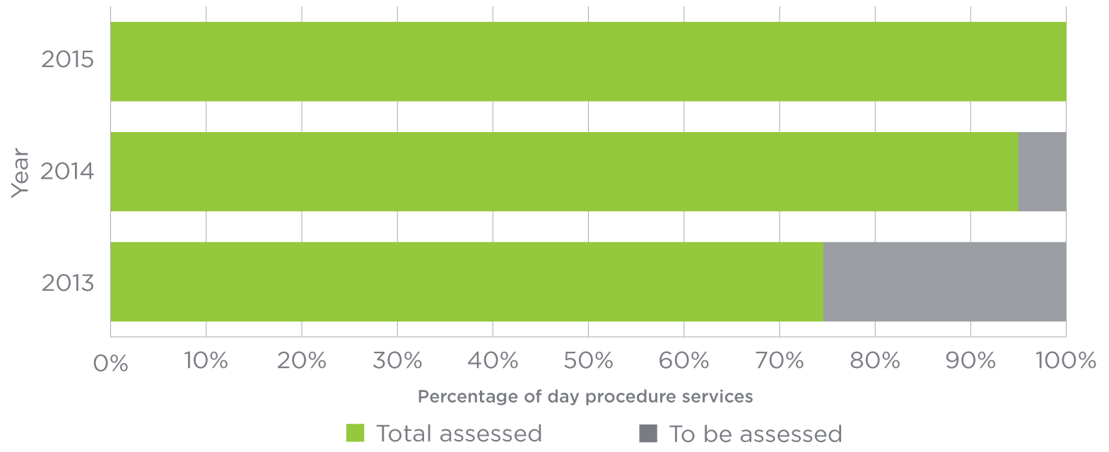

Source: Australian Commission on Safety and Quality in Health Care, 2014.

New safety and quality standards were introduced on 1 January 2013, and all hospitals and day procedure services must be assessed to them if they are to provide health services to the public

1,352

Number of hospitals and day procedure services in Australia that will be assessed to the NSQHS Standards by December 2015

## Reducing the risk of harm

Before a hospital or day procedure service can be accredited, it is first reviewed by an external agency. The agency tests the systems, processes and functions that govern safety and quality in the hospital or day procedure service to ensure they are working efficiently. Across the 10 NSQHS Standards, 256 different actions include requirements to ensure the safety and quality of care for patients. Of these, hospitals need to achieve 208 core actions to be accredited; 209 for day procedure services. The other actions are developmental actions related to aspirational targets. This section will focus on the core actions only.

If the external agency finds areas where improvements need to be made, the hospital or day procedure service has up to 90 days to make changes, in which time it must work to reduce risks to patients. Identifying and managing risks in this way helps to make patient care safer.

Of the 442 hospitals that were assessed in 2013, 44 per cent needed to make improvements before they were accredited, reducing the risk of patients being harmed. Some hospitals had a number of improvements to make, and four had more than 40 core actions to improve (see Figure 3). All of these hospitals were accredited after the improvements were made.

Day procedure services also made improvements before accreditation. Of the 237 day procedure services assessed in 2013, 46 per cent made improvements before they were accredited. Twelve had more than 40 core actions to improve before they could be accredited (see Figure 4). All of these day procedure services were accredited after the improvements were made.

679

Number of hospitals and day procedure services assessed to the NSQHS Standards in 2013

Figure 3

Number of actions rectified by hospitals

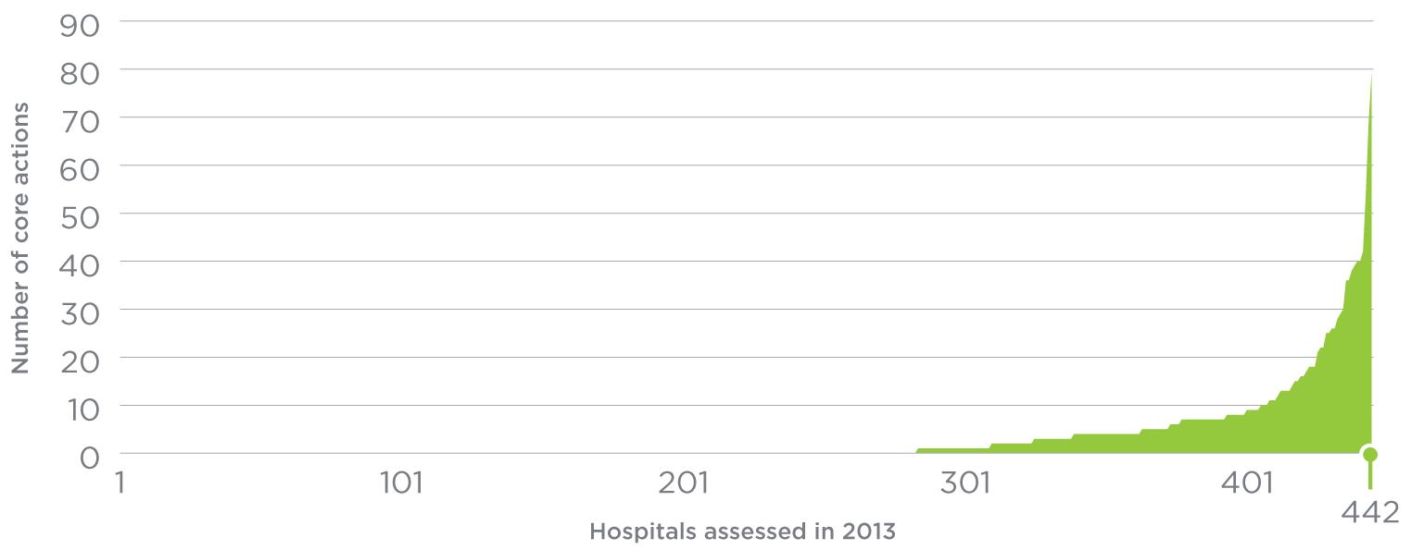

Source: Australian Commission on Safety and Quality in Health Care, 2014.

Figure 4

Number of actions rectified by day procedure services

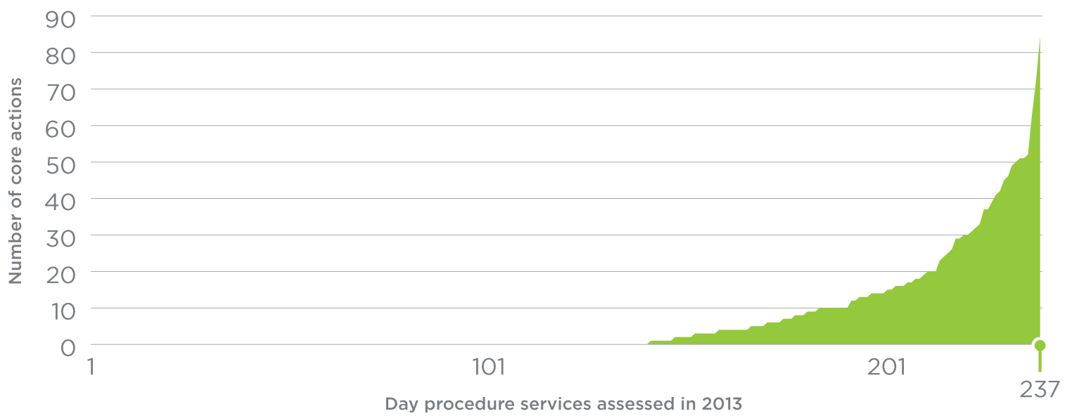

Source: Australian Commission on Safety and Quality in Health Care, 2014.

## National Safety and Quality Standards

The external accrediting agencies use a three-point rating scale to assess a hospital or day procedure service against the NSQHS Standards.

These ratings are:

* **Not met:** The actions required have not been achieved.
* **Satisfactorily met:** The actions required have been achieved.
* **Met with merit:** In addition to achieving the actions required, measures of good quality and a higher level of achievement are evident. There is a culture of safety, evaluation and improvement throughout the organisation in relation to the action or standard under review.

Across all the NSQHS Standards, external assessors rated 2 per cent of the assessed core actions as having been met with merit (see Figure 5). The hospitals and day procedure services that scored this rating excelled in:

* recording and monitoring incidents of harm to patients, and learning from that information to improve care for future patients
* involving board members and senior staff, so safety and quality is considered as part of the actions they take and in the decisions they make
* collecting and using compliments and complaints from patients and their carers to provide better care.

In 2013, external assessors reviewed more than 83,000 core actions in the NSQHS Standards for the 679 hospitals and day procedure services that received accreditation. Of these, only 2 per cent were found to need improvement (see Figure 6). The areas where hospitals and day procedure services faced the greatest challenges were:

* putting programs in place to ensure antibiotics are used effectively and appropriately
* preventing or minimising the introduction of harmful infectious agents into sterile areas of the body when clinicians provide care
* ensuring patients have access to information to make informed decisions about their treatment and that patients’ decisions are fully documented
* providing managers and clinicians with training to help involve patients in their own care.

Figure 5

Core actions awarded a ‘met with merit’ rating, by NSQHS Standard

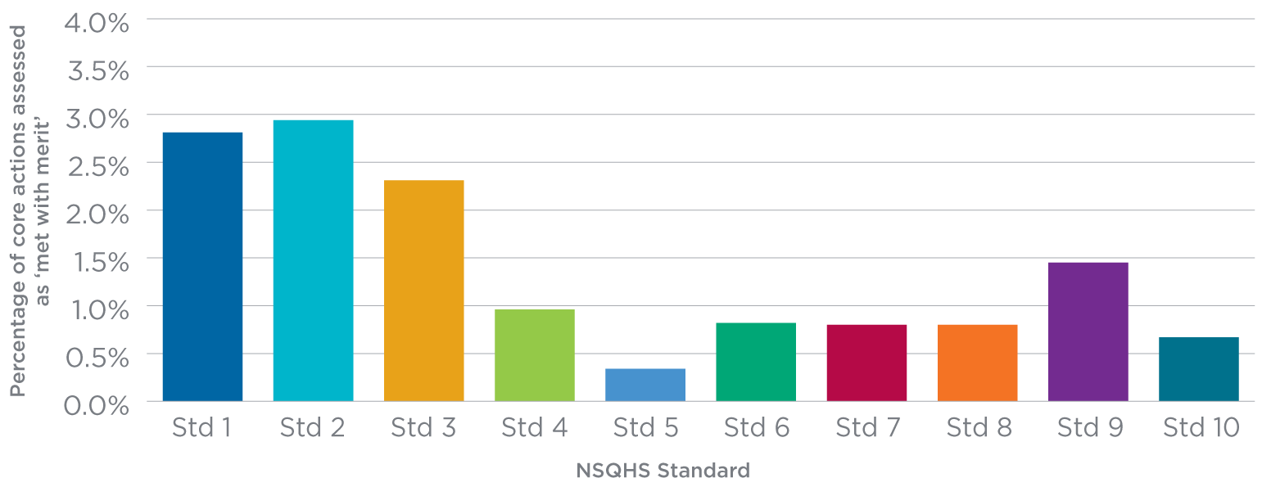

Source: Australian Commission on Safety and Quality in Health Care, 2014.

Figure 6

Core actions where improvements were needed before accreditation was awarded, by NSQHS Standard

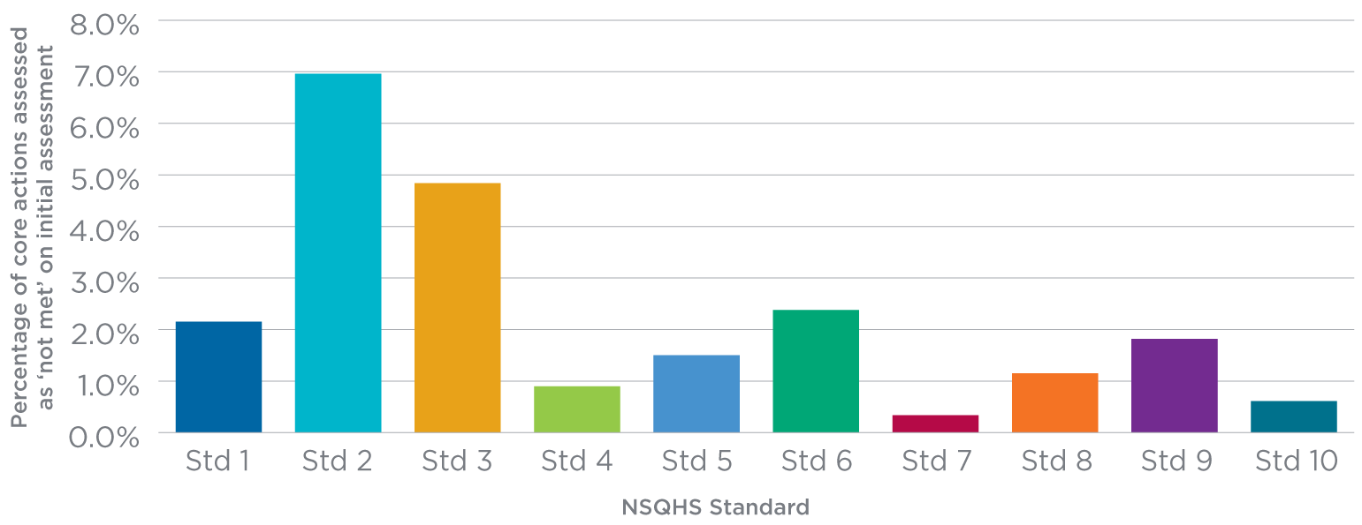

Source: Australian Commission on Safety and Quality in Health Care, 2014.

## Standards and accreditation in general practice

Just as the NSQHS Standards are making hospitals and day procedure services safer, the public expects that care provided in the community meets safety and quality standards.

General practices use standards developed by the RACGP.4

These standards cover five broad areas: practice services; rights and needs of patients; safety, quality improvement and education; practice management; and physical factors. General practices undergo a similar process to hospitals and day procedure services, where they are reviewed by an external agency to assess whether their systems meet the RACGP Standards.

There are more than 7,000 general practices in Australia.5 Although general practices do not have to be accredited, almost three-quarters (73%) of all practices are accredited to the RACGP Standards (Figure 7).

Figure 7

Accreditation of general practices in Australia, 2012/13

## Figure 7 Accreditation of general practices in Australia, 2012/13

Source: Practice Incentive Program, Australian Government Department of Health, 2014.

|  |
| --- |
| Where to next?  By the end of 2015, all hospitals and day procedure services should have been assessed to the NSQHS Standards. The Commission will continue to provide advice, support and guidance on how these services can improve their patient safety systems.  In 2014, the Commission will publish guides to help dentists and community health services use the NSQHS Standards.  We have learnt a lot from using the NSQHS Standards in hospitals and day procedure services in the first year of operation. However, there are areas we know can be improved. The Commission will start a full review of the NSQHS Standards in 2015.  The Commission is also working with the RACGP to develop a governance and reporting framework for general practice accreditation in Australia. The aim is to:   * identify problems general practices have with the existing accreditation scheme * maximise the safety and quality of patient care through the application of accreditation * coordinate general practice accreditation nationally. |

By December 2015 all hospitals and day procedure services should have been assessed to the NSQHS Standards

| What the Commission will do   * Use the information from accredited hospitals and day procedure services to learn more about the safety and quality of care being provided across Australia, and how this can be further improved. * Provide guidance and support to hospitals, day procedure services, dental practices, and community-based and other services that are using the NSQHS Standards to change their systems and improve care. * Work with groups like ambulance services to work out how they can best use the NSQHS Standards to improve the care they provide. * Work with the RACGP to examine and improve accreditation processes in general practice. |
| --- |

The NSQHS Standards are making care safer in hospitals and day procedure services; the RACGP standards are making care safer in the community

>83,000

Number of core actions reviewed by external assessors as part of the accreditation of hospitals and day procedure services in 2013

256

Number of different actions in the NSQHS Standards that include requirements to ensure the safety and quality of care for patients

¾

Proportion of general practices voluntarily accredited to standards from the RACGP

Hand hygiene: healthcare providers receive training about hand hygiene to reduce the risk of infection

Every year, thousands of Australians pick up infections in hospitals and other healthcare facilities.6 These infections can delay recovery, lengthen time spent in hospital and put sick people at risk of further complications. Hand hygiene – washing your hands thoroughly with soap and water, or using an alcohol-based rub – is one of the most effective ways to reduce and prevent these infections.

For people in hospitals and day procedure services, the hands of healthcare providers are one of the most significant sources of preventable infections. All staff providing health care should clean their hands before, during and after every instance of patient contact. However, we know that this does not always happen.

25%

Increase in the proportion of healthcare providers complying with proper hand hygiene processes between 2010 and 2013

National Hand Hygiene Initiative

In 2008, the Commission established the National Hand Hygiene Initiative (NHHI) to educate and promote change among all healthcare providers in Australia. The NHHI is based on a program developed by the World Health Organization (WHO), which specifies ‘5 Moments’ when hand hygiene should be used (see Figure 8). Through the NHHI, the Commission supports the provision of resources, training, and an audit and reporting process for hospitals to measure how they are performing in this important area of health care.

How are hospitals doing?

Since 2009, there has been a significant increase in the number of hospitals regularly auditing staff to assess their performance against the 5 Moments for Hand Hygiene. In 2013, 752 public and private hospitals submitted data about hand hygiene compliance as part of the NHHI. These hospitals included more than 95 per cent of the public hospital beds and more than 50 per cent of the private hospital beds in Australia.7

Over this period, the national average for healthcare providers complying with the proper hand hygiene processes has increased by 25 per cent, rising from 64 per cent to over 80 per cent across both public and private hospitals.7

Although the compliance rate in private hospitals was lower when fewer private hospitals submitted data about hand hygiene, it has increased substantially so that it is now equivalent to that for public hospitals (see Figure 9).

Figure 8

The 5 Moments for Hand Hygiene

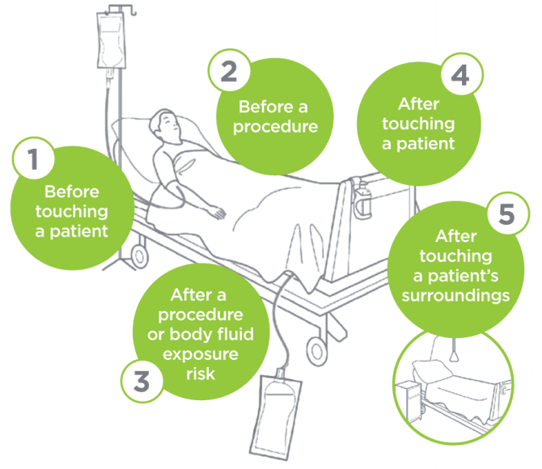

Source: Hand Hygiene Australia, Hand Hygiene Australia Manual, 2013.

Figure 9

Participation of hospitals and hand hygiene compliance rates for public and private hospitals 2009–2014

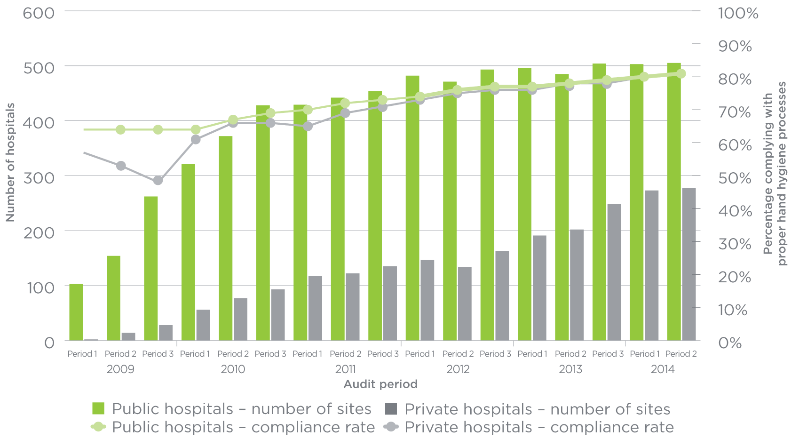

Source: Hand Hygiene Australia, www.hha.org.au, 2014.

Healthcare associated infections can delay recovery, lengthen time spent in hospital and put sick people at risk of further complications

752

Number of public and private hospitals submitting data about hand hygiene compliance

Overall, national compliance with proper hand hygiene protocols is now over 80 per cent, so the NHHI is looking at concentrating educational efforts on specific groups of healthcare providers that could further improve their hand hygiene compliance rates. Over the last 12 months, the NHHI has focused on using education and training to improve hand hygiene compliance rates for doctors and improving their awareness of the 5 Moments for Hand Hygiene.

Online training in hand hygiene

An important component of the increase in hand hygiene compliance rates is the strategy of providing standardised education about when healthcare providers should perform hand hygiene steps to reduce the risk of infecting patients. Because this is a national program, online learning is an efficient way to deliver information to many people over a large geographic area.

Hand Hygiene Australia has developed a series of online learning packages to help health services provide staff education on hand hygiene and infection prevention. These online learning packages are simple tools to improve and test healthcare providers’ knowledge about when to clean their hands when caring for patients. Specific learning packages have been developed for doctors, nurses and midwives, allied health staff and non-clinical staff. A standard package is also available for healthcare providers who don’t fit within these categories. It takes participants about 10–15 minutes to complete each learning package.

More than 700,000 healthcare providers have been trained and assessed in hand hygiene since the online learning packages were introduced in 2010.

Figure 10

Number of healthcare providers completing Hand Hygiene Australia online education packages, by type of package

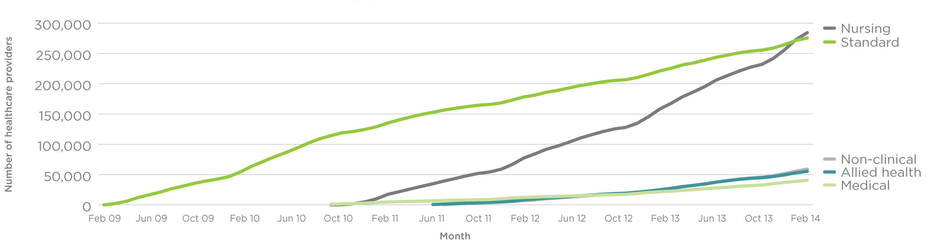

Source: Hand Hygiene Australia, www.hha.org.au, 2014.

Hand hygiene compliance rates

There has been a marked improvement in compliance since 2010

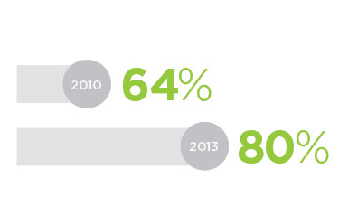

Over the past 12 months, there has been an increase of almost 40 per cent (200,000 people) in the number of healthcare providers completing the training packages (see Figure 10).7

After completing the learning package and correctly answering all the questions, participants can print a certificate with their name on it. Hand Hygiene Australia can also provide healthcare institutions with a list of participants from their institution who have completed the training. This is particularly useful in providing evidence as part of the NSQHS Standards accreditation process (see pages 6–11).

Hand Hygiene Australia has worked actively to embed hand hygiene learning in specific areas, developing a new online learning package with the Royal Australasian College of Surgeons in 2012. The number of trainee surgeons at the College being educated using the package increased from 693 to 2,687 in the 12 months to April 2014. Students must now complete this education package before sitting the College’s final surgical exams.

Hand Hygiene Australia has also developed two additional modules specifically for students. Many undergraduate courses now require students to complete these modules before they can start the clinical part of their training.

|  |
| --- |
| Where to next?  Since the introduction of NSQHS Standard 3: Preventing and Controlling Healthcare Associated Infections, it has become increasingly important for hospitals to be able to demonstrate that their staff are appropriately trained and educated, including in the field of hand hygiene. Online training is particularly well suited to delivering training on such a large scale. Increasingly sophisticated systems for delivering and monitoring online training are emerging, and the Commission – in conjunction with Hand Hygiene Australia – will explore how these can be best applied in the Australian healthcare context. |

| What the Commission will do   * Continue to support the National Hand Hygiene Initiative. * Enhance the online training packages for hand hygiene, and identify further education options for preventing and controlling infection. * Support health services’ efforts to meet NSQHS Standard 3: Preventing and Controlling Healthcare Associated Infections. |
| --- |

>700,000

Number of healthcare providers who have completed online training in hand hygiene since 2010

*Staphylococcus aureus* infection: action to reduce infections means that my care is safer

Staphylococcus aureus is a bacterium found on the skin of most people. It is normally harmless while on the skin, and most people who are carrying it are unaffected. Occasionally, Staphylococcusaureus gets into the bloodstream, where it can cause serious, long-term and potentially life-threatening illness. Information from Australian hospitals suggests that between 15 and 35 per cent of people who have a Staphylococcusaureus bloodstream (SAB) infection will die from the consequences of the infection, depending on their underlying health and the type of infection.8-10

People can develop SAB infections whether they are in or out of hospital. The majority of SAB infections are associated with medical treatments such as those involving the use of catheters and cannulas, and in most cases they are preventable. Because of this, the occurrence of SAB infections can be used as a marker for how well hospitals and other health services are doing in controlling infections and reducing the risk of harm to patients.

How often do SAB infections occur in Australia?

Most reports about SAB infections relate to infections that occur in hospitals, and show that the number of SAB infections in Australian hospitals has been decreasing over the past three years.9, 11, 12

In 2012/13, there were 1,724 SAB infections in Australian hospitals, down from 1,740 in 2011/12. While there was a small decrease in the total number of infections reported between 2011 and 2012, the number of hospitals reporting these statistics rose from 352 to 586 (see Figure 11).11, 13 This indicates a significant improvement in reducing the overall number of infections across the country.14

These improvements can also be seen when looking directly at the rate of SAB infections. Because these infections are relatively uncommon, it is usual to look at the number of infections that occur for every 10,000 days patients are in hospital. This allows comparisons across any number of hospitals. The rate of SAB infection dropped from 1.2 (per 10,000 days spent in hospital) in 2009/10 to 0.9 in 2012/13 (Figure 11).13, 14

Infections with *Staphylococcus aureus*

The number of infections that occur for every 10,000 days patients are in hospital has been dropping

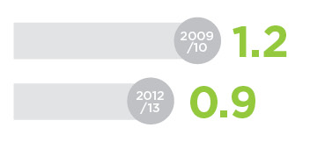

One of the factors that influences whether people are infected with SAB is how sick they are when they are in hospital and how many medical interventions they have while they are sick. Patients who are admitted for cancer, burns or surgery are more at risk of a SAB or other infection than patients who are not as sick. Major hospitals that treat sicker patients reported almost two-thirds of the total number of SAB infections in 2013.11 The number of infections in this group of hospitals decreased from 1,048 in 2012 to 1,020 in 2013 (Figure 12).11

An Australian study reviewed SAB infections in about one-quarter of Australian hospitals and found that the number of SAB cases in Australia fell by two-thirds between 2002 and 2013.9 On average, the rate of SAB infection in these hospitals decreased by about 10 per cent each year. It is estimated that up to 2,500 fewer Australian patients experienced SAB infections during this 10-year period. This represents around 50 lives saved per year, or about one life per week.9 The authors of this study concluded that the reduction in SAB infections was the result of a sustained approach to infection prevention and control, led by the Commission and embraced by the states and territories, clinicians and health managers.

Figure 11

Number of reported cases of SAB infection, number of hospitals reporting infections, and rate of occurrence of infection per 10,000 bed days, 2009/10 to 2012/13

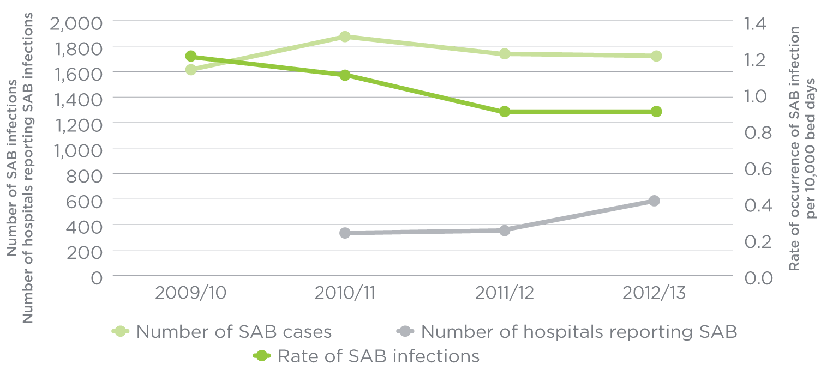

Source: Steering Committee for the Review of Government Service Provision, Report on Government Services, 2011; Australian Institute of Health and Welfare, Australian Hospital Statistics 2012–13: Staphylococcus aureus bacteraemia in Australian public hospitals, 2013.

Figure 12

Number of SAB infections reported in major hospitals that treat the sickest patients, 2010/11 to 2012/13

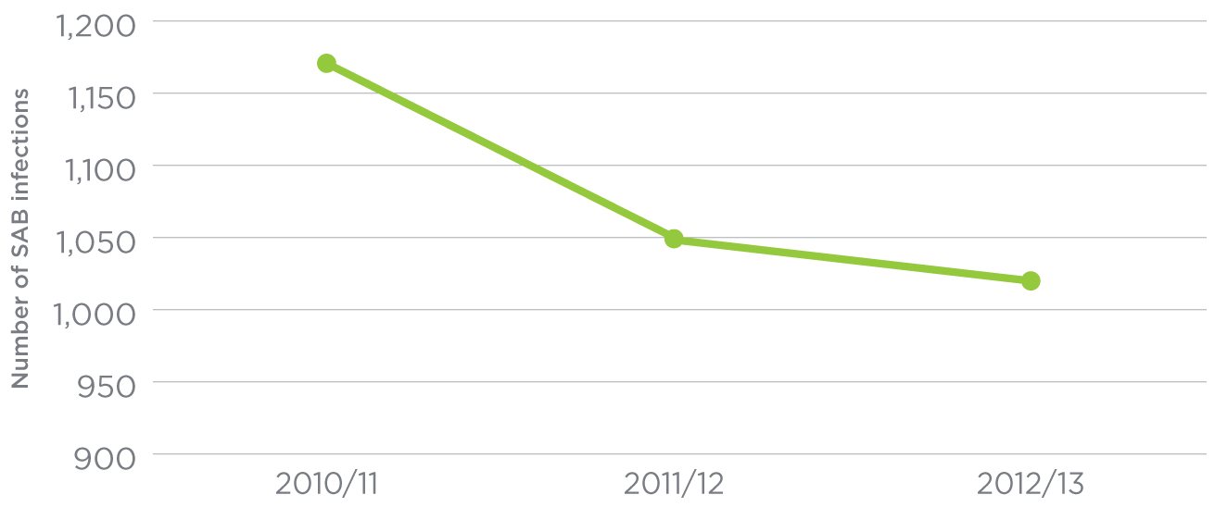

Source: National Health Performance Authority, Healthcare-associated Staphylococcus aureus bloodstream infections in 2012–13, 2014.

Staphylococcus aureus is normally harmless when it is on the skin, but when it gets into the bloodstream it can cause serious, long-term and potentially life-threatening illness

2,500

Estimated number of people who were not infected by **Staphylococcus aureus** because of improved practices between 2002 and 2013

586

Number of hospitals reporting data about **Staphylococcus aureus**

What is being done to reduce the number of SAB infections?

Because SAB infection represents a serious patient safety issue, the Commission has been involved in developing national initiatives to reduce SAB infections within hospitals and the community.

Because many factors influence the rate of SAB infection in hospitals and the community, a number of strategies are required to reduce SAB infection. The strategies currently in place to reduce all kinds of healthcare-associated infections, including SAB, are:

* **NSQHS Standards:** Because preventing infections is crucial to ensuring the safety of patients in hospitals, infection prevention and control is one of the NSQHS Standards (see pages 6–11 for more information about the NSQHS Standards). NSQHS Standard 3: Preventing and Controlling Healthcare Associated Infections aims to prevent patients acquiring preventable healthcare-associated infections, including SAB infections.
* **Hand hygiene:** Good hand hygiene among healthcare workers is an important strategy in reducing preventable infections such as SAB. All public hospitals are required to collect information about how well healthcare providers and other staff are following hand hygiene processes. This information is also reported on the MyHospitals web site for every public hospital and many private hospitals (see pages 12–15 for more information about hand hygiene).
* **National infection control guidelines:** The Australian Guidelines for the Prevention and Control of Infection in Healthcare6 are based on research evidence and provide hospitals with guidance on how to prevent and control infections. The guidelines include information on managing medical devices such as catheters and cannulas, with the aim of reducing all infections in hospitals, including SAB infections.
* **National standard definition for measuring SAB:** A standard definition for the surveillance of SAB infections means that SAB infection is now measured and reported in the same way in all Australian public hospitals and some private hospitals.
* **National reporting of SAB infection:** All public hospitals now report information about SAB infections on the MyHospitals web site: www.myhospitals.gov.au.

|  |
| --- |
| Where to next?  Hospitals around the country will continue to monitor and report the rates of SAB infection and the rates of hand hygiene compliance. This information will continue to be published on the MyHospitals web site so consumers have information about how their local hospital is performing in these two important areas. |

The majority of Staphylococcus aureus infections are preventable

| What the Commission will do   * Work with health departments from each of the states and territories – and with clinicians and colleges – on strategies for reducing the number of infections patients might get as a result of their health care. Strategies include:   + ensuring proper hand hygiene processes are in place through the National Hand Hygiene Initiative   + supporting judicious use of antibiotics   + improving the measurement and reporting of infections   + providing education resources for doctors, nurses and pharmacists. |
| --- |

Medication safety: my health service makes sure I get the right medicines when I go in and out of hospital

Medicines are the most common treatment used in health care and contribute to ensuring people stay healthy, relieving symptoms of disease, and curing some diseases and conditions. However, mistakes can happen when medicines are prescribed, dispensed and administered in a healthcare environment, as well as when people take medicines in their own home. Some of these mistakes can cause harm.

Between 2001 and 2011, the number of prescriptions dispensed in Australia increased by 40 per cent.15, 16As health care becomes increasingly complex and treatment of disease more intensive, people are taking more medicines, increasing the risk of mistakes and medication-related problems. It is estimated that approximately 230,000 patients are admitted to Australian hospitals each year with medication-related problems.17 Older people, people who are taking multiple medicines and people who see a number of different doctors are more likely to experience a medication error.17, 18

People who have their medicines reviewed at home have been found to have between 2.5 to five medication-related problems per person,17 many of which are preventable.

Medication errors are common when people move around the health system

One area where we can reduce medication errors is by improving communication between healthcare providers – and between healthcare providers and patients, carers and families – when patients are admitted to hospital. Around half of the medication errors that occur in hospital happen on admission or discharge,19 and around 30 per cent of these errors have the potential to cause patient harm.20, 21 Errors can occur when:22

* a medication history is obtained, such as on admission to hospital
* medicines are recorded in the medical record
* medicines are ordered when a patient is admitted, transferred between wards or discharged (see Figure 13).

Whenever a person is admitted to hospital, the hospital takes a record of the medicines the patient has been taking at home. This list of medicines (the medication history) is used to write orders for the medicines the patient will be given in hospital, to guide decisions about what treatment is required and to work out if a medicine taken at home has caused a problem or contributed to the admission.

Medication histories are often incomplete; they may be missing information about the strength or dose of the medicine and often omit non-prescribed medicines, such as over-the-counter or herbal medicines. If an incomplete or incorrect medication history is used to prescribe the medicines in hospital, the medicines ordered will differ from the medicines the patient has been taking at home. These variances (errors) are referred to as ‘unintentional discrepancies’.

Australian studies have found that between 60 and 80 per cent of people had a discrepancy with their medication history when they were admitted to hospital; on average, each patient experienced between one and 2.5 errors.17 The most common error was the omission of a regularly used medicine.17, 23, 24

If these discrepancies are not corrected, they will continue throughout the hospital stay. This may mean that patients stop taking essential medicines, restart taking unrequired medicines, receive inappropriate medicines and fail to have medicine-related problems identified. These errors may cause harm during the hospital stay or after the patient has gone home if the error is not picked up when they are discharged.

Medication errors can be reduced by improving communication when patients are admitted to hospital

Figure 13

Where medication errors occur at transfer of care

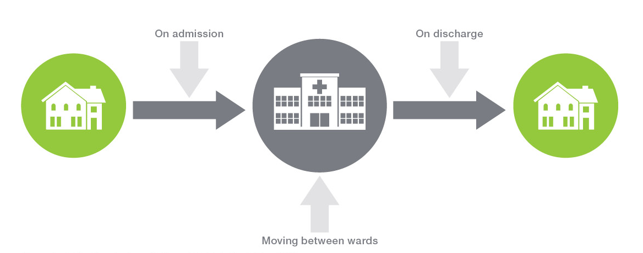

Source: Australian Commission on Safety and Quality in Health Care, 2014.

Figure 14

The steps in medication reconciliation

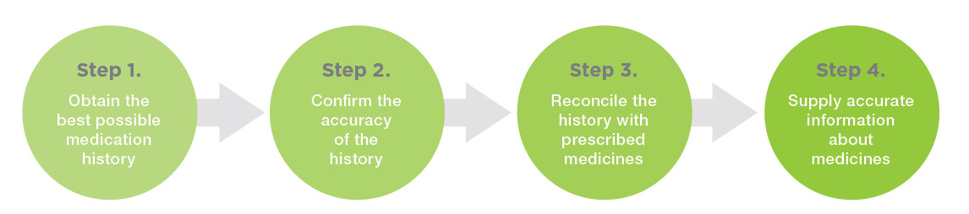

Source: Australian Commission on Safety and Quality in Health Care, 2014.

Patients aged 65 and over, and those taking multiple medicines, are more likely to experience errors when their care is transferred.18 Transfers within a hospital – such as going from intensive care to a general ward – also carry risk, particularly for the unintentional omission of medicines. Errors can also occur when patients are discharged, when prescriptions are written and when medicines lists are prepared. Medicines the patient needs to keep taking may be left off the prescription, placing the patient at an increased risk of being re-admitted to hospital.25

230,000

Estimated number of people who are admitted to hospital each year with medication-related problems

Medication reconciliation reduces errors with medicines

Medication reconciliation is a process designed to accurately and completely communicate information about a patient’s medicines when the patient is admitted to or discharged from hospital, or when their care is transferred within the hospital or to another healthcare provider.26The objective is to prevent medication errors associated with the handover process. Reconciliation involves independently checking key steps in the handover process, and has been shown to reduce unintentional discrepancies and potentially adverse medicine-related events by more than 50 per cent.17, 27-29

Medication reconciliation is a four-step process that works best when patients, carers and families participate in the process (see Figure 14).

The process starts by interviewing the patient, family or carer to identify all the medicines the patient is currently taking – including prescription medicines, medicines purchased over the counter in the pharmacy or supermarket, and complementary or herbal medicines. This step may include checking the patient’s medicine containers or medicines list, or contacting the patient’s GP or pharmacist to confirm that the list of medicines is as accurate and complete as possible. This list is sometimes called the ‘best possible medication history’.

This history is used to order the patient’s medicines or check against the medicines ordered to identify any mistakes (or unintentional discrepancies). Any mistakes are brought to the attention of the prescriber and corrected – that is, the medicines ordered for use in the hospital are reconciled with the medicines taken prior to admission. This step is repeated when patients change wards and when they are discharged to return home or to an aged care facility. This ensures all changes to the patient’s medicines during their stay are recorded and any new medicines are prescribed.

The final step occurs on transfer from hospital to the community, and involves giving the patient – and their GP – a medicines list containing all the medicines to be taken at home and the reasons for any changes.

Medication reconciliation is a process designed to accurately and completely communicate information about a patient’s medicines when the patient is admitted or discharged from hospital, or when their care is transferred within the hospital

>50%

Reduction in discrepancies in medication history when medication reconciliation is used

Improving medication reconciliation in Australia

Since January 2010 the Commission has been coordinating Australia’s involvement in an international project run by WHO.1 Hospitals in five countries, including 12 in Australia, have been implementing a standardised operating protocol for reconciling the medicines of people aged over 65 who are admitted to hospital through an emergency department.

Interim results from the Australian hospitals show that reconciling medications for people within 24 hours of their admission reduces medication errors. Participating Australian hospitals found that there were generally fewer than 0.3 unintentional discrepancies between the medicines taken by the patient before admission and those ordered for the patient in hospital (see Figure 15). These hospitals also found that less than 20 per cent of patients experienced an unintentional medication discrepancy and that this rate was sustained over time (see Figure 16).

Involving patients, carers and families in medication reconciliation

Successful medication reconciliation requires the involvement of patients, carers and families. The Commission has worked with NPS MedicineWise to develop a consumer medicines resource that encourages patients, carers and families to be actively involved in preventing medication errors when they enter and leave hospital. A wallet, designed to store the patient’s current medicines list, includes advice on keeping an up-to-date medicines list at home, and taking this list and all medicine containers when going into hospital.

1 The High 5s Project, established by WHO in 2007, is an international collaboration carried out in seven countries: Australia, France, Germany, the Netherlands, Singapore, Trinidad and Tobago, and the United States. It is coordinated by the WHO Collaborating Centre on Patient Safety Solutions. Its mission is to facilitate the implementation and evaluation of standardised patient safety solutions within a global learning community, to achieve measurable, significant and sustainable reductions in high-risk patient safety problems.

Figure 15

Average number of unintentional discrepancies per patient

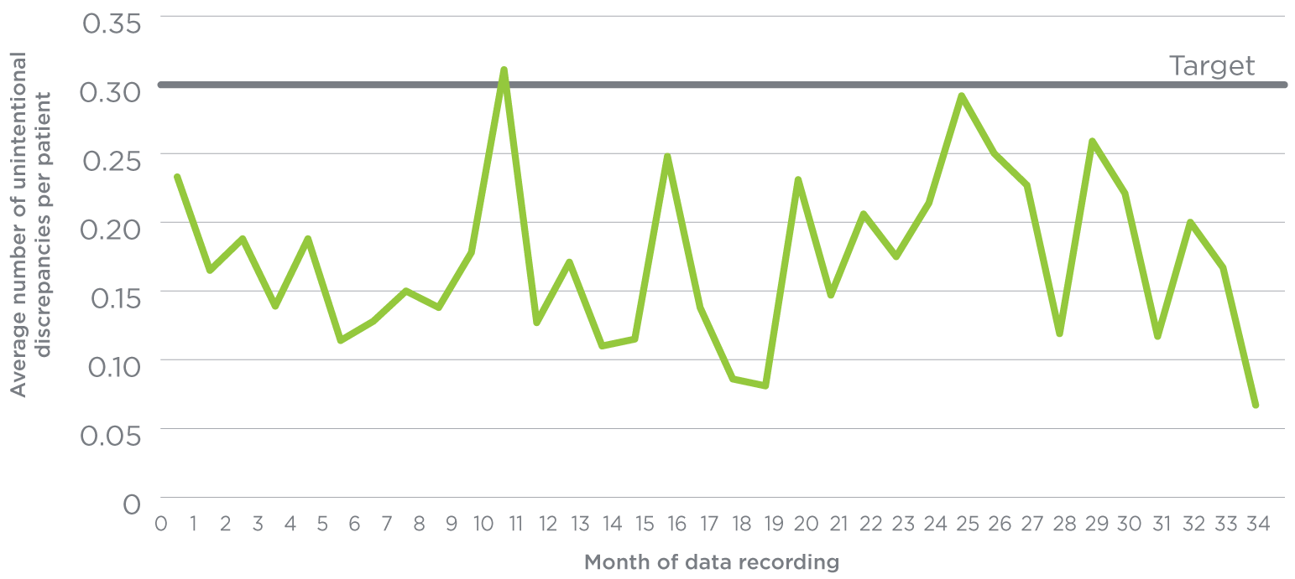

Source: Australian Commission on Safety and Quality in Health Care, 2014.

Figure 16

Proportion of patients experiencing one or more unintentional medication discrepancies

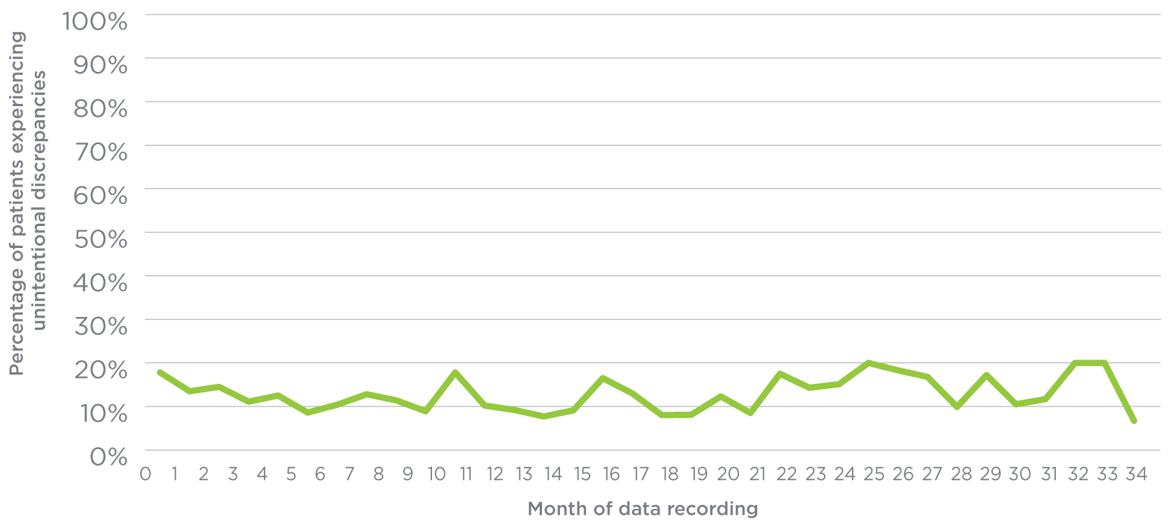

Source: Australian Commission on Safety and Quality in Health Care, 2014.

|  |
| --- |
| Where to next?  NSQHS Standard 4: Medication Safety requires hospitals to implement a process for reconciling patients’ medicines (see pages 6–11 for information about the NSQHS Standards).30 Hospitals need to demonstrate that they have effective processes in place to ensure that:   * the best possible medication history is documented for each patient * current medicines are reconciled upon admission and transfer of care between healthcare settings * a current, comprehensive list of medicines, and reasons for any change, is provided to the receiving clinician and the patient when care is transferred.   Having medication reconciliation included in the NSQHS Standards will help embed these practices across all hospitals in Australia and reduce the risk of medication-related errors for patients.  The increasing use of electronic systems to communicate information about medicines within and between hospitals and the community creates opportunities to improve access to this information.  The challenge will be ensuring the accuracy and completeness of this information, and the Commission will work with other organisations to ensure that the process of medication reconciliation is safely included in electronic systems. This will include continuing to work with the National E-Health Transition Authority to assure the safety of the medicines component in the Personally Controlled Electronic Health Record (PCEHR). |

| What the Commission will do   * Support hospitals to meet NSQHS Standard 4: Medication Safety. * Reduce the risk of harm to patients by standardising the way in which medicine information is communicated upon admission to, transfer within and discharge from hospital. * Provide training tools to help health services implement effective medication reconciliation processes. * Work with NPS MedicineWise to provide educational tools for healthcare providers and consumers that further improve the quality of medicine information when care is handed over from one healthcare provider to another. * Work with other organisations to integrate medication reconciliation into electronic medication management systems and electronic health records, including the PCEHR. |
| --- |

Introduction of a standard process for medication reconciliation in the emergency department reduced the rate of medication discrepancies to 20 per cent – from an estimated 60 to 80 per cent

Recognising and responding to clinical deterioration: if my health deteriorates while I am in hospital there are systems to ensure I get the care I need

Patients in hospital can experience unexpected deterioration in their physical health for a range of reasons. A patient’s health may deteriorate because the illness that led to their admission to hospital becomes worse, there are side effects from their treatment, or an unexpected complication occurs. If physical deterioration is not noticed quickly, the consequences can be severe, and may even include catastrophic events such as admission to intensive care, cardiac arrest or death.31-33

What needs to be done to make sure I am properly looked after if my condition deteriorates when I am in hospital?

Failure to recognise and respond to clinical deterioration has been a known problem for some time, and all hospitals and day procedure services in Australia are required to have processes in place to help healthcare providers recognise when a patient’s condition is deteriorating and provide the necessary clinical response. This requirement is included in NSQHS Standard 9: Recognising and Responding to Clinical Deterioration in Acute Health Care (see pages 6–11 for information about the NSQHS Standards).

To meet the NSQHS Standards and effectively manage clinical deterioration when it occurs, health services need to have systems in place for monitoring patients, recognising deterioration, calling for assistance when required, and ensuring that a healthcare provider with the necessary skills responds to that call. The NSQHS Standards also emphasise the important role that patients, carers and families can play in recognising when a patient’s condition is deteriorating. These processes are collectively referred to as ‘recognition and response systems’.

These systems work differently depending on where care is provided. For example, when a patient’s condition deteriorates in a large hospital in a city, a team of doctors and nurses from the intensive care unit might provide the emergency response. In a small rural hospital, this emergency response might come from a specially trained nurse, or the local GP or ambulance service. In some remote settings it is particularly important to identify patient deterioration as soon as possible, as the patient may need to be airlifted to a larger centre before they can be treated.

Patients can experience unexpected deterioration in their condition when they are in hospital for a range of reasons. If this is not noticed quickly, the consequences can be severe, and may even include catastrophic events such as admission to intensive care, cardiac arrest or death

Monitoring vital signs is an important way to identify whether a patient is deteriorating

An observation chart is a clinical tool for recording key vital signs such as blood pressure, breathing rate and pulse. It is important to monitor these vital signs so healthcare providers can recognise deterioration early and take prompt and effective action.34

The Commission has worked with state and territory health departments and researchers to develop a new type of observation chart that helps nurses, doctors and other people providing care to pick up early changes in a patient’s condition.35, 36 These charts include colour-coded zones that indicate when vital signs fall outside expected norms.

Figure 17

Example of an observation chart designed to make it easier for healthcare providers to identify when a patient’s condition is deteriorating

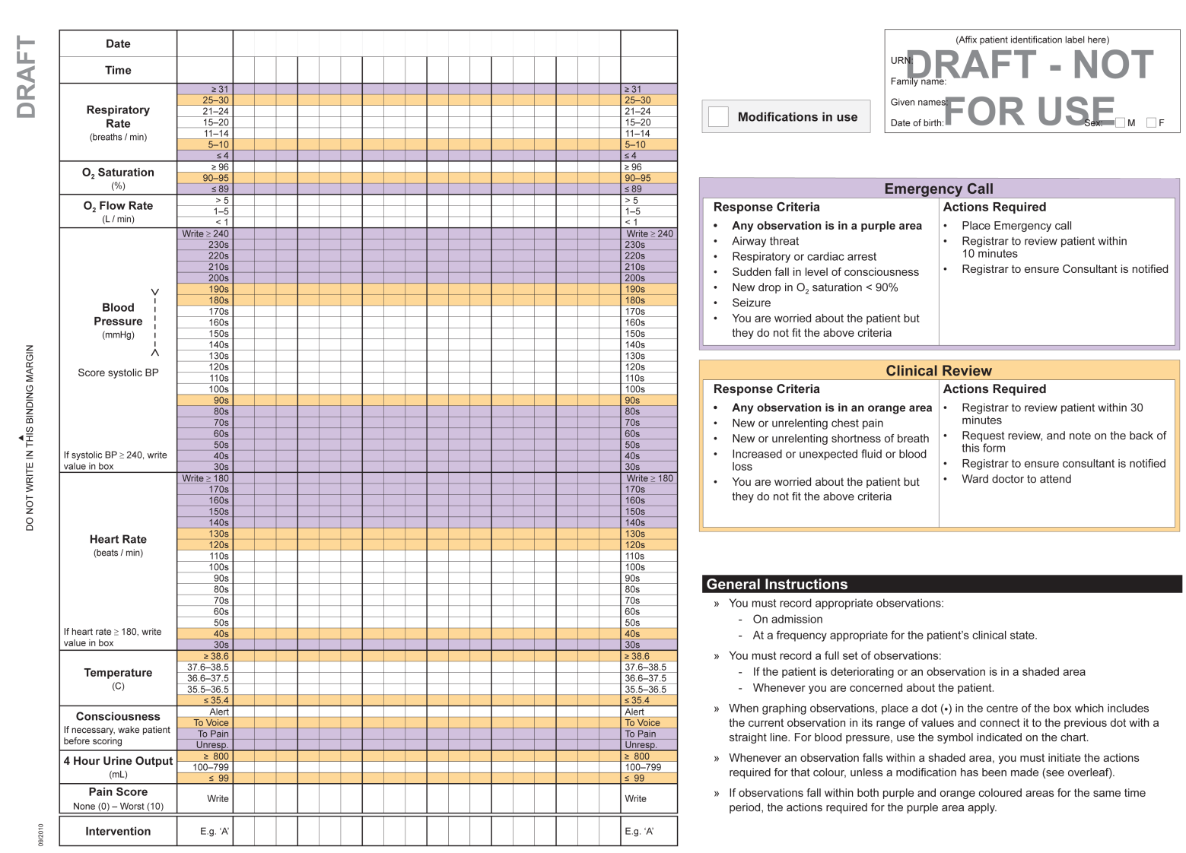

The coloured zones on the chart are linked to actions, and the actions taken become more urgent as a patient’s vital signs become more abnormal. For example, for vital signs falling in the orange zone in Figure 17, a doctor from the team looking after the patient would be expected to assess the patient within 30 minutes. For vital signs in the purple zone, an emergency call to healthcare providers with specialist life support skills would be required and an almost immediate response expected.

How do we know if recognition and response systems are working?

Successful recognition and response systems must clearly identify the people within the hospital who are responsible for overseeing the system and making sure it works well. This supervisory role includes measuring whether the system is making a difference in terms of preventing catastrophic events like cardiac arrests and death.

There are various challenges for individual hospitals trying to measure changes in cardiac arrest and death rates because the number of events that occur in a year might be very small. That means it can take a long time to see whether a new recognition and response system has made any difference – changes in a small number of cases could just be the result of chance.

Accurate measurement is further complicated by the fact that many other factors could affect cardiac arrest and death rates. For example, if a small hospital reduces the time it takes for very unwell patients to be transferred to a bigger hospital nearby, the small hospital is less likely to record episodes of clinical deterioration resulting in cardiac arrest. That means any decrease in cardiac arrest or death rates might be because there were fewer very unwell patients in the small hospital, not because the recognition and response system is working effectively. Complicating factors like these make it important to evaluate big systems that include data from many hospitals, to determine whether recognition and response systems are having the intended effect.

Under the NSQHS Standards, all hospitals and day procedure services now need to have systems in place to recognise when a patient’s condition is deteriorating and provide the necessary clinical response

An example of a recognition and response system that has made a difference – Between the Flags

Between the Flags (BTF) is one such large system in New South Wales (NSW). It operates as a ‘safety net’ for patients in the state’s public hospitals and is designed to improve the recognition of and responses to patients whose conditions deteriorate in hospital. The BTF system uses the analogy of Surf Life Saving Australia’s lifeguards, who keep swimmers safe by observing them and ensuring they don’t venture into unsafe areas – and quickly rescuing them if they are in trouble.

The Clinical Excellence Commission – supported by NSW’s Local Health Districts and the Ministry of Health – implemented BTF in 220 hospitals in January 2010.37



Between the Flags is a program in NSW public hospitals that is designed to provide a safety net for patients whose condition deteriorates in hospital

Figure 18

The five elements of the Between the Flags system

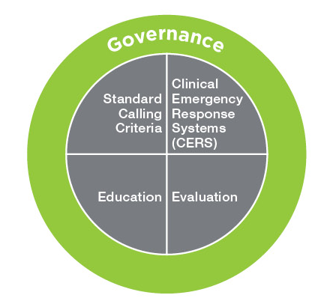

Source: New South Wales Clinical Excellence Commission, 2014.

220

Number of hospitals in NSW participating in the Between the Flags program

38%

Reduction in rate of cardiac arrests in NSW hospitals since the introduction of the Between the Flags program

800

Estimated number of lives saved because of the reduction in cardiac arrests in NSW hospitals associated with Between the Flags

The foundation of the BTF system is an observation chart with colour-coded zones and standard criteria that act as triggers for seeking help. The chart is one part of a comprehensive program that also includes a standardised approach to education, evaluation and governance (see Figure 18).

One way of determining whether patient outcomes have improved is by counting the number of cardiac arrests that occur per 1,000 patients admitted to hospital. This allows data to be compared and collected across hospitals, regardless of their size and the number of patients they see.

Information from the BTF program shows that cardiac arrest rates have decreased since the program started in 2010 (see Figure 19). There has been a 38 per cent reduction in the rate of cardiac arrests in NSW hospitals over the period, which translates to an estimated 800 fewer deaths.

|  |
| --- |
| Where to next?  So far, the Commission’s work on recognising and responding to deterioration has focused on people’s physical health. One of the next big challenges is to consider how the principles of recognition and response systems can be applied to circumstances where a patient’s mental state is deteriorating. A patient’s mental health can deteriorate for a range of reasons and in a range of care settings. Because of this, healthcare providers have varied levels of expertise when it comes to recognising deterioration and knowing how to respond.  One of the first steps is to work with clinical and consumer experts to identify the key adverse events that are associated with mental deterioration. The Commission has started by looking at the issues associated with practising seclusion and restraint in mental health services and emergency departments (see pages 29–31). |

Figure 19

Calls for cardiac arrests per 1,000 patients admitted to public hospitals in NSW, August 2010 – June 2013

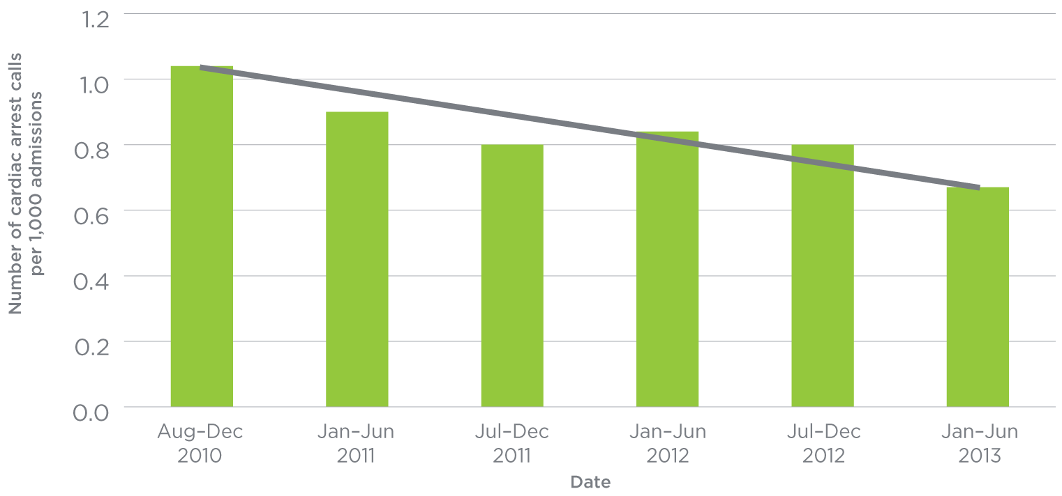

Source: New South Wales Clinical Excellence Commission, 2014.

| What the Commission will do   * Support health services to implement recognition and response systems that meet the requirements of NSQHS Standard 9: Recognising and Responding to Clinical Deterioration in Acute Health Care. * Examine the complex issues and situations that can influence deterioration in mental state. |
| --- |

Seclusion and restraint: if I have mental illness and my condition deteriorates this will be managed without causing additional harm

Seclusion refers to ‘the act of confining a patient in a room when it is not within their control to leave’.38 Restraint is ‘a restrictive intervention that relies on external controls to limit the movement or response of a person’.38 Three types of restraint have been identified: physical restraint of the body; mechanical restraint; and pharmacological restraint, where fast-acting tranquiliser medications are administered to the person as an alternative to physical or mechanical restraint.38

All states and territories in Australia have legislation in place governing the provision of care to people with mental illness, including people who are being treated on an involuntary basis. Seclusion and restraint are recognised as ‘restrictive interventions’ in this legislation. In other words, seclusion and restraint are intended to be used as last-resort safety measures to prevent imminent harm, after attempting less-restrictive interventions – such as de-escalation strategies in response to aggression.

What is the problem with seclusion and restraint?

Seclusion and restraint have been reported to cause trauma to people who experience them, which can influence future decisions to access treatment for mental health issues.39

Seclusion and restraint can also increase the risk of physical harm to the person receiving these interventions. Problems associated with seclusion and restraint include dehydration, loss of mobility, physical injury and, in rare circumstances, death.38 The healthcare providers who administer these practices may also be exposed to the risk of significant injuries.

Concerns about the impact of seclusion and restraint have led to calls for the elimination of these restrictive interventions.

Rate of seclusion events in public hospitals

There has been a marked reduction in the rate of seclusion events between 2008/09 and 2012/13

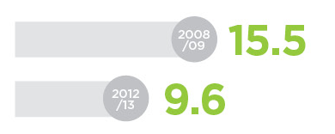

Number of seclusion events per 1,000 bed days

What is being done to eliminate seclusion and restraint?

There is broad community support for ending the use of seclusion and restraint. This can be seen in the grassroots promulgation and endorsement of the Seclusion and Restraint Declaration developed by the National Mental Health Commission.40

Concerns about the impact of seclusion and restraint have led to calls for the elimination of these practices

Seclusion and restraint are designed to be used as a last resort to prevent imminent harm after other interventions have been tried

Reducing the use of, and where possible eliminating, restraint and seclusion was identified as one of the four national safety priorities in mental health in 2005.38 Considerable work has been done over the past decade to support this priority, with evidence shared through a series of national forums.

Strategies designed to reduce the use of restraint and seclusion include:

* making mental health services more recovery-oriented, by focusing on the experiences of people with mental health issues and their families41
* providing trauma-informed care, which ensures that treatment and care is based on an understanding of the trauma and violence that may be experienced by people with mental health issues42
* ensuring earlier recognition of mental deterioration in people with mental health issues, and an appropriate and timely response
* increasing transparency and accountability around documenting the use of seclusion and restraint.

In July 2013, the Australian Institute of Health and Welfare published the first national data on rates of seclusion. Making this information available had been a goal for some time.

The rate of seclusion events is progressively reducing over time (see Figure 20), which indicates the implemented strategies are working. Between 2008/09 and 2012/13, instances of seclusion being used dropped from 15.5 times to 9.6 times for every 1,000 days patients were in hospital.

Figure 20

Rate of seclusion events in public sector acute mental health hospital services, 2008/09 to 2012/13

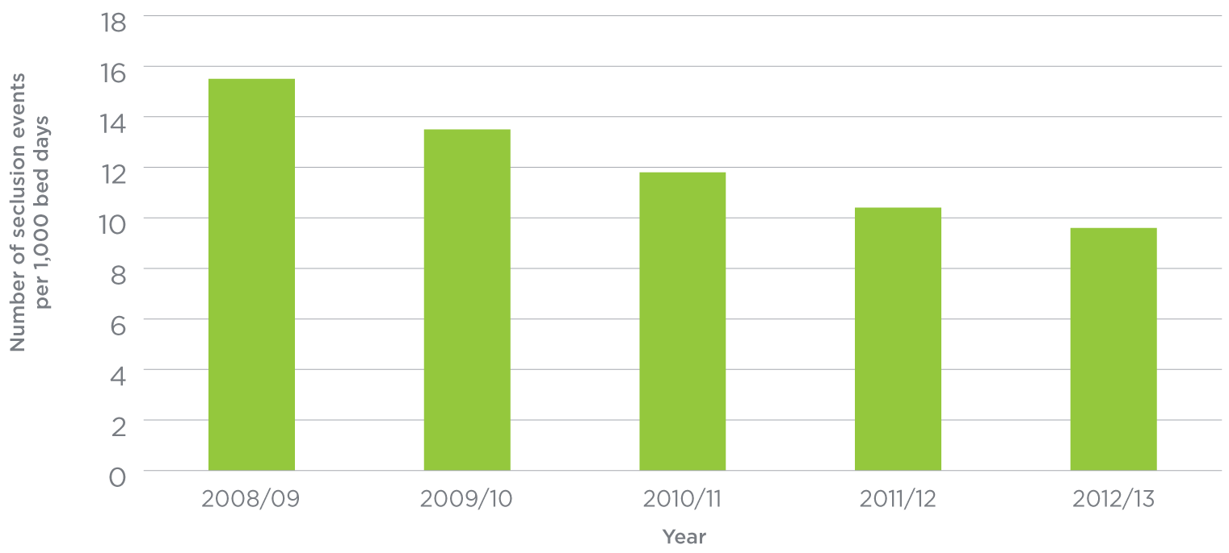

Source: Australian Institute of Health and Welfare, Use of restrictive practices during admitted patient care, 2013.

62%

Reduction in seclusion events in public hospitals between 2008/09 and 2012/13

|  |
| --- |
| Where to next? Seclusion and restraint continue to be key safety issues for people with mental health issues, as well as for healthcare providers working in mental health services and general healthcare settings. Improving the care provided to people with mental illnesses by reducing and minimising the use of seclusion and restraint remains a national priority, and around Australia there are many projects in place to address this, including the National Mental Health Commission’s National Seclusion and Restraint Project.  With the introduction of the NSQHS Standards in 2013 (see pages 6–11) and the revision of the National Standards for Mental Health Services in 2010,43 the role of standards in supporting work to minimise the use of seclusion and restraint is being considered. In 2013, the Commission undertook a scoping study on the implementation of both sets of standards in mental health services. More than 550 healthcare providers and people who use mental health services participated in the project. One clear message from the project was that any review of the NSQHS Standards should consider making it mandatory to ensure the safety of these interventions in all health settings. |

| What the Commission will do   * Incorporate strategies to reduce, and where possible eliminate, seclusion and restraint when the NSQHS Standards are reviewed in the future. * Expand its work in relation to recognising and responding to clinical deterioration (see pages 24–28), to incorporate responses to deterioration in mental state, including seclusion and restraint. * Work with national, state and territory organisations, and contribute to national consensus on optimal approaches for seclusion and restraint. |
| --- |

2 Will I get the right care?

Healthcare variation:

if health care varies across the country, am I getting the right care?

Cognitive impairment:

my healthcare providers will detect and treat my delirium

Advance care planning:

even if I am no longer able to speak for myself, healthcare providers will know what my wishes are

Will I get the right care?

Even if the standard of health care is appropriate – that is, safe – other important questions need to be asked.

Sometimes different people who have the same health conditions, concerns or problems do not receive the same health care. Depending on where they live, or which health service or healthcare provider they consult, people may be managed differently. This is referred to as ‘healthcare variation’, and it occurs around the world.44

There are many reasons why this variation occurs. The population is not all the same, and people have different needs. Sometimes variation is related to the preferences of individual patients or groups and the choices they make. Sometimes it reflects healthcare providers’ efforts to innovate and improve practice. However, it might also result in some people undergoing unnecessary and potentially harmful tests or treatments, while others miss out on necessary interventions.44

The Commission is working to make sure that everyone gets the care we know they should. All people involved in health care play a role in ensuring that this occurs: from the patient and their family, to their GP and the referrals that they make, and to the medical specialists that provide procedures across Australia.

This section provides information about a new study into how health care varies across Australia. It also discusses two areas where it is especially important to ensure the right care is provided: when people have a cognitive impairment and when they are at the end of their life.

Healthcare variation: if health care varies across the country, am I getting the right care?

People who have the same health concerns or problems do not necessarily receive the same health care. Depending on where they live, or which health service or healthcare provider they consult, they may end up receiving different types of treatment. Variation in health care occurs in health systems all around the world, including Australia.45

Some variation in health care is expected and warranted. For example, people living in one area may have different healthcare needs from those living in a different area. Variation in health care may also reflect differences in people’s preferred treatment options, or their cultural or personal preferences.

However, some healthcare variation is unwarranted, particularly where it cannot be explained by patient needs or preferences.

Unwarranted variation may indicate that some patients are not receiving the most appropriate or effective care, or that resources are not being put to the best use. For example, some patients might receive health care that will be of little benefit to them, while others may miss out on tests or treatments that could be helpful.44

Looking at healthcare variation in Australia

Knowing where, how and why healthcare variation occurs is an important first step in identifying whether the variation is unwarranted. Reducing unwarranted variation can result in a more equitable and efficient healthcare system. It can also ensure people are more likely to get the right care and that this care is based on their needs and preferences.

The Commission – in partnership with all states and territories, the Australian Government Department of Health, and the Australian Institute of Health and Welfare – recently examined variation in some of the procedures used to treat common reasons for hospital admissions in Australia (see the box on the right). This work was part of a major study by the Organisation for Economic Co-operation and Development (OECD) that examined variations in healthcare procedures in 13 countries.

|  |
| --- |
| Reasons for hospital admission examined in the national study into healthcare variation   * Hip fracture * Knee replacement * Knee arthroscopy * Caesarean section * Hysterectomy for women without any diagnosis of cancer * Cardiac catheterisation (an invasive diagnostic procedure to examine blocked blood vessels in the heart) * Percutaneous coronary intervention (a procedure to open blocked vessels in the heart) * Coronary artery bypass grafting (a heart bypass operation) |

The study used hospital data from 2010/11 to analyse variations in the rate of hospital admissions according to where people live, defined by the boundaries of Medicare Locals.

Medicare Locals are regional organisations that were established to coordinate the delivery of services by healthcare providers and community organisations, and to address local needs and gaps. There are currently 61 Medicare Locals in Australia; they will be replaced with new primary healthcare organisations in 2015.

As there are known differences in the likelihood of people of different genders and ages requiring health care, the analysis took into account differences in the age and sex profile of the population in each Medicare Local. These analyses produced the ‘national standardised rate’ used to examine the extent of healthcare variation in Australia.

Threefold variation

Variation in rates of admission for coronary artery bypass surgery, knee arthroscopy and hysterectomy without any diagnosis of cancer across Australia

Figure 21

Admissions for coronary artery bypass grafting per 100,000 people, by Medicare Local, 2010/11

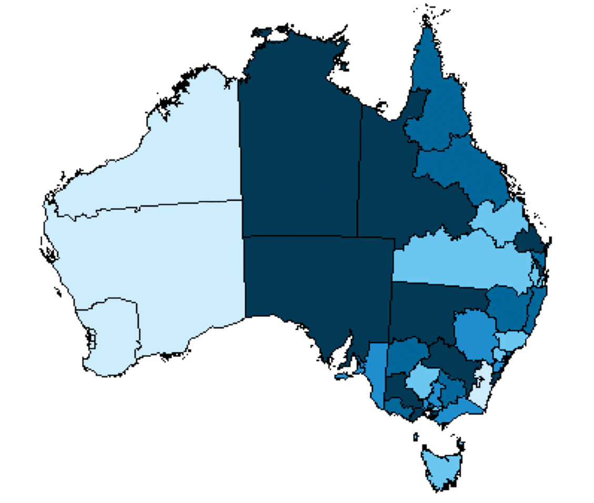

Greater Sydney



Australian Capital Territory



Greater Melbourne

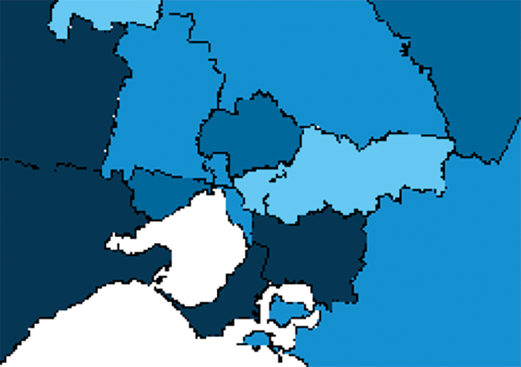

Greater Brisbane



Greater Perth



Greater Adelaide

## Greater Adelaide

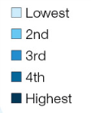

Note: The five groups are based on standardised age and sex rates. The range within each group is as follows: Lowest (32–58);   
2nd (59–67); 3rd (68–73); 4th (74–82); Highest (83–105).

Source: Australian Commission on Safety and Quality in Health Care and the Australian Institute of Health and Welfare, Exploring Healthcare Variation in Australia: Analyses Resulting from an OECD Study, 2014.

People who have the same health concerns or problems do not necessarily receive the same health care. Depending on where they live, or which health service or healthcare provider they consult, they may end up receiving different types of treatment

How much variation is there in Australia?

The study found healthcare variation existed in all the procedures examined. Procedures with relatively larger variations included coronary artery bypass grafting, knee arthroscopies (where people were admitted to hospitals or day procedure services for the procedure) and hysterectomies (when performed on women who did not have a diagnosis of cancer).

The national standardised rate of admission for coronary bypass surgery was 69 admissions per 100,000 people. Rates ranged from 105 admissions per 100,000 people in the Grampians Medicare Local (Victoria) to 32 admissions in Fremantle (Western Australia) (see Figure 21). This means that people living in the Grampians Medicare Local were more than three times more likely to be admitted for a coronary bypass than people living in the Fremantle Medicare Local. Figure 21 shows a map of the variation in rates for bypass surgery across Australia.

The national standardised admission rate for knee arthroscopy was 382 admissions per 100,000 people.

Rates ranged from 232 admissions per 100,000 people in Inner West Sydney (NSW) to 726 admissions in Country North (South Australia) (see Figure 22). This shows that people living in the Country North Medicare Local were three times more likely to have a knee arthroscopy than people living in the Inner West Sydney Medicare Local. The box below describes the reason why knee arthroscopies are performed and the alternatives.

The national standardised admission rate for hysterectomy without any diagnosis of cancer was 2.8 admissions per 1,000 women. Rates for Medicare Locals ranged from 1.7 (Inner West Sydney) to 5.2 (Grampians); that is, women living in the Grampians Medicare Local were three times more likely to have a hysterectomy than those living in the Inner West Sydney Medicare Local.

For all women, including those who have been diagnosed with cancer, Australia has a higher rate of hysterectomy than many other OECD countries (see Figure 23). However, the rate has been decreasing over time.

|  |
| --- |
| Why are knee arthroscopies performed and what are the alternatives?  Knee arthroscopies can be used to evaluate and treat cartilage problems, such as a torn meniscus, or to remove loose tissue from the knee joint. Arthroscopies are also used as a guide for more extensive procedures such as knee reconstructions. Alternatives to diagnostic arthroscopy include imaging – for example, magnetic resonance imaging (MRI) and X-ray.  Studies have shown that arthroscopies are of little benefit if the underlying cause of the problems is osteoarthritis.46, 47 In these cases, alternative treatments may include exercise and physiotherapy. |

**Variation in rates of admission for coronary artery bypass grafts**

There is a threefold variation in rates nationally

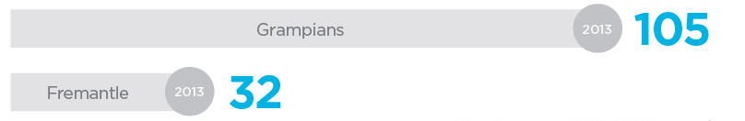

Number per 100,000 people

Figure 22

Admissions for knee arthroscopy per 100,000 people, by Medicare Local and hospital sector, 2010/11

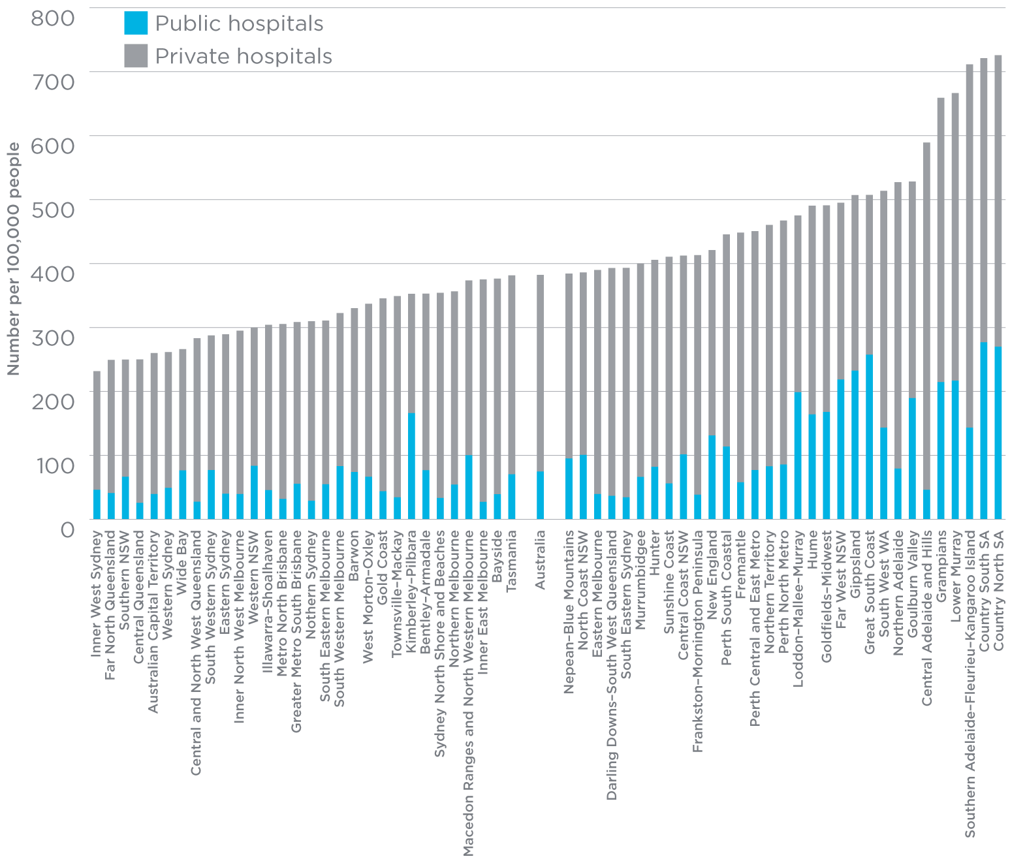

Notes:  
1. Rates are age and sex standardised to the 30 June 2001 Australian population.  
2. Data for rates based on a small number of admissions are unshaded.

Source: Australian Commission on Safety and Quality in Health Care and the Australian Institute of Health and Welfare, Exploring Healthcare Variation in Australia: Analyses Resulting from an OECD Study, 2014.

Figure 23

Rates of hysterectomy per 100,000 women, standardised for age, 2004 and 2008

## Figure 23 Rates of hysterectomy per 100,000 women, standardised for age, 2004 and 2008

Note: Rates are age standardised to the OECD standard population.

Source: Australian Commission on Safety and Quality in Health Care and the Australian Institute of Health and Welfare, Exploring Healthcare Variation in Australia: Analyses Resulting from an OECD Study, 2014.

Variation in rates of admission for knee arthroscopy

There is a threefold variation in rates nationally

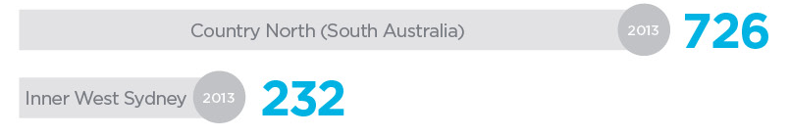

Number per 100,000 people

Reducing unwarranted variation through shared decision making

More work is needed to examine whether the variation found in this study was unwarranted. Increasing patients’ involvement in making decisions about their healthcare treatment is one way to minimise unwarranted variation.

Shared decision making involves combining a patient’s values, goals and concerns with the best available evidence about treatment risks, benefits and uncertainties to reach a decision about what type of care is best for that person. It places the patient at the centre of the care process and promotes a partnership with the healthcare provider to help achieve the best possible decision.

Patient decision aids are tools that support this shared decision making.

They summarise the evidence and help patients consider their personal values and circumstances. International research has shown that patient decision aids improve people’s knowledge about the options available to them and lead to more informed choices. Decision aids can change the decisions people make about their health care – for example, using them has reduced the number of people choosing major elective invasive surgery in favour of more conservative options.48

Using decision aids also improved the decision quality of patients with osteoarthritis considering knee replacement and may contribute to reducing unwarranted variation in this area.49 See pages 46–48 for more information about decision aids.

**Variation in rates of admission for hysterectomy without a diagnosis of cancer**

There is a threefold variation in rates nationally

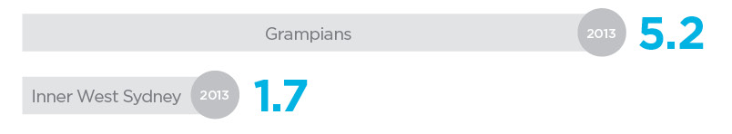

Number per 100,000 women

Increasing patients’ involvement in making decisions about their health care is one way to minimise unwarranted variation

|  |
| --- |
| Where to next?  The Commission has started working on a program to look at healthcare variation across a range of topics and activities – like knee replacement, for example. The Commission will create a visual map – or atlas – of variation in health care across Australia, to clearly present information about where variation exists. The Commission’s work will help explore why variation exists in those locations and support other efforts to reduce unwarranted variation.  The Commission is also working with consumers and healthcare providers to develop and promote the use of decision aids and other tools that support shared decision making between patients and healthcare providers. |

| What the Commission will do   * Work with healthcare providers, clinical organisations and consumer groups to examine the reasons for healthcare variation identified in the 2014 study. * Develop an Australian Atlas of Healthcare Variation that will examine healthcare variation in more clinical areas. * Promote the effective use of decision aids and other tools to support shared decision making between patients and healthcare providers. |
| --- |

Cognitive impairment: my healthcare providers will detect and treat my delirium

The characteristics of people who are treated in hospital are changing as the overall population changes. The majority of patients in hospitals are now older, and many have multiple, complex health conditions, including cognitive impairment.50 Hospitalised patients have an increased risk of complications and unnecessary decline if cognitive impairment is not recognised and properly managed. Delirium is of particular concern, as it is potentially preventable and treatable.

What is delirium?

Delirium is an acute disturbance of consciousness, attention, thinking and perception that tends to fluctuate during the course of the day. It is often mistaken for dementia, of which Alzheimer’s disease is the most common form. Dementia is different, in that it is usually a progressive, gradual, irreversible decline in cognitive functioning.

Delirium is a clinical syndrome that can have multiple causes, such as recent changes to medications or an infection. The risk of developing delirium increases if someone is older or severely ill, already has dementia or has suffered a hip fracture.51 If a person is vulnerable to developing delirium, what happens during their hospital stay can also increase its likelihood of developing.

For example, being prescribed more medication, not having enough to eat or drink, being restrained or sedated, or having an indwelling catheter inserted can increase the risk of delirium.52

Delirium is common among older people admitted to hospital. Approximately 10 per cent of people over 70 years old who are admitted to hospital have delirium, and a further 8 per cent will develop delirium during their time in hospital.53 A person is more likely to develop delirium if they already have dementia, and this is more common with increasing age. Rates of delirium also vary across different parts of the hospital; one study found higher rates in medical, orthopaedic and neurosurgical patients (24 per cent) than in general surgery patients (8 per cent).54, 55 The highest rates of delirium (up to 89 per cent) were found in intensive care patients.56

Why is delirium important?

It is crucial to distinguish delirium from dementia and to investigate it properly, as it may be the only sign of an acute, underlying, serious illness.57Too often, a patient’s cognitive impairment is labelled as existing dementia without confirmation.

It is important to prevent, detect and treat delirium, as it has long-term consequences. Patients whose delirium is not detected and treated can suffer outcomes including:58

* a decreased ability to care for themselves
* a permanent worsening of their cognitive abilities
* a greater risk of falling in hospital and developing a pressure injury
* a longer stay in hospital
* a greater risk of entering an aged-care facility after leaving hospital.

People with delirium have a high risk of dying; between 20 and 75 per cent of hospitalised people with delirium die in hospital.59 Failing to prevent or treat delirium properly contributes to this increased risk, as mortality rates increase by 11 per cent for every additional 48 hours of active delirium.55

Hospitalised patients have an increased risk of complications and unnecessary decline if cognitive impairment is not recognised and properly managed

10%

Estimated proportion of people over 70 with delirium when they are admitted to hospital

In addition, when delirium is not identified in patients admitted to an emergency department, there is a higher risk of death after the patient leaves hospital.54

Despite being common, preventable, treatable and associated with poor health outcomes, delirium remains mostly unrecognised, mistaken for dementia and under-treated.60–62 Dementia, the greatest risk factor for developing delirium, is also frequently undetected; it is not recorded as a diagnosis for almost half of the people later identified as having dementia in hospital.63

Using the NSQHS Standards to improve care for people with delirium

In 2013, the Australian Government Department of Health* funded the Commission to look at ways of improving care for people with cognitive impairment, with a particular focus on the NSQHS Standards (see pages 6–11).

As part of this process, the Commission talked to and received feedback from more than 500 healthcare providers, carers and consumer advocates. Overall, participants agreed that for safe care to be administered, it is essential to be alert to the risk of delirium and to recognise cognitive impairment early. Participants also emphasised the importance of involving the patient, family and carer in care and decision making.

The Commission has now developed new resources – in the context of the NSQHS Standards – that provide guidance on improving the care given to people with a cognitive impairment. These resources are based on expert knowledge and research on the best ways to care for people with delirium and dementia. They are also linked to actions that healthcare providers must take to meet the NSQHS Standards.

* Responsibility for this project moved to the Australian Government Department of Social Services in October 2013 as part of changes to the Australian public service.

Delirium is potentially preventable and treatable

|  |
| --- |
| Where to next?  There are many examples of local initiatives to enhance the recognition of patients with cognitive impairment and improve the care provided to them. However, these local actions are often the result of committed clinical leaders, and in their absence there are few requirements or incentives to address the safety and quality concerns relating to delirium.  Hospitals now need to be assessed against the NSQHS Standards, so the resources developed by the Commission will help hospitals put systems in place to ensure people with a cognitive impairment always receive safe and high-quality care. However, there is also an opportunity to incorporate strategies in the next version of the NSQHS Standards, to further embed best practice.  The Commission is also looking at making it easier for healthcare providers to provide the best care to people with delirium and will develop a new clinical care standard on this issue. This clinical care standard will comprise a small number of statements that describe the care hospitals should offer a patient with delirium, and indicators hospitals can use to monitor the provision of this care. The clinical care standard will also inform patients and their families about what care they should expect, and help them to make decisions about their care. |

| What the Commission will do   * Produce resources, linked to the NSQHS Standards, that aim to improve hospital care for older people with cognitive impairments. * Develop a clinical care standard for delirium to provide guidance on appropriate clinical care for delirium. * Recommend how the current NSQHS Standards can be strengthened to improve the care provided to people with cognitive impairment. |
| --- |

The Commission will provide resources that are linked to the NSQHS Standards to make it easier for healthcare providers to care for people with delirium

11%

Percentage increase in mortality rate for every additional 48 hours of active delirium

8%

Estimated proportion of people over 70 who will develop delirium while they are in hospital

I did not feel that the staff in the cardiac ward were treating him as a whole person when they told me “We treat hearts not heads here” when I drew his dementia to their attention.

Carer

The attitude that “oldies always get confused in hospital” needs to be dispelled because it creates a safety risk for a substantial number of patients entering the hospital system whose cognitive difficulties are ignored.

Nursing Director

The attitude towards patients changes when they are treated as people. Patients are no longer referred to as “being nuts”, “being a poor historian” or “being a bit confused”. Everyone in the hospital is now using the terms delirium and dementia and recognising them as conditions that require management.

Registered Nurse

Understanding patients’ preferences at the beginning of their hospital stay reduces subsequent treatment times by avoiding accidents and incidences. If staff know the strategies for supporting a patient it makes it easier for them to reduce that patient’s anxiety and distress.

Carer

You must be careful not to make assumptions about behaviour and say “it is just their dementia”. Once a dementia identification is made it can stop any further investigations into a patient’s condition. Often there is an overlay of delirium and it goes unnoticed and untreated.

Regional Director

Advance care planning: even if I am no longer able to speak for myself, healthcare providers will know what my wishes are

Advance care planning is a process of planning for future health and personal care.64 It helps people ensure their values and preferences are known when they can no longer make their own decisions or communicate their wishes. Advance care planning can be a useful process for all people, but it becomes particularly important when a person is diagnosed with a condition that is likely to make them unable to express how they wish to be cared for at a future time. These conditions may include mental health disorders, or terminal conditions like dementia, cancer or chronic organ failure (such as heart or kidney failure).

Advance care planning is a very important tool to help people express their wishes for the kind of treatments and care they wish or do not wish to receive at the end of their lives. Making these plans in advance can avoid distressing situations where others have to make critical decisions in a crisis – for example, deciding whether or not to try to resuscitate a person who has advanced cancer. It can also help ensure a person’s wishes are carried out – for example, that they die at home or in a hospice rather than in a hospital.

What is involved in advance care planning?

Advance care planning can be a formal process that involves nominating a substitute decision maker (for example, under enduring guardianship or power of attorney laws) or writing down instructions in a legal document called an advance care directive. It can also be an informal process where a person talks about their future wishes with their family; discussing whether quality of life is more important to the person than length of life can help family members if they need to work with the medical team to make choices about the person’s medical treatment in the future.

It can be helpful to talk about or write down preferences for situations that are likely to occur as a specific consequence of a person’s condition. For example, a person who has a chronic mental health disorder may not be able to express their wishes for care if they are involuntarily admitted to hospital. An advance care plan can help them express their care preferences if that situation occurs.

Ideally, advance care planning should occur over a period of time so people can discuss and think carefully about their wishes, particularly as their health status changes. Ideally, advance care planning conversations begin early so that a person has an opportunity to carefully reflect on their values, talk with their carers and family members, and consider who to appoint as their substitute decision maker. Written advance care plans or directives may need to be reviewed and updated regularly over many years (see Figure 24).

What do we know about advance care planning in Australia?

In one Australian study,65 people were randomly selected to receive usual hospital care or receive assistance in expressing their future wishes through a formal advance care planning program called Respecting Patient Choices©. The people who received the advance care planning intervention and went on to die were much more likely to have their end-of-life wishes known and followed. Importantly, their family members experienced significantly less stress, anxiety and depression than family members of the people who had not gone through the advance care planning process.

Although the process of advance care planning is generally considered to be useful and worthwhile, there is evidence that many doctors and members of the community in Australia have limited knowledge about how to develop and use formal advance care plans.66–68 In one recent study based in NSW, approximately one-fifth of doctors who were surveyed had not heard of advance health directives.69 In another study, healthcare providers were asked what they saw as the reasons for the low uptake of advance care planning in Australia.68 The reasons given included people’s reluctance to talk about death and dying; a lack of knowledge and involvement shown by many healthcare providers; and difficulties associated with the documentation and interpretation of advance care directives.

Who can help patients think about their advance care plans?

GPs play an important role in advance care planning. The RACGP has developed a position statement encouraging GPs to incorporate advance care planning into routine healthcare encounters.70

People often have a trusted relationship with their GP. This can make it easier to begin conversations about advance care planning, as these conversations may cover some very personal subjects. GPs can also help people understand the implications of their disease or condition, plan for possible future scenarios, and consider the choices that they or their family members may need to make in the future.

There are a number of web sites to help people to think about their advance care plans. Advance Care Planning Australia (http://advancecareplanning.org.au) provides information, in a number of languages, about making an advance care plan. Alzheimer’s Australia’s start2talk web site (http://start2talk.org.au) guides people through the process of planning for their future care and includes links to the relevant planning tools used in each state and territory.

|  |
| --- |
| Where to next?  There is a growing effort to make it easier for people to write formal advance care directives and to ensure these documents are available when they are needed. In 2011, The Australian Health Ministers Advisory Council published a national framework for advance care directives. The framework is designed to provide guidance about what should be included in advance care directives, to encourage a more unified approach across Australia.64 The Australian Government has recently invested in work to make advance care directives available through the PCEHR. |

Advance care planning is a process of planning for future health and personal care

| What the Commission will do   * Release a consensus statement about safe and high-quality end-of-life-care, including advance care planning. * Support hospitals and day procedure services meet the advance care planning actions required by the NSQHS Standards. * Consider end-of-life care and advance care planning when the NSQHS Standards are reviewed. |
| --- |

Figure 24

The advance care planning process

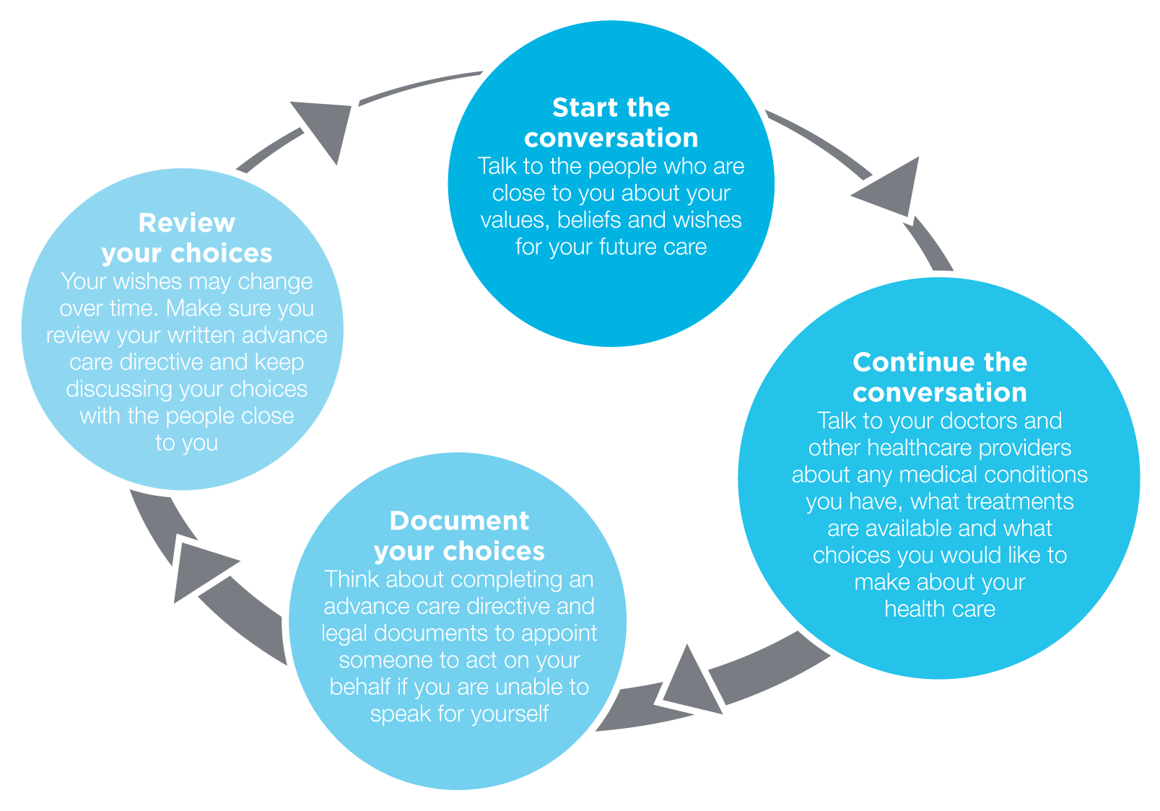

3 Will I be a partner in my care?

Decision aids:

there are tools to help me understand information and make decisions about my care

Health literacy:

making medication labels easier for me to understand means my care is safer

Patient stories and feedback:

information I share about my healthcare experience will be listened to and acted on

Will I be a partner in my care?

The Commission supports the right of people to be partners in their own health care. People who are partners in their health care, who understand the health care they receive, who share decisions and who actively engage with the processes of care are more likely to have a better healthcare experience and get better results.71–73

Establishing strong and effective partnerships is not always easy. Healthcare providers working in general practices and hospitals may be concerned about the time required to involve the patient in the decision making process. People might be unwilling or unable to take an active role in their own health care. Communication problems can lead to complaints and risks to safety.74, 75

Various tools, strategies and approaches have been developed and are being used to support patients, consumers, healthcare providers, managers and government officials in establishing effective partnerships.

This section looks at three different areas where efforts are being made: how people can be more involved in decisions about their care, how to make it easier for people to understand the medicines they are taking and how feedback is being used to improve health care.

Decision aids: there are tools to help me understand information and make decisions about my care

Helping people share decisions about their health care and work in partnership with their healthcare provider is a way of ensuring that people get the care that they want and need. To do this, people need to have information about their healthcare choices that is easy to understand and act on.

Healthcare providers and organisations need to be aware that patients can understand and use health information differently. Healthcare providers also need to have access to tools that help them tailor information to the needs of their patients and explain the healthcare options available. A decision aid is one such tool.

What is a decision aid?

A decision aid provides information on the options for and outcomes of a particular healthcare decision. It is designed to help people make choices about their health care by providing information on the risks, benefits and potential outcomes of the different options available in a way that is easy to understand. See the box on page 47 for an example of a decision aid for someone deciding whether or not to have mammography screening.

Decision aids can help patients and their healthcare providers decide whether to prescribe a medication, undergo a screening test or choose a treatment when there is more than one option available.

Decision aids are unbiased and non-directive, and aim to help people make informed choices that are consistent with their values and preferences. People should use decision aids in conjunction with discussions with their healthcare providers.

Why are decision aids important?

Effective communication is a fundamental requirement for safe and high-quality health care.76 Communication failures are one of the most commonly cited underlying causes of adverse events76 and complaints about the healthcare system.74, 75, 77 Without effective communication, people cannot share in decision making or be a partner in their own health care.

Decision aids can help to improve communication and shared decision making. A recent review examined 115 studies into the effects of using a decision aid. The review found that using a decision aid can contribute to:78

* improving people’s knowledge about care options
* reducing the conflict people may feel about making a decision
* encouraging people to take a more active role in decision making
* improving people’s understanding about risks, when the decision aid includes information about probabilities
* improving communication between the patient and their healthcare provider.

The review also found that decision aids reduce the number of people choosing surgery when other options are available, and that decision aids have no apparent adverse effects on health outcomes or satisfaction.78

An Australian study that trialled the use of a decision aid to help people decide whether to participate in bowel cancer screening found that people who used the decision aid were three times more likely to have enough knowledge to help them make a decision and were nearly three times more likely to have made an informed choice than those who did not use a decision aid.79

Another Australian study looked at the effect of using a decision aid for patients with advanced colorectal cancer and found that using the decision aid improved patients’ understanding of the prognosis, treatment options, risks and benefits, without increasing their anxiety levels. The authors of the study concluded that decision aids contribute to improved processes for informed consent.80

Research suggests that decision aids have a variable effect on the length of consultation, and further work needs to be undertaken to better understand the degree of detail required in a decision aid for it to have a positive effect on the decision making process.78

Without effective communication, people cannot share in decision making or be a partner in their own health care

|  |  |
| --- | --- |
| Example of a decision aid  The Screening and Test Evaluation Program at the University of Sydney has developed an online mammography decision aid using the decision support format established by the Ottawa Health Decision Centre, Canada.81  This mammography decision aid takes people through a series of questions designed to help them place the decision about whether to undertake a mammogram into perspective. It uses key questions about personal risk factors and graphical information about possible outcomes. In written and graphic format, patients answer questions designed to clarify the outcomes associated with screening. For example: | |
| **How many women aged 40 who start having screening mammograms every two years will die from breast cancer in the next 10 years?** | **How many women aged 40 who do not have screening mammograms will die from breast cancer in the next 10 years?** |
| Box | Box |
| * Out of 1,000 women aged 40 who start having screening mammograms every two years for the next 10 years, two women will die of breast cancer. | * Out of 1,000 women aged 40 who do not have screening mammograms every two years for the next 10 years, 2.5 women will die of breast cancer. |

Figure 25

Experiences of shared decision making with specialists, by country

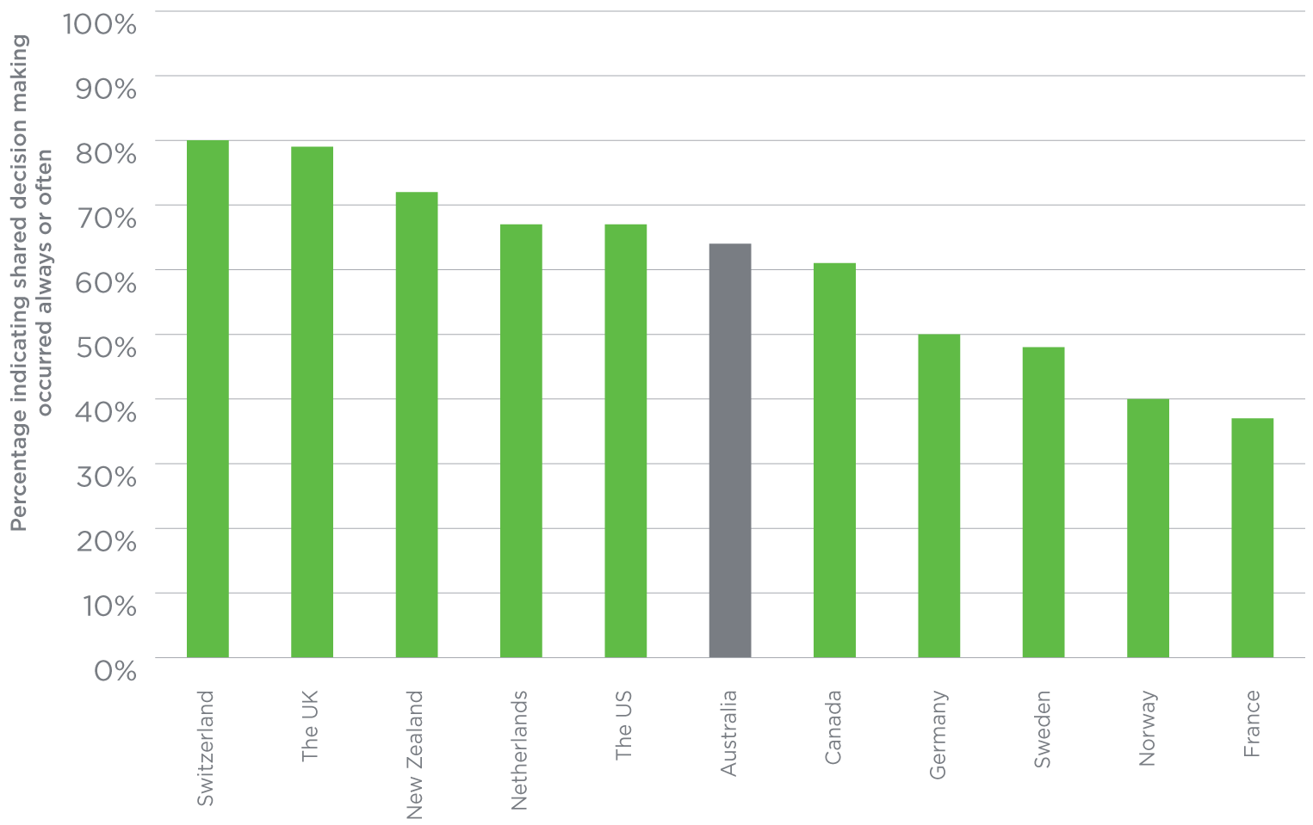

Source: Schoen C, et al. New 2011 survey of patients with complex care needs in eleven countries finds that care is often poorly coordinated, Health Affairs. 2011; 30, 2437–2448.

A decision aid provides information on the options for and outcomes of a particular healthcare decision

64%

Proportion of people reporting that they shared decision making with their specialist

Helping people share decision making about their health care and work in partnership with their healthcare provider is a way of ensuring that people get the care that they want and need

Threefold improvement

In people with enough knowledge to make a decision when using a decision aid

|  |
| --- |
| Where to next?  A 2011 international survey of people with a chronic condition found that around 64 per cent of Australian patients reported feeling that they and their specialists had made shared decisions (Figure 25).82 This is better result than in some other countries, but there is still room for improvement.  There has already been a lot of work done in Australia and internationally to develop and distribute decision aids, including tools to help people decide whether to immunise their children83, undergo a mammogram84 or participate in bowel cancer screening.85  The Ottawa Hospital Research Institute has developed a centralised online list of decision aids, which includes a number of Australian examples.86 These decision aids were developed by a range of different organisations using different approaches and strategies.  Internationally, there has been discussion and debate on how to ensure the quality of decision aids. The International Patient Decision Aid Standards Collaboration was established to develop a shared evidence-informed framework with a set of criteria for improving the content, development, implementation and evaluation of decision aids.87 The next step in this process is to look at mechanisms for disseminating these standards and ensuring the quality of decision aids. |

| What the Commission will do   * Work with consumers, healthcare organisations and providers, and governments to support the use of shared decision making. * Support and promote awareness of health literacy, and how different people can use health-related information and services to reduce barriers to understanding. * Support health services to meet the requirements of NSQHS Standards that relate to the provision of information to consumers. |
| --- |

Health literacy: making medication labels easier for me to understand means my care is safer

Health literacy is about how people understand information about health and health care, and how they apply that information to their lives, use it to make decisions and act on it (see the box on the right). Health literacy is important because it shapes people’s health and the safety and quality of the health care they receive.

Information about health and health care can be unnecessarily complex, making it difficult for people to understand and use when making decisions about their health.88 We know that the level at which materials such as consent forms, admission instructions and medicine information are written is above the reading ability of the average adult.89 Many studies have shown that health information cannot be understood by most of the people for whom it is intended, suggesting that assumptions regarding individual health literacy levels of the recipients are often incorrect.88

|  |
| --- |
| Definitions of health literacy  The Commission separates health literacy into two components:90  **Individual health literacy** is the skills, knowledge, motivation and capacity of a person to access, understand, appraise and apply information to make effective decisions about health and health care and take appropriate action.  **The health literacy environment** is the infrastructure, policies, processes, materials, people and relationships that make up the health system and have an impact on the way in which people access, understand, appraise and apply health-related information and services. |

Confusing medicine names and inadequate labelling and packaging of medicines are common problems for consumers

Why is health literacy important for medication safety?

Medicines are part of most people’s lives. In 2010, community pharmacies in Australia filled around 271 million prescriptions, which is almost 750,000 prescriptions per week.91

Managing the processes required to ensure that medicines are used properly can be a complicated undertaking. A number of steps are involved, including:92

* filling the prescription
* learning how to take the medication
* organising and planning medication use around daily schedules
* taking doses when required
* monitoring changes and side effects
* sustaining use of the medication throughout the duration of treatment (see Figure 26).

Usually, a doctor prescribes the medication and explains the key points. A pharmacist then dispenses the medication and may reinforce the most important information. The pharmacist may also provide the person with a consumer medicine information sheet, and should explain the medicine label, including the dosage instructions and any key warnings.

However, all these steps for providing information and ensuring it is understood rely on healthcare providers having an awareness of health literacy, as well as having the time, skills and capacity to address the specific health literacy needs of their patients and customers.

Is there a problem with medication labelling?

There has been a lot of international research into health literacy and medication safety, particularly around people’s understanding of dosage instructions.93–95 People with lower levels of individual health literacy may misunderstand common instructions and warnings about their medicines,96, 97 and they are less likely than others to take medicines as directed.96–98

There is evidence in Australia and from overseas that confusing medicine names and inadequate labelling and packaging of medicines are common problems for consumers.30, 96, 99

International studies have estimated that nearly half of adults tested misunderstand common dosage schedules (such as ‘take two tablets by mouth twice daily’) and warnings that detail important information to support safe and effective use (such as ‘do not chew or crush; swallow whole’ or ‘for external use only’).96, 97 Table 1 shows some of the misinterpretations of commonly used label warnings in the United States.

In Australia, a small pilot study demonstrated that patients may have difficulty reading or interpreting prescription labels. It found that 20 per cent of consumers have difficulty reading labels, and 20 per cent have difficulty understanding them.100Another Australian study – this time involving patients with glaucoma visiting an outpatient clinic – found that of the 200 patients recruited, 12 per cent were unable to read the dispensing labels. In addition, one-third could not report their own medicine accurately, and this correlated with their ability to read and understand the printed label.101

Medication labelling that is not easy to understand and use can contribute to medication errors and patient harm.

|  |
| --- |
| Where to next?  Research in the United States has found that using standardised, patient-centred label instructions could improve patients’ understanding of medication instructions and how they carry out their medication regimen.102 The Commission has been working for some time to improve medication safety, including being involved in work to help make labelling, packaging and consumer medicine information easier to understand.  In 2013, the Commission convened an expert workshop on improving the safety and quality of pharmacy dispensing labels. The workshop resulted in a series of recommendations aimed at developing guidance and standards for dispensing labels, to make them clearer and easier for consumers with varied levels of health literacy to understand.  The NSQHS Standards (see pages 6–11) also require health information, including medicine information, to be developed with consumers and provided in a way that is easy to understand and use.46 |

| What the Commission will do   * Work with healthcare providers, including prescribers and dispensers of medicines, to improve their understanding of the role health literacy plays in people’s understanding and use of medicines. * Develop tools and materials that help healthcare organisations and professionals improve their health literacy environment, including improving the development and presentation of medicine information aimed at consumers. * Work with pharmacy organisations and health literacy experts to identify standards for pharmacy dispensing labels. * Work with other national organisations, such as NPS MedicineWise and Healthdirect, to help people better understand medicines and their health. |
| --- |

271 million

Number of prescriptions filled by Australian community pharmacies in 2010, or 750,000 per week

⅓

Proportion of people who cannot report their own medicine accurately

Figure 26

Steps required to use medicines properly

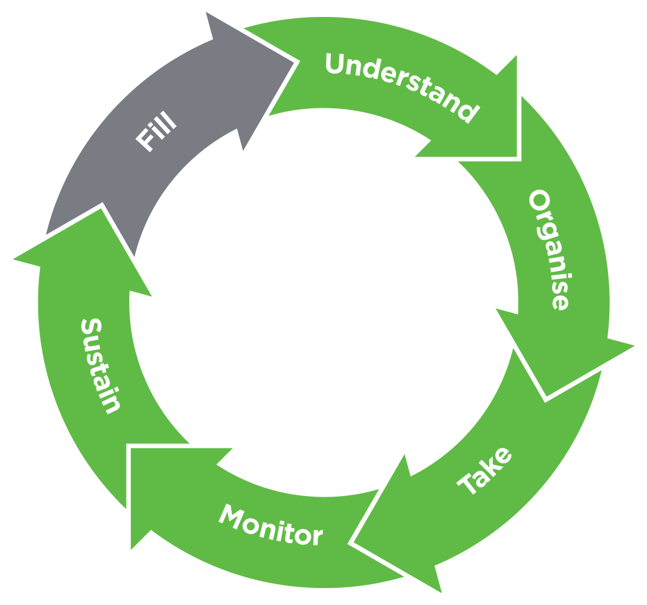

Source: Bailey S, et al. Rethinking adherence: A health literacy-informed model of medication management. *Journal of Health Communication*. 2013; 18 (Suppl. 1).

Table 1

Common examples of how medication labels can be misinterpreted

|  |  |
| --- | --- |
| Labels | Misinterpretations |
| Common examples of how medication labels can be misinterpreted | – Don’t take food |
| – Chew pill and crush before swallowing – Chew it up so it will dissolve, don’t swallow whole or you might choke  – Just for your stomach |
| – Don’t take when wet – Don’t drink hot water – Don’t need water |
| – Don’t drink and drive – Don’t drink alcohol, it’s poison  and it’ll kill you |
| – Use extreme caution in how you take it – Medicine will make you feel dizzy – Take only if you need it |

Source: Davis T, et al. Low literacy impairs comprehension of prescription drug warning labels. Annals of Internal Medicine, 2006. 145(12), 887–894.

Patient stories and feedback: information I share about my healthcare experience will be listened to and acted on

Stories and feedback from patients are important in helping us improve our healthcare system and the way health care is delivered. By listening to people’s experiences, health services can find out if they are doing something well, or if changes need to be made.

Actively listening and responding to feedback is also a way for health services to partner with consumers to make sure they provide care that meets the needs, preferences and expectations of the people who use their services. We know that people who say they have had a better care experience have better long-term clinical outcomes and that these good experiences can be associated with better safety and quality of care.103, 104 Therefore, collecting and listening to feedback about people’s experiences – and using this information to inform change – is key to ensuring people receive the best possible care.

Feedback tools on patient experience

It is important for health services to have processes and tools in place that allow people to provide feedback about the health care they receive.

There is no single way for a health service to gather feedback; they may use many different methods, including surveys and focus groups.

One way a health service can collect patient feedback is through the Patient Opinion web site: www.patientopinion.org.au.105 Patient Opinion is a not-for-profit, online, public platform that allows patients, families and carers to provide feedback and share their stories. Where possible, Patient Opinion will let the health service know that there is a story online about them. Health services that have subscribed to Patient Opinion can then directly respond to the patient and use the feedback to improve the safety and quality of their services.

Patient Opinion was founded in the United Kingdom in 2005, where it is now a leading independent healthcare feedback web site.106 Australia launched Patient Opinion in 2012, and by March 2014 the web site had more than 600 stories from across Australia and over 400,000 views.105

What are people saying?

The feedback posted on Patient Opinion is both positive and negative. Positive stories have been about kind and considerate staff, timely service and effective treatment. Negative stories have been about feeling dismissed and unheard, misdiagnosis and poor transfer of information between services. Generally, people who have submitted a negative story on Patient Opinion have experienced some form of communication failure.

We know that patient–clinician communication has an impact (either directly or indirectly) on patient outcomes,82,107 and all the NSQHS Standards recognise the importance of good communication.

One way health services can strengthen their communication is by responding openly to patient feedback and communicating how this type of information is being used to improve care for future patients.

|  |
| --- |
| Where to next?  The NSQHS Standards require health services to collect information and feedback about the experiences of people receiving care in their organisation. There are many opportunities to learn from people’s experiences, and this type of information can be used to help health services improve the way they deliver care, so people get the best health outcomes in the future. |

| What the Commission will do  The Commission will assist and encourage health services to meet the NSQHS Standards requirements of collecting information and feedback about the experiences of people receiving healthcare in their organisation and using this information to make improvements. |
| --- |

The NSQHS Standards include requirements to collect information about the experience of patients and use this information for improvement

Wonderful service – life changing! Staff have always been pleasant and accommodating … Gave me plenty of tools to assist me in life and great to talk to.

– Patient

**Thanks for taking the time to provide feedback, which helps to ensure we are delivering the best possible service to our clients. We are glad your experience [with the service] has been a positive one and have passed your comments to … the team.**

– Medicare Local, rural NSW

She had been fasted in anticipation of surgery. It did not happen that night. Nor the next, nor the next … a fully qualified nurse commented that my mother should not be taking up a bed, she should go home … In desperation, I asked the senior registrar what he would do if it was his mother, and his words will stay in my mind forever. He said “go home and Google a plastic surgeon”.

* + Family member

**I read your story with great concern and would like to sincerely apologise for any unnecessary distress that this experience caused your mother and yourself. We would like to offer you the opportunity to contact our Centre for Patient Experience … so that we can investigate your concerns with the relevant staff and to offer you a formal explanation.**

* + Teaching hospital, Victoria

… before I’d hardly opened by mouth to explain my situation she told me she was tired of all the people demanding … services … I just wished to explain my own circumstances. The lady seemed in no mood to even listen …

– Patient

**[The service] is deeply sorry that you had such a negative experience with the staff member. Your experience … was truly shameful, totally unacceptable and extremely disappointing to hear. Please be reassured that the comment has been escalated to the … Manager for action at site level and site staff have had subsequent retraining in communication and telephone skills.**

– Home and community care service, Queensland

Source: Patient Opinion Australia, https://www.patientopinion.org.au, 2014.

4 Case studies

Stroke

Palliative Care

Case studies

Measuring the safety and quality of care is a challenge, and there is often limited information available about whether care is safe, whether people receive the right care and whether people are partners in their care.

Information about the safety and quality of care can come from clinical quality registries and regular audits of clinical processes and outcomes. Clinical quality registries are clinical databases that have been established to collect, analyse and routinely report on information to improve healthcare quality at the team or hospital level. Registries are typically run by clinical societies and professional colleges. Audits are reviews of clinical processes and outcomes against agreed best practice. Audits can be conducted at many different levels – from local reviews in a single ward or practice to large-scale audits across many health services.

This section presents case studies that focus on two important clinical topics – stroke and palliative care – drawing on data collected through a clinical quality registry and a national audit. The case studies focus on two particular aspects of quality of care:

* how closely actual patient care aligns with recommended (evidence-based) care; this is known as ‘appropriateness of care’ (see page 32)
* the results of care (outcomes) for patients; this is known as ‘effectiveness of care’.

Appropriateness and effectiveness are difficult to measure. Typically, they require data on patients and their treatment that would not be recorded as part of their normal care. They can also require long-term follow-up on what has happened to a patient after their stay in hospital. In the case studies presented here, information about appropriateness and effectiveness is available due to data provided by healthcare providers and health services as part of the audit or to the clinical quality registry.

Stroke and palliative care were selected for the focus of this section because, in addition to being important national safety and quality issues, palliative care has a well-established registry with a high national participation rate, and stroke was the subject of a recent national audit. Two groups – the National Stroke Foundation and the Palliative Care Outcomes Collaboration – provided the data for the case studies. The Commission has worked with these groups to prepare the material presented here and acknowledges their assistance.

The case studies are based on a ‘chartbook’ format. This standard format has been developed by experts to support easy understanding and exploration of the quality of care for specific conditions.

Stroke

# Introduction

A stroke occurs when a blood clot or cholesterol-laden plaque blocks a blood vessel in, or leading to, the brain (an ischaemic stroke), or when a blood vessel in the brain breaks or ruptures (a haemorrhagic stroke). The resulting disruption to blood flow may cause part of the brain to die, leading to impaired movement, comprehension and/or speech. A stroke can often be fatal. Although ischaemic strokes are more common than haemorrhagic strokes, accounting for about 80 per cent of cases, haemorrhagic strokes are responsible for the majority of stroke-related deaths.108

The risk of stroke increases with age, and is higher for males and people with a family history of stroke. High blood pressure, high cholesterol, cigarette smoking, poor diet, physical inactivity, being overweight and excessive alcohol consumption also increase a person’s risk of stroke.109

Strokes are a principal cause of mortality in Australia

The National Stroke Foundation’s Clinical Guidelines for Stroke Management 2010 report presents a comprehensive set of evidence-based recommendations for stroke care, covering the accessibility of stroke services, stroke recognition and pre-hospital care, early assessment and diagnosis, acute medical and surgical management, secondary prevention, rehabilitation, management of complications, and community participation and longer-term recovery.110

Because it is a high-priority, high-morbidity condition, the Commission has developed a standard that governs clinical care for stroke. Clinical care standards provide a small number of quality statements that describe the clinical care a patient should be offered for a specific clinical condition.111

Recovery from stroke often depends on the provision of a coordinated program of care by a specialised, multidisciplinary team of healthcare providers, including doctors, nurses, pharmacists, dieticians, occupational therapists, physiotherapists, psychologists, social workers and speech pathologists.110

Data on the quality of care provided to stroke patients is not routinely collected in Australia. This case study therefore relies on data published in the National Stroke Foundation’s Clinical Audit Report 2013 and Organisational Survey Report 2013, both of which stem from the 2013 National Stroke Audit − Acute Services.112, 113

$606 million

Total stroke-related healthcare expenditure in 2008/09

8,304

Number of stroke-related deaths in 2010

33,345

Number of stroke-related hospitalisations in 2009/10

# Why is it important?

Rates of stroke-related mortality in Australia have declined consistently over several decades. Age-standardised mortality rates for stroke in males and females fell from 108 and 99 deaths per 100,000 people (respectively) in 1979, to 31 and 32 deaths per 100,000 people (respectively) in 2010. Nevertheless, stroke continues to be a principal cause of mortality in Australia. A total of 8,304 stroke-related deaths were registered in 2010, meaning that, on average, 23 people died as a result of stroke every day during that year. An estimated 375,759 Australians had suffered a stroke at some point in their lives in 2009, and in 2009/10, 35,345 stroke-related hospitalisations were recorded across Australia. Total stroke-related healthcare expenditure in Australia was estimated to have reached $606 million in 2008/09.108

Evidence-based care, as detailed in the Clinical Guidelines for Stroke Management 2010report, has been shown to significantly reduce mortality and disability resulting from stroke. For example, an international review in 2007 identified that stroke unit care has been shown to reduce mortality and disability after stroke by approximately 20 per cent compared to conventional care in a general ward.114 Health systems in Australia and internationally have developed clinical networks that are increasing the proportion of stroke patients who receive their care in a stroke unit. With the development of such networks, a variety of approaches have arisen in response to local circumstances such as distance, population concentration and pre-existing services. Providing patients who have suffered an ischaemic stroke with intravenous thrombolysis within 4.5 hours results in significantly improved outcomes, as does administering aspirin within 48 hours, although improvements are more modest.115, 116 Despite this, evidence-based clinical care is not always provided in practice.

# Findings

The National Stroke Foundation conducts the National Stroke Audit − Acute Services every two years. The audit aims to assess the quality of acute stroke care in Australia, examining the implementation of evidence-based recommendations for clinical care and the availability of resources to support best practice. Four acute care audits have been conducted to date (in 2007, 2009, 2011 and 2013), providing longitudinal data on clinical performance for a substantial proportion of eligible hospitals (82–88 per cent of hospitals in any one audit).112, 113

The proportion of stroke patients receiving care in a dedicated stroke unit has increased since the initial audit in 2007; 58 per cent of patients received stroke unit care in 2013, up from 50 per cent in 2007 (see Figure 27, item h).112, 117 However, the proportion of stroke patients receiving stroke unit care has remained unchanged since 2011. Among stroke patients admitted to a stroke unit, 65 per cent were admitted on the day of arrival in 2013, compared to 59 per cent in 2009 and 58 per cent in 2011 (see Figure 27, item i).112

The proportion of people receiving care in a dedicated stroke unit has increased from 50 per cent in 2007 to 58 per cent in 2013

The 2013 audit found that 91 per cent of stroke patients arriving at hospital received brain imaging within 48 hours (up slightly from 89 per cent in 2009) (see Figure 27, item n) and that 95 per cent of ischaemic stroke patients were discharged on antithrombotics (the same proportion as in 2009) (see Figure 27, item o). The proportion of ischaemic stroke patients who received intravenous thrombolysis did not improve from 2011 to 2013, remaining at a low 7 per cent (see Figure 27, item a).112 However, from 2009 to 2013, the proportion of stroke patients assessed by an occupational therapist within 48 hours of arriving at hospital improved considerably (up 9 per cent to 48 per cent) (see Figure 27, item c), as did the proportion of patients assessed by a physiotherapist within 48 hours of arrival (up 9 per cent to 69 per cent) (see Figure 27, item k). Data for these measures is unavailable for 2007.

A considerable decrease in the provision of carer training is apparent from 2009 to 2013, with only 37 per cent of carers receiving training in 2013, down from 50 per cent in 2009 (see Figure 27, item d). The proportion of incontinent stroke patients with a continence plan has also decreased substantially, from 34 per cent in 2009 to only 23 per cent in 2013 (see Figure 27, item b).112

Services to support evidence-based stroke care have generally improved since the initial audit in 2007. The number of hospitals without a dedicated stroke unit that admit more than 100 stroke patients per year decreased from 46 in 2007 to five in 2013, and the number of stroke unit beds across all hospitals increased consistently over this period (from 429 in 2007 to 615 in 2013). However, as noted earlier, the proportion of stroke patients admitted to a stroke unit did not change from 2011 to 2013, remaining at 58 per cent.112

There has been a substantial increase in the proportion of hospitals with emergency department protocols for rapid triage of acute stroke patients; 80 per cent of hospitals had protocols in place in 2013, compared to only 38 per cent in 2007 (see Figure 28, item l). There has been a considerable increase in the proportion of hospitals offering thrombolysis (up from 24 per cent in 2007 to 53 per cent in 2013) (see Figure 28, item e). Similarly, the proportion of hospitals routinely providing information on stroke to patients rose from 64 per cent in 2007 to 76 per cent in 2013 (see Figure 28, item r). However, the proportion of hospitals routinely providing stroke patients with a care plan after discharge has remained effectively unchanged since 2007; 59 per cent of hospitals routinely provided this element of care in 2013, compared to 62 per cent in 2007 (see Figure 28, item n).113

Services to support evidence-based stroke care have improved since 2007: hospitals have more stroke beds, and there are more hospitals with a stroke unit

# Implications

The 2013 National Stroke Audit − Acute Servicesreport provides evidence of improvement in several areas of stroke care since 2011. Most notably, there have been substantial increases in the number of hospitals with a dedicated stroke unit and the proportion of hospitals offering thrombolysis for eligible patients. Access to brain imaging, early admission to stroke unit care (among patients admitted to a stroke unit), and timely access to most allied healthcare providers have also improved considerably over time.

Nevertheless, adherence to several recommendations for clinical care either failed to improve or declined from 2011 to 2013. Although the number of stroke units and the proportion of hospitals offering thrombolysis increased significantly over this period, access to stroke unit care and thrombolytic therapy (where appropriate) remained effectively unchanged.

As noted previously, provision of care within a dedicated stroke unit (including thrombolysis, where appropriate) has been shown to significantly improve outcomes for stroke patients; indeed, the Clinical Guidelines for Stroke Management 2010 identifies stroke unit care as the most effective means of reducing stroke-related mortality and disability.110 As such, increasing the number of stroke patients treated in a dedicated stroke unit through an organised, formal stroke network should be a focus of future efforts to improve the quality of stroke care in Australia.

There is also considerable scope for increasing the number of hospitals routinely providing stroke patients with a care plan after discharge, and for improving continence management and the provision of carer training. As indicated in the Clinical Guidelines for Stroke Management 2010, optimal recovery and reintegration into the community after stroke is closely linked to effective discharge planning (of which carer training is a vital part).110, 112 However, in 2013, more than 40 per cent of hospitals still did not routinely provide patients with a discharge plan.

There is a need for more comprehensive, nationally consistent data collection on the implementation of recommended stroke care

# What we do not know

While the National Stroke Audit − Acute Services provides valuable information on the quality of stroke care in Australia, there is a need for more comprehensive, nationally consistent data collection on the implementation of evidence-based recommendations for clinical care. Efforts are currently underway to increase involvement in the Australian Stroke Clinical Registry, with the aim of providing fine-scale information on the entire population of stroke patients to help drive improvements in stroke care across Australia.

# Acknowledgements

The data presented in this case study are derived from the National Stroke Foundation’s 2013 National Stroke Audit − Acute Services. The Commission gratefully acknowledges the input of Dr Erin Lalor and the National Stroke Foundation team in preparing this section of Vital Signs 2014.

Figure 27

Adherence to recommended indicators of care for stroke, 2009–2013

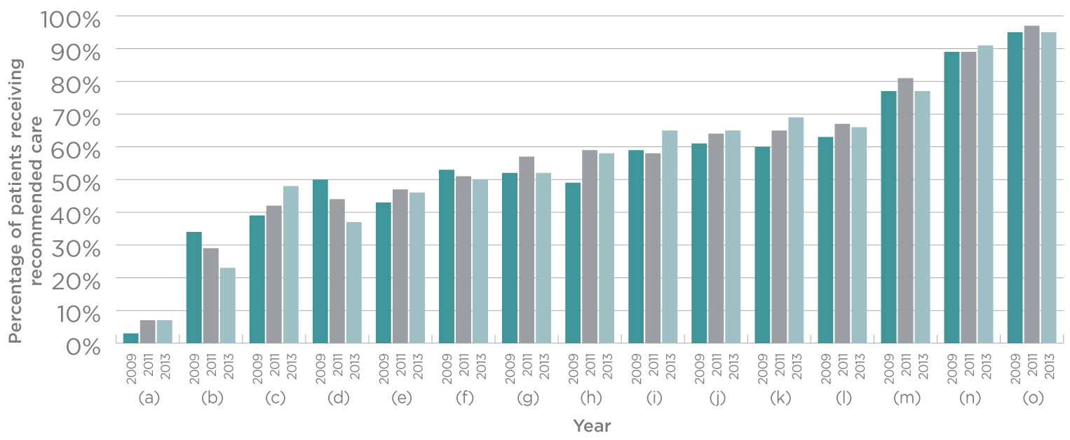

(a) Received intravenous thrombolysis (if ischaemic stroke)

(b) Incontinent patients with a continence plan

(c) Assessed by occupational therapy within 48 hours

(d) Received carer training

(e) Received behaviour change education

(f) Provided with a care plan

(g) Swallow screened or assessed before food or drink or oral medication

(h) Received stroke unit care

(i) Admitted to a stroke unit on the day of stroke (if admitted to a stroke unit)

(j) Assessed by speech pathologist within 48 hours

(k) Assessed by physiotherapy within 48 hours

(l) Aspirin within 48 hours (if ischaemic stroke)

(m) Discharged on antihypertensives

(n) Received brain imaging within 48 hours

(o) Discharged on antithrombotics (if ischaemic stroke)

Source: National Stroke Foundation, *Clinical Audit Report 2013.*

There has been a substantial increase in the proportion of hospitals with emergency department protocols for rapid triage of acute stroke patients

Figure 28

Progress on resources and processes to deliver evidence-based care for stroke, 2007–2013

# Figure 28 Progress on resources and processes to deliver evidence-based care for stroke, 2007–2013

(a) Hospitals with access to early supported discharge teams

(b) Hospitals with neurovascular/transient ischaemic attack clinic

(c) Hospitals with protocols for routinely reviewing patients with stroke discharged from hospital

(d) Hospitals with ambulance arrangements

(e) Hospitals offering thrombolysis (rt-PA)

(f) Patients who are on a stroke unit (all hospitals)

(g) Hospitals with ED protocols for transfer of patients to another hospital for care

(h) Hospitals routinely provide information on community stroke support groups

(i) Hospitals using a defined pathway for assessing TIA

(j) Hospitals using care pathways

(k) Hospitals with access to program of continuing education for staff in stroke management

(l) Hospitals with ED protocols for rapid triage of patients with acute stroke

(m) Hospitals with access to magnetic resonance imaging (MRI)

(n) Hospitals routinely providing a discharge care plan

(o) Hospitals providing routine assessments for all patients for the need for further rehabilitation

(p) Hospitals with access to telehealth for clinical support

(q) Hospitals routinely providing patient information on local community care arrangements

(r) Hospitals routinely providing patient information on stroke

(s) Hospitals where patients/carers are given details of a hospital contact on transfer from hospital to community

(t) Hospitals where team routinely meets with family

(u) Hospitals with access to community-based rehabilitation

(v) Hospitals with access to telehealth for professional development

(w) Hospitals with regular team meetings

(x) Hospitals with access to Carotid Doppler

(y) Hospitals offering thrombolysis (rt-PA) on a 24 hour, 7 days per week basis

(z) Hospitals with access to Computerised Tomography (CT) within 24 hours

(aa) Stroke unit hospitals admitting directly to a stroke unit

Source: National Stroke Foundation, *Organisational Survey Report 2013.*

Palliative Care

# Introduction

Palliative care is a vital component of Australia’s healthcare services, and is provided to those living with a life-threatening illness, whether they are adults, adolescents or children. The aim of palliative care is to improve a person’s quality of life by managing the symptoms of their illness and providing emotional, spiritual and social support for the person and their family or carers. Unlike other areas in health care, palliative care focuses on addressing the patient’s needs rather than the underlying medical diagnosis (see the box on the right).118

49%

Increase in the number of palliative care-related hospital stays between 2001 and 2010

|  |
| --- |
| What is palliative care?  According to WHO, palliative care is: an approach that improves the quality of life of patients and their families facing the problem associated with life-threatening illness, through the prevention and relief of suffering by means of early identification and impeccable assessment and treatment of pain and other problems, physical, psychosocial and spiritual. Palliative care:   * provides relief from pain and other distressing symptoms * affirms life and regards dying as a normal process * intends neither to hasten or postpone death * integrates the psychological and spiritual aspects of patient care * offers a support system to help patients live as actively as possible until death * offers a support system to help the family cope during the patient’s illness and in their own bereavement * uses a team approach to address the needs of patients and their families, including bereavement counselling, if indicated * will enhance quality of life, and may also positively influence the course of illness * is applicable early in the course of illness, in conjunction with other therapies that are intended to prolong life, such as chemotherapy or radiation therapy, and includes those investigations needed to better understand and manage distressing clinical complications.119 |

Palliative care is traditionally seen as a service for patients with cancer, and cancer remains the most common reason for referring patients to palliative care, accounting for approximately 83 per cent of people receiving care.120 However, people with non-cancer illnesses such as cardiovascular disease, renal failure, motor neurone disease, liver failure and dementia are now increasingly being referred to palliative care.120, 121

Palliative care aims to improve a person’s quality of life by managing the symptoms of their illness and providing emotional, spiritual and social support for the person and their family and carers

Palliative care can be provided in the home, in community-based settings (such as residential aged care centres), in hospices and in specialist and generalist hospital wards. Regardless of where it is delivered, palliative care is generally provided by multidisciplinary teams. Members of these teams can include counsellors, dieticians, GPs, nurses, occupational therapists, pastoral care workers, pharmacists, physiotherapists, social workers and specialist palliative care doctors. These specialist teams also support and provide advice to healthcare providers working in other parts of the health system whose patients require assistance with daily living and/or other support to enhance their quality of life and their emotional and/or spiritual wellbeing.

Palliative care, like every area of health care, involves a coordinated approach to improving the quality of care that patients and their families receive. One of the most effective ways to achieve this is by systematically collecting and comparing data on patient outcomes. This provides opportunities to identify best practice, and opportunities for palliative care services to learn from each other. The Palliative Care Outcomes Collaboration (PCOC) is a national program funded by the Australian Government that has adopted nationally validated clinical assessment tools to systematically measure patient outcomes and benchmark service performance across Australia.122

More than 100 palliative care services nationally submit data on patient outcomes to PCOC. These services receive a PCOC report twice a year summarising the patient outcomes they have achieved in the last six months. The report shows how their patient outcomes compare with those of other palliative care services and with national benchmarks (see the box on the right).

|  |
| --- |
| Benchmarks  Benchmarking is the process of establishing what is best practice, and benchmarks are standards of performance produced as a result of that process. In palliative care, national benchmarks relate to patient outcomes; all palliative care services are measured against a set of nationally agreed benchmarks. At the service level, benchmarking allows services to identify patient outcomes that could be improved and should be the focus of initiatives to improve quality. At the state and national levels, benchmarking allows the healthcare industry to identify successful quality improvement initiatives or models of care. |

# Why is it important?

Australians are living longer than ever before. In addition to this longer life expectancy, patterns of morbidity and mortality are changing, and there is an increase in the relative proportion of people living with, and dying from, chronic illnesses.

Many people living with chronic and life-threatening conditions need palliative care to help manage their symptoms and to support themselves and their families and carers for the duration of the illness and towards death. There has been an increase in referrals to palliative care services in recent years; the number of palliative care–related hospital stays increased by 49 per cent between 2001 and 2010. Of all the patients who died in hospital in 2010/11, more than one-third (37 per cent) received palliative care.121

While palliative care has traditionally been seen as a service for people with cancer, people with non-cancer illnesses are now increasingly being referred to palliative care

Palliative care services support the person and their families and carers in living with a life-threatening illness and in preparing for death. When possible, it aims to support a person’s preferences regarding the care they feel will best meet their needs and the place of their death. Because palliative care patients often move between hospital, home and other facilities, careful coordination is important to ensure that care remains patient-centred.

The supportive and educative role of palliative care contributes to people staying in their homes and helps with planning hospital admissions. Palliative care provided in the home can reduce unnecessary emergency department visits and hospital admissions. It can also reduce the number of unnecessary diagnostic tests that are ordered, while ensuring that the patient is prescribed the most effective medicines for pain and symptom relief.

# Findings

The information presented in this case study comes from data submitted to PCOC by participating palliative care services in the three-year period from January 2011 to December 2013. The information collected by PCOC includes patient characteristics, descriptions of the place of care and clinical assessments (see the box on the right).

In the most recent patient outcome report for July to December 2013, of all the palliative care services operating in Australia, 100 were benchmarked nationally. This excludes a number of services that participate in PCOC but are too small to be benchmarked. Of the 100 services, 54 provided PCOC with information about care provided in the hospital, 28 provided information on care provided in the home and 18 provided information across both settings.

|  |
| --- |
| Clinical assessment in palliative care  The PCOC clinical assessment covers:   * the stage of the patient’s illness (palliative care phase) * the patient’s ability to manage activities of daily living (function) * distress and problems associated with pain and other common physical symptoms * the patient’s psychological or spiritual problems * family or carer problems associated with the patient’s illness. |

One of PCOC’s national benchmarks is a measure of service responsiveness: how long patients wait to be contacted after being referred to palliative care. Over the three-year period, the time taken for palliative care services to contact people referred to them improved slightly. For care provided in hospital (see Figure 29, item a), the proportion of patients who were contacted on the

day of or the day after being referred increased from 90 per cent to 92 per cent. A similar improvement was seen in care provided in the home, with an increase from 52 per cent to 55 per cent (see Figure 30, item a) in those who were contacted soon after being referred. Despite this improvement, these findings highlight that patients living at home wait longer to receive palliative care services than patients who are in a hospital.

Another patient outcome measure in palliative care relates to periods when patients become clinically unstable. An unstable phase starts when a patient requires an urgent change in their plan of care, or emergency treatment is required because:

* the patient experiences a new problem that their existing plan of care did not anticipate
* the patient experiences a rapid increase in the severity of a current problem
* the circumstances of a carer or family member change suddenly, affecting the patient’s care.

The unstable phase ends when the new plan of care is in place and has been reviewed, and no further changes are required. While this does not necessarily mean that the change in symptoms and/or the crisis have been fully resolved, it does indicate that a clear plan of care is in place. It is important to establish the new plan of care and assess its effectiveness as soon as possible.

A patient is considered to have an acceptable outcome if they spend no more than three days in the unstable phase. There has been a considerable improvement in achieving this benchmark over the three-year period. For care provided in hospital, the proportion of patients spending no more than three days in the unstable phase increased from 62 per cent to 80 per cent (see Figure 29, item b), while in patients receiving care at home the proportion increased from 53 per cent to 70 per cent (see Figure 30, item b). Again, the results for patients cared for at home were not as good as those for patients cared for in hospital.

Palliative care services focus on managing the needs of patients and their family members and carers. For patients, this includes managing pain, other physical symptoms, and psychological and spiritual needs. The PCOC national benchmarks for each of these domains relate to the proportion of patients who experienced no distress or only mild distress at the end of a phase of palliative care. A palliative care phase ends when the patient’s plan of care changes or when they are discharged from the palliative care service. Patients may begin their palliative care phase with no or mild distress from pain and stay that way, or they may start with moderate or severe distress but have no distress or only mild distress at the end of their phase. For both of these situations, there have been improvements over the three years for patients receiving care in hospitals and at home (see Figure 29, items c and d, and Figure 30, items c and d).

Australians are living longer, and with this comes an increase in the relative proportion of people who are living with, and dying from, chronic illnesses

This means that more people are stable, with no or mild distress during their palliative care phase, and more people with moderate or severe distress see that distress reduced during their palliative care phase. The decline shown in Figure 30, item d, between January and June 2012 is attributed to a change in measurement, as this period includes additional information collected at discharge.

Similar patterns of improvement exist for the same measures of distress caused by nausea, breathing problems and bowel problems (as measured by the Symptom Assessment Scale123) – as well as for family or carer and psychological or spiritual problems (as measured by the Palliative Care Problem Severity Score124) – for palliative care provided in hospital and at home (see Figure 31).

# Implications

The availability and quality of Australian palliative care has improved considerably in the last decade. Benchmarking is one of the most effective strategies for promoting better patient outcomes.125 By embedding a common clinical language and introducing national benchmarks for patient outcomes, PCOC demonstrates significant improvements in patient outcomes across Australia. This is confirmed by an analysis of patient outcomes for services participating in PCOC between January 2009 and December 2011, which demonstrated statistically significant improvements in patient outcomes.126

From a national perspective, there is a concern that patients receiving palliative care in hospitals are generally achieving better outcomes (see Figures 29 and 31) than patients receiving palliative care at home (see Figures 30 and 32). A major concern is the difference in time that patients are unstable. In the most recently reported period (the last six months of 2013), there was a 10 per cent difference in the proportion of patients who were unstable for no more than three days in hospitals (80 per cent) compared to those receiving care in the home (70 per cent) (see Figure 29, item b and Figure 30, item b). There are also differences in pain and symptom outcomes – as well as how long patients wait after being referred to palliative care.

Better understanding the reasons behind the differences in patient outcomes is an essential step towards closing the gap in outcomes between care provided in hospital and care provided at home. It is also a key part of ensuring that patients and their families can make informed choices about the care they receive at the end of their life.

# What we do not know

In Australia, there is no single source of information that covers all aspects of palliative care. Although PCOC covers palliative care services at home and in hospital, there is still a small number of specialist palliative care services that do not collect or submit information. Other than PCOC, sources of information about palliative care concentrate on care provided in hospitals and residential aged care facilities,121 but provide limited information about the quality of care provided or about patient outcomes.

Furthermore, palliative care provided to children is currently outside the scope of PCOC. Although this accounts for only a small proportion of palliative care provided nationally, it is another important aspect of palliative care where only limited information is available.

# Acknowledgements

The Palliative Care Outcomes Collaboration is a national palliative care project funded by the Australian Government Department of Health. PCOC provided the content and analysis for this chapter, and the Commission gratefully acknowledges the contribution of:

* Professor Kathy Eagar, University of Wollongong
* Professor David Currow, Flinders University
* Professor Patsy Yates, Queensland University of Technology
* Assistant Professor Claire Johnson, University of Western Australia
* Samuel Allingham, University of Wollongong
* Karen Quinsey, University of Wollongong
* Sabina Clapham, University of Wollongong.

It is concerning that patients receiving palliative care in hospitals are generally achieving better outcomes than patients receiving palliative care at home

⅓

Proportion of patients who died in hospital in 2010/11 who received palliative care

Figure 29

Responsiveness indicators and pain outcome indicators for palliative care provided in hospital, 2011–2013

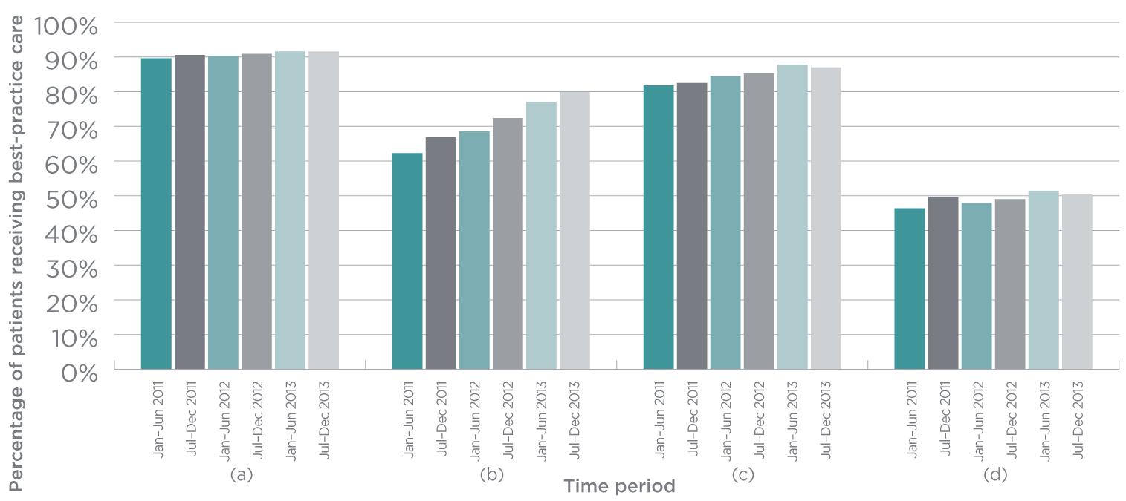

(a) Patients contacted on day of, or day after referral (%)

(b) Patients in unstable phase for 3 days or less (%)

(c) Patients with mild or no pain at phase start with mild or no pain at phase end (%)

(d) Patients with moderate or severe pain at phase start with mild or no pain at phase end (%)

Figure 30

Responsiveness indicators and pain outcome indicators for palliative care provided at home, 2011–2013

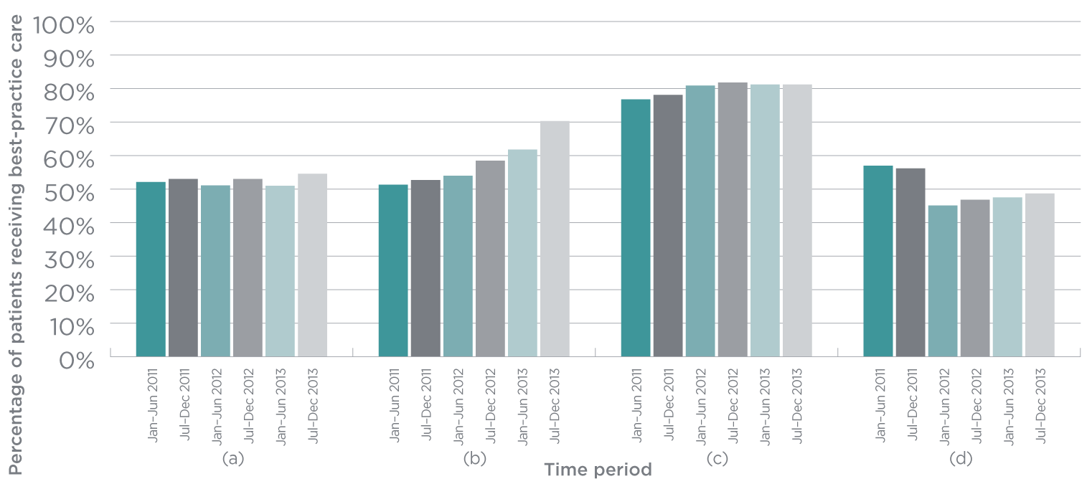

(a) Patients contacted on day of, or day after referral (%)

(b) Patients in unstable phase for 3 days or less (%)

(c) Patients with mild or no pain at phase start with mild or no pain at phase end (%)

(d) Patients with moderate or severe pain at phase start with mild or no pain at phase end (%)

Figure 31

Symptom outcome indicators for palliative care provided in hospital, 2011–2013

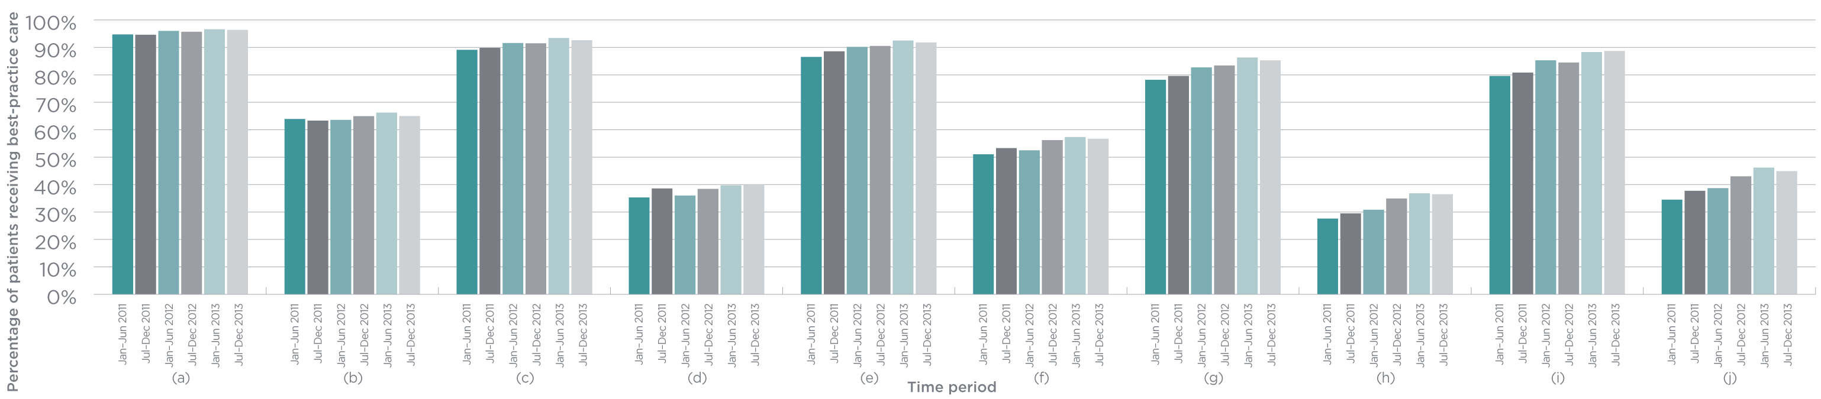

(a) Patients with mild or no nausea at phase start with mild or no nausea at phase end (%)

(b) Patients with moderate or severe nausea at phase start with mild or no nausea at phase end (%)

(c) Patients with mild or no breathing problems at phase start with mild or no breathing problems at phase end (%)

(d) Patients with moderate or severe breathing problems at phase start with mild or no breathing problems at phase end (%)

(e) Patients with mild or no bowel problems at phase start with mild or no bowel problems at phase end (%)

(f) Patients with moderate or severe bowel problems at phase start with mild or no bowel problems at phase end (%)

(g) Patients with mild or no family/carer problems at phase start with mild or no family/carer problems at phase end (%)

(h) Patients with moderate or severe family/carer problems at phase start with mild or no family/carer problems at phase end (%)

(i) Patients with mild or no psychological/spiritual problems at phase start with mild or no psychological/spiritual problems at phase end (%)

(j) Patients with moderate or severe psychological/spiritual problems at phase start with mild or no psychological/spiritual problems at phase end (%)

Figure 32

Symptom outcome indicators for palliative care provided at home, 2011–2013

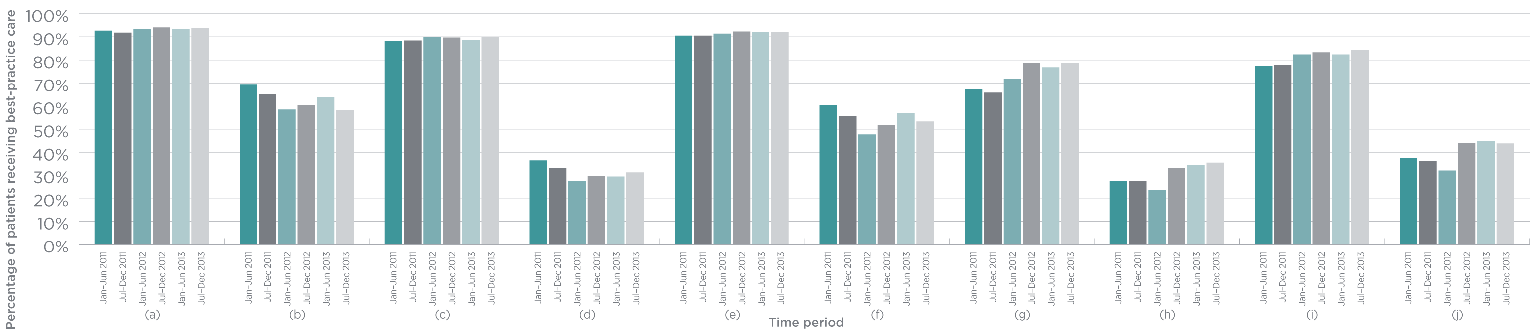

(a) Patients with mild or no nausea at phase start with mild or no nausea at phase end (%)

(b) Patients with moderate or severe nausea at phase start with mild or no nausea at phase end (%)

(c) Patients with mild or no breathing problems at phase start with mild or no breathing problems at phase end (%)

(d) Patients with moderate or severe breathing problems at phase start with mild or no breathing problems at phase end (%)

(e) Patients with mild or no bowel problems at phase start with mild or no bowel problems at phase end (%)

(f) Patients with moderate or severe bowel problems at phase start with mild or no bowel problems at phase end (%)

(g) Patients with mild or no family/carer problems at phase start with mild or no family/carer problems at phase end (%)

(h) Patients with moderate or severe family/carer problems at phase start with mild or no family/carer problems at phase end (%)

(i) Patients with mild or no psychological/spiritual problems at phase start with mild or no psychological/spiritual problems at phase end (%)

(j) Patients with moderate or severe psychological/spiritual problems at phase start with mild or no psychological/spiritual problems at phase end (%)

5 Conclusion

Conclusion

Safety and quality is a complex field that is integrated into all aspects of health care. There are many people and organisations involved in ensuring that people receiving health care in Australia are safe and receive high-quality care.

This means there is no single source of data that can provide comprehensive information about the safety and quality of the Australian healthcare system. The information in Vital Signs 2014 covers 14 separate safety and quality topics and draws on data from a wide range of sources. Combined, this information paints a picture about the work being done in Australia to improve safety and quality, as well as the success of these efforts and the work that remains.

In many respects, people receiving health care in Australia are safer than they have been in the past. People are now less likely to be infected with the potentially fatal Staphylococcus aureus bacteraemia, more likely to be identified and cared for appropriately if their condition deteriorates in hospital, more likely to have their medicines reconciled on admission and discharge, and less likely to be secluded if they have a mental illness and their condition deteriorates in hospital. We know that when errors and problems occur in hospitals there are associated increases in costs, so improving safety and ensuring that good systems are in place has the potential to reduce costs and waste in the health system.127

While some of these results are based on small-scale studies, some are based on data from across Australia and indicate consistent trends towards safer care. Further efforts are needed to nationally embed successful patient safety initiatives into routine practice; the NSQHS Standards can help make this happen.

The success of the first year of the new national accreditation scheme – and the assessment of more than half of all Australian hospitals and day procedure services against the NSQHS Standards – indicates further progress towards safer care. The NSQHS Standards apply to areas where too many people suffer harm because of their health care, and where there is good evidence of how to provide better care. Hospitals and day procedure services that meet the NSQHS Standards are taking the steps required to ensure the safety of people receiving their services.

Although all hospitals and day procedure services will not be assessed against the NSQHS Standards until December 2015, the Commission is starting to look at how the next version of the NSQHS Standards can be strengthened when they commence in 2017. There are opportunities to reflect some of the emerging safety and quality issues in the NSQHS Standards, to ensure that all people receive the best care.

Vital Signs 2014 highlights issues concerning seclusion and restraint, and the appropriate care for people with cognitive impairment. These, together with other issues such as nutrition and personal care, will be considered as the NSQHS Standards are reviewed. The Commission will work closely with the states and territories and the private hospital sector in reviewing the NSQHS Standards.

There is an increasing focus in Australia on whether people receive the right care, and the variation in care that does exist. It is important to understand the extent of variation in the healthcare system and where unwarranted variation might be occurring. This knowledge can help efforts to maximise the value and quality of health care in Australia, ensuring that resources are directed in a way that will bring the most benefit to everyone across the system.44 The Commission has been working with national and international partners to examine healthcare variation in Australia. It will continue to explore this variation, together with methods of reducing it.

Across all of the topics included in Vital Signs 2014, there is an increasing recognition of the important role of consumers, patients, family members and carers in ensuring healthcare safety and quality. Consumers need to be true partners in health and healthcare processes in order to achieve a sustainable and effective health system that provides safe and high-quality care.

Health literacy is a core requirement for effective partnerships. For partnerships to work, everyone involved in the partnership needs to be able to give, receive, interpret and act on information in an effective way. These conditions can improve the safety and quality of health care, reduce health disparities and increase equity.

The first contact that most people have with the health system is through general practice. In 2011/12, 84 per cent of the population had consulted a GP at least once in the previous 12 months.128 Health services and healthcare providers in the community are essential for ensuring that people receive safe and high-quality care. Many of the intitiatives described in Vital Signs 2014 will create opportunities to improve the safety and quality of care provided in the community, including improving the process for accreditation of general practices, examining the extent and nature of healthcare variation in Australia, and supporting people in the community to be involved in making decisions about their own health care. Because of the unique nature of general practice and other care provided in the community, it is also important to understand the particular safety and quality issues that are relevant in this environment.

The Commission will continue to work with its partners – patients, families, carers, consumer groups, healthcare providers, managers, executives and policymakers – to improve the care, experiences and outcomes of people in the Australian health system. It is only through this commitment to partnership that we will achieve sustainable change and better care.

References

1. OECD. Health at a Glance: OECD Indicators. Paris: OECD, 2013.

2. Thomson S, Osborn R, Squires D and Jun M. *International Profiles of Health Care Systems,* 2013. New York: The Commonwealth Fund, 2013.

3. Australian Commission on Safety and Quality in Health Care. National Safety and Quality Health Service Standards. Sydney: ACSQHC, 2011.

4. Royal Australian College of General Practitioners. Standards for General Practices (4th Edition). Melbourne: RACGP, 2013.

5. Primary Health Care Research Information Service. General practice numbers in Australia, 2000–01 to 2010–11. Adealide: PHCRIS, 2014.

6. National Health and Medical Research Council. Australian Guidelines for the Prevention and Control of Infection in Healthcare. Canberra: NHMRC, 2010.

7. Hand Hygiene Australia, Melbourne: Hand Hygiene Australia, 2014.

8. Collignon P, Nimmo G, Gottlieb T, Gosbell I on behalf of the Australian Group on Antimicrobial Resistance. Staphylococcus aureus bacteraemia, Australia. Emerging Infectious Diseases. 2005; 11: 554–61.

9. Mitchell B, Collignon P, McCann R, Wilkinson I and Wells A. A major reducation in hospital onset Staphylococcus aureus bacteraemia in Australia – 12 years of progress: An observational study. Clinical Infectious Diseases. 2014; 59: 969–75.

10. Turnidge J, Kotsanas D, Munckhof W, et al. Staphylococcal aureus bacteraemia: A major cause of mortality in Australia and New Zealand. Medical Journal of Australia. 2009; 191: 368–73.

11. National Health Performance Authority. Healthcare-associated Staphylococcus aureus Bloodstream Infections in 2012–13 (In Focus). Sydney: NHPA, 2014.

12. Worth L, Spelman T, Bull A and Richards M. Staphylococcus aureus bloodstream infection in Australian hospitals: Findings from a Victorian surveillance system. Medical Journal of Australia. 2014; 200: 282–4.

13. Australian Institute of Health and Welfare. Australian Hospital Statistics 2012–13: Staphylococcus aureus Bacteraemia in Australian Public HospitalsHealth Services Series no. 53 Cat. no. HSE 144. Canberra: AIHW, 2013.

14. Steering Committee for the Review of Government Service Provision. Report on Government Services 2011. Canberra: Productivity Commission, 2011.

15. Department of Health. Australian Statistics on Medicines: 2001–2002.Canberra: Commonwealth of Australia, 2002.

16. Department of Health. Australian Statistics on Medicines: 2011. Canberra: Commonwealth of Australia, 2011.

17. Roughead E, Semple S and Rosenfeld E. Literature Review: Medication Safety in Australia.Sydney: ACSQHC, 2013.

18. Gleason KM, McDaniel MR, Feinglass J, et al. Results of the Medications at Transitions and Clinical Handoffs (MATCH) Study: An Analysis of Medication Reconciliation Errors and Risk Factors at Hospital Admission. Journal of General Internal Medicine. 2010; 25: 441–7.

19. Sullivan C, Gleason KM, Rooney D, Groszek JM and Barnard C. Medication reconciliation in the acute care setting: Opportunity and challenge for nursing. Journal of Nursing Care Quality. 2005; 20: 95–8.

20. Vira T, Colquhoun M and Etchells E. Reconcilable differences: correcting medication errors at hospital admission and discharge. Quality and Safety in Health Care. 2006; 15: 122–6.

21. Cornish PL, Knowles SR, et al. Unintended medication discrepancies at the time of hospital admission. Archives Int Med. 2005; 165: 424–9.

22. National Institute for Health and Clinical Excellence. Technical Patient Safety Solutions for Medicines Reconciliation on Admission of Adults to Hospital.London: National Patient Safety Agency, 2007.

23. Cornish P, Knowles S, Marchesano R, et al. Unintended medication discrepancies at the time of hospital admission. Archives of Internal Medicine. 2005; 165: 424–9.

24. Chan EW, Taylor SE, Marriott JL and Barger B. Bringing patient’s own medications into an emergency department by ambulance: effect on prescribing accuracy when these patients are admitted to hospital. Medical Journal of Australia. 2009; 191: 374–7.

25. Stowasser D, Collins D and Stowasser M. A randomised controlled trial of medication liaison services – patient outcomes. Journal of Pharmacy Practice and Research. 2002; 32: 133–40.

26. ISMP Canada. Medication reconciliation can help reduce the chance of errors with medicines. Safe Medication Use Newsletter. 2012.

27. Schnipper JL, Kirwin JL, Cotugno MC, et al. Role of pharmacist counselling in preventing adverse events after hospitalisation. Archives of Internal Medicine. 2006; 166: 565–71.

28. Mueller S, Sponsler K, Kripalani S and Schnipper J. Hospital-based medication reconciliation practices: A systematic review. Archives of Internal Medicine. 2012; 172: 1057–69.

29. Kwan JL, Lo L, Sampson M and Shojana KG. Medication reconciliation during transitions of care as a patient safety strategy. Annals of Internal Medicine. 2013; 158: 397–403.

30. Australian Commission on Safety and Quality in Health Care. Report on the National Round Table on Safer Naming, Labelling and Packaging of Medicines.Sydney: ACSQHC, 2011.

31. Goldhill D, White S and Sumner A. Physiological values and procedures in the 24 hours before ICU admission from the ward. Anaesthesia. 1999; 54: 529–34.

32. Hillman K, Bristow P, Chey T, et al. Antecedents to hospital deaths. Internal Medicine Journal. 2001; 31: 343–8.

33. McQuillan P, Pilkington S, Allan A, et al. Confidential inquiry into quality of care before admission to intensive care. British Medical Journal. 1998; 316: 1853–8.

34. National Patient Safety Agency. Recognising and responding appropriately to early signs of deterioration in hospitalised patients.London:National Patient Safety Agency, 2007.

35. Horswill M, Preece M, Hill A, Christofidis M and Watson M. Recording Patient Data on Six Observation Charts: An Experimental Comparison. Sydney: ACSQHC, 2010.

36. Horswill M, Preece M, Hill A and Watson M. Detecting Abnormal Vital Signs on Six Observation Charts: An Experimental Comparison. Sydney: Australian Commission on Safety and Quality in Health Care, 2010.

37. Hughes C, Pain C, Braithwaite J and Hillman K. ‘Between the Flags’: Implementing a rapid response system at scale. British Medical Journal Quality and Safety. 2014; 0: 1–4.

38. National Mental Health Working Group, Health Priorities and Suicide Prevention Branch and Department of Health and Ageing. National Safety Priorities in Mental Health: A National Plan for Reducing Harm.Canberra: Commonwealth of Australia, 2005.

39. National Mental Health Consumer and Carer Forum. Ending Seclusion and Restraint in Australian Mental Health Services. Canberra: 2009.

40. National Mental Health Commission. The Seclusion and Restraint Declaration. Sydney: 2014.

41. Australian Health Ministers’ Advisory Council. A National Framework for Recovery-oriented Mental Health Services: Policy and Theory. Canberra: Commonwealth of Australia, 2013.

42. National Executive Training Institute. Training curriculum for reduction of seclusion and restraint. Draft curriculum manual. Alexandria, Virginia: National Association of State Mental Health Program Directors, National Technical Assistance Center for State Mental Health Planning, 2005.

43. Commonwealth of Australia. National Standards for Mental Health Services.Canberra: Commonwealth of Australia, 2010.

44. Australian Commission on Safety and Quality in Health Care and the Australian Institute of Health and Welfare. Exploring Healthcare Variation in Australia: Analyses Resulting from an OECD Study.Sydney: ACSQHC, 2014.

45. Australian Commission on Safety and Quality in Health Care. Medical Practice Variation: Background Paper.Sydney: ACSQHC, 2013.

46. Laupattarakasem W, Laopaiboon M, Laupattarakasem P and Sumananont C. Arthroscopic debridement for knee osteoarthritis. Cochrane Database of Systematic Reviews. 2008; CD005118.

47. Sihvonen R, Paavola M, Malmivaara A, et al. Partial meniscectomy versus sham surgery for a degenerative meniscal tear. New England Journal of Medicine. 2013; 369: 2515–24.

48. Stacey D, Bennett C, Barry M, et al. Decision aids for people facing health treatment or screening decisions. Cochrane Database of Systematic Reviews. 2011.

49. Stacey D, Hawker G, Dervin G, et al. Decision aid for patients considering total knee arthroplasty with preference report for surgeons: a pilot randomized controlled trial. BMC Musculoskeletal Disorders. 2014; 15.

50. Gray LC, Peel NM, Costa AP, et al. Profiles of older patients in the emergency department: Findings from the interRAI Multinational Emergency Department Study. Annals of Emergency Medicine. 2013; 62: 467–74.

51. National Institute for Health and Clinical Excellence. Delirium: Diagnosis, prevention and management.Clinical Guideline 103. London 2010.

52. Inouye S, Westendorp R and Saczynski J. Delirium in elderly people. Lancet. 2014; 383: 911–22.

53. Travers C, Byrne G, Pachana N, Klein K and Gray L. Prospective observational study of dementia and delirium in the acute hospital setting. Internal Medicine Journal. 2013; 43: 262–9.

54. Australian Commission on Safety and Quality in Health Care. Evidence for Safety and Quality Issues Associated with the Care of Patients with Cognitive Impairment in Acute Care Settings: A Rapid Review.Sydney: ACSQHC, 2013.

55. Ryan DJ, O’Regan NA, Caoimh RO, et al. Delirium in an adult acute hospital population: Predictors, prevalence and detection. BMJ Open. 2013; 3.

56. Eijk MM and Slooter AJ. Delirium in intensive care unit patients. Seminars in Cardiothoracic and Vascular Anesthesia. 2010; 14: 141–7.

57. Australian and New Zealand Society for Geriatric Medicine. Delirium in Older People. Position Statement 13. 2012.

58. Eeles E, Hubbard R, White S, O’Mahony M, Savva G and Rayer A. Hospital use, institutionalisation and mortality associated with delirium. Age and Ageing. 2010; 39: 470–5.

59. Inouye S. Delirium in older persons. New England Journal of Medicine. 2006; 354: 1157–65.

60. Barron E and Holmes J. Delirium within the emergency care setting, occurrence and detection: A systematic review. Emergency Medicine Journal. 2013; 30: 263–8.

61. Rice K, Gomez M, Theall K, Knight M and Foreman M. Nurses’ recognition of delirium in the hospitalized older adult. Clinical Nurse Specialist. 2011; 25: 299–311.

62. Suffoletto B, Miller T, Frisch A and Callaway C. Emergency physician recognition of delirium. Postgraduate Medical Journal. 2013; 29: 621–5.

63. Australian Institute of Health and Welfare. Dementia Care in Hospitals: Costs and Strategies. Canberra: AIHW, 2013.

64. Working Group of the Clinical Technical and Ethical Principal Committee of the Australian Health Ministers’ Advisory Council. A National Framework for Advance Care Directives. Canberra: Australian Health Ministers’ Advisory Council, 2011.

65. Detering K, Hancock A, Reade M and Silvester W. The impact of advance care planning on end of life care in elderly patients: Randomised controlled trial. British Medical Journal. 2010; 340.

66. Bezzina A. Prevalence of advance care directives in aged care facilities of the Northern Illawarra. Emergency Medicine Australasia. 2009; 21: 379–85.

67. Taylor D, Ugami A and Cameron P. Advance directives and emergency department patients: Ownership rates and perceptions of use. Internal Medicine Journal. 2003; 33: 586–92.

68. Rhee J, Zwar N and Kemp L. Uptake and implementation of advance care planning in Australia: Findings of key informant interviews. Australian Health Review. 2012; 36: 98–104.

69. Cartwright C, Montogomery J, Rhee J, Zwar N and Banbury A. Medical practitioners’ knowledge and self-reported practices of substitute decision making and implementation of advance care plans. Internal Medicine Journal. 2014; 44: 234–9.

70. Royal Australian College of General Practitioners. Position Statement: Advance care planning should be incorporated into routine general practice. Melbourne: RACGP, 2012.

71. Doyle C, Lennox L and Bell D. A systematic review of evidence on the links between patient experience and clinical safety and effectiveness. BMJ Open. 2013; 3: e001570.doi:10.1136/bmjopen-2012-001570.

72. Hibbard JH and Greene J. What the evidence shows about patient activation: Better health outcomes and care experiences; fewer data on costs. Health Affairs. 2013; 32: 207–14.

73. Rathert C, Wyrwich MD and Boren SA. Patient-centred care and outcomes: A systematic review of the literature. Medical Care Research and Review. 2013; 70: 351–79.

74. NSW Health Care Complaints Commission. Protecting the Health and Safety of the Public: Annual Report 2011–12. Sydney: NSW HCCC, 2012.

75. Office of the Health Services Commissioner. Annual Report 2012. Melbourne: OHSC, 2012.

76. The Joint Commission. What Did the Doctor Say? Improving Health Literacy to Protect Patient Safety. Oakbrook Terrace: The Joint Commission, 2007.

77. Health Quality and Complaints Commission. Positive Change: Annual Report 2011–12. Brisbane: HQCC, 2012.

78. Miller M, Abrams M, Earles B, Phillips K and McCleeary E. Improving patient-provider communication for patients having surgery: Patient perceptions of a revised health literacy-based consent process. Journal of Patient Safety. 2011; 7: 30–8.

79. Smith S, Simpson J, Trevena L and McCaffery K. Factors associated with informed decisions and participartion in bowel cancer screening among adults with lower education and literacy. Medical Decision Making. 2014; doi: 10.1177/0272989X13518976.

80. Leighl NB, Shepherd HL, Butow PN, et al. Supporting Treatment Decision Making in Advanced Cancer: A randomized trial of a decision aid for patients with advanced colorectal cancer considering chemotherapy. Journal of Clinical Oncology. 2011; 29: 2077–84.

81. Australian Screening Mammography Decision Aid Trial: A decision aid for women aged 40 thinking about starting mammography screening. Sydney: University of Sydney, 2007.

82. Schoen C, Osborn R, Squires D, Doty M, Pierson R and Applebaum S. New 2011 survey of patients with complex care needs in eleven countries finds that care is often poorly coordinated. Health Affairs. 2011; 30: 2437–48.

83. Iedema R and Manidis M. Patient-Clinician Communication: An Overview of Relevant Research and Policy Literatures.Sydney: ACSQHC and UTS Centre for Health Communication, 2013.

84. Schenker Y, Fernandez A, Sudore R and Schillinger D. Interventions to improve patient comprehension in informed consent for medical and surgical procedures: A systematic review.Medical Decision Making. 2011; 31: 151–73.

85. Commonwealth Scientific and Industrial Research Organisation. Bowel Cancer Screening Decision Aid. Canberra: CSIRO, 2011.

86. Ottawa Hospital Research Institute. Patient Decision Aids. Ottawa: OHRI, 2014.

87. International Patient Decision Aid Standards Collaboration. International Patient Decision Aid Standards Collaboration. Home Page. Ottawa: IPDAS, 2013.

88. Institute of Medicine. Health Literacy: A Prescription to End Confusion. Washington, DC: The National Academies Press, 2004.

89. Rudd RE, Moeykens BA and Colton TC. Health and literacy: A review of medical and public health literature. In: Comings JP, Garner B and Smith C, (eds.). The Annual Review of Adult Learning and Literacy. San Francisco: Jossey-Bass, 2000.

90. Australian Commission on Safety and Quality in Health Care. Health Literacy: Taking Action to Improve Safety and Quality. Sydney: ACSQHC, 2014.

91. Australian Institute of Health and Welfare. Australia’s Health 2012. Australia’s Health Series no.13. Cat. no. AUS 156. Canberra: AIHW, 2012.

92. Bailey S, Oramasionwu C and Wolf M. Rethinking adherence: A health literacy-informed model of medication management. Journal of Health Communication. 2013; 18.

93. Hernandez L. Standardizing Medication Labels: Confusing Patients Less. Workshop Summary. Washington DC: Roundtable on Health Literacy, Board on Population Health and Public Health Practice, Institute of Medicine, 2008.

94. Chang M-C, Chen Y-C, Chang S-C and Smith G. Knowledge of using acetaminophen syrup and comprehension of written medication instruction among caregivers with febrile children. Journal of Clinical Nursing. 2012; 21: 42–51.

95. Shone LP, King JP, Doane C, Wilson KM and Wolf MS. Misunderstanding and potential unintended misuse of acetaminophen among adolescents and young adults. Journal of Health Communication. 2011; 16: 256–67.

96. Davis T, Wolf M, Bass I, et al. Literacy and misunderstanding prescription drug labels. Annals of Internal Medicine. 2006; 145: 887–94.

97. Davis T, Wolf M, Bass P, et al. Low literacy impairs comprehension of prescription drug warning labels. Journal of General Internal Medicine. 2006; 21: 847–51.

98. DeWalt D, Berkman N, Sheridan S, Lohr K and Pigone M. Literacy and health outcomes: Systematic review of the literature. Journal of General Internal Medicine. 2004; 19: 1228–39.

99. Wolf M, Davis T, Shrank W, et al. To err is human: Patient misinterpretations of prescription drug label instructions. Patient Education and Counseling. 2007; 67: 293–300.

100. Sweet G and Wilson S. The 3D Labels Project: Dandenong District Division of General Practice. Pharmacy Guild of Australia. Canberra: 2006.

101. O’Hare F, Jeganathan VS, Rokahr CG, Rogers SL and Crowston JG. Readability of prescription labels and medication recall in a population of tertiary referral glaucoma patients. Clinical and Experimental Ophthalmology. 2009; 37: 849–54.

102. Wolf M, Davis T, Curtis L, et al. Effect of standardized, patient-centred label instructions to improve comprehension of prescription drug use. Medical Care. 2011; 49.

103. Australian Commission on Safety and Quality in Health Care. Patient-Centred Care: Improving Safety and Quality Through Partnerships with Patients and Consumers.Sydney: ACSQHC, 2011.

104. National Patient Safety Foundation’s Lucian Leape Institute. Safety is Personal: Partnering with Patients and Families for the Safest Care. Report of the Roundtable on Consumer Engagement in Patient Safety. Boston: NPSF, 2014.

105. Patient Opinion (Australia). Brisbane: Patient Opinion. www.patientopinion.org.au. Accessed 17 April 2014.

106. Patient Opinion (UK). London: Patient Opinion. www.patientopinion.org.uk. Accessed 17 April 2014.

107. Australian Commission on Safety and Quality in Health Care. Implementation Toolkit for Clinical Handover Improvement.Sydney: ACSQHC, 2011.

108. Australian Institute of Health and Welfare. Stroke and its Management in Australia: An Update. Cardiovascular Disease Series no 37 Cat. no. CVD 61. Canberra: AIHW, 2013.

109. National Stroke Foundation. Risk Factors for Stroke. National Stroke Foundation, 2014.

110. National Stroke Foundation. Clinical Guidelines for Stroke Management. Melbourne: National Stroke Foundation, 2010.

111. Australian Commission on Safety and Quality in Health Care. Clinical Care Standards. Sydney: ACSQHC, 2014.

112. National Stroke Foundation. National Stroke Audit – Acute Services. Clinical Audit Report 2013. Melbourne: National Stroke Foundation, 2013.

113. National Stroke Foundation. National Stroke Audit – Acute Services. Organisational Survey Report 2013. Melbourne: National Stroke Foundation, 2013.

114. Stroke Unit Trialists’ Collaboration. Organised inpatient (stroke unit) care for stroke. Cochrane Database of Systematic Reviews. 2007; 4: CD000197.

115. Sandercock P, Counsell C, Gubitz G and Tseng M. Antiplatelet therapy for acute ischaemic stroke. Cochrane Database of Systematic Reviews. 2007; 3: CD000029.

116. Wardlaw J, Murray V, Berge E and del Zoppo G. Thrombolysis for acute ischaemic stroke. Cochrane Database of Systematic Reviews. 2007; 4.

117. National Stroke Foundation. National Stroke Audit – Acute Services. Clinical Audit Report 2011. Melbourne: National Stroke Foundation, 2011.

118. Palliative care. Canberra: Department of Health, 2014.

119. World Health Organization. Definition of Palliative Care. Geneva: World Health Organization, 2010.

120. Holloway A, Allingham S, Hope C, Clapham S and Foskett L. PCOC National Report on Patient Outcomes in Palliative Care in Australia, July to December 2013. Wollongong: Palliative Care Outcomes Collaboration, Australian Health Services Research Institute, University of Wollongong, 2014.

121. Australian Institute of Health and Welfare. Palliative Care Services in Australia Cat. no. HWI 123. Canberra: AIHW, 2013.

122. The Australian Government’s National Palliative Care Program. Canberra: Department of Health, 2014.

123. Kristjanson L, Pickstock S, Yuen K, et al. Development and Testing of the Revised Symptom Assessment Scale: Final Report. Perth: Edith Cowan University, 1999.

124. Smith M and Firms P. Palliative care case mix classification – testing a model in a variety of palliative care settings: Preliminary results. 6th National Case Mix Conference. Canberra: Commonwealth Department of Human Services and Health, 1994.

125. McNeil JJ, Evans SM, Johnson NP and Cameron PA. Clinical-quality registries: Their role in quality improvement. Medical Journal of Australia. 2010; 192: 244–5.

126. Currow D, Allingham S, Yates P, Johnson C, Clark K and Eagar K. Improving national hospice/palliative care outcomes systematically (Manuscript submitted for publication). 2014.

127. Øvretveit J. Does improving quality save money? A review of evidence of which improvements to quality reduce costs to health service providers. London: Health Foundation, 2009.

128. Australian Institute of Health and Welfare. Australia’s Health 2014. Australia’s Health Series no 14 – Cat. no. AUS 178. Canberra: AIHW, 2014.

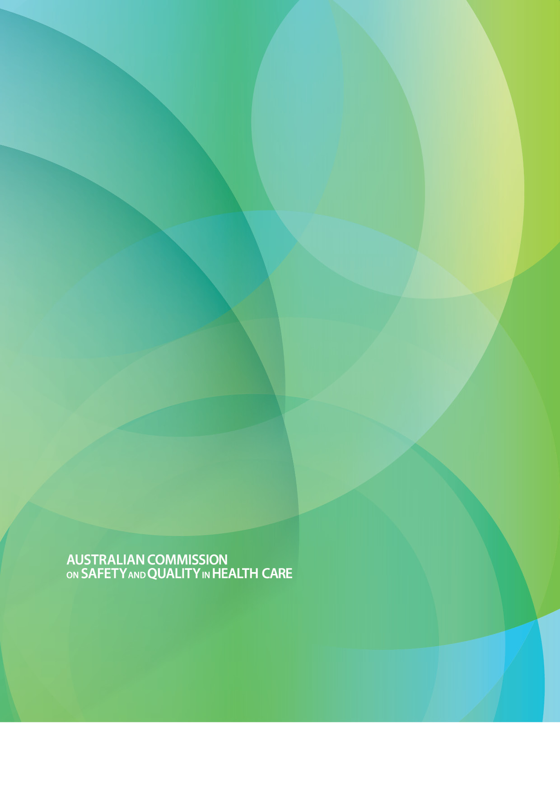

Level 5, 255 Elizabeth Street, SYDNEY NSW 2000   
GPO Box 5480, SYDNEY NSW 2001

Telephone: (02) 9126 3600   
Fax: (02) 9126 3613

mail@safetyandquality.gov.au   
www.safetyandquality.gov.au