

Australian Commission on Safety and Quality in Health Care

Vital Signs 2015

The State of Safety and Quality in Australian Health Care

© Commonwealth of Australia 2015

This work is copyright. It may be reproduced in whole or in part for study or training purposes, subject to the inclusion of an acknowledgement of the source.

Address requests and inquiries concerning reproduction and rights for purposes other than those indicated above in writing to:

Australian Commission on Safety and Quality in Health Care, GPO Box 5480, Sydney NSW 2001

Or email [mail@safetyandquality.gov.au](mailto:mail@safetyandquality.gov.au)

Suggested citation: Australian Commission on Safety and Quality in Health Care (ACSQHC). Vital signs 2015: The State of Safety and Quality in Australian Health Care. Sydney: ACSQHC, 2015.

An online version of this report can be accessed at www.safetyandquality.gov.au

ISSN: 2002-7696 (print and online)

Contents

Acronyms and abbreviations 2

Introduction 2

**01** Will my care be safe? 2

Safety and quality standards: there are safety and quality standards that are improving my care 2

Multi-resistant *Escherichia coli*, *Klebsiella* and related species: action is being taken to contain the spread of highly resistant bacteria so that I am safe in hospital 2

Medication safety: systems are in place to make sure my medicines are administered safely 2

Patient safety in primary care: when I visit a primary care practitioner systems are in place to ensure I receive safe care 2

Safety and quality in mental health: mental health standards ensure I receive safe care 2

eHealth: systems are in place allow providers to share my health information safely 2

**02** Will I get the right care? 2

Antimicrobial prescribing: I get the right care because the health system is tracking how antimicrobials are prescribed in hospitals 2

Management of chronic conditions: if I have a chronic condition, systems in place at my general practice ensure I get the right care 2

Aboriginal and Torres Strait Islander health: my healthcare providers ask if I am Indigenous to improve the care I receive 2

Cognitive impairment: my healthcare providers will try to prevent me from developing delirium and keep me safe if I have dementia 2

03 Will I be a partner in my care? 2

Patient-clinician communication: my healthcare provider will communicate with me about my care as I move through the health system 2

Patient experience measurement: my experiences of health care will be used to help improve safety and quality 2

Perceptions of safety and quality: when I visit a general practice, I trust that I will receive safe care 2

**04** Case studies 2

Case studies 2

Rehabilitation 2

High priority complications 2

Healthcare variation 2

05 Conclusion 2

References 2

# Acronyms and abbreviations

**ACSQHC** Australian Commission on Safety and Quality in Health Care

**ADL score** Activities of daily living score

**APCC Program** Australian Primary Care Collaboratives Program

**AROC** Australasian Rehabilitation Outcomes Centre

**AURA** Project Antimicrobial Use and Resistance in Australia Project

**CAM** Confusion assessment method

**CHOPs** Confused Hospitalised Older Persons Program

**CRE** Carbapenem-resistant Enterobacteriaceae

**DCHP** Dementia Care in Hospitals Program

**DIC** Dignity in Care

**E. coli** Escherichia coli

**EMM** Electronic medication management

**GP** General practitioner

**HPCs** High priority complications

**NAPS** National Antimicrobial Prescribing Survey

**NEHTA** National E-Health Transition Authority

**NHCDC** National Hospital Costs Data Collection

**NIMC** National inpatient medication chart

**NSQHS** Standards National Safety and Quality Health Service Standards

**NASCAR** National Alert System for Critical Antimicrobial Resistances

**PHN** Primary Health Network

**RACGP** Royal Australian College of General Practitioners

**WHO** World Health Organization

# Introduction

Welcome to the Australian Commission on Safety and Quality in Health Care’s (the Commission’s) third report on the state of safety and quality of health care in Australia, Vital signs 2015.

The Commission leads and coordinates national improvements in safety and quality in health care to contribute to better health outcomes and experiences for patients and improved productivity and sustainability of the health system. Key functions include developing national standards, providing advice about best practice, coordinating work in specific areas to improve outcomes for patients, and providing information, publications and resources about safety and quality.

One of the Commission’s core functions is to report on the state of safety and quality of the Australian health system. This is important because it can help people understand their health system, what the system is doing to improve safety and quality, and how successful their efforts are. It can also help to bring about change and improvement in experiences and outcomes for patients.

Vital signs 2015 provides information about the safety and quality of health care for the general public. It is structured around three important questions that members of the public ask about their health care:

* Will my care be safe?
* Will I get the right care?
* Will I be a partner in my care?

Australia generally performs very well in international comparisons about health. For example, the Australian population has a relatively high life expectancy, a relatively low rate of avoidable death and a high proportion of people who report that they are in good health.1,2 However, measuring the safety and quality of care can be challenging. While there is information about things such as the diagnoses people receive and how many procedures people have, there is less complete information about safety and quality. Vital signs 2015 brings together information from a range of sources to provide a snapshot of safety and quality performance and activity on a number of important topics.

Vital signs 2015 also includes three case studies that provide an in-depth analysis of safety and quality in three important areas. The case studies illustrate the type of work that is needed to properly understand issues about safety and quality in health care, and to develop solutions to address them.

# **01** Will my care be safe?

The Australian health system generally provides safe and high-quality care. Unfortunately some people are harmed as a result of the care they receive. Doctors, nurses and everyone involved in health work very hard to ensure that people are safe. But health care is a complex process that requires much planning and coordination – and sometimes things go wrong.

An important way to minimise the likelihood of harm occurring is to make sure that good processes are in place – that health services have systems to ensure safety, and that people working in health services are aware of what those systems are and use them properly.

This is one of the most important roles of the Commission – to ensure good systems are in place. The Commission has worked with the Australian Government, all state and territory governments, the private hospital sector, clinical groups and patients, carers and consumers to develop safety and quality standards that all hospitals and day procedure services in Australia need to be assessed against.

This section provides information about some of the changes that have been made since these standards were introduced in 2013. It also highlights some of the newly emerging areas of focus in safety and quality, including primary care, mental health and eHealth.

Will my care be safe?

**Safety and quality standards:** there are safety and quality standards that are improving my care

**Multi-resistant** Escherichia coli**,** Klebsiella **and related species:** action is being taken to contain the spread of highly resistant bacteria so that I am safe in hospital

**Medication safety:** systems are in place to make sure my medicines are administered safely

**Patient safety in primary care:** when I visit a primary care practitioner systems are in place to ensure I receive safe care

**Safety and quality in mental health:** mental health standards ensure I receive safe care

**eHealth:** systems are in place to allow providers to share my health information safely

## Safety and quality standards: there are safety and quality standards that are improving my care

Hospitals and day procedure services have been using the National Safety and Quality Health Service (NSQHS) Standards since January 2013 as their guide to safety and quality improvement.3 The NSQHS Standards cover areas where it is known that patients experience higher levels of harm, and where evidence shows how to provide safer and better care.

### All hospitals and day procedure services will soon be assessed to the NSQHS Standards

Since January 2013, all hospitals and day procedure services must be assessed to the NSQHS Standards when they were accredited. Accreditation is a formal process that involves:

* the health service assessing itself against standards that have been set externally
* an independent agency reviewing that health service and its assessment
* the health service making recommended improvements.

Not all health services need to be accredited at the same time, but by the end of 2015 all hospitals and day procedure services in Australia will have been tested against the NSQHS Standards (Figure 1).

In 2014, 1072 health services were assessed to the NSQHS Standards. Box 1 provides an overview of these assessments.

**1072** hospitals and day procedure services assessed to the NSQHS Standards in 2014

### NSQHS Standards

 Governance for Safety and Quality in Health Service Organisations

 Partnering with Consumers

 Preventing and Controlling Healthcare Associated Infections

 Medication Safety

 Patient Identification and Procedure Matching

 Clinical Handover

 Blood and Blood Products

 Preventing and Managing Pressure Injuries

 Recognising and Responding to Clinical Deterioration in Acute Health Care

 Preventing Falls and Harm from Falls

The NSQHS Standards are improving outcomes for patients and the culture of health services for patient safety

Figure 1: Progress towards accreditation in all Australian health services by year

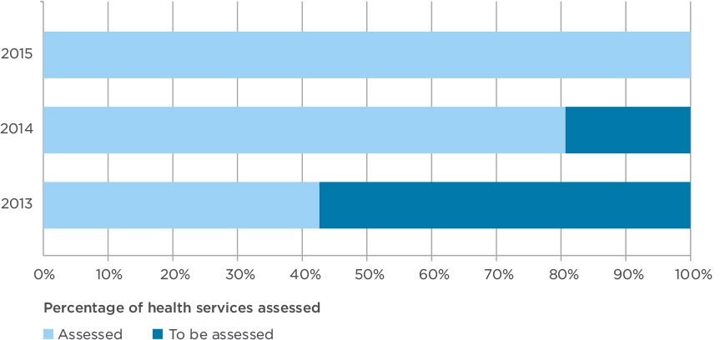

Source: ACSQHC, 2015.

Box 1: Health services assessed to the NSQHS Standards in 2014

1072 health services were assessed to the NSQHS Standards in 2014.

481 assessments (45%) were in private health services and 591 (55%) in public health services.

747assessments (70%) were in hospitals, 259 (24%) in day procedure services and 66 (6%) in other types of health services, such as community services.

619 health services (48%) completed an organisation-wide assessment to all 10 NSQHS Standards.

431 health services (40%) completed an assessment at the middle of their accreditation cycle to NSQHS Standard 1: Governance for Safety and Quality; Standard 2: Partnering with Consumers; and Standard 3: Preventing and Controlling Healthcare Associated Infections.

22 new health services (2%) undertook an interim assessment to ensure that they had processes in place to provide safe care.

All of these health services were accredited as a result of the assessment to the NSQHS Standards.

### More health services now have processes in place to provide safe care

When systems meet the NSQHS Standards, it means that processes are in place to keep people safe during health care. The NSQHS Standards consist of 256 actions that describe the processes a health service must have in place and accreditation tests that those actions are being fully applied.

At accreditation, health services are measured against 209 mandatory core actions. If the external accreditation agency finds that a health service does not meet a core action, it has 90 days to make improvements. Identifying and managing risks in this way helps to make patient care safer. To be accredited, a health service must meet all core actions at the final assessment.

**256** actions are included in the NSQHS Standards to ensure the safety and quality of care for patients

Between 2013 and 2014, the percentage of core actions that health services did not meet at the initial assessment fell significantly. More health services met all of the requirements of the NSQHS Standards first time around (Figure 2). This means that more health services are putting in place systems to ensure patient safety. All the health services that needed to make improvements after the initial assessment were subsequently accredited at the final assessment.

In addition to the 209 core actions, the NSQHS Standards include 47 additional actions that are more difficult to achieve. These are known as developmental actions and, while health services do not need to meet these actions to be accredited, they do need to show progress towards achieving them. Between 2013 and 2014, health services showed some improvement in meeting these actions but there is further work to be done in some health services (Figure 3) and for some specific NSQHS Standards (Box 2).

Figure 2: Percentage of core actions not met by hospitals and day procedure services in 2013 and 2014

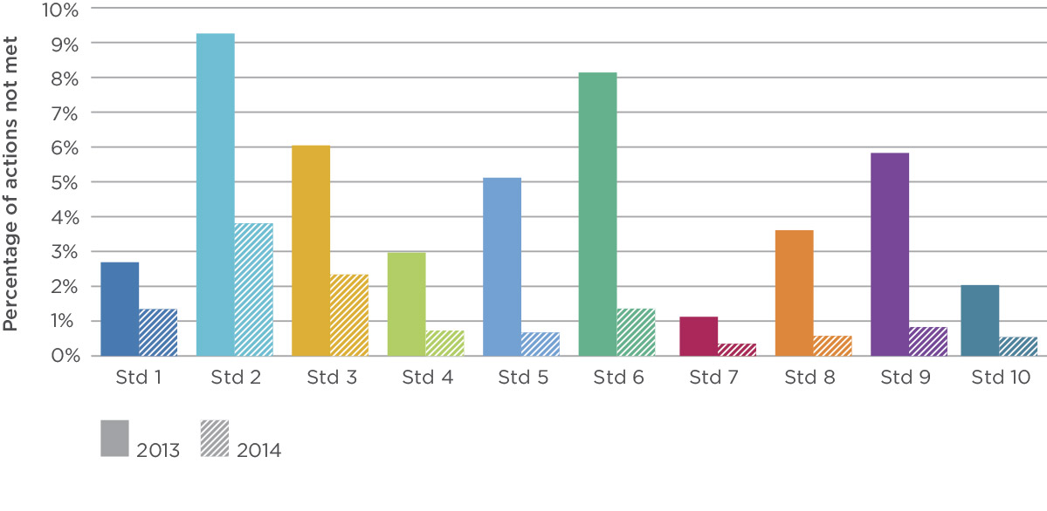

Source: ACSQHC, 2015.

Figure 3: Percentage of developmental actions not met by hospitals and day procedure services in 2013 and 2014

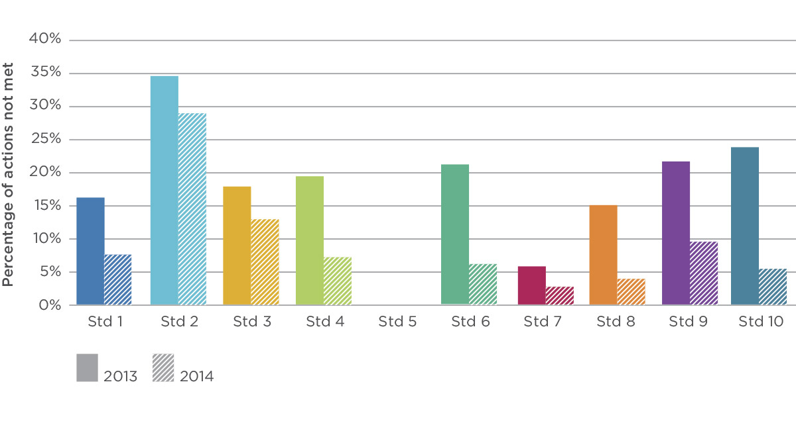

Source: ACSQHC, 2015.

Note: There are no developmental actions for NSQHS Standard 5.

Each year, more health services are putting systems in place to ensure patient safety

### NSQHS Standards have had an impact on processes and outcomes

Evaluating the impact of the NSQHS Standards is not straightforward. While the Commission sets the NSQHS Standards, they are put in place by health services locally, so it is often at that local level that changes can be seen most directly. Measuring the impact of the NSQHS Standards and improvements nationally will take longer.

The Commission is examining the impact of the introduction of the NSQHS Standards nationally; this evaluation is due to be finished in December 2015. The evaluation will look at whether the NSQHS Standards have made a difference to safety and quality for patients and how to measure the impact in the future. Data from many different sources and research methods are being used to assess what changes have occurred in the processes and outcomes of patient care since the implementation of the NSQHS Standards.

Early indications from the evaluation indicate that the implementation of the NSQHS Standards is improving outcomes for patients, and the culture of health services around patient safety. For example, outcomes for patients have improved since the introduction of systems to better recognise and respond to clinical deterioration (NSQHS Standard 9). From 2010 to 2013 in NSW the rate of cardiac arrests fell 38%, with an estimated 800 fewer deaths in this period.6 Vital signs 2015 highlights a number of areas where systems associated with the NSQHS Standards are improving safety and quality of care, and outcomes for patients. These include control of infections (page 12), prescribing of antibiotics (page 40), and communication between healthcare providers and patients (page 68).

Box 2: Implementing systems to partner with consumers is challenging for some health services

NSQHS Standard 2: Partnering with Consumers aims to create a health service that is responsive to patient, carer and consumer needs. Delivering care that is based on partnerships benefits consumers, healthcare providers and organisations. Evidence is growing of a link between effective partnerships, good consumer experiences and high-quality health care.4

The Commission has received ongoing feedback that some health services have found the implementation of systems to meet Standard 2 challenging. This feedback is supported by the results of accreditation.

In 2014, 1072 health services were assessed to Standard 2; with a total of 19 314 individual actions assessed. Across all of these actions, 78% were met at the first assessment and 19% were not. While this is an improvement on 2013, when 24% of actions were not met,5 Standard 2 continues to have the highest proportion of unmet actions across the NSQHS Standards. Standard 2 also has the highest proportion of developmental actions that do not need to be met to achieve accreditation (73%).

Challenges identified with Standard 2 include:5

* understanding its intent and purpose
* gaining executive and management support and leadership
* the availability of resources for partnering with consumers
* the need for effective strategies for partnering with consumers, particularly across different types of health services
* how to meaningfully involve consumers in decision making in the organisation.

To address these challenges, the Commission produced a report on these issues with strategies for effectively partnering with consumers. The Commission has also developed short fact sheets and case studies that health services can use to develop strategies to meet the requirements of Standard 2.

Source: Australian Commission on Safety and Quality in Health Care, National Safety and Quality Health Service Standard 2: Partnering with Consumers – embedding partnerships in health care, 2014.

In addition to improved outcomes for patients, the introduction of the NSQHS Standards has improved the way health services think about safety and quality so that it is part of every activity, every day, for everyone. The Commission has conducted a number of focus groups with healthcare providers and managers about safety and quality and the NSQHS Standards. These indicate that, while the process of implementing systems to meet the NSQHS Standards has sometimes been challenging, it is recognised as worthwhile and produced positive outcomes for organisations (Box 3). These focus groups have also helped to identify areas where more work may be needed to support the use of the NSQHS Standards as a framework for quality improvement.

By December 2015, all hospitals and day procedure services will have been assessed to the NSQHS Standards

### Other organisations are using the NSQHS Standards

Only hospitals and day procedure services have to be assessed to the NSQHS Standards to be accredited; however, many other types of health-related organisations have begun using them as a framework for quality improvement. This is another indicator that the NSQHS Standards are seen as a positive influence on the health system.

The Commission is working with the Royal Flying Doctor Service, South Australian Ambulance Services, the Australian Dental Association and a wide variety of community health services across the country interpreting and adapting the NSQHS Standards for their use. Already, more than 1300 private dental practices have completed or enrolled in an accreditation program and 43 community services have been assessed. The Commission has also been working with the NSW Ministry of Health on the accreditation of multi-purpose services, which are small rural health services that provide a mix of acute, community and residential aged care. This work may enable the application of NSQHS Standards more effectively across all care settings.

Box 3: Nurses and managers give feedback about the NSQHS Standards

“Preparing for accreditation has been a real growth exercise, we enjoyed it because we were able to have ideas about new quality improvements.”

“The fact is that safety and quality is what we do in everyday life with patient care, but [they are often seen as] two different [things], the national standards and patient care. It means the same thing.”

“It has been an arduous process, but [it is] exactly what we should be doing to promote safety.”

“The standards make us realise what we do really well.”

“The feedback we’ve had about the standards is ‘This is hard, but it’s good!’ So how can we try to embed what we need to embed so that it becomes part of practice all the time, part of the systems, without you feeling like you are filling out a piece of paper rather than caring for your patients.”

Source: ACSQHC, 2015.

### Where to next?

As well as supporting health services to implement the NSQHS Standards, the Commission is responsible for maintaining them. In this role, the Commission has started reviewing the NSQHS Standards, and it is anticipated that health services will need to be assessed to version 2 from 2017/18.

The review involves examining what has worked well, what has not, simplifying the NSQHS Standards, removing any duplication and importantly, looking for gaps.

Since the first set of NSQHS Standards were finalised in 2011, new evidence has been published, and the Commission has undertaken additional work that identifies a number of areas with additional risks of harm to patients. Some of these are discussed in Vital signs 2015, including the issues regarding safety and quality for Aboriginal and Torres Strait Islander people (page 49), people with cognitive impairment (page 54) or mental illness (page 26), and people at the end of life (page 62). The Commission will look at how to reflect these and other potential new safety and quality issues in the next version of the NSQHS Standards.

### What the Commission will do

* Use the information from accredited hospitals and day procedure services to learn more about the safety and quality of care being provided across Australia, and how this can be further improved.
* Guide and support to hospitals, day procedure services, dental practices, community and other services that are using the NSQHS Standards in changing their systems and improving care.
* Work with a range of different types of services to help them best use the NSQHS Standards to improve the care they provide.
* Review the NSQHS Standards and develop a second version.

## Multi-resistant Escherichia coli, Klebsiella and related species: action is being taken to contain the spread of highly resistant bacteria so that I am safe in hospital

Escherichia coli (E. coli) is a bacterium everyone carries in their gastrointestinal tract. E. coli is:

* the most common cause of urinary tract and kidney infections
* the most frequent cause of blood poisoning (septicaemia)
* associated with intra-abdominal infections such as peritonitis, and with skin and soft tissue infections
* a cause of meningitis in neonates
* one of the leading causes of foodborne infections worldwide.7

Klebsiella species cause similar infections to E. coli, but the species are less frequent in the community and more common in vulnerable hospital patients such as pre-term babies, patients with immune and system disorders or diabetes, and those receiving complex medical care.

Like other bacteria in healthcare settings, E. coli and Klebsiella can spread easily between patients, leading to outbreaks. However, of particular concern is their ability to evolve and become resistant to multiple classes of antibiotics, including those normally used as a last line of defence, which has become evident in recent years. These are a type of ‘superbug’, which is the common term for bacteria that are resistant to many antibiotic classes.

Carbapenem antibiotics, such as meropenem, are examples of important last-line antibiotics used to treat infections caused by strains of E. coli and Klebsiella that are resistant to many other classes of antibiotics. When these bacteria become resistant to carbapenems, healthcare providers face a treatment problem and have to use combinations of antibiotics that are potentially toxic. Even when these combinations of antibiotics are used, the risk of dying greatly increases for serious infections.

Some countries are seeing increasing numbers of E. coli and Klebsiella strains that are resistant to carbapenems.7, 8, 9 These strains produce enzymes that break down carbapenems, called carbapenemases. Carbapenemases have been found not just in E. coli and Klebsiella species, but also in other members of the same bacterial family of Enterobacteriaceae and, collectively, they are known as carbapenem-resistant Enterobacteriaceae (CRE).

CRE carries genes that also have the capacity to spread among other bacteria, so not only are the bacteria potentially capable of spread, so are their resistance genes. The experiences of some countries shows that containing this spread is vital to protect the health of the population.

E. coli is a common infection-causing bacterium that can evolve and become resistant to multiple classes of antibiotics

### How common are CRE in Australia?

Data collected by the Australian Group on Antimicrobial Resistance has identified that CRE are causing occasional infections in Australia. Figure 4 shows that most E. coli and Klebsiella cases have occurred in hospitals, but some are now being found in the community. There have even been reported outbreaks in hospitals of CRE.10, 11, 12

While the proportion of Klebsiella species that are CRE is very low in Australia (less than 0.5%) compared with the United States (11% for Klebsiella and 2% for E. coli in 20138) and some European countries,9 their presence provides an important marker of growing antimicrobial resistance. It is clear that CRE have great capacity to become established within the Australian population.

### How will Australia monitor CRE?

Until now, there have been no formal mechanisms to collect and report on CRE across Australia. With funding support from the Australian Government Department of Health, the Commission is establishing a National Alert System for Critical Antimicrobial Resistances (NASCAR). Under NASCAR:

* diagnostic laboratories across Australia will be given guidelines for detecting CRE, and putting in place screening prevention programs for potential carriers
* suspected CRE strains will be referred to specialised laboratories to detect resistance genes
* strains that are confirmed as CRE will be entered into a national database, and an automatic alert will be generated for those who need to respond.

These alerts will provide an up-to-date picture of evolving resistance across all states and territories, and assist in putting in place a nationally coordinated response (Figure 5).

Figure 4: Evolution of CRE in Australia from 2004 to 2014

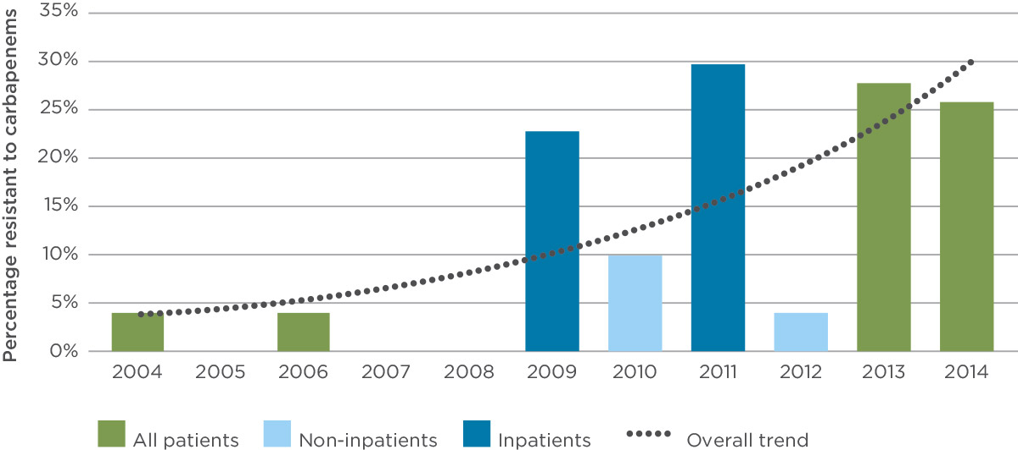

Source: Australian Group on Antimicrobial Resistance, 2015.

Note: No surveys were conducted in 2005 and 2007. The percentage of CRE in 2008 was zero. Non-inpatients includes outpatients and emergency department attendances.

When E. coli becomes resistant to carbapenems, doctors need to use combinations of antibiotics that can be toxic, and patients have a much greater risk of dying

Figure 5: Information flow under NASCAR

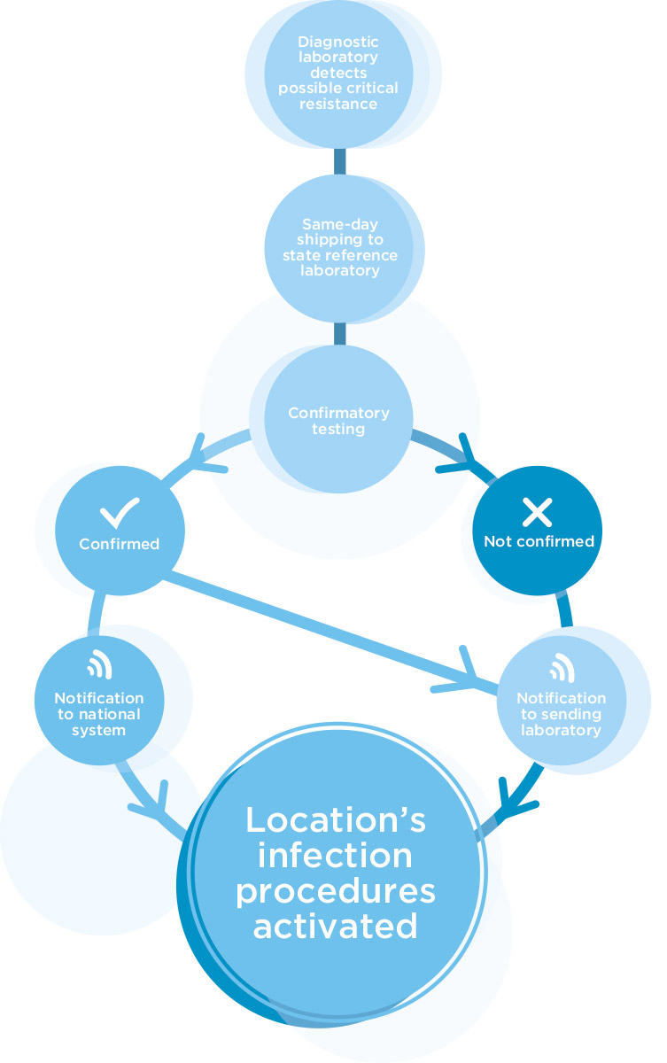

Source: ACSQHC, 2015.

Most E. coli and Klebsiella species occur in hospitals, but some are now being found in the community

### What actions are being taken to contain CRE?

The seriousness of CRE has been recognised by all Australian governments. The Australian, state and territory governments are working with doctors, nurses, infection control practitioners and hospitals on a national approach to contain their spread.13 This approach will involve:

* strengthening infection control procedures
* implementing screening for those at high risk
* bolstering laboratory procedures to ensure early detection
* improving communication between sectors of the healthcare system
* advancing the appropriate use and management of antibiotics in hospitals and the community.

This work will occur in the context of Australia’s first national antimicrobial resistance strategy, which was released in 2015.14

Although the proportion of Klebsiella species that are CRE is low, it has great capacity to become established in Australia

### Where to next?

Coordinated national action will contribute to a greater understanding of the spread and rapid evolution of CRE, not only in the hospital setting but also in the community. Because of the importance of this issue, everyone across the health system has a role to play in containing the spread of CRE. These roles include:

* consumers ensuring that they correctly follow prescriptions when taking antibiotics
* healthcare providers implementing treatment and infection control procedures in line with new guidelines about the management of CRE and use of antibiotics
* hospitals reviewing their infection control procedures in the light of up-to-date surveillance data through NASCAR and new national surveillance arrangements
* laboratories adapting their procedures to ensure early detection of CRE
* state and territory governments developing action plans for hospitals experiencing a CRE outbreak.

A new system is being developed to monitor CRE in Australia

### What the Commission will do

* Implement a fully operational National Alert System for Critical Antimicrobial Resistance by May 2016.
* Develop a national approach to containing CRE that will include developing up-to-date guidelines about the detection and management of CRE.
* Continue to support the safe and appropriate use of antibiotics in health services through the NSQHS Standards.

## Medication safety: systems are in place to make sure my medicines are administered safely

Ensuring hospital patients receive the right medicines, in the right way, at the right time can be challenging. In hospitals, doctors need to prescribe the right medicines, pharmacists need to dispense the right medicines and nurses need to administer them appropriately.

Safe medication management in hospitals requires good communication and coordination to ensure each medicine is right for each patient.

### Standard medication charts can improve safety

The key tool for communicating information about patients’ medicines in hospital is the medication chart. It describes to doctors, nurses and pharmacists the medicines patients should receive and when. In doing so, the chart connects these people to coordinate treatment for patients.

Information that needs to be communicated on the chart includes:

* allergies and previous adverse reactions to medicines
* the medicine’s name
* the dose
* the form, such as whether the medicine is a tablet or syrup
* when the medicine is to be taken.

In the past, charts varied between hospitals. Doctors, nurses and pharmacists using different charts sometimes had trouble ensuring the medication information was correct and complete, resulting in prescribing and dispensing errors.

In 2003, a study found that standardising the medication chart reduced prescribing errors, improved documentation of adverse drug reactions and allowed for simplified education of prescribers using the charts.15 As a result, from 2006 onward, all states and territories agreed to use a standardised medication chart in hospitals.

Based on work in Queensland, the Commission and hospital experts developed, tested and continue to support a standard chart, now called the national inpatient medication chart (NIMC). To ensure the NIMC helps safe prescribing and administration of medicines in hospitals, regular audits of components of the chart are conducted; the most recent was conducted in 2014.16

Audits of the chart inform hospitals and the Commission about how it is being used, and how well it supports prescribing. Information collected helps to understand whether communication between healthcare providers about medicines is complete. Audits also provide an opportunity to assess the quality of the information documented, and help answer questions about issues that affect the safety of medicines administration.

Safe use of medicines requires good communication and coordination

**83%** of patients had allergies recorded on their medication chart

These include:

* Is the writing easy to read?
* Have abbreviations been used that not everyone understands?
* Is any information about the medicine missing?

Audit results also highlight whether any parts of the medication chart need to be revised to improve the safety of prescribing and administration of medicines to patients in hospitals.

The 2014 national audit captured information from more than 18 500 medication charts in almost 400 hospitals.17 The results show that healthcare providers complete some areas of the chart properly, while filling out of other areas has not improved since the last audit in 2012.

### Documentation of adverse reactions or allergies to medicines

Failure to document a patient’s adverse reactions or allergies to medicines can result in serious harm to a patient. Prescribers, nurses, pharmacists and others need this information to prevent further reactions.

In 2014, the national audit results showed that 83% of patients had information about previous allergies documented on their medication chart.17 This is an improvement on the previous audit, when 79% had documented information (Figure 6).18

However, ensuring prescribers review this information remains a challenge. The 2014 audit results showed that 11% of patients with allergies were prescribed a similar medicine again.17

A medication chart is the key tool for communicating information about a patient’s medicines to doctors, nurses and pharmacists

**11%** of patients with allergies recorded were prescribed a similar medicine again

### Standard terms and abbreviations

Some prescriptions still contain terms and abbreviations that not everybody understands.

In the recent audit, 20% of the prescriptions assessed contained terms or abbreviations that were inconsistent with those recommended nationally.19 This is consistent with the result obtained in 201218 and highlights a need for more work to ensure prescriptions can be easily understood with minimal risk of misinterpretation (Figure 6).

**18 500** medication charts were reviewed as part of the 2014 national audit

### Ceasing a prescription appropriately

The way medicines are ceased also needs further improvement. To stop a medicine safely, four pieces of written information are needed to clearly communicate a medicine is no longer required and should not be administered:

* One line should be drawn through the medicine order and another through the administration section.
* The date on which the medicine must be stopped should be documented.
* The doctor responsible for stopping the medicine should include their initials.
* The reason the medicine is being changed or ceased should be included.20

Of the relevant prescriptions reviewed in the 2014 audit, only 38% had documentation to clearly show that the medicines had been stopped.17 This is similar to the results for 2012 (Figure 6).18

Figure 6: Documentation of information on the national inpatient medication chart in 2012–14

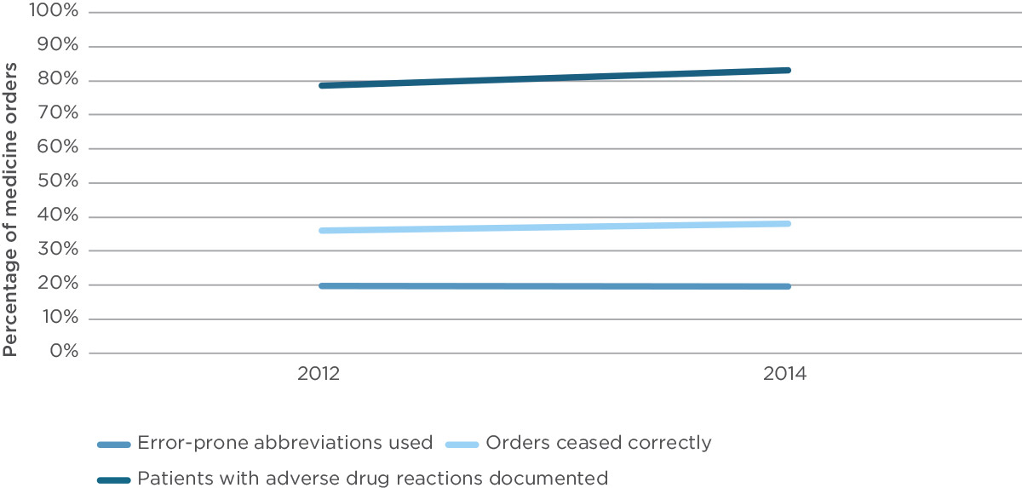

Source: Australian Commission on Safety and Quality in Health Care, National inpatient medication chart 2014 national audit report, 2014.

Some of the safety issues identified in the audit may be resolved by using electronic medication systems

### Where to next?

To learn from the 2014 audit, the results will be made available to all hospitals that want to undertake their own audits to see how they compare with the rest of the country. It may help them identify where they might need to focus their efforts to improve prescribing and administering. The Commission will also work with states, territories and the private hospital sector to review the results from the 2014 audit, and develop a plan of action for improvement.

In 2015, the Commission is piloting new hospital charts to support safe and efficient prescribing and dispensing of medications for patients on discharge, and to improve the safety of managing insulin administration for diabetic patients in hospital. In each case, an expert group has designed the chart based on experience with existing charts subjected to specialised testing, and they will be piloted in hospitals across Australia before their publication and issue for national use.

The NIMC audit is designed to be used for paper-based medication charts. However, elements of the audit can also be useful when looking at the performance of prescribing in electronic medication management (EMM) systems. There is some evidence that the safety issues seen in the 2014 audit may be resolved by using EMM systems.

States, territories and some private hospital groups are putting in place EMM systems or planning for EMM. Rolling out EMM systems across hospitals is a complex and expensive project, demanding major changes to work practices. Evidence is emerging about how careful implementation of EMM systems can reduce errors and improve the quality use of medicines.21 However, when the introduction of EMM systems is poorly planned and supported, new types of errors can emerge.22 The Commission will provide guidance to help address these potential problems.

### What the Commission will do

* Review the results of the 2014 audit with the states and territories and develop a plan of action to ensure ongoing safe prescribing and administration of medicines.
* Test new hospital charts to ensure they are safe.
* Support health services to introduce EMM systems safely.

## Patient safety in primary care: when I visit a primary care practitioner systems are in place to ensure I receive safe care

Most health care in Australia is provided in primary care settings. Primary care includes health services delivered in the community by healthcare providers, such as general practitioners (GPs), community nurses, dentists, pharmacists, physiotherapists and other allied health providers. More than 80% of the population visits a GP during a year, almost 50% visit a dentist and almost 20% visit an allied health professional.23 Given the size and importance of this sector, it is essential that the care provided is safe and that unnecessary harm associated with the delivery of care is minimised.

The field of patient safety emerged following Australian and international research showing that a large number of harmful, but potentially preventable incidents occur in hospitals.24, 25, 26 A patient safety incident is an event that could have resulted, or did result, in unnecessary harm to a patient. This focus on hospitals was emphasised by high-profile inquiries into incidents at specific hospitals in Australia.27, 28 These origins mean that early patient safety work focussed mostly on issues that were particularly relevant for acute care settings such as hospitals, and less attention has been paid to patient safety in primary care.

### The types of risks in primary care are different

Providing health care in primary care settings is different to that in hospitals, and this changes the types of risks and patient safety incidents.29, 30, 31, 32

Primary care is part of a complex network. To manage their health care, a patient might need to see a GP, a pharmacist or a specialist, or have a pathology test. In a hospital, this might all occur in one building. In primary care, a patient will visit different people in different places. This means that communication between these healthcare providers and sites is particularly important.

There are different types of patient safety risks in primary care compared to hospitals

The types of treatments offered in primary care tend to be less invasive than those provided in hospitals. While this may limit the opportunities for harm from the provision of treatment, the volume of treatments means the cumulative risk of harm across the population is still high.

The contribution of patients, their families and carers significantly affects the outcomes of care in all healthcare settings, and is particularly important in primary care. This means that, while risks are associated with delivering primary care services, the actions and knowledge of patients, families and carers can support safe and high-quality care.

Compared to hospitals, primary care tends to be delivered in much smaller organisations with limited staff numbers. While some larger practices might have a practice manager, in many cases the doctors, nurses, allied health providers, pathologists, imaging providers and clerical staff are the only resources available to support patient safety – in addition to their existing roles.

>80% of the population visit a GP during a year

### Patient safety incidents in primary care

Information about patient safety incidents in Australia can come from a variety of sources, including research studies, complaints made to complaints commissioners in each state and territory, and alerts about problems with medications from organisations such as the Therapeutic Goods Administration. However, Australia does not have a system for routinely collecting information about things that go wrong in primary care.

In the United Kingdom, the National Reporting and Learning System (NRLS) is a central database of reports from all health services in the National Health Service for England and Wales. Since the NRLS was set up in 2003, more than 4 million reports about patient safety incidents have been submitted.33

The NRLS includes reports about primary care organisations, including general practices, community pharmacies and community dentists. The similarities between the primary care systems in the United Kingdom and Australia mean that the information from the NRLS can provide some direction about the likely nature of patients’ safety incidents in Australia.

For the 12 months from October 2013, 4590 patient safety incidents in general practice were reported to the NRLS. The most common type of patient safety incident related to providing care and ongoing patient monitoring, followed by medication-related incidents (Figure 7). These two groups comprised almost half of reported incidents (44%). For community dentists, the pattern was different, with 48% of 897 reported incidents of providing care and ongoing monitoring, treatments and procedures, and documentation of information (Figure 8). For community pharmacies, almost all of the 13 906 reported incidents (97%) related to medication.

The most common types of patient safety incidents in general practice relate to the way in which care is provided and the monitoring of patients

Figure 7: Types of patient safety incidents in general practice in England and Wales from October 2013 to September 2014

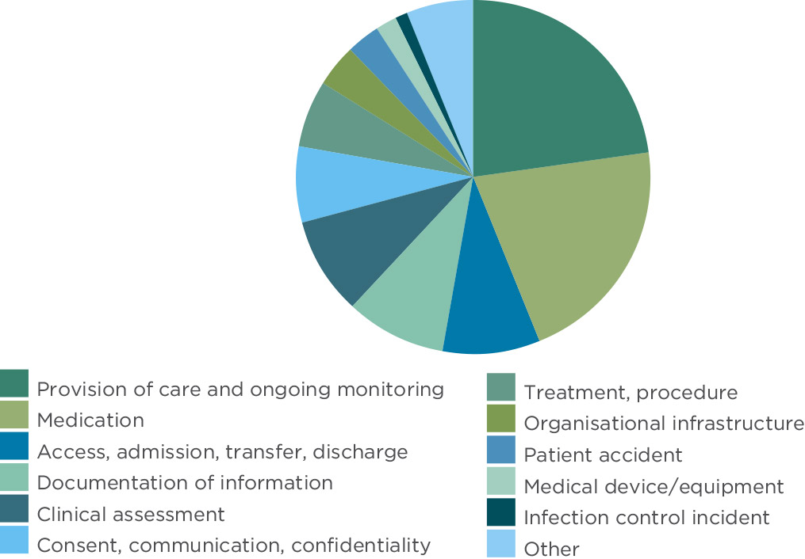

Source: National Reporting and Learning System, Quarterly Data Summaries, [www.nrls.nhs.uk/resources/collections/quarterly-data-summaries/?entryid45=135410](http://www.nrls.nhs.uk/resources/collections/quarterly-data-summaries/?entryid45=135410).

Figure 8: Types of patient safety incidents in community dentistry in England and Wales from October 2013 to September 2014

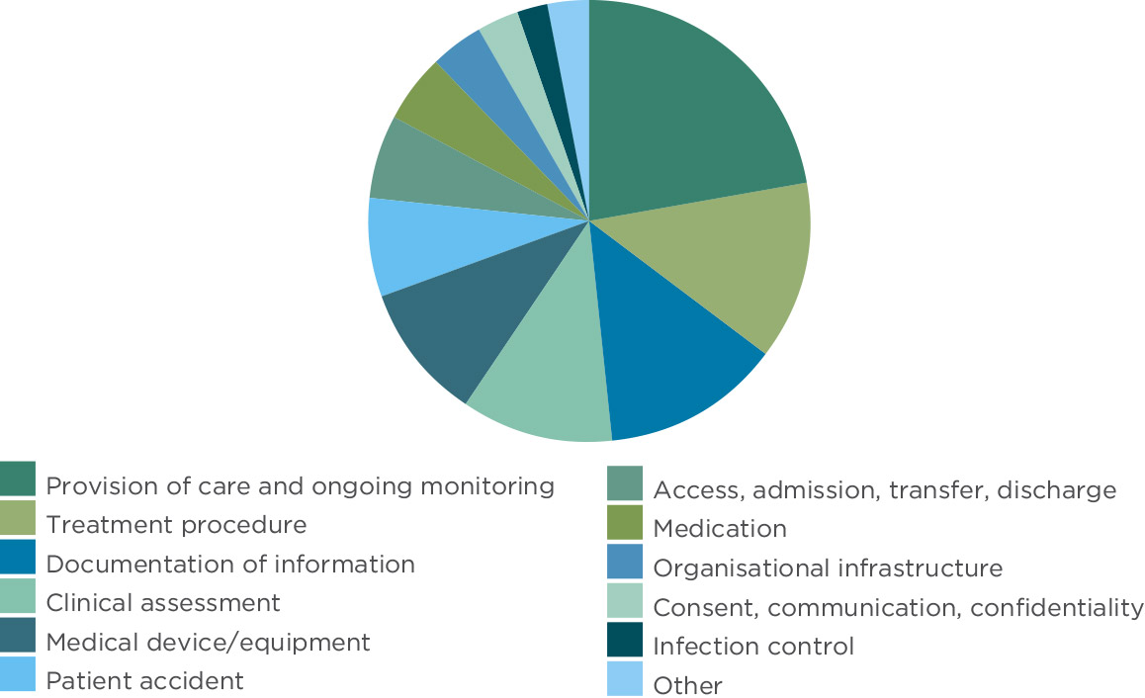

Source: National Reporting and Learning System, Quarterly Data Summaries, [www.nrls.nhs.uk/resources/collections/quarterly-data-summaries/?entryid45=135410](http://www.nrls.nhs.uk/resources/collections/quarterly-data-summaries/?entryid45=135410).

There are similarities between the types of patient safety incidents identified in the United Kingdom and research results about patient safety incidents in general practice in Australia. One of the largest studies of patient safety in primary care in Australia identified that the most common types of incidents related to the processes of health care.34 These types of incidents comprised about 70% of the total and included incidents relating to:

* the systems in place within the practice, such as the way in which information is filed or the processes for recalling patients for follow-up
* investigations such as pathology and diagnostic imaging, including the processes for reporting on the results of investigations and managing these reports
* medications, including incidents associated with writing prescriptions and dispensing
* other treatments such as immunisations
* communication, including between hospitals and general practices.

The other common type of incidents relate to the knowledge and skills of the healthcare provider. These include incidents associated with diagnosis and managing patient care, including in settings outside general practice. Box 4 provides examples of these two different types of patient safety incidents.

**70%** of patient safety incidents in general practice relate to the processes of health care

Box 4: Examples of patient safety incidents in general practice

**An incident associated with the processes of health care**

A patient with schizophrenia and epilepsy regularly attended a general practice. The patient used different surnames on different occasions; these names were the surnames of each of the patient’s divorced parents. The practice held two records for the patient, one under each of the patient’s names, and these records contained two different medication lists. Based on one medication list, the patient was prescribed a new medication. This new medication caused the patient to become lethargic and drowsy because of an interaction with a medication that was on the other list.

**An incident associated with the knowledge and skills of the healthcare provider**

A patient with severe depression was referred by their GP to the regional psychiatric hospital. A week later the patient returned to the GP for follow-up after discharge. The patient reported to the GP that they had complained of increasing pain in the chest after admission to the psychiatric unit. After some delay the patient was sent for a chest x-ray without actually being physically examined. The chest x-ray showed normal findings. After another three days the patient was examined by a doctor and found to have a painful rash caused by shingles. The patient was sent home with painkillers, but did not receive the correct medication to treat the shingles.

Source: Makeham M et al. Patient safety events reported in general practice: a taxonomy. Quality and Safety in Health Care. 2008; 17: 53–57.

The Royal Australian College of General Practitioners has standards for general practices

### Standards can help to ensure that primary care is safe

While the NSQHS Standards are only mandatory for hospitals and day procedure services, they are also being used in primary care settings such as dentists and community health services. In addition, standards and accreditation systems exist specifically for primary care services. For example, the Royal Australian College of General Practitioners (RACGP) has developed a set of standards for general practices, and there are also standards that apply in other community-based services, such as drug and alcohol services, community rehabilitation programs and early childhood services. There are also standards that apply to services delivered in the home.

Requirements in these standards and accreditation schemes vary. The requirements in the standards for general practices cover many of the risk areas that have been identified in patient safety incidents, including diagnosis and management of health problems, systems for following up test results and documentation of information.35 These and other sets of standards also include requirements about working with patients and clients to provide them with the right care and having effective management systems in place.

**30%** of patient safety incidents in general practice relate to the clinician’s knowledge and skills

### Where to next?

While different sets of standards apply across a range of primary care settings, they do not all cover the key patient safety issues that exist in this environment. In addition, it is increasingly common for primary care services to become part of integrated healthcare services, such as multipurpose clinics where general practices are co-located with allied health providers, pharmacists and specialists. One or more of these professional groups may be implementing standards and be part of an accreditation process. However, these may be unrelated or duplicative, or may not apply to the whole of the practice. This can be an added burden for the health service.

One way to address this would be to have a single set of safety and quality standards and accreditation processes that could be applied in different settings, including primary care. This could reduce duplication, help streamline processes across acute and primary care, and make it easier for patients to understand the safety and quality of their care in different settings. As part of the review of the NSQHS Standards, the Commission is examining the language and actions to see how they apply in primary care.

The Commission is also working with the RACGP to develop a governance and reporting framework for general practice accreditation in Australia. The aim is to:

* identify problems general practices have with the existing accreditation scheme
* use accreditation to maximise the safety and quality of patient care
* coordinate general practice accreditation nationally.

### What the Commission will do

* Work with the RACGP to examine and improve accreditation processes in general practice.
* Examine how the NSQHS Standards could be used as a framework for patient safety improvement in primary care settings.

## Safety and quality in mental health: mental health standards ensure I receive safe care

The NSQHS Standards and the National Standards for Mental Health Services both apply in mental health

Two sets of standards can apply to mental health services: the NSQHS Standards (page 6) and the National Standards for Mental Health Services.36 In 2013/14, the Commission collaborated with the National Mental Health Commission on a study to look at how health services were implementing these two sets of standards.37

More than 500 people participated in the study, either through completing an online survey or attending a focus group. The Commission talked to people with lived experience of mental health issues about the services they used when they had mental or physical health problems. People who provided services in a range of roles in the public, private and community managed (or NGO) sectors were also asked about their experience of implementing the standards, the factors that enabled their work, and the barriers and challenges they faced.

A key question for the people who used health services was ‘Do you feel safe when you access health services?’ More than half of the people who used services reported that they did feel safe. People were asked to describe the things that made them feel safe and the things that made them feel unsafe.

### What made people feel safe

When people talked about the elements that made them feel safe, the key factors they identified related to how mental health service providers interacted with them.

These factors included:

* staff listening to them
* a sense of engagement and acceptance
* confidentiality being respected
* a calm environment.

People said a calm environment meant more than simply the physical environment, though they noted the importance of access to quiet and privacy. Environment was reported to include the sense of interpersonal safety created by staff being present, available and engaged. For some service users, this was most visibly created by senior staff.

### What made people feel unsafe

When participants talked about what made them feel unsafe, they identified factors including the behaviour of the other people in the unit, the physical environment and the practices of the staff on the wards.

The way that healthcare providers interact with service users influences whether service users feel safe

People reported that they understood that, due to their symptoms, other inpatients may behave unpredictably. However, they identified the factors that the health service could modify to reduce the risks, including staff being consistently present on the ward.

One strategy that was suggested was greater involvement of people with lived experience in planning mental health services.

People recognised that the ‘bricks and mortar’ can’t always be changed easily, but potential problems can be avoided if services are tailored to meet the needs of individuals.

A flashpoint for many service users was the emergency department. For many people, particularly outside large metropolitan areas, the emergency department is the point of entry to receive mental health services. Yet many service users reported that emergency departments are not ideal environments when users are experiencing mental distress. They are typically noisy, crowded and brightly lit, which creates sensory overload that can lead to increased agitation.

The negative experiences people reported when they accessed emergency departments for help with mental health problems were mirrored by their experiences when they presented with physical health problems.

“Mental health wards often don’t feel safe – it is just a fact of life because of the unpredictable behaviours of people who are unwell. Patients are up and about and bored out of their brains. People are pacing up and down. The staff separate themselves from the patients behind glass screens.”   
Service user

“The level of experience of the staff working on a ward: the more experienced the staff the greater feeling of safety.”   
Service user

The next version of the NSQHS Standards will address the safety needs of people who live with mental illness

### Safe and effective care of physical problems for people with mental health issues

Many people reported that they experienced poor health care for physical problems once their mental health history was known by clinicians. This occurred most frequently in emergency departments.

The willingness of health services to tailor their service delivery to help people with complex needs was reported to be variable. One carer reported that his mother found the long periods in the waiting room at their local physical health centre worsened her mental health symptoms, but requests to modify the system – for instance, by allowing her to wait outside and sending a text when staff were ready to see her – were rejected by the service.

This complexity extended to broader recognition of the impact of physical health problems on people’s mental health.

When service users were asked how best the two sets of national standards could address these issues, responses were remarkably consistent, emphasising the need for treatment of the whole person, rather than separating the physical and mental illnesses.

### What is being done?

Service users and service providers reported innovative partnerships in which they were collaborating on service planning and evaluation. Representation is occurring at different levels, with some service users sitting on boards and other organisations developing pathways to allow service users to communicate directly with executives.

Peak bodies representing community groups have published guidelines on how mental health services can better respond to their populations.38, 39

The Royal Australian and New Zealand College of Psychiatrists has also called for psychiatrists to take a leadership role in ensuring greater cooperation between healthcare professionals providing both physical and mental health care, and greater focus on the views of people receiving care.40

The National Mental Health Commission reviewed mental health services in Australia on behalf of the Australian Government, and called for ‘greater consistency in access to services which meet safety and quality standards’,41 highlighting that the level of care people receive should not be an accidental consequence of their postcode or the individual service providers they encounter. Mental Health Commissions have been established in Western Australia, New South Wales and Queensland. Victoria has created the first specific Mental Health Complaints Commission.

“Lack of safety often arises in ED [emergency departments] and hospitals generally for a number of reasons. First, they are geared towards perceiving need in a physical way – a need to see blood and damage – before prioritising treatment for someone. This gives rise to subjective admission criteria. Second, stigma around mental health issues results in consumers and carers being treated differently. Third, security guards do not have training in how to deal with aggressive behaviour and, even if they have been given training, the training is often not appropriate.”   
Service user

“… failure to identify liver problems because the symptoms were attributed to mental health issues, and no coordination between medications for physical and psychological illnesses, with the medication for the psychological condition being withdrawn without any consultation.”   
Service user

“The safety of mental health services could be improved if people with lived experience were involved in the design of facilities and determining how services are delivered. People without such experience are not aware of the triggers that can cause a person to feel unsafe. For example, a lack of safety can be generated by being observed all the time.”   
Service user

“Clinicians often do not deal with how a consumer’s physical health may affect the consumer’s psychological health. For example, a cancer diagnosis means the consumer is likely to suffer added stress, which could exacerbate existing psychological conditions. Clinicians do not have appropriate conversations with either the consumer or carer about how to deal with the impact of physical conditions.”   
Service user

“The division between ‘health’ and ‘mental health’ services often leads to mental health people being treated as second-class citizens. There is a need for improved integration of services: a mandatory standard that integrates physical and mental health standards into one document.”   
Service user

### Where to next?

The Commission is developing version 2 of the NSQHS Standards. Building on what was learned in the study of the NSQHS Standards and the National Standards for Mental Health Services, and ongoing consultation with service users and service providers, new elements are being incorporated into the standards to specifically address the safety and quality issues that people who live with mental illness experience when they access health care.

Version 2 of the NSQHS Standards will address collaboration between service users and service providers on the direct delivery of care. This includes developing comprehensive care plans, and involving service users, carers and other nominated support people at every stage of the decision-making process. The NSQHS Standards will also address comprehensive screening and assessment of both physical and mental health problems for all people accessing health care. These assessments will be accompanied by improved systems to support staff in recognising deterioration early and intervening effectively.

### What the Commission will do

* Introduce new elements in version 2 of the NSQHS Standards that address specific gaps in safety when people with mental health issues access health care.
* Develop resources to support health service organisations to implement these new requirements.
* Undertake a scoping study about medication safety in mental health to understand the safety issues in this area.

## eHealth: systems are in place allow providers to share my health information safely

Clinical information about a person’s health care can be found in a variety of places, including both electronic and paper-based records. These clinical records are typically managed separately by a range of healthcare providers, such as GPs, pharmacists and hospitals. The records of any one health provider are rarely shared with the patient or with other healthcare providers.

This can be a problem when people need to see more than one healthcare provider. According to the Australian Bureau of Statistics about one in six people over the age of 15 see three or more healthcare providers for the same condition.42 This is more common for women than men, for people who have a long-term health condition, and for older people (Figure 9). In addition, it is estimated that one-quarter of the population have more than one chronic condition,43 increasing the likelihood that they will need to see more than one healthcare provider.

### It is important that information is shared when people see more than one healthcare provider

When people see more than one healthcare provider for the same condition, it is important that providers have information and it is available from one healthcare event to another.44 This information needs to include details of a person’s medical condition, as well as information about their healthcare preferences and values. This information about preferences is important for bridging separate healthcare events and ensuring that health services respond to needs.44

However, it is known that important information is not always shared. Older people report problems such as test results and records not being available at appointments, duplicate tests being ordered, specialists not being informed about their medical history, and regular doctors not being informed about hospitalisations (Figure 10).45 Other problems include patients receiving conflicting information from different doctors, GPs not being involved in discussions with hospital doctors about plans when their patients leave hospital, and GPs seeing patients who had been hospitalised before they received any information from the hospital.46

These types of events have an impact on care, and 14% of Australians who saw three or more healthcare providers for the same condition reported that lack of communication between healthcare providers caused issues.42 These issues can include spending more time in the emergency department or being readmitted to hospital.47 People with long-term health conditions and those living in regional and remote areas were more likely to report issues caused by a lack of communication between providers.42

When people see more than one healthcare provider for the same condition, it is important that information is shared

Figure 9: People who see three or more healthcare providers for the same condition by age group

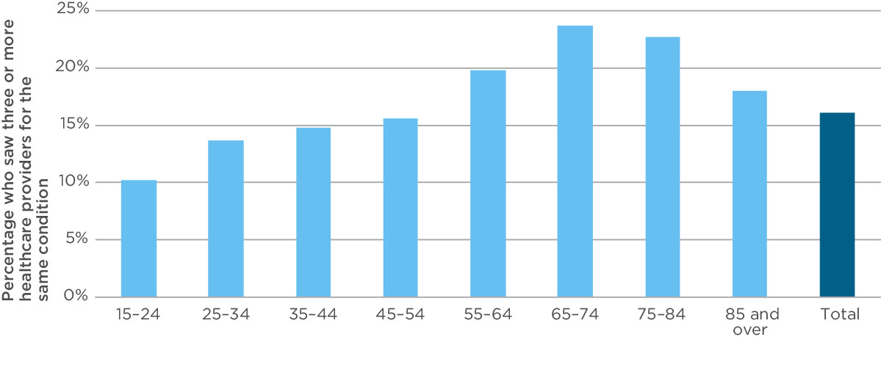

Source: Australian Bureau of Statistics, Patient Experiences in Australia: Summary of Findings, 2013–14, 2014.

eHealth can help to share information between healthcare providers

Figure 10: Experiences of gaps in continuity of information, by country

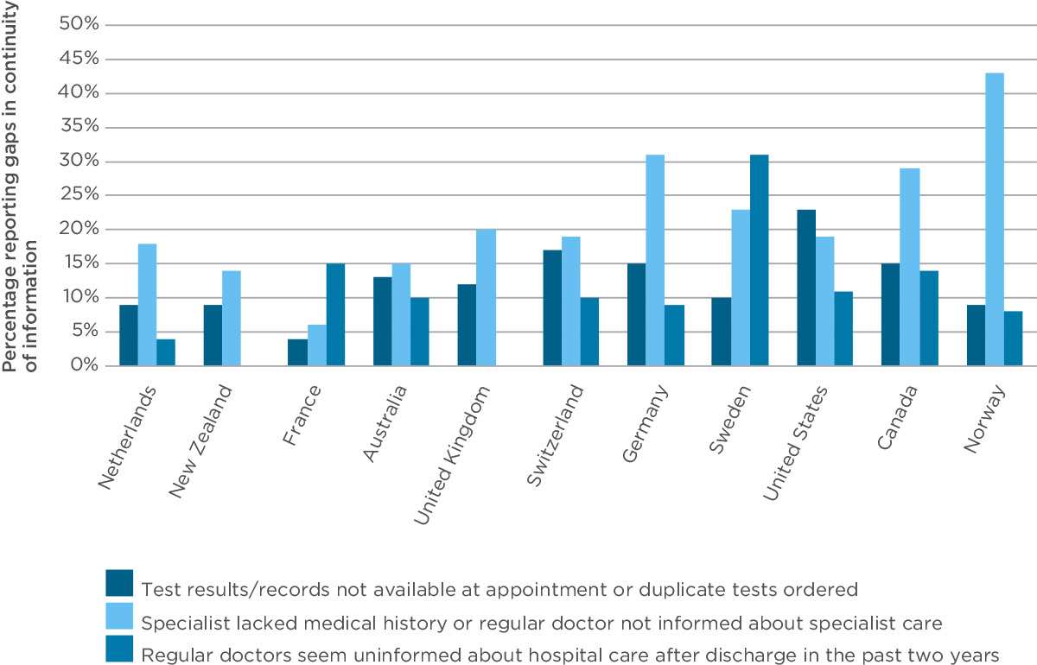

Source: Osborn R et al. International survey of older adults finds shortcomings in access, coordination and patient-centered care. Health Affairs 2014; 33: 2247–2255.

Note: Data about regular doctor seeming uninformed about hospital care were omitted for New Zealand and the United Kingdom because of small sample sizes.

**1 in 6** people over the age of 15 sees three or more healthcare providers for the same condition

Using eHealth records means people can be more involved in their own care

### eHealth can help to address these problems

The Australian Government’s personally controlled electronic health record system allows people to view and manage summaries of their own health information. This eHealth record system does not replace other clinical records. Rather, it provides an avenue through which people can access their personal health information, and can provide consent to share that information with different healthcare providers.

A typical eHealth record can contain information such as:

* discharge summaries from hospital
* electronic referrals (eReferrals) from GPs to specialists
* medicine information, including a medicines list
* laboratory and imaging results.

The eHealth record has been available since July 2012, and has been an opt-in system for both patients and healthcare providers. A number of organisations have roles in the system: the Australian Government Department of Health operates it, the National E-Health Transition Authority (NEHTA) develops specifications for the system and reviews risks and issues, and the Commission monitors and works to improve its clinical safety.

### How does eHealth improve the safety of health care?

Electronic health records provide a mechanism for transferring information between different healthcare providers. The eHealth record does not replace existing health records, but is a source of additional information that may be otherwise unavailable, particularly at transitions of care (page 68). It is intended to improve the continuity and safety of health care as people move through the health system and receive care from different providers. It is designed to ensure people receive better, more efficient care. Box 5 provides an example of how the eHealth record can be used to improve the quality and safety of care.

**1/4** of the population have more than one chronic condition

The ‘personally controlled’ aspect of the system is also an important contributor to improved safety. The eHealth record provides opportunities for people to be involved in their own health care, and to manage how their information is made available to different healthcare providers. Evidence shows that people have better health outcomes when they are more involved in their own care.48 Box 6 provides information about how people can use the eHealth record safely.

Box 5: Donna’s story – how the eHealth record can improve the safety and quality of health care

Donna is 52 years-old and has a number of chronic health conditions. She has registered for an eHealth record and uses it to support her health care:

* Her GP regularly uploads a new summary of her health care (a document called a shared health summary) when major things change in Donna’s health care, such as changes to her medications.
* Donna requires regular hospital admissions to treat one of her health conditions. The healthcare providers at the hospital access Donna’s eHealth record so that she does not have to remember the details of her past medical care, or current medications and diagnoses, and the hospital clinicians can provide the most effective care.
* Donna also enters her own information into her eHealth record. She notes her symptoms in the personal notes section of her eHealth record, and records her next appointment with her healthcare providers. If required, she can also change her emergency contact details.

Donna likes having an eHealth record because she can review her own health information. She knows that if she forgets a particular detail, she can look it up. As she looks at the content regularly, she also knows the type of information that is there, and can suggest that other healthcare providers look at her eHealth record when they treat her. Over time, this will help her eHealth record grow.

Source: Safe Use Guide for Consumers, ACSQHC, 2015.

Box 6: A checklist for managing your eHealth record

* Become familiar with how the eHealth record system works and the meaning of the documents in your eHealth record.
* Check your eHealth record regularly.
* Ask your healthcare providers to use your eHealth record including entering your healthcare information.
* Ask for help if you do not understand the information in your eHealth record, or think the information is wrong.
* Complete your Personal Health Summary and keep it up to date.
* Use your personal notes section to write yourself reminders and keep a record of your health and how you are feeling.
* Appoint a representative if you think you need help using your eHealth record.

You control your eHealth record, but you should think carefully before:

* blocking access to a particular part of your eHealth record
* removing a document from your eHealth record.
* Source: Safe Use Guide for Consumers, ACSQHC, 2015.

### Enhancing the safety of the eHealth record

Expanded use of computerised clinical record systems may help address some critical clinical safety issues that occur too regularly. Legible clinical information that follows people on their journeys between healthcare providers reduces opportunities for harm. However, as evidence and research into eHealth grows, new risks have been identified, and cases of harm have been associated with poorly implemented health information technology programs. Proactive clinical safety monitoring and surveillance of health information technology systems are important in protecting against these risks.

Three layers of governance support the clinical safety of the eHealth record system:

1. **System operator and end users** (patients using the system and healthcare providers) supply information day-to-day monitoring and reporting of potential or actual clinical safety issues.
2. **NEHTA Clinical Safety Unit** provides expert advice to the system operator and users about the mitigation and resolution of clinical safety issues.
3. **The Commission** provides independent oversight, expertise and support to the system operator and NEHTA on clinical safety issues.

The Commission ensures the safety of the eHealth record system using the following strategies:

* establishing and maintaining an advisory group of healthcare providers, consumer representatives and information technology experts, which:
  + monitor the progress and implementation of eHealth records
  + provides advice to the Commission and the Australian Government Department of Health as the system operator
* developing a system to receive, log, analyse and respond to safety incidents notified by healthcare providers and people whose healthcare information is stored in the system
* undertaking clinical safety reviews of the system:
  + to date, the Commission has conducted four clinical safety reviews of the eHealth record system that have targeted early identification of potential safety hazards
  + the reviews have made recommendations to improve the clinical governance of the system and the presentation of information in the eHealth record, typically involving missing or incomplete information
* conducting in-depth incident reviews of identified safety issues –recommendations from these reviews are managed by the expert advisory group
* developing safe use guides for people using the system, including healthcare providers. The purpose of the guides is to:
  + improve awareness about the potential safety benefits and issues around the eHealth record
  + ensure the greatest possible benefit from participation in the system.

**>500** healthcare provider organisations access an eHealth record at least once a week

**>2 million** people had registered for an eHealth record at 31 May 2015

There are systems to make sure that the information in eHealth records is safe

### Where to next?

By May 2015, more than 2 million people had registered for an eHealth record. On average, 538 provider organisations (such as GPs and hospitals) access an eHealth record at least once a week.

The Australian Government has committed $485 million to further develop and implement the system, and the eHealth record will become known as ‘My Health Record’. Starting in July 2016, the Australian Commission for Electronic Health will replace NEHTA. The Australian Government Department of Health has been in charge of operating the eHealth record system since its launch in 2012, but it will pass this responsibility on to the new Commission. While the system is currently ‘opt-in’, a trial will test the safety, quality and improvement in coverage that might come with an opt-out system.

### What the Commission will do

* Continue its involvement in the national implementation of the eHealth record system in partnership with the Australian Government Department of Health and NEHTA.
* Support implementation of a clinical incident management framework to ensure safety within the system.
* Develop two safe-use guides about using the system.

# **02** Will I get the right care?

If the standard of health care is appropriate and safe, other important questions need to be asked.

Sometimes there is agreement about what care people should receive, but this care is not always provided.49 There are many reasons for this gap between the care that should be provided and what happens in practice.

The Commission is working to make sure that everyone gets the right care.

This section provides information about four areas where it is important that people get the right care: using antimicrobials such as antibiotics, managing chronic conditions in general practice, providing care to Indigenous people and providing care to people with cognitive impairment.

Will I get the right care?

**Antimicrobial prescribing:** I get the right care because the health system is tracking how antimicrobials are prescribed in hospitals

**Management of chronic conditions:** if I have a chronic condition, systems in place at my general practice ensure I get the right care

**Aboriginal and Torres Strait Islander health:** my healthcare providers ask if I am Indigenous to improve the care I receive

**Cognitive impairment:** my healthcare providers will try to prevent me from developing delirium and keep me safe if I have dementia

## Antimicrobial prescribing: I get the right care because the health system is tracking how antimicrobials are prescribed in hospitals

Antimicrobials are medicines that are used to treat infections, especially those caused by bacteria and fungi. The most common type of antimicrobials are antibiotics, which are used to treat bacterial infections.

Antimicrobials are essential to modern medicine. Many of the treatments given in hospital, such as joint replacement surgery and cancer chemotherapy, require the use of effective antimicrobials to prevent infections. However, antimicrobials are losing effectiveness because many bacteria have developed ways of becoming resistant to them. The World Health Organization (WHO) has identified antimicrobial resistance as a global challenge to the delivery of effective health care.7

Although antimicrobial resistance is a natural feature of bacterial evolution, the inappropriate use of antimicrobials increases the potential for resistance. Examples of inappropriate care include prescribing:

* antimicrobials for viral infections such as colds and flu, against which they are ineffective
* antimicrobials for longer than necessary after surgery, as a preventative (prophylactic) measure against infection
* broad-spectrum antibiotics that affect a wide range of bacteria when a more specific, narrow-spectrum antibiotic is as effective.

### Measuring how antimicrobials are used

In Australia, it has been reported that up to half of prescriptions for antimicrobials may be inappropriate.50 However, in the past it has been difficult to obtain a complete national picture of how antimicrobials are used and why. This is changing, and work is underway at many levels to track antimicrobial resistance and the use of antimicrobials.

One program is the National Antimicrobial Prescribing Survey (NAPS), an initiative of Melbourne Health and the Doherty Institute, and supported by the Commission.

NAPS collects information on antibiotic prescribing practices from a wide range of public and private hospitals, of different sizes, and from all states and territories.

Antimicrobials are used to treat infections caused by bacteria and fungi

Participating hospitals undertake an annual survey, run over one day or many, depending on their size and resources. The survey has been conducted each year since 2011 using an online survey tool.

In 2014, 248 hospitals – 197 public and 51 private hospitals – participated covering 19 944 antibiotic prescriptions. The overall results were similar to those of the 2013 survey, in which 151 hospitals participated.

The survey focussed on whether antimicrobials were prescribed in accordance with national or locally endorsed guidelines, and whether prescriptions for antimicrobials were appropriate.

### How much prescribing in Australian hospitals is not in accordance with guidelines?

Australia has had national guidelines for antibiotic prescribing since 1989,51 but until recently hospitals have adopted them rather slowly and incompletely. The Commission has been very active in this area, providing guidance on how antibiotics should be used in different hospital settings.50, 51, 52These issues are also reflected in the NSQHS Standards (page 6). The NAPS results are therefore of considerable interest nationally and to participating hospitals to identify areas where they are not following guidelines.

In 2014, 24% of prescriptions did not follow recommendations found in national or local prescribing guidelines. Most commonly prescriptions did not comply with guidelines for surgical prophylaxis and acute exacerbations of chronic obstructive pulmonary disease (Figure 11).

### How much prescribing in Australian hospitals is inappropriate?

Compliance with guidelines is only one part of determining whether prescribing of antimicrobials in hospitals is appropriate. For some antimicrobials and indications, endorsed guidelines may not exist for their use. In some cases, experts decide not to fully comply with guidelines based on the likely cause of the infection. In other cases, treatment is based on the results of laboratory tests and deemed to be appropriate.

In 2014, 23% of prescriptions were inappropriate. The main types of inappropriate prescribing were using an antimicrobial when none was indicated and using an antimicrobial with an unnecessarily broad spectrum (Figure 12). Other common reasons for inappropriate use were that the antimicrobial was prescribed for the incorrect duration (typically too long), and the incorrect dose or frequency. In some cases, it was not possible to determine whether the prescribing of antimicrobials was appropriate or inappropriate due to poor documentation in the medical record. Overall, almost 30% of prescriptions did not have a reason for prescribing in the medical record.

The most common conditions for which prescribing of antimicrobials was inappropriate were acute exacerbations of asthma, bronchitis and surgical prophylaxis (Figure 13). Almost 40% of antimicrobials given for surgical prophylaxis were given for longer than necessary. Overall, lower respiratory tract infections of various types also had high rates of inappropriate prescribing.

The most common type of antimicrobials are antibiotics, which are used to treat bacterial infections

**19 944** antibiotic prescriptions were considered in the 2014 study

Figure 11: Non-compliance with guidelines for the 10 most common reasons for prescribing antimicrobials

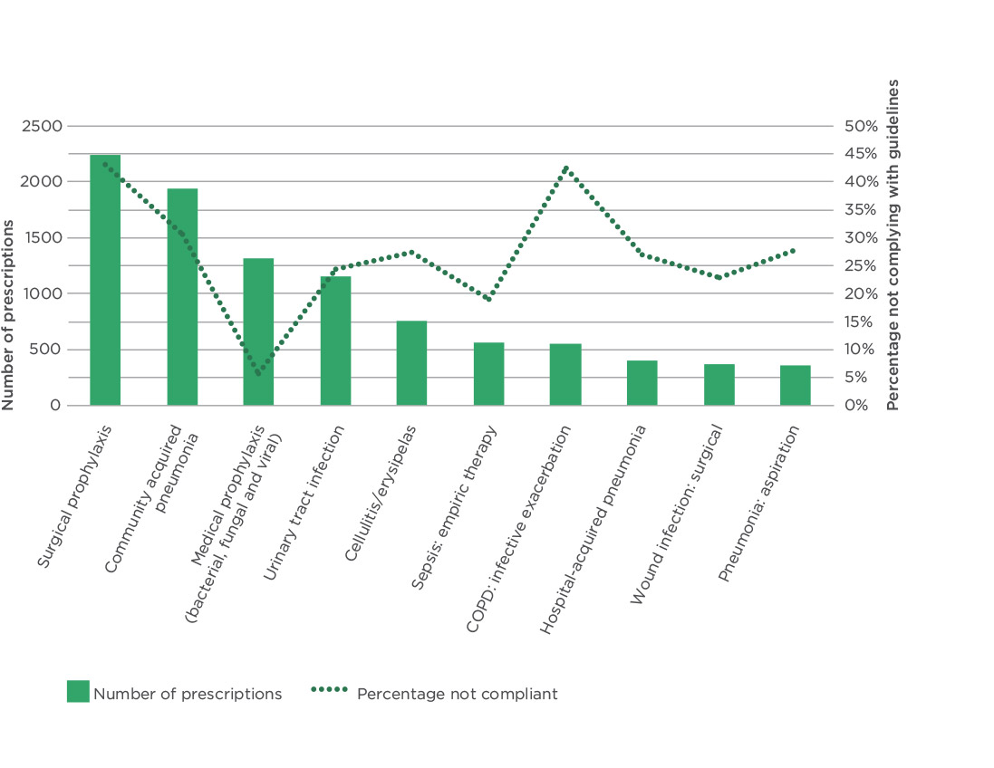

Source: Antimicrobial Prescribing Practice in Australia. Final Report Results of the 2014 National Antimicrobial Prescribing Survey, ACSQHC, 2015.

Antimicrobial resistance is a global challenge to the delivery of effective health care

Figure 12: Antimicrobial prescriptions that were inappropriate, by reason

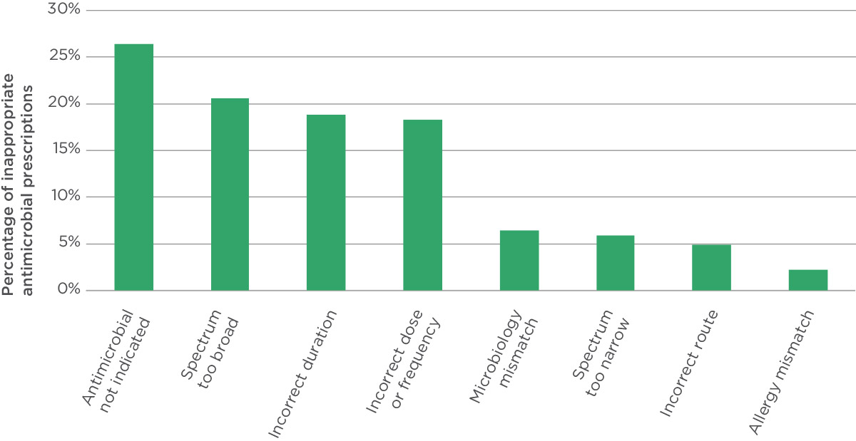

Source: Antimicrobial Prescribing Practice in Australia. Final Report Results of the 2014 National Antimicrobial Prescribing Survey, ACSQHC, 2015.

Note: An antimicrobial prescription may be inappropriate for more than one reason.

Figure 13: Indications for which antimicrobials were commonly inappropriately prescribed

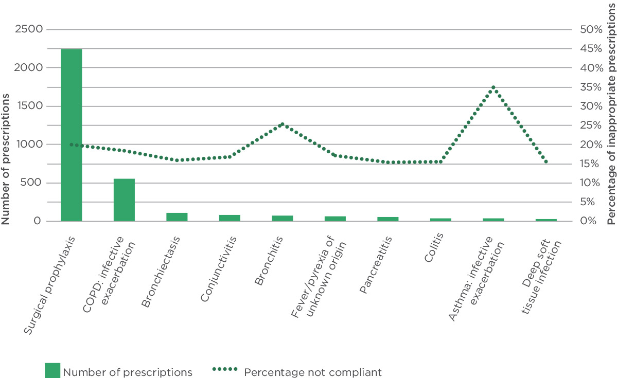

Source: Antimicrobial Prescribing Practice in Australia. Final Report Results of the 2014 National Antimicrobial Prescribing Survey, ACSQHC, 2015.

### Where to next?

NAPS surveys are revealing a wide range of areas of antibiotic prescribing that need to be addressed within hospitals: surgical prophylaxis, documentation in the medical record, compliance with guidelines and treatment of hospitalised patients with different types of respiratory tract infections.

Antimicrobial stewardship concerns efforts by hospitals to optimise antimicrobial use to improve patient outcomes, ensure cost-effective therapy and reduce the occurrence of antimicrobial resistance.53 NAPS provides information to health providers in hospitals with responsibility for antimicrobial stewardship so they can examine which areas they need to address in their hospital, compare their performance with similar hospitals, and track improvements through yearly participation.

In 2014, NAPS identified significant problems in the use of antimicrobials for surgical prophylaxis. This is a concern as surgical prophylaxis is the most common reason for prescribing. In response to this issue, in 2015 NAPS will include a module specifically about surgical prophylaxis to explore the use of antimicrobials in this context. The Commission is also working with the Royal Australasian College of Surgeons to build on the clinical care standard for antimicrobial stewardship that was released in 201452 to develop resources about surgical prophylaxis and improve prescribing in this important area.

NAPS is part of a broader national and international push to address antimicrobial resistance. The National Antimicrobial Resistance Strategy describes seven objectives to minimise the development and spread of antimicrobial resistance and ensure the continued availability of effective antimicrobials.14 One of these relates to surveillance, and working with the Australian Government Department of Health, the state and territory governments and the private hospital sector, the Commission is leading the AURA (Antimicrobial Use and Resistance in Australia) project, which will establish a new national surveillance program about antimicrobial resistance and antimicrobial use. This project has been funded by the Australian Government Department of Health and will be up and running in 2016.

### What the Commission will do

* Continue working with Melbourne Health and the Doherty Institute to further enhance NAPS, including focusing on surgical prophylaxis and using of antimicrobials in residential aged care.
* Work with the Royal Australasian College of Surgeons to develop resources about surgical prophylaxis.
* Support health services to meet the requirements of the NSQHS Standards on antimicrobial stewardship.
* Establish NASCAR, a national antimicrobial resistance and antimicrobial usage surveillance system.

## Management of chronic conditions: if I have a chronic condition, systems in place at my general practice ensure I get the right care

Chronic conditions are the leading cause of illness, disability and death in Australia, accounting for 90% of deaths in 2011.54 Chronic conditions have complex and multiple causes and can compromise quality of life through physical limitations and disability. While they are not usually immediately life-threatening, chronic conditions are long term and persistent, and can lead to a gradual deterioration in health.55 The most common long-term conditions in Australia are arthritis, back pain, high blood pressure, asthma and depression; and the most common causes of death from a chronic condition are coronary heart disease, cerebrovascular disease (such as a stroke), dementia and Alzheimer’s disease, lung cancer and chronic lower respiratory diseases.54

Chronic conditions often require long-term management. This management frequently occurs in a primary care setting such as general practice, often in collaboration with specialist services. GPs and other primary care providers are well placed to deliver good care to people with chronic conditions: they are more likely to be able to effectively care for the whole person, rather than just one specific disease or condition in isolation, and they can provide continuity of care as the needs of the person change.56

More than one-third of problems managed by GPs are chronic conditions, most frequently high blood pressure, depression and diabetes (Figure 14).57

People often have more than one chronic condition. It has been estimated that almost 30% of the population who visit a general practice have more than one chronic condition and, of these, almost 60% have two or more chronic conditions.43

### How well are we caring for people with chronic conditions?

We know that people do not always receive the care that they should, and this is also true for people with chronic conditions who are being managed in general practice. A large Australian study looked at the appropriateness of care that people received in a range of healthcare settings.49 For those chronic conditions that are common in general practice, it found that appropriate care was provided in 72% of encounters when high blood pressure was managed, 63% of encounters when diabetes was managed and only 55% of encounters when depression was managed.49 These results align with other studies of the management of chronic conditions. Such studies have found, for example, that of a group of patients at high risk of a heart attack or other cardiovascular event, approximately half did not receive the combination of medications that were recommended;58 less than one-quarter of patients had height and weight recorded in their clinical record as recommended in guidelines for managing obesity;59 and one-quarter of patients with Type 2 diabetes and high blood pressure were not being treated for their high blood pressure.60

Figure 14: Most frequently managed chronic conditions in general practice

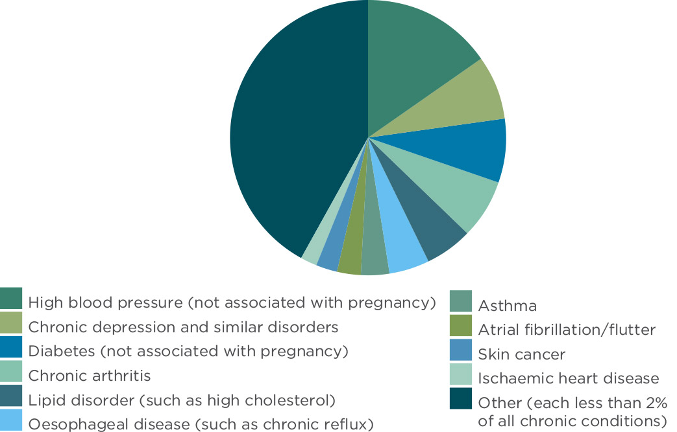

Source: Britt H et al. General Practice Activity in Australia 2013–14, 2014.

People with more than one chronic condition face challenges. Issues that have been identified include:61, 62

* the additional time taken for both patients and healthcare providers
* the need for healthcare services to be better integrated to provide more seamless care
* the lack of guidance for healthcare providers for managing people with multiple conditions that interact, rather than one standalone condition
* the difficulty of self-management for people with more than one condition, including the difficulty in managing risk factors, identifying the signs and symptoms of illness and managing multiple medications.

**90%** of deaths in 2011 were caused by chronic conditions

The most common chronic conditions in Australia are arthritis, back pain, high blood pressure, asthma and depression

### Providing care that aligns with best practice

The gap between the kind of care that is recommended in guidelines and the way that care is delivered in practice is well known, and many strategies, initiatives and programs have been developed to address this problem. These strategies include providing support for multidisciplinary team care, improving the way that the health service is organised, and supporting patients to be better involved in their own care, including managing their chronic condition.56, 63

One of the barriers to providing appropriate care for people with chronic conditions in general practice relates to use of information systems and clinical audit.56 To manage patients with chronic conditions effectively, GPs need to know the characteristics of the people who attend the practice, the care they receive and the outcomes of that care. Systems that support this knowledge are not in place in all general practices. In an international survey of GPs in 2012, only 42% of Australian GPs reported that they routinely received and reviewed data on clinical outcomes, and only 53% reviewed their clinical performance against targets at least annually.64

### Australian Primary Care Collaboratives Program

One initiative to address this problem of poor systems is the Australian Primary Care Collaboratives (APCC) Program. This program is funded by the Australian Government and aims to increase capacity for quality improvement in primary care by focusing on systems.65 Since it began in 2004, the APCC Program has addressed a number of important clinical topics related to chronic conditions, including diabetes, heart disease, obstructive pulmonary disease, kidney disease, disease prevention and patient self-management. As part of the collaborative approach, over 18 months small teams from each participating practice attend regular workshops. In between these workshops they make changes and collect data about their performance. The APCC Program provides data about performance compared to other participants and an opportunity for practices to share ideas.65 Overall, the APCC program has had a positive impact on the recording of information about people with chronic conditions, as well as health outcomes.65, 66

One area with a measurable impact is in the care of people with diabetes. Ongoing monitoring of blood glucose levels is important to prevent complications. A test that is commonly performed to measure blood glucose is the glycated haemoglobin, or HbA1c. GPs should make sure that patients with diabetes are included in a specific register, have their HbA1c tested regularly, and aim to have the HbA1c at or below the target level, which is 7%.

Between 2004 and 2009, 743 practices completed the diabetes topic within the APCC Program, serving approximately 150 000 people with diabetes.66 During the program, recording of information about diabetes improved, with the number of patients with HbA1c recorded increasing from 41% to 71%. The clinical outcomes for patients also improved, with the proportion of patients on each diabetes register with a HbA1c at the target level increasing markedly from 25% at baseline to 38% at the end of the program.66 In addition, the proportion of patients who also met targets for blood pressure and cholesterol increased during this period (Figure 15). Examples of types of changes that were introduced into practices as part of this program are included in Box 7.

**>1/3** of problems managed by GPs are chronic conditions

People with chronic conditions do not always get the care we know they should

Figure 15: Mean percentage of patients on diabetes registers meeting targets, across all participating primary care services

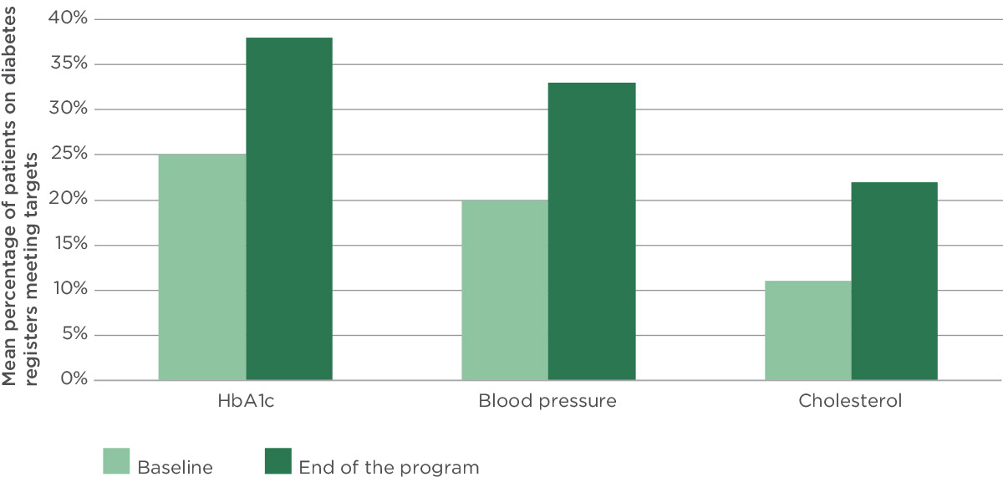

Source: Knight AW et al. The Australian Primary Care Collaboratives Program: improving diabetes care BMJ Quality and Safety 2012; doi 10.1136/bmjqs-2011-000460.

Box 7: Examples of actions taken by practices in the APCC Program to improve care of people with diabetes

Patients were identified who were prescribed diabetic medications, but were not coded as having diabetes. The practice updated its records so that they were coded as having diabetes and included in the practice’s diabetes register. This meant that these patients were flagged to receive additional services such as the diabetes educator, podiatrist and GP management plan.

The practice instituted a new care plan for diabetes that was coordinated by a practice nurse. This plan included detailed information for the patient that allowed them to better manage their condition.

When patients aged between 40 and 49 attended the practice, they were asked to complete a risk assessment tool for diabetes and cardiovascular disease. Patients who were at risk were included on a register and managed proactively to reduce their risk of getting diabetes.

Source: APCC Program, [www.apcc.org.au/sharing_ideas/case_studies/](http://www.apcc.org.au/sharing_ideas/case_studies/).

To manage patients with chronic conditions effectively, GPs need to know who attends their practice, the care they receive and the outcomes of that care

### Where to next?

The APCC Program has brought about measurable improvements in care and outcomes for patients in the practices involved in the program. While a large number of practices have participated in the program (more than 1100 between 2005 and 201165), it is not known whether there have been improvements outside of these practices. The APCC’s approach to quality improvement has the potential to be shared more widely across general practice and primary care.

In July 2015, new regional organisations of primary health services, the Primary Health Networks (PHNs), were established. The purpose of the PHNs is to increase the efficiency and effectiveness of medical services and improve the coordination of care. The PHNs are particularly focused on improving care for people at risk of poor health outcomes, which includes people with chronic conditions. These new PHNs provide an opportunity to address barriers to high-quality care for people with chronic conditions, particularly regarding support for multidisciplinary services and integration of care across services.

Opportunities may also exist to improve care for people with chronic conditions through better use of clinical guidelines and their integration into practice systems. The Commission is working with the Australian Government Department of Health and the National Health and Medical Research Council to develop a priority list of clinical guidelines. Clinical areas for prioritisation will be assessed based on criteria including whether there is potential to provide significant benefits to patients and whether the area represents a significant burden of disease. It is likely that the final priority list will include clinical areas of care for people with chronic conditions. The need for guidelines that are applicable for people with more than one chronic condition is particularly important.

Processes to support the use of these guidelines are also necessary. One option that could be considered is to link the use of a clinical quality registry with a clinical guideline. Clinical quality registries are organisations that monitor and report on the appropriateness and effectiveness of health care. Currently, however, only a small number of data collections capture and report process and outcomes data for specific clinical conditions or interventions. The development of a number of high-priority national registries that are linked to clinical guidelines has the potential to address the current gap in healthcare-quality measurement and inform improvements in the quality of care for people with chronic conditions.

### What the Commission will do

* Explore the variation in the way in which care is provided to people with chronic conditions.
* Develop clinical care standards that are relevant for people with chronic conditions.
* Prioritise the development of clinical guidelines using transparent criteria.
* Support the development of clinical quality registries as a mechanism to improve measurement of the quality of care, including for people with chronic conditions.

## Aboriginal and Torres Strait Islander health: my healthcare providers ask if I am Indigenous to improve the care I receive

There are major differences in health outcomes for Aboriginal and Torres Strait Islander people compared to the wider community. Indigenous people have higher rates of child mortality, disability, chronic disease and mental health problems. A greater proportion of Indigenous children than non-Indigenous children will die before the age of five. A disproportionate number of Indigenous people are living with chronic diseases, and Indigenous people are getting these chronic diseases at much earlier ages than non-Indigenous people. These and other factors add to the burden of disease that exists in the Indigenous community, and, as a result, Indigenous people today have a shorter life expectancy than non-Indigenous Australians (Figure 16).67, 68

Internationally, the concept of racial bias is used to identify and describe behaviours and processes that underpin and contribute to the differences in health outcomes experienced by Indigenous people. Racial bias can be seen in the structures of the health system and societal norms, in the prejudices and views of people working in the health system, and in the internalised views and behaviours of Indigenous people.69

Racial bias can unintentionally influence the safety and quality of care, and the person’s experience of that care. Racial bias affects the varying access that Indigenous people have to health care: Indigenous people in public hospitals are 35% less likely than non-Indigenous people to receive a procedure.70 It also influences the pervasive and consistent negative assumptions about health literacy and compliance that may lead healthcare providers to offer reduced treatment options that in turn result in poorer quality care and outcomes.71 It can be argued that delayed health-seeking behaviour and low self-efficacy of patients may be displays of internalised concepts of lower self-worth as responses to racial bias and racism.72

### Leaving before treatment is completed

An example of the way in which unintentional racial bias can influence health care is when a person leaves a hospital before their care or treatment plan is finished. This is known as discharge against medical advice. Discharges against medical advice can result in poorer health outcomes, unplanned readmissions and other complications of care. Indigenous people are eight times more likely than non-Indigenous people to discharge themselves against medical advice (Figure 17).73

Indigenous people discharge themselves against medical advice for many different reasons, including:

* family or cultural commitments that were not identified before treatment began
* the sense of prolonged isolation from family and carers while they are a patient
* limited involvement in, and therefore little knowledge about, the treatment plan
* limited communication about what and when treatment is to be provided
* an environment that is uncomfortable, such as wards being excessively cold
* expressing concerns but feeling as though these have not been heard or acted on
* not feeling respected
* unwarranted assumptions that may be made about them, which affect treatment options.

Figure 16: Life expectancy at birth

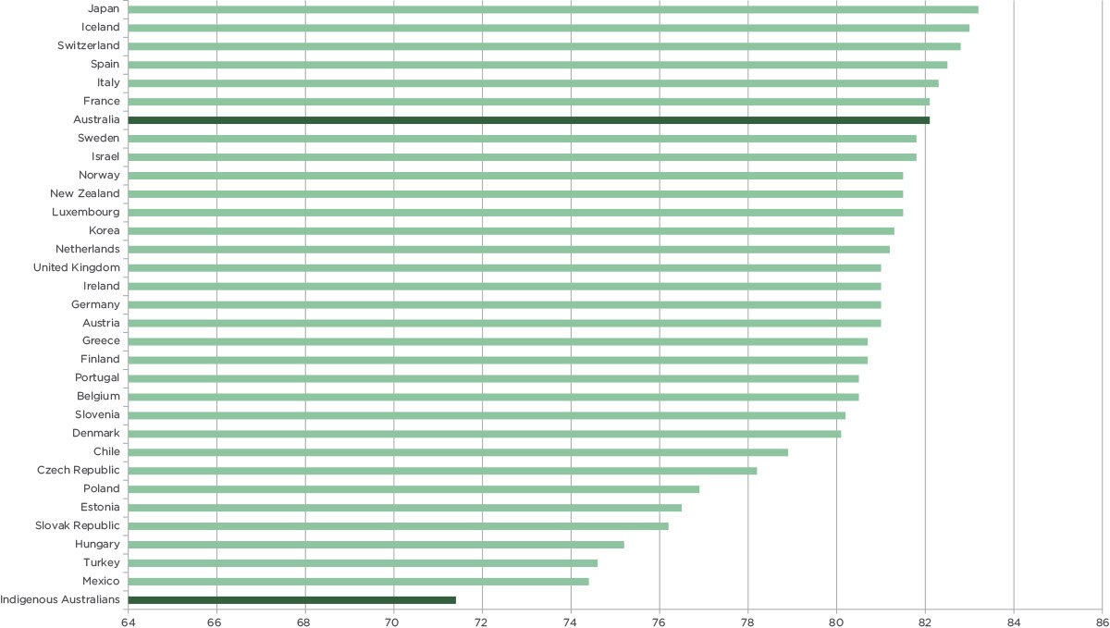

Source: OECD, Life expectancy at birth, total population, [dx.doi.org/10.1787/lifexpy-total-table-2014-1-en](http://dx.doi.org/10.1787/lifexpy-total-table-2014-1-en), 2014; Australian Bureau of Statistics, Life Tables for Aboriginal and Torres Strait Islander Australians, 2010–2012, Cat. no. 3302.0.55.003, 2013.

There are major differences in health outcomes for Aboriginal and Torres Strait Islander people compared to the wider community

Discharge against medical advice is an indirect indicator of how responsive a service is to a patient’s needs

Figure 17: Discharges against medical advice by Indigenous status, 2004/05 to 2012/13

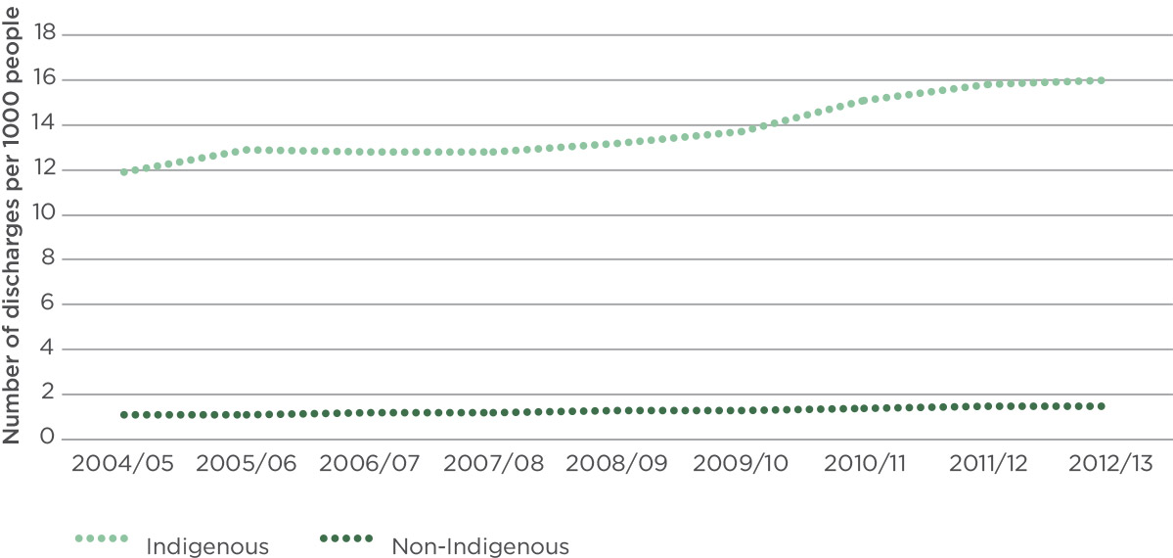

Source: Australian Institute of Health and Welfare, Aboriginal and Torres Strait Islander Health Performance Framework 2014: Data tables, [www.aihw.gov.au/indigenous-data/health-performance-framework/](http://www.aihw.gov.au/indigenous-data/health-performance-framework/), 2015.

Discharges against medical advice can be a measure of how safe, welcome or understood an Indigenous person feels. The higher the number of these discharges, the less safe, welcome or understood people feel. Discharges against medical advice provide an indirect indicator of the extent to which services respond to an Indigenous patient’s needs. The rate of discharges against medical advice for Indigenous patients has increased by an average of 0.5% annually since 2004/05,74 suggesting that strategies the health services are putting in place to respond to the needs of these patients are unsuccessful.

Understanding the reasons Indigenous people seek to be discharged before completing treatment will help health services address issues that have an impact on the safety and quality of care that Indigenous people receive. Reducing the number of people who are discharged before treatment is completed will improve the health outcome for patients and can potentially reduce health service costs from unplanned readmissions and ongoing care. For example, it has been estimated that the cost of discharges against medical advice to the Department of Health in the Northern Territory between 1999 and 2004 was $30 million because people who left before their treatment was finished came back worse than when they left, and needed more intense treatment when they next received care.75

### Improving the identification of Indigenous people

Historically, Indigenous world views and culture have not been a primary consideration or well understood by mainstream health services when they are providing care. By asking if a person identifies as Indigenous, a health service can ensure those people who are identified are given the care and help they need to bridge this gap in healthcare outcomes. This can help to address the impact of unintentional racial bias.

For Indigenous people, being asked if you are an Aboriginal or Torres Strait Islander is a key step in making sure the health care provided is supportive and meets both health and cultural needs. Knowing that someone is Indigenous can help the health service connect them with an Aboriginal liaison officer. Among other things, Aboriginal liaison officers can help people to better understand the processes involved in health care and the role of different healthcare providers. They can also support people to find their way around a health facility.

Health services should generally ask people if they are Indigenous when they first present at a service; however the request for and recording of Aboriginality varies between services. In more remote locations, information about whether or not a person is Indigenous is more commonly recorded; this reduces with proximity to major cities (Figure 18).76 Knowing how many Indigenous people attend a health service means that the health service can better plan for their care.

Health service providers should also ask a person if they are Indigenous when collecting clinical information, such as taking a history or providing care. This information helps healthcare providers understand what additional assistance might be needed so that people understand treatment options, when planning or providing treatment and what additional risk factors they may need to consider to provide good quality and safe care.

Identification at entry and when care is provided can allow a health service to recognise where significant safety and quality problems occur for Indigenous people. If a health service can see where in a healthcare journey Indigenous people are having difficulty, they can adjust the way the service is delivered to reduce these problems. When health services improve the safety and quality of care they provide to Indigenous people, improvements in health outcomes will follow.

The life expectancy at birth for Indigenous Australians is **71 years**

Figure 18: Indigenous identification in hospitals, by remoteness

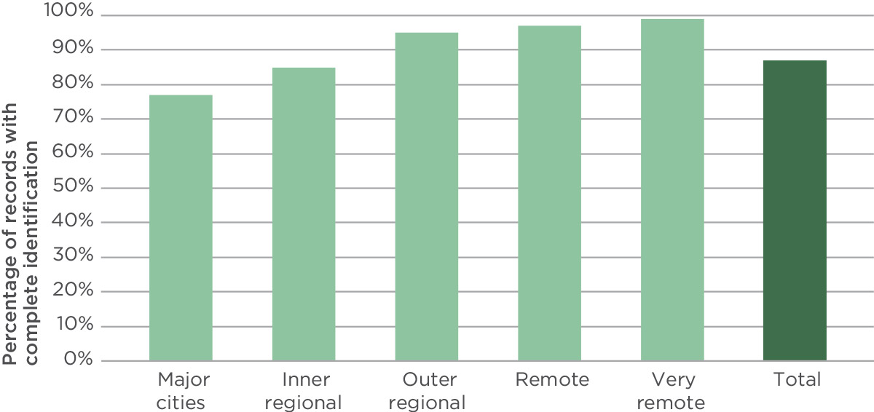

Source: Australian Institute of Health and Welfare, Indigenous Identification in Hospital Separations Data: Quality Report, 2013.

Indigenous people are eight times more likely to discharge themselves against medical advice than non-Indigenous people

### Where to next?

Although a national focus on Indigenous health has brought some improvements in health outcomes, the extent of the gap between the Indigenous population and the general population means that it is important to keep looking for ways to make progress and to embed mechanisms to help close this gap.

The NSQHS Standards (page 6) are driving changes to improve patient safety and quality. They also provide a useful opportunity to advance health outcomes for Indigenous people by improving the systems that provide care across mainstream health services. This systematic approach to enhance the safety and quality of care provided to Indigenous people will contribute to closing the gap in Indigenous health outcomes. For example, in version 2 of the NSQHS Standards the Commission hopes to improve the identification of Indigenous people when they present at a health service so they can get the care they need and reduce the number of Indigenous people who leave care before treatment has been completed.

### What the Commission will do

* Develop resources for health services about how to use the NSQHS Standards to improve the safety and quality of care for Indigenous people.
* Include actions aimed at improving the safety and quality of care for Indigenous people in version 2 of the NSQHS Standards.

## Cognitive impairment: my healthcare providers will try to prevent me from developing delirium and keep me safe if I have dementia

Although cognitive impairment (delirium or dementia) is not a normal part of ageing, it is common in older people in hospital.77 People with delirium or dementia are at increased risk of accidents, such as falls, or preventable complications, such as pressure injuries.78 These can be prevented or harm minimised if cognitive impairment is recognised early and action is taken to reduce risks.79

### Preventing delirium

Delirium is an acute disturbance of consciousness, attention, cognition and perception that develops over a short period of time (usually hours or days) and tends to fluctuate during the day.80

There are two types of delirium. In hyperactive delirium, a person may be restless, agitated and aggressive; in hypoactive delirium, a person may be withdrawn and drowsy. Some people can show signs of both.80

Delirium was once thought to be an inevitable and unavoidable part of a hospital stay, especially for older people. It was also thought to be transient and therefore insignificant. However, we now know that delirium can have serious short- and long-term consequences. A person is at greater risk of dying, falling or developing a pressure injury in the short term, and of developing dementia or entering residential care in the long term.79 Delirium is also frightening for the person experiencing it and alarming for families to witness.

While many people in hospital are at risk of developing delirium it can be prevented. A recent review of interventions for delirium that did not involve medications found that the occurrence of delirium during admission could be reduced by 53%.81

Delirium can be prevented with quite simple measures,80 such as assisting patients to:

* get enough sleep and keep their normal sleep patterns
* get out of bed and look after themselves as much as possible
* drink enough fluids and eat their meals
* have their glasses handy and their hearing aids in
* see a working clock
* have familiar faces around them, such as family and friends who can remind them where they are and provide meaningful activities.

Delirium is an acute disturbance of consciousness, attention, cognition and perception that develops over a short period of time

Avoiding physical restraints, catheters and ward and bed moves can also help. Medication reviews are also recommended.82 For patients with a hip fracture, having a geriatric consultation before or just after surgery can help prevent delirium from happening after surgery.83

Carers and family members can be asked to alert the person’s doctor or nurse of any change to the person during their hospital stay. Often delirium is recognised when a family member reports the person is not their normal self – ‘this is not my mum!’

### Improving care for people with dementia

In contrast, people with dementia experience a progressive, gradual decline in cognitive functioning. Alzheimer’s disease is the most common cause of dementia.

It is important that the hospital workforce knows if someone has dementia when they come to hospital. A person with dementia may have difficulty providing informed consent or following instructions. They may be more disorientated and unable to find their way around and may become frightened in the unfamiliar environment.

Clinicians can lessen anxiety by communicating simply, calmly and with respect. Skilled clinicians find the right balance by enabling a person to contribute to their own care within their capabilities and providing assistance in a way that maintains their dignity. If a person is not able, carers can be asked to describe a person’s routines and preferences, advising about assistance required and how to minimise distress in their absence.

Awareness of someone’s dementia is particularly important as the person is at increased risk of developing delirium on top of dementia while they are in hospital. Delirium can lead to a rapid decline in a person’s cognition and general functioning and it can persist. Rather than assuming nothing can be done, people with dementia will benefit from the simple measures described earlier for preventing delirium.

### Safe and high-quality care

The Commission is driving national improvement in the recognition and care of people with cognitive impairment. The three main areas of action are:

1. Releasing resources targeting health service managers, clinicians and consumers titled A better way to care: safe and high-quality care for patients with cognitive impairment (dementia and delirium) in hospitals, available in hardcopy, as an e-resource and in printable versions. An app focusing on actions for clinicians was also released for mobile devices.
2. Developing a new delirium clinical care standard to guide clinical practice and help provide appropriate care for patients with cognitive impairment.
3. Including cognitive impairment actions as part of the review process for version 2 of the NSQHS Standards.

People with delirium have a higher risk of falling, developing dementia and dying

### Where to next?

Version 2 of the NSQHS Standards will be finalised in 2017 and health services will then need to be assessed to them when they are accredited. This means that hospitals will be reviewing their current practices and working out what they need to do to improve the recognition and care of people with cognitive impairment.

Many hospitals will not be starting from scratch as they are already aware of cognitive impairment as a safety and quality issue, and many hospital-level initiatives are underway throughout Australia. Important policy developments, pathway developments, program pilots and education programs are being rolled out that will contribute to improvements in this area.

Boxes 8–15 provide examples of these initiatives, noting that many more are in place across Australia.

Box 8: Confused Hospitalised Older Persons Program

Twelve hospital sites in NSW have committed to implementing and evaluating the Confused Hospitalised Older Persons Program (CHOPs).

The program focuses on implementing key principles by applying evidence-based strategies in a flexible and practical way. The principles include cognitive screening, delirium risk identification and prevention strategies, assessment and management, and communication to support person-centred care, staff education and supportive care environments.

The program includes both the carer and the person with cognitive impairment in the plan of care and empowers staff to be ‘aware and care’. CHOPs emphasises the importance of communicating beyond the hospital walls; with primary care and extended care services, including residential care.

The NSW Agency for Clinical Innovation is supporting the hospitals to implement CHOPs through funding from the NHMRC Cognitive Decline Partnership Centre. Evaluation of the first seven hospitals implementing CHOPs is due for completion at the end of 2015.

Preliminary results from the pre-implementation staff survey highlighted the importance of training and educational opportunities. Of the 503 staff surveyed, 45% had not received training in how to manage confusion in the hospital setting and, of those who had, a significant number (48%) thought the training was inadequate. An important focus is to increase staff knowledge and confidence through education that will support the development of a positive culture of care.

Source: NSW Agency for Clinical Innovation, CHOPs Program, 2015.

Box 9: Dementia Care in Hospitals Program

In Victoria, Ballarat Health Services developed a Dementia Care in Hospitals Program (DCHP) as an all-of-hospital education program to improve communication and awareness of patients with cognitive impairment using a bedside alert called the cognitive impairment identifier.

The program commenced in Ballarat Base Hospital in 2004, was evaluated in 2006 in seven hospitals in the public sector and was further reviewed when introduced at three private hospitals in 2012. It was found to improve staff knowledge, attitudes and perceived organisational support.

Through funding from the Australian Government Department of Social Services, the DCHP will be implemented and evaluated in four hospitals in other states: Queen Elizabeth Hospital (South Australia), the Canberra Hospital (ACT), Sir Charles Gairdner Hospital (Western Australia) and the Royal Hobart Hospital (Tasmania). Deakin University will undertake an independent evaluation of the national DCHP.

Source: Ballarat Health Services, DCHP, 2015.

Box 10: TOP 5 Program

TOP 5 is a structured program initially developed by the Central Coast Local Health District NSW to assist clinicians when asking for carers their five best tips caring for a person with dementia in their absence. The program has been implemented in four private hospitals and 17 public hospitals in NSW and is supported by the NSW Clinical Excellence Commission through the HCF Research Foundation.

A recent evaluation of the program has confirmed that consultation with carers can improve the care of patients with dementia in hospital.84 TOP 5 has been shown to be simple, time efficient and effective, with staff agreeing that the program benefits patients and carers, with reports of higher levels of satisfaction.

There were fewer falls among patients with dementia in the ward where TOP 5 was implemented compared with the control ward and a reduction in the use of anti-psychotic medicines.

Phase two of the study is looking at the usefulness of TOP 5 in transitions between hospitals, aged care facilities, ambulances and the community.

Source: K Luxford et al. Improving clinician–carer communication for safer hospital care: a study of the ‘TOP 5’ strategy in patients with dementia. International Journal of Quality in Health Care, 2015.

Box 11: Dignity in Care Program

A program that is gaining momentum in South Australia is Dignity in Care (DIC) Australia, which has a formal alliance with DIC UK. The program was first launched in 2011 at the Queen Elizabeth Hospital in Adelaide, with Maggie Beer as the patron. The program now has more than 1000 champions across a range of settings, including hospitals. Champions act as role models, speak up about dignity and promote the 10 DIC principles as a way to guide and evaluate how care is delivered. Carers are encouraged to be aware of and have an expectation of care that is consistent with the principles. The 10 principles are:

1. Zero tolerance of all forms of abuse.
2. Support people with the same respect you would want for yourself or a member of your family.
3. Treat each person as an individual by offering a personalised service.
4. Enable people to maintain the maximum possible level of independence, choice and control.
5. Listen and support people to express their needs and wants.
6. Respect people’s privacy.
7. Ensure people feel able to complain without fear of retribution.
8. Engage with family members and carers as care partners.
9. Assist people to maintain confidence and positive self-esteem.
10. Act to alleviate people’s loneliness and isolation.

Source: SA Health, DIC Program, [www.sahealth.sa.gov.au/wps/wcm/connect/public+content/sa+health+internet/clinical+resources/clinical+programs/dignity+in+care](http://www.sahealth.sa.gov.au/wps/wcm/connect/public+content/sa+health+internet/clinical+resources/clinical+programs/dignity+in+care)).

Healthcare providers can lessen the anxiety associated with dementia and delirium by communicating simply, calmly and with respect

Box 12: Cognitive Care Champions Program

After reviewing the level of staff awareness of delirium, the Royal Hobart Hospital embarked on a cognitive care champion program in 2014 to:

* increase the assessment and diagnosis of delirium, and staff confidence in screening and assessment tools by implementing an education package focused on the Mini-Cognitive test and the 3D-CAM (confusion assessment method), which has increased documentation of assessment processes.
* create cognitive champions whose role is to:
  + clearly communicate a diagnosis of delirium with medical staff and others using the 3D-CAM and Mini-Cognitive test
  + use visual prompts, such as the delirium alert and delirium stickers, to maintain awareness among other staff during day-to-day interventions
  + promote the use of non-pharmacological strategies for delirium prevention and management
  + support and educate their colleagues as well as provide family with a delirium pamphlet and encourage participation in care.

As of May 2015, the hospital has 77 trained cognitive champions.

Source: Royal Hobart Hospital, Tasmanian Department of Health and Human Services, 2015.

Box 13: WA Health – a framework for improvement

For hospitals and patients with cognitive impairment in Western Australia, a strategy is underway that is underpinned by the state’s models of care for delirium and for dementia, and that has been closely aligned with the Commission’s work on cognitive impairment. Notably, the West Australian strategy includes implementing the Commission’s A better way to care resources, along with supporting hospitals to report against the current NSQHS standards and the planned focus on cognitive impairment being introduced into the second version.

Western Australia has produced a core tool for hospitals: Hospitals in Western Australia & Patients with cognitive impairment; A framework for improvement. The framework and associated tools and resources will support Western Australian hospitals as they embark on improvements in this critical area. An objective is to provide hospitals with tools to support exploration of current processes to identify and act on areas for improvement. With an emphasis on safety, quality and effectiveness, the focus areas are prevention (delirium and behavioural and psychological symptoms of dementia), identification, assessment, effective treatment and care. Workforce awareness and education are included as areas for attention, for both clinical and non-clinical staff.

Source: WA Health, 2015.

Many initiatives are taking place across Australia to improve the care of people with dementia and delirium

Box 14: Dementia Care Pathway – Victoria

Through funding from the Victorian Department of Health, The Melbourne EpiCentre (University of Melbourne and Melbourne Health) is leading the development, implementation and evaluation of a comprehensive acute hospital pathway for people with dementia that is patient-centred, collaborative and evidence based. The project began in January 2014 and involves Royal Melbourne Hospital and Wimmera Health Care Group, and is expected to be completed in May 2017. It will inform the better care of a large and growing group of hospitalised patients whose outcomes are currently poor compared to patients without dementia.

Source: Melbourne EpiCentre, 2015.

Box 15: Cognitive Care Project

Royal Darwin Hospital has established a Cognitive Care Project Reference Group which is developing, implementing and evaluating a whole-hospital approach for meeting the cognitive care needs of patients and for the prevention, early intervention and management of delirium. In order to reflect their patient population, the challenge will be to incorporate a broader perspective for reasons for cognitive impairment (such as brain injury), younger age groups, and ensuring their approach is culturally appropriate for Indigenous people. The project will make an important contribution to knowledge about recognising and caring for Indegenous people with cognitive impairment in all hospitals and will assist hospitals in the Top End region of the Northern Territory in particular.

Source: Royal Darwin Hospital, 2015.

### What the Commission will do

* Introduce new elements in version 2 of the NSQHS Standards that address the specific gaps in safety and quality for people with cognitive impairment in hospitals.
* Launch a campaign to encourage hospitals to commit to improving the recognition and care of people with delirium and dementia.
* Assist hospitals to prepare for version 2 of the NSQHS Standards through:
  + access to evidence and information
  + opportunities to share success and learn from others.

# **03** Will I be a partner in my care?

The Commission supports the right of people to be partners in their health care. People who are partners in their health care, who understand the health they are given, who share decisions and who actively engage with the processes of care are more likely to have a better experience of care and get better results from their health care.48, 85, 86

Establishing strong and effective partnerships is not always easy. Healthcare providers and managers working in hospitals and day procedure services may be concerned about the time that might be needed. People might be unwilling or unable to take an active role in their own health care. Communication problems can exist that lead to complaints and risks to safety.

Tools, strategies and approaches are available to support patients, consumers, healthcare providers, managers and government officials in establishing effective partnerships.

This section looks at four different areas where efforts are being made. These include ways in which people can be more involved in decisions about their care at the end of life and when care is transferred between healthcare providers. Also included is information about how the experiences of patients in health services are being collected and used for improving care.

Will I be a partner in my care?

**End-of-life care:** my hospital will look after me and my family as I approach the end of my life

**Patient-clinician communication:** my healthcare provider will communicate with me about my care as I move through the health system

**Patient experience measurement:** my experiences of health care will be used to help improve safety and quality

**Perceptions of safety and quality:** when I visit a general practice, I trust that I will receive safe care

End-of-life care: my hospital will look after me and my family as I approach the end of my life

Patients and families, healthcare providers and hospital managers all have a role to play in ensuring that end-of-life care is safe and of high quality

The way people are cared for when they are dying is important. Good care at the end of life can help to reduce distress and grief for the person who is dying and for their friends, family and carers. Healthcare providers and others working in hospitals do what they can to make sure that people get the best care possible at the end of life. But sometimes the care is not as good as it could be. Many family members, carers and healthcare providers have experienced this.

Many things are necessary for good end-of-life care. In 2015, the Commission published the National consensus statement: essential elements for safe and high-quality end-of-life care.87 The consensus statement describes 10 elements that are needed for safe and high-quality end-of-life care (Box 16). The actions in the consensus statement are based on evidence, expert knowledge, and the experience of patients, families and carers.

**53%** of people have a written plan naming someone else to make treatment decisions for them if they are not able to do so

Box 16: Essential elements for safe and high-quality end-of-life care

**A. Processes of care**

1. Patient-centred communication and shared decision making: involving patients and families in decisions about end-of-life care

2. Team work and coordination of care: working together to provide safe and high-quality end-of-life care

3. Components of care: providing end-of-life care that is compassionate and in accordance with the patient’s wishes

4. Use of triggers to help recognise patients approaching the end of life: recognising when people are at the end of life so that they can receive safe and high-quality care

5. Response to concerns: getting help to provide safe and high-quality care to people at the end of life

**B. Organisational prerequisites**

6. Leadership and governance: having leaders throughout the hospital who understand the importance of safe and high-quality end-of-life care

7. Education and training: having healthcare providers with the skills and knowledge they need to provide safe and high-quality end-of-life care

8. Supervision and support for interdisciplinary team members: having healthcare providers who are supported to provide safe and high-quality end-of-life care

9. Evaluation, audit and feedback: monitoring how end-of-life care is provided so improvements can be made if needed

10. Systems to support high-quality care: having systems that ensure that safe and high-quality end-of-life care is provided

Source: National Consensus Statement: Essential Elements for Safe and High-quality End-of-life Care, ACSQHC, 2015.

### Measuring the safety and quality of end-of-life care

Because of the range of factors that influence how care is provided for people at the end of life, measuring whether this care is safe and of high quality is complex. The hospital needs to have systems in place to support the type of care that is needed; healthcare providers need to recognise when someone is at the end of their life, provide the appropriate care, and communicate well with patients and families, and with each other; and patients and families need to be supported to express their wishes and participate in communication and decision making as much as they choose.

One aspect of safe and high-quality end-of-life care that has been looked at closely is whether doctors and nurses have had conversations with people about their wishes and preferences for care at the end of life. The purpose of these conversations is to help people plan for future health and personal care. This is known as advance care planning. Some information about the systems in place in hospitals for advance care planning comes from the results of accreditation processes and assessment to the NSQHS Standards (page 6). The NSQHS Standards include two actions that require health services to have systems in place for preparing, receiving and documenting advance care plans. In 2013, 80% of health services assessed met these requirements, and in 2014 this increased to 90%. However, a recent national survey of advance care planning in palliative care services in Australia found that only half of surveyed managers reported that their services had access to written policies and procedures about advance care planning.88

### How does Australia perform in international comparisons?

Information about advance care planning can also come directly from people who may be thinking about their wishes for future care. In 2014, the Commonwealth Fund, a not-for-profit organisation based in the United States, conducted an international survey of people aged over 65 that included questions about advance care planning.45 Australia performed reasonably well in these international comparisons (Figure 19). More than half of the Australian participants reported that they had had a discussion with a family member, close friend or healthcare provider about the healthcare treatment they would want if they became very ill and could not make decisions for themselves. More than half also had a written plan naming someone to make treatment decisions for them if they could not do so. Like other countries in the survey, Australia had a lower proportion (31%) of people who reported that they had a written plan describing treatment they wanted at the end of life.

There is national consensus about what is important for good end-of-life care

**50%** of people have had a discussion with a family member about the treatment they would want if they became ill and could not make decisions for themselves

Figure 19: End-of-life care planning, by country

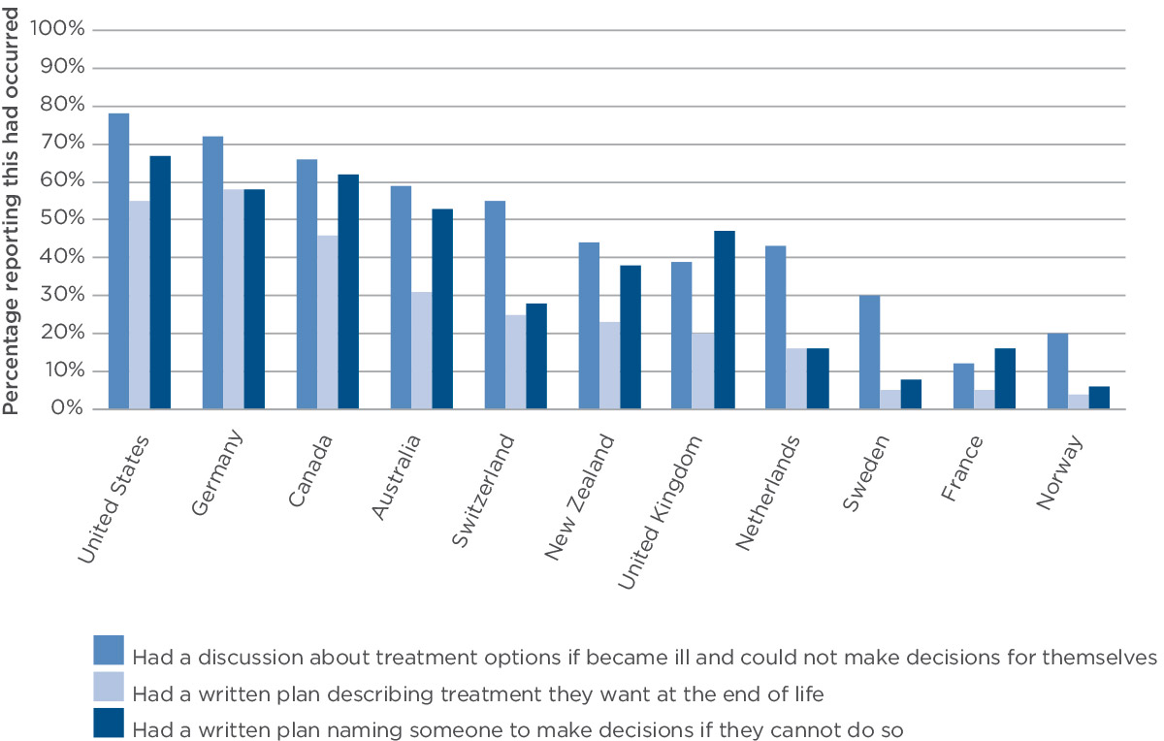

Source: Osborn R, et al. International survey of older adults finds shortcomings in access, coordination, and patient-centered care. Health Affairs 2014; 33: 2247–2255.

### Advance care planning in Australia

The performance of Australia in these international comparisons reflects results found in Australian studies about the uptake of advance care planning processes.89 A national study conducted in 2014 found that only 14% of people had a document that recorded their decisions about the medical treatment they wanted or did not want.[1] People were more likely to have a documented plan in place if they had a financial enduring power of attorney or had made a will. Different arrangements and laws apply in each state and territory about documenting advance care plans, and differences are seen between the states and territories in the proportion of people reporting that they had documented plans (Figure 20).

Figure 20: Documentation of advance care plan, by state

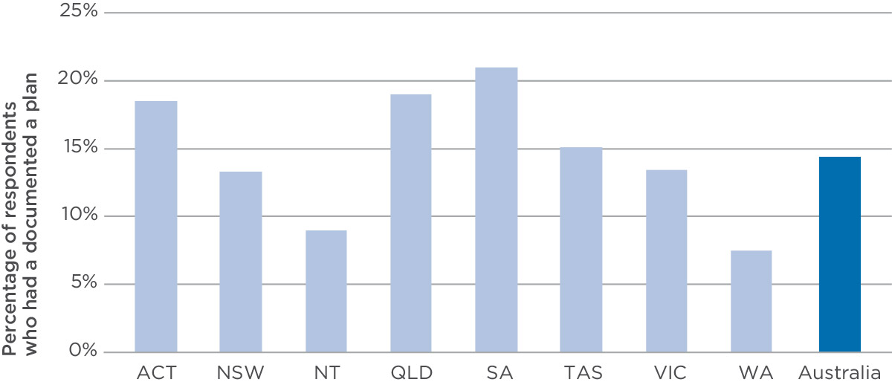

Source: White B, et al. Prevalence and predictors of advance directives in Australia. Internal Medicine Journal 2014; 44: 975–980.

**90%** of health services met the requirements for advance care planning prescribed in the NSQHS Standards in 2014

**31%** of people have a written plan describing the treatment they want at the end of life

### Where to next?

Endorsement of the National consensus statement: essential elements for safe and high-quality end-of-life care by health ministers in 2015 means that there is now an agreed national framework for safe and high-quality end-of-life care in Australia. This provides a consistent platform for ongoing and future work, and should make it easier to measure whether care for people at the end of life is safe and of high quality.

The consensus statement can be used by people across the health system when they are planning programs, services and systems for people at the end of life. It will inform the review of the NSQHS Standards to ensure that health services have the systems they need to provide safe and high-quality care to people at the end of life. It can also be used by organisations that provide training to healthcare providers, and organisations that register and regulate health services. Most importantly, the consensus statement describes how care should be provided, and how patients and families can be involved in this care. The Commission has developed information for patients and families about the consensus statement and the care they should expect at the end of life.

### What the Commission will do

* Provide information for patients and families to support them to be involved in decision making about end-of-life care.
* Develop tools and resources that make it easier for healthcare providers to recognise when patients are at the end of life and provide appropriate care to them.
* Support hospitals and day procedure services to meet the current requirements about end-of-life care in the NSQHS Standards.
* Strengthen actions about end-of-life care in version 2 of the NSQHS Standards

## Patient-clinician communication: my healthcare provider will communicate with me about my care as I move through the health system

When care is provided in a hospital or health service, communication between a patient and their healthcare provider is one of the most important factors for ensuring the safety and quality of care. This communication is called patient-clinician communication and it can include the conversations that happen when:

* a doctor is taking a person’s medical history
* a doctor is providing information to a patient about their care or treatment
* a nurse is checking on a person’s care needs when they are in hospital
* a doctor hands over care to another healthcare provider, and the patient is involved in this process.

Effective patient-clinician communication is when there is two-way communication (spoken, written and non-verbal) between a person and their healthcare provider that is tailored, open, honest and respectful.4, 90 It should respond to the needs, preferences and values of the patient,4 provide an opportunity for clarification and feedback, and include communications with the patient’s family or carer.91

### Patient-clinician communication at transitions of care

Hospitals are busy places and when a person goes to hospital they are often seen by many different healthcare providers depending on the care they need. This process and the actions involved in transferring a person’s care (either to another person or moving them to a different location) is known as transitions of care (Box 17). Patient-clinician communication at transitions of care is the communication that occurs between a patient and their healthcare provider at these times.

While transitions of care are usually necessary to ensure that the most appropriate care is delivered, they can also pose a considerable risk to patient safety if there is ineffective transfer of information or poor communication.92, 93, 94 In particular, research has shown that 60% of events that cause harm (adverse events) are related to incorrect or incomplete transfer of medication information during transitions of care.95 Similar preventable adverse events have also been reported in relation to the transfer of care for older people in hospitals for missed diagnosis, falls and delirium.92, 96, 98

### Why is it important?

Transitions of care can be complex and they can be confusing for a patient. However, while a person’s location or healthcare provider may change, the one consistent and common element is the person receiving care. Therefore, communicating and engaging with that person are essential to ensuring that the right care is delivered and that the person’s preferences, needs and goals are met.

Additionally, emerging research shows that effective patient-clinician communication and patient participation can positively influence patient outcomes99, 100, 101 and patient satisfaction,102 prevent adverse events during care,102 and reduce readmission to hospitals following discharge.103 Effective patient-clinician communication at transitions of care is essential to delivering safe and high-quality care.

### What can health services do?

The Commission engaged researchers from Deakin and Griffith universities to conduct a research project focused on engaging patients in communication at transitions of care in acute services.92 The report proposes three guiding principles for health services for effective communication at transitions of care, with examples of how health services in Australia are meeting these principles.

#### Guiding principle 1: Strong organisational leadership and commitment to patient-centred care at all levels of the health service and across all disciplines

Example: One health service has embedded patient-centred care into its mission, philosophy and core values. It has appointed innovation facilitators and patient care coordinators to ensure consistency of staff development, and widespread dissemination of patient-centred care and safety and quality principles throughout the health service.

“We have a structured framework to hold our managers accountable and in monthly accountability meetings they will look at operations, complaints, compliments and all the initiatives. There is an expectation that all clinical managers will speak to patients every day, asking do you know what’s happened … what’s going to happen?, Is discharge planning clear? Do you have any concerns?”   
Innovation facilitator

Communication is one of the most important factors for ensuring safety and quality

Box 17: What are ‘transitions of care’?

A transition of care is when a person’s care is transferred between healthcare locations, providers or different levels of care within the same location as their conditions and care needs change.

Examples of when transitions of care occur include when:

* a person enters a health service (such as being admitted to hospital)
* a person is in hospital and their care is transferred or referred to another healthcare provider or service (such as going from a ward to the radiology department for an X-ray while in hospital)
* a person leaves a health service and returns to the community (such as being discharged from a hospital).

#### Guiding principle 2: Early engagement and support for patients, families and health professionals to participate in transition communications

Example: One health service uses a pre-admission tool that allows for multidisciplinary assessment. The tool prompts patient inclusion in setting goals for care – including advanced care planning, and preferences and values related to what is to be achieved – with discussions about what is possible and realistic. Staff also engage patients in discussions about their goals, timeframes, and the realistic achievements for their rehabilitation or discharge.

“It takes the team: the nursing team, the allied health team, the medical team, and the family and patient. Everybody’s on board. We’re here for the patient”  
Nurse manager

Patients are safer when they are involved in communication about their health care

#### Guiding principle 3: Standardised tools and strategies to engage patients in transition of care communications are in place

Example: Whiteboards have been placed around patients’ beds in some health services to aid patient-clinician communication. Whiteboards are designed with patient input and prompt two-way sharing of information. They also give staff an opportunity to provide a contact person and information about upcoming appointments and to record the estimated date of discharge. The patient can record important information, such as prompts for queries to medical staff or notes from family members.

“People have been at pains to try and make sure that they know what’s happening for me and how I’m feeling and what needs to happen. With the board, I find that if it’s something you might not remember, or that you need to ask, then it is useful for that. Having the information to contact, especially if it changes … that’s really good.”   
Patient

### Where to next?

Effective patient-clinician communication is essential to the safety and quality of care, and underpins many areas of the Commission’s work. The review of the NSQHS Standards provides an opportunity to build systems for effective communication. The NSQHS Standards cover clinical handover, which is one type of transition of care. It is proposed to expand this focus for version 2 of the NSQHS Standards to communication more broadly, including that between patients and healthcare providers. All NSQHS Standards are based on the need for safe, effective, reliable and appropriate use of communication between patients, carers, families, healthcare providers and health services.

Good communication is particularly important when people move between healthcare providers and health services

### What the Commission will do

* Develop resources that help patients and healthcare providers improve patient-clinician communication at transitions of care.
* Support and promote the work of other program areas at the Commission related to patient-clinician communication, such as patient-centred care, open disclosure, shared decision making and health literacy.
* Strengthen the importance of patient-clinician communication in version 2 of the NSQHS Standards.

## Patient experience measurement: my experiences of health care will be used to help improve safety and quality

When people visit a local health service or go into hospital, their observations and experiences give them a unique insight into what is working and what is not working in the healthcare system. Measurement of patient experiences is about trying to capture these unique insights in a systematic way, so that poor experiences can be addressed and avoided, and good experiences built upon.

### A positive patient experience is not just an optional extra

Every day, thousands of people all over Australia greet reception staff, sit in waiting rooms, feel the insertion of a needle into a vein, wake up after an operation or receive test results. Every single one of these commonplace events involves an interaction between the person and a healthcare provider. This is the daily business of health care.

The quality of these interactions and environments is often considered secondary to the main clinical outcomes, such as the accurate use of the surgeon’s knife or the correct choice of antibiotic for a particular infection.

When people think about their own past experiences of visiting a doctor or asking a nurse for help in hospital, they may remember the kind face, the reassuring tone, or the feeling of being understood and heard. However, if the receptionist was rude, if the person spent two hours in the waiting room, if the needle was roughly and repeatedly inserted, or the bad test results were poorly communicated, people would probably say they received poor quality of care, regardless of the outcome of the treatment.

Patient experience is not just about those things that are nice to have but not really necessary to the delivery of safe and high-quality care. The experience of people in a health service is an important pointer to what organisations do well and what they need to improve. If an organisation provides a positive environment (for example, if a person feels that staff treat them respectfully), it is likely to do other things well, including providing safe and clinically effective care.85, 104

The quality of particular patient experiences and safety are directly linked. For example, the association between the clarity of doctor-patient communication and the likelihood that a person will follow a prescribed treatment regime is well known.105 Equally, attention to and respect for a patient’s self-reported level of discomfort or pain gives staff an important warning sign of clinical deterioration or even early evidence of an adverse event.

Patients have unique insights into what is working and not working in the health system

### Measuring the experience of patients

Information about patient experiences can be collected in many ways. Vital signs 2014, discussed the importance of collecting information about patients’ experiences in the form of stories.6 This year, the focus is on efforts being made around Australia to measure these experiences using numbers rather than words.

It might seem as though people’s individual experiences are just that – individual and not generalisable. Even so, researchers all over the world have found valid and reliable ways to systematically measure these experiences so that trends in people’s experiences can be shown and analysed. They do this by developing questionnaires for patients to fill in during, or soon after, their encounter with a health service.

The questionnaires allow comparisons between health services and even between hospital wards. The information from these questionnaires can be analysed and reported to let people and governments know how services are performing in terms of patient experiences. They can also be used at hospital, ward or service level to identify specific areas for safety and quality improvement.

The Australian Bureau of Statistics has conducted an annual national patient experience survey since 2010/11. This survey collects information about access and barriers to a range of healthcare services including GPs, medical specialists, dental professionals, imaging and pathology services, hospital admissions and emergency departments.42 It also asks about people’s experiences when they are receiving care in these settings, and about coordination of care between different healthcare providers. This survey does not target people who have recently accessed a healthcare service, but does provide useful information about trends in the public’s use of, and general opinions about, the health system. These survey findings are reported publicly and form part of the government’s assessment of the performance of health services.106

Many states and territories also have systems that measure the experiences of patients who have recently received care in public hospitals and other types of facilities. Four states (New South Wales, Victoria, South Australia and Queensland) are collecting responses to nationally consistent patient experience questions as part of their own patient surveys, and others plan to do so.

Box 18: Examples of patient experience questions

Did you feel you were treated with respect and dignity while you were in hospital?a

How often did the doctors, nurses and other health professionals caring for you explain things in a way you could understand?b

Were you involved, as much as you wanted to be, in decisions about your care and treatment?c

How clean were the toilets and bathrooms in hospital?d

Thinking about when you left hospital, were you given enough information about how to manage your care at home?e

How would you rate how well the doctors and nurses worked together?f

Source:   
a: adapted from Q H1, NHS Adult Inpatient 2011 Sample Bank Questionnaire v4, [www.nhssurveys.org/survey/1094](http://www.nhssurveys.org/survey/1094);   
b: adapted from HCAHPS v6 2011 Q 3 and Q 7 combined. [www.hcahps.org](http://www.hcahps.org/);   
c: Q 32, NHS Inpatient Questionnaire v11, 2012. [www.nhssurveys.org/Filestore/documents/IP12_Core_Questionnaire_v11.pdf](http://www.nhssurveys.org/Filestore/documents/IP12_Core_Questionnaire_v11.pdf);   
d: adapted from Q 18, NHS Inpatient Questionnaire v11, 2012;   
e: adapted from Q 20, Victoria Patient Satisfaction Monitor. [www.health.vic.gov.au/patsat/ult_vpsm_survey.pdf](http://www.health.vic.gov.au/patsat/ult_vpsm_survey.pdf);   
f: NHS Adult Inpatient 2011 Core Questionnaire v5. www.nhssurveys.org/survey/1093.

There is a nationally agreed approach to collecting information about the experiences of patients in hospital

The Commission adapted these core common questions from questions used in the National Health Service in England for patients who stay in hospital overnight or have a day procedure. Box 18 shows the types of questions put to patients.107

The respondents were asked additional questions so that information can be compared between, for example, Indigenous populations and the general population, people from non-English speaking backgrounds and the general population, older and younger people, and people living in disadvantaged areas and the general population. The replies are useful when identifying whether health services need to think carefully about tailoring their care to patient characteristics.

### Using patient experience data for improvement

Although the Commission is in the early stages of rolling out a national approach to understanding variation in patient experiences around Australia, evidence shows that health services are making promising use of the core common questions data. Box 19 shows examples from South Australia and Victoria of how patients’ perspectives are leading to quality improvement.

Box 19: How patients’ experiences are driving quality improvement

**Making it easier for patients to provide feedback**

In South Australia, SA Health has been piloting the use of the core common questions as part of its computerised Safety Learning System. It wants to enable more people to share their experiences, identifying areas for improvement and directly contribute to the health system’s safety and quality initiatives. They can do this easily via computer, including at the bedside or handheld devices. Pilot sites are already reporting benefits from this tool. Through analysis of feedback, SA Health is focused on learning more about how to tailor services to the needs and preferences of all people, including metropolitan and country patients, Indigenous patients, patients with culturally and linguistically diverse backgrounds, patients aged under 16, and people experiencing mental illness.

**Peer comparisons can drive improvement**

In Victoria, there is also a statewide electronic system for monitoring people’s experiences of health care at every public hospital. The Victorian Healthcare Experience Survey is sent out to a sample of people who have received inpatient or emergency department services during the previous month. They are asked about what did and did not happen during their stay. Their responses feed into a quarterly report, which hospital staff can access online. This makes it easy for these staff to quickly identify specific improvements. The fact that services can see each other’s performance is an extra incentive to listen to and act on patients’ feedback. In addition, the Victorian Department of Health and Human Services reviews and uses this information as part of its efforts to monitor and improve the quality and safety of services across the state.

Source: SA Health, 2015; Victorian Department of Health and Human Services, 2015.

### Where to next?

While great improvements have been made in recent years, Australia is still in the early stages of using patient experiences to directly influence policy making and investment decisions. In some countries, information about patient experience ratings is made public to inform decision making about choice of healthcare provider. In some cases, it is also being used as the basis of incentives to healthcare providers to improve the quality of their services.

Good patient experience is associated with safe and high-quality care

### What the Commission will do

* Work towards achieving of nationally consistent information about patient experiences using the core common question sets.
* Develop resources for primary care providers outside general practice to measure their patients’ experience at a local level.

## Perceptions of safety and quality: when I visit a general practice, I trust that I will receive safe care

It is important to know what people think about the health system in Australia. This knowledge can be used influence the ways in which health care is provided, and also to inform and educate the general public about the health system. This information is different to that about people’s experiences when receiving health care (page 72), which focuses on a particular encounter with a health service or healthcare provider. It is more about their views of the health service as citizens, rather than as consumers of care.

In 2014, the Commission organised focus groups with members of the public to learn about their views of the Australian health system. Participants were asked what they thought of the health system generally, what they thought about safety and quality, and what aspects they thought worked well and not so well. In addition to the general focus groups, specific focus groups were held with Indigenous people, people with culturally and linguistically diverse backgrounds, and carers.

These focus groups covered a wide range of issues in health care, and much of the feedback was about what people thought about general practice in Australia. General practice is one of the cornerstones of the Australian health system, and is the first point of entry into the system for most people. In 2012/13, almost 85% of the population visited a GP at least once.108

### People are positive about the health system

Participants in the focus groups generally had very positive views about the Australian health system. Medicare, which makes health care available for everyone, was considered to be one of the most important aspects of good quality of life in Australia. Participants born outside Australia contrasted this with other countries where health care was either prohibitively expensive or unavailable for those without high incomes.

The quality of GPs was also felt to be very high overall – although it was seen as sometimes variable, depending on the individual healthcare provider. The length and standard of their training and the tough eligibility criteria for studying medicine were seen as contributing to these high standards.

Indigenous participants were also positive about the health system, particularly about the availability of Aboriginal health services.

These positive findings align with other research that shows that Australians are confident that they would get safe and high-quality care if they fell ill.109 General practice and GPs are consistently among the most trusted healthcare providers.109. 110

“If you have no money you can still get access to good health care, unlike our countries of origin.”

It is important to know what people think about the health system

Some of the participants who were more negative about the health system used it more frequently. For general practice, concerns were raised about waiting times and a feeling that GPs were often over-booked and ‘pushed you through without properly listening to your problem’. Concerns were also raised about rising costs threatening the affordability of the system.

Participants who were carers had specific concerns about the health system. These included support available outside hospitals, the high costs of multiple visits to the GP, and the need to do a lot of research and advocacy themselves to get the best possible care for the person they cared for.

In discussions about safety and quality of health services, participants identified issues that fell into four broad themes: communication, the physical environment, policies and procedures, and confidence and trust.

### Communication

Participants identified communication as being one of the most important issues when thinking about safety and quality in health care. Participants wanted to feel that they were in control of their health and they understood what was happening and why actions were being taken. Communication with healthcare providers was an essential part of this process. The more informed participants thought they were, the more they felt that the health service was providing good quality care.

Within a general practice, participants thought it was important to be treated as a person not a number. They said it was important to have adequate time during an appointment to explain what was wrong, and for the GP to consider treatment options. Many participants stated that they made sure they raised their concerns with their doctor (sometimes listing questions before an appointment).

“Aboriginal health services ensure they make people feel welcome: both Aboriginal and non-Aboriginal. They have an open-door policy, work closely with the local community, and provide a safe and healthy environment for families.”

“Carers are stressed to the max. We are worried about getting physically or mentally sick ourselves and this just makes it more stressful.”

“It’s your life and it is important to know what is going on.”

People think that communication with healthcare providers is one of the most important aspects of safety and quality

“My baby just wouldn’t stop crying, and I knew something was wrong. My GP was very thorough, asking me lots of questions and finally diagnosing a bladder infection, whereas other doctors would not have been as thorough.”

“They always cut it short, and I don’t have time to ask what I want to ask.”

“The best doctors ask you lots of questions.”

Some participants noted that ‘others’, such as the elderly, can get confused and are more likely to miss pieces of information if they are rushed.

Participants also said it was important that GPs show empathy toward their patient, and ideally build a relationship with them. This was thought to be particularly important if the patient was a repeat visitor, and if the problem was more than just the renewal of a prescription or other simple issue.

Suggesting preventive health measures was also considered to be part of good communication. This included looking at the patient’s history, and sending reminders or suggestions of screening or blood tests as needed. In addition, thoroughly assessing a patient and providing information about symptoms, if relevant, were also seen as an important part of safety and quality in general practice.

Participants’ assessment of the adequacy of communication varied; they believed it depended on the practice and the GPs within a practice. Many participants reported that through trial and error, they had found a GP who communicated well, and they spoke highly of that GP. However, past experiences showed them that some GPs did not offer this level of service.

Indigenous participants also linked quality and safety to communication. Good communication was thought to include friendly, attentive and respectful staff, and a welcoming and relaxed environment. Healthcare providers with good communication skills were those who tried to build a relationship, ‘understand your story’, explain treatments and procedures and provide follow up.

### Physical environment

The physical environment of the health service, and the observed actions of healthcare providers, played an important role in influencing perceptions of safety and quality. The overall look of the health service, such as whether it was clean and modern, and whether healthcare providers undertook activities such as hand washing, meant that participants either felt comfortable and confident, or concerned about using the health service.

Overall, participants considered that being able to observe physical indicators (such as clean facilities and healthcare providers washing their hands and using sterilised equipment) was more important than being told about the policies and procedures in place to ensure they occur.

In general practices, one area that contributed to initial perceptions of cleanliness was waiting rooms. Participants thought that waiting rooms did not need to feel clinical, but they did need to look clean and fresh. Participants also preferred people who appeared sick, or who sneezed and coughed be seated in a separate area. The main criticism of GP waiting rooms concerned the state of toys and magazines available for patients and their children. These were felt to sometimes look grubby, and some people had concerns about touching them.

Other important aspects of the physical environment were observing the GP washing their hands before a consultation, wearing newly opened gloves when necessary, and opening new packets of sterilised equipment. When these behaviours were observed in general practice, participants were generally confident that the physical environment contributed to safety and quality.

### Policies and procedures

Participants recognised the importance of policies and procedures for ensuing safety and quality in the health system; however they also felt that they did not need detailed information about the existence of these policies and procedures. As noted earlier, it was more important to see the outcomes of these policies and procedures.

In general practice, it was assumed that the appropriate processes would be in place for things like record keeping, disposal of waste, privacy and cleanliness.

Other processes mentioned related to follow-up and reminders. These included sending reminders to prompt patients to come in for a check-up or to undertake screening or other tests, as well as reminders about preventative measures such as diet or quitting smoking. The extent to which GPs undertook these measures varied a great deal. Participants felt that ‘good GPs’ did this, encouraging loyalty and confidence in the integrity of the GP.

### Confidence and trust

Many participants spoke about the overall implicit ‘trust’ they felt about the health system and the people who worked in it. Many felt that they judged the safety and quality of a health service intuitively, and if they did not feel confident about one service they chose another.

Participants who used the health system more frequently felt that they had a responsibility to ask questions and to take an interest in their own health. They felt confident in doing this. They acknowledged that some people were reluctant to ask questions of their GP or other healthcare provider, and needed help to do so.

Participants generally had an innate trust in the health system to provide a certain level of safety and quality. They assumed that government regulations or accreditation processes were in place to ensure this. They did not know, and often did not want to know, the exact details of how this happened or who was responsible; they wanted to see the results in practice.

What a party of germs the magazines are!

“How do we know how safe we are in the hands of doctors and how do we know we are getting the right diagnosis? I don’t know. Safety in terms of clean and washing hands I am sure is good, but how do we know the rest? This is why so many of our community are going overseas for a second opinion. They are not very confident in the doctors here so they go and get an opinion from doctors in Dubai, Turkey, Egypt and other countries.”

While this high level of confidence and trust was also generally present among participants who were not born in Australia, one participant who was from the Horn of Africa, expressed a high level of mistrust in the Australian health system. This is important to note, and illustrates that in some newly arrived communities people can feel alienated by the Australian health system for a period of time.

For Indigenous participants, trust and confidence were strongly influenced by the extent to which they felt culturally safe. When Indigenous participants thought that their cultural needs were understood and catered for, they had more confidence and trust in the service. The aspects of service delivery that contributed to feelings of cultural safety included: healthcare providers who could display knowledge and understanding of the unique issues facing Indigenous people; use of plain English and limited use of jargon; an informal and relaxed atmosphere; and avoiding stereotypes on topics such as alcohol use, smoking, illicit drug use and family violence.

People think that it is more important to see the outcomes of policies and procedures about safety and quality than to hear about them

People generally have an innate trust in the health system to provide a certain level of safety and quality

Indigenous people have more confidence and trust in a health service when they feel that their needs are understood

### Where to next?

Many of the issues raised by participants in these focus groups related to information about health, health care and communication processes with their healthcare provider. These issues are at the core of the concept of health literacy. Health literacy is about the way people understand and use information about health. It is also about the way that information is presented and the communication and interactions that occur between patients and healthcare providers.

Focus on health literacy in Australia has increased over the last decade, and in 2014 the Commission released a statement about how to address health literacy in a systematic way. These focus groups indicate that one way that general practices can improve the safety and quality of care they provide and the experience of their patients is to address health literacy. Strategies that can be useful in this process include:

* recognising the needs and preferences of individual patients and tailoring the communication style to suit
* assuming that most people will have difficulty understanding and applying complex health information and concepts
* using a range of interpersonal strategies to confirm that information has been received and understood
* encouraging people to speak up if they have difficulty understanding information provided
* providing clear and understandable health information
* examining the practice environment to identify ways to improve.

### What the Commission will do

* Provide information for the general public about safety and quality of health care.
* Support health services to address health literacy in their environment.
* Work with general practice organisations to ensure that systems are in place to continually improve the safety and quality of health care in general practice.

# **04** Case studies

Measuring the safety and quality of care is a challenge, and there is often limited information available about whether care is safe, whether people receive the right care and whether people are partners in their care.

Information about the safety and quality of care can come from a range of sources. One of these is clinical quality registries, which are clinical databases that have been established to collect, analyse and report routinely on information to improve healthcare quality at the team or hospital level.

In previous years, Vital signs has included case studies that have drawn on a number of registries, including palliative care, intensive care and end-stage kidney disease. This is continued in 2015, with information from a registry about processes and outcomes of rehabilitation. This case study focuses on two particular aspects of quality of care:

* how closely actual patient care aligns with recommended (evidence-based) care; this is known as appropriateness of care
* the results of care (outcomes) for patients; this is known as effectiveness of care.

The appropriateness and effectiveness of health care are difficult to measure. Typically, they require data about patients and their treatment that would not be recorded as part of their normal care. They can also require long-term follow-up about what has happened to a patient after their stay in hospital. In the first of the following case studies, information about appropriateness and effectiveness is available through the efforts of healthcare providers and health services providing data to the clinical quality registry.

Two other case studies have a different focus: productivity and sustainability. Australia spends about 10% of GDP on health care each year, and this is growing.111 In the decade to 2012/13, total spending grew by an average of 4.7% per year, which was faster than GDP grew over the same period. Given this growth it is important to look at ways of reducing costs and ensuring that the health system is sustainable. The impact of patient safety incidents and healthcare variation on healthcare costs is explored in these case studies.

The case studies are based on a standard ‘chartbook’ format developed by experts to support easy understanding and exploration of the quality of care for specific conditions.

Case studies

Rehabilitation

High priority complications

Healthcare variation

## Rehabilitation

Physical rehabilitation happens after a person suffers a disabling injury or illness. Rehabilitation does not save lives, but makes the saved life worth living.112

Rehabilitation of people with disabilities aims to enable them to reach and maintain their optimal physical, sensory, intellectual, psychological and social functioning. Rehabilitation provides people with a disability with the tools they need to attain independence and self-determination.

The number of people with a disability is increasing due to chronic diseases, substance abuse, accidents, environmental damage, population growth and medical advances that preserve and prolong life.

Rehabilitation is a human right enshrined in the UN Convention on the Rights of Persons with Disabilities, Article 26, a convention ratified by the Australian Government.113

### What is rehabilitation medicine?

At its core, rehabilitation is about a multidisciplinary healthcare team (including medical, nursing and allied health professionals) working together with the patient and their family to:

* maximise the patient’s abilities and independence
* restore lost function
* prevent new or further functional loss
* provide support and achieve emotional adjustment
* enhance the patient’s ability to contribute productively to society after injury or illness.

Rehabilitation teams do not cure people; however they do require their patients to actively participate in the rehabilitation process. They help people to improve their ability to manage activities of daily living (their function) despite their disability, and to resume, as far as possible, their former roles in society.

“John M is a 28-year-old butcher who was knocked off his motorcycle at high speed. He suffered fractured arms, a fractured pelvis and brain injury. Following his acute care in Griffith, he was transferred to Sydney, his closest inpatient brain injury service. He took part in a coordinated multidisciplinary rehabilitation program to restore his mobility and arm use, and teach him strategies to cope with his memory and concentration difficulties and to communicate effectively with those around him. He also required provision of splints and management of his complex pain. After four months of rehabilitation as an inpatient and eight months ambulatory rehabilitation, he returned to independent living with community support.”

Rehabilitation does not happen spontaneously. The process is complex, different for every individual and requires input from all members of the team, including the patient. Teams can accomplish much more than individuals working alone.

### Why is it important?

Just under one in five Australians reported having a disability in 2012. Of these, one-third (or 1.4 million people) needed help with basic daily activities of self-care, moving around and communicating.114 Also, with an increasing proportion of older people living alone, the ability to keep living in the community is often more dependent on functional independence than on medical factors.115

Indigenous people are more than twice as likely as non-Indigenous people to need help with core daily activities because of disability. Disability shows an uneven geographic distribution, not always linked to remoteness. Census data on capital cities show that higher levels of disability tend to be more prevalent in areas of relative economic disadvantage.114

Thus the provision of specialist rehabilitation services in Australia is becoming increasingly important and the number of these services has grown rapidly over the last 20 years. Over this time the site and model of service delivery has changed fundamentally. Previously the (then) Commonwealth Rehabilitation Service comprised federally funded and medically run rehabilitation facilities in most states and territories for injured service people. The model now consists of teams of multi-skilled clinicians led by rehabilitation physicians who coordinate local rehabilitation services within the public and private health sectors.

Rehabilitation services have four predominant target groups:

* patients who cannot go home from hospital without a return of, or improvement in, function
* patients discharged after a hospital admission requiring assistance to improve function as an outpatient
* people living with congenital or acquired disability or chronic illness with the goal of preventing deterioration and the need for hospitalisation
* people who are ageing and experiencing the functional losses associated with multiple chronic diseases.

Historically, rehabilitation has been largely an inpatient service. It has provided care for people after an acute illness or injury with the primary focus on stroke, amputation, brain injury, joint replacement, fracture, spinal cord injury, neurological disease, the physical disabilities of people with developmental and intellectual disability, restorative care, and cancer and cardiac rehabilitation.

Rehabilitation has also had a traditional role as a community-based service that provides community management of people with disability, including developmental disability, pain management and work-related injury, with the goal of preventing hospitalisation or institutionalisation, promoting independence, and participation in society and the workforce.

**98%** of rehabilitation inpatients have their activities of daily living assessed within three days of admission

**60%** of patients aged over 50 with a hip fracture have inpatient rehabilitation

Contemporary rehabilitation is developing new models of care in response to changing patterns of morbidity and changes in the acute care sector. These include:

* early intervention in acute care to prevent complications and maximise function
* developing substitutable community models including outpatient and ambulatory care
* extending the role of rehabilitation in promoting independence in older people.

Traditionally, rehabilitation services have been added onto the end of an acute care episode. However, integration of rehabilitation services into the continuum of care within acute hospitals accelerates discharge planning and reduces the burden of care in the acute sector.

### Quality of rehabilitation care

In early 2000, the Australasian Faculty of Rehabilitation Medicine facilitated collaboration of rehabilitation sector stakeholders to establish the Australasian Rehabilitation Outcomes Centre (AROC).

AROC’s major objective is to improve rehabilitation quality and patient outcomes. It has developed a national benchmarking system to improve clinical rehabilitation outcomes for patients in both the public and private sectors and its initial focus was on inpatient rehabilitation. It was recognised that the collection of outcome information would assist in developing clinical protocols for rehabilitation, interpreting consumer outcome and service utilisation data, developing quality improvement initiatives, and interpreting cost variations between service providers.

In 2014, 225 inpatient rehabilitation units were open in Australia, of which 125 were in the public sector and 100 in the private sector. In total, 219 submitted data to AROC, reporting on 105 000 inpatient rehabilitation episodes. Each member service receives a suite of outcome benchmarking reports every six months, comparing their patient outcomes with those of other rehabilitation services and with the national data.

### Findings

The information presented in this case study comes from data submitted to AROC by participating rehabilitation services over the five-year period from January 2010 to December 2014. While AROC collects data on the various care pathways of rehabilitation, this case study focuses on inpatient care for people after stroke and rehabilitation for people after a hip fracture, which collectively account for 15% of all inpatient rehabilitation each year.

Rehabilitation is provided to people with many different disabilities (Figure 21). While there has been a small increase proportionately in the number of people undergoing rehabilitation in the re-conditioning disability group, the number has proportionately remained unchanged in most disability groups.

**1/3** of hospital patients with stroke will transition to some form of rehabilitation

### Measuring outcomes in rehabilitation

The clinician’s goal for inpatient rehabilitation is to start as soon as possible after a patient is injured or after the onset of the condition for the rehabilitation to achieve the maximum possible improvement, and for the patient to be discharged home and resume normal activities of daily living as soon as possible.

Key clinical indicators and outcomes used to measure these goals are:

* timeliness from the injury or onset of symptoms to the start of rehabilitation
* timeliness of clinical assessments at the beginning and end of each patient’s episode
* length of stay on the inpatient rehabilitation ward
* improvement in functional ability to manage activities of daily living as a proportion of all episodes showing improvement, and weekly improvement
* the patient’s living situation following discharge.

Between 2010 and 2014, three out of five rehabilitation patients were female, although this varied by disability, and more than four out of five were aged over 60. In 2014, patients were more likely than in previous years to start inpatient rehabilitation within a week of the onset of symptoms or injury, increasing from one in four patients to two in five patients. Typically, patients stay in rehabilitation for 18 days, about one day less than four years ago.

In the inpatient setting, activities of daily living are measured using a standard national functional tool that measures 18 attributes: 13 related to physical function and five related to cognitive function. These activities of daily living are measured at the beginning and end of each patient’s inpatient rehabilitation stay to measure the change in their level of functioning. The higher the assessment score, known as the ADL score, the more independent a person is. The larger the difference between a patient’s beginning and end ADL score, the greater the improvement in function, or independence, the patient has achieved. In this case study, activities of daily living are reported as a percentage of the maximum ADL score.

Figure 21: Distribution of disabilities, 2010–2014

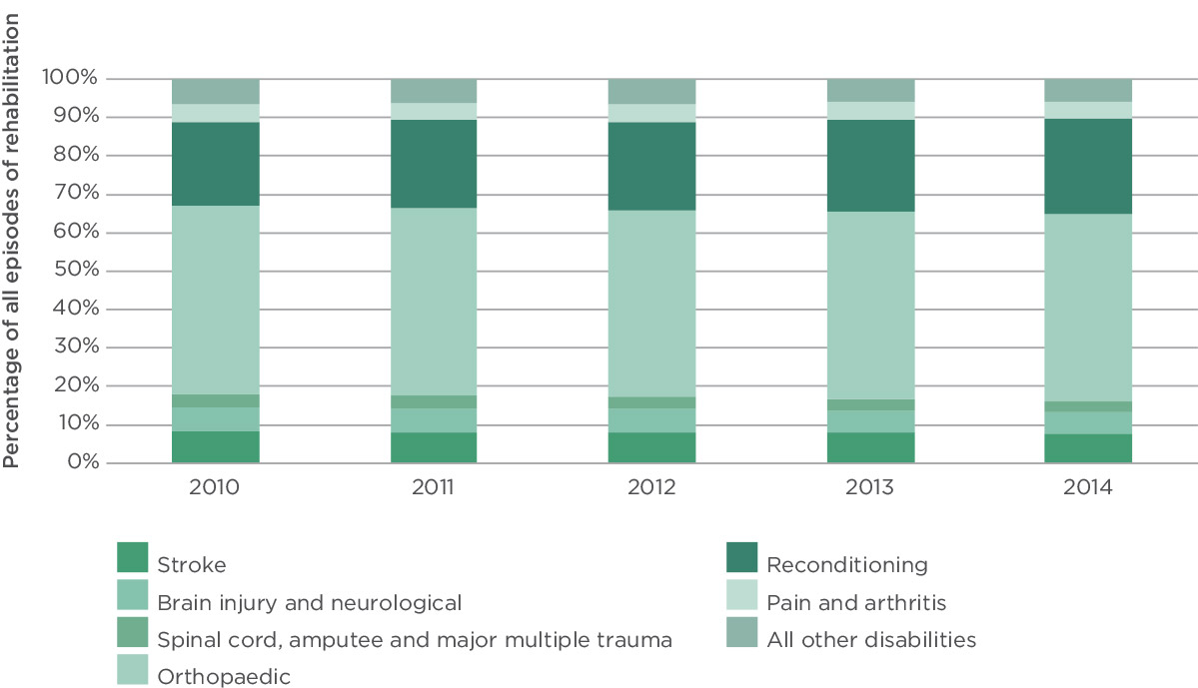

Source: AROC

Figure 22: Average ADL score on admission as a percentage of total score

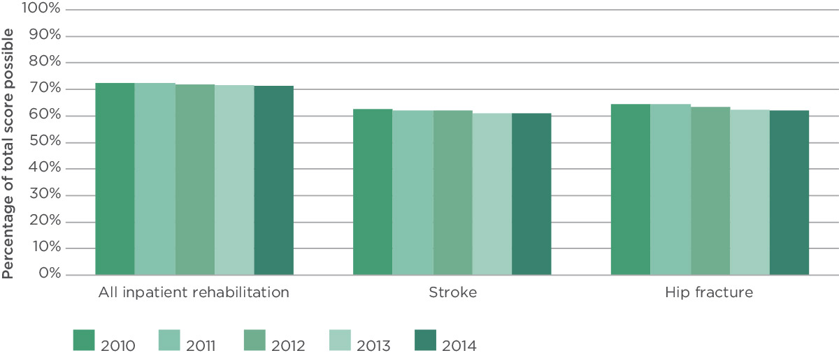

Source: AROC

Many facilities that provide inpatient rehabilitation participate in the Australian Council of Healthcare Standards Clinical Indicator Program. This national clinical dataset aids benchmarking by participating healthcare organisations at a peer and national level. Timeliness of the activities of daily living assessments at the beginning and end of each patient’s rehabilitation stay are two of the six indicators specific to inpatient rehabilitation. Timeliness is important to detect the maximum amount of improvement each patient achieves.

Over the past five years, admission ADL scores have fallen from 72% to 71% (Figure 22). This decrease is probably due to a combination of increasing timeliness of the assessment – from 96% assessed within three days of admission to 98% (Figure 23) – and patients being admitted to rehabilitation earlier than before – from 26% admitted within seven days to 38% (Figure 24).

The overall change in ADL score between the beginning and end of a patient’s inpatient rehabilitation episode has remained constant at about 14% improvement, despite a reduction in length of stay (Figure 25). The overall efficiency in improving functional gain, or independence, has increased from 5.2% per week to 5.5% per week (Figure 26).

Rehabilitation aims to enable people to reach and maintain optimal physical, sensory, intellectual, psychological and social functioning

Figure 23: Percentage of patients assessed for activities of daily living within three days of being admitted to an inpatient ward

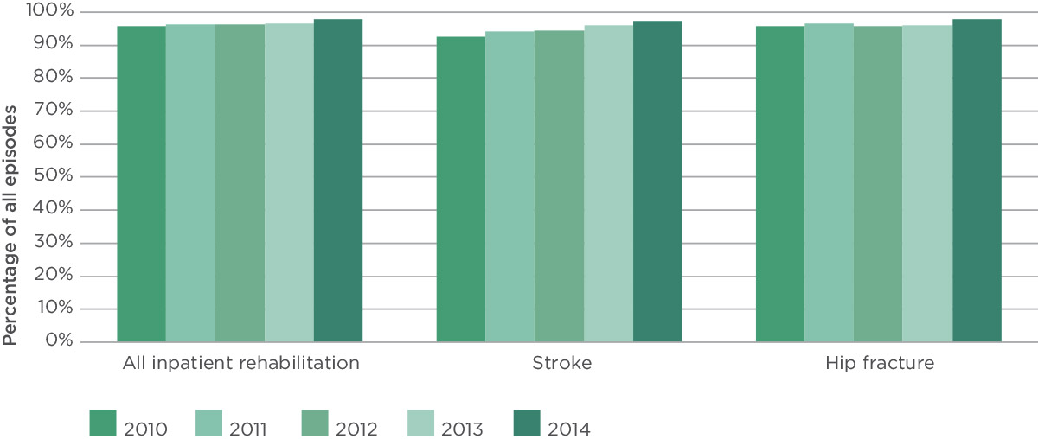

Source: AROC

Figure 24: Percentage of patients admitted to rehabilitation within a week of their injury or onset of symptoms

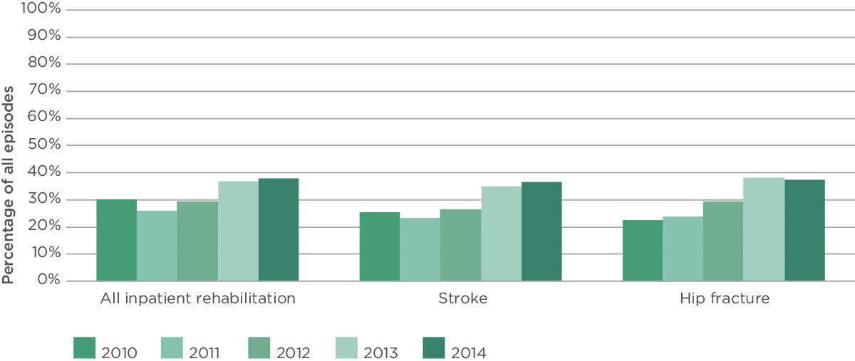

Source: AROC

Figure 25: Average length of stay in inpatient rehabilitation

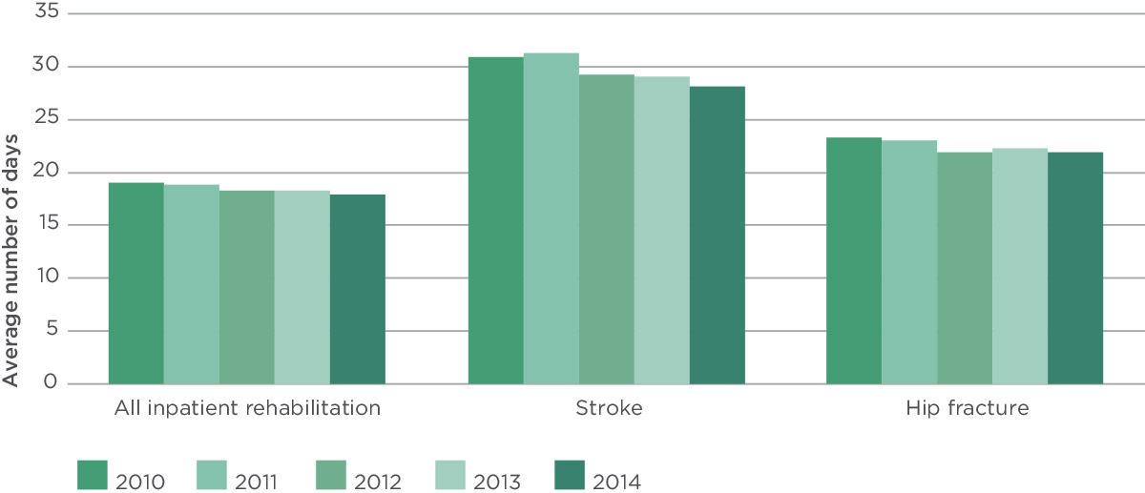

Source: AROC

Figure 26: Average improvement in ADL scores during inpatient rehabilitation episode

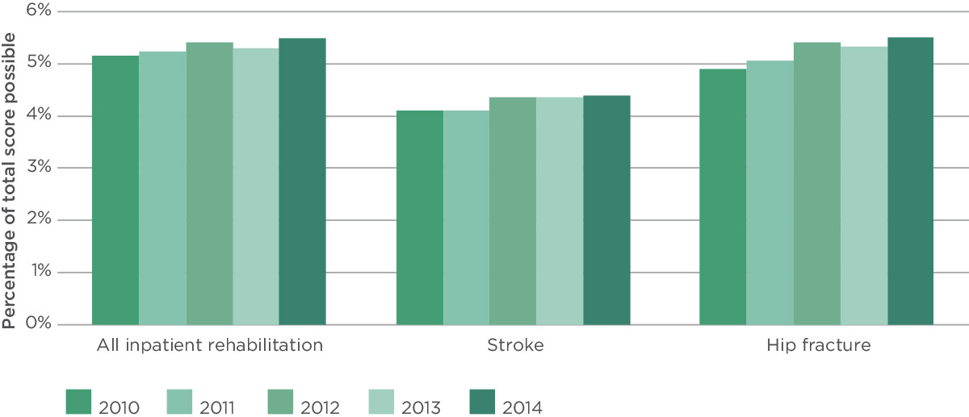

Source: AROC

### Stroke

Stroke is Australia’s second biggest killer and one of the leading causes of disability among adults.116 Almost 90% of patients with stroke will be admitted to hospital following their stroke and over one-third of these will transition to some form of rehabilitation care following their acute care.

Most patients with stroke benefit from rehabilitation, although the most appropriate setting (inpatient or ambulatory) for this care will depend on the individual. In 2014, one in five acute care stroke patients went on to have inpatient rehabilitation. This should begin as early as possible because early intervention is linked to improved health outcomes.117

In 2014, one in three patients started inpatient rehabilitation within seven days of their stroke, an increase of 13% from 2010; and two in three patients started within a fortnight of their stroke, an increase of 23%.

“Seventeen-year-old Andrea J sustained a stroke. She needed help to walk, shower, feed herself and learn to talk again. Three weeks after her stroke, her parents were advised to place her in a nursing home due to her extensive care needs, but they refused to do so. After three months of rehabilitation, she returned home with her family. After a further 12 months of ambulatory rehabilitation at home, she returned to school and eventually trained as a teacher.”

Figure 27: Average ADL item score for stroke patients, 2010–2014

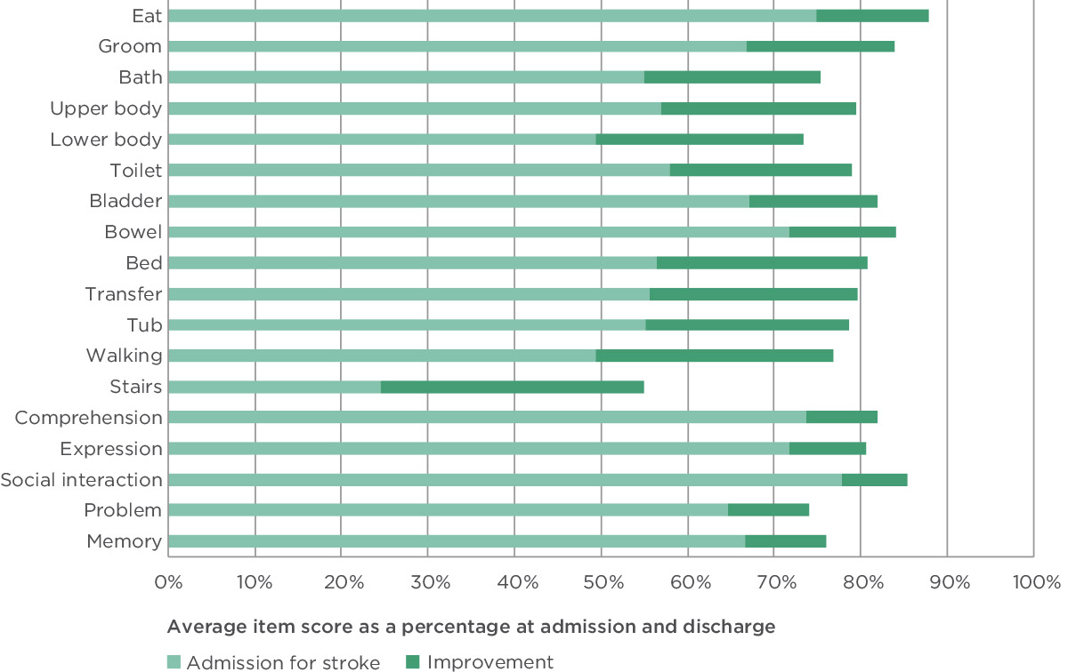

Source: AROC

Rehabilitation for people after a stroke or hip fracture accounts for 15% of all inpatient rehabilitation episodes

Over the past five years, the timeliness of clinical assessments for stroke patients has improved by nearly 5% at the start of rehabilitation (97% of patients are assessed within three days of rehabilitation starting) and 3% at the end of rehabilitation (98% are assessed in the three days prior to discharge from inpatient rehabilitation).

Between 2010 and 2014, the length of stay on the inpatient rehabilitation ward for stroke patients decreased from 31 days to 28 days. Over this same period, the average ADL score at the start of a stroke inpatient rehabilitation episode decreased from 63% to 61%. Almost all patients (95%) improved their ADL score by 23% during the course of their care, achieving a 4.4% increase per week, up from 4.1%. The starting point and rate of improvement varied for each activity of daily living (Figure 27).

Nine out of 10 stroke rehabilitation patients were discharged back to the community: 82% went to a private residence, 12% to residential aged care, and 5% to some other form of accommodation.

Figure 28: Average ADL item score for hip fracture patients, 2010–2014

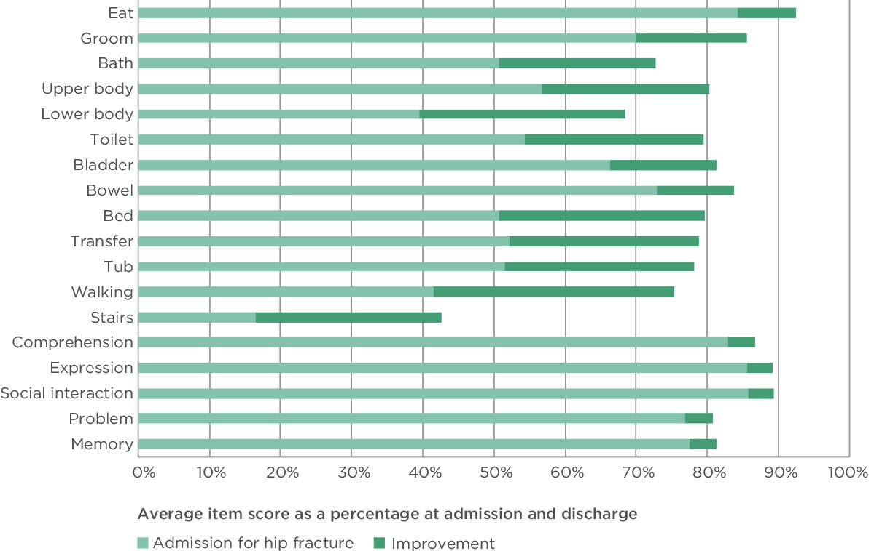

Source: AROC

The impact of rehabilitation can be measured by looking at activities of daily living – both physical and cognitive functioning

### Hip fracture

A hip fracture is a break at the top of the thigh bone. It is the only type of minimal trauma fracture likely to be comprehensively captured in the National Hospital Morbidity Database as it necessarily involves hospitalisation and surgery. Hip fracture is the most serious minimal trauma fracture and is associated with the most complications.118

Hip fractures are a considerable burden on the community and the Australian health system. They occur at a rate of 263 per 100 000 population. They are most likely among those aged 80 and older, with women over two and a half times more likely than men to be hospitalised with a hip fracture.

**38%** of rehabilitation inpatients are admitted within seven days of their hospital stay

“Elsie is a 78-year-old widow who was independent and living alone in Bourke. On her way to visit friends, she slipped and fractured her left hip. She was taken to her regional hospital and her fractured hip was repaired. Post-operatively she was confused and unable to walk. Her son, a busy commercial lawyer, insisted that his mother could not manage at home and should be transferred to rehabilitation. She was sent to Dubbo for rehabilitation as this was the closest service. After three weeks of rehabilitation, she could walk with a frame, was alert and orientated, and was able to return home with the help of community services.”

Between 2002/03 and 2011/12, the number of hospitalisations for hip fracture among people aged 50 and over increased by 22% (from 15 588 in 2002/03 to 19 063 in 2011/12).119

More than 70% of hip fracture rehabilitation patients are female and most are 70 years or older. In 2011/12, 60% of patients aged in their 50s who had a hip fracture went on to inpatient rehabilitation after their acute stay. This declined to one in three patients in their 60s and 70s, and declined further to one in four patients aged in their 80s or older.

In 2014, 37% of patients started inpatient rehabilitation within seven days of their hip fracture, an increase of nearly 15% from 2010; and 70% of patients started within a fortnight of their hip fracture, an increase of 20%. The patient’s age had no impact on timeliness to rehabilitation.

Over the past five years, the timeliness of rehabilitation assessments for stroke patients has improved by 2% at the start of rehabilitation (98% assessed within three days of rehabilitation starting) and by 1% at the end of rehabilitation (98% assessed within three days of discharge).

Length of stay on the inpatient rehabilitation ward for hip fracture has declined by one and a half days to 22 days over the past five years. However the length of stay is slightly longer for older patients: 23 days among patients aged 80 or older, compared with 19 days for patients in their 50s and 60s. This longer length of stay would in part be due to lower ADL scores on admission and more complications during their inpatient rehabilitation care.

Over this same period, the average ADL score at the start of a hip fracture inpatient rehabilitation episode decreased by 2% to 62%. Almost all patients (97%) improved their ADL score by 17% during the course of their care, achieving 5.5% increase per week, up from 4.9%. The starting point and rate of improvement varied for each activity of daily living (Figure 28).

When looking at discharge rates, 85% of hip fracture rehabilitation patients were discharged back to the community: 79% went to a private residence, 14% to residential aged care, and 7% to some other form of accommodation.

### Implications

The volume of rehabilitation episodes has been steadily increasing over time, partly due to the ageing of the population, and partly due to the fact that the community is better educated, more aware that rehabilitation may allow them to remain independent for longer, and less willing to accept dependence. While the health sector places significant focus on acute care, and downstream on community care, it is rehabilitation that often provides the glue between those two sectors. In attempting to ensure an efficient and effective distribution of a limited budget, the health sector is actively encouraging people to maintain their independence for as long as possible. Rehabilitation plays a significant and important role in achieving this.

In many ways AROC is unique — it is supported by the entire rehabilitation sector, it covers the vast majority of inpatient rehabilitation episodes in both the public and private sectors, and it uses an agreed and clinically endorsed standard outcome measure. Because of this it can, and does, benchmark rehabilitation services across the country and systematically measures trends in clinical practice. This in turn improves understanding of factors that influence rehabilitation outcomes and costs and therefore performance of the sector.

### What we do not know

In Australia, no single source of information covers all aspects of rehabilitation care, including inpatient and ambulatory. The current AROC dataset has the ability to collect information on these various care pathways; however most participating facilities still only submit data for inpatient rehabilitation. AROC is starting to report more ambulatory rehabilitation. Other than AROC, sources of information about rehabilitation services are few and generally limited to individual impairments, such as reports produced by the Stroke Foundation.117 In addition, AROC is yet to be in a position to benchmark paediatric rehabilitation services.

### Acknowledgements

The data presented in this case study are from AROC’s data warehouse. AROC is a medical rehabilitation care clinical registry funded by participating facilities and funders of rehabilitation medicine. AROC provided the content and analysis for this chapter, and the Commission gratefully acknowledges the contribution of:

* the many staff from the rehabilitation facilities who have spent a great deal of time and care collecting, collating and correcting the data, and without whose considerable effort it would not have been possible to present the data in this case study
* Australasian Faculty of Rehabilitation Medicine
* Australian Rehabilitation Alliance, which provided the vignettes used in this case study112
* AROC staff.

**23%** improvement in activities of daily living score for stroke patients from beginning to end of rehabilitation

**17%** improvement in activities of daily living score for patients with a hip fracture from beginning to end of rehabilitation

## High priority complications

There are many possible methods for conceptualising and measuring the way in which health care can cause unnecessary harm to patients. One of the most common is through the voluntary or mandatory reporting of patient safety incidents. Hospitals capture information on incidents and near misses to monitor and improve patient safety. These systems are important for understanding the types of problems that can occur in hospital. However, they are less useful for understanding how often unnecessary harm occurs, and the impact it has on the organisation, as they have been repeatedly shown to report fewer patient safety incidents compared to audits of clinical records.120

Another source of information about unnecessary patient harm is administrative data, which is a summary of a patient’s hospital stay that has been coded according to their condition and what happened to them in hospital. All people who are admitted to hospital have information about their stay coded in this way. Administrative data underestimates the true rate of harm because it relies on the way information is recorded in the patient’s notes and how these notes are coded.121 However, this administrative data is a useful source of information about patient safety as it is routinely collected as part of every person’s stay in hospital, and does not require any additional data collection processes. There are also opportunities to improve these practices of recording and coding to draw a more accurate picture of patient safety in hospitals.

The Commission has been working with the Independent Hospital Pricing Authority to support hospitals in using administrative data to improve patient safety. As part of this process, a panel of senior clinical experts from a range of specialities and professions identified a set of the highest priority complications of care. These complications are events that occur during a patient’s stay in hospital that cause harm to the patient and that should be prevented. The complications were agreed by the panel based on an assessment of how preventable the complication was, how important it was clinically, and the severity of impact on the patient and the health service.122 The 33 high priority complications (HPCs) identified as part of this process fell into 13 groups:[2]

The groups include:

* pressure injuries
* falls resulting in fractures and intracranial injuries
* healthcare associated infections
* respiratory complications
* venous thromboembolism
* renal failure
* gastrointestinal bleeding
* medication complications
* delirium
* persistent incontinence
* malnutrition
* cardiac complications
* iatrogenic pneumothorax requiring intercostal catheter.

### Why is it important?

Estimates of the proportion of patients who experience patient safety incidents in hospital range from 3% to 15% of admissions.26, 123, 124, 125 The variation occurs because of differences in definitions and methods of collecting information. Even if the lower, more conservative rate of 3% is used, this means that almost 300 000 people would have been affected by a patient safety incident in hospital in 2013/14 in Australia.126

Patient safety incidents can be associated with adverse outcomes for the patient, such as pain, delays in care, short-term or permanent disabilities (both physical and psychological) and death. They can also be associated with increased healthcare costs due to longer hospital stays, additional treatments and readmissions.

The 33 HPCs that have been identified represent conditions that occur in hospital that have a significant impact on the patient and the health service, and that should be prevented. Understanding the costs that these HPCs add to the health system will help to identify potential areas to improve outcomes for patients, and improve the efficiency and sustainability of the health system.

### Findings

To examine this issue in more depth, the Commission engaged Deloitte Access Economics to analyse the burden of HPCs in public hospitals in Australia. The results of this analysis are the basis for the information presented in this chapter.

The analysis was based on ‘separations’ from public hospitals in Australia in 2011/12. A separation is an episode of care when a patient is admitted. It can be the total hospital stay (from admission to discharge, transfer or death), or a portion of a hospital stay beginning or ending in a change in the type of care (such as from acute care to rehabilitation).126

The analysis looked at separations where an HPC occurred while patients were in hospital, and compared the cost and length of their stay with that of patients who were in hospital for the same condition, but did not have an HPC. That is, the analysis looked at the additional cost caused by the HPC above the separation cost, had the HPC not occurred. This analysis controlled for the age of the patient. Information about the data used in the analysis is provided in Box 20.

### Types of high priority complications

In 2011/12, there were 82 659 separations in Australia with an HPC; 2% of all public hospital separations in Australia for which information was available.

Healthcare associated infections were the most common type of HPC (Figure 29). More than one-third (37%) of all HPCs were infections – almost 1% of all separations. Approximately half of these infections were urinary tract infections and pneumonia. Cardiac complications – particularly arrhythmias – were also relatively common, comprising 26% of all HPCs. Delirium and pressure injuries were the next most common HPC groups; the remaining nine HPC groups comprised 18% of the total HPCs, and each group accounted for less than 0.15% of all separations.

High priority complications are events that occur during a patient’s hospital stay that cause harm to patients, and that should be prevented

**52%** of the cost of high priority complications related to infections

Box 20: Sources of data used in the analysis

The primary source of data for the analysis was the National Hospital Costs Data Collection (NHCDC) 2011/12, provided by the Independent Hospital Pricing Authority. The NHCDC is an annual collection of public hospital data and contains component costs per diagnosis-related group (DRG) based on patient-costed and cost-modelled information. The analysis is restricted to public hospitals in Australia.

As the NHCDC is a voluntary collection, not all hospitals in scope are included in a given financial year. To estimate patient harm for all public hospitals in Australia, the analysis using the NHCDC dataset was extrapolated to all acute public hospital separations using aggregated data published in Australian hospital statistics 2011–12.

To determine the number of public hospital separations that involved a complication (whether or not it was a HPC), the NHCDC has a condition onset flag. For each amenable code assigned to a separation, the condition onset flag is set to reflect whether the condition was present on admission.

From this, those separations with a condition onset flag were categorised using the set of HPCs. In 2011/12, coding standards for the condition onset flag for reporting to the NHCDC were not fully implemented across all states and territories. As such, the analysis was based only on those hospitals that had condition onset flag information in the NHCDC.

The cost was estimated separately for each category of HPC, for each DRG.

### Cost of high priority complications

The cost of an HPC varied by complication group. Across all groups, the average cost of a HPC was $7751.

Renal failures were the most costly on average, at just over $15 000 per HPC (Figure 30). This was followed by respiratory complications, iatrogenic pneumothorax and pressure injuries. On average, these most expensive HPCs cost the health system $10 000 every time they occurred. This is almost double the burden of cardiac complications, falls and delirium, which had an average cost of less than $5500 for every HPC.

**$7751** average cost of a high priority complication

Patient safety incidents can be associated with adverse outcomes for the patient and increased costs for the health service

Figure 29: Rates of HPC by complication group

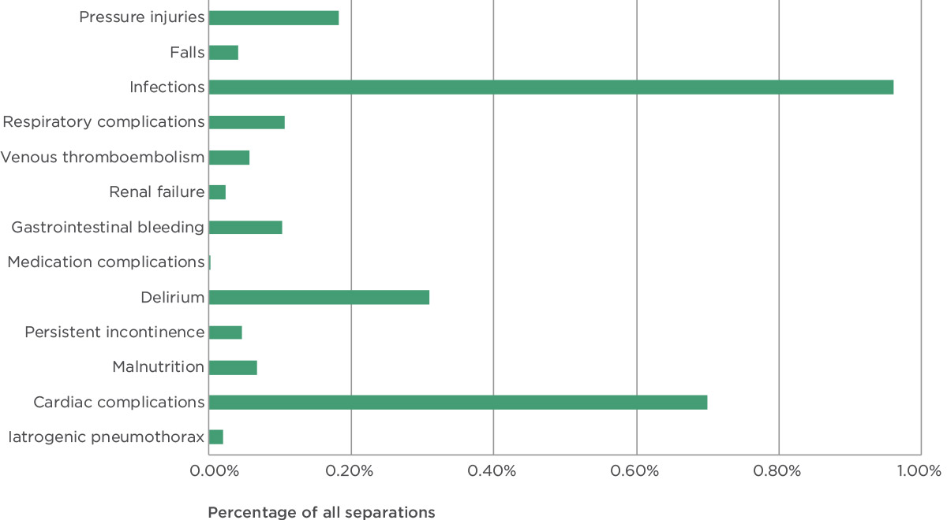

Source: ACSQHC, 2015.

Another way to look at the burden of HPCs is to look at the impact that they have on the number of days people spend in hospital. This is known as excess bed days, as people with an HPC generally spend longer in hospital than people with the same condition who do not have an HPC. Pressure injuries and infections were responsible for most excess bed days, with each complication leading to an increased length of stay of just over eight days on average (Figure 31). Respiratory and cardiac complications had the smallest impact on bed days.

**$973m** the total cost of all high priority complications in 2011/12

Figure 30: Average cost per complication by complication group

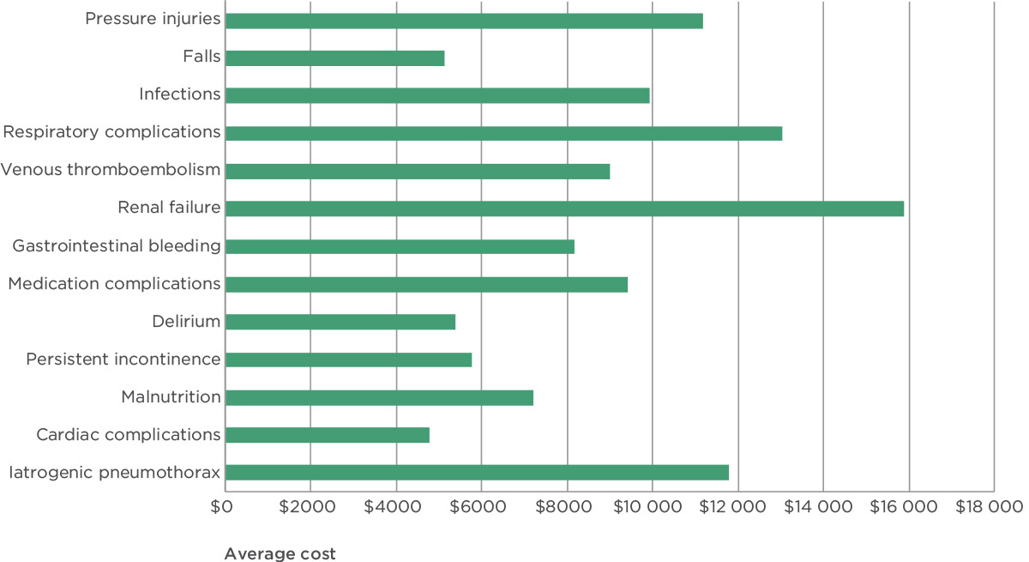

Source: ACSQHC, 2015.

The total cost of HPCs was estimated by multiplying the cost per complication for each HPC group by the number of HPCs in each group. The total cost of HPCs was estimated to be more than $973 million, over 4% of the total cost of public hospital separations in 2011/12. Infections were responsible for the majority of the additional costs associated with an HPC, accounting for 52% of the total cost of HPCs, or just over $501 million (Figure 32). Cardiac complications and pressure injuries were also significant, responsible for $135 million and $81 million respectively. In comparison, despite their relatively high cost per complication, the total cost of medication complications and iatrogenic pneumothorax were significantly lower, at $0.94 million and $5.76 million respectively (Figure 33).

**82 659** the number of separations with a high priority complication in 2011/12

Figure 31: Average excess bed days by complication group

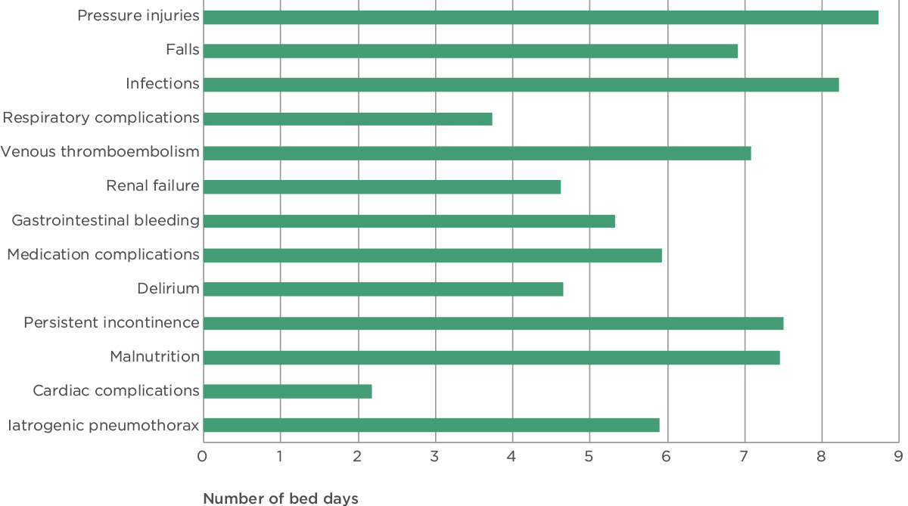

Source: ACSQHC, 2015.

The total impact of HPCs on length of stay was estimated to be more than 690 000 bed days, approximately 4% of all bed days in Australian public hospitals in 2011/12. The distribution of excess bed days across the HPC categories mirrors the distribution for financial cost, with infections having the biggest impact (accounting for more than half of the total increased length of stay), and medication complications and iatrogenic pneumothorax the smallest.

### Implications

This analysis shows that HPCs places a burden on health services in terms of both financial costs and excess bed days. Reducing the number of HPCs by 5%, 10% or 25% would potentially have an impact of $48.7 million, $97.3 million or $243.3 million respectively; or 34 500, 69 000 or 172 500 bed days.

It is important to note that in practice a reduction in complications may not necessarily translate into cashable cost savings to hospitals or the health system. Because public hospitals generally operate at close to capacity, the impact of reducing HPCs on length of stay is particularly important. When excess bed days are reduced, capacity increases within hospitals, flow of patients improves, and delays and waiting lists may be reduced.

Figure 32: Total financial cost of HPCs by complication group

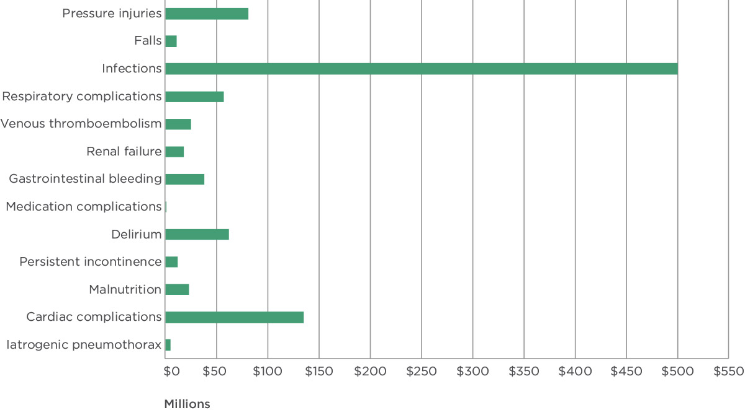

Source: ACSQHC, 2015.

### What we do not know

Tracking the HPCs relies on staff members documenting occurrences of complications in patient notes, and coding complications in the administrative dataset. This documentation and coding is not always complete, and so this administrative data may not represent the full picture of all HPCs that occur in hospitals. The Commission is examining the way HPCs are documented and coded, and testing improvements in practice.

In addition, the HPCs included in this analysis are only a small subset of all possible complications. While one of the criteria used to identify the HPCs was how preventable they are, in practice many factors contribute to the occurrence of a HPC. Assessment of preventability is difficult, and it may be that some HPCs are more preventable than others.

Work is underway across Australia to address the patient safety issues that are reflected in the burden associated with the occurrence of a HPC. The NSQHS Standards (page 6) include requirements about some of these areas, including infections, falls, pressure injuries and medication safety. The data used in this analysis are from 2011/12, before the introduction of the NSQHS Standards. It is not known whether the introduction of the NSQHS Standards has affected the number of HPCs. The early changes that have occurred in other areas following the introduction of the NSQHS Standards suggest that this is possible.

**37%** of all high priority complications were infections

The Commission’s clinical care standards address some other areas with high costs associated with HPCs, including cardiac complications and delirium. A clinical care standard relating to acute coronary syndrome (one of the HPCs included in the cardiac complications category) was released in late 2014, and work is underway to develop a clinical care standard for delirium. The clinical care standards include quality statements describing the care that should be offered to patients, and which is in line with the best available evidence. Provision of care in accordance with the clinical care standards should also reduce the occurrence of HPCs.

Figure 33: Total cost of HPCs by category

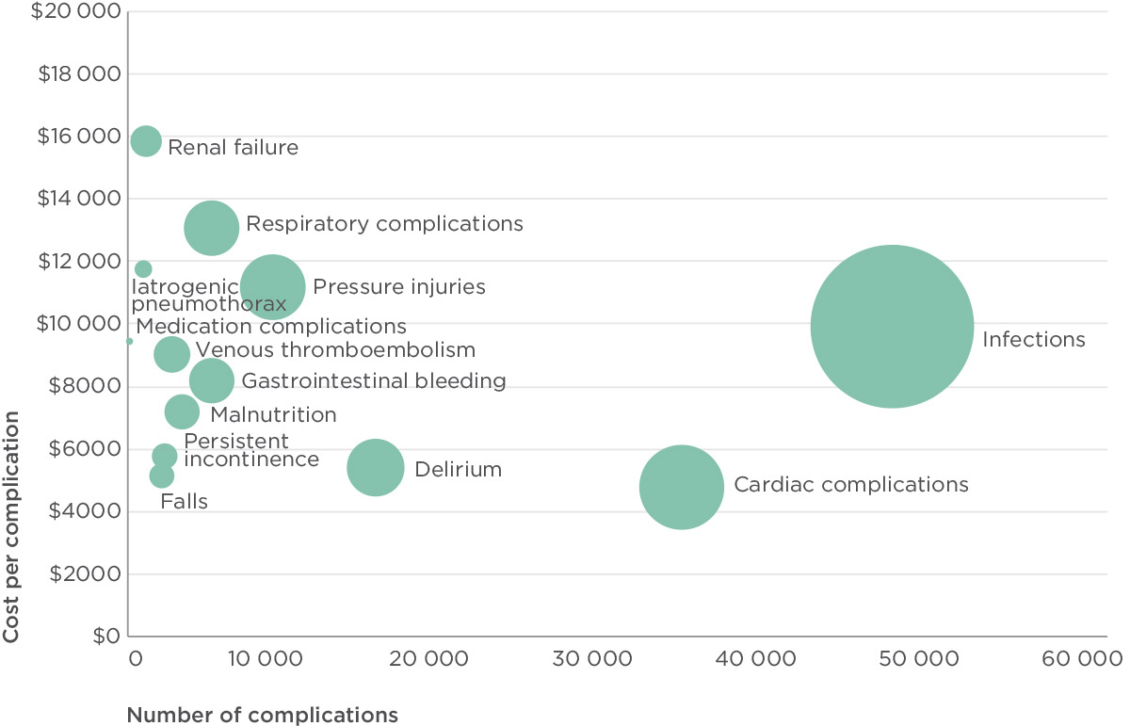

Source: ACSQHC, 2015.

## Healthcare variation

People with the same health concerns or problems do not necessarily receive the same health care. Depending on where they live, or which health service or healthcare provider they consult, they may end up receiving different types of treatment. Variation in health care occurs in health systems all around the world, including in Australia.127

Some variation in health care is expected and warranted. For example, people living in one area may have different healthcare needs from those living in a different area. Variation in health care may also reflect differences in people’s preferred treatment options, or their cultural or personal preferences.

However, some healthcare variation is unwarranted, particularly when it cannot be explained by the patient’s needs or preferences. Unwarranted variation may indicate that some patients are not receiving the most appropriate or effective care, or that resources are not being put to the best use. For example, some patients might receive health care that is of little benefit to them, while others may miss out on tests or treatments that could help.

### Why is this important?

In 2013/14, Australia participated in an international study on healthcare variation led by the OECD. This study identified three-fold variation in the occurrence of some common procedures in different parts of Australia.128

It is not known whether the variation identified in this study was warranted or unwarranted. However, the study also identified that some of these procedures occurred more commonly in Australia than in other countries.128 The rate of occurrence of procedures per 100 000 people is known as the treatment rate, and as a whole Australia had higher treatment rates for a number of procedures than many of the other countries participating in the study. This suggests that it would be worthwhile further examining the health variation identified within Australia.

As well as affecting whether a patient receives the right care, unwarranted variation can affect costs in the healthcare system. If people are receiving unnecessary treatments, this results in unnecessary costs; reducing the rate of unnecessary treatments can lead to improved value.128

### Findings

To examine this issue in more depth, the Commission engaged Deloitte Access Economics to analyse the impact of reducing aspects of healthcare variation in Australia in seven common, discretionary procedures. The results of this analysis are the basis for the information in this chapter. The analysis estimated the potential changes in expenditure and improvements in value generated by aligning high treatment rates for these interventions to various benchmark, or competitor rates.[3]

The analysis was based on a recent OECD-led international study of healthcare variation, and the seven procedures were based on that study. They are:128

* coronary artery bypass grafting (a heart bypass operation)
* percutaneous transluminal coronary angioplasty (a procedure to open blocked vessels in the heart)
* cardiac catherterisation (an invasive diagnostic procedure to examine blocked blood vessels in the heart)
* knee replacement
* knee arthroscopy
* Caesarean section
* hysterectomy for women without a diagnosis of cancer.

As there are known differences in the likelihood of people of different genders and ages requiring health care, the analysis took into account differences in age and sex. However, the analysis did not control for differences in socioeconomic status, which may also affect the use of certain procedures.

The analysis used the difference in treatment rates for each of these procedures relative to an average benchmark rate as the primary measure of interest. Data from both public and private hospitals were used in the analysis. The difference in treatment rates between Australia and the various benchmark rates was multiplied by the cost of the procedure in Australia to estimate the potential change in expenditure.

One of the difficulties in looking at healthcare variation is knowing what level of variation is acceptable, and what is unwarranted. The correct treatment rate for each procedure, and whether the treatment rate can be reduced in Australia is not known. In this analysis, a better understanding of the variation in treatment rates in Australia was achieved by comparing actual rates compared to four different rates in the following scenarios:

* aligning Australian treatment rates with treatment rates in other countries
* aligning rates in Australian regions with the national average
* aligning rates in Australian regions with the average of a regional peer group
* reducing Australian treatment rates by 10% and 25%.

**$1.63B** the value of potential improvements from aligning treatment rates with the international average

People who have the same health concerns and problems do not necessarily receive the same health care

**$174.2** million: potential improvements in value from aligning high regional treatment rates with their peer group average

### Scenario 1: Aligning Australian rates with other countries

The first scenario compared Australian average treatment rates with those in 11 other countries, being Canada, the Czech Republic, Finland, France, Germany, Israel, Italy, Portugal, Spain, Switzerland and the United Kingdom. The average international treatment rate was calculated for each procedure and compared with the rate in Australia.

Australia has high treatment rates relative to other international healthcare systems, with a higher-than-average treatment rate in all procedures analysed. Australia was in the top three highest rates in four of the seven procedures. Cardiac catheterisation rates in particular are much higher in Australia (Figure 34).

Figure 35 shows the potential improvements in value if Australia’s treatment rates were brought into line with the average international rate. The gap between the two coloured bars for each procedure represents the change in expenditure associated with the difference in Australia’s treatment rates compared to the average of the countries included in the analysis.

Although cardiac catheterisation rates in Australia are relatively high, the cost of these procedures is low compared to the costs of the other procedures.

Figure 34: Treatment rates per 100 000 population

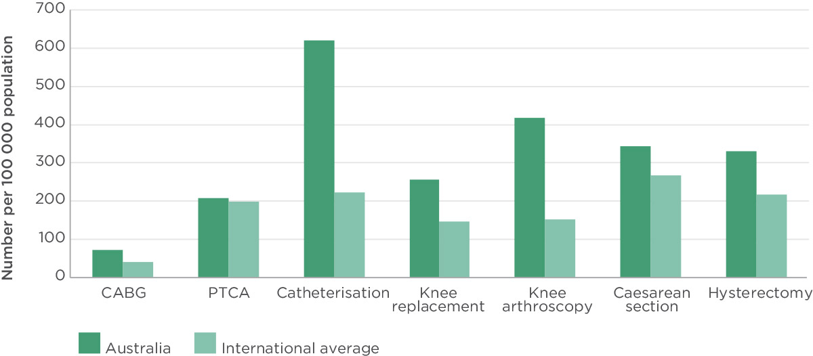

Source: ACSQHC, 2015.

Note: Treatment rates for caesarean sections were calculated per 1000 live births, and hysterectomy rates were calculated per 100 000 women.

As a result, despite the disparity in treatment rates, cardiac catheterisations were not a major driver of expenditure. Conversely, while the difference in treatment rates of coronary artery bypass grafts and caesarean sections are not striking in Figure 34, the high unit cost of each procedure means much higher expenditure overall.

Knee replacements, knee arthroscopies and hysterectomies are the procedures that generate the largest differences in expenditure in Australia. A reduction in treatment rates to the international average for these three procedures would lower expenditure in Australia by $1.15 billion, which is 70% of the potential reduction in expenditure across all seven procedures ($1.63 billion).

Figure 35: Potential improvements in value of aligning Australian treatment rates with average international treatment rates

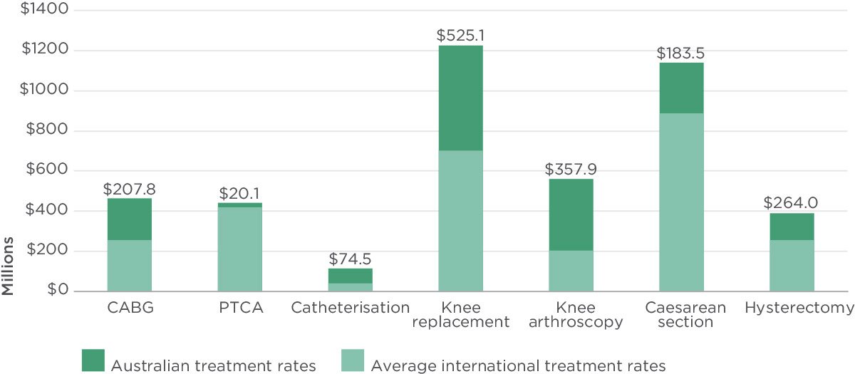

Source: ACSQHC, 2015.

### Scenario 2: Aligning higher Australian regional rates with the national average

In the second scenario, Australian regional treatment rates for each procedure were compared to the average treatment rate. The regions used in the analysis were based on 61 geographic areas, known as Medicare Locals, and the populations living within their boundaries. Medicare Locals were regional organisations that were established to coordinate the delivery of services by healthcare providers and community organisations, and to address local needs and gaps. They were replaced in July 2015 with PHNs.

The analysis estimated the potential improvements in value from aligning treatment rates in regions above the national average with the national average for each procedure.

When higher than average regional treatment rates were aligned to the national average, it was estimated that the changes in expenditure would be up to $211.3 million across the seven procedures (Figure 36). The largest changes were in the areas of knee replacements, caesarean sections and knee arthroscopies. The potential improvement in value in this scenario is less than when Australian treatment rates are compared with international rates because variation within Australia is significantly less than the differences between Australia and international rates.

There is threefold variation in some common procedures in different parts of Australia

Figure 36: Potential improvements in value from aligning regional treatment rates in upper half to the average regional rate

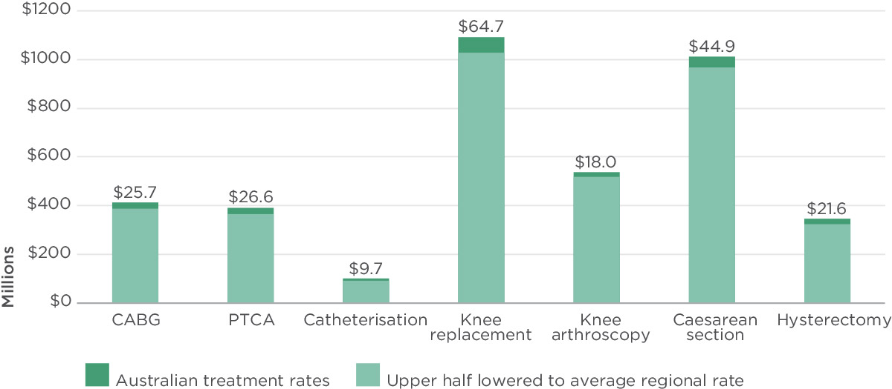

Source: ACSQHC, 2015.

Figure 37: Potential improvements in value by reducing treatment rates by 10%

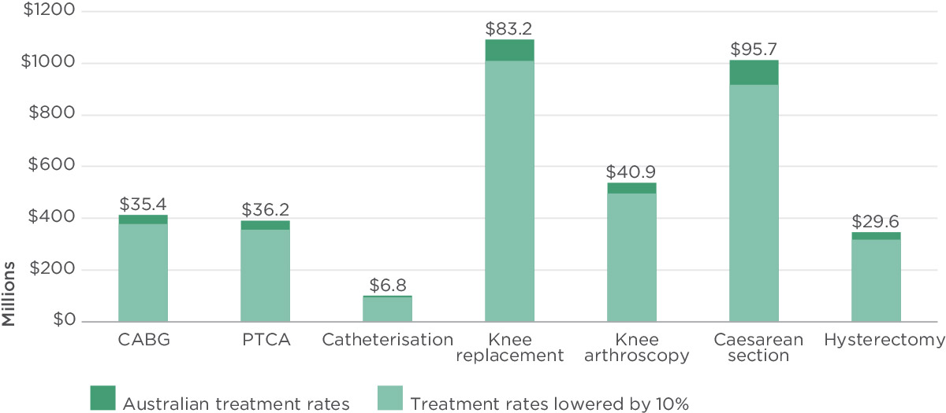

Source: ACSQHC, 2015.

### Scenario 3: Aligning Australian regional rates by peer group

Observed healthcare variation may be driven by differences in service availability and socioeconomic status between metropolitan, regional and rural areas. One way of addressing these factors is to look at the variation in treatment rates within peer groups of Medicare Locals. The 61 Medicare Locals can be grouped into seven peer groups based on their proximity to major metropolitan cities, proximity to major hospitals and socioeconomic status. Looking at the variation within each of these peer groups provides an understanding of variation within a group of regions that are relatively alike.

This analysis estimated the potential improvements in value associated with aligning Medicare Local regions with higher-than-average treatment rates to the average treatment rate within their peer group.

Across peer groups, the changes in expenditure from moving regional rates to average rates within peer groups was estimated to be $174.2 million. The largest changes were in knee replacements and knee arthroscopy.

### Scenario 4: Reducing Australian treatment rates by fixed percentages

Given the high treatment rates in Australia relative to other healthcare systems, it is possible that treatment rates are higher than is optimal in all areas. This scenario estimated the potential improvements in value from reducing treatment rates for each procedure by 10% and 25% respectively.

The change in expenditure that would result from a 10% cut in treatment rates across all procedures was estimated to be $329.8 million (Figure 37). For a 25% reduction, the change was $824.6 million (Figure 38).

Figure 38: Potential improvements in value by reducing treatment rates by 10%

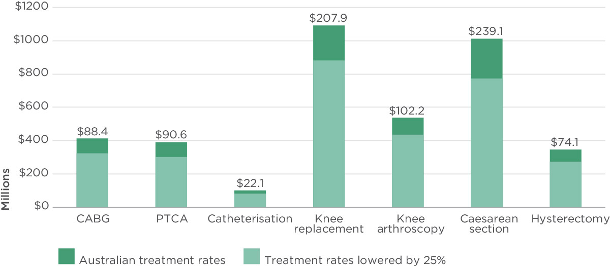

Source: ACSQHC, 2015.

Unwarranted variation can increase costs in the healthcare system

**$824.6** million: potential improvements in value from reducing treatment rates by 25%

### Implications

Substantial improvements in value for health care can be generated by aligning treatment rates for several hospital interventions with various benchmarks. The figures provided here are estimates only. Without optimal treatment rates that are based on observed outcomes, it is not possible to identify what proportion of variation in Australia is unwarranted and could therefore be reduced.

Even so, the results of this international OECD-led study indicate that Australia has high variation in, and aggregate treatment rates for, the procedures examined compared with other developed countries. If some of the variation in these seven procedures is unwarranted, then some reduction in the number of these procedures, and the associated reduction in costs and expenditure, may be achieved without adversely affecting patient outcomes and population health.

This analysis found that the greatest potential for improvements in value for health care occurred when Australian treatment rates were aligned with international rates, and the smallest occurred when analyses were based on regional peer groups (Figure 39). This indicates that the treatment rates for these procedures are relatively high across Australia compared to other countries, suggesting that action may be warranted to bring Australian treatment rates in line with the average of other OECD countries.

A number of approaches can be taken to address unwarranted variation. Building on the information from the OECD study, the Commission will soon release a larger atlas of variation for Australia that provides information about variation in a range of procedures and treatments. Information from this atlas will help to identify areas that need to be explored to establish why variation exists. For example, based on the results of the OECD study, the Commission established a Knee Pain Working Group to discuss the high levels of variation in knee arthroscopies and knee replacements. This working group will develop strategies and resources that will help to reduce unwarranted variation in these areas.

As a whole, Australia has higher treatment rates for a number of procedures than many other OECD countries

**$228.3** million: potential improvements in value from aligning high regional treatment rates with the Australian average

### What we do not know

Evidence does not identify clear optimal, or benchmark, rates for the procedures examined in this study. It is therefore difficult to assess if the observed inter- or intra-country variation is warranted or unwarranted. Therefore, the estimates of potential reductions in expenditure are approximations only.

This analysis focused only on treatment rates, and assumed a constant unit cost for each procedure to estimate the potential reductions in expenditure if treatment rates were decreased. However, some variations in costs of treatment should also be accounted for. In addition, it is likely that treatment rates and costs are interlinked, although they have been treated as independent in the analysis. It is unclear whether reducing treatment rates would be likely to increase the cost of procedures (leading to the estimates in this analysis being overstated) or decrease the cost of procedures (leading to estimates being understated).

Figure 39: Estimates of improvements in value, by scenario

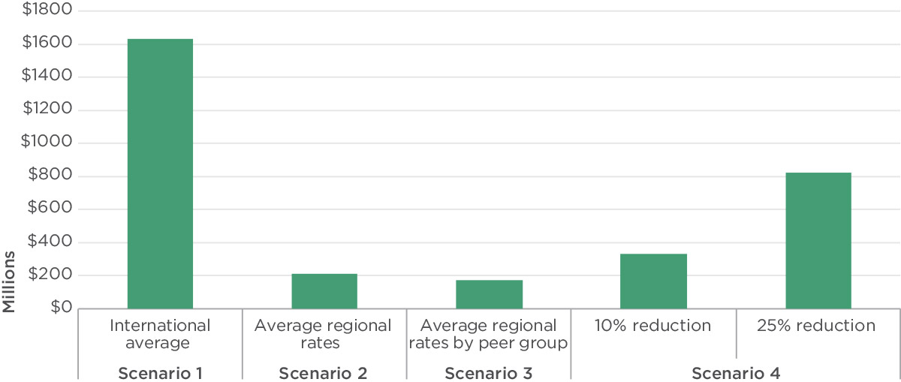

Source: ACSQHC, 2015.

**$329.8** million: potential improvements in value from reducing treatment rates by 10%

# **05** Conclusion

Safety and quality is a complex field that is integrated into all aspects of health care. Many people and organisations are involved in making sure that people who receive health care in Australia are safe and that the care is of high quality.

This means no single source of data can provide comprehensive information about the safety and quality of the Australian healthcare system. In Vital signs 2015, information is provided about 17 separate safety and quality topics that draw on data from a wide range of sources. Together, this information paints a picture about the work being done in Australia to improve safety and quality of health care.

Two of the case studies in Vital signs 2015 highlight the burden that preventable complications and healthcare variation place on the health system. These results align with other research about the costs of patient safety lapses,129 as well as the potential to reduce costs through implementing quality improvement initiatives.130

Vital signs 2015 describes work being done to improve safety and quality across a range of different areas, from monitoring the occurrence of resistant bacteria to improving communication between patients and healthcare providers; and from standardising medication charts in hospitals to improving the care patients with chronic conditions receive in general practice. This work has the potential to reduce the occurrence of patient safety incidents, increase the delivery of care that complies with evidence-based guidelines, and support the involvement of patients in making decisions about their own care. All of these outcomes also have the potential to reduce costs and free up capacity in the healthcare system.

Underpinning much of this work are the NSQHS Standards, which provide a systems-based approach to improvement across the health sector. By the end of 2015, all hospitals and day procedure services will have been assessed to the NSQHS Standards, and the use of the NSQHS Standards as a framework for quality improvement in other types of services is increasing. A comprehensive evaluation of the impact of the NSQHS Standards is underway, and early results indicate that they have had an impact on the processes of health care and outcomes for patients. Feedback from healthcare providers and managers who have been responsible for implementing systems to meet the NSQHS Standards has been positive about the way that they have helped to transform the culture of health services to be focused on patient safety.

This kind of systems-based approach is also being taken with another important initiative of the Commission that is described in Vital signs 2015. Antimicrobial resistance has the potential to significantly hamper the delivery of effective health care in the future. Essential to tackling antimicrobial resistance is information about the magnitude, distribution and impact of resistant organisms, and use of antimicrobials. Currently, the surveillance framework in Australia is fragmented, leading to gaps in knowledge and limiting the ability for effective planning and priority setting.14 To address this gap, Australia’s first national antimicrobial resistance strategy was released in 2015. The Australian Government Department of Health has funded the Commission to work with the states and territories, the private hospital sector, and diagnostic and pathology organisations to establish a new, national surveillance network Developed within the AURA project, this new system will collect information about antimicrobial resistance and antibiotic use in hospitals, the community and residential aged care settings. Information from the surveillance network will be reported publicly and used to inform clinical and public health decision making.14 This surveillance network will support achievement of the objectives of the national antimicrobial resistance strategy.

Vital signs 2015 also includes information about a number of new topics where a systems-based approach can also bring improvements in safety and quality, particularly through the vehicle of the NSQHS Standards. The review of the NSQHS Standards and the release of a new version in 2017 provide an opportunity to address important safety and quality issues for Indigenous people, for people with mental illness or cognitive impairment, and for people at the end of life. There has been significant investment in a range of different initiatives and programs in these areas over many years. While this investment has brought successes, the Commission has identified that there are still gaps, and that people in these groups have particular safety and quality risks that are not always addressed. Because the NSQHS Standards are mandatory for hospitals and day procedure services, the Commission recognises that decisions to include additional topics need to be made carefully. However, the Commission also considers that these are such important national safety and quality priorities that they should be addressed in the NSQHS Standards. Integrating these issues into the NSQHS Standards will increase the investments that have already been made and focus attention in health services on the need to put systems and strategies in place to address them.

For the first time, in Vital signs 2015, topics that specifically relate to primary care have been included. Much of the Commission’s work, and many of the topics that have been included in Vital signs since 2013, are broadly applicable in primary care, including antimicrobial resistance, healthcare variation, communication and caring for people with cognitive impairment. However, the unique nature of primary care and the importance of this sector to the community mean that it is also important to understand the particular safety and quality issues relevant to this environment. A systems-based approach may also improve safety and quality in this sector.

The Commission will continue working with its partners – patients, families and carers, consumer groups, healthcare providers, managers, executives and policy makers – to improve the care, experiences and outcomes for people in the health system in Australia. It is only through such partnerships sustainable change and better care can be achieved.

# References

1. OECD. Health at a Glance: OECD Indicators. Paris: OECD, 2013.
2. Thomson S, Osborn R, Squires D Jun M. International Profiles of Health Care Systems. New York: Commonwealth Fund, 2013.
3. Australian Commission on Safety and Quality in Health Care. National Safety and Quality Health Service Standards. Sydney: ACSQHC, 2011.
4. Australian Commission on Safety and Quality in Health Care. Patient-centred Care: Improving Quality and Safety Through Partnerships with Patients and Consumers. Sydney: ACSQHC, 2011.
5. Australian Commission on Safety and Quality in Health Care. National Safety and Quality Health Service Standard 2: Partnering with Consumers – Embedding Partnerships in Health Care. Sydney: ACSQHC, 2014.
6. Australian Commission on Safety and Quality in Health Care. Vital Signs 2014: The State of Safety and Quality in Australian Health Care. Sydney: ACSQHC, 2014.
7. World Health Organization. The Evolving Threat of Antimicrobial Resistance – Options for Action. Geneva: WHO, 2012.
8. Centers for Disease Control. Antibiotic Resistance Threats in the United States. Atlanta: CDC, 2013.
9. European Centre for Disease Prevention and Control. Antimicrobial Resistance Surveillance in Europe 2013. Annual Report of the European Antimicrobial Resistance Surveillance Network (EARS-Net). Stockholm: ECDC, 2014.
10. Espedido BA, Partridge SR and Iredell JR. *bla(IMP-4)* in different genetic context in *Enterobacteriaceae* isolates from Australia. Antimicrobial Agents and Chemotherapy.2008; 52: 2984–7.
11. Espedido BA, Steen JA, Ziochos H, et al. Whole genome sequence analysis of the first Australian OXA-48-producing outbreak-associated *Klebsiella pneumoniae* isolates: The resistome and *in vivo evolution*. PLoS One. 2013; 8: e59920.
12. Peleg AY, Franklin C, Bell JM and Spelman DW. Dissemination of the metallo-beta-lactamase gene *bla*IMP-4 among gram-negative pathogens in a clinical setting in Australia. *Clinical Infectious Diseases.* 2005; 41: 1549-56.
13. Australian Commission on Safety and Quality in Health Care. Recommendations for the Control of Multi-drug Resistant Gram-negatives: Carbapenem-resistant Enterobacteriaceae. Sydney: ACSQHC, 2013.
14. Department of Health and Department of Agriculture. National Antimicrobial Resistance Strategy 2015–2019. Canberra: Commonwealth of Australia, 2015.
15. Coombes ID, Stowasser DA, Reid C, Mitchell CA. Impact of a standard medication chart on prescribing errors. *Quality and Safety in Health Care.* 2009; 18: 478-85.
16. Australian Commission on Safety and Quality in Health Care. National Inpatient Medication (NIMC) 2014 National Audit. 2014.
17. Australian Commission on Safety and Quality in Health Care. National Inpatient Medication Chart 2014 National Audit Report. Sydney: ACSQHC, 2015.
18. Australian Commission on Safety and Quality in Health Care. National Inpatient Medication Chart 2012 National Audit Report. Sydney: ACSQHC, 2013.
19. Australian Commission on Safety and Quality in Health Care. Recommendations for Terminology, Abbreviations and Symbols used in the Prescribing and Administration of Medicines. Sydney: ACSQHC, 2011.
20. Australian Commission on Safety and Quality in Health Care. National Inpatient Medication Chart User Guide. Sydney: ACSQHC, 2014.
21. Westbrook JI, Reckmann M, Li L, et al. Effects of two commercial electronic prescribing systems on prescribing error rates in hospital inpatients: A before and after study. *PLoS Med.* 2012; 9: e1001164.
22. Han Y, Y, Carcillo JA, Venkataraman ST, et al. Unexpected increased mortality after implementation of a commercially sold computerized physician order entry system. *Pediatrics.* 2005; 116: 1506–12.
23. Australian Bureau of Statistics. Australian Health Survey: Health Service Usage and Health Related Actions, 2011–12. 4364.0.55.002. Canberra: ABS, 2013.
24. Department of Health. An Organisation with a Memory: Report of an Expert Group on Learning from Adverse Events in the NHS Chaired by the Chief Medical Officer. London: Department of Health, 2000.
25. Kohn LT, Corrigan JM and Donaldson MS, editors. To Err is Human: Building a Safer Health System. Washington D.D.: National Academy Press; 2000.
26. Wilson RM, Runciman WB, Gibberd RW, Harrison BT, Newby L and Hamilton JD. The Quality in Australian Health Care Study. *Medical Journal of Australia.* 1995; 163: 458-71.
27. Faunce TA and Bolsin SNC. Three Australian whistleblowing sagas: Lessons for internal and external regulation. *Medical Journal of Australia.* 2004; 181: 44-7.
28. Van Der Weyden M. The Bundaberg Hospital scandal: The need for reform in Queensland and beyond. *Medical Journal of Australia.* 2005; 183: 284-85.
29. Hammons T, Piland NF, Small SD, Hatlie MJ and Burstin HR. Ambulatory patient safety: What we know and need to know. *Journal of Ambulatory Care Management.* 2002; 26: 63-82.
30. Schauberger CW and Larson P. Implementing patient safety practices in small ambulatory care settings. *Joint Commission Journal on Quality and Patient Safety.* 2006; 32: 419-25.
31. Wachter RM. Is ambulatory patient safety just like hospital safety, only without the ‘stat’? *Annals of Internal Medicine.* 2006; 145: 547-9.
32. Wachter RM. *Understanding Patient Safety.* New York: McGraw-Hill, 2008.
33. National Health Service. NRLS Reporting. 2015.
34. Makeham MAB, Stromer S, Bridges-Webb C, et al. Patient safety events reported in general practice: a taxonomy. *Quality and Safety in Health Care.* 2008; 17: 53-7.
35. Royal Australian College of General Practitioners. Standards for General Practices (4th Edition). Melbourne: RACGP, 2013.
36. Commonwealth of Australia. National Standards for Mental Health Services. Canberra: Commonwealth of Australia, 2010.
37. Australian Commission on Safety and Quality in Health Care. Scoping Study on the Implementation of National Standards in Mental Health Services. Sydney: ACSQHC, 2014.
38. Mental Health in Multicultural Australia. Framework for Mental Health in Multicultural Australia: Towards Culturally Inclusive Service Delivery. Brisbane: Mental Health in Multicultural Australia, 2014.
39. National LGBTI Health Alliance. LGBTI Cultural Competency Framework: Including LGBTI People in Mental Health and Suicide Prevention Organisations. Newtown: National LGBTI Health Alliance, 2013.
40. Royal Australian and New Zealand College of Psychiatrists. Keeping Body and Mind Together: Improving the Physical Health and Life Expectancy of People with Serious Mental Illness. Melbourne: RANZCP, 2015.
41. National Mental Health Commission. National Review of Mental Health Programmes and Services. Sydney: NMHC, 2014.
42. Australian Bureau of Statistics. Patient Experiences in Australia: Summary of Findings 2013-14. 4839.0. Canberra: ABS, 2014.
43. Britt HC, Harrison CC, Miller GC and Knox SA. Prevalence and patterns of multimorbidity in Australia. *Medical Journal of Australia.* 2008; 189: 72-7.
44. Haggerty JL, Reid RJ, Freeman GK, Starfield BH, Adair CE and McKendry R. Continuity of care: a multidisciplinary review. *British Medical Journal.* 2003; 327: 1219-21.
45. Osborn R, Moulds D, Squires D, Doty MM and Anderson C. International survey of older adults finds shortcomings in access, coordination and patient-centred care. *Health Affairs*. 2014; 33: 2247-55.
46. Bodenheimer T. Coordinating care – a perilous journey through the health care system. *New England Journal of Medicine*. 2008; 358: 1064-71.
47. van Walraven C, Oake N, Jennings A and Forster AJ. The association between continuity of care and outcomes: a systematic and critical review. *Journal of Evaluation in Clinical Practice.* 2010; 16: 947-56.
48. Hibbard J and Greene J. What the evidence shows about patient activation: Better health outcomes and care experiences; fewer data on costs. *Health Affairs.* 2013; 32: 207-14.
49. Runciman WB, Hunt TD, Hannaford NA, et al. CareTrack: Assessing the appropriateness of healthcare delivery in Australia. *Medical Journal of Australia.* 2012; 197: 100-5.
50. Duguid M and Cruickshank M, editors. Antimicrobial Stewardship in Australian Hospitals. Sydney: ACSQHC; 2011.
51. Antibiotic Writing Group. *Therapeutic Guidelines: Antibiotic.* Melbourne: Therapeutic Guidelines Limited, 2014.
52. Australian Commission on Safety and Quality in Health Care. Antimicrobial Stewardship Clinical Care Standard. Sydney: ACSQHC, 2014.
53. Australian Commission on Safety and Quality in Health Care. Safety and Quality Improvement Guide Standard 3: Preventing and Controlling Healthcare Associated Infections. Sydney: ACSQHC, 2012.
54. Australian Institute of Health and Welfare. Australia’s Health 2014. Cat no. AUS 178. Canberra: AIHW, 2014.
55. National Health Priority Action Council. National Chronic Disease Strategy. Canberra: Australian Government Department of Health and Ageing, 2006.
56. Harris MF and Zwar NA. Care of patients with chronic disease: the challenge for general practice. *Medical Journal of Australia*. 2007; 187: 104-7.
57. Britt H, Miller G, Henderson J, et al. A Decade of Australian General Practice Activity 2004-2005 to 2013-2014. General practice series no. 37. Sydney: Sydney University Press, 2014.
58. Heeley EL, Peiris DP, Patel AA, et al. Cardiovascular risk perception and evidence-practice gaps in Australian general practice (the AusHEART study). *Medical Journal of Australia.* 2010; 192: 254-9.
59. Turner LR, Harris MF and Mazza D. Obesity management in general practice: does current practice match guideline recommendations? *Medical Journal of Australia*. 2015; 202: 370-3.
60. Furler J, Hii JW, Liew D, et al. The ‘cost’ of treating to target: cross-sectional analysis of patients with poorly controlled type 2 diabetes in Australian general practice. *BMC Family Practice*. 2013; 14.
61. Bower P, Macdonald W, Harkness E, et al. Multimorbidity, service organization and clinical decision making in primary care: a qualitative study. *Family Practice.* 2011; 28: 579-87.
62. Jowsey T, Jeon YH, Dugdale P, Glasgow NJ, Kljakovic M and Usherwood T. Challenges for co-morbod chronic illness care and policy in Australia: a qualitative study. *Australia and New* *Zealand Health Policy.* 2009; 6.
63. Davy C, Bleasel J, Liu H, Tchan M, Ponniah S and Brown A. Effectiveness of chronic care models: Opportunities for improving healthcare practice and health outcomes: A systematic review. *BMC Health Services Research.* 2015; 15: 194.
64. Schoen C, Osborn R, Squires D, et al. A survey of primary care doctors in ten countries shows progress in use of health information technology, less in other areas. *Health Affairs.* 2012; 31.
65. Knight AW, Caesar C, Ford D, Coughlin A and Frick C. Improving primary care in Australia through the Australian Primary Care Collaboratives Program: A quality improvement report. *BMJ Safety and Quality*. 2012.
66. Knight AW, Ford D, Audehm R, Colagiuri S and Best J. The Australian Primary Care Collaboratives Program: Improving diabetes care. *BMJ Safety and Quality.* 2012.
67. Australian Government Department of Health. Aboriginal and Torres Strait Islander Health Performance Framework. Canberra: Commonwealth of Australia, 2012.
68. Australian Government. Closing the Gap: Prime Minister’s Report. Canberra: Commonwealth of Australia, 2015.
69. Jones CP. Levels of racism: A theoretic framework and a gardener’s tale. *American Journal of Public Health*. 2000; 90: 1212-5.
70. Australian Institute of Health and Welfare. Aboriginal and Torres Strait Islander Health Performance Framework 2012: Detailed analyses. Cat. no. IHW 94. Canberra: AIHW, 2013.
71. Smedley BD, Sith AY, Nelson AR and Committee on Understanding and Eliminating Racial and Ethnic Disparities in Health Care, editors. Unequal Treatment: Confronting Racial and Ethnic Disparities in Health Care. Washington D.C.: Institute of Medicine, National Academies Press; 2003.
72. Ziersch AM, Gallaher G, Baum F and Bently M. Responding to racism: Insights on how racism can damage health from an urban study of Australian Aboriginal people. *Social Science and Medicine*. 2011; 73: 1045-53.
73. Australian Health Ministers’ Advisory Council. Aboriginal and Torres Strait Islander Health Performance Framework 2014 Report Canberra: AHMAC, 2015.
74. Australian Institute of Health and Welfare. Aboriginal and Torres Strait Islander Health Performance Framework 2014: Data tables. 2015.
75. Graduate School for Health Practice and the School for Social and Policy Research Charles Darwin University and Cooperative Research Centre for Aboriginal Health. Self-discharge Against Medical Advice from Northern Territory Hospitals: A Report Prepared for the Department of Health and Community Services. Darwin: Charles Darwin University and Cooperative Research Centre for Aboriginal Health, 2007.
76. Australian Institute of Health and Welfare. Indigenous identification in hospital separations data–Quality report. Cat. no. IHW 90. Canberra: AIHW, 2013.
77. Travers C, Byrne G, Pachana N, Klein K and Gray L. Prospective observational study of dementia and delirium in the acute hospital setting. *Internal Medicine Journal*. 2013; 43: 262-9.
78. Australian Commission on Safety and Quality in Health Care. Evidence for the safety and quality issues associated with the care of patients with cognitive impairment in acute care settings: A rapid review. Sydney: ACSQHC, 2013.
79. Australian Commission on Safety and Quality in Health Care. A Better Way to Care: Safer and High-quality Care for Patients with Cognitive Impairment (Dementia and Delirium) in Hospital – Actions for Health Service Managers. Sydney: ACSQHC, 2014.
80. National Institute for Health and Clinical Excellence. Delirium: Diagnosis, Prevention and Management; Clinical Guideline 103. London: NICE, 2010.
81. Hshieh TT, Yue J, Oh E, et al. Effectiveness of multicomponent nonpharmacological delirium interventions: A meta-analysis. *JAMA Internal Medicine*. 2015; 175: 512-20.
82. Inouye S, Westendorp R and Sacsynski J. Delirium in elderly people. *The Lancet.* 2014; 383: 911-22.
83. Marcantonio E, Flacker J, Wright R and Resnick N. Reducing delirium after hip fracture: A randomized trial. *Journal of the American Geriatrics Society.* 2001; 49: 516-22.
84. Luxford K, Axam A, Hasnip F, et al. Improving clinician-carer communication for safer hospital care: A study of the ‘TOP 5’ strategy in patients with dementia. *International Journal for Quality in Health Care.* 2015.
85. Doyle C, Lennox L and Bell D. A systematic review of evidence on the links between patient experience and clinical safety and effectiveness. *BMJ Open*. 2013; 3: e001570.
86. Rathert C, Wyrwich MD and Boren SA. Patient-centred care and outcomes: A systematic review of the literature. *Medical Care Research and Review*. 2012; 70: 351-79.
87. Australian Commission on Safety and Quality in Health Care. National Consensus Statement: Essential Elements for Safe and High-quality End-of-life Care. Sydney: ACSQHC, 2015.
88. Sellars M, Silvester W, Masso M and Johnson CE. Advance care planning in palliative care: a national survey of health professionals and service managers. *Australian Health Review.* 2015; 39: 146-53.
89. White B, Tilse C, Wilson J, et al. Prevalence and predictors of advance directives in Australia. *Internal Medicine Journal*. 2014; 44: 975-80.
90. Iedema R and Manidis M. Patient-clinician Communication: An Overview of Relevant Research and Policy Literatures. Sydney: ACSQHC and UTS Centre for Health Communication, 2013.
91. Snow V, Beck D, Budnitz T, et al. Transitions of Care Consensus Policy Statement: American College of Physicians, Society of General Internal Medicine, Society of Hospital Medicine, American Geriatrics Society, American College of Emergency Physicians, and Society for Academic Emergency Medicine. *Journal of Hospital Medicine*. 2009; 4: 364-70.
92. Bucknall T, Chaboyer W, Hutchinson A, et al. Review: Engaging Patients in Communication at Transitions of Care. Sydney: ACSQHC, 2014.
93. Forster A. Clinical transitions: Implications for patient safety. In: Hurwitz B and Sheikh A, (eds.). *Health Care Errors and Patient Safety.* Oxford: Wiley-Blackwell, 2009.
94. Parrish MM, O’Malley K, Adams RI, Adams SR and Coleman EA. Implementation of the care transitions intervention: Sustainability and lessons learned. *Professional Case Management.* 2009; 14: 282-93.
95. Pronovost P, Weast B, Schwarz M, et al. Medication reconciliation: A practical tool to reduce the risk of medication errors. *Journal of Critical Care.* 2003; 18: 201-5.
96. Forster A, Murff H, Peterson J, Gandhi T and Bates D. The incidence and severity of adverse events affecting patients after discharge from hospital. *Annals of Internal Medicine.* 2003; 138: 161-7.
97. Nazareth I, A B, Shulman S, Smith P, Haines A and Timberall H. A pharmacy discharge plan for hospitalized elderly patients – A randomized controlled trial. *Age and Ageing*. 2001; 30: 33-40.
98. Paniagua MA, Malphurs JE and Phelan EA. Older patients presenting to a county hospital ED after a fall: Missed opportunities for prevention. *American Journal of Emergency Medicine.* 2006; 24: 413-7.
99. Arnetz J, Almin I, Bergstrom K, Franzen Y and Nilsson H. Active patient involvement in the establishment of physical therapy goals: Effects on treatment outcomes and quality of care. *Advances in Physiotherapy.* 2004; 6: 50-69.
100. Arnetz JE, Winblad U, Höglund AT, et al. Is patient involvement during hospitalization for acute myocardial infarction associated with post-discharge treatment outcome? An exploratory study. *Health Expectations*. 2010; 13: 298-311.
101. Rachmani R, Levi Z, Slavachevski I, Avin M and Ravid M. Teaching patients to monitor their risk factors retards the progression of vascular complications in high-risk patients with type 2 diabetes mellitus – A randomised prospective study. *Diabetic Medicine.* 2002; 19: 385-92.
102. Weingart SN, Zhu J, Chiappetta L, et al. Hospitalized patients’ participation and its impact on quality of care and patient safety. *International Journal for Quality in Health Care.* 2011; 23: 269-77.
103. Coleman E, Smith J, Frank J, Min S, Parry C and Kramer A. Preparing patients and caregivers to participate in care delivered across settings: The care transitions intervention. *Journal of the American Geriatric Society.* 2004; 52: 1817-25.
104. Jha A, Orav E, Zheng J and Epstein A. Patient’s perceptions of hospital care in the United States. *New England Journal of Medicine*. 2008; 359: 1921-31.
105. Zolnierek K and DiMatteo M. Physician communication and patient adherence to treatment: A meta-analysis. *Medical Care.* 2009; 47: 826-34.
106. National Health Performance Authority. Healthy Communities: Australians’ Experiences with Access to Health Care in 2011-12: Technical Supplement. Sydney: NHPA, 2013.
107. Australian Commission on Safety and Quality in Health Care. National set of Core, Common Patient Experience Questions for Overnight Admitted Patients (CATI version). 2015.
108. National Health Performance Authority. Health Communities: Frequent GP Attenders and Their Use of Health Services in 2012-13. Sydney: NHPA, 2015.
109. Menzies Centre for Health Policy, Australian National University, University of Sydney and Nous Group. The Menzies-Nous Australian Health Survey 2012. Sydney: Nous Group, 2012.
110. Hardie EA and Critchley CR. Public perceptions of Australia’s doctors, hospitals and health care systems. *Medical Journal of Australia*. 2008; 189: 210-4.
111. Productivity Commission. Efficiency in Health. Canberra: Commonwealth of Australia, 2015.
112. Australian Rehabilitation Alliance. The Need for a National Rehabilitation Strategy – Position Statement. 2011.
113. United Nations. Final report of the Ad Hoc Committee on a Comprehensive and Integral International Convention on the Protection and Promotion of the Rights and Dignity of Persons with Disabilities [A/61/611]. 2006.
114. Australian Bureau of Statistics. Disability, Ageing and Carers, Australia: Summary of Findings. Cat. no. 4430.0. Canberra: ABS, 2012.
115. New PW and Poulos CJ. Functional improvement of the Australian health care system — can rehabilitation assist? *Medical Journal of Australia*. 2008; 189: 340-3.
116. Stroke Foundation. Stroke in Australia: No Postcode Untouched. Melbourne: Stroke Foundation, 2014.
117. Stroke Foundation. National Stroke Audit – Rehabilitation Services Report 2014. Melbourne: Stroke Foundation, 2014.
118. Johnell O and Kanis J. Epidemiology of osteoporotic hip fractures. *Osteoporosis International*. 2005; 16: S3-S7.
119. Australian Institute of Health and Welfare. Estimating the prevalence of osteoporosis in Australia. Cat. no. PHE 178. Canberra: AIHW, 2014.
120. Sari ABA, Sheldon TA, Cracknell A and Turnbull A. Sensitivity of routine system for reporting patient safety incidents in an NHS hospital: Retrospective patient case note review. *British Medical Journal*. 2007; 334: 79.
121. Naessens JM, Campbell CR, Huddleston JM, et al. A comparison of hospital adverse events identified by three widely used detection methods. *International Journal for Quality in Health Care.* 2009; 21: 301-7.
122. KPMG. Final Report: Identify, specify and group a national set of high-priority complications which occur in hospital for routine local review and to inform Joint Working Party consideration of appropriate potential approaches to ensuring safety and quality in the provision of healthcare services. Sydney: ACSQHC, 2014.
123. Baker G, Norton P, Flintoft V, et al. The Canadian Adverse Events Study: the incidence of adverse events among hospital patients in Canada. *CMAJ*. 2004; 170: 1678 – 86.
124. Brennan TA, Leape LL, Laird NM, et al. Incidence of adverse events and negligence in hospitalized patients. Results of the Harvard Medical Practice Study I. *New England Journal of Medicine.* 1991; 324: 370-6.
125. Forster AJ, Asmis TR, Clark HD, et al. Ottawa Hospital Patient Safety Study: Incidence and timing of adverse events in patients admitted to a Canadian teaching hospital. *Canadian Medical Association Journal.* 2004; 170: 1235-40.
126. Australian Institute of Health and Welfare. Admitted Patient Care 2013-14: Australian Hospital Statistics. Health services series no. 60. Cat HSE 156. Canberra: AIHW, 2015.
127. Australian Commission on Safety and Quality in Health Care. Medical Practice Variation: Background Paper. Sydney: ACSQHC, 2013.
128. Australian Commission on Safety and Quality in Health Care and Australian Institute of Health and Welfare. Exploring Healthcare Variation in Australia: Analyses Resulting from an OECD Study. Sydney: ACSQHC, 2014.
129. Jackson T. One Dollar in Seven: Scoping the Economics of Patient Safety. Ottowa: Canadian Patient Safety Institute, 2009.
130. Øvretveit J. Does Improving Quality Save Money: A Review of Evidence of Which Improvements to Quality Reduce Costs to Health Service Providers. London, 2009.





Level 5, 255 Elizabeth Street, SYDNEY NSW 2000   
GPO Box 5480, SYDNEY NSW 2001

Telephone: (02) 9126 3600   
Fax: (02) 9126 3613

[mail@safetyandquality.gov.au](mailto:mail@safetyandquality.gov.au)   
www.safetyandquality.gov.au

1. This figure of 14% is considerably lower than the 31% who reported in the international survey that they had a written plan describing what they want at the end of life. This difference may be associated with the differences in the age of the participants in the two studies. The international survey only included people over 65, while the mean age of the sample in the Australian study was 47 years, with a range of 18-98 years.
2. Details of the ICD-10-AM codes for the specific complications included in this analysis are available from: www.safetyandquality.gov.au/wp-content/uploads/2014/06/National-set-of-high-priority-hospital-complications-Dec-2013.pdf, accessed 18 May 2015.
3. Three main data sources were used for this analysis. Information about treatment rates came from the OECD-led study in which Australia participated in 2013/14. Information about the cost of procedures came from the Independent Hospital Pricing Authority, the World Health Organization and International Federation of Health Plans. Information about the population of each of the comparator countries came from the CIA World Factbook.